Supplementary Materials for

High-throughput 2D-to-4D fabrication of magneto-origami machines

Shengzhu Yi, Liu Wang, Zhipeng Chen, Qingqing Luo, Jian Wang, Yuanxi Zhang, Lelun Peng, Chuan Fei Guo, * Lelun Jiang *
*Corresponding author. Email: jianglel@mail.sysu.edu.cn; guocf@sustech.edu.cn

Contents:

Figure S1. Characterization of the magnetic paper.
Figure S2. Laser cutting and drawing of origami patterns on a magnetic sheet for tearing off and folding.
Figure S3. The hysteresis loop of magnetic composite.
Figure S4. The angle of a single-fold magnetic sheet at the rest state increases as the magnetic composite layer gets thicker.
Figure S5. A cuboid permanent magnet for actuating magneto-origami machines.
Figure S6. Experimental demonstration of the single-fold magneto-origami machine folding under magnetic actuation
Figure S7. A single-fold magneto-origami machine under cyclic magnetic actuation.
Figure S8. Schematic illustration of the fabrication of magneto-origami spring actuator.
Figure S9. Circuit design and wireless charging of ME-robot.
Figure S10. The electronic design and demonstration of the magneto-origami 8-3 encoder.
Figure S11. The loading process of a sphere cargo on the magneto-origami quadruped robot
Table S1. Comparison of various fabrication methods for magneto-active soft machines

Legends for movies S1 to S8

Other Supplementary Materials for this manuscript include the following:

Movie S1. Direct 2D-to-4D fabrication of magneto-origami machines.
Movie S2. Demonstration of magneto-origami machines.
Movie S3. Self-folding/unfolding of deployable magneto-origami machines.
Movie S4. Sequential folding and unfolding of the magneto-strips.
Movie S5. Different actuation modes of a magneto-origami spring actuator.
Movie S6. The magneto-origami electronic robot.
Movie S7. The magneto-origami 8-3 encoder using the spring actuator.
Movie S8. The magneto-origami quadruped robot for cargo-release task.

Figure S1. Characterization of the magnetic sheet. Scanning electron microscope (SEM) images of (a) Paper, and (b) magnetic composite layer. (c-d) Optical and SEM images of the cross-section of the magnetic sheet, respectively. The yellow dotted line represents the boundary between paper and the magnetic composite layer. The thickness of the paper and the magnetic composite layer is 90 µm and 100 µm, respectively.

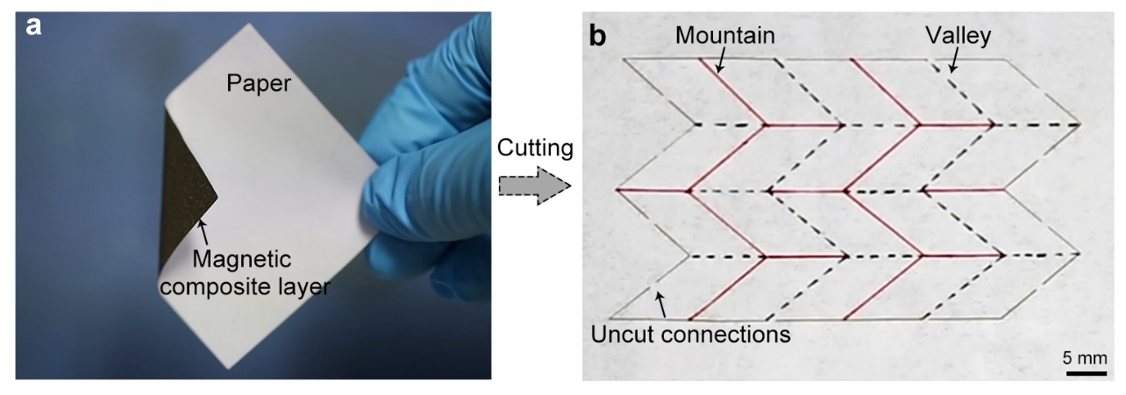
Figure S2. Laser cutting and drawing of origami patterns on a magnetic sheet for tearing off and folding. (a) Optical image of a magnetic paper. The magnetic paper consists of a paper layer and a magnetic composite layer. (b) Programmed magnetic paper with predesigned origami patterns and discontinuous cutting path. The origami pattern can be printed or drew on the paper layer, and a laser machine is used to cut the paper. The uncut connections help to avoid falling off and enable us to easily tear off the programmed part of the magnetic paper.

Figure S3. The hysteresis loop of magnetic composite. The residual magnetization and the relative permeability of magnetic paper are 170 kA‧m⁻¹ and 1.05, respectively.

Figure S4. The angle of a single-fold magnetic sheet at the rest state increases as the magnetic composite layer gets thicker. A thicker magnetic composite layer may result in excessive recovery at the rest state that impairs the construction of the magneto-origami machine.

Figure S5. A cuboid permanent magnet for actuating magneto-origami machines. (A) Schematic of the cuboid magnet with 25 mm in width, 50 mm in length and 25 mm in height. (B) The magnetic field around the cuboid magnet.

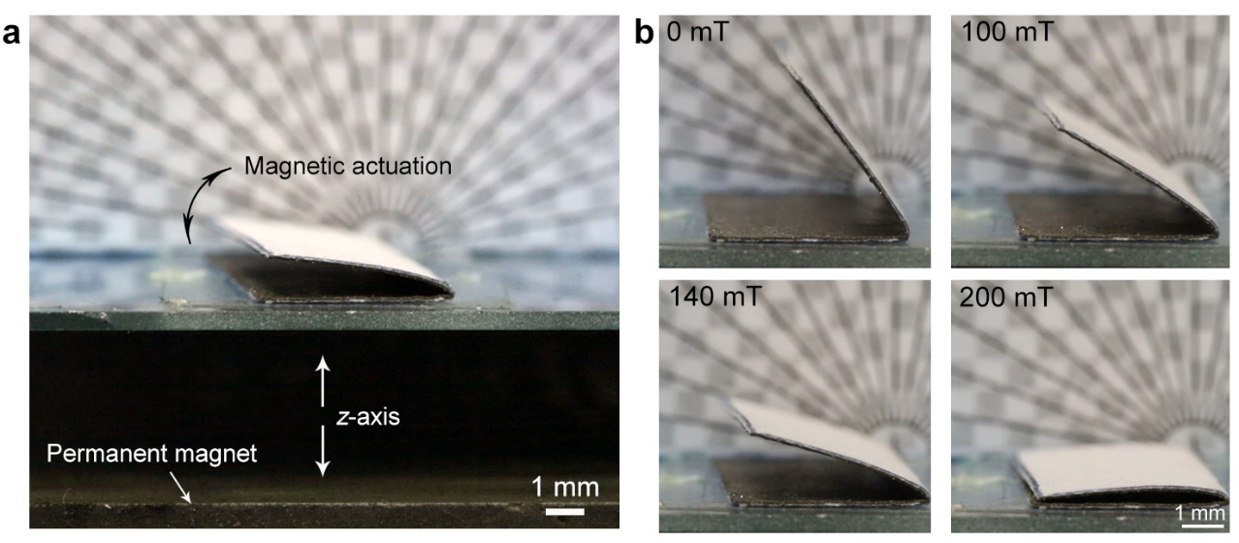
Figure S6. Experimental demonstration of the single-fold magneto-origami machine folding under magnetic actuation. (a) Shape-morphing of the single-fold magneto-origami machine under actuation of the permanent magnet. (b) Folding behaviors of single-fold magneto-origami machine under different actuation magnetic fields.

Figure S7. A single-fold magneto-origami machine under cyclic magnetic actuation. (a) Images of the single-fold magneto-origami machine under different cycles. (b) The angle of the single-fold magneto-origami machine almost remains almost unchanged after 1000 cycles.

Figure S8. Schematic illustration of the fabrication of magneto-origami spring actuator. First, the end sections of two magneto strips are glued together. Next, two magneto strips are alternatively folded. By repeating this, a magneto-origami spring actuator is eventually finished. The spring actuator was compressed tightly and magnetized by a strong pulsed magnetic field. When the compression was removed, the spring actuator returned to its rest state.

Figure S9. Circuit design and wireless charging of ME-robot. (a) The optical image of ME-robot with an electronic circuit on the paper layer. (b) The electronic circuit pattern designed by AutoCAD software. The rectifier (LX10M, MBCN) is utilized to convert alternating current into direct current and the voltage stabilizer (LP2981IM5X-3.3) is employed to provide constant voltage output. (c) The schematic illustration of the wireless charging circuit of the ME-robot. (d) The optical image of the charging station. The external diameter and internal diameter of the induction coil of the charging station are 44 mm and 21 mm, respectively. The input voltage of the charging station was 25 V, and the direct distance between the charging station and ME-robot was approximately 6 mm.
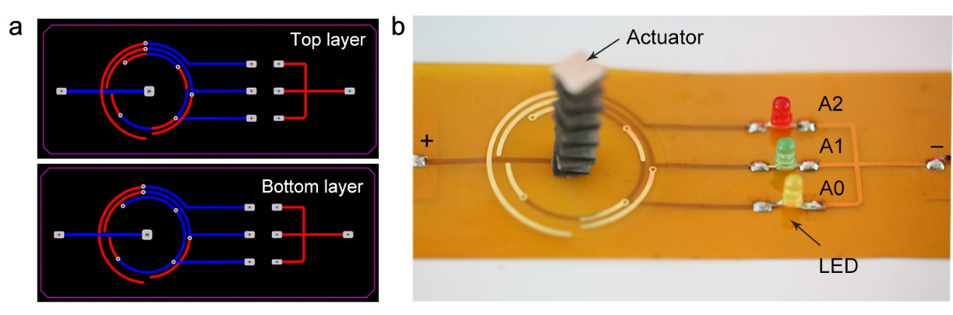
Figure S10. The electronic design and demonstration of the magneto-origami 8-3 encoder. (a) The logical circuit design of 8-3 encoder. (b) Image of the 8-3 encoder. Red LED, green LED, and yellow LED represents the output A1, A2, and A0, respectively.

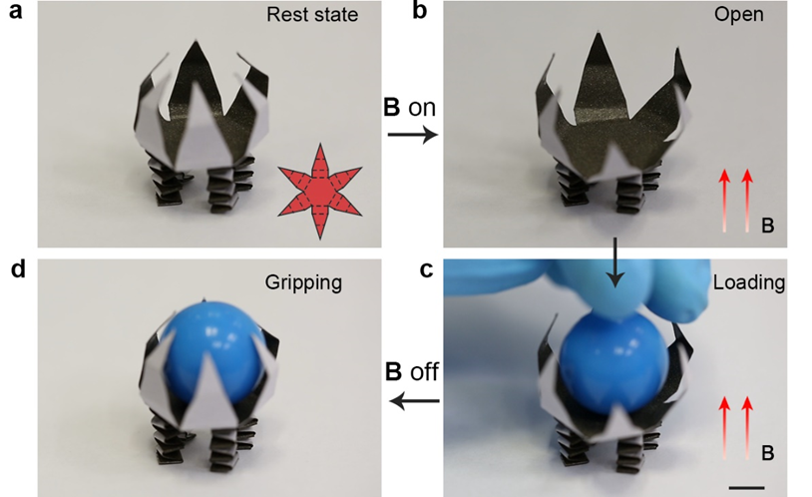
Figure S11. The loading process of a sphere cargo on the magneto-origami quadruped robot. (a) Image of the magneto-origami quadruped robot. The insert image shows the folding and magnetization pattern of the gripper. (b) The gripper opens upon application of 150 mT actuating field, (c) sphere cargo is loaded in the gripper, and (d) the cargo was grasped by the gripper upon removal of the magnetic field. Scale bar: 5 mm.

Table S1. Comparision of various fabrication methods for magneto-active soft machines.

