Supplementary Information for
Reaction-induced Ni-based interstitial carbon atoms for coke-free dry reforming of methane
Qianqian Wang^{1,+}, Wu Wang^{2,+}, Sha Li¹, Min Cao¹, Pengfei Wang³, Xiaoliang Yan^{1,4,*}, Ruifeng Li^{1,4}
¹College of Chemistry and Chemical Engineering, Taiyuan University of Technology, Taiyuan, Shanxi, 030024, P. R. China. ² Department of Physics, Southern University of Science and Technology, Shenzhen, Guangdong, 518055, P. R. China. ³State Key Laboratory of Clean and Efficient Coal Utilization, Institute of Coal Chemistry, Chinese Academy of Sciences, Taiyuan, Shanxi, 030001, P. R. China. ⁴Key Laboratory of Coal Science and Technology of Ministry of Education and Shanxi Province, Taiyuan University of Technology, Taiyuan, Shanxi 030024, P. R. China.
These authors contributed equally: Qianqian Wang and Wu Wang.
Corresponding author, *e-mail: yanxiaoliang@tyut.edu.cn
This PDF file includes:
Supplementary Figures 1 to 17
Supplementary Tables 1 to 3
Supplementary Note
Supplementary References
Supplementary Note
Thermodynamic study. The Gibbs free energy change of the reaction (Ni₃Zn + 0.7CH₄ → Ni₃ZnC_{0.7} + 1.4H₂, Equation 1) was calculated in the temperature range from 27 to 627℃. The general gradient approximation (GGA) with the Perdew–Burke–Ernzerhof (PBE) functional^{[1, 2]} were performed for the structure optimization of H₂, CH₄, Ni₃Zn and Ni₃ZnC_{0.7}. To better describe the structure of Ni₃Zn and Ni₃ZnC_{0.7}, a crystal model of Ni₆₀Zn₂₀ and Ni₆₀Zn₂₀C₁₄ were selected. The projected-augmented wave (PAW)^{[3]} pseudopotential was employed to treat the electron-ion interaction with cut-off energy of 500 eV and the k-points meshes were sampled as 3×3×3. The density functional dispersion correction (DFT-D3)^{[4]} was used to consider the van der Waals interactions. All the above calculations were carried out in Vienna Ab initio Simulation Package (VASP)^{[5, 6]}. The convergence criteria of total energy and force were 1×10⁻⁶ eV and 0.01 eV/Å, respectively. In the temperature range from 27 to 627℃, all of the thermodynamic data of Ni₆₀Zn₂₀ and Ni₆₀Zn₂₀C₁₄ were obtained by Phonopy package^{[7]}, and the thermodynamic data of H₂ and CH₄ were obtained by Vaspkit code^{[8]}. The Gibbs free energy change of the reaction (Equation 1) was obtained by following formula:
$${}_{\text{r}}\text{G}\left(\text{T}\right)=\text{[}{\text{G}}_{{\text{Ni}}_{\text{60}}{{\text{Zn}}_{\text{20}}\text{C}}_{\text{14}}}\left(\text{T}\right)\text{-}{\text{G}}_{{\text{Ni}}_{\text{60}}{\text{Zn}}_{\text{20}}}\left(\text{T}\right)+\text{28}{\text{G}}_{{\text{H}}_{\text{2}}}\left(\text{T}\right)\text{-14}{\text{G}}_{{\text{CH}}_{\text{4}}}\left(\text{T}\right)\text{)]/20}$$
where ${}_{\text{r}}\text{G}$ represents the Gibbs free energy change of the reaction (Equation 1), $\text{G}$ represents the Gibbs free energy of Ni₆₀Zn₂₀C₁₄, Ni₆₀Zn₂₀, CH₄ and H₂.
Supplementary Table 1. The Gibbs free energy of Ni₆₀Zn₂₀C₁₄, Ni₆₀Zn₂₀, CH₄, H₂ and the Gibbs free energy change of the reaction between Ni₃Zn and CH₄.
Temperature (℃) | Ni₆₀Zn₂₀C₁₄  (kJ/mol) | Ni₆₀Zn₂₀  (kJ/mol) | CH₄  (kJ/mol) | H₂  (kJ/mol) | Δ_{r}G  (kJ/mol)
27 | -55787.22 | -37921.96814 | -2241.339513 | -603.699744 | -169.5046482
77 | -55917.74 | -38038.25826 | -2250.762105 | -610.136832 | -172.6323159
127 | -56061.80 | -38168.14782 | -2260.456665 | -616.781472 | -175.857069
177 | -56217.85 | -38310.30438 | -2270.405625 | -623.607552 | -179.1438428
227 | -56384.64 | -38463.61519 | -2280.596793 | -630.594912 | -182.4664086
277 | -56561.16 | -38627.1401 | -2291.020569 | -637.727136 | -185.8046586
327 | -56746.56 | -38800.07635 | -2301.669177 | -644.991264 | -189.1437547
377 | -56940.14 | -38981.73196 | -2312.535609 | -652.376064 | -192.4718276
427 | -57141.27 | -39171.50522 | -2323.613721 | -659.872416 | -195.7800542
477 | -57349.44 | -39368.86884 | -2334.897849 | -667.472256 | -199.0611963
527 | -57564.19 | -39573.35741 | -2346.382809 | -675.168672 | -202.3095723
577 | -57785.11 | -39784.55747 | -2358.063609 | -682.955616 | -205.5207485
627 | -58011.84 | -40002.09955 | -2369.935545 | -690.827904 | -208.6914027

Supplementary Table 2. Reaction rate and rate constant with different partial pressure of CH₄ at 390, 400, 410 and 420℃ during DRM.
Temperature (℃) | Partial pressure of reactant  (kPa) |  | Reaction rate  (mol g_{cat}⁻¹·s⁻¹） |  | k₁
 | CH₄ | CO₂ | CH₄ | CO₂
390 | 19.50 | 48.59 | 6.01×10⁻⁷ | 4.40×10⁻⁶ | 0.172
 | 29.60 | 49.19 | 1.05×10⁻⁶ | 4.48×10⁻⁶
 | 39.05 | 48.46 | 1.70×10⁻⁶ | 3.94×10⁻⁶
 | 48.50 | 48.45 | 2.06×10⁻⁶ | 4.33×10⁻⁶
400 | 19.34 | 48.18 | 8.39×10⁻⁷ | 5.97×10⁻⁶ | 0.233
 | 29.58 | 49.10 | 1.46×10⁻⁶ | 5.86×10⁻⁶
 | 39.18 | 48.53 | 2.18×10⁻⁶ | 5.06×10⁻⁶
 | 48.71 | 48.58 | 2.74×10⁻⁶ | 5.34×10⁻⁶
410 | 19.14 | 47.74 | 9.81×10⁻⁷ | 6.62×10⁻⁶ | 0.324
 | 29.01 | 48.12 | 2.23×10⁻⁶ | 8.18×10⁻⁶
 | 38.80 | 47.92 | 2.99×10⁻⁶ | 6.94×10⁻⁶
 | 48.13 | 47.84 | 3.47×10⁻⁶ | 6.79×10⁻⁶
420 | 19.09 | 47.67 | 1.36×10⁻⁶ | 8.71×10⁻⁶ | 0.413
 | 28.80 | 47.76 | 2.48×10⁻⁶ | 8.94×10⁻⁶
 | 38.50 | 47.52 | 3.42×10⁻⁶ | 7.73×10⁻⁶
 | 47.64 | 47.22 | 4.88×10⁻⁶ | 8.85×10⁻⁶

Supplementary Table 3. Reaction rate and rate constant with different partial pressure of CO₂ at 390, 400, 410 and 420℃ during DRM.
Temperature (℃) | Partial pressure of reactant  (kPa) |  | Reaction rate  (mol g_{cat}⁻¹·s⁻¹） |  | k₂
 | CH₄ | CO₂ | CH₄ | CO₂
390 | 48.82 | 19.41 | 4.28×10⁻⁶ | 1.48×10⁻⁶ | 0.460
 | 49.02 | 29.27 | 2.92×10⁻⁶ | 2.18×10⁻⁶
 | 48.60 | 38.93 | 2.93×10⁻⁶ | 3.59×10⁻⁶
 | 48.68 | 48.60 | 4.98×10⁻⁶ | 6.54×10⁻⁶
400 | 49.18 | 19.44 | 3.48×10⁻⁶ | 1.55×10⁻⁶ | 0.519
 | 48.87 | 29.07 | 3.40×10⁻⁶ | 2.65×10⁻⁶
 | 48.36 | 38.62 | 3.49×10⁻⁶ | 4.35×10⁻⁶
 | 48.77 | 48.54 | 4.71×10⁻⁶ | 6.90×10⁻⁶
410 | 49.02 | 19.25 | 4.42×10⁻⁶ | 1.93×10⁻⁶ | 0.621
 | 49.25 | 29.18 | 3.90×10⁻⁶ | 3.10×10⁻⁶
 | 48.60 | 38.71 | 3.92×10⁻⁶ | 4.99×10⁻⁶
 | 48.66 | 48.34 | 5.75×10⁻⁶ | 8.36×10⁻⁶
420 | 49.30 | 19.24 | 3.74×10⁻⁶ | 2.03×10⁻⁶ | 0.684
 | 48.99 | 28.88 | 4.04×10⁻⁶ | 3.55×10⁻⁶
 | 48.43 | 38.44 | 4.45×10⁻⁶ | 5.81×10⁻⁶
 | 48.83 | 48.37 | 5.48×10⁻⁶ | 8.66×10⁻⁶
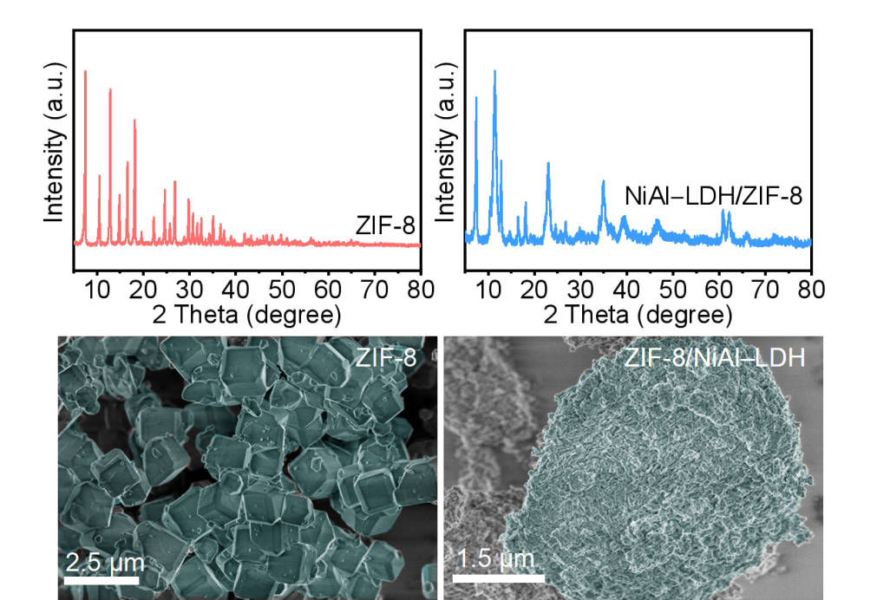
a
b
c
d
Supplementary Figure 1. a, b, XRD patterns and c, d, SEM images of (a, c) ZIF-8 and (b, d) ZIF-8/NiAl−LDH composite.

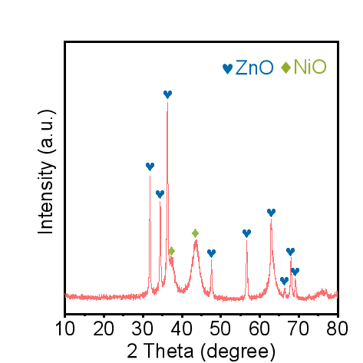
Supplementary Figure 2. XRD pattern of NiO−ZnO/Al₂O₃.
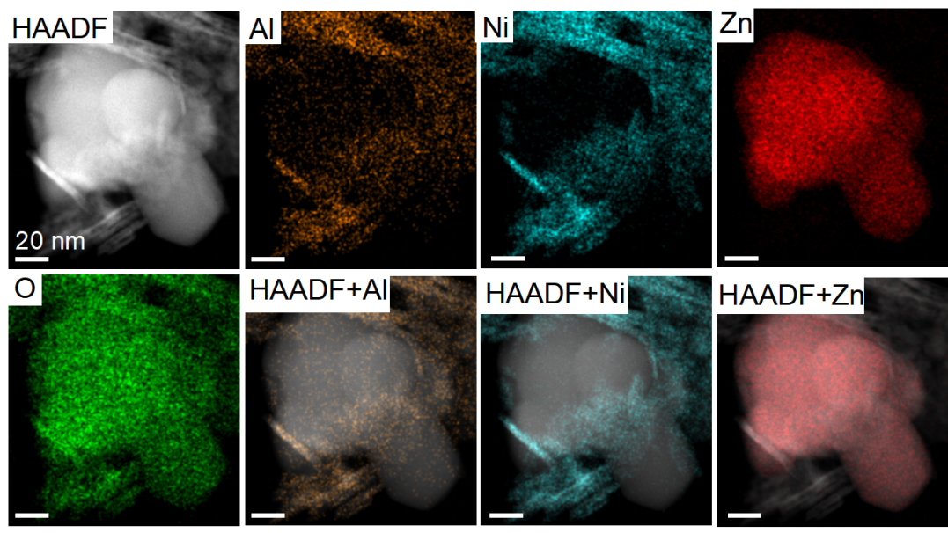
Supplementary Figure 3. STEM−HAADF images with elemental mapping of NiO−ZnO/Al₂O₃.
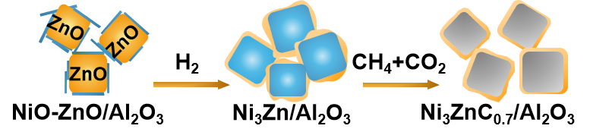
Supplementary Figure 4. Schematic illustration of the process of the changes from NiO−ZnO/Al₂O₃ to Ni₃Zn/Al₂O₃ under H₂ reduction and further to Ni₃ZnC_{0.7}/Al₂O₃ during DRM.
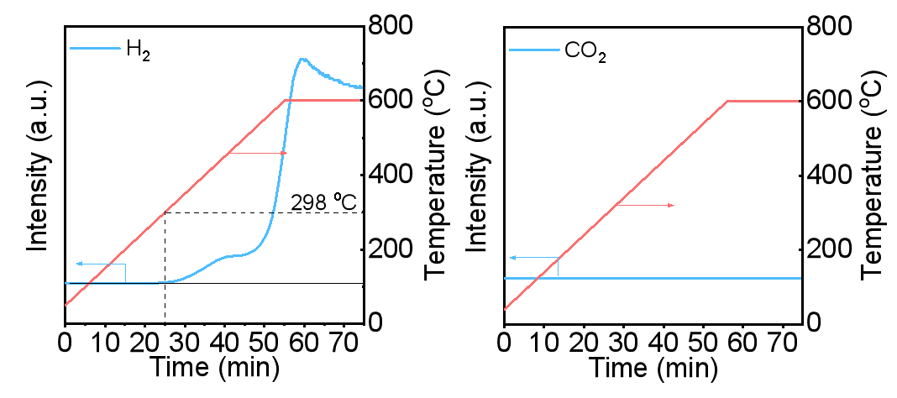
a
b
Supplementary Figure 5. TPSR−MS results of Ni₃Zn/Al₂O₃ at elevated temperatures under (a) CH₄ and (b) CO atmosphere.
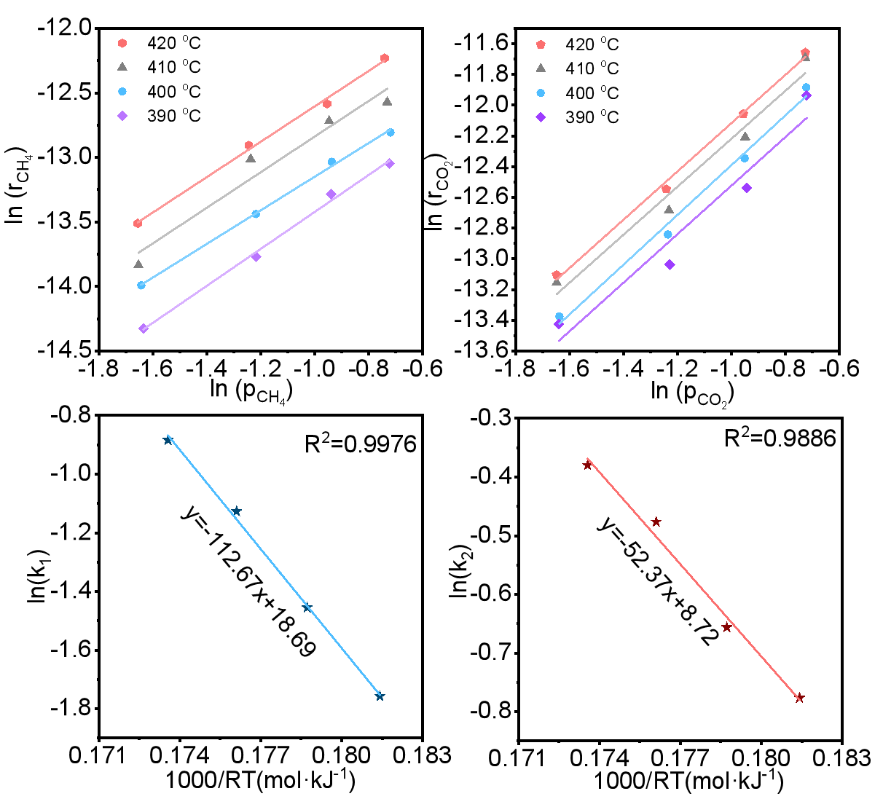
a
b
c
d
Supplementary Figure 6. (a, b) Changes of reaction rates as the partial concentration of reactants changes and the corresponding Arrhenius plots for (c) CH₄ and (d) CO₂ activation energies over Ni₃ZnC_{0.7}/Al₂O₃.
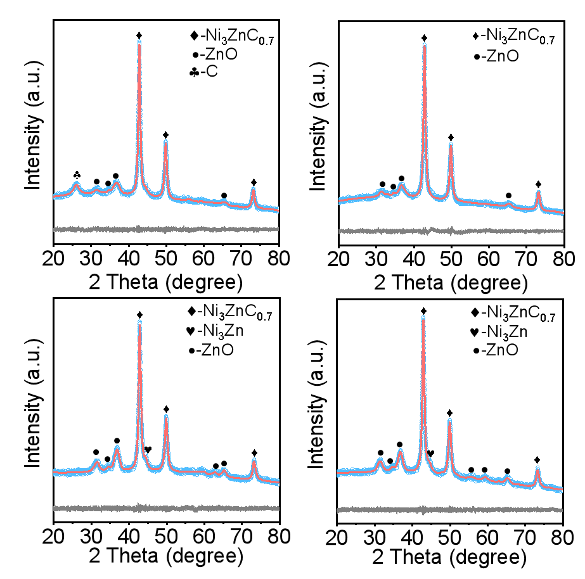
a
b
c
d
Supplementary Figure 7. Refined XRD patterns of Ni₃ZnC_{0.7}/Al₂O₃ after 100 h DMR at 500℃ with CH₄/CO₂ ratio of (a) 4/1, (b) 2/1, (c) 1/2 and (d) 1/4.
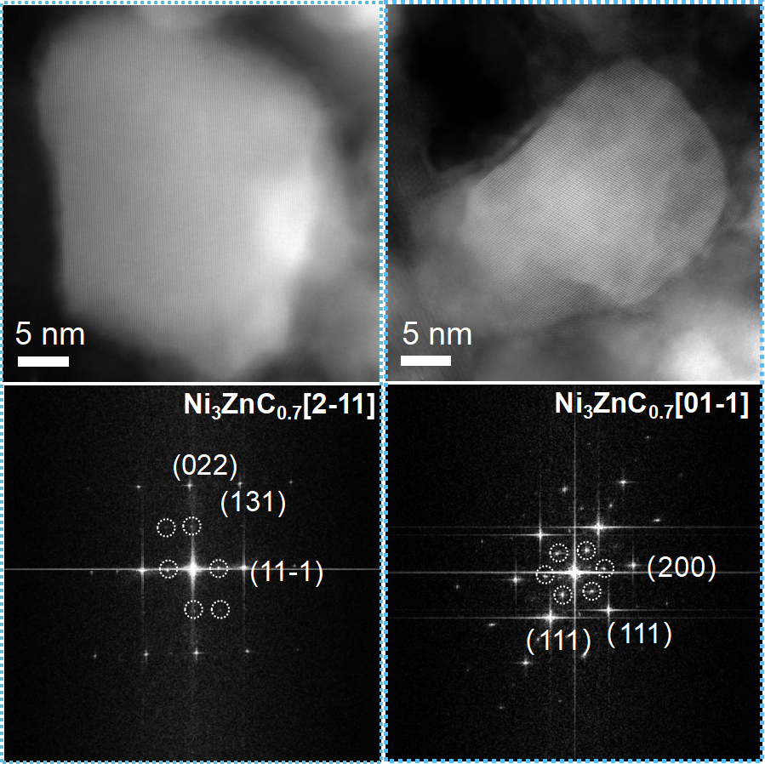
a
b
Supplementary Figure 8. HRTEM images and SAED patterns of Ni₃ZnC_{0.7}/Al₂O₃ after 100 h reaction with CH₄/CO₂ ratio of 1/1 in different regions and different crystal axis directions.

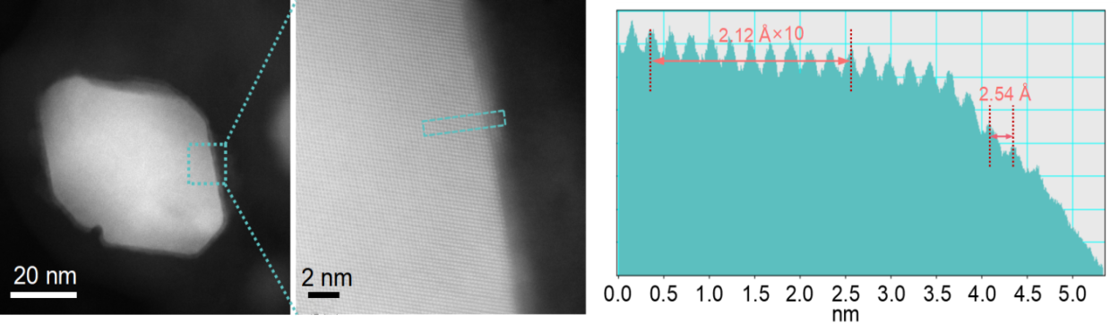
a
b
c
Supplementary Figure 9. (a) TEM, (b) HRTEM images, and (c) corresponding profile of the Ni₃ZnC_{0.7}/Al₂O₃.
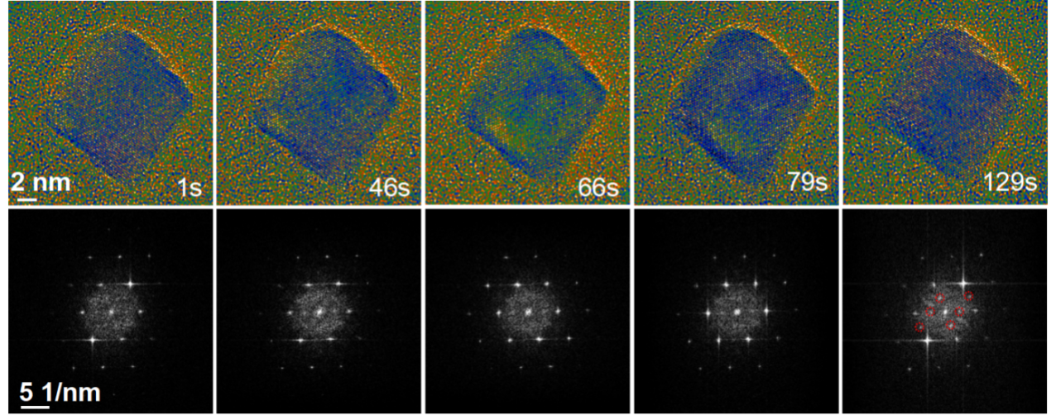
a
b
Supplementary Figure 10. (a) Color-coded in-situ HRTEM images on the evolution from Ni₃Zn to Ni₃ZnC_{0.7} during the DMR with CH₄/CO₂ ratio of 1/1 at 500℃ and (b) corresponding FFT images.
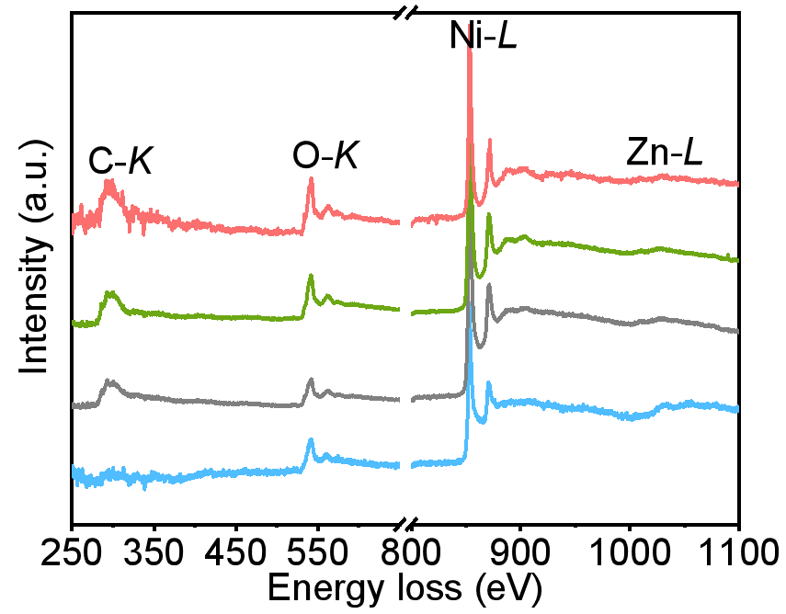
Supplementary Figure 11. In situ EEL spectra of Ni₃Zn/Al₂O₃ during DRM with CH₄/CO₂ ratio of 1/1. The profile from bottom to up was obtained at room temperature, at 500℃ under CH₄ and CO₂, at 500℃ without reactants, and at room temperature after the reaction.
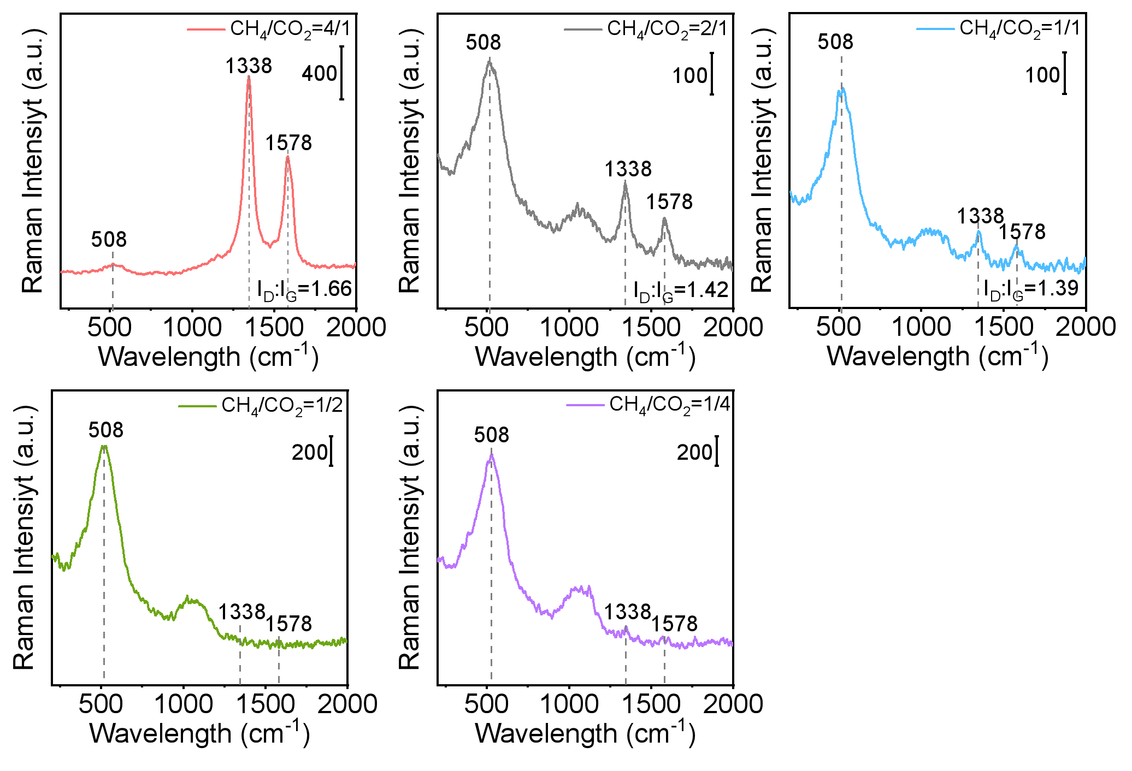
a
b
c
d
e
Supplementary Figure 12. Raman spectra of the catalysts after 100 h at 500℃ with CH₄/CO₂ ratio of (a) 4/1, (b) 2/1, (c) 1/1, (d) 1/2 and (e) 1/4.
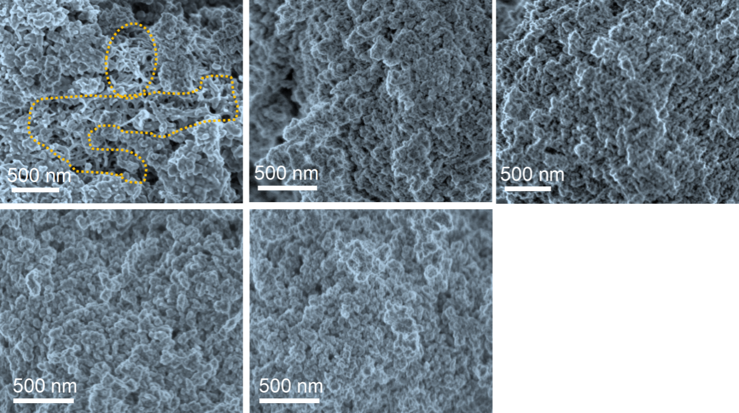
a
b
c
d
e
Supplementary Figure 13. SEM images of Ni₃ZnC_{0.7}/Al₂O₃ after 100 h period at 500℃ with CH₄/CO₂ ratio of (a) 4/1, (b) 2/1, (c) 1/1, (d) 1/2, and (e) 1/4.
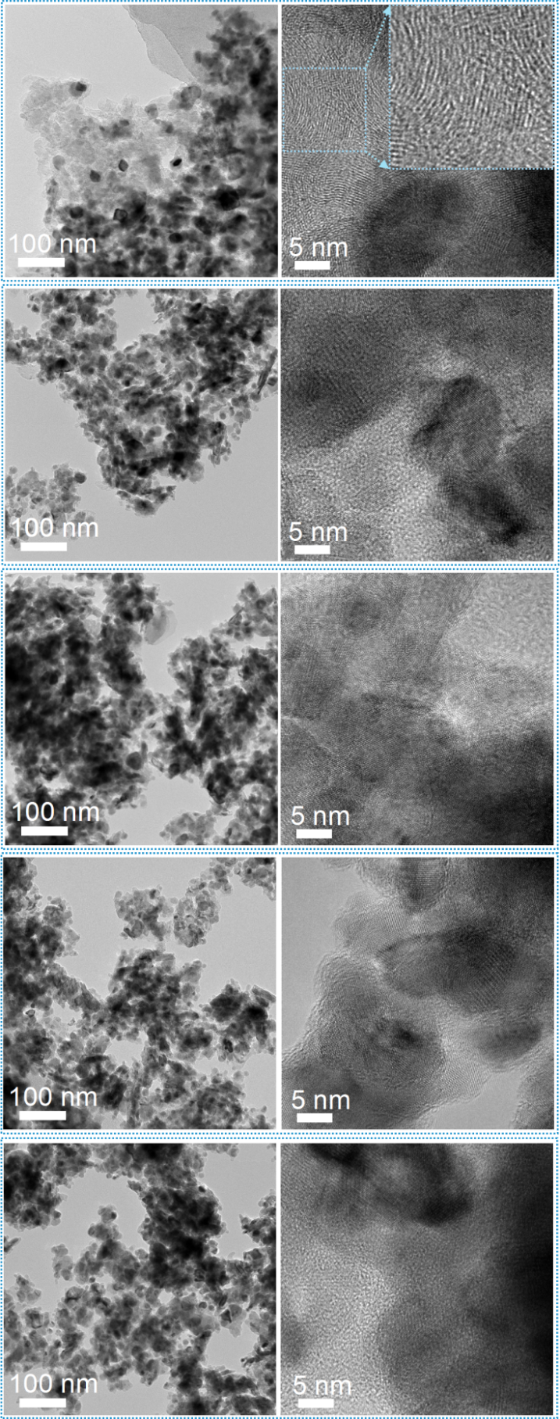
a
c
e
g
i
b
d
f
h
j
Supplementary Figure 14. TEM and HRTEM images of Ni₃ZnC_{0.7}/Al₂O₃ after 100 h period at 500℃ with CH₄/CO₂ ratio of (a, b) 4/1, (c, d) 2/1, (e, f) 1/1, (g, h) 1/2, and (i, j) 1/4.
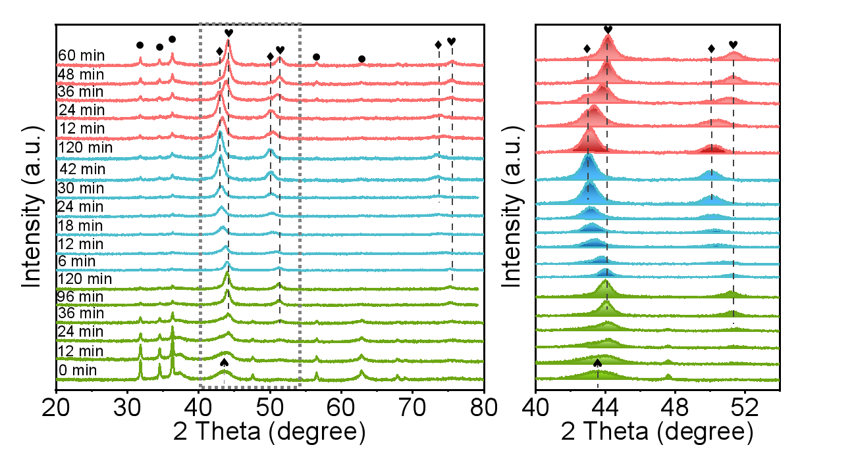
a
b
Supplementary Figure 15. a, In situ (a) XRD patterns and (b) cross sections of NiO−ZnO/Al₂O₃ under H₂ reduction process at 550℃ (green curve), and then under DRM with CH₄/CO₂ ratio of 1/1 at 500℃ (blue curve), and further under CO₂ at 500℃ (pink curve). ●, ♥, ♦ and ♠: ZnO, Ni₃Zn, Ni₃ZnC_{0.7} and NiO.
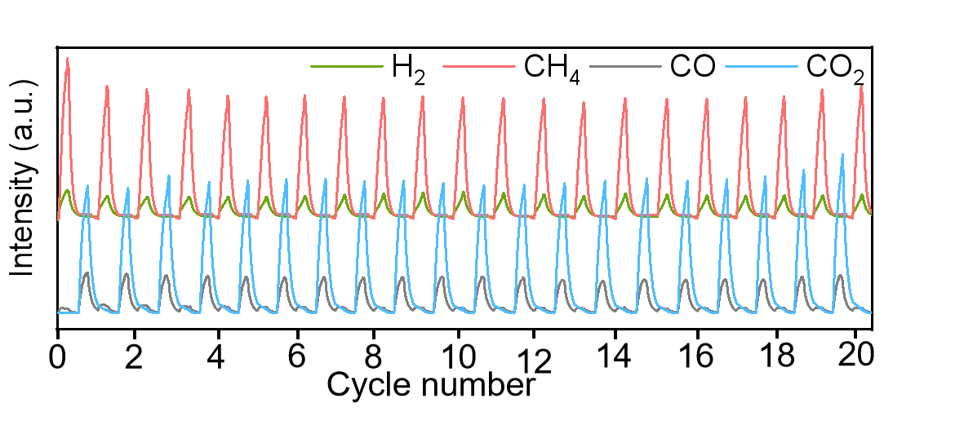
Supplementary Figure 16. Pulse experiment of CH₄−Ar−CO₂−Ar−CH₄ cycles for the reduced catalyst at 600℃.
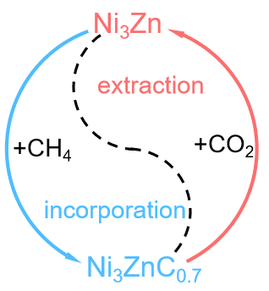
Supplementary Figure 17. Illustration of carbon cycle between Ni₃Zn and Ni₃ZnC_{0.7} during DRM.
Supplementary References
- Perdew, J. P., Burke, K. & Ernzerhof, M. Generalized gradient approximation made simple. Phys. Rev. Lett. 77, 3865-3868 (1996).
- Kresse, G. & Furthmüller, J. Efficient iterative schemes for ab initio total-energy calculations using a plane-wave basis set. Phys. Rev. B 54, 11169-11186 (1996).
- Blöchl, P. E., Jepsen, O. & Andersen, O. K. Improved tetrahedron method for brillouin-zone integrations. Phys. Rev. B 49, 16223-16233 (1994).
- Grimme, S., Antony, J., Ehrlich, S. & Krieg, H. A consistent and accurate ab initio parametrization of density functional dispersion correction (DFT-D) for the 94 elements H-Pu. J. Chem. Phys. 132, 154104 (2010).
- Kresse, G. & Furthmüller, J. Efficiency of ab-initio total energy calculations for metals and semiconductors using a plane-wave basis set. Comput. Mater. Sci. 6, 15-50 (1996).
- Kresse, G. & Joubert, D. From ultrasoft pseudopotentials to the projector augmented-wave method. Phys. Rev. B 59, 1758-1775 (1999).
- Kresse, G., Furthmüller, J. & Hafner, J. Ab initio force constant approach to phonon dispersion relations of diamond and graphite. Europhysics Lett. 32, 729-734 (1995).
- Wang, V., Xu, N., Liu, J. C., Tang, G. & Geng W. T. VASPKIT: A user-friendly interface facilitating high–throughput computing and analysis using VASP code. Comput. Phys. Commun. 267, 108033 (2021).

