Supplementary materials for “Course of post COVID-19 disease symptoms over time in the ComPaRe long COVID prospective e-cohort”

Supplementary material 1: Study flow chart. *The high number of patients without a confirmed infection is due to the limited availability of testing during the first wave of COVID-19 in March 2020, in France
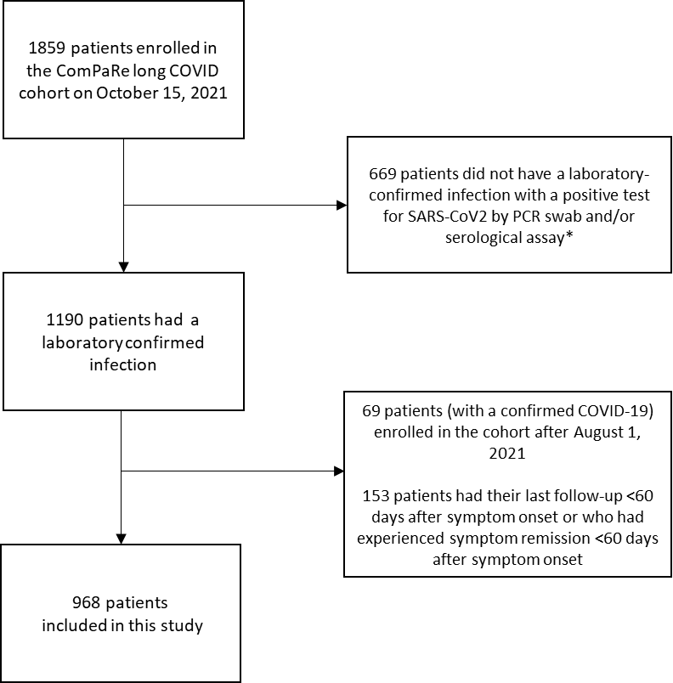

Supplementary material 2: Patients’ characteristics (n=968). Weighted data were obtained by calibration on margins with weights for age (<24, 25-34, 35-49, 50-69, and ≥70 years old), gender and hospitalisation during the acute phase of the disease, derived from the data from the Office of National Statistics in the United Kingdom.
Characteristic | Raw data  (n=968) | Weighted data  (n=968)
Age, median (Q1−Q3) – year | 47 (38−54) | 48 (32-56)
Age categories – number (%)  <24  24-34  35-49  50-69  >70 | 25 (2.6)  136 (14)  448 (46.3)  337 (34.8)  22 (2.3) | 147 (15.2)  138 (14.3)  259 (26.8)  335 (34.6)  89 (9.2)
Male sex – number (%) | 201 (20.8) | 559 (57.7)
Educational level – number (%)  Middle school or equivalent  High school or equivalent  2 years post-secondary education  ≥ 3 years post-secondary education  Other | 75 (7.7)  105 (10.8)  216 (22.3)  553 (57.1)  19 (2.0) | 70 (7.2)  147 (15.2)  178 (18.4)  559 (57.8)  14 (1.5)
At least one comorbidity – number (%) | 382 (39.5) | 340 (35.1)
Comorbidities – number (%)  High blood pressure  Diabetes  Stroke or cardiac ischemic disease  Chronic kidney disease  Chronic lung disease (e.g., asthma/COPD)  Thyroid disorder  Cancer  Depression/Anxiety | 45 (4.6)  23 (2.4)  5 (0.5)  2 (0.2)  71 (7.3)  25 (2.6)  18 (1.9)  42 (4.3) | 41 (4.2)  25 (2.6)  6 (0.6)  1 (0.1)  61 (6.3)  17 (1.7)  18 (1.9)  40 (4.1)
Time since symptom onset, median (Q1−Q3) - days | 192 (97 - 297) | 174 (97-284)
Hospitalised for covid-19 – number (%) | 156 (16.1) | 75 (7.7)
Hospitalised in ICU for covid-19 – number (%) | 42 (4.3) | 34 (3.5)
Duration of hospitalisation, median (Q1-Q3) | 7 (1−14) | 12 (3-26)

Supplementary material 3: Follow-up of patients included in the study. As data collection is in progress, all figures may improve with time. *Unavailable data may be due to 1) patients who have not yet reached the time point; 2) who reached the time point less than 30 days ago and may still answer the online questionnaire; and 3) patients actually lost to follow-up. Only the latter can cause informative censoring and bias. For other patients, we can assume that their survival prospects are similar to those of the participants who continue to be followed.
 | Number of patients enrolled in the cohort | Number (%) of patients  With available data* | Number(%) of patients with actual missing data at the observation point
At least 2 months since enrollment (enrolled before September 2021) | 968 | 789 (81.5) | 168 (17.4)
At least 4 months since enrollment (enrolled before July 2021) | 924 | 711 (76.9) | 167 (18.1)
At least 6 months since enrollment (enrolled before May 2021) | 766 | 551(71.9) | 139 (18.1)
At least 8 months since enrollment (enrolled before March 2021) | 576 | 329 (57.1) | 74 (12.8)
At least 10 months since enrollment (enrolled before January 2021) | 250 | 120 (48) | 0

Supplementary material 4: Day-by-day trends in the prevalence of post COVID-19 disease symptoms (A) and in their impact on patients’ lives (B) (n=968 [raw data]) A: The figure presents the day-by-day prevalence of each of the 53 symptoms assessed by the Long COVID ST (grey lines). Examples of specific symptoms have been highlighted (coloured lines). For each symptom and at each observation point, we assumed that patients were either “experiencing” or “not experiencing” the symptom. We assumed that their state at an arbitrary time was the same as the state at their previous observation point and that their states before their first observation and after their last observation are unknown. B: The figure presents the day-by-day evolution of 6 domains of patients’ lives that can be affected by post COVID-19 disease (assessed by the Long COVID IT). For each item and at each observation point, we modelled patients answers as either “reporting" a significant impact of the disease on this domain” (i.e., item score >7) or “not reporting” this impact (i.e., item score <8). We assumed that their state at an arbitrary time was the same as the state at their previous observation point and that their states before their first observation and after their last observation are unknown. The red lines represent a similar model for the Patient Acceptable Symptomatic State (PASS) of the long COVID IT, which is the long COVID IT score below which 75% of patients find that their disease state is acceptable.
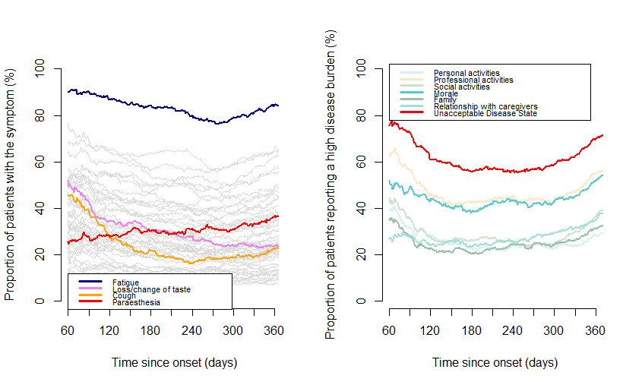

Supplementary material 5: Estimated prevalence of each of the 53 symptoms assessed by the Long COVID ST at 60 and 360 days after disease onset (n=968 [weighed data]). Prevalence is estimated by a multistate model where patients were considered to be either “experiencing" or “not experiencing" each symptom. On the assumption that a patient’s state at an arbitrary time was the same as the state at their previous observation time and that each patient’s states before the first observation and after the last observation are unknown, we estimated the prevalence of the given symptom day by day from disease onset. Colours indicate symptoms with a prevalence decreasing over time (green), symptoms with no change in prevalence over time (yellow), and symptoms with an increasing prevalence over time (red).
Symptom | Prevalence at 60 days | Prevalence at 360 days | Difference
Loss of appetite | 30.6 | 6.9 | -23.7
Change/Loss of taste | 46.9 | 24.1 | -22.8
Cough | 44.6 | 21.8 | -22.8
Headache | 82.8 | 63.7 | -19.1
Fever and chills | 41 | 22.9 | -18.1
Change/Loss of smell | 46.9 | 29 | -17.9
Diarrhoea | 38.7 | 22.9 | -15.8
Changing mood/impact on morale | 61.1 | 46.2 | -14.9
Sore tongue/mouth, dysphagia | 33.1 | 18.3 | -14.8
Dry skin/peeling | 35.3 | 21.3 | -14
Muscle aches | 54.6 | 42.2 | -12.4
Fatigue | 93 | 81 | -12
Dizziness/malaise | 55.2 | 43.3 | -11.9
Brain fog/Difficulty concentrating | 71.8 | 60.2 | -11.6
Balance disorder | 33.8 | 22.7 | -11.1
Nausea/Vomiting | 27.6 | 16.7 | -10.9
Sleeping more | 32.5 | 21.7 | -10.8
Tachycardia/palpitations/Arrhythmia | 43.8 | 33 | -10.8
Chest pressure | 44.1 | 33.7 | -10.4
Tremor | 23.1 | 13.6 | -9.5
Difficulty sleeping | 70.1 | 60.8 | -9.3
Swollen lymph nodes | 14.8 | 6.2 | -8.6
Skin rash | 28 | 20.1 | -7.9
Abdominal pain | 41.9 | 34.4 | -7.5
Sharp sudden pain, chest burns | 32.1 | 24.8 | -7.3
Memory problems | 55.7 | 50.2 | -5.5
Body aches | 43.6 | 38.3 | -5.3
Costal pain | 29.9 | 25.8 | -4.1
Weight loss | 12 | 7.9 | -4.1
High or low blood pressure | 15.3 | 11.5 | -3.8
Tinnitus | 38.9 | 36.1 | -2.8
Sweats | 20.5 | 18.3 | -2.2
Hot Flushes | 22.3 | 20.7 | -1.6
Congested/Runny nose | 33.9 | 34.1 | 0.2
Dyspnoea | 44.2 | 44.5 | 0.3
Clogged ears | 11.1 | 11.5 | 0.4
Word-finding problems | 47.5 | 48.3 | 0.8
Gynaecological problems | 5.2 | 6.3 | 1.1
Phono/photophobia | 10.8 | 12.7 | 1.9
Circulatory problems (incl. Bulging veins) | 6.1 | 8.3 | 2.2
Spontaneous bruises | 5.7 | 8.3 | 2.6
Heat/Cold intolerance | 9.2 | 11.8 | 2.6
Hypoesthesia | 3.2 | 5.9 | 2.7
Dry eyes | 23.9 | 28.4 | 4.5
Urinary symptoms | 8.5 | 13.4 | 4.9
Discolouration/swelling of hands and feet | 6.2 | 11.3 | 5.1
Heavy legs/swelling of the legs | 14.3 | 19.8 | 5.5
Blurry vision | 26.2 | 32 | 5.8
Hair loss | 8.2 | 15.1 | 6.9
Bone and Joint Pain | 32.2 | 41.4 | 9.2
Ear pain | 5.2 | 16.9 | 11.7
Paraesthesia | 21.1 | 33.7 | 12.6
Neck, back and low back pain | 23.4 | 38.5 | 15.1

Supplementary material 6: Estimated prevalence of symptoms of male and female patients (n=968 [weighted data]). For each of the 53 symptoms assessed by the long COVID ST, the day-by-day prevalence in male and female patients was calculated (all lines). Some symptoms are highlighted (coloured lines).
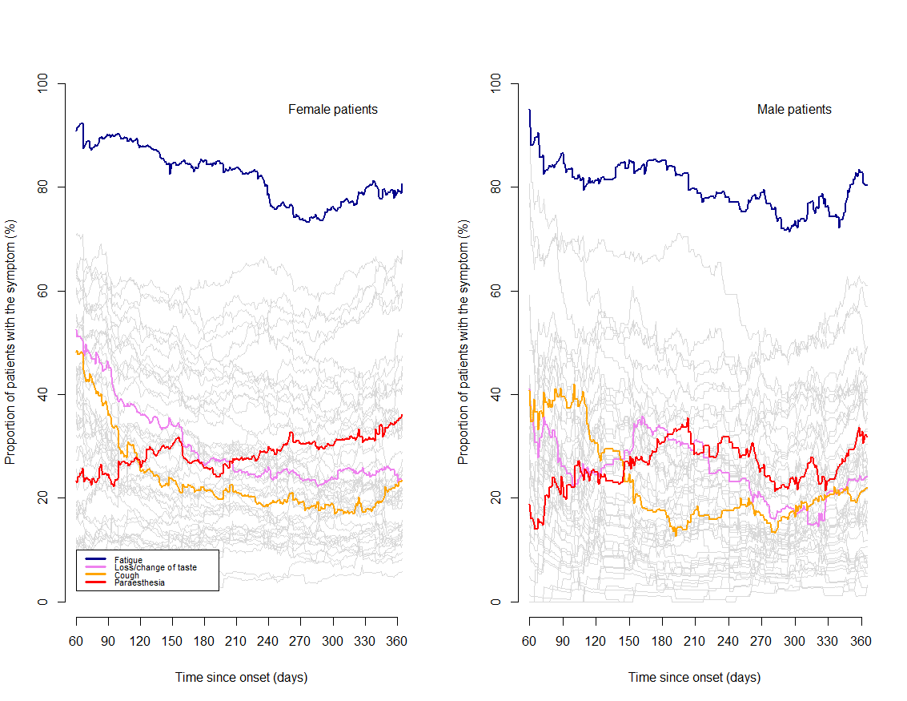

Supplementary material 7: Estimated prevalence of symptoms of patients with and without comorbidities (n=968 [weighted data]). For each of the 53 symptoms assessed by the long COVID ST, the day-by-day prevalence in patients with and without comorbidities was calculated (all lines). Some symptoms are highlighted (coloured lines).
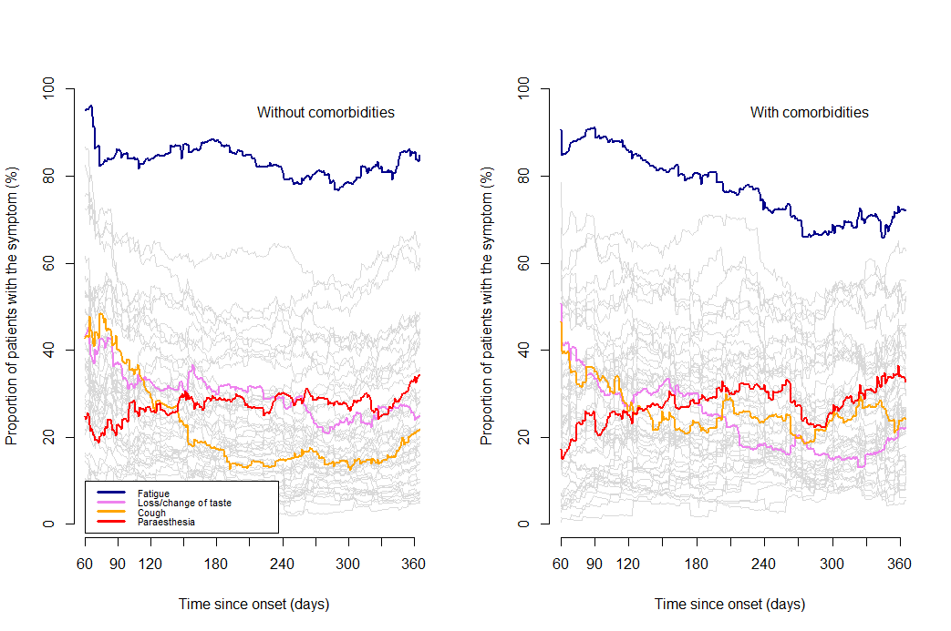

Supplementary material 8: Estimated prevalence of symptoms of aged ≤ 40 years and of those >40 years (n=968 [weighted data]). For each of the 53 symptoms assessed by the long COVID ST, the day-by-day prevalence in patients aged 40 years or less, and those older than 40 years was calculated. We present below the 6 symptoms for which the sum of absolute differences in prevalence between the two subgroups from 60 to 360 days exceeds 10%).
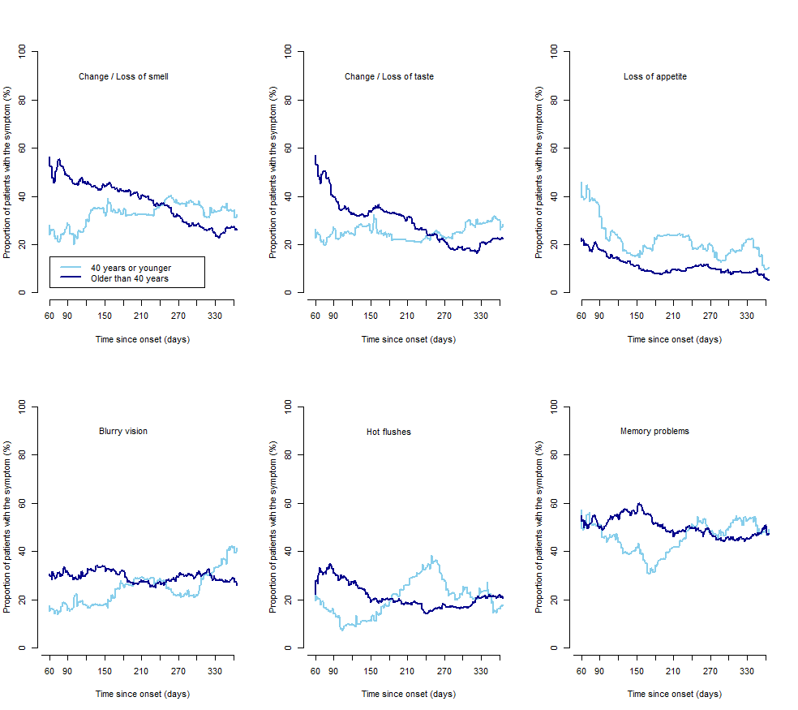

Supplementary material 9: Longitudinal course of the frequency of symptoms for patients with post COVID-19 disease (n=968 [weighted data]). Data come from the answer to the question: “how often did your symptoms occur during the last 30 days,” with four response options: “permanent symptoms”, “daily relapses”, “weekly relapses”, and “less than weekly relapses.”
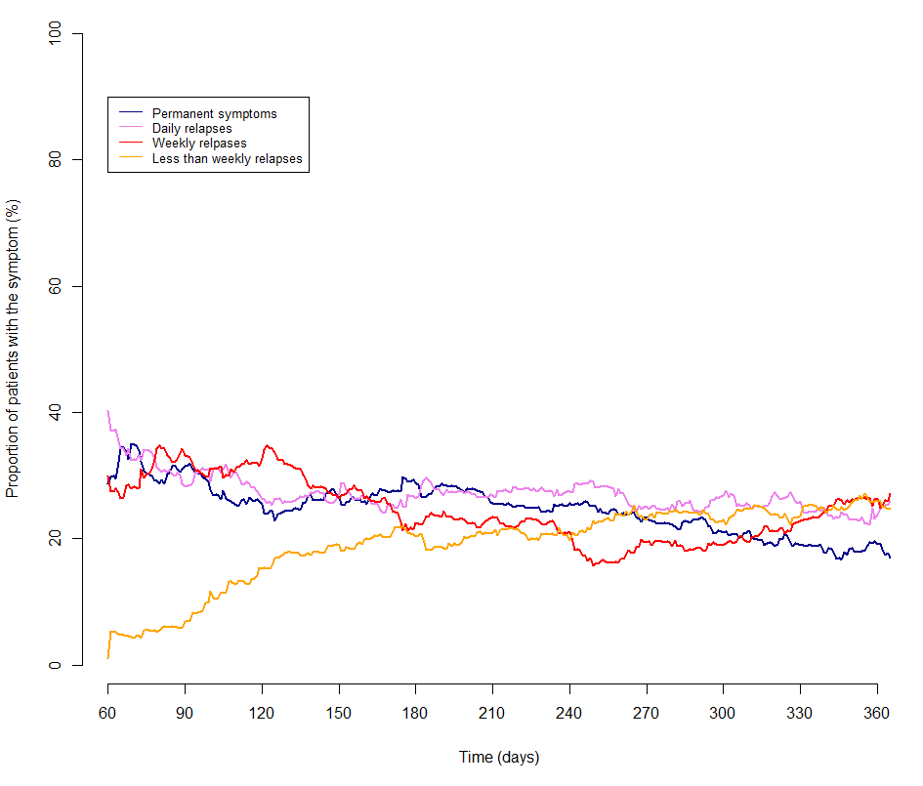

Supplementary material 10: Evolution of patients’ perception of the impact of post COVID-19 disease on their lives for male and female patients (n=968 [weighted data]). The figure presents the day-by-day evolution of 6 domains of patients’ lives that can be affected by post COVID-19 disease (assessed by the Long COVID IT). For each item and at each observation point, we modelled patients answers as either “reporting" a significant impact of the disease on this domain” (i.e., item score >7) or “not reporting” this impact (i.e., item score <8). We assumed that their state at an arbitrary time was the same as the state at their previous observation point and that their states before their first observation and after their last observation are unknown. The red lines represent a similar model for the Patient Acceptable Symptomatic State (PASS) of the long COVID IT, which is the long COVID IT score below which 75% of patients find that their disease state is acceptable.
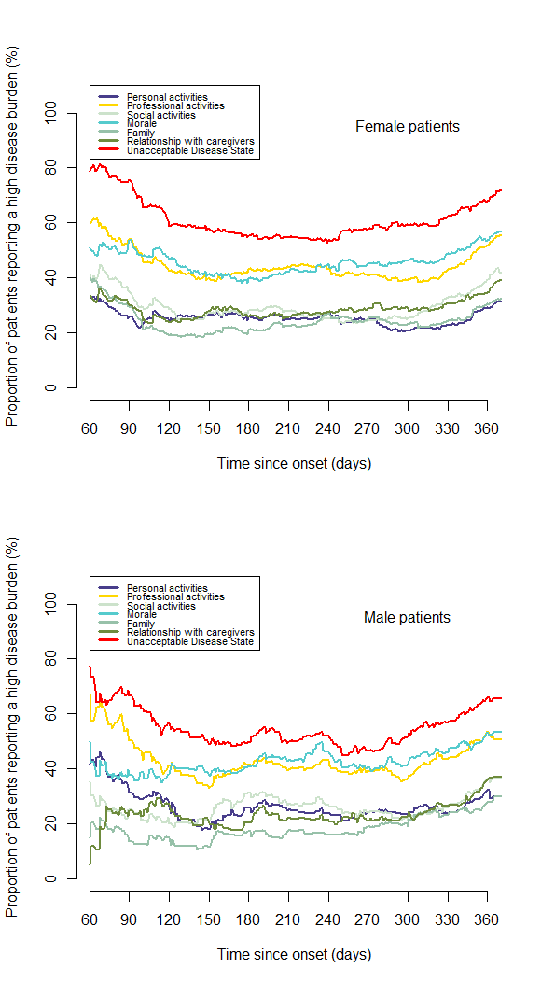

Supplementary material 11: Evolution of patients’ perception of the impact of post COVID-19 disease on their lives between patients aged ≤ and > 40 years (n=968 [weighted data]). The figure presents the day-by-day evolution of 6 domains of patients’ lives that can be affected by post COVID-19 disease (assessed by the Long COVID IT). For each item and at each observation point, we modelled patients answers as either “reporting" a significant impact of the disease on this domain” (i.e., item score >7) or “not reporting” this impact (i.e., item score <8). We assumed that their state at an arbitrary time was the same as the state at their previous observation point and that their states before their first observation and after their last observation are unknown. The red lines represent a similar model for the Patient Acceptable Symptomatic State (PASS) of the long COVID IT, which is the long COVID IT score below which 75% of patients find that their disease state is acceptable.
