Supplementary Materials for

A New in-situ Exsolution Supporting Framework for Metal Nanoparticle Growth

Mengchu Wang¹†, Bike Zhang¹†, Jiaqi Ding¹†, Fanxing Zhang¹, Rui Tu¹, Matthew T. Bernards², Yi He^{1,3}*, Pengfei Xie¹ and Yao Shi¹

†These authors contributed equally to this work.
*Corresponding author. Email: yihezj@zju.edu.cn (Y. H.).

This PDF file includes:

Materials and Methods
Supplementary Text
Figs. S1 to S18
Tables S1 to S3

Materials and Methods
Materials
Copper (II) nitrate trihydrate (Cu(NO₃)₂·3H₂O, ≥99%, Aladdin), nickel (II) nitrate hexahydrate (Ni(NO₃)₂·6H₂O, deionized water (H₂O, Aladdin), citric acid monohydrate (C₆H₈O₇·H₂O, 99.8%, Macklin), potassium bicarbonate (KHCO₃, 99.99%, Macklin), ethanol (CH₃CH₂OH, ≥95%, Sinopharm chemical reagent Co., Ltd), nafion solution (5 wt%, Shanghai He Sen Electric Co., Ltd.), formic acid (HCOOH, 99%, Aladdin), deuteroxide (D₂O, 99.9%, Euriso), and dimethyl sulfoxide (C₂H₆OS, ≥99.9%, Macklin) were purchased and used as received. Multi-walled carbon nanotubes (MWCNTs, 99.9%, Chengdu organic chemicals Co., Ltd. Chinese academy of sciences) were purchased and pretreated with the following steps. Moderate amounts of MWCNTs were placed in a dilute sulfuric acid solution, followed by heating to 80°C for an hour under vigorous stirring to remove any metal impurities, which may substantially impact the electrochemical performance testing. After the preliminary treatment, the MWCNTs were transferred to a flask with concentrated nitric acid in it, then heated with reflux at 85°C for 2 hours, then cooled to room temperature. The precipitation was rinsed with deionized water until the filtrate was near neutral. Finally, the MWCNTs were transferred to a vacuum drying oven and dried overnight at 80°C to obtain pretreated MWCNTs for later use.

Catalyst preparation
Pristine copper doping/nickel oxyhydroxide (Cu_{0.5}NiOOH)
Cu_{0.5}NiOOH was synthesized through a one-step hydrothermal method. Briefly, 1 mmol Cu(NO₃)₂·3H₂O, 2 mmol Ni(NO₃)₂·6H₂O, 0.1 g MWCNTs and 0.0756 g citric acid monohydrate were dissolved in 20 mL deionized water with stirring. The solution was transferred to a flask and heated to 80°C until the solvent was totally evaporated. The gel-like green precipitates were calcined at 200°C for 1 h to remove the citric acid monohydrate. Finally, the resulting green powder was washed several times with alternating ethanol and water, and dried in a vacuum oven at 60°C overnight.
The preparation of catalysts with different copper-nickel ratios (Cu_{x}NiOOH) were similar to Cu_{0.5}NiOOH, with the amount of copper (II) nitrate being changed to x mmol. The rest of the experimental conditions are consistent.
Exsolved copper doping/nickel oxyhydroxide (Cu_{x}@NiOOH)
In the preparation of the Cu_{x}@NiOOH, an applied potential activation was performed on the Cu_{x}NiOOH at a scan rate of 50 mV s⁻¹ between -0.3 V to -1.5 V vs. RHE.
Pristine manganese doping/nickel oxyhydroxide (Mn_{0.25}NiOOH)
Pristine-Mn_{0.25}NiOOH was synthesized through a one-step hydrothermal method. Briefly, 0.5 mmol Mn(NO₃)₂·4H₂O, 2 mmol Ni(NO₃)₂·6H₂O, 0.1 g MWCNTs and 0.0756 g citric acid monohydrate were dissolved in 20 mL deionized water with stirring. The solution was transferred to a flask and heated to 80°C until the solvent was totally evaporated. The gel-like precipitates were calcined at 200°C for 1 h to remove the citric acid monohydrate. Finally, the resulting powder was washed several times with alternating ethanol and water, and dried in a vacuum oven at 60°C overnight.
Exsolved manganese doping/nickel oxyhydroxide (Mn_{0.25}@NiOOH)
In the preparation of the exsolved-Mn_{0.25}@NiOOH, an applied potential activation was performed on the pristine-Mn_{0.25}NiOOH at a scan rate of 50 mV s⁻¹ between -0.2 V to -3 V vs. SCE.
Pristine zinc doping/nickel oxyhydroxide (Zn_{0.25}NiOOH)
Pristine-Zn_{0.25}NiOOH was synthesized through a one-step hydrothermal method. Briefly, 0.5 mmol Zn(NO₃)₂·6H₂O, 2 mmol Ni(NO₃)₂·6H₂O, 0.1 g MWCNTs and 0.0756 g citric acid monohydrate were dissolved in 20 mL deionized water with stirring. The solution was transferred to a flask and heated to 80°C until the solvent was totally evaporated. The gel-like precipitates were calcined at 200°C for 1 h to remove the citric acid monohydrate. Finally, the resulting powder was washed several times with alternating ethanol and water, and dried in a vacuum oven at 60°C overnight.
Exsolved zinc doping/nickel oxyhydroxide (Zn_{0.25}@NiOOH)
In the preparation of the exsolved-Zn_{0.25}@NiOOH, an applied potential activation was performed on the pristine-Zn_{0.25}NiOOH at a scan rate of 50 mV s⁻¹ between -0.2 V to -2.5 V vs. SCE.

Characterization
The X-ray diffraction (XRD) patterns were obtained using a Rigaku Ultimate IV X-ray diffractometer with Cu Kα radiation (40 kV and 30 mA) at a range of 5-90°, with a scanning speed of 5.0º min⁻¹. Raman spectra were obtained on an UV laser Raman spectrometer (JDbin-yvon, LabRamHRUV) equipped with a 514-nm laser. X-ray photoelectron spectroscopy (XPS; Thermo Scientific K-Alpha+) was conducted to ascertain the surface chemical states and elemental compositions. All of the binding energies were referenced to the C 1s peak (248.6 eV). The amount of Cu and Ni was confirmed by an inductively coupled plasma atomic emission spectrometer (ICP-AES; Leeman Labs Prodigy7). Elemental analysis (EA) was performed on a fully automatic Elementar (vario MICRO cube) to measure the content of the nonmetallic elements of samples. Nitrogen adsorption–desorption was used to determine the Brunauer–Emmett–Teller (BET) specific surface area and pore parameters with an automatic gas adsorption analyzer (Quantachrome instruments, Autosorb iQ Station 1). The X-ray absorption fine structure (XAFS) of Cu K-edge spectra was collected at the TLS07A1 station in the National Synchrotron Radiation Research Center (NSRRC, the storage rings were operated at 1.5 GeV with a current of 220 mA). Scanning electron microscopy (SEM) was carried out with a field emission scanning electron microscope (Hitachi, SU-8010) equipped with an energy dispersive spectrometer (EDS; Oxford, X-max80) to preliminarily investigate the microstructure of electrocatalysts. The morphology was further evaluated by transmission electron microscopy (TEM) operating in normal mode and high-resolution mode (HRTEM), and high-angle annular dark field scanning transmission electron microscopy (HAADF-STEM) was completed with an FEI Tecnai G2 F20 transmission electron microscope at an accelerating voltage of 200 kV. The corresponding dispersive X-ray spectroscopy (EDX) mapping was recorded with an Oxford x-max 80T instrument (Figure S16). Before TEM testing, prepared samples were dispersed in acetone with the assistance of ultrasonication. The diluent suspension was dropped on a molybdenum grid and the acetone was totally evaporated.

Electrochemical measurements
The electrochemical tests were performed in a gas tight H-type cell with two compartments (30 mL for each) separated by a proton exchange membrane (Nafion® 117, DuPont, thickness 0.007 in). All of the electrochemical measurements were conducted on a CHI 6043 electrochemical workstation (CH Instruments, Inc., USA). The three-electrode electrochemical setup applied consisted of a counter electrode (Pt plate, 1×2 cm²), a saturated calomel electrode (SCE) reference electrode (saturated KCl aqueous solution), and a working electrode (carbon paper loaded with 0.4 mg catalyst, 1×1 cm²). In a typical process for preparing a working electrode, 5 mg of catalyst was dispersed in 1 mL of a prepared solvent mixture (670 μL ethanol, 300 μL isopropanol, and 30 μL 5 wt% Nafion solution) by ultrasonic treatment to form a homogeneous ink. Then 80 μL of ink was pipetted onto a cut-out carbon paper, followed by drying in the ambient air environment.

CO₂ electroreduction and products quantification
Prior to electrolysis, the catholyte was purged with CO₂ (or Ar) for 30 min to ensure the solution was supersaturated. During the electrochemical measurements, CO₂ (or Ar) was delivered to the cathode side of the H-cell at an average rate of 15 mL min⁻¹, and simultaneously the catholyte was stirred at a constant rate. The pH of CO₂-saturated and Ar-saturated 0.5 M KHCO₃ aqueous solution are 7.2 and 8.8, respectively.
The following formula was applied to convert all of the measured potentials with respect to a reversible hydrogen electrode (RHE):
E (vs. RHE) = E (vs. SCE) + 0.2412 V + 0.059 V × pH (Eq. 1)
Cyclic voltammetry (CV) was applied to activate the working electrode before the electrochemical experiments at a scan rate of 50 mV s⁻¹ between -0.2 V to -1.5 V vs. SCE for 20 sweep segments. Electro double layer capacitance measurements were performed through CV testing at different scan rates (10, 20, 40, 60, 80, 100, 120, and 140 mV s⁻¹) in an CO₂-saturated 0.5 M KHCO₃ electrolyte. The linear sweep voltammetry (LSV) was carried out in Ar/CO₂-saturated 0.5 M KHCO₃ aqueous solution at a scan rate of 5 mV s⁻¹ between -0.2 to -1.9 V vs. SCE. The LSV curves shown in this paper were all compensated by 90% of resistance. The electrochemical impedance spectroscopy (EIS) was performed at -0.1 V vs. RHE with an amplitude of 5 mV and a frequency range between 100 kHz and 0.1 Hz. The surface roughness was estimated by electro double layer capacitance measurements. To concretely obtain the value of double layer capacitance (C_{dl}), a series of cyclic voltammetry (CV) measurements were performed on 1×1 cm² carbon paper coated with prepared catalysts at different scan rates (10, 20, 40, 60, 80, 100, 120, and 140 mV s⁻¹) in an CO₂-saturated 0.5 M KHCO₃ electrolyte. The C_{dl} can be determined by Eq. 2, in which $△J$ is the current difference between the anodic and cathodic current density at a potential of 0.31 V vs. RHE and dV/dt is the scan rate. The ECSA can then be calculated by Eq. 3 and Eq. 4, in which C_{dl} _{smooth} is the specific capacitance for a complanate surface and S is the specific area of the smooth metal electrode. The C_{dl smooth} was usually set at a value between 0.04 mF cm⁻² to 0.06 mF cm⁻² and S was measured as 1 cm². However, the 3D structured carbon paper, whose capacitance value was much bigger than an atomically smooth planar surface, was used as the substrate. Thus, the C_{dl} of blank carbon paper was measured to 0.133 mF cm⁻² and taken as C_{dl smooth}.
$C_{dl experimental}=\frac{△J/2}{dV/dt}$ (Eq. 2)
$R_{f}=\frac{C_{dl experimental}}{C_{dl smooth}}$ (Eq. 3)
$ECSA=R_{f}S$ (Eq. 4)
Control potential electrolysis (CPE) was performed on the activated working electrode at a given potential for at least 1 h. During the CPE, CO₂ gas flow (15 mL min⁻¹) was constantly delivered to the cathodic compartment and routed to the gas sampling loop (1 mL) of a gas chromatograph (GC; Superlab Smart GC), which is equipped with a packed column (Porapak N 80/100 mesh), a thermal conductivity detector (TCD; for H₂), and a flame ionization detector (FID; for CO and CH₄). To accurately quantify the amounts of gas products, detection was replicated 4 times (15, 30, 45, and 60 min), then the average value of the integral area was taken. Typically, the instantaneous faradaic efficiency (FE) of CO was computed as:
${FE}_{CO}=\frac{N_{CO}}{N_{Total}}×100\%=\frac{A_{average}αnN_{A}n_{0}}{I_{0}t/e}×100\%$ (Eq. 5)
Where the N_{CO} is the electrons consumed in the CO formation, N_{Total} is the amount of all electrons consumed, A_{average} is the average value of the integral area of CO detected by FID, α is the calibration number obtained by CO/N₂ standard samples, n = 4.073 × 10⁻⁵ mol is the amount of substance in one vial (1 cm³), N_{A} is Avogadro's number, n₀ is the electrons required to form one CO molecule (n₀ = 2), I₀ is the instantaneous current density obtained from a chronoamperogram, t = 4 s is the time required to fill the gas sampling loop, and e is the charge of a single electron.
After 1 h of CO₂ reduction, 0.5 mL of liquid products were collected, then mixed with 100 μL D₂O and 30 μL internal standard aqueous solution (0.1 vol% DMSO aqueous solution) and transferred to a nuclear magnetic resonance (NMR) tube. Then ¹H NMR (500 MHz, BRUKER AVIII500M) spectroscopy was used to identify the composition of the electrolyte. Meanwhile, the excessively strong water peak was suppressed through the solvent pre-saturation technique. As shown in Figure S17, the representative NMR spectrum shows that formate is the only liquid product during electrolysis. The FE of formate was computed as:
${FE}_{formate}=\frac{N_{formate}}{N_{Total}}×100\%=\frac{c_{formate}VN_{A}n_{0}}{(\int{it)}/e}×100\%$ (Eq. 6)
Where N_{formate} is the electrons consumed in the formate formation, N_{Total} is the total amount of electrons consumed, c_{formate} is the concentration of formate in catholyte quantified by NMR, V is the volume of catholyte, N_{A} is Avogadro's number, n₀ is the electrons required to form one formate molecule (n₀ = 2), $\int{it}$ is the integration of the chronoamperogram curves, and e is the charge of a single electron.

Density functional theory (DFT) simulation
All DFT calculations and DFT-based constrained molecular dynamics (MD) calculations were performed using the Vienna ab initio simulation package (VASP).¹ The PerdewBurke-Ernzerhof (PBE) functional was adopted as the exchange-correlation functional based on the generalized gradient approximation (GGA).² An energy cutoff of 500 eV with a 3×3×1 Γ-centered k-point sampling was used for slab structure optimization, and a 400 eV cutoff with only Γ point was used for DFT-based constrained MD. The energy tolerance and force tolerance were 1×10⁻⁶ eV and 1×10⁻² eV Å⁻¹, respectively. On-site interactions of systems with d-electrons were included using GGA+U approach, with effective U values of 6.2, 3.32, 3.7, 5.3, and 3.9 for Ni, Co, Cr, Fe, and Mn, respectively.
The free energy profile of the exsolution processes were scanned by DFT-based constrained MD and slow-growth approach.³ In the initial state, the doping atoms are at subsurface sites. Then, the constrained value ξ was linearly changed with a velocity of 1×10⁻⁴ fractional coordination per time step (1.0 fs). Simulations were performed in the NVT ensemble at 300 K controlled by the Nose–Hoover thermostat.⁴ The Helmholtz free energy difference ΔF was then obtained by integrating the calculated gradients over a connecting path:
$ΔF_{1→2}=\int_{ξ(1)}^{ξ(2)}{\left(\frac{∂F(ξ)}{∂ξ}\right)}·dξ$ (Eq. 7)
The segregation energy E_{seg} of all of the models was defined as the total energy difference between the system with the exsolving atom located at surface and at the sub-surface:
$E_{seg}=E_{surf}-E_{sub}$ (Eq. 8)
Where E_{surf} and E_{sub} denote the total energy of the system with the exsolving atom at the surface and sub-surface, respectively. With this definition, a negative E_{seg} means the exsolving atom is thermodynamically favorable to be segregated to the surface.
The bader charge analysis was used to determine the oxidation state of exsolved Cu atom on NiOOH surface. To correlate the bader charges and the oxidation states, we fitted the relationship by calculating the bader charge of pure Cu, Cu₂O, and CuO (Figure S9). Based on the x-ray diffraction results, γ-NiOOH was determined to be a layered structure with an interlayer distance of around 7 Å. However, the definite structure of metal ions and water molecules between the NiO₂ layers was not well characterized.⁵ To avoid uncertainty caused by the interlayer species, we approximate the structure by shortening the interlayer distance and ignoring the interlayer species. The simplified γ-NiOOH has a calculated lattice constant of a = b = 0.295 nm and c = 1.307 nm (Figure S18A). This model captures the layered NiO₂ structure and local bonding environment of nickel. Similar approximation approaches can be found in (6-8). For LaSrFeO₄ perovskite, we used the structure reported in (9), with the calculated lattice constant of a = b = 0.378 nm and c = 1.250 nm (Figure S18B). The γ-NiOOH (1 0 2) facet was chosen for calculations of segregation energies and the free energy barrier, according to the XRD patterns. The LaSrFeO₄ (1 0 0) facet was chosen for free energy barrier calculations since it has the lowest surface energy. Both slab models have five layers, and the bottom two layers were fixed to represent the bulk area.

Results and Discussion
Figure S1. Schematic diagram of the catalyst synthesis.

Figure S2. Representative Ni 2p XPS spectra for Cu₂NiOOH, Cu₁NiOOH, Cu_{0.5}NiOOH, and NiOOH samples.
Figure S3. Representative Cu 2p XPS spectra for Cu₂NiOOH, Cu₁NiOOH, and Cu_{0.5}NiOOH catalysts.

Figure S4. Experimental and fitting data for EXAFS of Cu_{0.5}NiOOH.

Figure S5. Representative EXAFS spectra of Cu foil, CuO and Cu_{0.5}NiOOH catalysts.

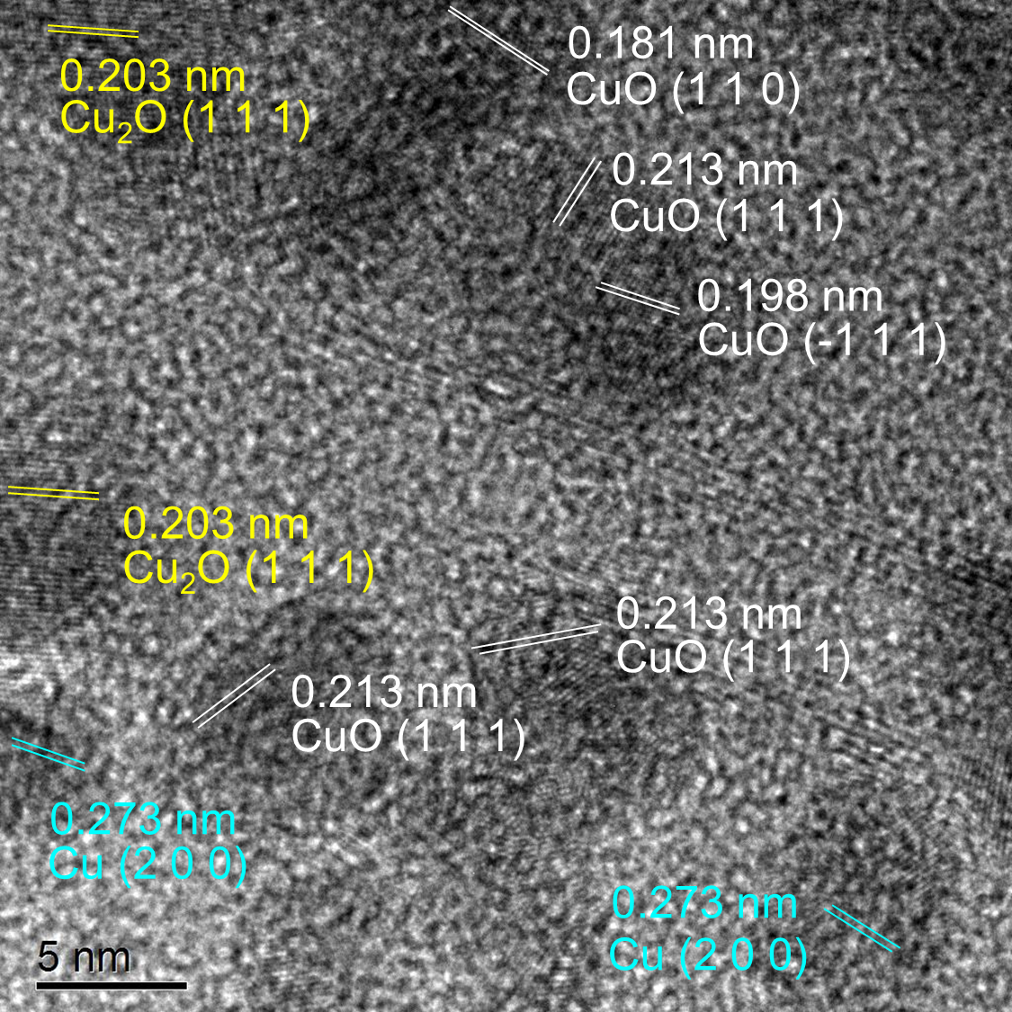

Figure S6. Representative TEM micrograph of Cu_{0.5}@NiOOH catalysts.

Figure S7. (A) Distribution of particle sizes based on TEM image analysis (Figure 2D). (B) Impact of potential on mean particle size.

Figure S8. DFT models for segregation energy calculation used in this work. The segregation energy was determined by the total energy difference between the system with the exsolving atom located at surface and at the sub-surface.

Figure S9. Bader charge of Cu oxidation state.

Figure S10. Faradaic efficiency towards CO, formate, H₂, and CH₄ for various catalysts. (A) Cu₂@NiOOH, (B) Cu₁@NiOOH, (C) Cu_{0.7}@NiOOH, (D) Cu_{0.3}@NiOOH and (E) NiOOH.

Figure S11. Representative LSVs curves for Cu_{x}@NiOOH catalysts with different Cu-Ni ratio and pristine NiOOH in a CO₂/Ar saturated 0.5 M aqueous solution at a scan rate of 5 mV s⁻¹.

Figure S12. Representative LSV curves for different catalysts tested in a CO₂-saturated 0.5 M KHCO₃ aqueous solution at a scan rate of 5 mV s⁻¹.

Figure S13. Charge current density as a function of scan rate for NiOOH and exsolved-catalysts.

Figure S14. Representative CO₂ adsorption isotherm curves for pristine NiOOH and Cu_{0.5}@NiOOH.

Figure S15. Representative TEM micrograph of Cu_{0.5}@NiOOHs after 40 h of use.

Figure S16. Representative SEM micrographs for Cu_{0.5}NiOOH at (A) low magnification and (B) high magnification. (C) TEM micrographs for Cu_{0.5}NiOOH. (D) SAED patterns performed within the red circled region of (C). (E) HR-TEM image of Cu_{0.5}NiOOH. (F) STEM in bright field mode, STEM in HAADF mode, and corresponding EDS mapping of Cu_{0.5}NiOOH.

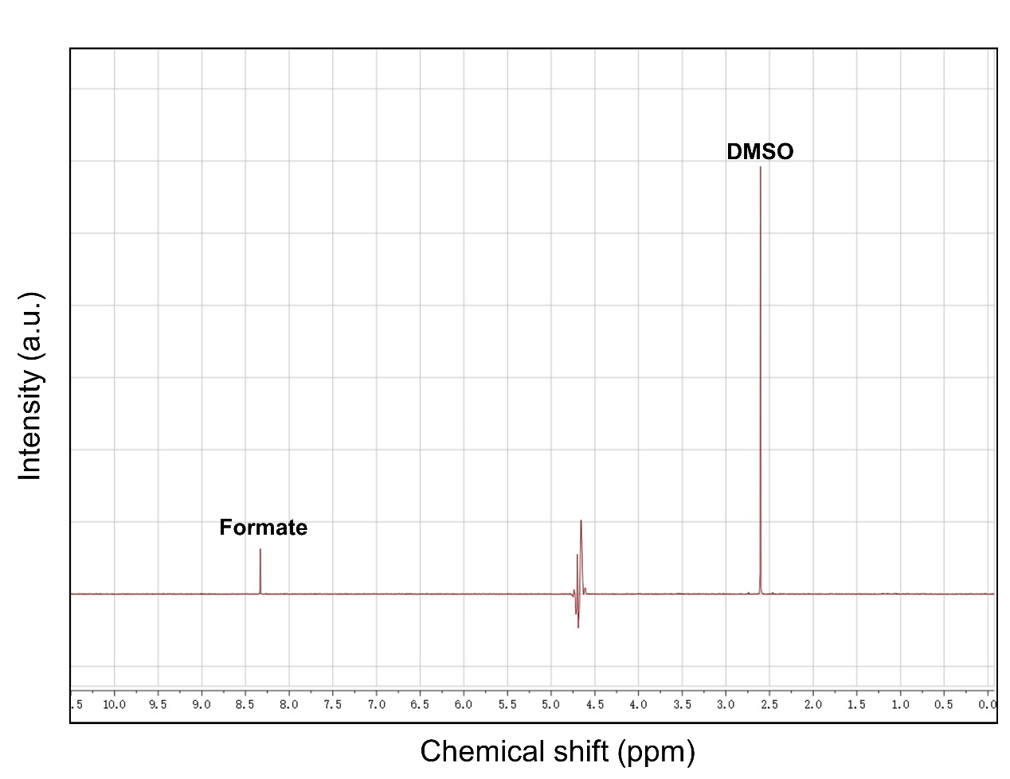
Figure S17. Representative NMR spectra for the catholyte sample containing formate.

Figure S18. Simulation models for (A) γ-NiOOH and (B) LaSrFeO₄.

Table S1. Structural parameters extracted from the Cu K-edge EXAFS fitting
 | Path | CN | ΔE (eV) | 10³×σ² (Å²) | 10²×R (Å) | r-factor
Cu | Cu-Cu1 | 12 | 3.27(0.8) | 8.56(0.6) | 253.7(0.5) | 0.010
 | Cu-Cu2 | 6 | 3.27(0.8) | 10.91(1.8) | 359.5(1.4)
CuO | Cu-O | 4 | 1.88(1.3) | 3.67(1.0) | 194.6(0.9) | 0.012
 | Cu-Cu1 | 4 | 2.20(1.9) | 6.12(1.1) | 289.7(1.5)
 | Cu-Cu2 | 8 | 2.20(1.9) | 11.62(1.4) | 309.5(1.8)
Cu_{0.5}NiOOH | Cu-O | 3.9(0.6) | 4.32(1.9) | 4.12(1.8) | 195.2(1.8) | 0.030
 | Cu-Ni(Cu) | 8.1(3.8) | 3.11(3.7) | 16.41(5.4) | 313.9(5.4)
Where CN is the coordination number, ΔE is edge-energy shift (the difference between the zero kinetic energy value of the sample and that of the theoretical model), σ² is Debye-Waller factor, and R is the interatomic distance.

Table S2. Catalytic properties and corresponding parameters of various comparative catalysts.
Heterogeneous catalyst | Working potential (V) | FE_{co} (%) | J(mA·cm⁻²) | H(hour) | Electrode
Cu_{0.5}@NiOOH (this work) | -0.7V (vs RHE) | 95.6 | 10.6 | 40 | Carbon paper
Cu₅Pd₅ nanoalloys ¹⁰ | -0.87V (vs RHE) | 88 | 4 | 20 | Glassy carbon
CuPd NP ¹¹ | -0.9V (vs RHE) | 87 | 3 | 5 | Carbon paper
Cu_{0.2}-Zn_{0.4}-Sn_{0.4} ¹² | -0.5V (vs RHE) | >80 | 3 | 4 | Carbon paper
Cu nanowire ¹³ | -0.5V (vs RHE) | ≈60 | 3.2 | 1 | Integrated electrode
Au₃Cu nanoparticle ¹⁴ | -0.73V (vs RHE) | ≈60 | 3 | 2 | Glassy carbon

Table S3. The measured double layer capacitance (C_{dl}) (Figure 3D), rough factor (R_{f}), and ECSA values of prepared catalysts。
Catalyst | C_{dl experimental} (mF cm⁻²) | R_{f} | ECSA (cm²)
Cu₁@NiOOH | 12.83 | 96.69 | 96.69
Cu_{0.7}@NiOOH | 14.53 | 109.25 | 109.25
Cu_{0.5}@NiOOH | 17.76 | 133.53 | 133.53
Cu_{0.3}@NiOOH | 17.25 | 129.70 | 129.70
NiOOH | 11.02 | 82.86 | 82.86

References
1. Kresse, G. & Furthmüller, J. Efficient iterative schemes for ab initio total-energy calculations using a plane-wave basis set. Phys. Rev. B 54, 11169-11186 (1996).
2. Perdew, J. P., Burke, K. & Ernzerhof, M. Generalized Gradient Approximation Made Simple. Phys. Rev. Lett. 77, 3865-3868 (1996).
3. Woo, T. K., Margl, P. M., Blöchl, P. E. & Ziegler, T. A Combined Car−Parrinello QM/MM Implementation for ab Initio Molecular Dynamics Simulations of Extended Systems: Application to Transition Metal Catalysis. J. Phys. Chem. B 101, 7877-7880 (1997).
4. Martyna, G. J., Klein, M. L. & Tuckerman, M. Nosé-Hoover chains: The canonical ensemble via continuous dynamics. J. Chem. Phys. 97, 2635-2643 (1992).
5. Van der Ven, A., Morgan, D., Meng, Y. S. & Ceder, G. Phase Stability of Nickel Hydroxides and Oxyhydroxides. J. Electrochem. Soc. 153, A210 (2006).
6. Li, L.-F., Li, Y.-F. & Liu, Z.-P. Oxygen Evolution Activity on NiOOH Catalysts: Four-Coordinated Ni Cation as the Active Site and the Hydroperoxide Mechanism. ACS Catal. 10, 2581-2590 (2020).
7. Friebel, D. et al. Identification of Highly Active Fe Sites in (Ni,Fe)OOH for Electrocatalytic Water Splitting. J. Am. Chem. Soc. 137, 1305-1313 (2015).
8. Song, F. et al. An Unconventional Iron Nickel Catalyst for the Oxygen Evolution Reaction. ACS Cent. Sci. 5, 558-568 (2019).
9. Fu, L. et al. Exsolution of Cu nanoparticles in (LaSr)0.9Fe0.9Cu0.1O4 Ruddlesden-Popper oxide as symmetrical electrode for solid oxide cells. Appl. Surf. Sci. 511, 145525 (2020).
10. Chen, D. et al. Surface composition dominates the electrocatalytic reduction of CO2 on ultrafine CuPd nanoalloys. Carbon Energy 2, 443-451 (2020).
11. Mun, Y. et al. Cu-Pd alloy nanoparticles as highly selective catalysts for efficient electrochemical reduction of CO2 to CO. Appl. Catal. B Environ. 246, 82-88 (2019).
12. He, J., Dettelbach, K. E., Huang, A. & Berlinguette, C. P. Brass and Bronze as Effective CO2 Reduction Electrocatalysts. Angew. Chemie Int. Ed. 56, 16579-16582 (2017).
13. Raciti, D., Livi, K. J. & Wang, C. Highly Dense Cu Nanowires for Low-Overpotential CO2 Reduction. Nano Lett. 15, 6829-6835 (2015).
14. Kim, D., Resasco, J., Yu, Y., Asiri, A. M. & Yang, P. Synergistic geometric and electronic effects for electrochemical reduction of carbon dioxide using gold-copper bimetallic nanoparticles. Nat. Commun. 5, 4948 (2014).

