Supplementary figures
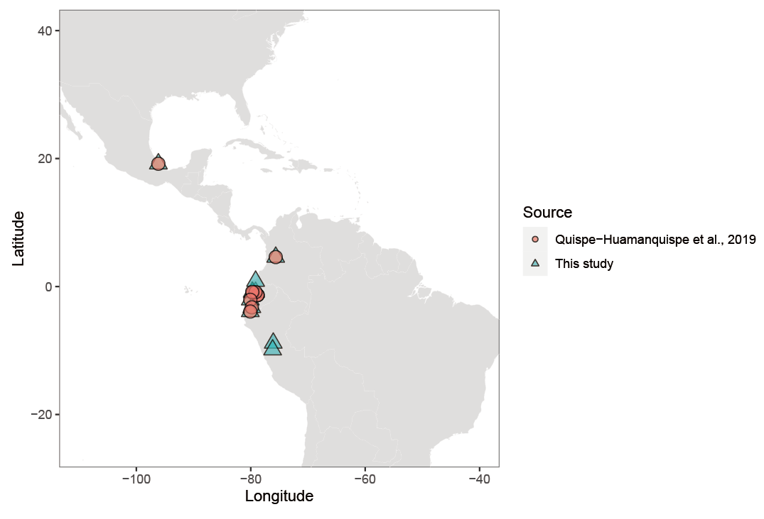
Supplementary Fig. 1 Geographic location of I. batatas 4x
Comparison of the genomic locality of I. batatas 4x of previous report, Quispe-Huamanquispe, et al., 2019 (illustrated as orange circle), and our samples in this study (illustrated as blue triangle).

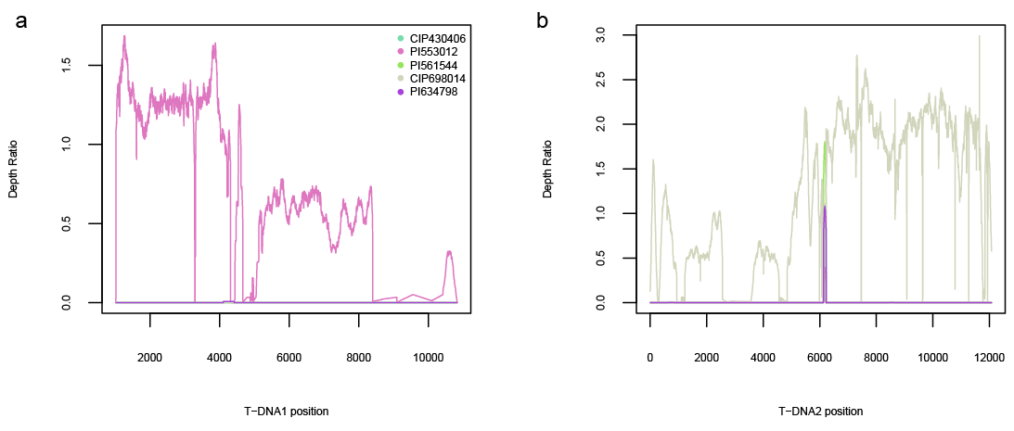
Supplementary Fig. 2 Depth ratio of IbT-DNA1 (a) and IbT-DNA2 (b) insertion region of five diploid wild relatives, the different accessions are color-labeled.

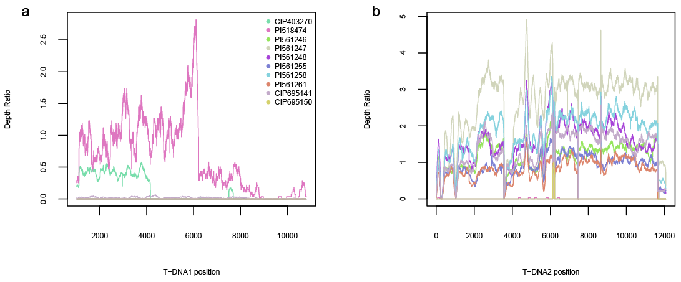
Supplementary Fig. 3 Depth ratio of IbT-DNA1 (a) and IbT-DNA2 (b) insertion region of ten tetraploid wild relatives, the different accessions are color-labeled.
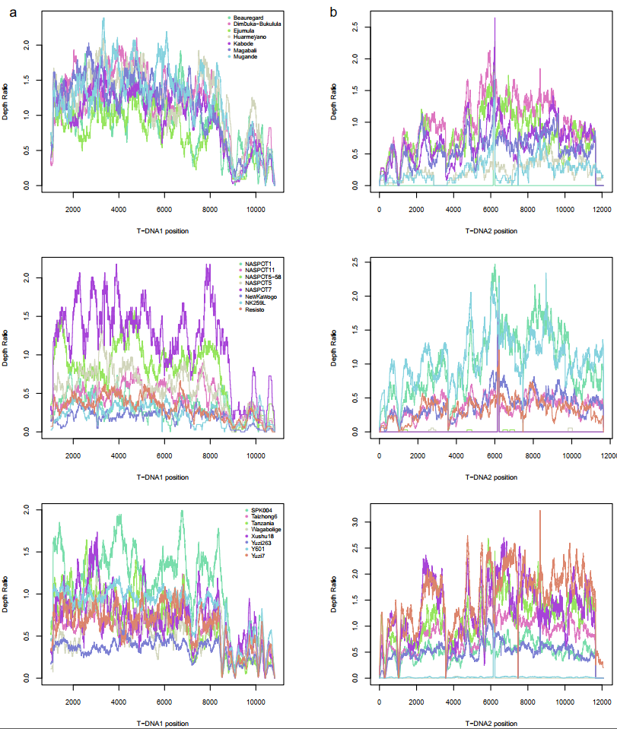
Supplementary Fig. 4 Depth ratio of IbT-DNA1 (a) and IbT-DNA2 (b) insertion region of 23 sweet potato cultivars/landraces, the different accessions are color-labeled.

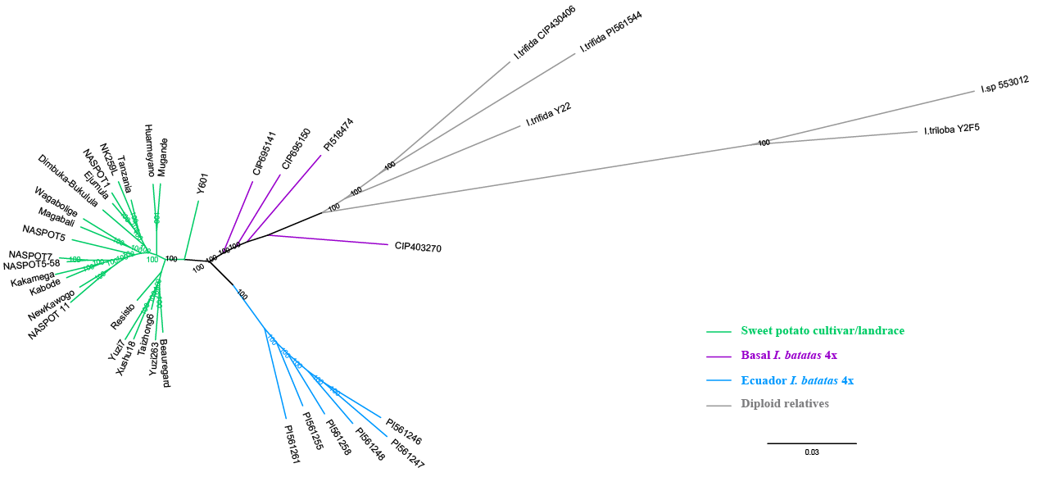
Supplementary Fig. 5 Unrooted phylogeny of sampled sweet potato and the wild relatives was inferred using the maximum likelihood method (unrooted layout of the same tree in Fig. 1). Basal I. batatas 4x, Ecuador I. batatas 4x, sweet potato cultivar/landrace and diploid wild relatives are color-coded.

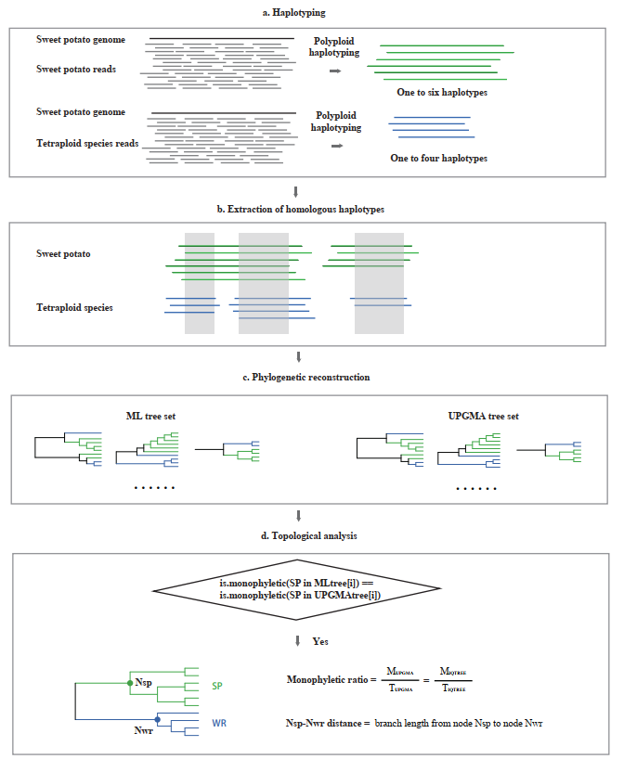
Supplementary Fig. 6 The pipeline of haplotype-based phylogenetic analysis. a, haplotyping for hexaploid sweet potato and tetraploid wild relative. b, Extraction of syntenic haplotype blocks between sweet potato and tetraploid wild relative based on their genomic positions. c, High-throughput phylogenetic reconstruction using both UPGMA and ML methods for each syntenic haplotype block. d, calculation of monophyletic ratio and Nsp-Nwr distance for the filtered syntenic haplotype blocks.

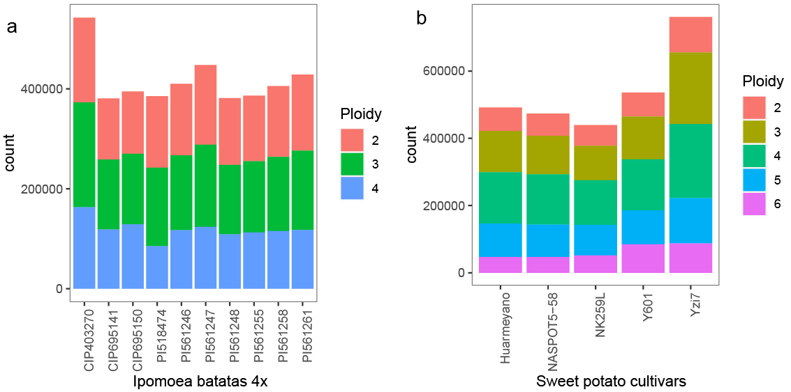
Supplementary Fig. 7 The counts of haplotype blocks of I. batatas 4x accessions (a) and sweet potato cultivars (b), the ploidy of blocks are color-labeled

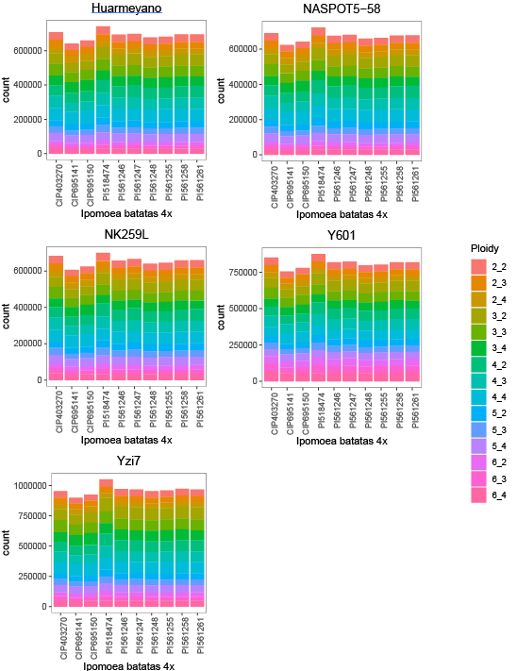

Supplementary Fig. 8 The counts of original extracted syntenic haplotype blocks between each sweet potato cultivar and each tetraploid accession, the ploidy combinations of block are color-labeled

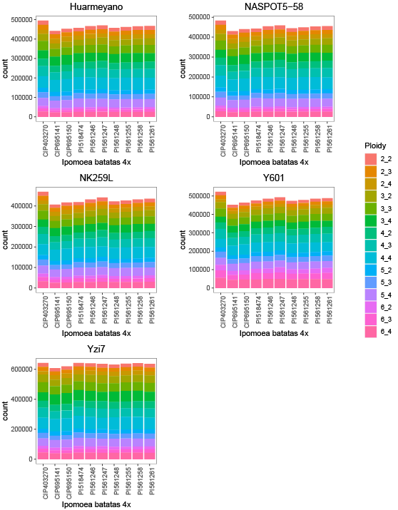
Supplementary Fig. 9 The counts of filtered syntenic haplotype blocks between each sweet potato cultivar and tetraploid accession, the ploidy combinations of block are color-labeled

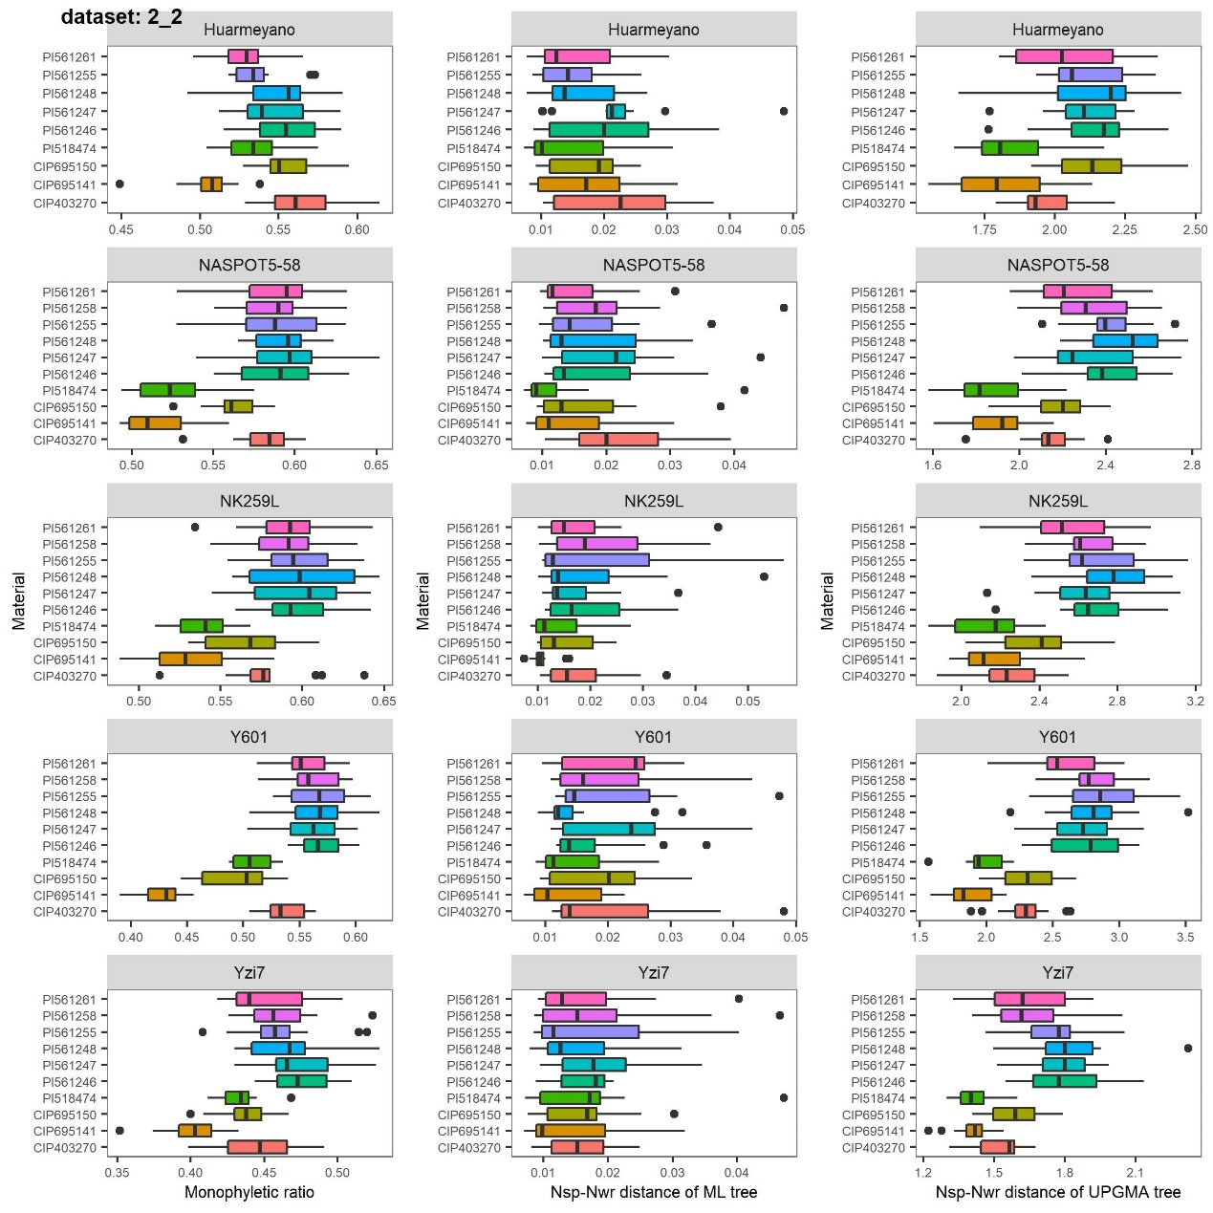
Supplementary Fig. 10 Estimation of the robustness of 2:2 ploidy combination data set (syntenic haplotype blocks composed of two haplotypes of sweet potato and two haplotypes of tetraploid relatives). Monophyletic ratio, Nsp-Nwr distance based on ML tree set and Nsp-Nwr distance based on UPGMA tree set using five sweet potato cultivars as reference, respectively. Results of each sweet potato cultivar were illustrated in one row. 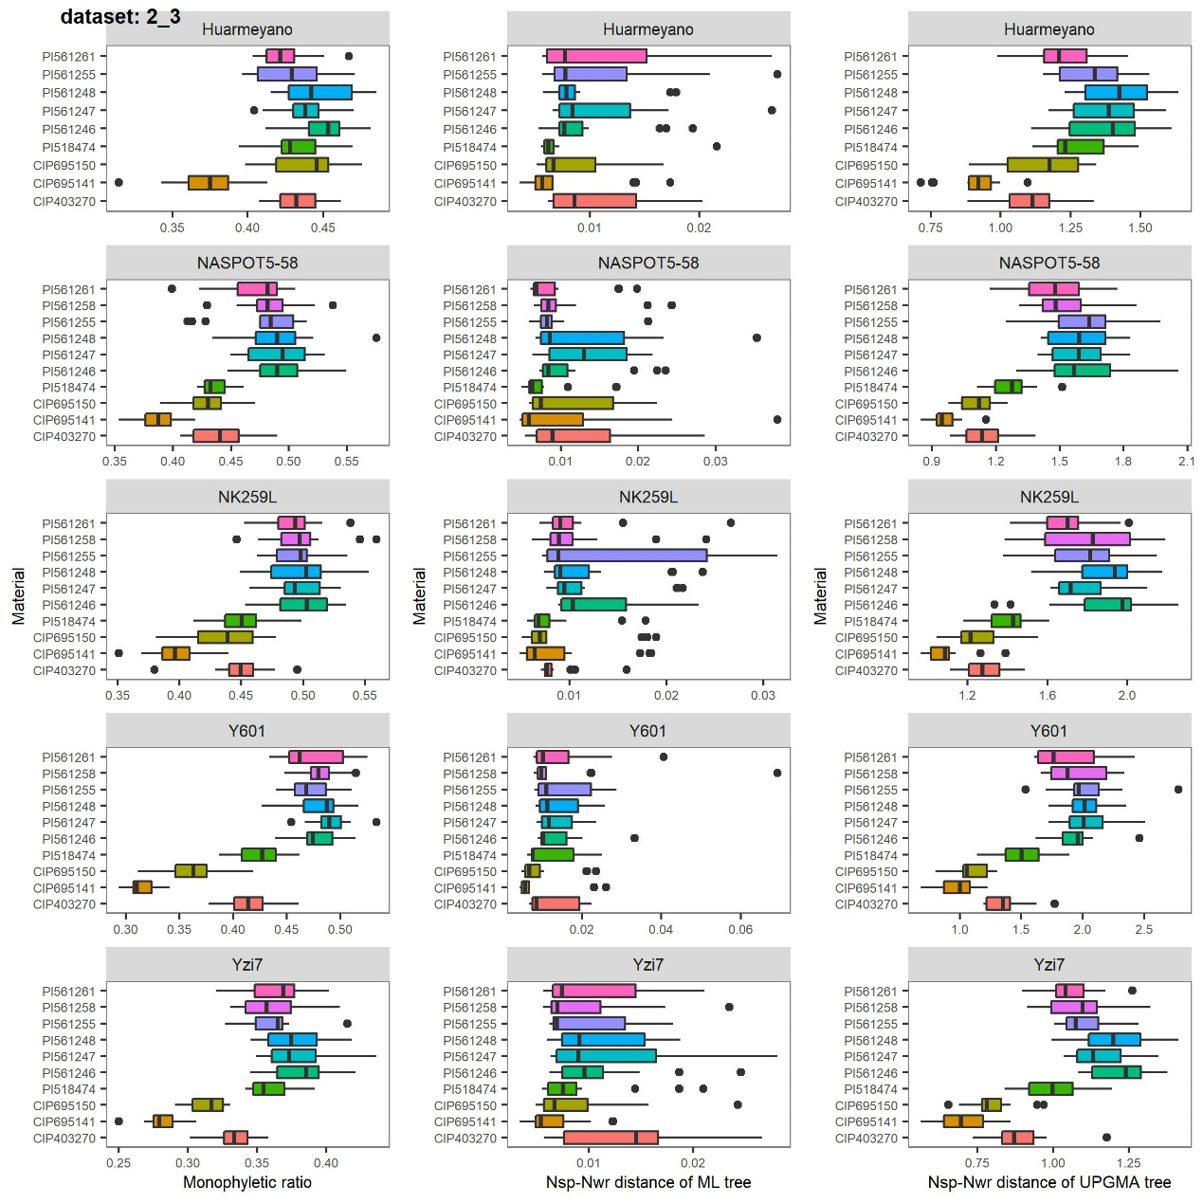
Supplementary Fig. 11 Estimation of the robustness of 2:3 data set (syntenic haplotype blocks composed of two haplotypes of sweet potato and three haplotypes of tetraploid relatives). Monophyletic ratio, Nsp-Nwr distance based on ML tree set and Nsp-Nwr distance based on UPGMA tree set using five sweet potato cultivars as reference, respectively. Results of each sweet potato cultivar were illustrated in one row.
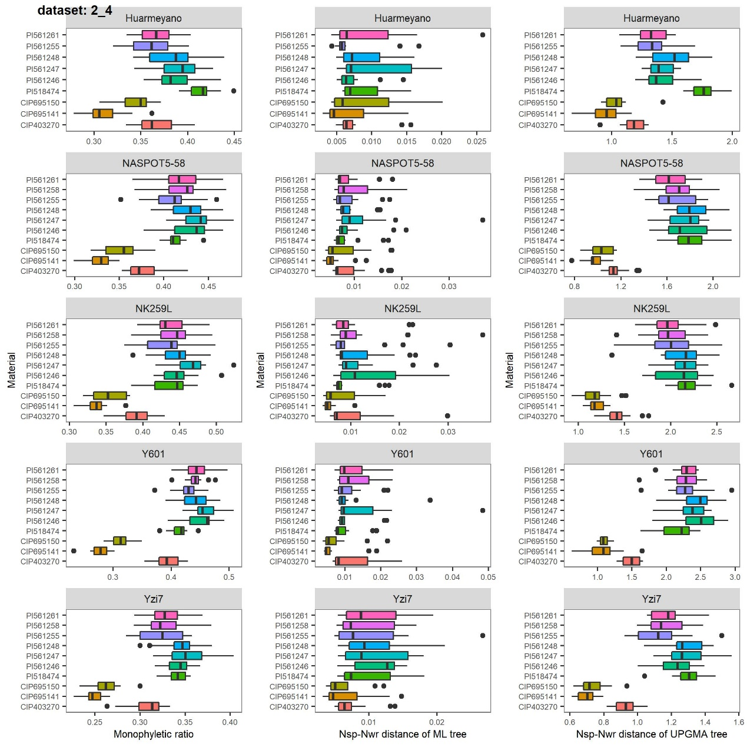
Supplementary Fig. 12 Estimation of the robustness of 2:4 data set (syntenic haplotype blocks composed of two haplotypes of sweet potato and four haplotypes of tetraploid relatives). Monophyletic ratio, Nsp-Nwr distance based on ML tree set and Nsp-Nwr distance based on UPGMA tree set using five sweet potato cultivars as reference, respectively. Results of each sweet potato cultivar were illustrated in one row.
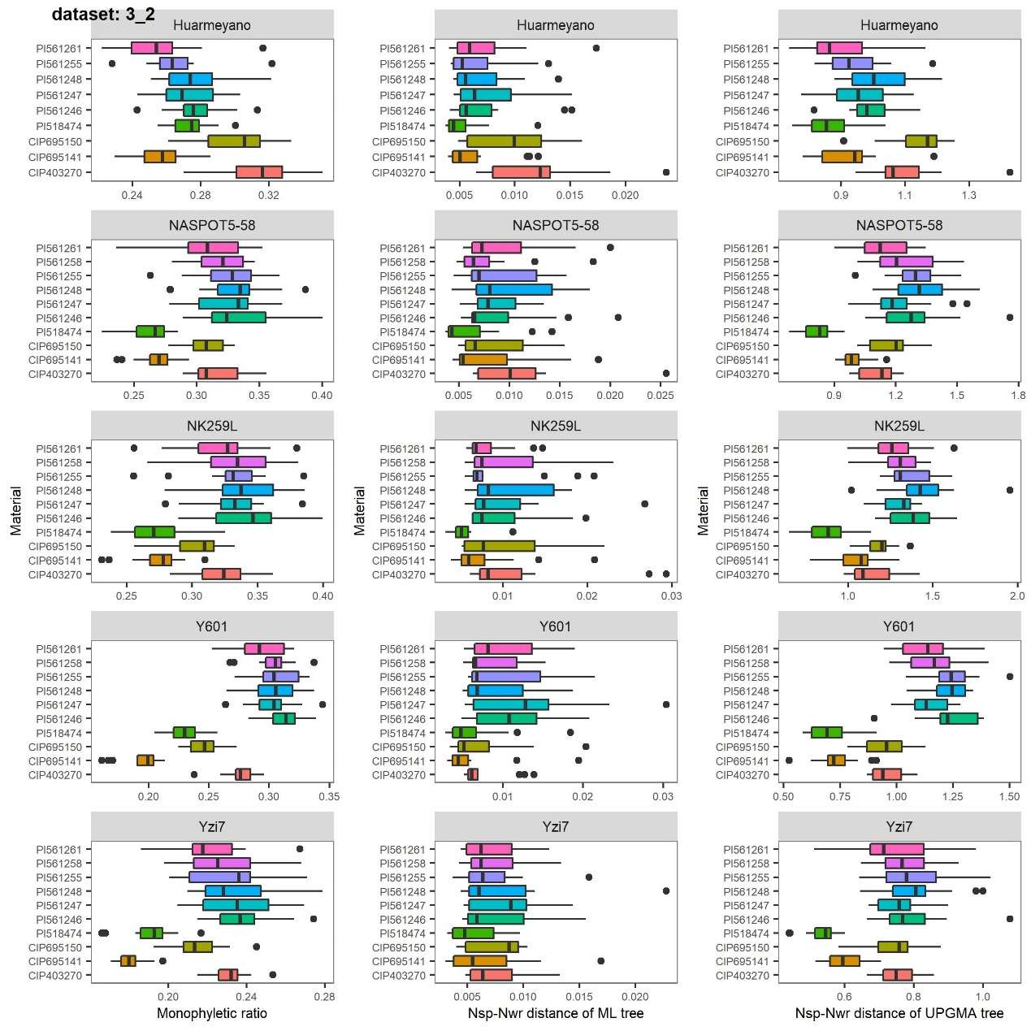
Supplementary Fig. 13 Estimation of the robustness of 3:2 data set (syntenic haplotype blocks composed of three haplotypes of sweet potato and two haplotypes of tetraploid relatives). Monophyletic ratio, Nsp-Nwr distance based on ML tree set and Nsp-Nwr distance based on UPGMA tree set using five sweet potato cultivars as reference, respectively. Results of each sweet potato cultivar were illustrated in one row.

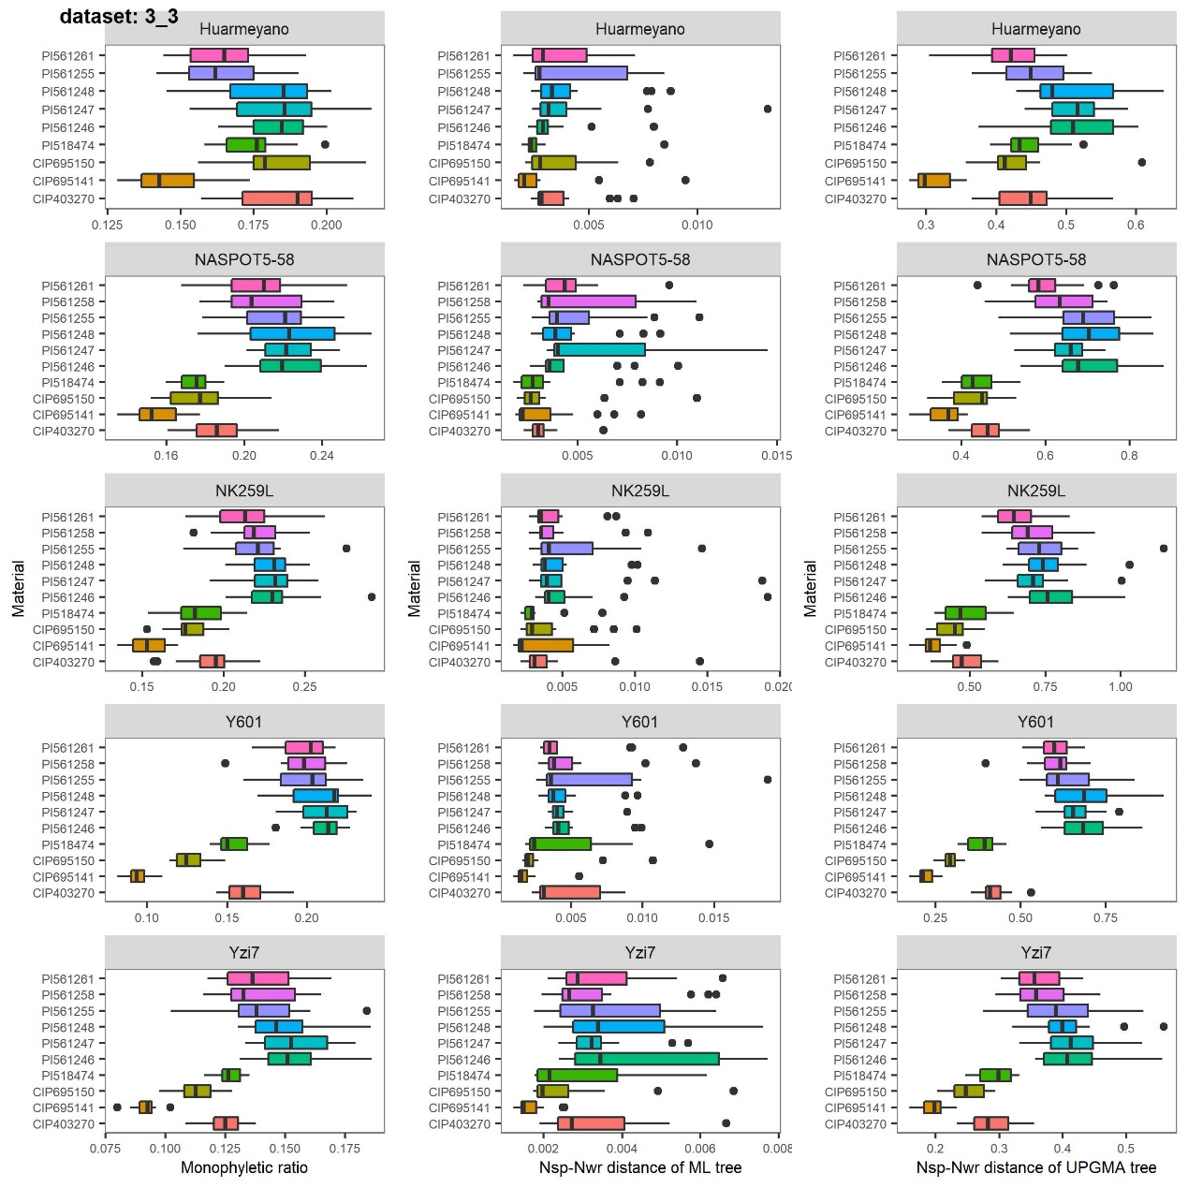
Supplementary Fig. 14 Estimation of the robustness of 3:3 data set (syntenic haplotype blocks composed of three haplotypes of sweet potato and three haplotypes of tetraploid relatives). Monophyletic ratio, Nsp-Nwr distance based on ML tree set and Nsp-Nwr distance based on UPGMA tree set using five sweet potato cultivars as reference, respectively. Results of each sweet potato cultivar were illustrated in one row.
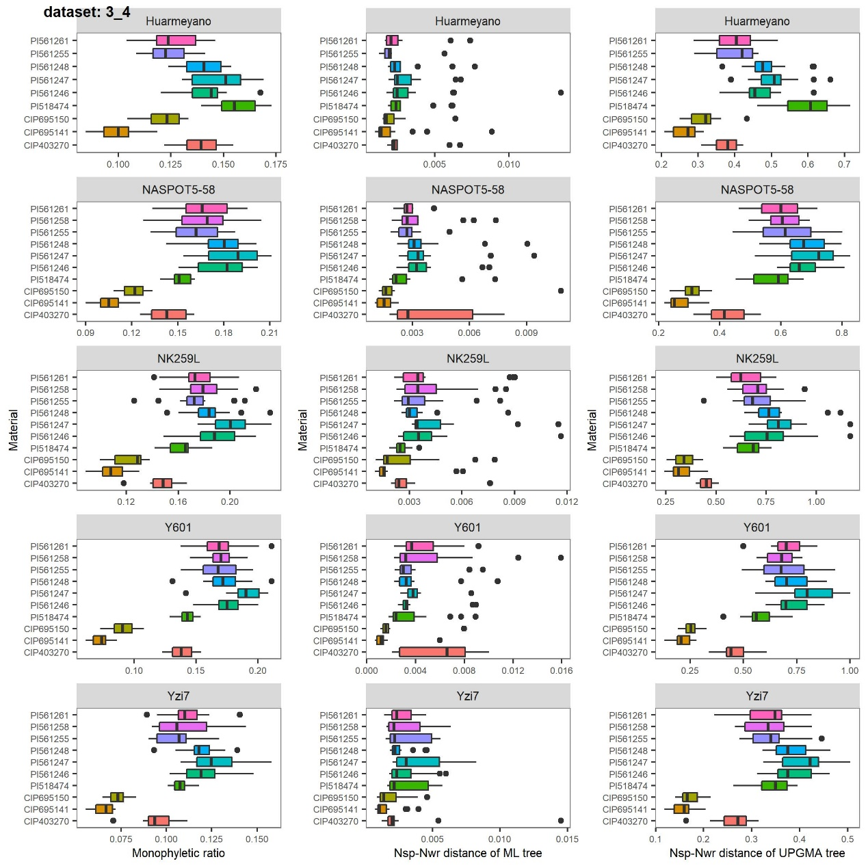
Supplementary Fig. 15 Estimation of the robustness of 3:4 data set (syntenic haplotype blocks composed of three haplotypes of sweet potato and four haplotypes of tetraploid relatives). Monophyletic ratio, Nsp-Nwr distance based on ML tree set and Nsp-Nwr distance based on UPGMA tree set using five sweet potato cultivars as reference, respectively. Results of each sweet potato cultivar were illustrated in one row.
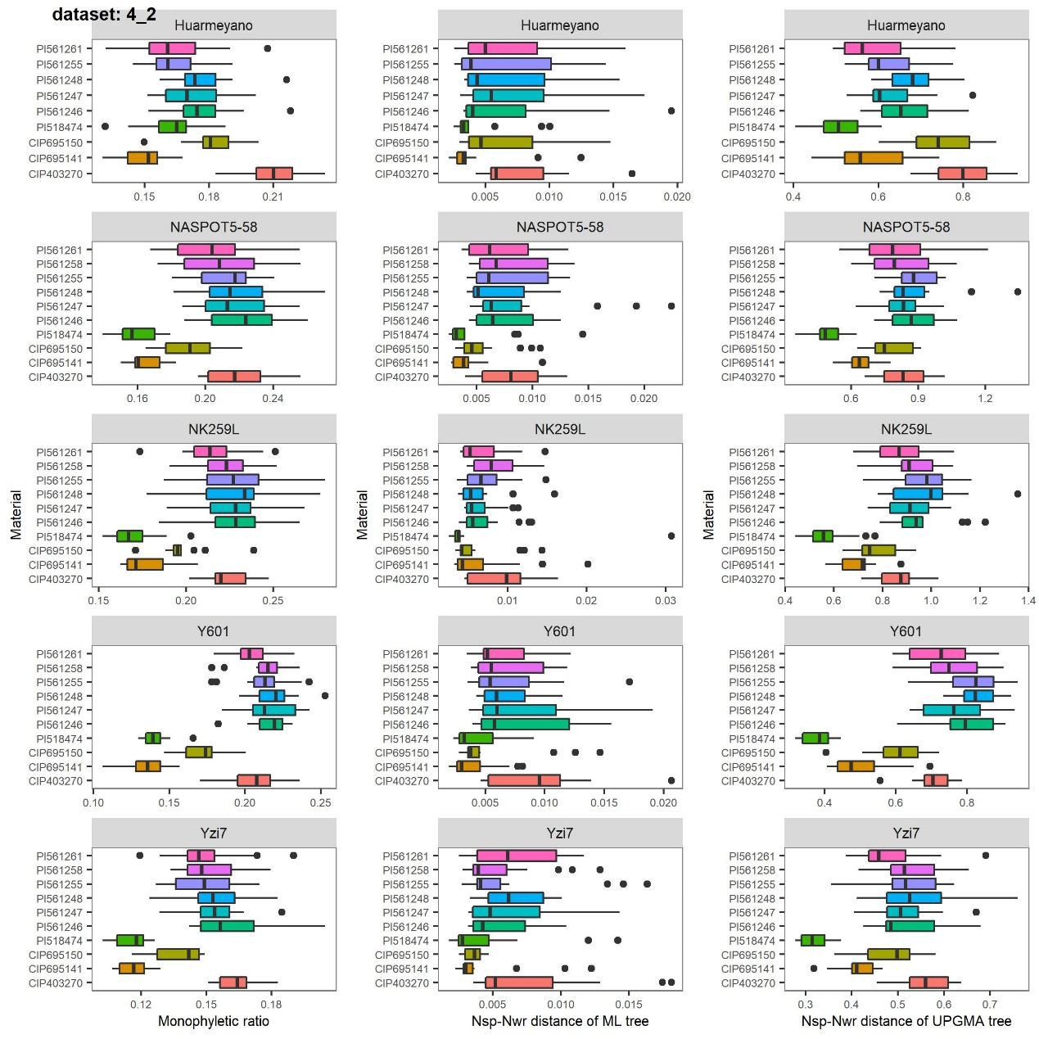
Supplementary Fig. 16 Estimation of the robustness of 4:2 data set (syntenic haplotype blocks composed of four haplotypes of sweet potato and two haplotypes of tetraploid relatives). Monophyletic ratio, Nsp-Nwr distance based on ML tree set and Nsp-Nwr distance based on UPGMA tree set using five sweet potato cultivars as reference, respectively. Results of each sweet potato cultivar were illustrated in one row.

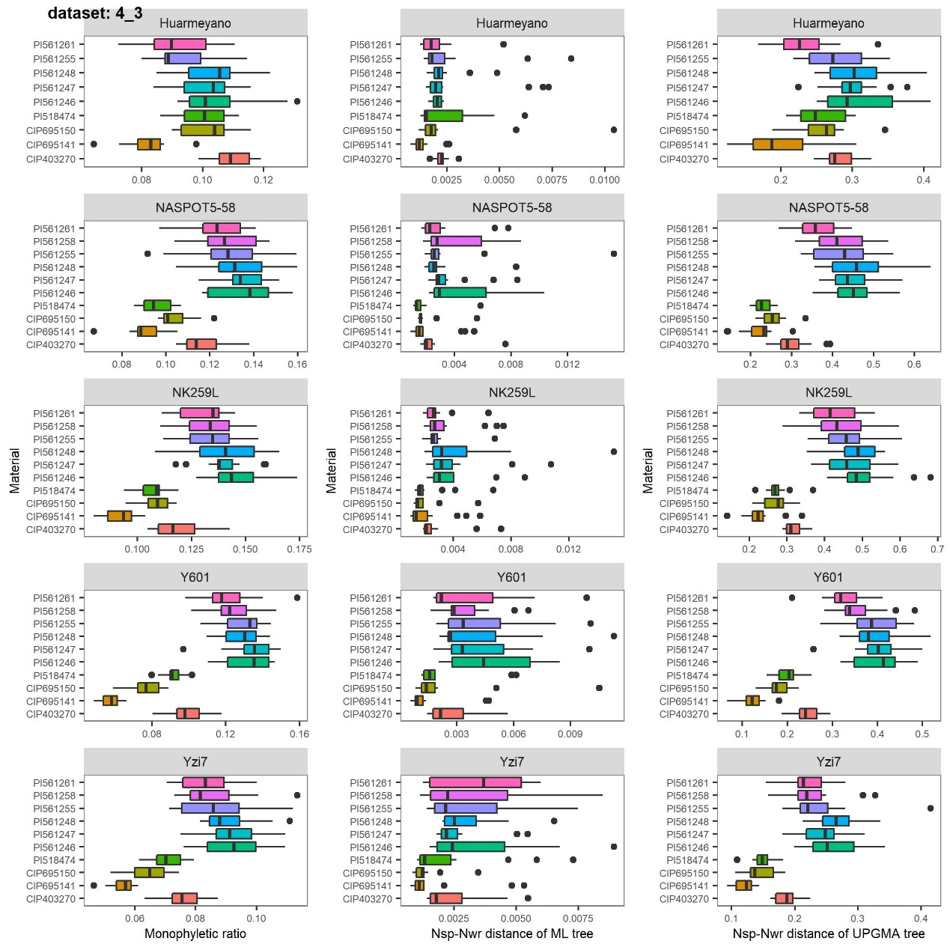
Supplementary Fig. 17 Estimation of the robustness of 4:3 data set (syntenic haplotype blocks composed of four haplotypes of sweet potato and three haplotypes of tetraploid relatives). Monophyletic ratio, Nsp-Nwr distance based on ML tree set and Nsp-Nwr distance based on UPGMA tree set using five sweet potato cultivars as reference, respectively. Results of each sweet potato cultivar were illustrated in one row.
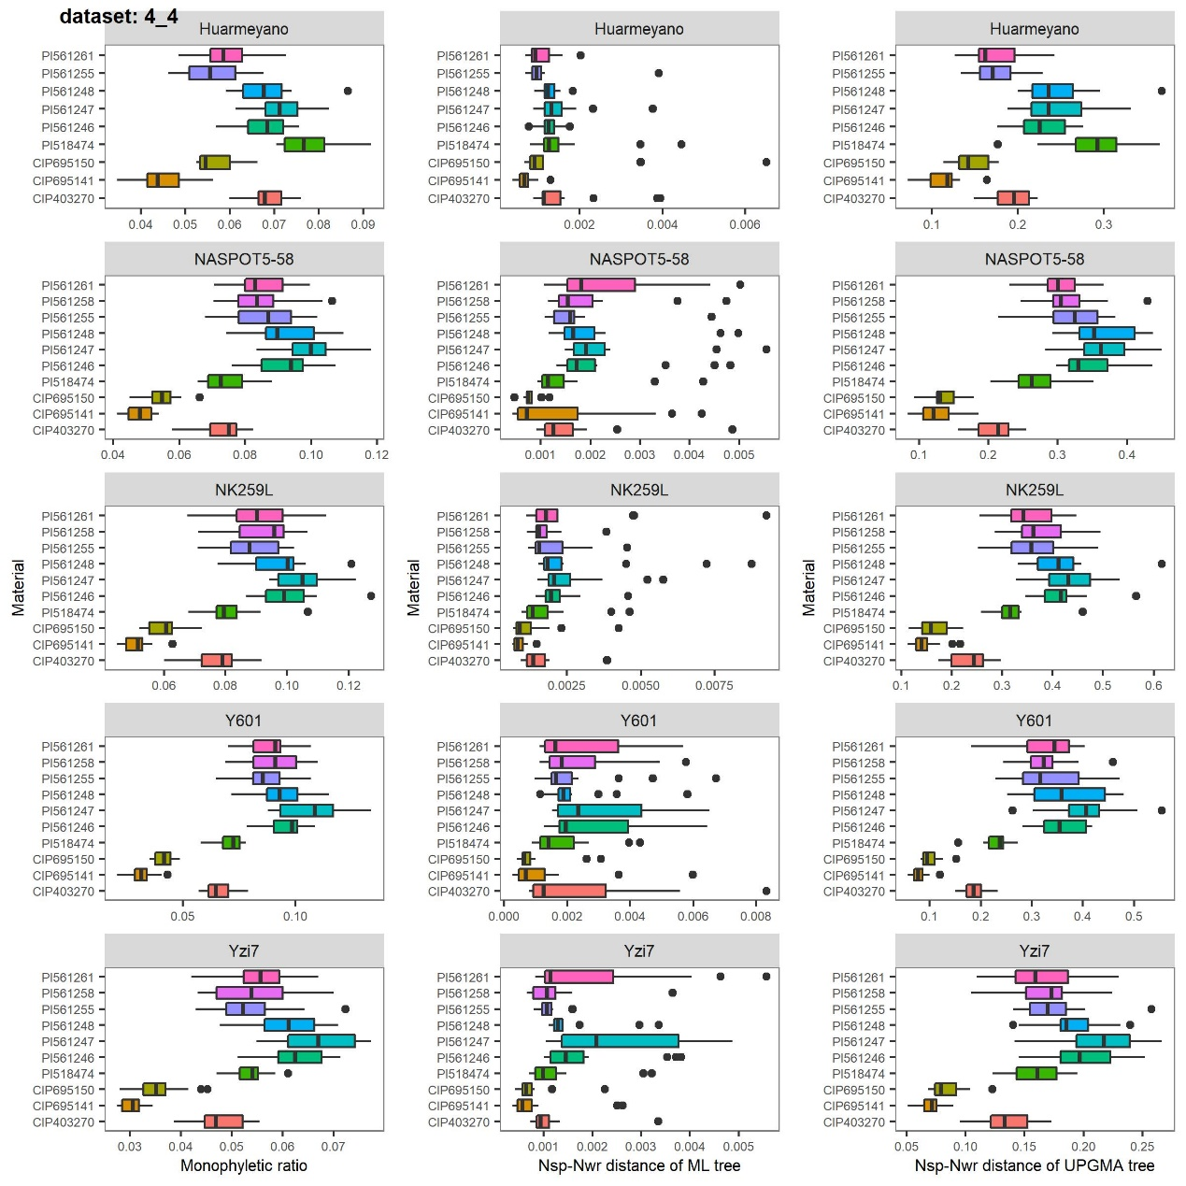
Supplementary Fig. 18 Estimation of the robustness of 4:4 data set (syntenic haplotype blocks composed of four haplotypes of sweet potato and four haplotypes of tetraploid relatives). Monophyletic ratio, Nsp-Nwr distance based on ML tree set and Nsp-Nwr distance based on UPGMA tree set using five sweet potato cultivars as reference, respectively. Results of each sweet potato cultivar were illustrated in one row.
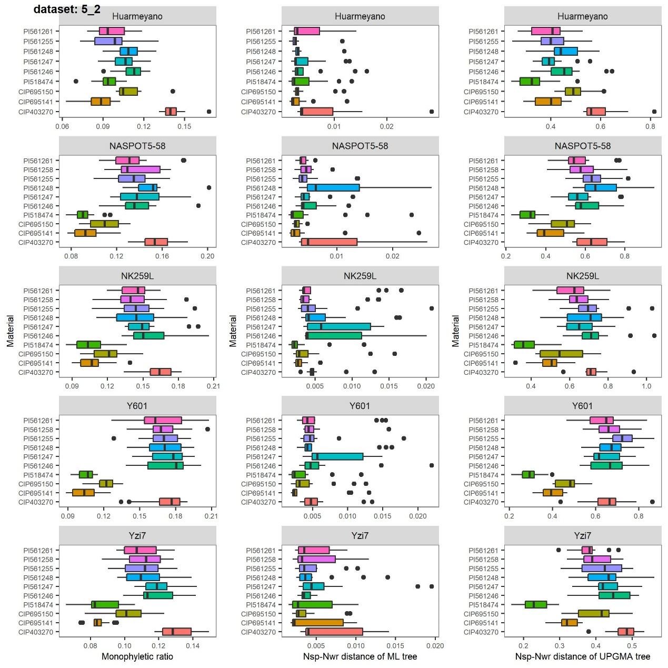
Supplementary Fig. 19 Estimation of the robustness of 5:2 data set (syntenic haplotype blocks composed of five haplotypes of sweet potato and two haplotypes of tetraploid relatives). Monophyletic ratio, Nsp-Nwr distance based on ML tree set and Nsp-Nwr distance based on UPGMA tree set using five sweet potato cultivars as reference, respectively. Results of each sweet potato cultivar were illustrated in one row.
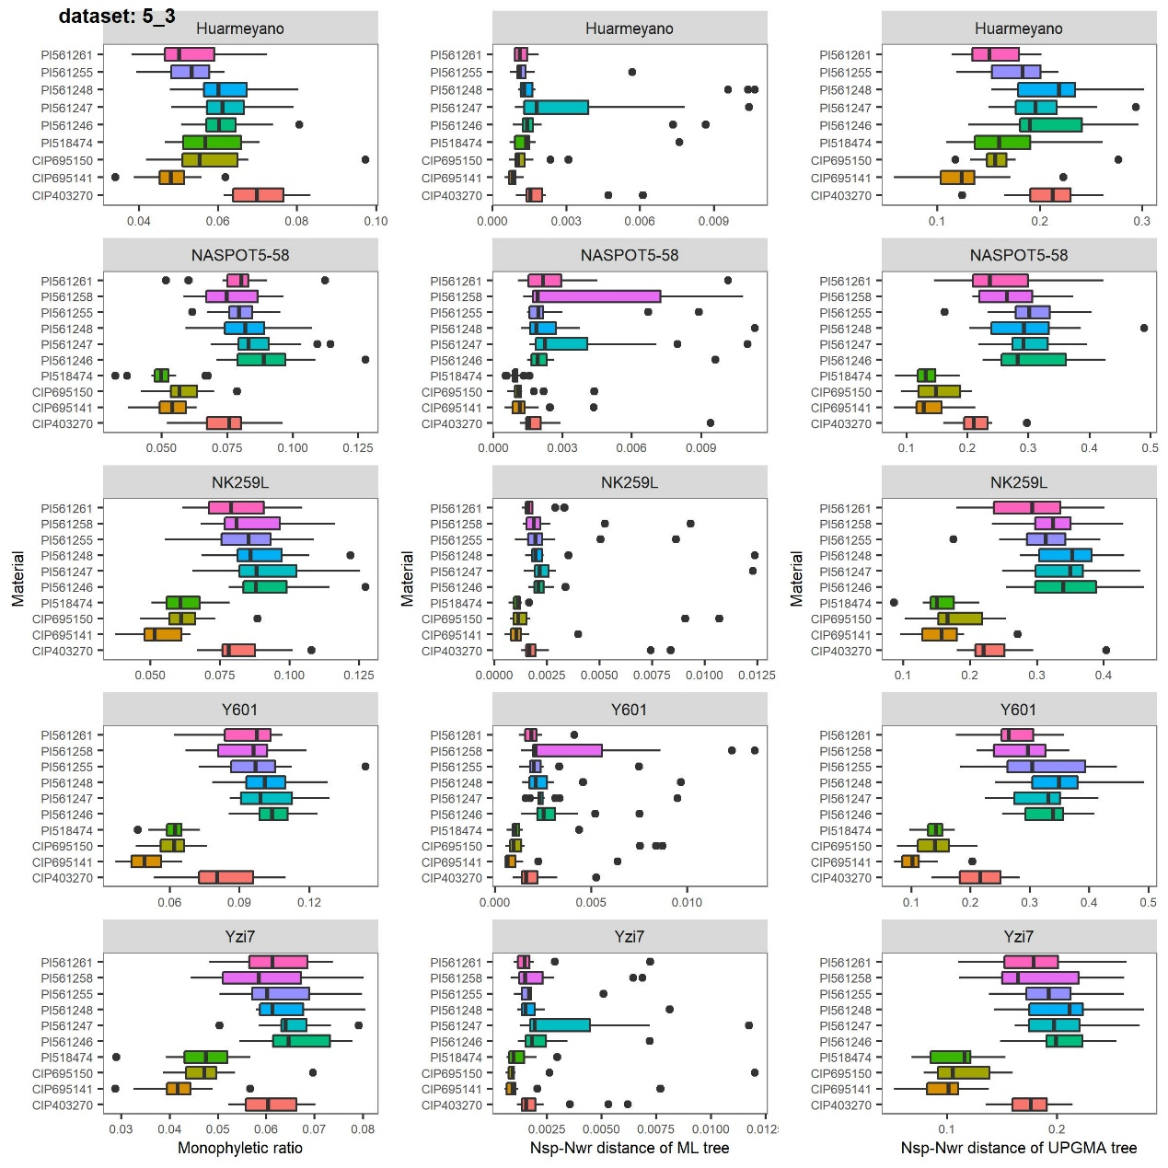
Supplementary Fig. 20 Estimation of the robustness of 5:3 data set (syntenic haplotype blocks composed of five haplotypes of sweet potato and three haplotypes of tetraploid relatives). Monophyletic ratio, Nsp-Nwr distance based on ML tree set and Nsp-Nwr distance based on UPGMA tree set using five sweet potato cultivars as reference, respectively. Results of each sweet potato cultivar were illustrated in one row.
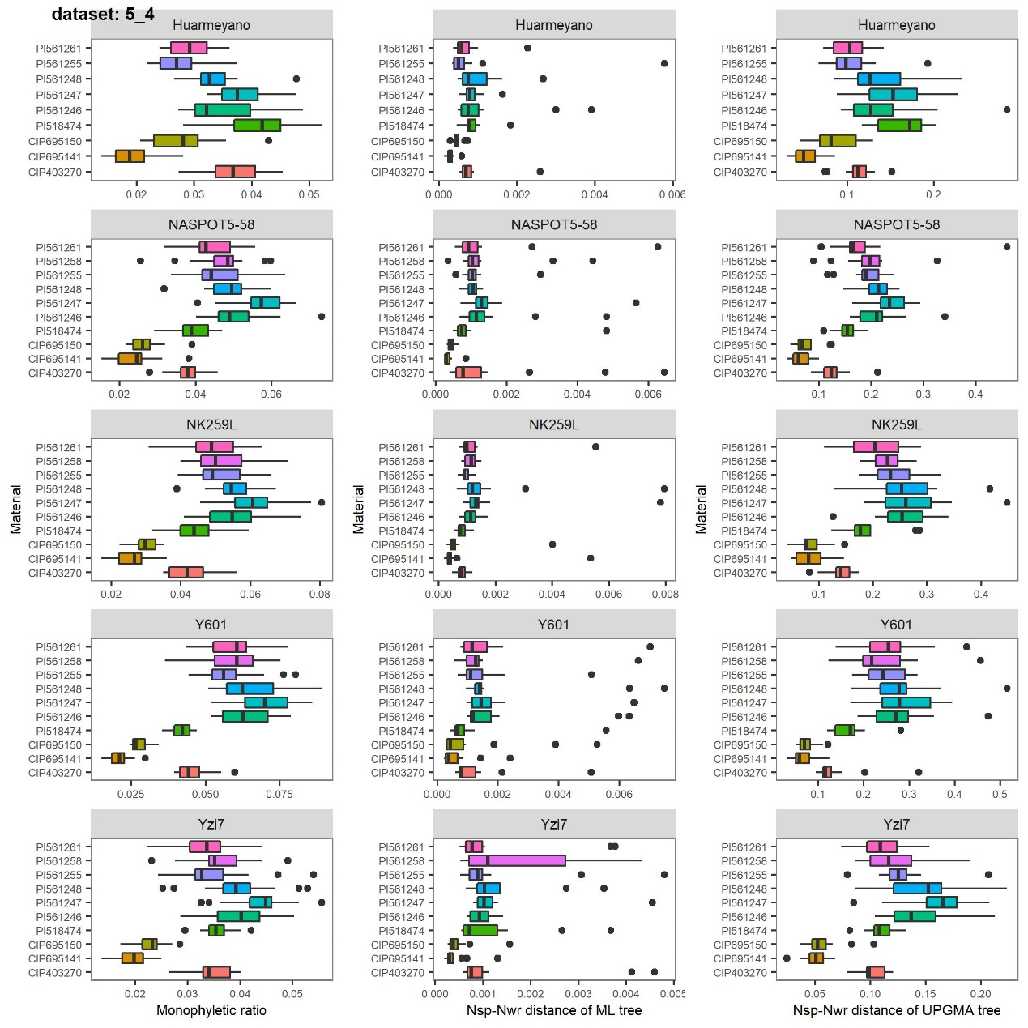
Supplementary Fig. 21 Estimation of the robustness of 5:4 data set (syntenic haplotype blocks composed of five haplotypes of sweet potato and four haplotypes of tetraploid relatives). Monophyletic ratio, Nsp-Nwr distance based on ML tree set and Nsp-Nwr distance based on UPGMA tree set using five sweet potato cultivars as reference, respectively. Results of each sweet potato cultivar were illustrated in one row.
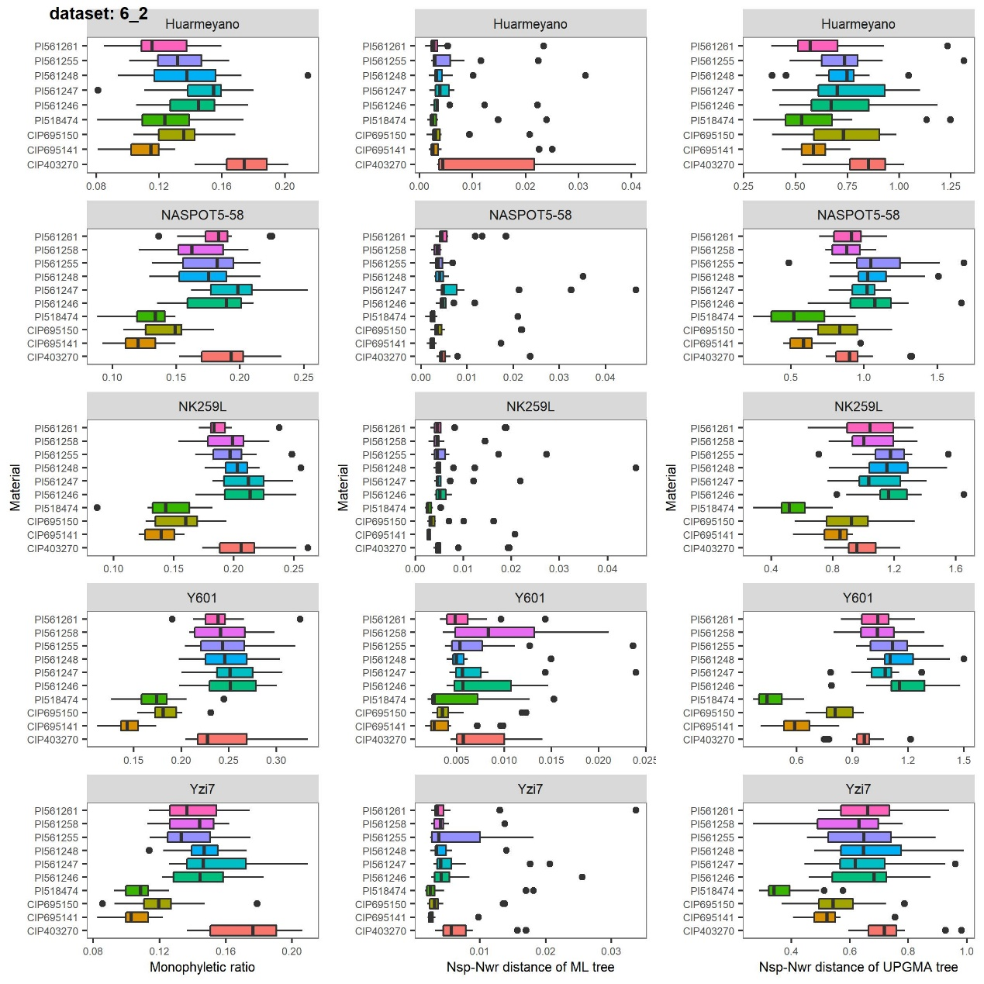

Supplementary Fig. 22 Estimation of the robustness of 6:2 data set (syntenic haplotype blocks composed of six haplotypes of sweet potato and two haplotypes of tetraploid relatives). Monophyletic ratio, Nsp-Nwr distance based on ML tree set and Nsp-Nwr distance based on UPGMA tree set using five sweet potato cultivars as reference, respectively. Results of each sweet potato cultivar were illustrated in one row.
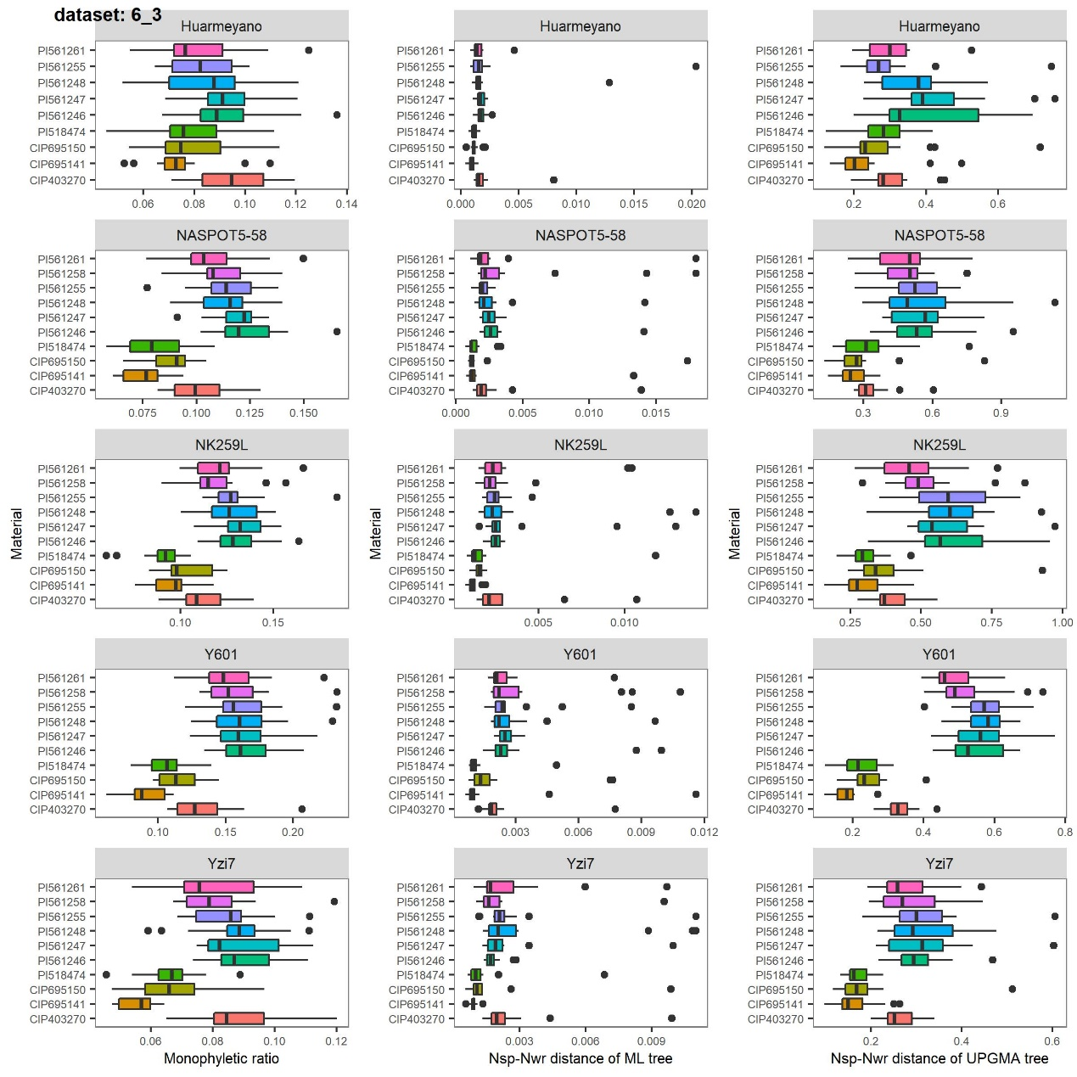
Supplementary Fig. 23 Estimation of the robustness of 6:3 data set (syntenic haplotype blocks composed of six haplotypes of sweet potato and three haplotypes of tetraploid relatives). Monophyletic ratio, Nsp-Nwr distance based on ML tree set and Nsp-Nwr distance based on UPGMA tree set using five sweet potato cultivars as reference, respectively. Results of each sweet potato cultivar were illustrated in one row.
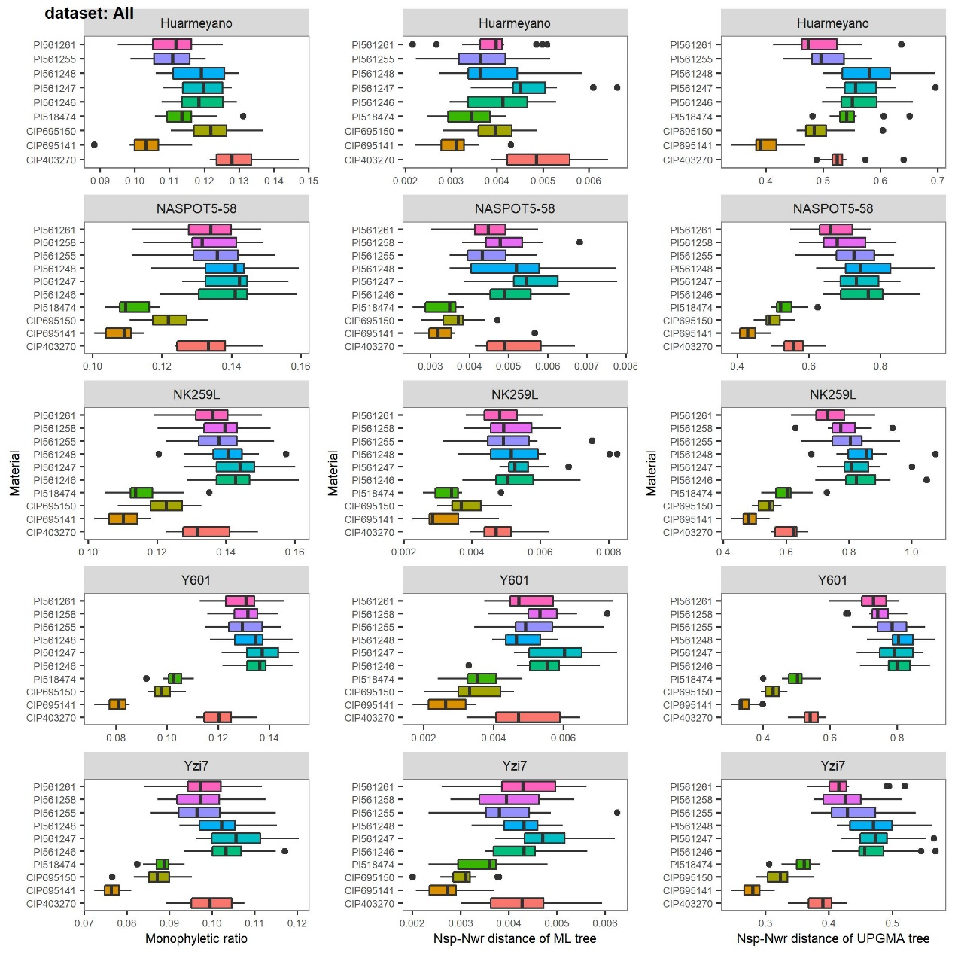
Supplementary Fig. 24 Estimation of the robustness of all data sets (all syntenic haplotype blocks). Monophyletic ratio, Nsp-Nwr distance based on ML tree set and Nsp-Nwr distance based on UPGMA tree set using five sweet potato cultivars as reference, respectively. Results of each sweet potato cultivar were illustrated in one row.

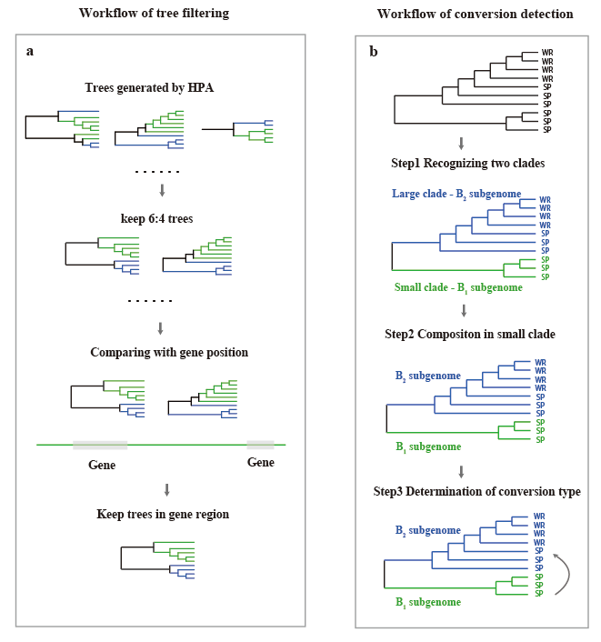 Supplementary Fig. 25 The pipeline of gene conversion analysis. a, the workflow to filter the tree set generated by HPA for gene conversion analysis, only keeping the 6:4 trees (tree with six haplotypes of sweet potato and four haplotypes of tetraploid wild relative) in gene regions. b, the workflow to detect gene conversion between subgenomes by analyzing the tree topology.

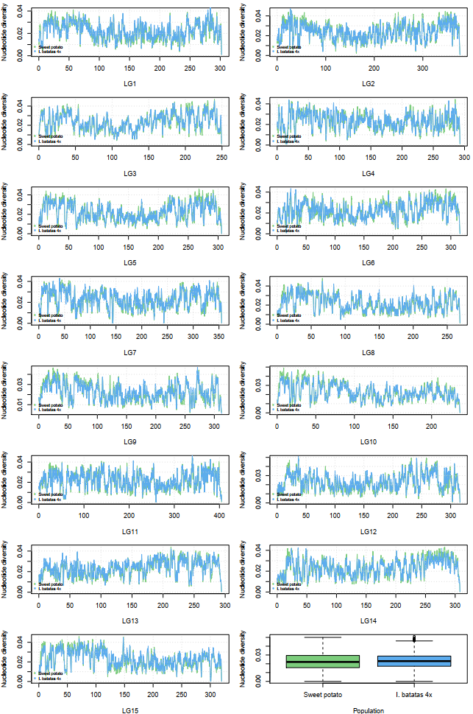
Supplementary Fig. 26 Genome-wide nucleotide diversity of sweet potato and I. batatas 4x. The nucleotide diversity of each chromosome was illustrated in each plot and the box plot illustrated the nucleotide diversity of all genomic windows (window size 100kb, step 10kb).

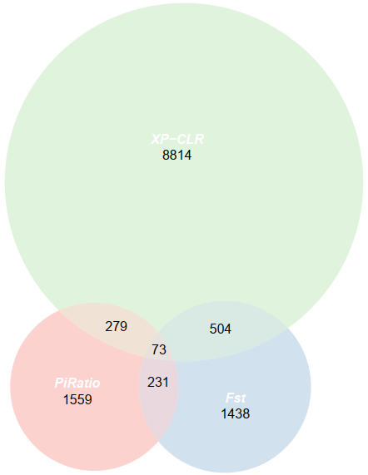

Supplementary Fig. 27 Venn diagram of selective gene numbers detected by top 1% of π ratio, Fst and XP-CLR scores. Gene numbers of π ratio, Fst and XP-CLR were illustrated in pink, blue and green, respectively. The overlapped gene numbers were labeled in the overlap regions.

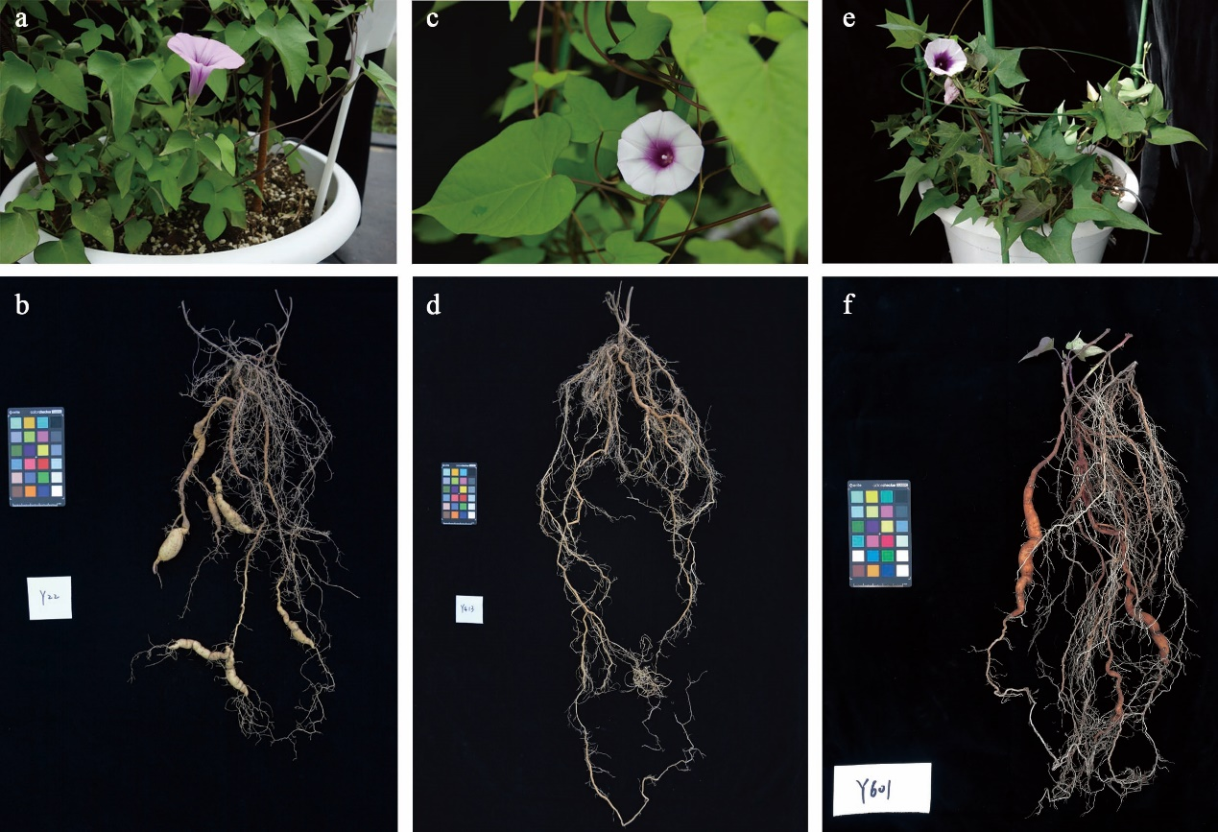
Supplementary Fig. 28 Phenotypes of I. trifida, I. batatas 4x and wild hexaploid sweet potato. a. Aerial phenotype of I. trifida accession Y22. b. Underground phenotype of I. trifida accession showing slightly enlarged storage roots. c. Aerial phenotype of the closest tetraploid accession CIP695141. d. Underground phenotype of the closest tetraploid accession CIP695141 with only fibrous root. e. Aerial phenotype of the wild sweet potato (Y601). f. Underground phenotype of the wild sweet potato (Y601) showing slightly enlarged storage roots.

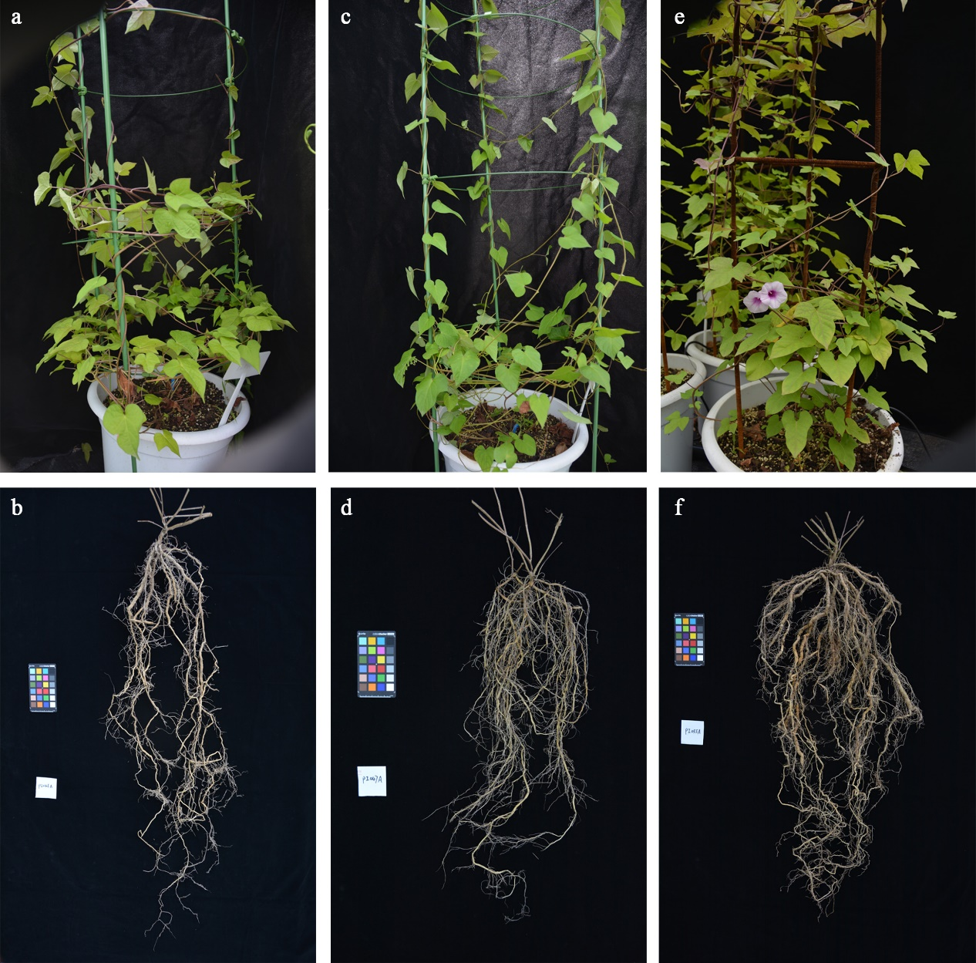Supplementary Fig. 29 Phenotypes of I. batatas 4x, a-b. Phenotype of accession PI561246. c-d. Phenotype of accession PI561247. e-f. Phenotype of accession PI561255.

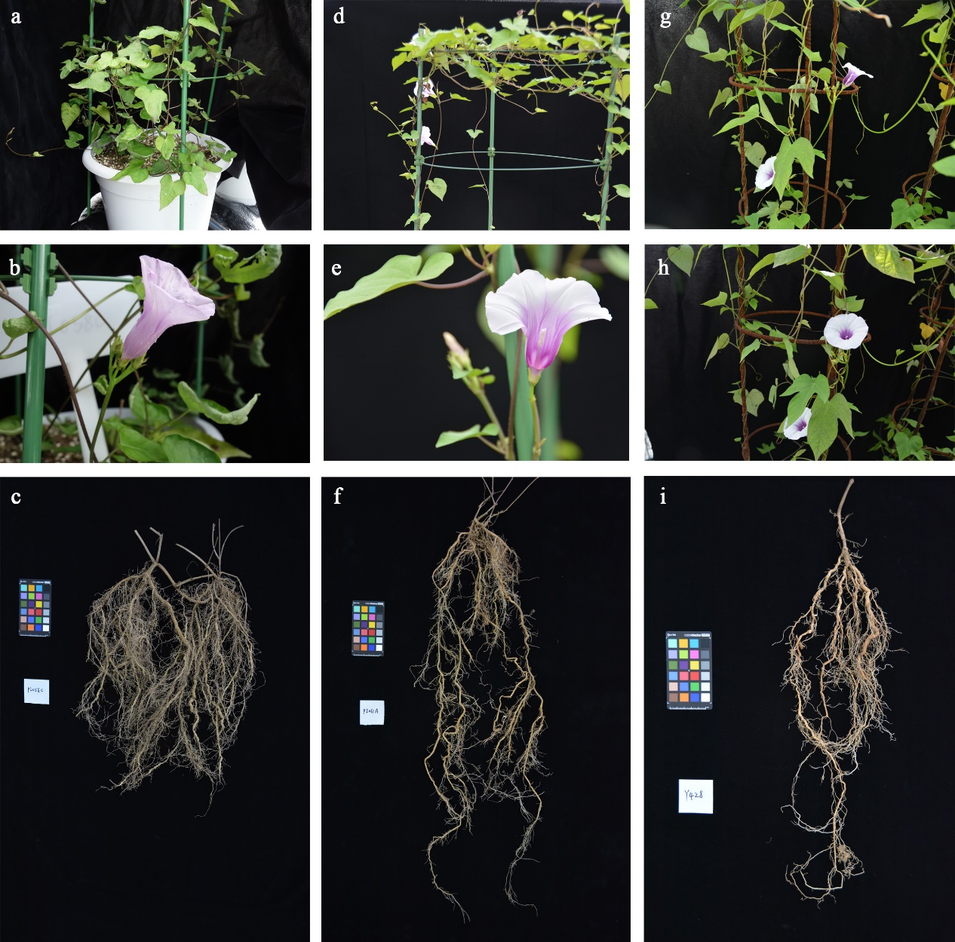
Supplementary Fig. 30 Phenotypes of I. batatas 4x, a-c. Phenotype of accession PI561258. d-f. Phenotype of accession PI561261. g-i. Phenotype of accession CIP695150.

