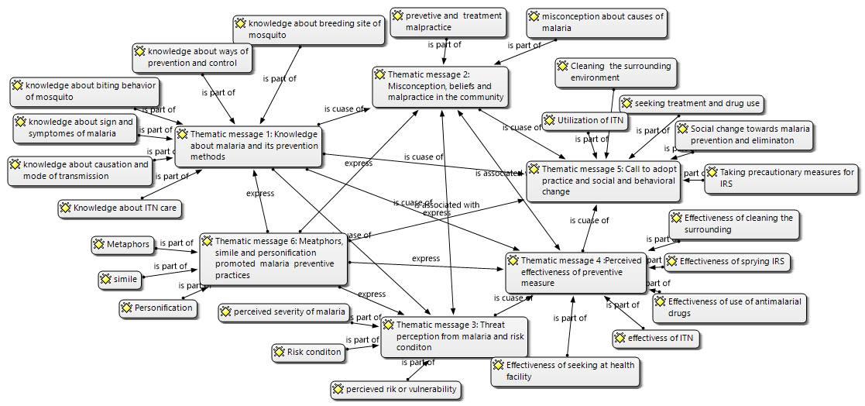

Fig. 2: Networks of themes and categories of message contents across the poems, Jimma zone, Ethiopia 2020

