Supplementary Fig.1. Characterization assay of percentage of positive MSC markers (CD29, CD44 and CD90) and negative hematopoietic markers (CD34 and CD45) by flow cytometry. (a) Flow cytometry analysis of the expression of CD44. (b) Flow cytometry analysis of the expression of CD29. (c) Flow cytometry analysis of the expression of CD90. (d) Flow cytometry analysis of the expression of CD45. (e) Flow cytometry analysis of the expression of CD34. Gate based on isotype control antibodies.

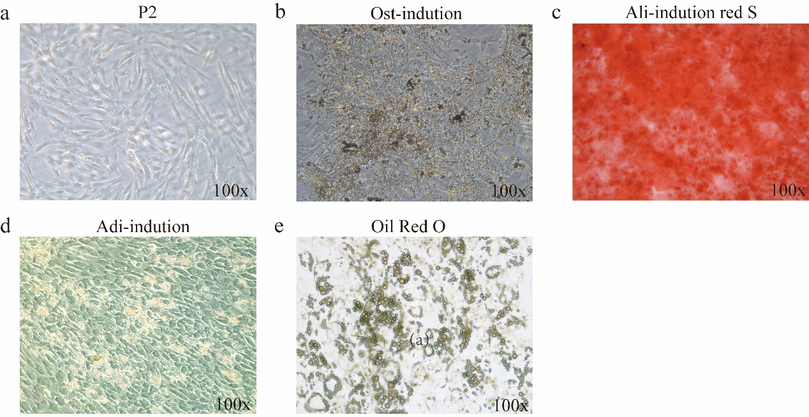

Supplementary Fig. 2. (a) hBMSCs were cultured for 3 days，Cell morphology of hBMSCs was shown under a light mirror. (b)The hBMSCs were treated for osteogenic induction for 14 days, (c) and mineralization nodules were determined by alizarin red S staining. (d) The hBMSCs were treated for adipogenic induction for 21 days, (e)and lipid droplets were determined by Oil Red O staining showed.

Supplementary Fig.3. Relationship between the urinary cadmium, BM-4 and network indices.
(a) Urinary cadmium vs BMP-4. (b) BMP-4 vs Tvalue, where the effect of urinary cadmium is regressed out. (c) Urinary cadmium vs Tvalue, where the effect of BMP-4 is regressed out. A symbol represents an individual.

