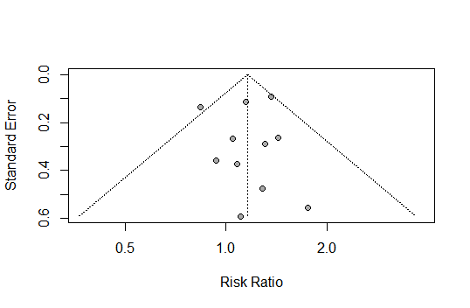
Additional file S5: Funnel plot of comparison: dihydroartemisinin-piperaquine versus artemether-lumefantrine for treatment of uncomplicated plasmodium falciparum malaria among children in Africa, outcome: Gastrointestinal adverse events (diarrhea).

