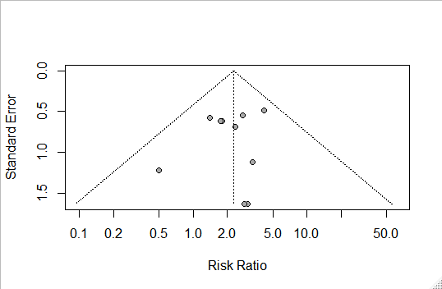
Additional file S4: Funnel plot of comparison: dihydroartemisinin-piperaquine versus artemether-lumefantrine for treatment of uncomplicated plasmodium falciparum malaria among African children, outcome: Gastrointestinal adverse events (early vomiting).

