Additional file 5. Risk of bias for methods studies with case study design based on the Joanna Briggs Institute Critical Appraisal Checklist for Case Reports (14)
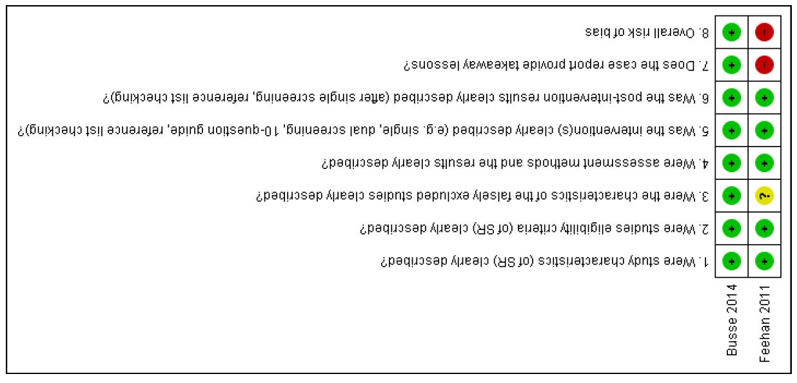

Risk of bias for methods studies with a case series design based on the Joanna Briggs Institute Critical Appraisal Checklist for Case Series (14)
