Supplementary Information

Statistical significance for the increase in σ² of q˙^{f}(x, t)
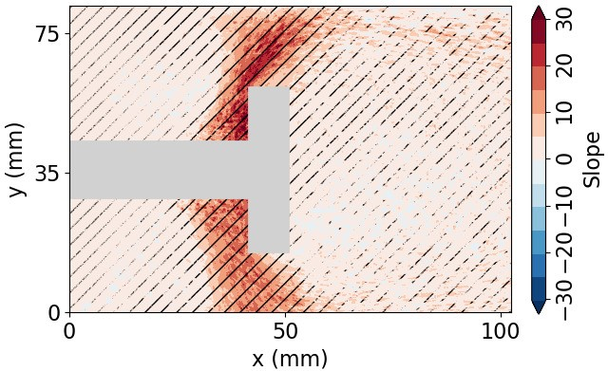

Figure 8: The increase in σ2 at Z1 and Z2 is statistically significant utilizing the student t-test. The increase in σ2 is estimated by the slope of the line in the time interval between 21 s and 25.5 s. We examine this period of time because the highest growth in σ2 at Z1 and Z2. In this time interval, we consider that σ2 increases linearly. The surface plot shows the increase in σ2 as the slope of the linear line at each pixel. The flame zone shows a high value of the slope at Z1 and Z2. The diagonal black lines show that at these regions, the increase in σ2 is significant (99.9%) utilizing the student t-test. In the wake, the significance is weaker, indicated by grainy diagonal lines.

Statistical significance for the Pearson correlation

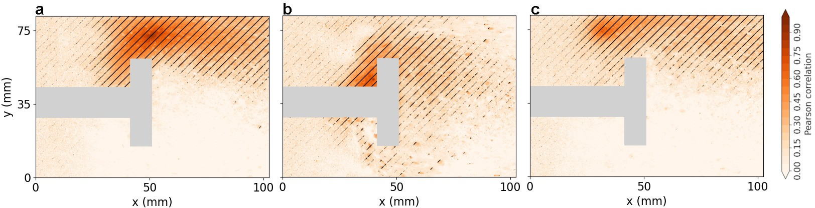

Figure 9: Pearson’s correlation show significant correlation between Z1, Z2 and Z3. The spatial distribution of the Pearson’s correlation coefficient between the time series of q˙^{f}(x, t) at every location with the time series at (a) Z1, (b) Z2 and (c) Z3. The black diagonal lines in each plot shows regions
where the correlation is significant (p < 0.001). For example, in a, we find that the correlation is significant around Z1, extending till Z2 and downstream of Z1. On the other hand, the correlation with Z1 is not significant for areas downstream of the shaft and upstream of the bluff body. The correlation is calculated for the time interval between 10 s to 20 s, which is the same time period used to check the significance of the increase in correlation in Fig. 4a.

Relation of the critical threshold with the Hurst exponent of p^{f}

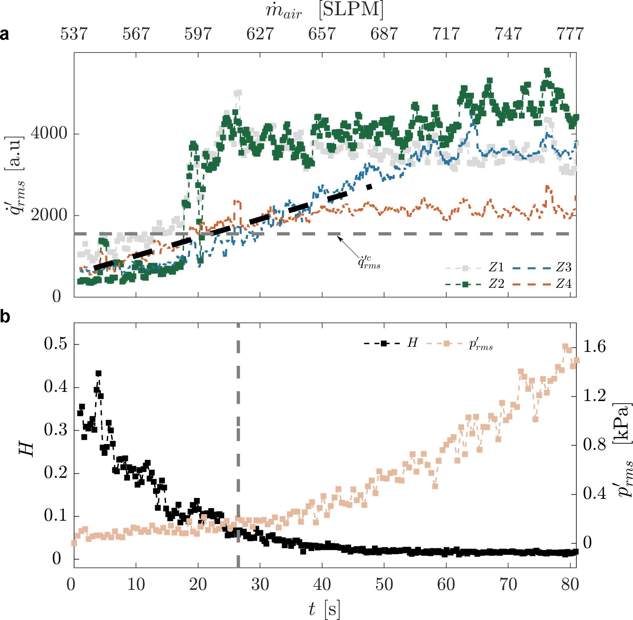

Figure 10: Increase in q˙^{f}rms at the interconnected mark the phase transition. (a) Variation of q˙^{f}rms with respect to mass flow rate of air at Z1, Z2, Z3 and Z4. This plot is similar to Fig.5 but with the addition of q˙^{f}rms at Z4. (b) The variation of Hurst exponent H of p^{f} and p^{f}rms with respect to t. H
decreases and becomes nearly constant after t = 41 (m˙ _{air} = 660 SLPM). Refer to Nair and Sujith¹ on
the calculation of H. At the intersection point of Z2 and Z4, we find H as 0.1.

References
1 Nair, V. & Sujith, R. I. Multifractality in combustion noise: predicting an impending combustion instability. J. Fluid. Mech. 747, 635–655 (2014).

