Supplementary Information for
Diel cycle of sea spray aerosol concentration over vast areas of the tropical Pacific Ocean and the Caribbean Sea
J. Michel Flores^{1*}, Guillaume Bourdin^{2,3}, Alex Kostinski⁴, Orit Altaratz¹, Guy Dagan⁵, Fabien Lombard³, Nils Haëntjens², Emmanuel Boss², Matthew B. Sullivan⁶, Gabriel Gorsky³, Naama Lang-Yona⁷, Miri Trainic¹, Sarah Romac⁸, Christian R. Voolstra⁹, Yinon Rudich¹, Assaf Vardi^{7*}, and Ilan Koren^{1*}
¹ Weizmann Institute of Science, Department of Earth and Planetary Sciences, 7610001 Rehovot, Israel.
² School of Marine Sciences, University of Maine, Orono, ME 04469, USA.
³ Sorbonne Université, CNRS, Laboratoire d’Océanographie de Villefranche, F-06230 Villefranche-sur-Mer, France.
⁴ Department of Physics, Michigan Technological University, Houghton, MI 49931 , U. S. A.
⁵ Atmospheric, Oceanic and Planetary Physics, Department of Physics, University of Oxford, Oxford OX1 3PU, UK.
⁶ Ohio State University, Departments of Microbiology and Civil, Environmental and Geodetic Engineering, Columbus, Ohio, 43210 U. S. A.
⁷Weizmann Institute of Science, Department of Plant and Environmental Science, 7610001 Rehovot, Israel.
⁸ Sorbonne Université, CNRS, Station Biologique de Roscoff, AD2M, UMR 7144, ECOMAP 29680 Roscoff, France.
⁹ Department of Biology, University of Konstanz, 78457 Konstanz, Germany.
*Corresponding authors: flores@weizmann.ac.il, assaf.vardi@weizmann.ac.il, ilan.koren@weizmann.ac.il
This PDF file includes:
S1. Effect of Tara and local influence on the diel cycle of SSA
Figures S1 to S12
Tables S1 to S2

S1. Influence of the boat and instrumentation setup on the measured SSA concentration
To discard a possible local influence by the boat on our finding, we explored the effect of engine contamination, daily routines on board, daily heating of the instrument, or a relative humidity effect.
In Flores et al.¹⁴ we showed that the aerosol measurements were affected by engine contamination only along the first month of the data (i.e., the Atlantic transect) when the inlets were located at ~15 m height. After this period the inlets were moved to the top of the mast. Hence, as part of this analysis the first month of data was cleaned from pollution and all the rest of the data used in this manuscript was measured after moving the inlets to the top of the mast, which rules out any interference by the boat.
Additionally, the OPC instrument was new at the beginning of the campaign and it was checked and recalibrated by the company when Tara anchored in the island of Guam, Micronesia (about 8 months after the beginning of the expedition), assuring a well-functioning instrument.
The OPC was installed in the aft of the boat. A special sensor measured the temperature and RH of the sampled air after the Nafion dryer. We did not see RH or temperature fluctuations at the time of change in aerosol concentration, ruling out that RH effects caused the diel changes in aerosol concentration. Moreover, the temperature in the room and after the dryer was always below 40°C, the OPC is made to function properly up to +50 °C, hence the temperature is within its predefined specifications.
Finally, we checked a possible influence of the daily routines on the boat on our measurements. The boat’s route combined sailing periods with days to week-long stops near islands (the cycle was observed during the 2 types of periods). The OPC was continuously running connected to its own inlet tubbing (separated from the filter system), and was monitored from another part of the boat. The OPC was untouched unless it showed an error (and in that case, it was turned off, and fixed). Twice a day, between 8-10am and 8-10pm the filters from the custom-made aerosol filter system were changed. The exact times of the filters are provided in Table S1. The daily changes in concentration measured by the OPC happened around 6am and 5-6pm local time, when people on board were either asleep or doing other daily routines. We could not identify regular actions on board that could have caused the diurnal aerosol concentration changes.
Supplementary Figures
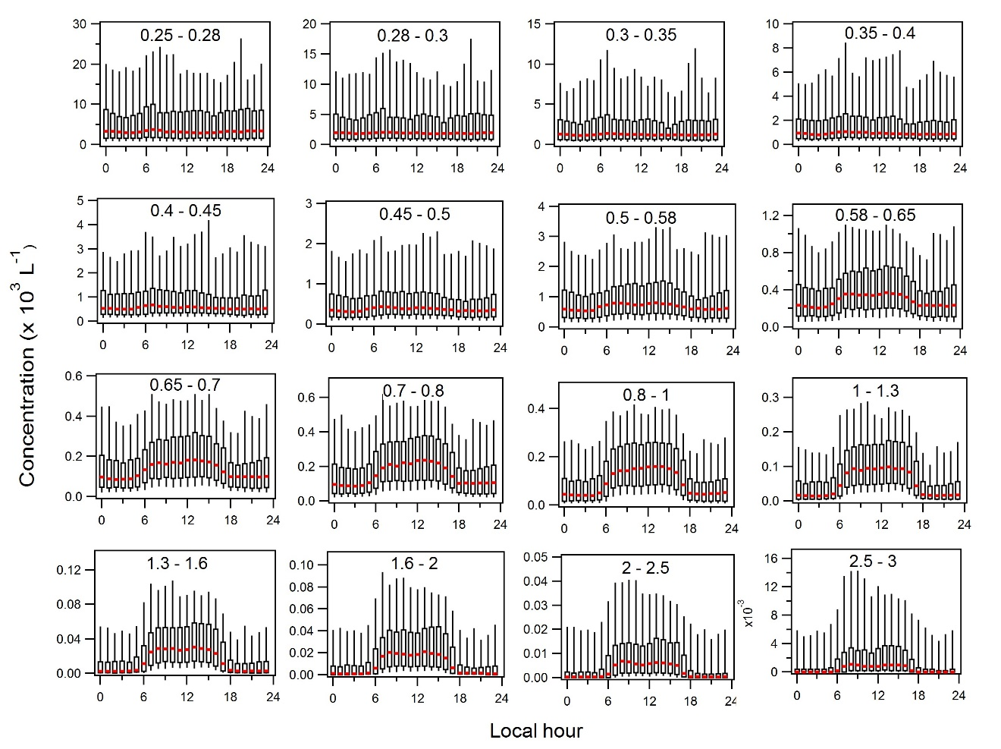
Fig. S1.
Diurnal box plot analysis of total concentration of aerosol diameters per hour for 16 bins of the OPC. The box plot analysis shows the median, and the 5th, 25th, 75th, and 95th percentiles. Only data from the Pacific Ocean and when Tara was at least 100 km away from land were used for this analysis. At the top of each panel the lower and upper limit in micrometers of the OPC bins are shown.

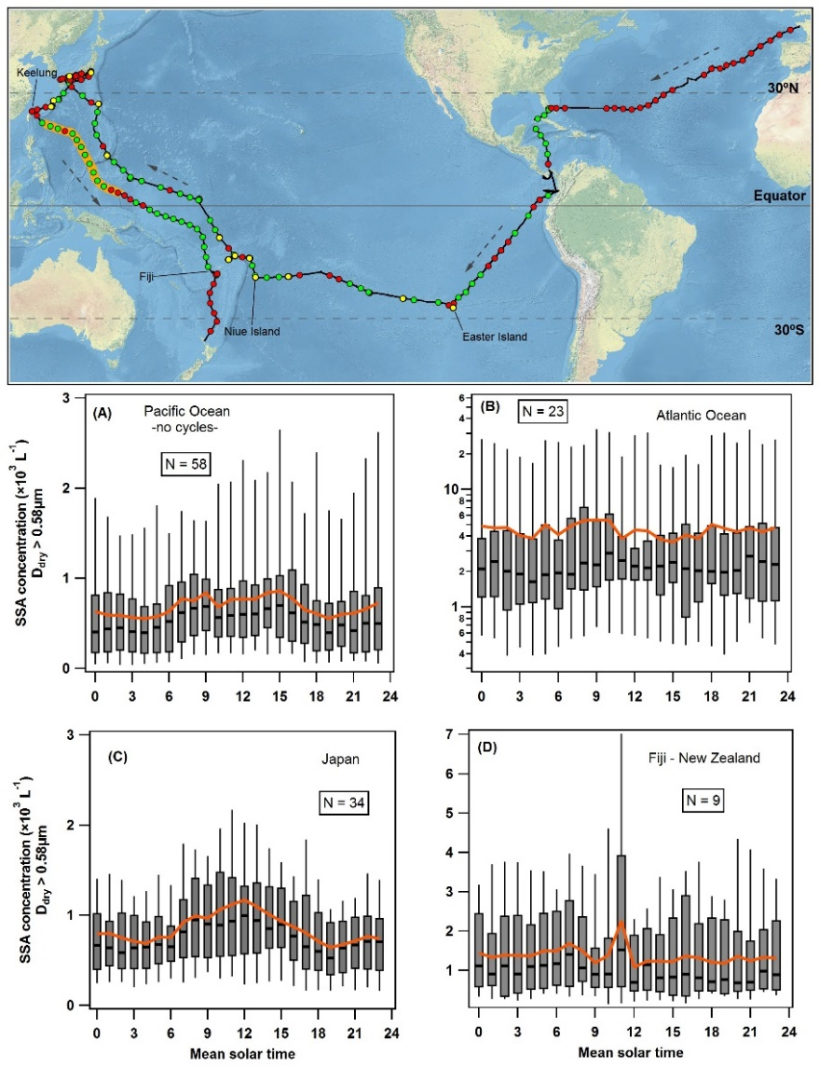
Fig. S2.
Map showing the regions where the diel cycle of N_{SSA_0.58µm} was observed according to the definition of the diel cycle, and box plot analyses of total concentration of aerosol diameters greater than 0.58 µm per hour for four different regions. Map shows R/V Tara’s route where the green and red circles show where diurnal cycles were detected and not, respectively. The yellow dots are Island stops where both, cycles and no cycles were measured. The dotted arrows show R/V Tara’s sailing direction. The orange line along the route in the western Pacific corresponds to the data of Fig. 1. Box plot analysis in A) In the Pacific Ocean for the days with no diel cycle detected. B) In the Atlantic Ocean transect. C) Around Japan, and D) in the Fiji to New Zealand transect. The box plot analyses show the median, and the 5th, 25th, 75th, and 95th percentiles. The orange lines are the averages.

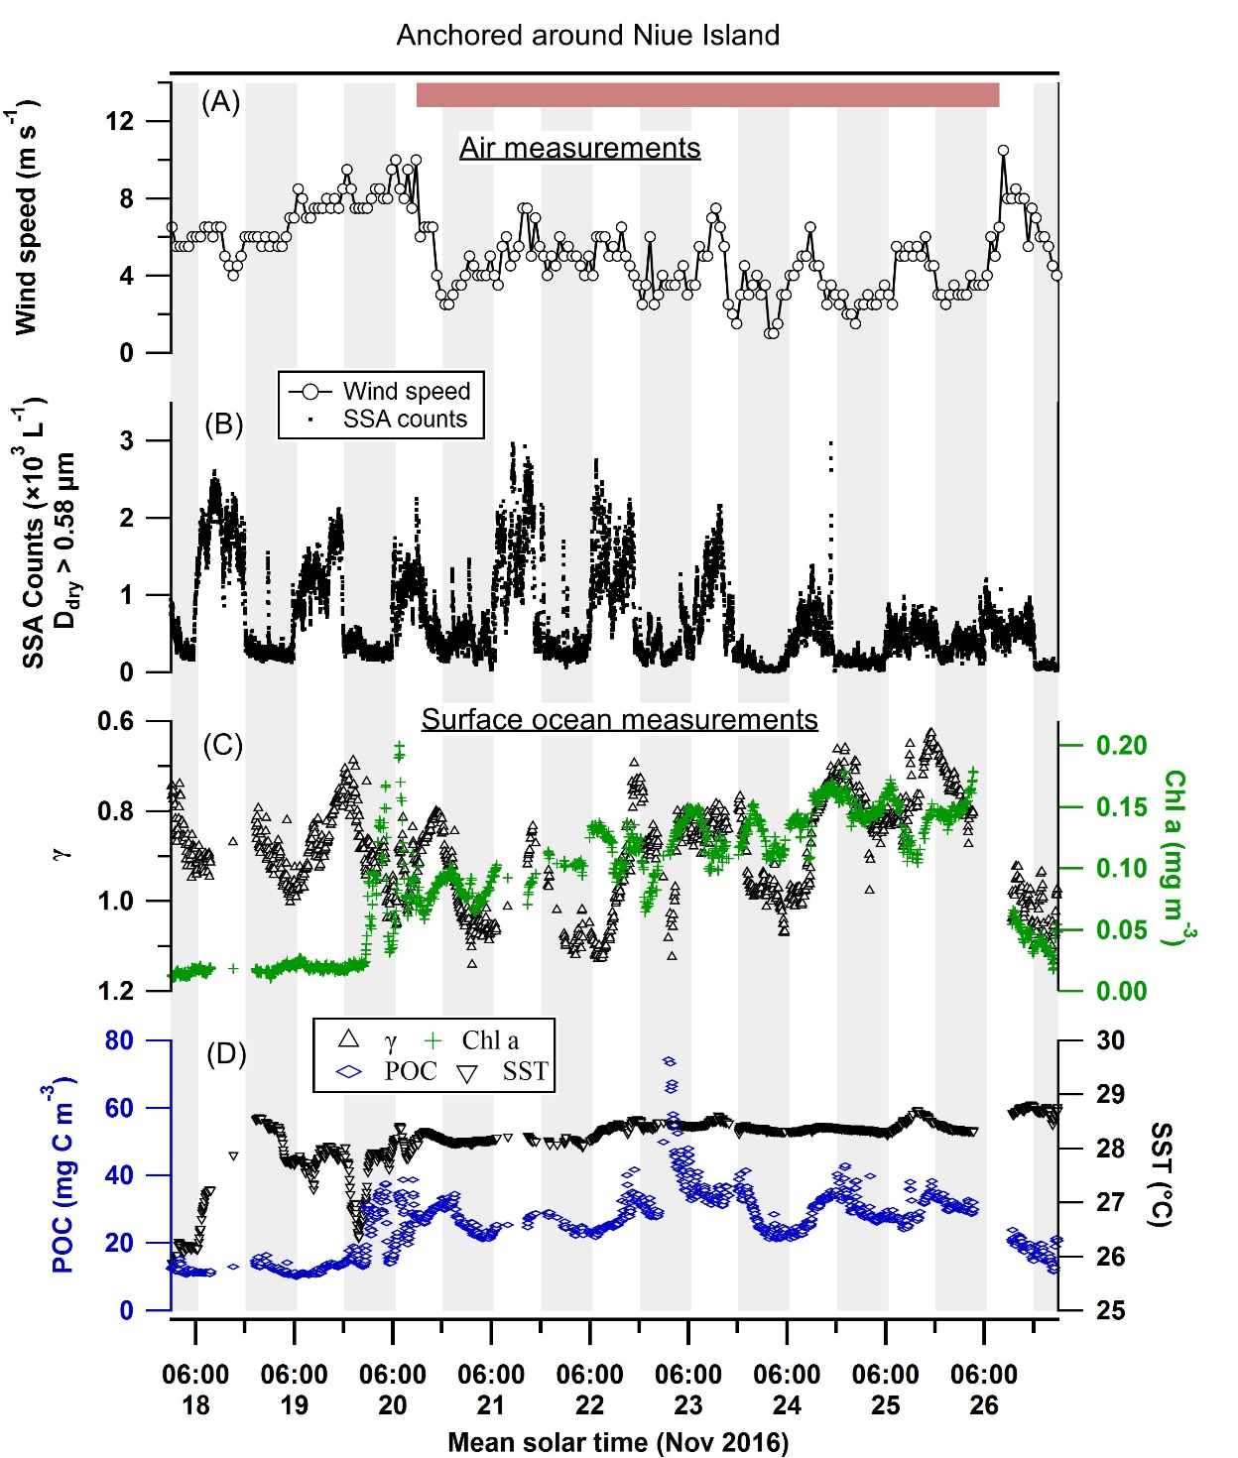

Fig. S3.
Diurnal emission of SSA_{0.58µm} when Tara was anchored around Niue Island. a) Wind speed measured at the top of Tara’s mast 27 m above sea level. The Photosynthetically active radiation (PAR) measured on board Tara was not available in this stop over. b) Total counts per litter of aerosols with D > 0.58µm. c) Spectral exponent of the particulate beam attenuation (γ; inverse axis) and chlorophyll a concentration e) Particulate organic carbon and sea surface temperature. The red bar marks the period Tara was anchored.

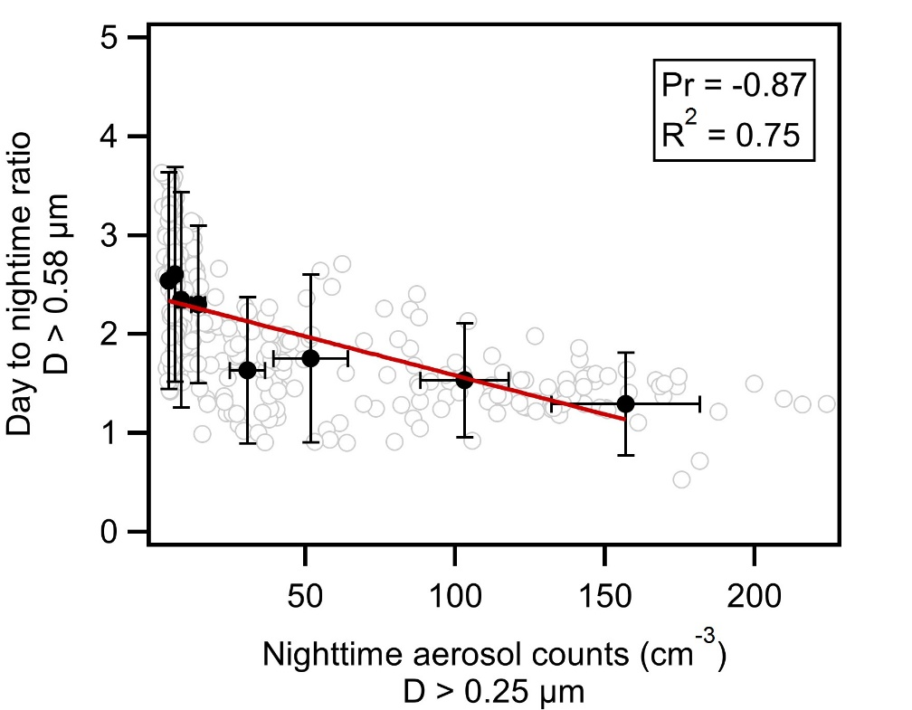

Fig. S4.
Ratio of the daytime to nighttime concentration for aerosols with D > 0.58µm vs total nighttime aerosol count. The grey open circles show all the data. The black circles show the average of the data, binned into equally number of points bins (N=38 per bin). The red line is the linear fit to the averaged data. Pr refers to the Pearson correlation coefficient.

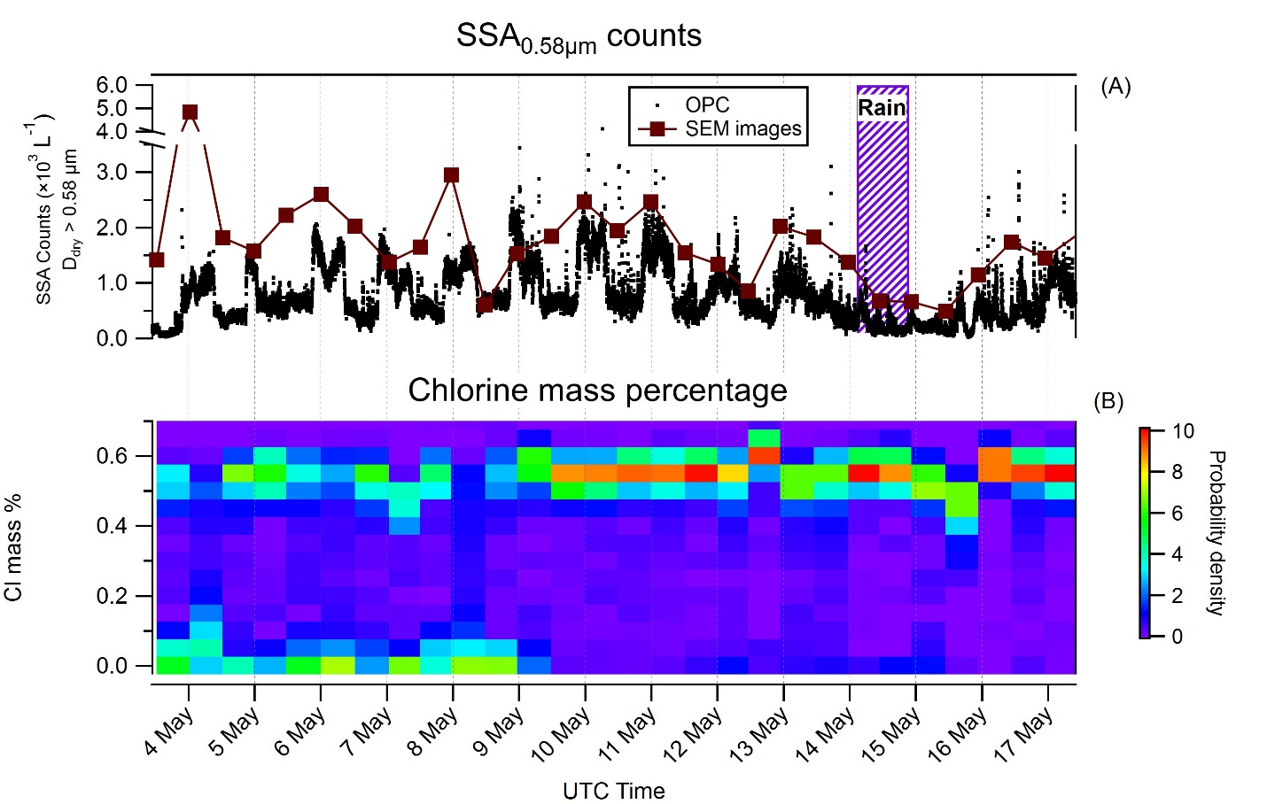
Fig. S5.
Calculated SSA counts from SEM images and histograms of the Chlorine mass percentage found in each filter (normalized to probability density). The red squares show the SSA counts calculated using the SEM images and are overlaid on the SSA measurements from the OPC (black dots).

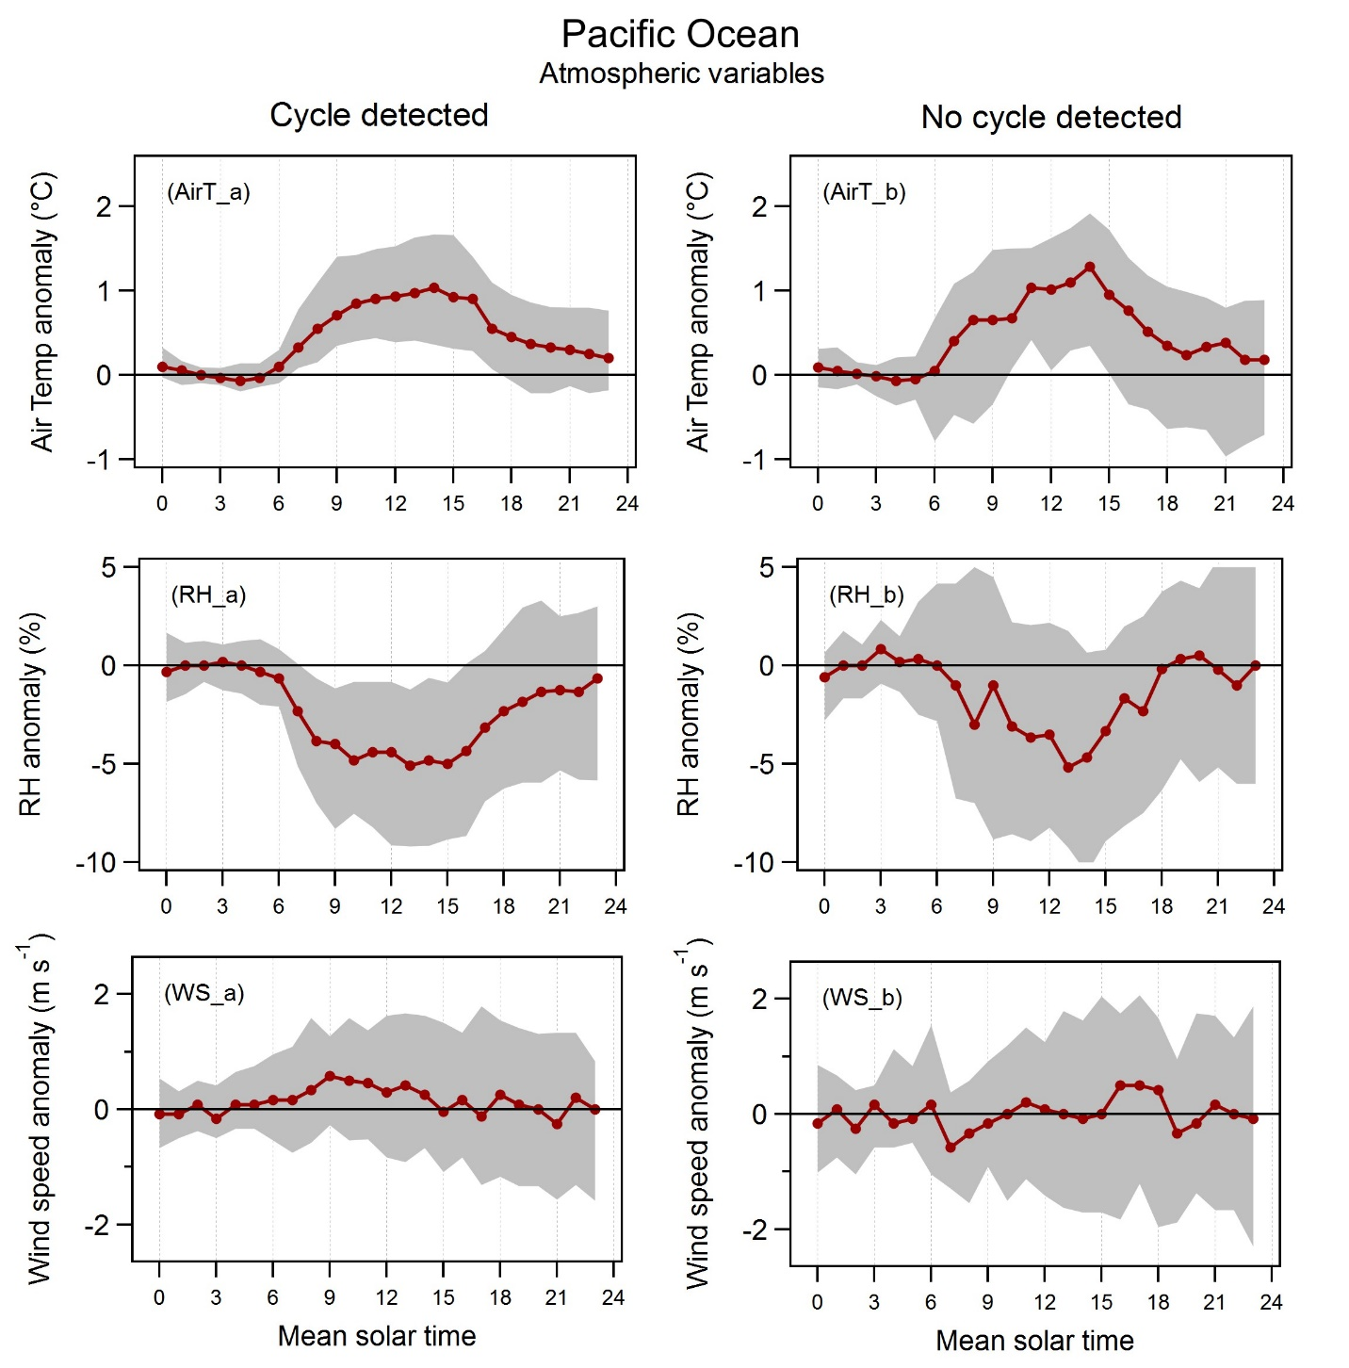
Fig. S6.
Diurnal anomalies for air temperature, relative humidity (~7 m asl), and wind speed (~27 m asl). The anomalies were calculated in the Pacific Ocean (open ocean and near islands). The baseline was taken to be the average value between midnight and five in the morning.
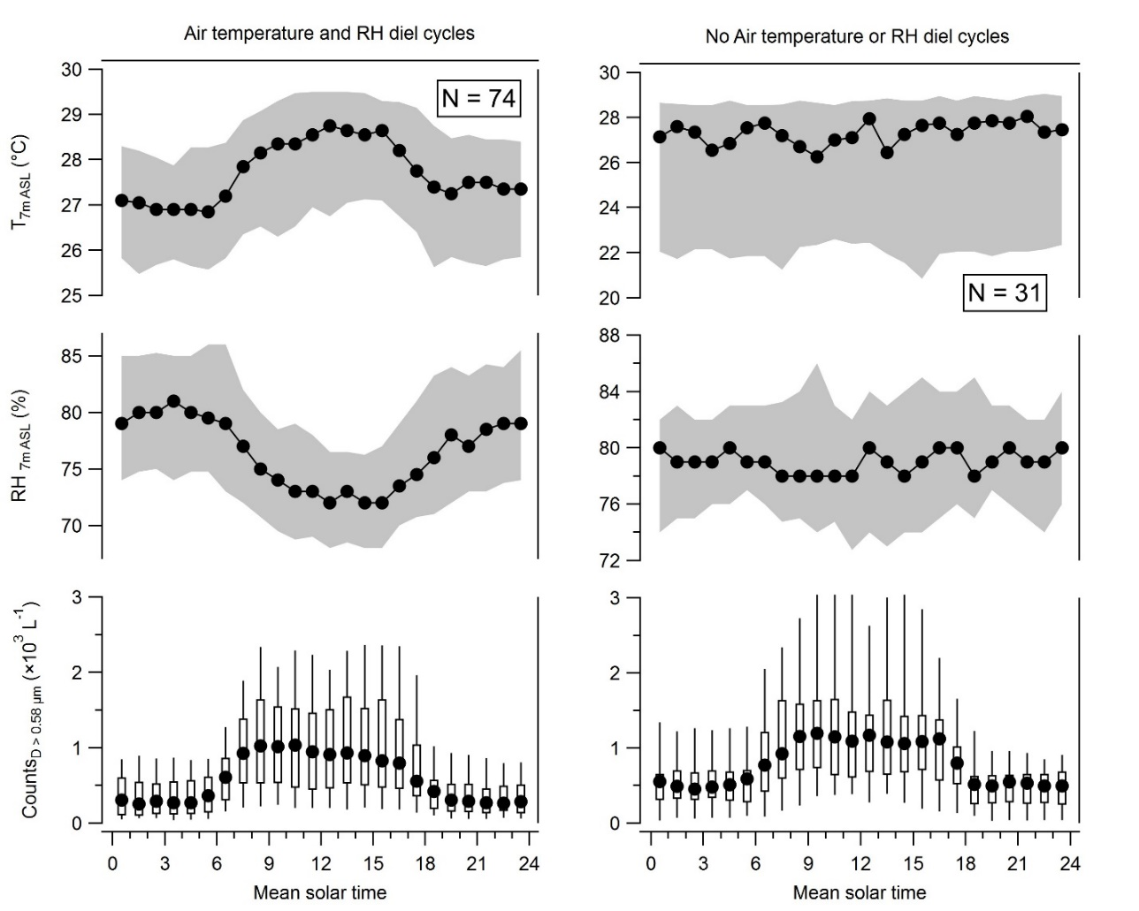
Fig. S7.
Air temperature and relative humidity (~7 m asl) daily variations. The left panel shows 74 days where a diurnal cycle in air temperature, relative humidity, and N_{SSA_0.58µm} was found, and the right panel shows 31 days where a diurnal cycle in N_{SSA_0.58µm} was found but without daily variations in air temperature and relative humidity.

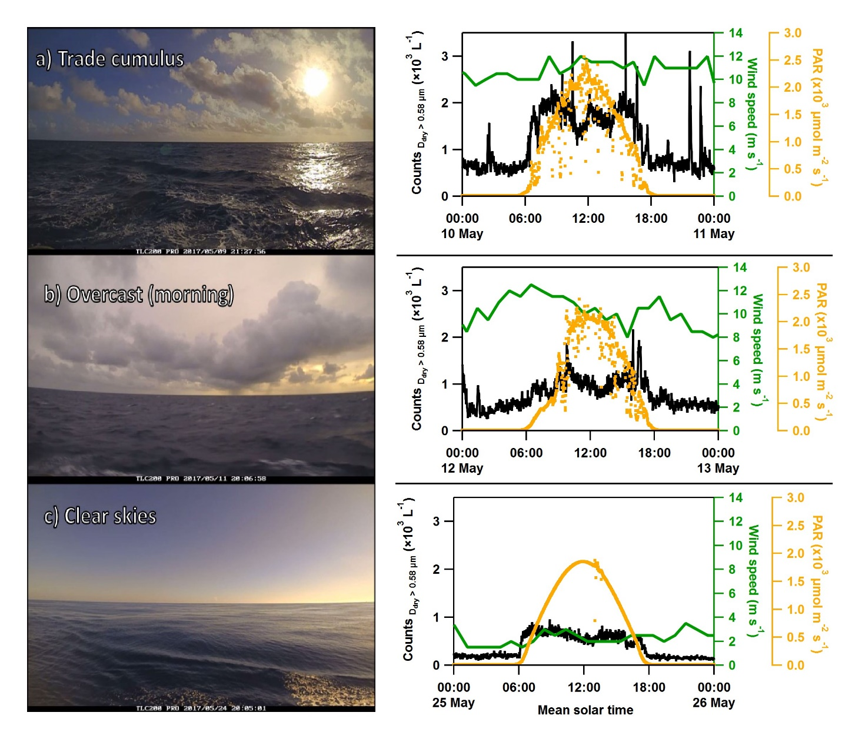
Fig. S8.
Representative pictures of the ocean and atmosphere state during three distinct days. Each snapshot was taken from time-lapse videos taken during the Keelung – Fiji leg on May 2017. On the right side of each picture, the corresponding total counts for D > 0.58 µm, wind speed, and photosynthetically available radiation (PAR) measured on Tara, are shown.
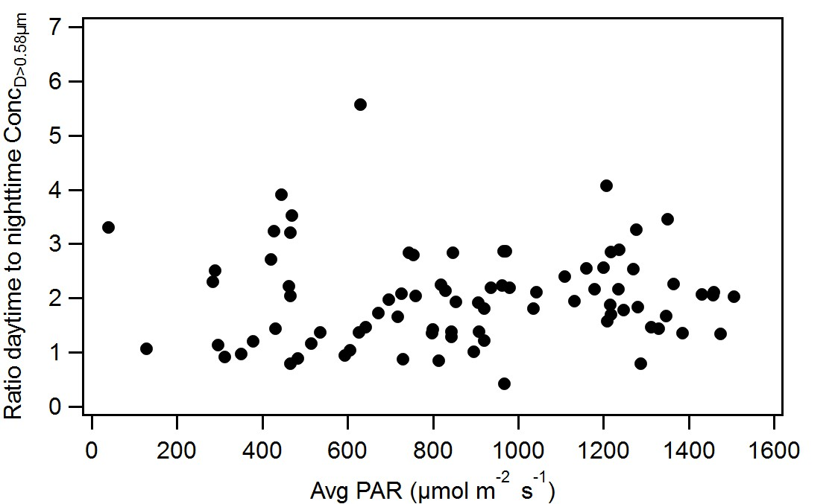
Fig. S9.
Ratio of the daytime to nighttime concentration for aerosols with D > 0.58µm vs the average photosynthetically active radiation for the days when the diurnal emission occurred.
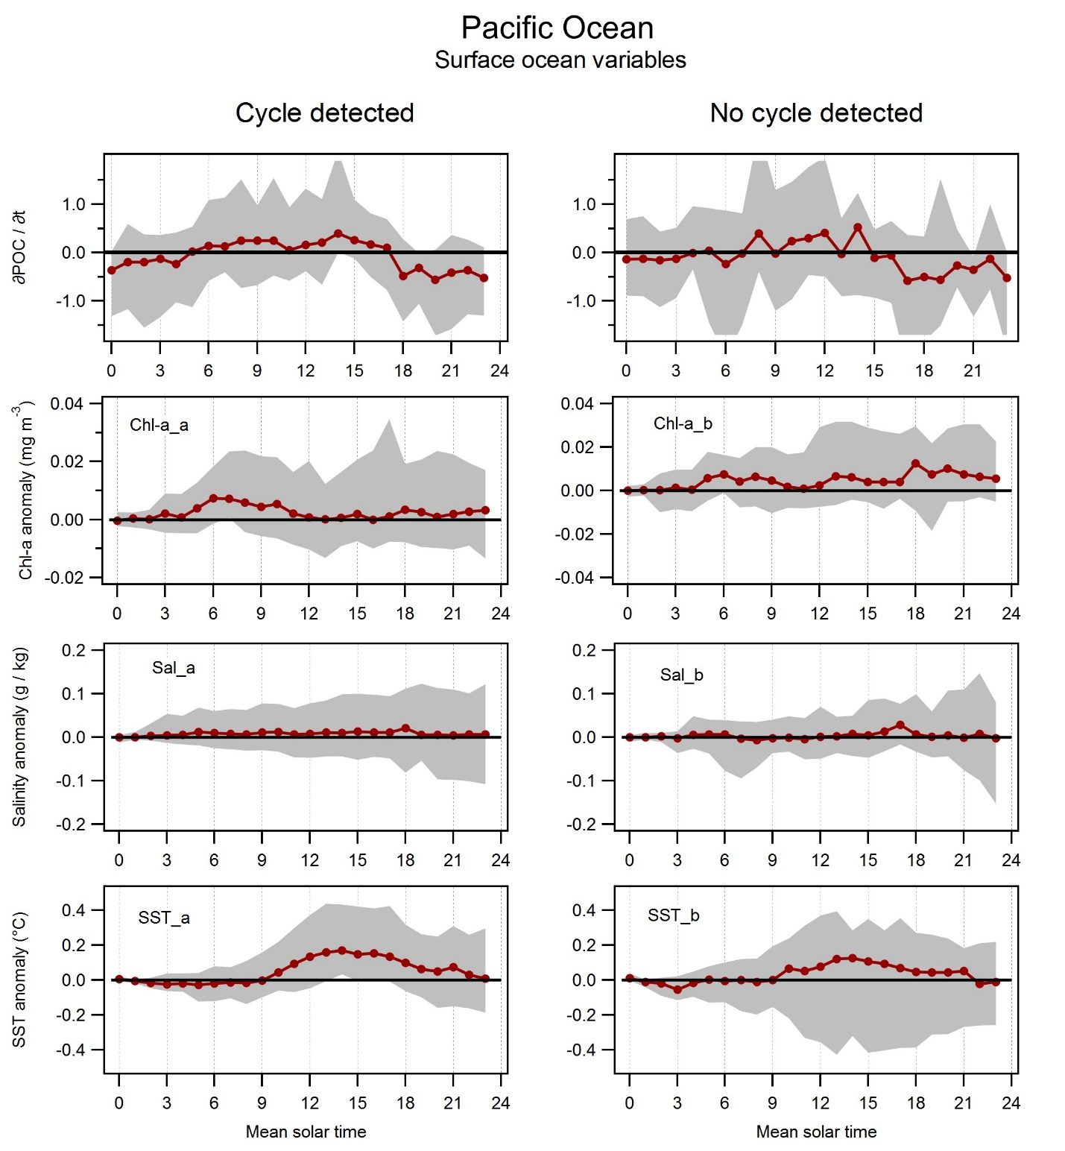
Fig. S10.
Rate of change of particulate organic carbon, and diurnal anomalies for γ, chloropyll a, salinity, and sea surface temperature at a depth of around 0.5 – 3.0 m. The variables were calculated in the Pacific Ocean (open ocean and near islands). The baseline was taken to be the average value between midnight and two in the morning.

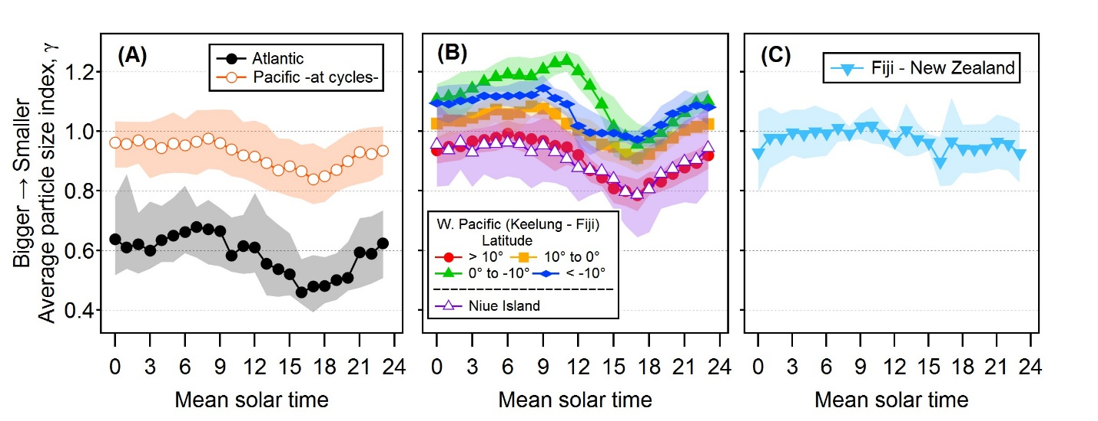
Fig. S11.
Average particle size index, γ, in different oceanic regions. A) In the Atlantic (black circles) and in the Pacific Ocean (open circles) when diurnal cycles in N_{SSA_0.58µm} were measured. B) During the Keelung – Fiji transect for latitudes above 10°N (red circles), between the Equator and 10°N (orange squares), between the Equator and 10°S (green triangles), and below 10°S (blue diamonds). The average γ values while Tara was anchored near Niue Island are also shown (open purple triangles). C) During the Fiji – New Zealand transect. The shaded areas are 1σ.

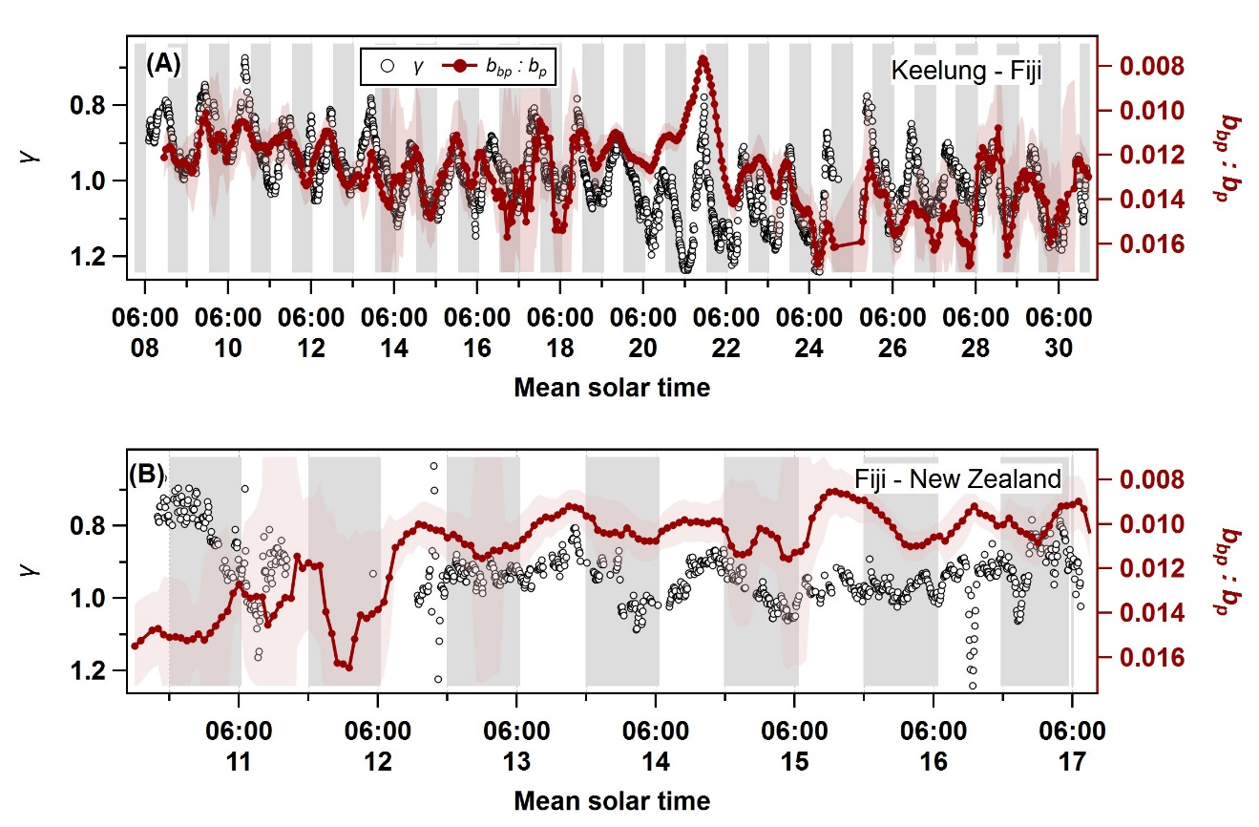
Fig. S12.
Contribution of small (~<1 µm) particles to γ variations. Particle size index (γ, black circles) and backscattering to total particulate scattering ratio (b_{bp} : b_{p}) for the Keelung – Fiji leg (A) where diel cycles in N_{SSA_0.58μm} were also observed, and in the Fiji – New Zealand leg (B) where no diel cycles in N_{SSA_0.58μm} were observed. Shaded areas indicate nighttime.

Table S1.
SEM-EDX analysis filter times, latitude, longitude and number of particles analyzed.
Filter type* | Initial Solar time** | Final solar time | Latitude range | Longitude range | # Particles counted | Sea salt fraction
N | 03-May 20:58:40 | 04-May 08:55:28 | 21 - 20.5 | 128.2 – 129.5 | 233 | 0.70
D | 04-May 09:08:16 | 04-May 20:48:00 | 20.5 – 20.3 | 129.5 – 130.4 | 781 | 0.52
N | 04-May 21:05:04 | 05-May 08:02:08 | 20.3 – 19.9 | 130.4 – 131.5 | 276 | 0.70
D | 05-May 08:27:44 | 05-May 20:07:28 | 19.9 – 19.6 | 131.5 – 132.6 | 254 | 0.79
N | 05-May 20:16:00 | 06-May 08:55:28 | 19.6 – 19.5 | 132.6 – 134 | 388 | 0.54
D | 06-May 09:04:00 | 06-May 21:17:52 | 19.5 – 18.6 | 134 – 134.6 | 438 | 0.50
N | 06-May 21:26:24 | 07-May 09:40:16 | 18.6 – 17.7 | 134.6 – 135.5 | 342 | 0.78
D | 07-May 09:53:04 | 07-May 20:54:24 | 17.7 – 16.7 | 135.5 – 135.8 | 211 | 0.82
N | 07-May 21:02:56 | 08-May 08:21:20 | 16.7 – 15.9 | 135.8 – 136.8 | 257 | 0.71
D | 08-May 08:29:52 | 08-May 20:48:00 | 15.9 – 14.7 | 136.8 – 137.1 | 502 | 0.51
N | 08-May20:56:32 | 09-May 08:19:12 | 14.7 – 13.8 | 137.1 – 137.8 | 95 | 0.56
D | 09-May 08:27:44 | 09-May 20:41:36 | 13.8 -12.6 | 137.8 – 138.5 | 260 | 0.78
N | 09-May 20:54:24 | 10-May 08:34:08 | 12.6 – 11.4 | 138.5 – 139.2 | 298 | 0.94
D | 10-May 08:46:56 | 10-May 20:48:00 | 11.4 – 10.3 | 139.2 – 140 | 411 | 0.93
N | 10-May 21:00:48 | 11-May 09:06:08 | 10.3 – 9 | 140 – 140.5 | 325 | 0.91
D | 11-May 09:10:24 | 11-May 21:20:00 | 9 – 7.9 | 140.5 – 140.9 | 416 | 0.93
N | 11-May 21:32:48 | 12-May 09:21:04 | 7.9 – 6.8 | 140.9 – 141.5 | 253 | 0.92
D | 12-May 09:29:36 | 12-May 20:26:40 | 6.8 – 6 | 141.5 – 142.3 | 201 | 0.91
N | 12-May 20:43:44 | 13-May 08:14:56 | 6 – 5.3 | 142.3 – 143.4 | 137 | 0.94
D | 13-May 08:23:28 | 13-May 20:28:48 | 5.3 – 4.7 | 143.4 – 144.5 | 338 | 0.90
N | 13-May 20:37:20 | 14-May 09:08:16 | 4.7 – 4.3 | 144.5 – 145.6 | 317 | 0.86
D | 14-May 09:12:32 | 14-May 20:22:24 | 4.3 -4.1 | 145.6 – 146.7 | 213 | 0.95
N | 14-May 20:35:12 | 15-May 08:06:24 | 4.1 – 3.6 | 146.7 – 147.6 | 107 | 0.96
D | 15-May 08:10:40 | 15-May 20:33:04 | 3.6 – 3.2 | 147.6 – 148.8 | 113 | 0.84
N | 15-May 20:41:36 | 16-May 08:29:52 | 3.2 – 2.9 | 148.8 – 149.8 | 80 | 1
D | 16-May 08:34:08 | 16-May 20:35:12 | 2.9 – 2.3 | 149.8 – 150.8 | 190 | 0.99
N | 16-May 20:43:44 | 17-May 08:49:04 | 2.3 – 1.7 | 150.8 – 151.7 | 291 | 0.93
D | 17-May 08:53:20 | 17-May 20:24:32 | 1.7 – 1.3 | 151.7 – 152.4 | 232 | 0.98
N | 17-May 20:33:04 | 18-May 08:25:36 | 1.3 - 1 | 152.4 – 153.2 | 307 | 0.91
* The letter marked in bold and Italic are shown in Fig. 1B. **All filter were collected in the year 2017

Table S2.
Tara’s Meteorological data

Parameter | Sensor | Measurement | Precision | Resolution
Pressure | Vaisala PTU200 | Every 5 s  Median over 3 minutes | 0.1 hPa | 0.1 hPa
Temperature | Vaisala HMP45D | Every 5 s  Median over the minute | 0.1 °C | 0.1 °C
Humidity | Vaisala HMP45D | Every 5 s  Median over the minute | 3% | 1%
Wind | Gill Windsonic WS2 | Sensor sending frames every 250 ms  1-minute average true wind computed | Speed 2% at 12 m/s  Direction 3° at 12 m/s | Speed : 0.01 m/s  Direction 0.1°

