Supplementary material for “Increased Indian-North Atlantic Ocean Warming Chain under greenhouse warming”

Young-Min Yang^{1,4*}, Jae-Heung Park², Soon-Il³ An, Bin Wang^{1,4}

¹Joint International Research Laboratory of Climate and Environment Change and Key Laboratory for Prevention of Meteorological Disaster Ministry of Education, Nanjing University of Information Science and Technology, Nanjing, 210044, China. ²Division of Environmental Science and Engineering, Pohang University of Science and Technology, Pohang 37673, Korea. ³Department of Atmospheric Sciences and Irreversible Climate Change Research Center, Yonsei University, Seoul 03722, Korea. 4Department of Atmospheric Sciences and International Pacific Research Center, University of Hawaii, Honolulu HI 96822, USA. email:sian@yonsei.ac.kr;bwang@hawaii.edu

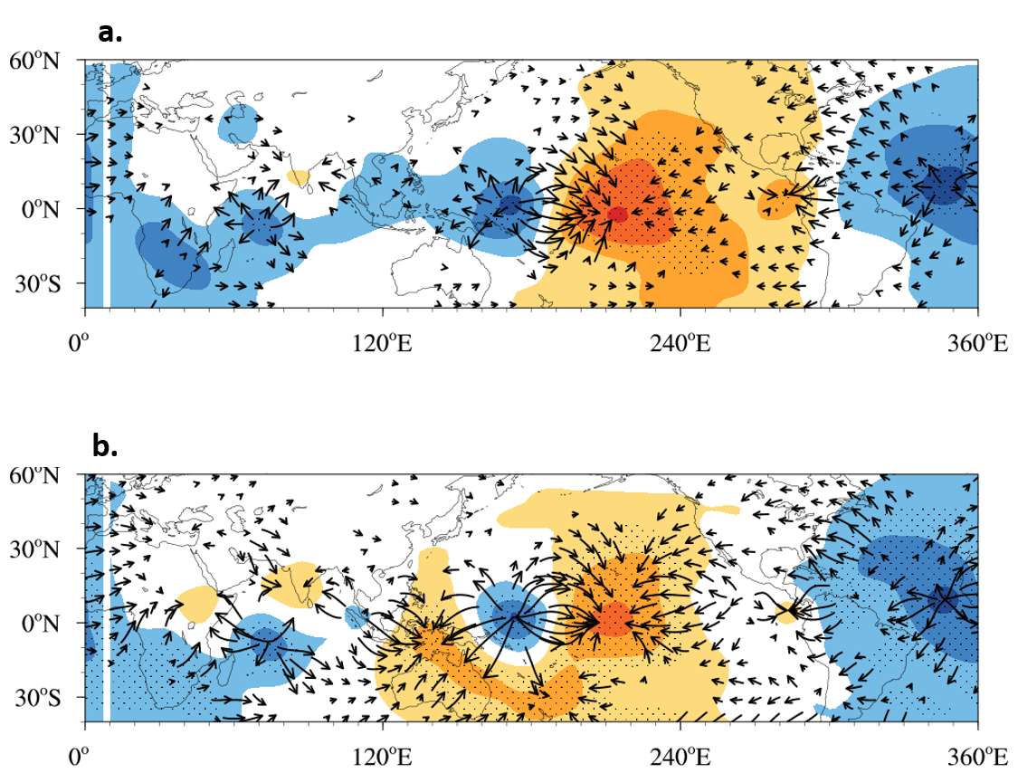

Supplementary Fig. S1 Upper-level circulation induced by IO-NA warming. a Observed velocity potential (shading, 10⁵ m² s⁻¹) and divergent winds (m s⁻¹) anomalies regressed onto the NA index (0°–70°N, 80°W–0°). The 11-year running average was used for 1970–2019, and the first and last 5 years were excluded. The dotted area represents significant velocity potential at the 95% confidence level. b Same as a but associated with the IO index (35S°–30°N, 40°–120°E). Long-term linear trends in the SST data were removed before regression,

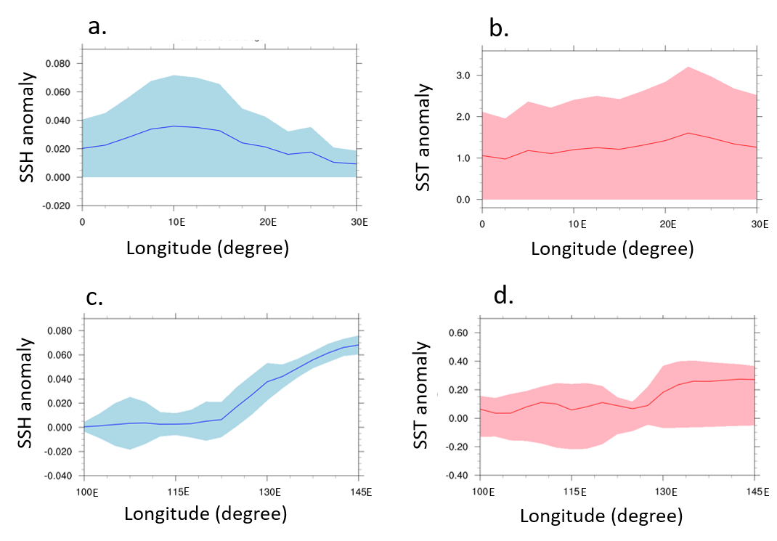

Supplementary Figure S2 Ocean response to IO and NA warming from PI simulation. a-b Differences of zonal structure of anomalies in SSH (m, a) and SST (°C, b) and averaged over 40°S-35°S between the preindustrial (PI) simulation with observed IO SST anomalies and relatively increased SST anomalies uniformly by 1°C. c-d same as a-b but for preindustrial (PI) simulation with observed NA SST anomalies averaged over 10°S-5°N. The anomalies are computed for the last 50 years of the simulations

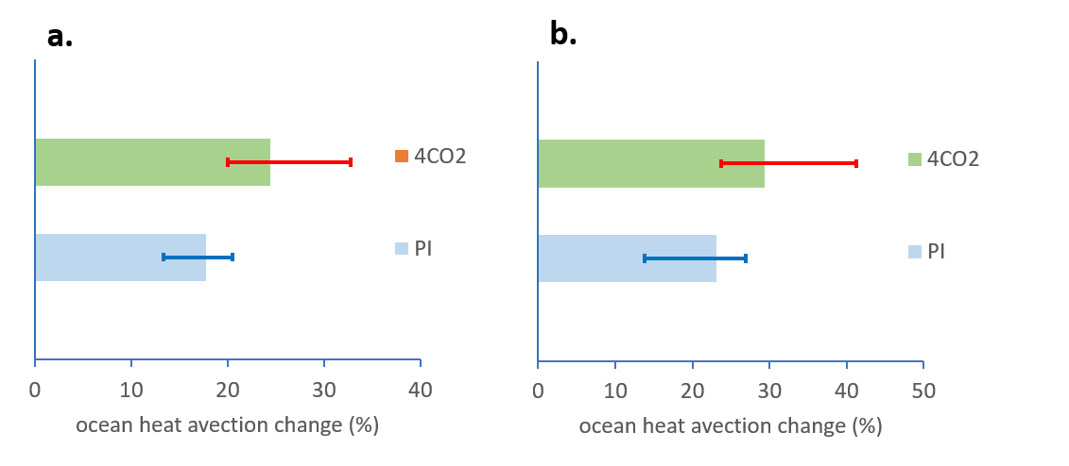

Supplementary Figure S3 IO-NA ocean heat advection from PI and 4CO2 simulations. a percentage changes of the ocean heat advection over Indonesian throughflow region (110°E-120°E, 10°S-5°N) in the preindustrial (PI) and quadruple CO2 (4CO2) experments. The changes are defined as difference of IO (or NA) index between PI simulation with observed NA SST anomalies and with relatively warmed NA SST Anomalies by 1°C. The blue (red) circle represents PI (4CO2) simulations. The blue (red) line shows linear regression curves from PI (4CO2) simulations. b same as a but for changes of ocean heat advection (°C yr⁻¹) over Allguhas current region (10°E-20°E, 40°S-30°S) simulation with observed IO SST anomlaies

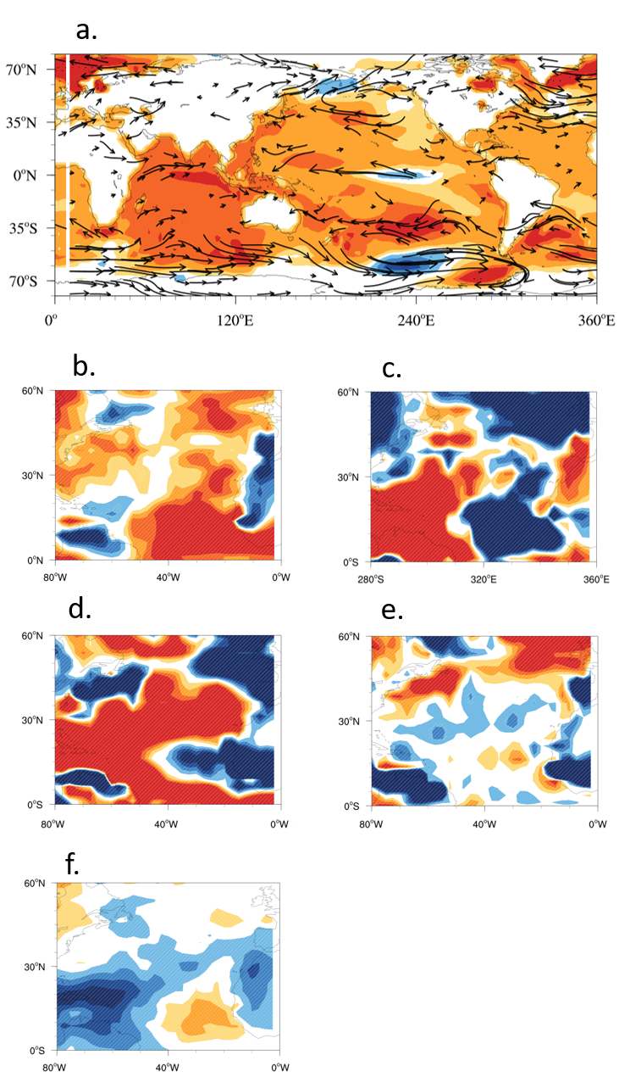

Supplementary Fig. S4 Global climate response to IO warming from fixed anthropogenic PI experiments. Same as figure 4 but for preindustrial (PI) simulation with observed IO SST anomalies

