Supplementary Table 1. Plasma and CSF Comparison of Lithium Concentrations in Acute (Figure 4) and Long-Term Treatment Groups (Figure 5)
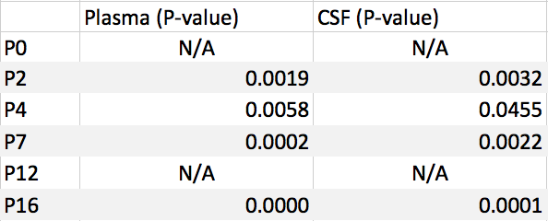
N/A - not available
Statistical analysis using two-tailed t-test
Results between Figure 4 and 5 are statistically significant (P-value < 0.05)

Supplementary Table 2. Statistical Analysis for CSF/ Plasma Ratios (Figure 3)
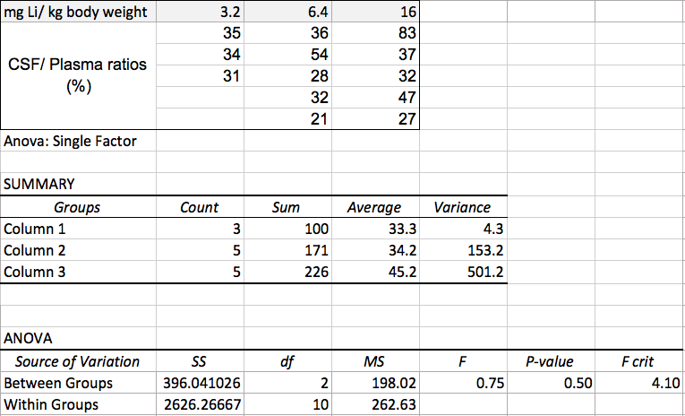
Statistical analysis using two-tailed t-test
CSF/ Plasma ratios in Figure 3 not significantly different (P-value = 0.5)

