Supplementary material
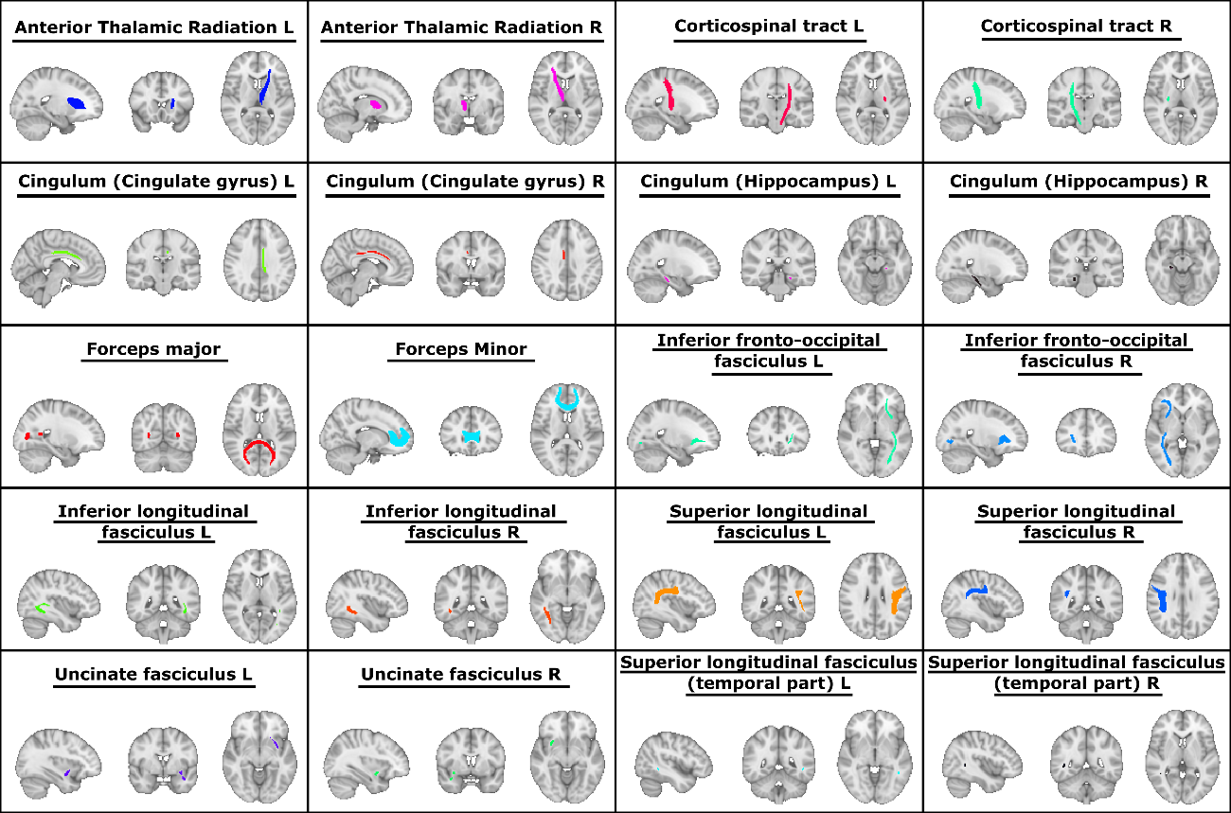
Supplementary Figure 1: Major tracts over which alterations were assessed.

Supplementary Table 1. Analysis of neuropsychological performance from baseline to follow-up in DM1 patients.
 | Baseline |  |  | Follow-up
Domain | Mean | (SD) |  | Mean | (SD) |  | t | p | d
Attention/Processing speed | 45.13 | (5.05) |  | 39.61 | (4.26) |  | 2.74 | .029 | 1.37
Verbal memory | 50.69 | (11.14) |  | 45.64 | (8.98) |  | 1.15 | .289 | 0.57
Visual memory | 47.50 | (9.75) |  | 46.75 | (8.38) |  | 0.19 | .857 | 0.09
Visuoconstruction | 49.81 | (9.45) |  | 47.75 | (8.25) |  | 0.69 | .513 | 0.34
Executive functioning | 45.45 | (7.75) |  | 42.06 | (9.64) |  | 1.42 | .198 | 0.71
Intellectual Functioning | 97.63 | (11.54) |  | 100.00 | (10.53) |  | -0.79 | .458 | 0.39
Note. SD: Standard Deviation

Supplementary Table 2. Group differences in WM integrity FA values
 | Intergroup differences |  |  | Post hoc analyses
 |  |  |  | DM1 baseline  vs  HC baseline |  |  | DM1 follow-up  vs  HC follow-up |  |  | HC baseline  vs  HC follow-up |  |  | DM1 baseline  vs  HC follow-up
 | $$x^{2}$$ | p |  | $$x^{2}$$ | P |  | $$x^{2}$$ | p |  | $$x^{2}$$ | p |  | $$x^{2}$$ | p
Anterior Thalamic Radiation | 192.671 | 0.0002 |  | 45.474 | 0.030 |  | 108.079 | 0.001 |  | -- | -- |  | 80.404 | 0.005
Corticospinal Tract | -- | -- |  | -- | -- |  | 75.868 | 0.006 |  | -- | -- |  | -- | --
Cingulum (Cingulate Gyrus) | 111.597 | 0.010 |  | -- | -- |  | 57.553 | 0.020 |  | -- | -- |  | -- | --
Cingulum (Hippocampus) | 100.984 | 0.020 |  | -- | -- |  | 66.395 | 0.010 |  | -- | -- |  | -- | --
Forceps Major | 93.065 | 0.030 |  | -- | -- |  | 61.895 | 0.010 |  | -- | -- |  | -- | --
Forceps Minor | 127.541 | 0.005 |  | -- | -- |  | 71.053 | 0.008 |  | -- | -- |  | -- | --
Inferior Fronto-occipital Fasciculus | 18.702 | 0.0003 |  | 57.553 | 0.020 |  | 108.079 | 0.001 |  | 48.057 | 0.030 |  | -- | --
Inferior Longitudinal Fasciculus | 161.137 | 0.001 |  | 66.395 | 0.010 |  | 80.842 | 0.004 |  | -- | -- |  | -- | --
Superior Longitudinal Fasciculus | 174.018 | 0.0006 |  | 41.763 | 0.040 |  | 91.263 | 0.003 |  | 41.657 | 0.040 |  | 4.864 | 0.030
Uncinate Fasciculus | 159.392 | 0.001 |  | 85.974 | 0.003 |  | 66.395 | 0.010 |  | -- | -- |  | -- | --
Superior Longitudinal Fasciculus (Temporal Part) | 95.786 | 0.020 |  | -- | -- |  | -- | -- |  | -- | -- |  | 80.404 | 0.005
Global FA | 173.284 | 0.0006 |  | -- | -- |  | 91.263 | 0.003 |  | 48.057 | 0.030 |  | 74.559 | 0.006
Note. Only results where statistically significant differences were found are shown (remaining cells are left blank). DM1: Myotonic Dystrophy Type 1; HC: Healthy controls; FA: Fractional Anisotropy

Supplementary Table 3. Significant regions resulting from group comparisons (DM1 < HC) at baseline.
Tract (JHU ICBM) | Peak X  (MNI) | Peak Y  (MNI) | Peak Z  (MNI) | Peak p | Peak t | Mean t | N Voxels | Vol (mm³)
Inferior Fronto-occipital Fasciculus R | 28 | 16 | -4 | 0,0444 | 4,8354 | 2,9123 | 20 | 28
Inferior Longitudinal Fasciculus R | 42 | -10 | -20 | 0,046 | 4,6402 | 3,249 | 14 | 22
Uncinate Fasciculus R | 32 | 2 | -10 | 0,049 | 3,5133 | 2,6954 | 10 | 18
Note. Only tracts with N voxels greater than 10 are shown. L: left; R: right

Supplementary Table 4. Significant regions resulting from group comparisons (DM1 < HC) at follow-up.
Tract | Peak X  (MNI) | Peak Y  (MNI) | Peak Z  (MNI) | Peak p | Peak t | Mean t | N Voxels | Vol (mm³)
Anterior Thalamic Radiation L | -10 | 0 | -2 | 0,003 | 4,3372 | 1,9391 | 63 | 504
Anterior Thalamic Radiation R | 18 | 18 | 0 | 0,002 | 3,979 | 1,89 | 51 | 408
Corticospinal Tract L | -24 | -16 | 6 | 0,004 | 3,1946 | 1,7549 | 46 | 368
Corticospinal Tract R | 22 | -16 | -2 | 0,002 | 3,1426 | 1,9909 | 47 | 376
Cingulum  (Cingulate Gyrus) L | -8 | -24 | 32 | 0,004 | 3,04 | 2,0445 | 15 | 120
Cingulum (Hippocampus) R | 24 | -24 | -18 | 0,008 | 4,0946 | 2,0253 | 25 | 200
Forceps Major | 22 | -80 | 8 | 0,043 | 3,5965 | 1,8643 | 135 | 1080
Forceps Minor | -14 | 44 | -10 | 0,002 | 5,9171 | 2,1132 | 528 | 4224
Inferior Fronto-occipital Fasciculus L | -34 | 2 | -6 | 0,002 | 5,7826 | 2,0435 | 202 | 1616
Inferior Fronto-occipital Fasciculus R | 40 | -22 | -10 | 0,002 | 4,7534 | 2,0815 | 243 | 1944
Inferior Longitudinal Fasciculus L | -46 | 0 | -16 | 0,002 | 5,3999 | 2,183 | 142 | 1136
Inferior Longitudinal Fasciculus R | 44 | -8 | -14 | 0,005 | 5,2797 | 2,3102 | 82 | 656
Superior Longitudinal Fasciculus L | -38 | -44 | 16 | 0,002 | 4,9712 | 1,9591 | 237 | 1896
Superior Longitudinal Fasciculus R | 36 | -10 | 24 | 0,004 | 4,6874 | 2,1655 | 195 | 1560
Uncinate Fasciculus L | -40 | 4 | -26 | 0,002 | 2,907 | 1,7682 | 38 | 304
Note. Only tracts with N voxels greater than 10 are shown. L: left; R: right.

Supplementary Table 5. Correlation analyses (Pearson r) between clinical and neuropsychological data and regional and global FA at follow-up
Domain | Anterior Thalamic Radiation | Corticospinal Tract | Cingulum (Cingulate Gyrus) | Cingulum (Hippocampus) | Forceps Major | Forceps Minor | Inferior Fronto-occipital Fasciculus | Inferior Longitudinal Fasciculus | Superior Longitudinal Fasciculus | Uncinate Fasciculus | Superior Longitudinal Fasciculus (Temporal Part) | Global FA
Attention/ Processing speed | -0.33 | -0.059 | 0.02 | 0.146 | -0.44 | -0.022 | -0.33 | -0.346 | -0.182 | -0.615 | -0.206 | -0.252
Verbal memory | -0.26 | 0.062 | 0.277 | 0.35 | 0.112 | 0.005 | -0.126 | -0.09 | -0.22 | -0.146 | 0.153 | 0.075
Visual memory | -0.213 | 0.506 | 0.341 | 0.154 | 0.205 | -0.051 | -0.076 | 0.107 | 0.157 | 0.191 | 0.029 | 0.269
Visuo-construction | 0.733 | 0.581 | 0.663 | 0.692 | 0.772* | 0.778* | 0.798* | 0.7 | 0.614 | 0.739 | 0.695 | 0.788*
Executive functioning | -0.638 | -0.138 | 0.109 | -0.017 | -0.367 | -0.252 | -0.555 | -0.519 | -0.418 | -0.564 | -0.19 | -0.382
Intellectual Functioning | 0.032 | 0.45 | 0.839* | 0.511 | 0.543 | 0.472 | 0.245 | 0.213 | 0.228 | 0.387 | 0.614 | 0.37
CTG | -0.511 | -0.239 | -0.18 | -0.463 | -0.651 | -0.461 | -0.705 | -0.727 | -0.479 | -0.581 | -0.67 | -0.52
MIRS | -0.34 | -0.475 | -0.337 | -0.744 | -0.442 | -0.442 | -0.476 | -0.533 | -0.368 | -0.237 | -0.41 | -0.618
WM lesion load | -0,64 | -0,64 | -0,28 | -0,56 | -0,64 | -0,57 | -0,79* | -0,88** | -0,8* | -0,66 | -0,55 | -0,76*
Note. * p<0.05; ** p<0.01. FA: Fractional Anisotropy;

