Supplementary
Real time q-PCR analysis protocol
SYBR Green real time q-PCR Master Mix（TOYOBO, Japan）mix was used and conducted under the following reaction conditions: 5 min of initial denaturation at 94°C; 40 cycles of 30 s of denaturation at 94°C, 45 s of annealing at 60°C, and 1 min of elongation at 72°C. Fluorescence of SYBR green was detected after every cycle. The dissolution curve was collected when the whole reaction ended in 0.5ºC increments from 65ºC to 95ºC. The amplification of the PCR reactions had an efficiency of 1.99, where 2 is the highest quality representing doubling each amplification cycle [48] and an error value of 0.002 calculated as the mean squared error of the standard curve. No amplification was detected in the negative controls.
¹³C DNA stable isotope probing (SIP) analysis
The carbon isotope ratios of soil samples were determined using a DeltaPlusXP mass spectrometer (Thermo Scientifc, Bremen, Germany) coupled with an elemental analyzer (FlashEA 1112; CE Instruments, Wigan, UK) in the continuous ﬂow mode at the Stable Isotope Laboratory of the College of Resources and Environmental Sciences, China Agricultural University, Beijing, China. The elemental analyzer combustion temperature was 1020ºC. The carbon isotopic ratios were reported in the delta notation relative to the V-PDB (Vienna-Pee Dee Belemnite) standard using the following equation according to Deniro and Epstein (1978) [49]:
δ¹³C=-(R_{sample}/R_{PDB})×1000
Where δ¹³C is the carbon isotope ratio of the sample in parts per thousand (‰), and R_{sample} and R_{PDB} are the ¹³C/¹²C ratios of the sample and standard, respectively. The SD for the δ¹³C measurements was <0.15‰.
Processing of pyrosequencing data
The Quantitative Insights Into Microbial Ecology (QIIME, v1.8.0) pipeline was employed to process the sequencing data. Brieﬂy, raw sequencing reads with exact matches to the barcodes were assigned to respective samples and identiﬁed as valid sequences. The low-quality sequences were filtered using the following criteria: sequences that had a length of <150 bp, sequences that had average Phred scores of <20, sequences that contained ambiguous bases, and sequences that contained mononucleotide repeats of >8 bp. Paired-end reads were assembled using FLASH. After chimera detection, the remaining high-quality sequences were clustered into operational taxonomic units (OTUs) at 97% sequence identity by UCLUST [50]. A representative sequence was selected from each OTUs using default parameters. Operational taxonomic unit classification was conducted by BLAST searching the representative sequences set against the Greengenes Database [51] using the best hit. An OTU table was further generated to record the abundance of each OTUs in each sample and the taxonomy of these OTUs. Any OTUs containing less than 0.001% of total sequences across all samples were discarded. To minimize the difference of sequencing depth across samples, an average, rounded rarefied OTUs table was generated by averaging 100 evenly resampled OTUs subsets under the 90% of the minimum sequencing depth for further analysis. Initial classification of sequences was performed in QIIME using the NCBI database (https://www.ncbi.nlm.nih.gov/) to obtain taxonomy information.

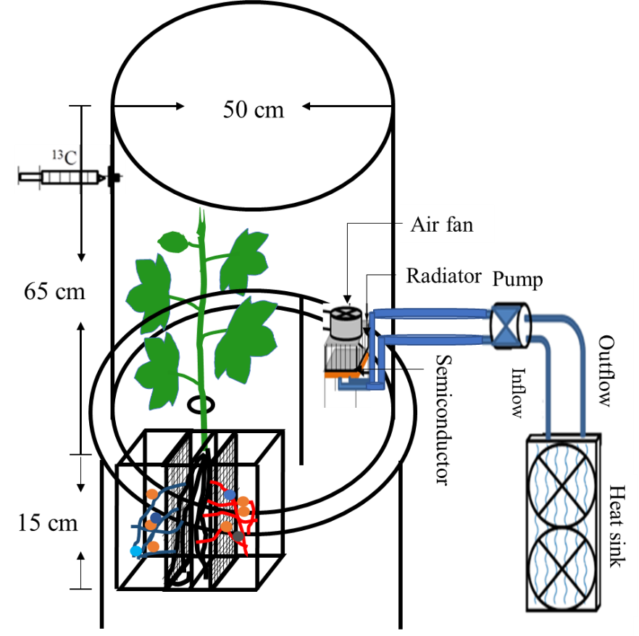
Fig. S1 Root growth system and ¹³CO₂ isotope probing equipment. The growing system was made up of a combination of four compartments, as detailed in Fig. 1. Cotton roots were divided equally into two root compartments by the PVC plate to prevent the interaction between divided roots. The probing equipment included a holder, a cover and a cooling system. The holder was 30 cm in height and consisted of a hyaline acrylic plate. A 5-cm height water channel and a 5-cm diameter hole were in the top of holder. The cover also used a hyaline acrylic plate, which was sealed with a holder by water in a water channel. The cooling system consisted of a semiconductor, air fan, radiator, pump, heat sink and two water pipes. Water was used to cool the set-up by exchanging heat through the heat sink. When probing, plant shoots were passed through the hole and sealed with vaseline to separate the atmosphere from the soil.

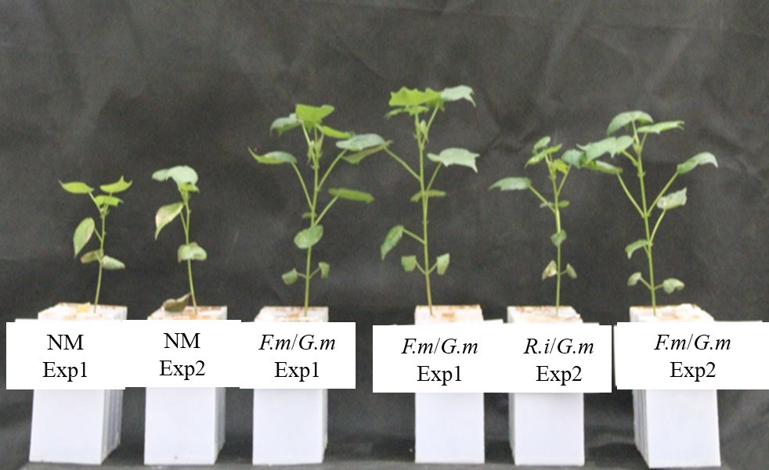

Fig. S2 Photograph before harvesting. Exp 1 and Exp 2 mean two independent experiments. While NM means non-mycorrhizal control. F.m, R.i and G.m mean three different AM fungal inoculums All the treatments showed in this part were ¹³C labeled.

Fig. S3 Quantitative distribution of density-resolved bacterial 16S rDNA obtained from hyphospheres of different inoculation treatments after a 7-day labeling period with ¹³CO₂ and ¹²CO₂. Bacterial template distribution within DNA gradient fractions was quantified with real-time q-PCR. The normalized data are the ratio of the copy number in each gradient fraction to the maximum quantities from each treatment. The DNA fractions subjected to pyrosequencing analysis are marked with arrows.

Fig. S4 Rarefaction curves of the sequences. The nonmycorrhizal (NM) control is compared to Rhizophagus intraradices (R.i) (EY108), Funneliformis mosseae (F.m) (MD118) and Gigaspora margarita (G.m) (JA101A), the three different AM fungal inocula. The value shown in the curve was the mean of three replicates.

Fig. S5 Taxonomic assignment of sequence data at the phylum level. ‘Others’ includes low abundance taxa (<1% of the population). All relative abundance data were the mean of three samples. Exp 1 and Exp 2 refer to two independent experiments. The nonmycorrhizal (NM) control is compared to Rhizophagus intraradices (R.i) (EY108), Funneliformis mosseae (F.m) (MD118) and Gigaspora margarita (G.m) (JA101A), the three different AM fungal inocula. All samples are shown in this part.

Fig. S6 The Principal Component Analysis (PCA) of 16S rRNA genes from all 30 samples. The three different AM fungal inocula were Rhizophagus intraradices (R.i) (EY108), Funneliformis mosseae (F.m) (MD118) and Gigaspora margarita (G.m) (JA101A). All samples are shown in this part.

Table S1. The physicochemical properties of the soil used in this study.
Physicochemical properties
pH (soil: H₂O=1:5) | 6.5
organic matter | 5.8 g kg⁻¹
mineral N | 7.2 mg kg⁻¹
Olsen-P [(NaHCO₃) extractable] | 3.6 mg kg⁻¹
NH₄OAc exchangeable K | 37.6 mg kg⁻¹

Table S2. Basal mineral nutrients added to the soil.
Nutrition | Nutrient form | Addition (mg kg⁻¹)
N | (NH4)₂SO₄ | 200
K | K₂SO₄ | 200
Mg | MgSO₄·7H₂O | 50
Zn | ZnSO₄·7H₂O | 5
Mn | MnSO₄·H₂O | 5
Cu | CuSO₄·5H₂O | 2
P | KH₂PO₄ | 30

Table S3 Arbuscular mycorrhizal inoculation treatments and inoculum filtrates supplied to RCs.
Experiments |  | Treatments | RC1 | RC2
Exp 1 | NM |  | Sterilized F. mosseae + filtrates of mixed inoculum of F. mosseae and G. margarita | Sterilized G. margarita + filtrates of mixed inoculum of F. mosseae and G. margarita
 | F.m/G.m |  | F. mosseae + filtrates of inoculum of G. margarita | G. margarita + filtrates of inoculum of F. mosseae
Exp 2 | NM |  | Sterilized R. intraradices + filtrates of mixed inoculum of R. intraradices and G. margarita | Sterilized G. margarita + filtrates of mixed inoculum of R. intraradices and G. margarita
 | R.i/G.m |  | R. intraradices + filtrates of inoculum of G. margarita | G. margarita + filtrates of inoculum of R. intraradices

Table S4. Details of primers used in this experiment.

Gene | Name of primer | Sequence of primer | reference
16S rDNA | Ba338f | ACTCCTACGGGAGGCAGCAG | [52]
 | Ba806r | GGACTACHVGGGTWTCTAAT
16S rDNA | Ba519f | CAGCMGCCGCGGTAANWC | [53]
 | Ba907r | CCGTCAATTCMTTTRAGTT
AM fungi | AMV4.5NF | AAGCTCGTAGTTGAATTTCG | [54]
 | AMDGR | CCCAACTATCCCTATTAATCAT

Table S5. The relative abundance (%) of phosphate solubilizing bacteria (PSB) referred to previous studies.
PSB |  | Exp1 |  | Exp2
Phylum | Genus | F.m | G.m | R.i | G.m
Proteobacteria | Pseudomonas | 0.27 | 21.37 | 0.24 | 18.0
 | Rhizobium | 0.01 | 0.12 | 0.01 | 0.13
 | Burkholderia | 0.02 | 0.00 | 0.02 | 0.00
 | Achromobacter | 0.04 | 0.36 | 0.10 | 0.23
Actinobacteria | Agrobacterium | 0.00 | 0.00 | 0.05 | 0.00
 | Microccocus | 0.00 | 0.03 | 0.03 | 0.16
Firmicutes | Bacillus | 7.38 | 2.71 | 8.49 | 2.16
Bacteroidetes | Flavobacterium | 0.00 | 0.03 | 0.00 | 0.06

Table S6. The relative abundance (%) of mycorrhizal helper bacteria (MHB) referred to previous studies.
MHB |  | Exp1 |  | Exp2
Phylum | Genus | F.m | G.m | R.i | G.m
Proteobacteria | Pseudomonas | 0.27 | 21.37 | 0.24 | 18.0
 | Azospirillum | 0.21 | <0.01 | 0.13 | 0.02
 | Klebsiella | <0.01 | 0.10 | <0.01 | 0.10
 | Rhizobium | <0.01 | 0.12 | <0.01 | 0.13
 | Enterobacter | <0.01 | 0.10 | <0.01 | 0.04
 | Bradyrrhizobium | 0.11 | 0.19 | 0.16 | 0.39
Actinobacteria | Agrobacterium | <0.01 | <0.01 | <0.01 | 0.05
 | Streptomyces | 7.00 | 0.63 | 5.97 | 0.45
Firmicutes | Bacillus | 7.38 | 2.71 | 8.49 | 2.16
 | Paenibacillus | 1.03 | 0.46 | 1.12 | 0.22
 | Brevibacillus | 1.33 | 0.31 | 1.31 | 0.14

Reference
[48] Tellmann G. The E-Method: a highly accurate technique for gene-expression analysis. Nat Methods. 2008;3:i–ii.
[49] Deniro MJ, Epstein S. Carbon Isotopic Evidence for Different Feeding Patterns in Two Hyrax Species Occupying the Same Habitat. Science. 1978;201:906-908.
[50] Edgar, R.C., 2010. Search and clustering orders of magnitude faster than BLAST. Bioinformatics. 26, 2460-2461.
[51] DeSantis TZ, Hugenholtz P, Larsen N, Rojas M, Brodie EL, Keller K, Huber T, Dalevi D, Hu P, Andersen GL. Greengenes, a chimera-checked 16S rRNA gene database and workbench compatible with ARB. Appl Environ Microbiol. 2006;72:5069-5072.
[52] Xu N, Tan G, Wang H, Gai XP. Effect of biochar additions to soil on nitrogen leaching, microbial biomass and bacterial community structure. Eur J Soil Biol. 2016;74:1-8.
[53] Stubner S. Enumeration of 16S rDNA of Desulfotomaculum lineage 1 in rice field soil by real-time PCR with SybrGreen detection. J Microbiol Methods. 2002;50:155-164.
[54] Sato K, Suyama Y, Saito M, Sugawara K. A new primer for discrimination of arbuscular mycorrhizal fungi with polymerase chain reaction-denature gradient gel electrophoresis. Grassl Sci. 2005;51:179-181.

