Appendix
Model setup and domain information
The Advanced Research Weather Research and Forecasting model version 4.1 (WRF) was used in a convection-permitting configuration with 4 km horizontal grid spacing. The study domain consists of 796 × 496 grid cells, 51 vertical levels up to 50 hPa, and covers the entirety of the northern North American Great Plains between 95°W and 115°W and from 40°N to 55°N (Bromley et al. 2020) (Figure A1). The domain was selected to have at least 40 grid cells between the domain boundary and the study area to avoid model spin-up issues. The European Center for Medium-Range Weather Forecasting’s (ECMWF) ERA5 dataset was used as initial and lateral boundary conditions (Hersbach et al. 2020). The high resolution of ERA5 (~31 km) allows us to directly downscale to 4 km grid spacing without an intermediate nest. The model parameterizations follow those used by L17, including the YSU boundary scheme (Hong et al. 2006), Thompson microphysics scheme (Thompson et al. 2008), and the RRTMG radiation scheme (Iacono et al. 2008) as noted. We did not use spectral nudging due to the limited size of the domain.
The Noah-MP land surface model was used with dynamic vegetation options turned off. Vegetation fraction was fixed at the annual maximum in order to facilitate the experiments that focus on the vegetative growing season. Leaf area index is provided by table values for each land use category. The TOPMODEL groundwater scheme was utilized, which was found to reduce summertime biases (Niu et al. 2007; Barlage et al. 2015, 2021). The control simulations were continuously run from October 2010 to October 2013. The analysis is focused on the warm season, and the first three months of the simulations are utilized for model spinup.

Creation of the fallow dataset
We obtained Landsat 5 TM Collection 1 Level 1 (LS) imagery for 1984 and 2011 ranging between May 1 and Aug 31 from https://earthexplorer.usgs.gov/, resulting in 95 image tiles ranging between 1 and 7 individual dates per tile (1984 N = 350, 2011 N = 455; Supplemental Table S1). Using visual cues, we digitized polygons for every LS Tile/Year and every landcover type (Crop, Fallow, Forest, GrassShrub, Water, excluding Urban). For all LS analyses, we used R v3.5 (R Core Team 2020). We corrected each image and band for surface reflectance and masked pixels containing clouds. Using the surface reflectance images and their associated training polygons, we extracted pixel values for each tile/scene combination. Using the randomForest package (Liaw and Wiener 2002) within R, a multinomial random forest classification model was independently fit to each scene with the response variable as the digitized cover class, the independent variables as LS bands 1-5 and 7, and using 501 trees. We predicted cover classes for the current scene and stacked the rasters (e.g. for 1984 and Tile 030031, the six rasters were stacked into a single object), calculating the majority class of the pixel-based time-series. Finally we mosaicked all of the tiles for each year into a single file. Since Urban areas represent a small fraction of the predominantly rural NNAGP (Stoy et al. 2018), coupled with high levels of classification errors within this class, we chose to backfill pixels as Urban using the 2011 NLCD (Homer et al. 2015). The vegetation fractions were adjusted to match published agricultural statistics (Vick et al. 2016) (Fig. 1) on a state and province basis with the approximate location estimated via LS.
The 30 m summer fallow dataset was interpolated to the 4 km model domain using a conservative remap approach. The Noah-MP land surface model uses a split-cell design where the vegetated fraction of the cell undergoes separate calculations from the non-vegetation fraction. We replaced the default vegetation fraction by setting vegetation fraction equal to the estimated fallow vegetation fraction (1 – fallow area) in pixels for which fallow area was greater than 0 (Figure A1). For areas where there was no fallow change, the vegetation fraction matches the WRF default MODIS vegetation fraction. The October 2010 – 2013 simulation uses the estimated fallow for 2011 and is called the control 2011 simulation (C11). Multiple studies have documented the reduction in summer fallow in the NNAGP and its impact on atmospheric boundary layer processes (Raddatz 1998; Campbell et al. 2002; Gameda et al. 2007; Betts et al. 2013b; Vick et al. 2016; Bromley et al. 2020). These estimates come from state and province-level agricultural census data. Summer fallow has been reduced since the mid-1970s and we assume that the results reported in the census are largely accurate, but the uncertainty lies in the exact timing and location of the changes. The agricultural statistics are conducted every 5 years in the U.S., but the spatial locations of fallow fields within those five years can change considerably. Summer fallow is a part of a wheat-fallow rotation, which makes it difficult to replicate the exact amount of land area under summer fallow for the intervening years between agricultural census surveys and makes specific attribution in any single year a challenge. Our approach to use fallow statistics to adjust Landsat-based estimates is designed to ensure that the total amount of reported fallow is represented in the simulations, but spatial uncertainties exist due to the intermittent overpass of Landsat (Figure A1). Additionally, the timing of planting and harvesting varies with the weather of any given year which further obscures what is summer fallow and what is a field that hasn’t been planted. From this perspective, our goal is to simulate the climate effects of the total amount of fallow that existed in the NNAGP during the study years (1984 and 2011) and its approximate distribution across the NNAGP rather than at the individual field scale which is at a finer spatial grain than the 4 × 4 km WRF resolution.
Observational Verification Data
We compare the temperature and precipitation from model simulations to several observational datasets to understand potential model biases. Daymet is a gridded observational dataset that uses a Gaussian filter to interpolate between station observations and accounts for elevation using a 30 arc-second digital elevation model (Thornton et al. 2016). The horizontal grid spacing is 1 km and the dataset contains daily maximum (Tmax) and minimum (Tmin) air temperature, vapor pressure, and precipitation among other variables. The daily mean temperature was created by averaging daily Tmax and Tmin (Thornton et al. 1997). The CRU dataset is a 0.5 degree global dataset interpolating meteorological station data from multiple sources to a grid using angular distance weighting (Harris et al. 2020b). Monthly mean temperature, vapor pressure, and precipitation are used from the CRU dataset. The Gridded Meteorological Ensemble Tool described by Newman et al., 2015 a,b (hereafter GMET) interpolates North American station observations to a 0.125 degree grid (nominally 14 km grid). The dataset contains 100 ensemble members that are generated based on uncertainty in the interpolation routines as well as measurement uncertainty. We also used the Global Precipitation Climatology Centre monthly precipitation dataset (Rustemeier et al. 2020) for the validation of the precipitation output to create a more robust comparison. All datasets are individually upscaled to match the 0.5-degree monthly means of CRU and the GPCC dataset and remapped using a flux conservation algorithm for both temperature and precipitation using the Climate Data Operators software (Schulzweida 2019).

Since VPD is calculated using the saturation vapor pressure, which is exponentially dependent on temperature via the Clauisus-Clapeyron relationship, VPD model biases are dominated by the temperature bias. Vapor pressure is calculated internally in WRF using mixing ratio and surface pressure, reducing the temperature dependence.
To test the significance of model biases, we first conservatively remap the model simulation data to a 0.5 degree regular grid to match the coarsest observational datasets. Monthly-averaged two-meter temperature (T2) and precipitation (P) from the model are compared to Daymet, CRU, GPCC, and all 100 GMET ensemble members. The maximum and minimum values found across all observational datasets for each month and grid point are used as estimates for observational uncertainties. Model biases are significant if they exceed the range of observational uncertainties. This method is also used by L17 to test the significance of the 13-year convection permitting simulations of the continental United States.
To test whether WRF can reproduce extreme precipitation, the control simulation is compared to the station-based hourly precipitation dataset NCEI DSI 3240 (Hammer and Steurer 1997). An inverse distance weighting average of the nearest four grid cells are employed to create the model estimate at the station location. NCEI DSI 3240 only provides stations in the U.S. A kernel density estimate is used to create empirical density functions for the U.S. portion of the study area compared to the modeled probability density functions. Only overlapping time periods are used for verification and station completeness needs to be at 90% for the comparison. We limit the analysis to the warm season (MJJA) as we are primarily interested in the climate impacts of agricultural management. The early warm season (AMJ) tends to be dominated by frontal rainfall and convection that is initiated by upper level forcing, whereas the late warm season (JAS) tends to be dry and the little rain that falls is predominantly from convection (Gerken et al. 2018).
The vertical structure of the atmosphere is assessed using observed vertical profiles of temperature and dew point temperature from sounding locations within the NNAGP. Profiles are obtained for Glasgow, Montana, USA (GGW), Bismarck, North Dakota, USA (BIS), and Edmonton, Alberta, Canada, (WSE) from the Integrated Global Radiosonde Archive (Durre et al. 2006). The modeled vertical profiles are found via nearest neighbor search for the grid cell closest to the observational sounding location. The profiles from both the observational soundings and the model simulations are log-interpolated to common levels and only the 00UTC and the 12UTC model hours are used for the comparison. Each profile is differenced with the corresponding observational sounding profile and then the difference is averaged across pressure levels for a given month to create a composite profile.
Finally, surface energy flux data was obtained from a grassland eddy covariance site near Lethbridge, Canada, ‘CA-Let’, for the years 2011-2013 (Flanagan et al. 2002). Observed latent heat flux (LE) and H values were adjusted using the (Twine et al. 2000) method, which adjusts these fluxes while keeping the observed Bowen ratio constant to achieve energy balance closure; the observed energy balance of most eddy covariance research sites is not closed (e.g. (Stoy et al. 2013)). The data were filtered by removing data with a friction velocity (u*) of less than 0.25 m/s to ensure sufficient turbulence and removing data points where the energy balance ratio exceeded 1.5 to avoid anomalous measurements. Comparisons of the surface fluxes between C11 simulation and CA-Let for the entire simulation period were made using a maximum-likelihood robust linear estimator noting that robust regression is preferred to standard least squared approaches given the Laplacian (double-exponential) error distribution of eddy covariance measurements (Richardson et al. 2006).

3. Results
Results of comparing seasonal temperature and precipitation differences between the control simulation (C11) and the Daymet dataset are presented. Hourly precipitation, vertical profiles of temperature and dewpoint from soundings, and surface fluxes are compared for the warm season.
a. Seasonal Temperature
Figure A2 compares T2 between the C11 simulation and Daymet. C11 is 2.9 +/− 0.81 ℃ colder than Daymet within the study area during winter (Figure A2c). In the Rocky Mountains, immediately outside of the study area, the winter biases are stronger (< – 5℃) as also found by Liu et al., (2017) (hereafter L17). A lake temperature model was not employed so a warm bias was found over Lake Winnipeg, but since this location is downstream of the study area, there were no adverse effects on the simulations. While not explicitly in the study area, the Rocky Mountains are important for seasonal runoff and for influencing air masses that approach the study area from the West. C11 is about –0.69 ℃ cooler than observations in Spring (MAM) and captures the spatial pattern well (r=0.94) (Figure A2f). The largest warm season biases are present during the summer (JJA), an issue also found by L17. Summer temperatures are generally 3 and 4 ℃ too warm across the majority of the study area with a few exceptions (Figure A2i). The largest bias when compared to Daymet is found in the lee of the Rocky Mountains on the western side of the study area and is in excess of 5 ℃ too warm but this might be due to the re-gridding process averaging temperatures across elevational gradients. Fall shows very little bias, with temperature differences between −1 and 1 ℃ (Figure A2l).
b. Seasonal Precipitation
The C11 seasonal precipitation totals compare favorably with Daymet, especially during the warm season, with some biases that are important to note (Figure A3). Wintertime wet biases between C11 and Daymet are large on a percent basis but total seasonal accumulation differences are comparatively small (<20 mm) (Figure A3d). A moderate (34%) wet bias occurred during spring months, which amounts to ~30 mm. A minor (–11%) dry bias is apparent in Summer. Fall has the smallest bias of only –2%. The spatial correlation coefficients are ~0.6 in Winter, Spring and Fall and 0.81 in Summer.
c. Seasonal Vapor Pressure
The C11 simulation performs well in Fall and Winter with biases generally less than 0.1 kPa, while there are stronger biases present in Spring and Summer (Figure A4). Spring is notably more humid by over 0.3 kPa for most of the study area and beyond (Figure A4f). When compared to the CRU vapor pressure data product (not shown), the C11 simulation is unbiased during spring indicating variability in the observational datasets. C11 has a dry bias compared to Daymet, especially in the plains east of the Rocky Mountains. A north-south moisture bias gradient is evident in the Canadian Prairies but is generally less than 0.1 kPa (Figure A4i). The CRU dataset agrees with Daymet in that the summer is dry-biased but puts the region of greatest bias over the eastern side of the study area instead (not shown).
d. Precipitation intensities
C11 generally captures the distribution of precipitation intensities but under predicts moderate intensity precipitation (Figure A5). The bucket size for observed hourly precipitation is 2.5 mm whereas the model does not have a bucket size. The relatively short simulation period does not allow for an extensive record of extreme precipitation, but the C11 confidence interval does overlap the confidence interval of hourly precipitation station observations.
e. Soundings
Figure A6 shows the C11 composite dewpoint profile differences for AMJ and JAS compared to sounding observations. There is considerable variation with almost a 20 ℃ spread in the 95% confidence interval. AMJ has a wet bias at each sounding location through most of the atmosphere, with a more pronounced moist bias in the upper levels of the troposphere. JAS has a 3-5 ℃ dry bias at the surface but then more closely follows the profile for AMJ higher than 700 hPa. Differences in the vertical profile of temperature for the C11 simulation follow the bias pattern seen in the 2 m temperature figures (Figure A7). AMJ shows minimal bias through most of the troposphere with the exception of WSE which shows a 1 ℃ cool bias from near the surface up to 850 hPa (Figure 11c).
f. Surface fluxes
Surface fluxes influence boundary-layer temperature and the development and formation of convective precipitation (Santanello et al. 2017). C11 LE and H are compared to the CA-Let eddy covariance site for overlapping years in Figure A8. H is generally under-estimated averaged over the simulation period while the 2011 warm season shows that the C11 simulation underestimates H from April to June by –26 W m⁻² but comes into much better agreement from June to August with a mean difference of 11 W m⁻². When comparing fluxes across the entire simulation period, a robust linear regression of the model simulated H compared to the observed eddy covariance H results in a slope 0.81, indicating the model underestimates H compared to observations. Latent heat flux is generally better-represented by the model but follows an opposite pattern compared to H. C11 overestimates April to July LE by ~40 W m⁻² WRF while the July to September LE is underestimated by –40 W m⁻². When comparing the model estimated LE and the observed LE over the entire simulation period using a robust linear regression, the slope is 0.87 indicating that the model better represents LE but still underestimates overall. Overall, for both H and LE, WRF can reproduce weekly and seasonal changes in surface energy fluctuations reasonably well.

4. Discussion
Comparison with other Convection-Permitting Simulations
The C11 simulation has predictable biases that are comparable to other convection-permitting simulations but generally well represent temperature and precipitation during the simulated time periods within the northern North American Great Plains (Liu et al. 2017; Wang et al. 2018). Here we compare the results to those of other convection permitting simulations over the same area noting that the source of differences between the simulations cannot be fully ascertained since the model version, parameters, land surface datasets, and domain size all differ.
The pattern of biases evident in the C11 simulation follows those found by L17, namely that Winter and Summer biases are larger than Spring and Fall. The C11 simulation generally has better representations of the shoulder seasons in that minimum (slightly cool) biases are found compared to L17. The L17 simulation uses spectral nudging above the boundary layer for large wavelengths (> 2000 km) which limits the model drift from long simulations but allows for variability at smaller spatial scales (Liu et al. 2012; Spero et al. 2014). L17 found that spectral nudging of geopotential, wind, and temperature reduced the summertime temperature bias most. Spectral nudging also would limit the bias in upper levels of the atmosphere, meaning that atmospheric soundings would likely converge to the driving data, whereas the C11 simulation shows ± 2℃ spread at upper levels in both temperature and dewpoint (Figures A6-A7). Both simulations use a groundwater scheme within the land surface model that has been shown to reduce summertime warm biases by 2-3ºC (Barlage et al. 2021). In summary the model biases presented here are on similar order of magnitudes of biases seen in L17 and are reasonable enough to allow further analysis looking into the impact of changing land use conditions on the regional climate.
Summer Warm Bias
Regional and global climate models have a well-known warm bias in the Great Plains of the United States. This is likely due to multiple factors including near-surface energy balance issues, the under-representation of groundwater and irrigation (Lin et al. 2017; Cheruy et al. 2014; Qian et al. 2020), and the simulation of the GPLLJ. Nine regional and global climate models across a variety of spatial resolutions, including WRF at ∆x = 36 km, were compared to understand the source of the Great Plains warm bias common to all of the models (Ma et al. 2018). All models over-predicted the incoming shortwave radiation and the warm bias was tied to biases in evaporative fraction. Land cover representation is another potential source of bias in regional climate models. WRF was found to not be particularly sensitive to the different default landcovers at a coarse resolution (∆x = 36 km) but the sensitivity might increase at fine spatial scales (Mallard et al. 2018). Taking land use and land cover change into account during WRF simulations at 12 km grid spacing found differences in temperature on the order of 1 °C and reduced the model bias compared to observations (Huang et al. 2020). At convective permitting resolutions, WRF was more sensitive to increasing the spatial resolution of topography and soil moisture than to increasing the resolution of the land cover representation (i.e. more heterogeneous land cover) (Knist et al. 2020), but the NNAGP represents a relatively extreme case of recent land cover change.
Convection permitting models more realistically capture precipitation and especially MCSs which make up a dominant portion of summertime rainfall (Prein et al. 2017). An integral part of capturing these precipitation processes is the use of a groundwater scheme, which reduces precipitation biases by half and reduces summertime temperature biases by 2-3 °C (Barlage et al. 2021).
The summer warm bias seems confined to July, August, September; April, May, and June are less biased compared to Daymet. The comparison to eddy-covariance data in Figure A8 shows that H is underestimated overall (slope = 0.81), with slight under estimations for April, May, June, while H is better simulated for July, August, September. Latent heat flux appears to have a seasonal bias compared to the observations (slope =0.88), showing a systematic over-estimation early in the warm season and a systematic under-estimation in the late part of the warm season. In the C11 simulation the relatively unbiased H in the late warm season plus the negative bias in LE might contribute to too much surface warming. This relationship might be exacerbated where summer fallow is misrepresented since the surface energy balance within Noah-MP is averaged between the bare and vegetated fractions of the grid cell.
Representation of Convective Precipitation
In the C11 simulation, spring precipitation is well captured (within observational uncertainties). Summer precipitation is well captured in C11 with a 7% dry bias respectively (Figures A3). Spring in the NNAGP sees many passing upper air disturbances which bring frontal rainfall, while summer rain is more convectively driven. The JAS profiles of C11 show warmer and drier conditions than observations (Figures A6-A7). This warmer and drier surface may suppress some amount of the convection by drying out the boundary layer and possibly leading to reduced rainfall rates in the convection that does form. Summer rainfall rates are generally under-predicted at moderate intensities (5-15 mm hr⁻¹) (Figures A5) but do fall within the 95% confidence interval of the observations, which was also found by Prein et al., 2017.
The Impact of Fallow Representation
The surface energy calculations that are conducted by Noah-MP would likely increase the near-surface bias where the location and timing of summer fallow was mis-represented, while it might reduce the bias in areas where it was well captured. Surface fluxes within WRF are calculated using the Noah-MP land surface model which uses split-cell calculations, differentiating between the vegetated portion of the grid cell and the bare ground portion of the grid cell. The approach presented here adjusts this fraction of vegetation and bare ground to try and match the summer fallow amounts for the corresponding time periods. Where there is agreement, the model bias would be systematic, i.e. bias due to the modeling system alone, where there is not good agreement, the bias would be higher.

Appendix Tables
Table A1: The total number of scenes per Landsat 5 tile for each of the two sampling periods that met minimum quality and cloud cover specifications.
LS5 Tile | 1984 | 2011
028027 | 3 | 4
028028 | 2 | 3
028029 | 2 | 3
028030 | 3 | 4
028031 | 4 | 4
029026 | 3 | 4
029027 | 2 | 6
029028 | 2 | 6
029029 | 2 | 6
029030 | 2 | 7
029031 | 3 | 6
030026 | 5 | 2
030027 | 4 | 2
030028 | 4 | 3
030029 | 5 | 2
030030 | 2 | 5
030031 | 6 | 5
031025 | 5 | 6
031026 | 4 | 7
031027 | 4 | 6
031028 | 4 | 6
031029 | 5 | 6
031030 | 3 | 5
031031 | 4 | 6
032024 | 4 | 7
032025 | 6 | 7
032026 | 5 | 5
032027 | 6 | 5
032028 | 4 | 2
032029 | 3 | 3
032030 | 1 | 2
032031 | 5 | 3
033024 | 3 | 7
033025 | 3 | 2
033026 | 3 | 4
033027 | 3 | 5
033028 | 2 | 2
033029 | 4 | 8
033030 | 6 | 8
033031 | 5 | 7
034024 | 5 | 5
034025 | 3 | 2
034026 | 3 | 2
034027 | 3 | 3
034028 | 3 | 5
034029 | 3 | 6
034030 | 3 | 5
034031 | 3 | 6
035024 | 1 | 3
035025 | 2 | 6
035026 | 2 | 6
035027 | 2 | 6
035028 | 3 | 6
035029 | 2 | 7
035030 | 3 | 5
036023 | 3 | 5
036024 | 6 | 6
036025 | 5 | 5
036026 | 5 | 7
036027 | 5 | 5
036028 | 5 | 6
036029 | 4 | 6
036030 | 3 | 6
037023 | 4 | 5
037024 | 4 | 5
037025 | 3 | 5
037026 | 4 | 5
037027 | 3 | 5
037028 | 3 | 5
037029 | 4 | 3
038023 | 4 | 5
038024 | 4 | 5
038025 | 5 | 6
038026 | 4 | 1
038027 | 5 | 2
038028 | 2 | 6
039023 | 3 | 4
039024 | 3 | 2
039025 | 3 | 5
039026 | 3 | 6
039027 | 4 | 6
040023 | 5 | 4
040024 | 4 | 5
040025 | 4 | 5
040026 | 5 | 5
040027 | 5 | 3
041022 | 3 | 6
041023 | 6 | 5
041024 | 7 | 3
041025 | 4 | 4
041026 | 5 | 5
042022 | 4 | 5
042023 | 4 | 4
042024 | 3 | 4
042025 | 3 | 6

Appendix Figures

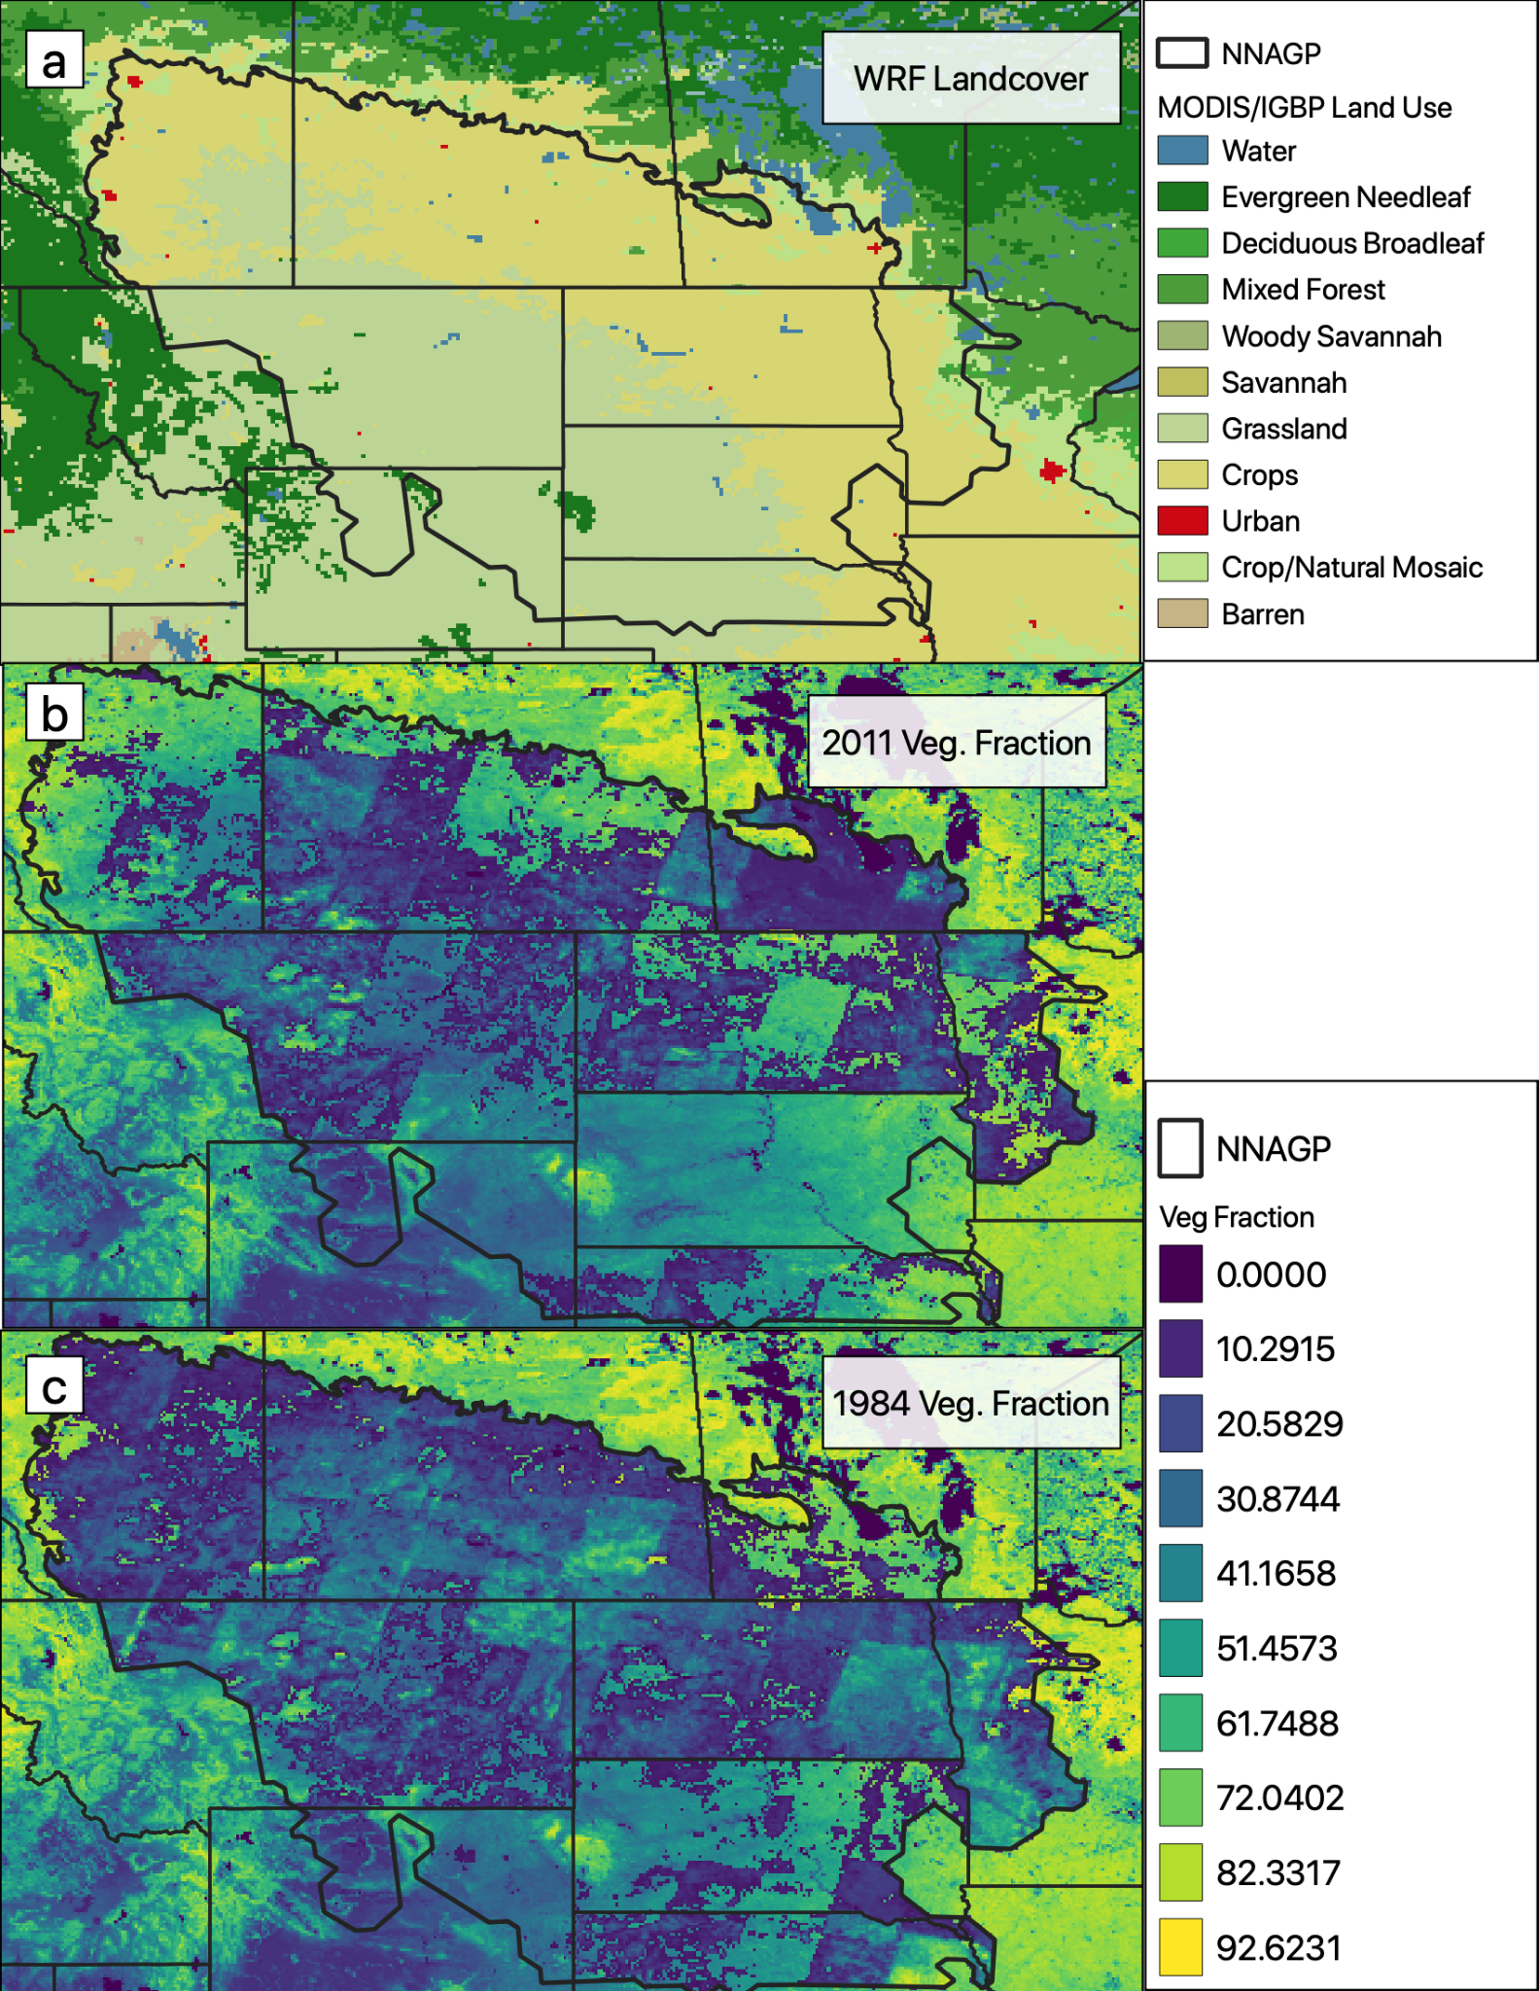
Figure A1: (a) WRF landcover for the northern North American Great Plains following Bromley et al. (2020), outlined in black. (b) Vegetation fraction used with the C11 simulation. (c) Vegetation fraction used with the F11 simulation.

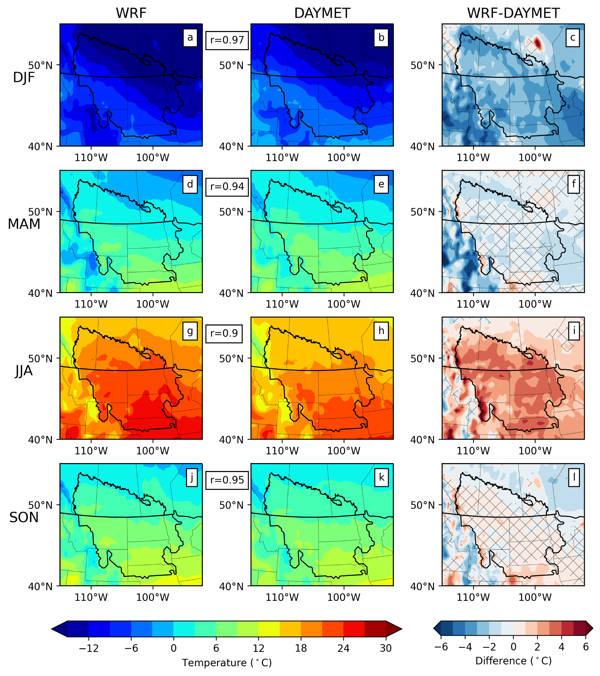
Figure A2: (a) Mean temperature for DJF 2010-2013 for the C11 WRF simulation, observed by Daymet (b) and the difference between simulated and observed temperature (c). (d-f) Same as (a-c) but for MAM. (g-i) same as (a-c) but for JJA. (j-k) same as (a-c) but for SON. Pearson’s r correlation coefficients shown between columns 1 and 2. Non-significant bias is marked by a cross hatch pattern. WRF and Daymet were conservatively remapped to 0.5-degree regular grid.

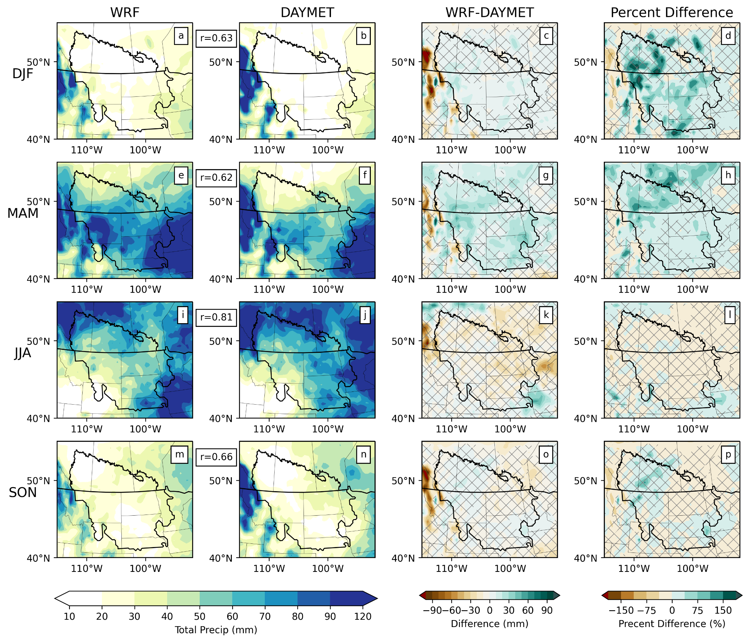
Figure A3: (a) C11 WRF simulated accumulated precipitation for DJF averaged over 2010-2013. (b) Daymet estimated accumulated precipitation for DJF averaged over 2010-2013. (c) Absolute differences between WRF and Daymet. (d) Percent difference between WRF and Daymet. Pearson’s r correlation coefficient shown between (a) and (b). (e-f) Same as (a-d) but for MAM. (i-l) Same as (a-d) but for JJA. (m-p) Same as (a-d) but for SON. Non-significant bias is marked by a cross hatch pattern. Both WRF and Daymet were conservatively remapped to a 0.5-degree regular grid.

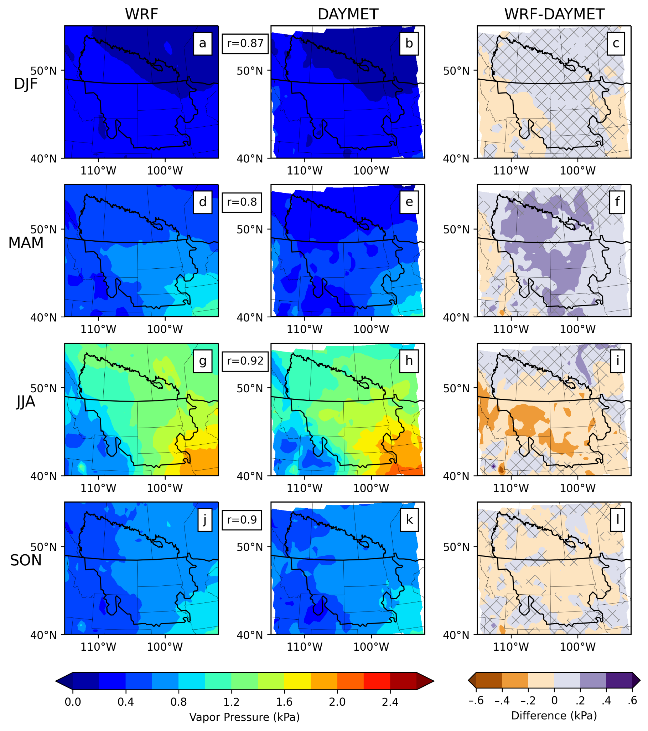
Figure A4: Mean vapor pressure for DJF 2010-2013 for the C11 WRF simulation (a) observed by Daymet (b) and the difference between simulated and observed vapor pressure (c). (d-f) Same as (a-c) but for MAM. (g-i) same as (a-c) but for JJA. (j-k) same as (a-c) but for SON. Pearson’s r correlation coefficients shown between columns 1 and 2. Areas where the difference between WRF and Daymet is less than the differences between CRU and Daymet are marked by a cross hatch pattern. Pearson’s r correlation coefficient shown between columns 1 and 1. WRF and Daymet were conservatively remapped to 0.5-degree regular grid.

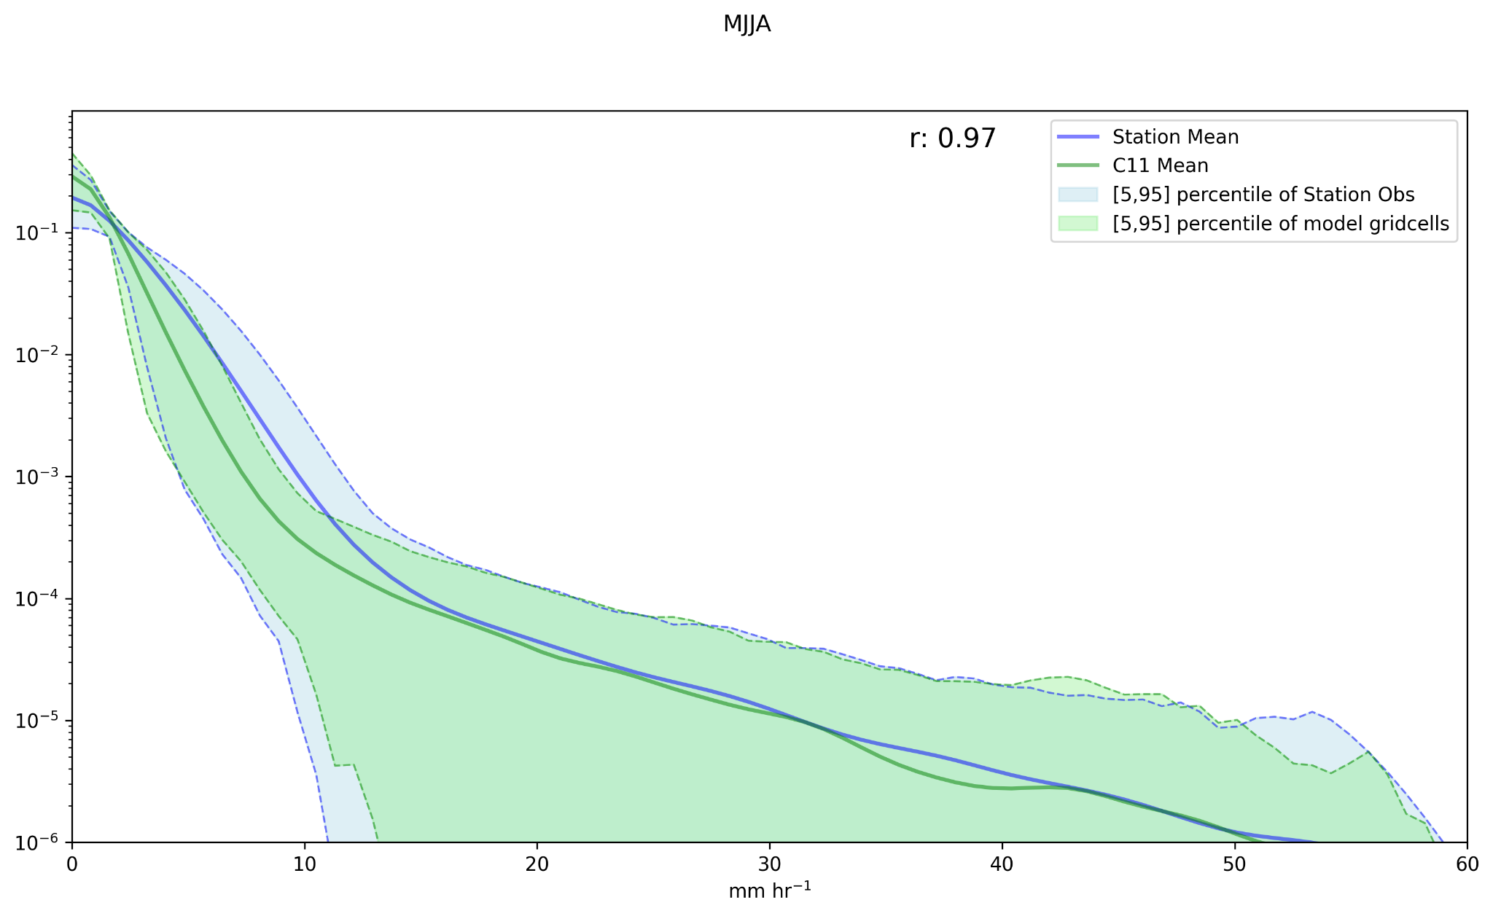
Figure A5: Probability densities of hourly precipitation from the C11 simulations and the U.S. hourly station observations. The solid Blue (Green) line is the average PDF of all of the station (simulation) grid cells. Dashed lines represent the spread between the [5,95] percentile PDF distributions of stations (blue) and model estimates at the station locations (green). Pearson’s r correlation coefficient shown next to the legend.

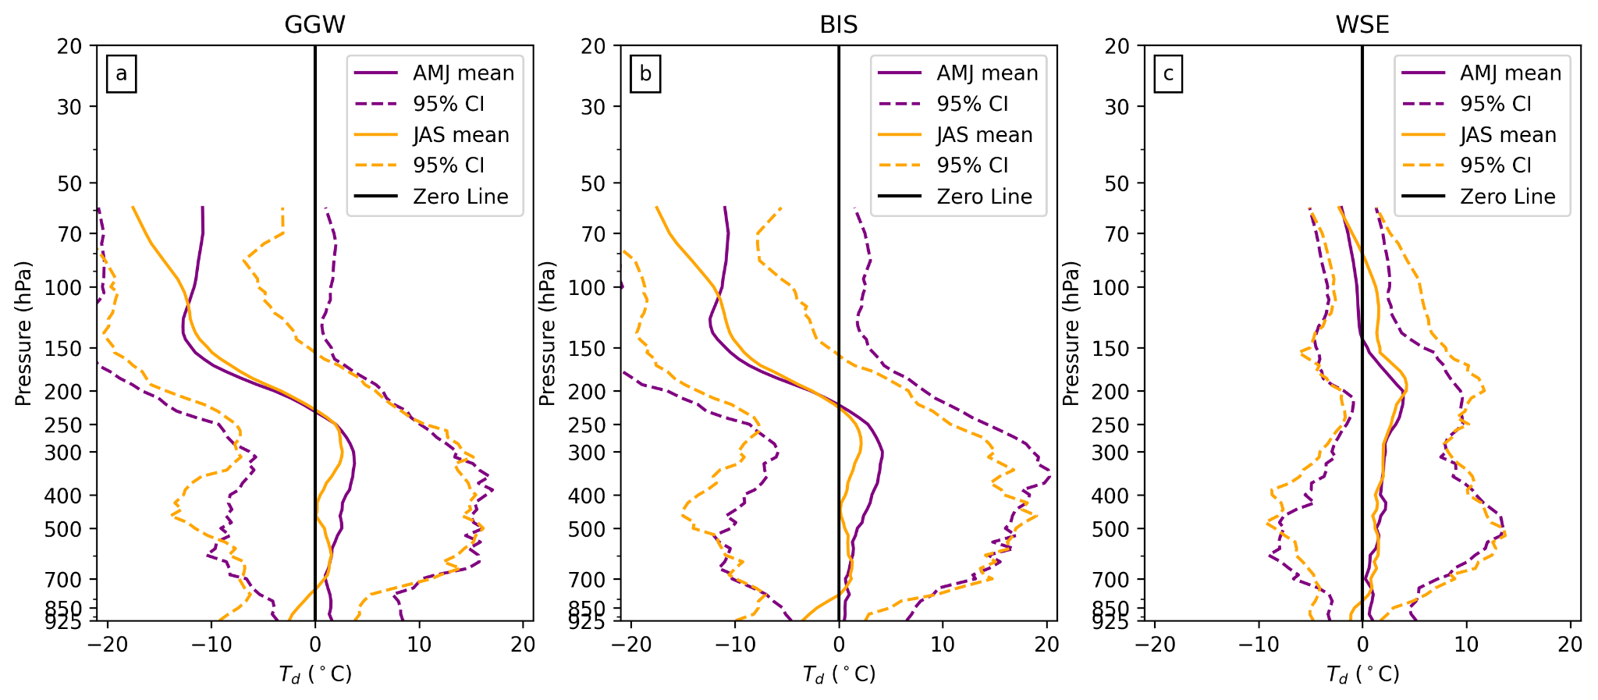

Figure A6: Vertical profiles of dewpoint temperature for the Glasgow, MT sounding location (GGW), the Bismarck, ND sounding location (BIS), Edmonton, AB, sounding location (WSE). The 2010-2013 AMJ average is shown in purple and the 2010-2013 JAS average is shown in gold. Dashed lines represent the 95% confidence interval of the mean.

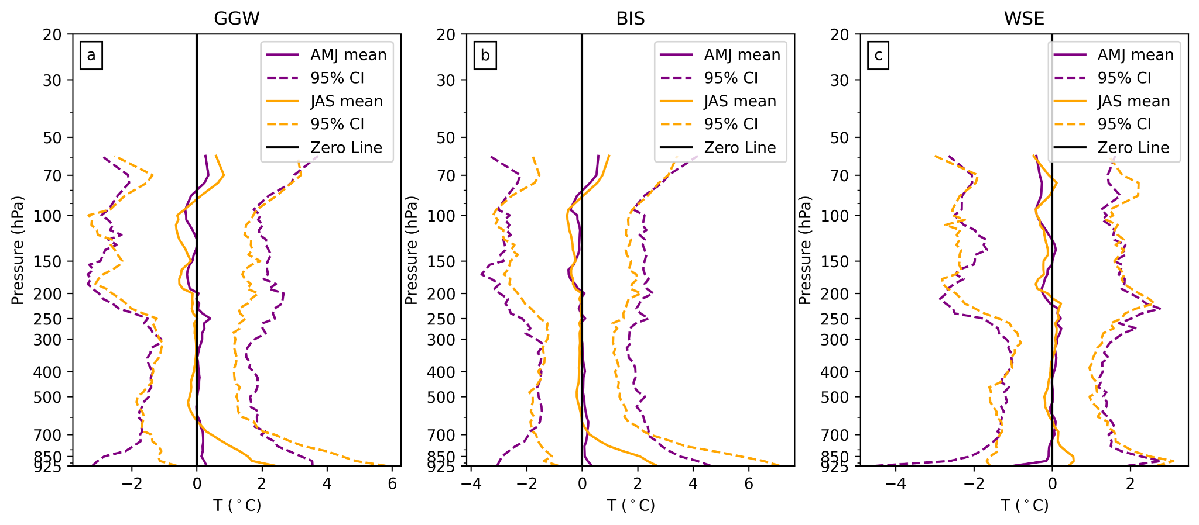
Figure A7: Same as Figure A6 but for temperature.

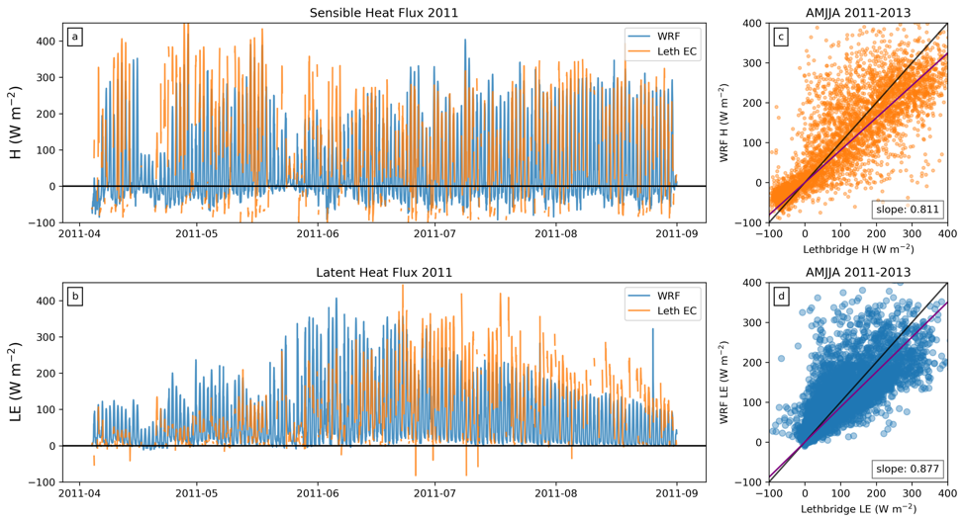
Figure A8: Sensible heat flux (H) (a) and latent heat flux (LE) (b) from WRF (blue) and CA-Let (orange) shown for the 2011 warm season, taken here to be AMJJA. The relationship between H (c) and LE (d) simulated by WRF and observed at CA-Let for the 2011-2013 warm seasons, the slope of the robust linear regression shown in the bottom left.

