Appendix to “Is Genetic Testing of Autism Cost-Effective compared to current Diagnostics?”

Cost of early intervention:
We took the information on costs from the Table 3 of Roddy et al. [44]. We calculated the cost of health services utilization based on the cohort and number of children that effective received the treatment or care. The partial results of the categories summed into the sum per year were divided by the hours reported for Ireland by Salomone et al [25] and multiplied with the number of used hours in Germany, also based on Salomone et al. Only a number of 4.2 hours per week were indicated for medical intervention and EI in Germany. The results were cost per year in Germany (see Table S4 in the Appendix).
The costs were calculated and stratified in years, because the model cycle length evaluated yearly. We further calculated different costs for the first 5 years of life and the following years up to the year 15 based on Perry et al. [50]. Further stratification was implemented in the division of IQ under 70 and IQ over 70 based on Howlin et al. [65]. The R-Code is attached at the end of the Appendix.
Cost of EIBI:
The Cost for EIBI was taken from Penner et al. [7]. The values in CD$ were translated into € at the current exchange rates. The value of CD$56.000 per year changed to 38.295.04 €/year. This value was integrated into the Cost table for EIBI at the years/cycles 3 and 4.
Exchange rates: 2014: £ 1 = € 1.2873
2019: £ 1 = € 1.1669
2019: $CD 1 = € 0.6839

Parameter calculation and derivation:
The probability of going from EI to independent, semi dependent or dependent states come from Perry et al. The probability for the first 5 years were assumed to be normal distributed with the mean IQ of 71.42 and the quantile of IQ < 70. The SD was 30.53 (Perry et al. table 3). We calculated the normal distribution with the R-function pnorm(70, 71.42, 30.53) and get the probability of 0.4814512 for ID. The probability of children without ID was 1 - 0.4814512 = 0.51855.
The values for the age of 5 up to 15 years were calculated with the same distribution and function with the mean IQ of 51.00, the quantile of IQ < 70 and the SD of 24.70 (Perry et al. table 3). We get the probability of 0.77912 for Early Intervention with ID and for the children without ID was 1 - 0.77912 = 0.22087.

EIBI Probability:
The meta-analysis of Reichow et al. [51,52] shows increasing IQ values under EIBI and calculated the difference between the EIBI group and TAU (treatment as usual). We assumed a normal distribution for the two groups. We calculated the weighted mean and standard derivation (SD) of the IQ results and calculated the probability difference based on the IQ difference. The IQ increase was 15.4 IQ points under EIBI. The EIBI additional probability of reaching (semi-)independence was 0.246. The increased probability of reaching (semi-)independence applies to EIBI started before age 4, only.

Table S1: Parameters of beta distributions assumed for probabilities in probabilistic sensitivity analysis reflect sample sizes of original research.
Probability |  | n | alpha | beta | mean | SD | Q2.5% | Q97.5% | Reference
Prevalence | 0.0168 | 325483 | 5468 | 320015 | 0.017 | 0.000 | 0.016 | 0.017 | MMWR
P(ID|ASD) | 0.316 | 3390 | 1071 | 2319 | 0.316 | 0.008 | 0.300 | 0.332 | MMWR
Sens. ADOS | 0.904 | 135 | 122 | 13 | 0.904 | 0.025 | 0.849 | 0.947 | Bölte & Poustka 2004 ZKinderJugendsychiatrPychother
Spec. ADOS | 0.481 | 27 | 13 | 14 | 0.481 | 0.094 | 0.299 | 0.666 | Bölte & Poustka 2004 ZKinderJugendsychiatrPychother
Sens. ADIR | 0.92 | 72 | 66 | 6 | 0.917 | 0.032 | 0.843 | 0.968 | Bölte et al. 2000 Diagnostica
Spec. ADIR | 0.99 | 68 | 67 | 1 | 0.985 | 0.014 | 0.946 | 1.000 | Bölte et al. 2000 Diagnostica
Sens. Gen.test | 0.17 | 461 | 78 | 383 | 0.169 | 0.017 | 0.136 | 0.205 | Carayol et al. 2010 Mol Autism
Spec. Gen.test | 0.93 | 127 | 118 | 9 | 0.929 | 0.023 | 0.879 | 0.967 | Carayol et al. 2010 Mol Autism
P(indep.|ID) | 0.04 | 23 | 1 | 22 | 0.043 | 0.042 | 0.001 | 0.154 | Howlin et al. 2004
P(semidep.|ID) | 0.13 | 23 | 3 | 20 | 0.130 | 0.069 | 0.029 | 0.292 | Howlin et al. 2004
P(dep.|ID) | 0.83 | 44 | 19 | 4 | 0.826 | 0.077 | 0.651 | 0.948 | Howlin et al. 2004
P(indep.|noID) | 0.32 | 44 | 14 | 30 | 0.318 | 0.069 | 0.191 | 0.461 | Howlin et al. 2004
P(semidep.|noID) | 0.23 | 44 | 10 | 34 | 0.227 | 0.062 | 0.118 | 0.360 | Howlin et al. 2004
P(dep.|noID) | 0.45 | 23 | 20 | 24 | 0.455 | 0.074 | 0.312 | 0.601 | Howlin et al. 2004
P(Parents agree) | 0.786 | 1381 | 1085 | 296 | 0.786 | 0.011 | 0.764 | 0.807 | Johannesson 2017
P(Recurrence|ASD) | 0.199 | 664 | 132 | 532 | 0.199 | 0.015 | 0.169 | 0.230 | Ozonoff 2011
P(Recurrence|noASD) | 0.07 | 50 | 1 | 49 | 0.020 | 0.020 | 0.001 | 0.073 | Ozonoff 2011

Table S2: Probability of testing for ASD based on Howlin et al. [65] and own estimation for the predisposed.

 | tableparentconcerned | tableparentnotconcerned
Age | gentableparentconcerned | gentableparentnotconcerned
0 | 0 | 0.99
1 | 0.01 | 0.99
2 | 0.19 | 0.95
3 | 0.2 | 0.9
4 | 0.15 | 0.95
5 | 0.15 | 0.95
6 | 0.1 | 0.9
7 | 0.1 | 0.95
8 | 0.025 | 0.99
9 | 0.025 | 0.99
10 | 0.02 | 0.99
11 | 0.008 | 0.99
12 | 0.008 | 0.999
13 | 0.007 | 0.999
14 | 0.007 | 0.999
15 | 0 | 0.999

Table S3: Probability of leaving EI and cost based on Roddy, Perry and Salomone et al. [50,44,25]. Shown are the values for the EI model. The EIBI model includes the cost of €38.295.04.- for the life years three and four of the children with ID. The probabilities of being dependent after EIBI also change from 0.826 to 0.580 for children with ID and from 0.4545 to 0.2085 for children without ID.

Ages | P | EI before 4 | C | EI before 4 | P | EI before 4, ID | C | EI before 4, ID
0 to 4 | 0.51855 | 396.88 | 0.48145 | 736.98
5 to 15 | 0.22087 | 359.24 | 0.77912 | 2.534.35

Table S4: Calculation of the costs for the medical disciplines and the EI in detail based on the cost values of Roddy, Perry and Salomone et al. [50,44,25]. Roddy_supplement_s7_20191219

Disciplines | n |  | Visit NumberMean visits | Cost portions visit/  session € | Cost per year visits Euro and £ to € | Factor calculation | Reference | Page | Institutions
Dentist | 102 |  | 2.1595 | 51.30 | 142.61 |  | Curtis et al. 2015 | 182 | NHS choices Band 1 charge
GP | 95 |  | 6.7356 | 43.29 | 375.36 | 11.7 Min | Curtis et al. 2015 | 177 | PSSRU 2012
Practice Nurse | 13 |  | 0.6108 | 12.13 | 9.53 | 15.5 Min = 15 Min 30 Sec= 0.258 hours; 1 hour = 12.44 £ | Curtis et al. 2015 | 174 | PSSRU 2012
Optician | 40 |  | 0.8559 | 22.51 | 38.53 | Per eye | HSE 2018 | 256 | PRIMARY CARE REIMBURSEMENT SERVICE
Dietician | 1 |  | 0.0146 | 43.00 | 0.81 | First appointment 30 min | Curtis et al. 2018 | 164 | NHS reference costs 2011/2012
Dietician | 18 |  | 0.2635 | 14.33 | 4.86 | Follow up appointments 10 min | Curtis et al. 2018 | 164 | NHS reference costs 2011/2012
Speech & Language therapist | 79 |  | 3.0390 | 91.00 | 356.00 | One to one session | Curtis et al. 2015 | 83 | PSSRU 2012
Occupational therapist | 75 |  | 2.7331 | 124.00 | 436.27 | One to one session | Curtis et al. 2015 | 83 | PSSRU 2012
Physiotherapist | 35 |  | 1.3133 | 80.00 | 135.25 | One to one session | Curtis et al. 2015 | 83 | PSSRU 2012
ABA | 8 |  | 1.1423 | 100.62 | 147.97 | 120 min session | Curtis et al. 2015 |  | Acuity behavior solutions 2017
Sensory integration therapy | 4 |  | 0.0360 | 103.33 | 4.79 | 50 min one to one session | Curtis et al. 2015 | 83 | PSSRU 2012
CBT | 4 |  | 0.2072 | 98.00 | 26.14 | 55 min for one session | Curtis et al. 2015 | 90 | PSSRU 2012
Play therapy | 2 |  | 0.0315 | 124.00 | 3.91 | 60 min session | HSE 2013 |  | Irish play therapy association 2018
Psychiatrist | 1 |  | 1.0000 | 171.00 | 220.13 | First appointment 90 min | Curtis et al. 2015 | 101 | PSSRU 2012
Psychiatrist | 33 |  | 2.8244 | 171.00 | 621.73 | First appointment 60 min | Curtis et al. 2015 | 130 | PSSRU 2012
Psychologist | 22 |  | 0.7333 | 139.00 | 131.22 | One to one session | Curtis et al. 2015 | 130 | PSSRU 2012
Social worker | 24 |  | 0.5135 | 46.00 | 30.41 | Family support | Curtis et al. 2015 | 134 | Beechham 2000
Behavioural therapist | 6 |  | 0.2095 | 207.00 | 55.81 | 55 min for one session | Curtis et al. 2015 | 50 | PSSRU 2012
Neurologist | 14 |  | 0.4099 | 61.43 | 25.18 | Client visit 30 min | Curtis et al. 2015 |  | NHS University College London Hospitals 2017
Gastroenterologist | 7 |  | 0.2207 | 21.33 | 6.06 | One face-to-face visit per month by community team 2.047.00/year 30 min | Curtis et al. 2015 | 152 | PSSRU 2012
Accident & Emergency | 25 |  | 0.5473 | 233.00 | 164.16 | Cost per contact | Curtis et al. 2015 | 130 | PSSRU 2012
Social skills training/group | 12 |  | 0.6330 | 226.40 | 184.47 | Session, 90 min | Curtis et al. 2015 |  | Hotton and Coles 2016
Paediatrician | 7 |  | 0.0735 | 349.00 | 33.01 | Per consultation | Curtis et al. 2015 | 155 | PSSRU 2012
Hanen programme | 1 |  | 0.0180 | 665.45 | 11.99 | 150 min | Weitzman 2013 |  | Hanen Program for Parents of Children with Autism Spectrum Disorder:
Childcare worker | 1 |  | 0.0270 | 19.15 | 0.67 | 60 min session Total costs + training + supervisor cost /452 hours per year | Curtis et al. 2015 | 100 | PSSRU 2012
Podiatrist | 1 |  | 0.0045 | 2.56 | 0.01 | Visit 30 min | Curtis et al. 2015 |  | Guy’s and St Thomas’ NHS Foundation Trust
Development clinic | 1 |  | 0.0135 | 207.09 | 2.80 | Visit 60 min | Curtis et al. 2015 |  | PSSRU 2012
Maxifacial OPD | 1 |  | 0.0196 | 103.21 | 2.02 | Unit cost per contact | Curtis et al. 2015 |  | PSSRU 2012
Urologist | 1 |  | 0.0045 | 122.85 | 0.55 | Visit 60 min | Curtis et al. 2015 |  | Guy’s and St Thomas’ NHS Foundation Trust
Ophtalmology | 1 |  | 0.0045 | 51.11 | 0.23 | Per examination | HSE 2015 | 256 | PRIMARY CARE REIMBURSEMENT SERVICE
 |  |  |  |  | 3172.48
 |  |  |  |  |  | Irish | hours per week | 10.8
 |  |  |  |  |  | Ger | hours per week | 4.2
Ireland Cost/year = € 3.172.48.-

R-Code: Calculation of the costs for the cycles(years) based on Roddy, Perry and Salomone et al.
#ASD_Kosten_20191129.R
##########################################################################################
# Cost Roddy Medical cost + early intervention
# 4.2 hours/week Germany Salomone 2015
# Factor under5 and over5, 5 years. Perry table 4
#Calculated Roddy_supplement_s7_20191129
# Cost/year sum cost = 3.172,48 = sum of cost per year from Ireland; Roddy et. al. at 10,8 hours /week Salomone 2015 et al.
# Cost/week for Germany: (4,2/10.8) * €3.172,48.- = €1.233.65.-/52 weeks = €23.73.-

GerCosth = €23.73.-

# The number/portion (hours/week) of EI in the first 4 years of life
# is lower than after the first 4 years of life.
# The number of hours/week at EIBI in the first 2 years of life is 20 hours/week.
# We assume a normal distribution.
under5 = 0.32 #Perry table 4 95/296 age under 5 years
over5 = 0.68 #Perry table 4 201/296 age over 5 years

Portionunder5 = under5 #number of children under 5 years
IQlimit <-70 #Knapp 2009, Howlin 2004
Germanh <- 4.2 * 0.923 #Salomone 2015 table 3
Irishh <- 10.8 * 0.71 #Salomone 2015 table 3

Gerhoursunder5 = Germanh * under5 #Salomone 2015
Gerhoursover5 = Germanh * over5 #Salomone 2015

Portionunder70under5 <- pnorm(IQlimit, mean = 71.42, sd = 30.53) # Perry 2011 table 3
Portionunder70over5 <- pnorm(IQlimit, mean = 51, sd = 24.7) # Perry 2011 table 3
Discounthover70 <- 0.5 # Discount for cost of hours when IQ over 70 lower cost of EI

#Germany
GerCostunder5under70 <- Portionunder70under5 * Gerhoursunder5 * GerCosth
GerCostunder5over70 <- (1 - Portionunder70under5) * Gerhoursunder5 * GerCosth * Discounthover70
GerCostover5under70 <- Portionunder70over5 * Gerhoursover5 * GerCosth
GerCostover5over70 <- (1 - Portionunder70over5) * Gerhoursover5 * GerCosth * Discounthover70

##################hours calculated in cost per year
#Result Germany 4,2 hours per week
#> GerCostunder5under70 #[1] 14.17265
#> GerCostunder5over70 #[1] 7.632351
#> GerCostover5under70 #[1] 48.73747
#> GerCostover5over70 #[1] 6.908447
##########################################
# Calculation per year
GerCostunder5under70Year = GerCostunder5under70 * 52 #= €736.98.-/year
GerCostunder5over70Year = GerCostunder5over70 * 52 #= €396.88.-/year
GerCostover5under70Year = GerCostover5under70 * 52 #= €2534.35.-/year
GerCostover5over70Year = GerCostover5over70 * 52 #= €359.24.-/year

Fig. S1 Decision tree for scenario Screening: Screening with genetic testing at birth in addition to status quo.
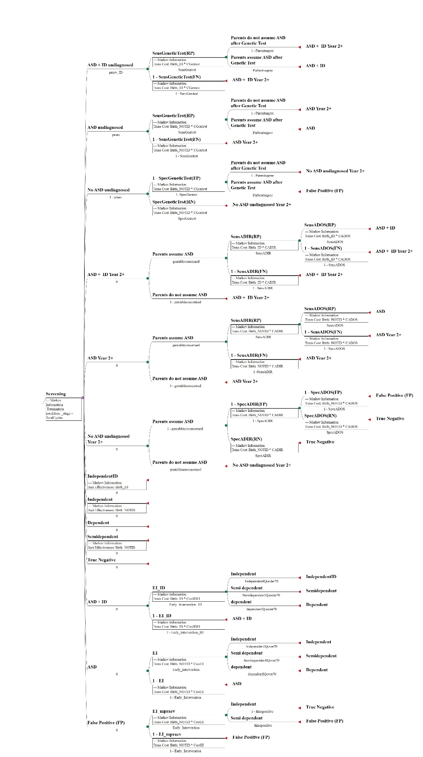

Fig. S2 Decision tree for scenario Predisposition.
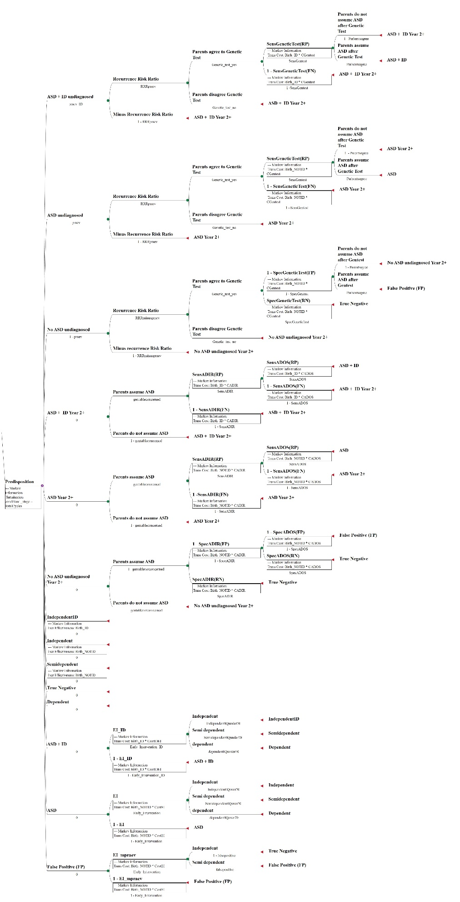

Fig. S3 Decision tree for scenario Genetic test on request.
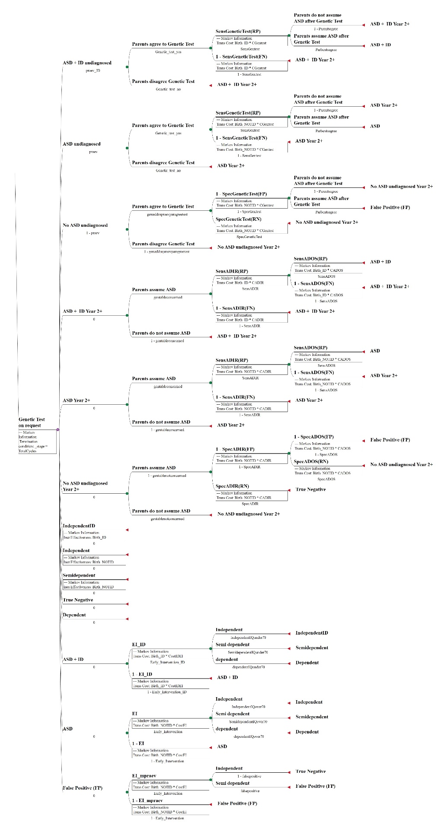

Fig. S4.1 Probabilities of having reached independence and semi-dependence after EI by age

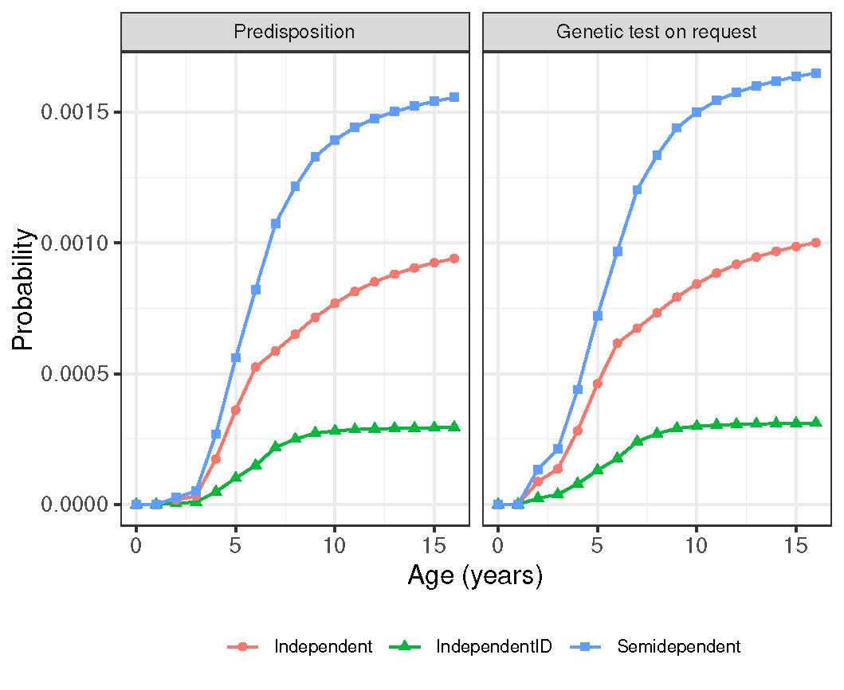

Fig. S4.2 Probabilities of true positive and false positive diagnoses of ASD, i.e. eligibility for early intervention, by age and scenario
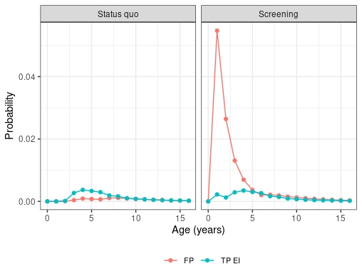

Fig. S5.1 Number of patients receiving early intervention by true need (red line: ASD patients, green line: false positives), age and scenario.
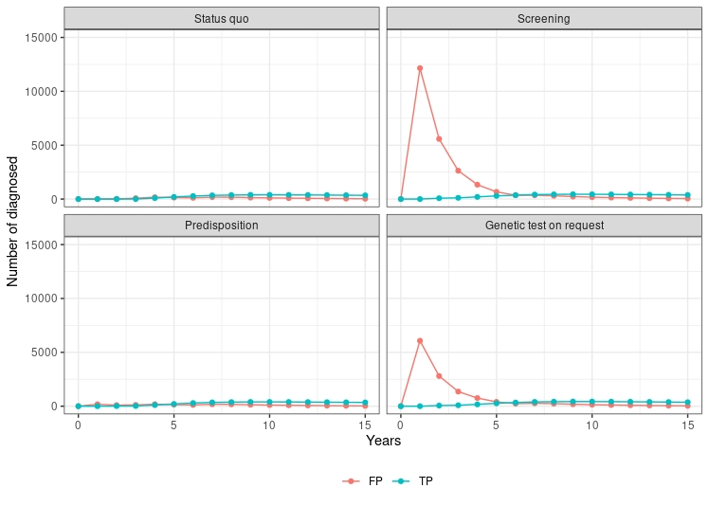

Fig. S5.2 Number of patients receiving early intervention or EIBI by true need (red line: ASD patients, green line: false positives), age and scenario.
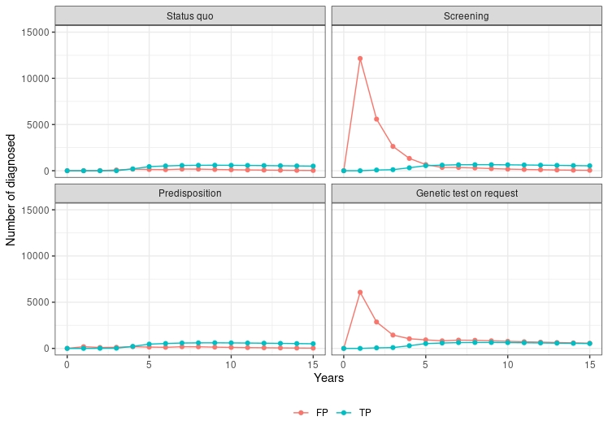

Fig. S6.1 Number of patients transitioning from EI to semi-dependence or independence by age and scenario.
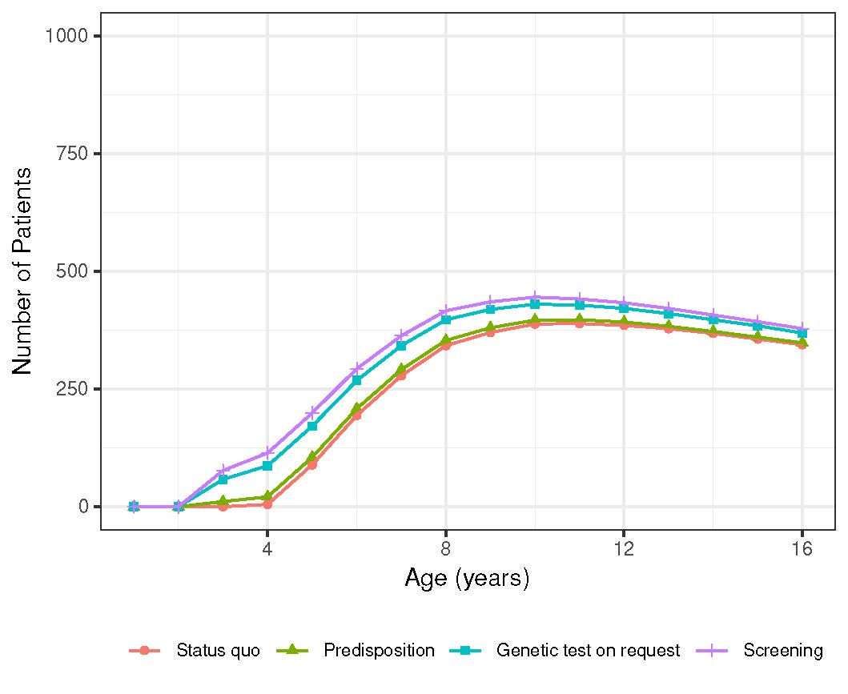

Fig. S6.2 Number of patients transitioning from EIBI to semi-dependence or independence by age and scenario.
