Supplementary Information
Supplementary Figure S1-FISH identification of Syn-SAU-117 and its parent. a: FISH karyotypes of the A, B, and D genomes in Syn-SAU-117 and its parents; b: Ma; c: Syn-SAU-117; d: AS92.
Supplementary Figure S2-FISH identification of Syn-SAU-118 and its parent. a: FISH karyotypes of the A, B, and D genomes in Syn-SAU-118 and its parents; b: Ma; c: Syn-SAU-118; d: AS95.
Supplementary Figure S3-FISH identification of Syn-SAU-119 and its parent. a: FISH karyotypes of the A, B, and D genomes in Syn-SAU-119 and its parents; b: Ma; c: Syn-SAU-119; d: AS96.
Figure S1
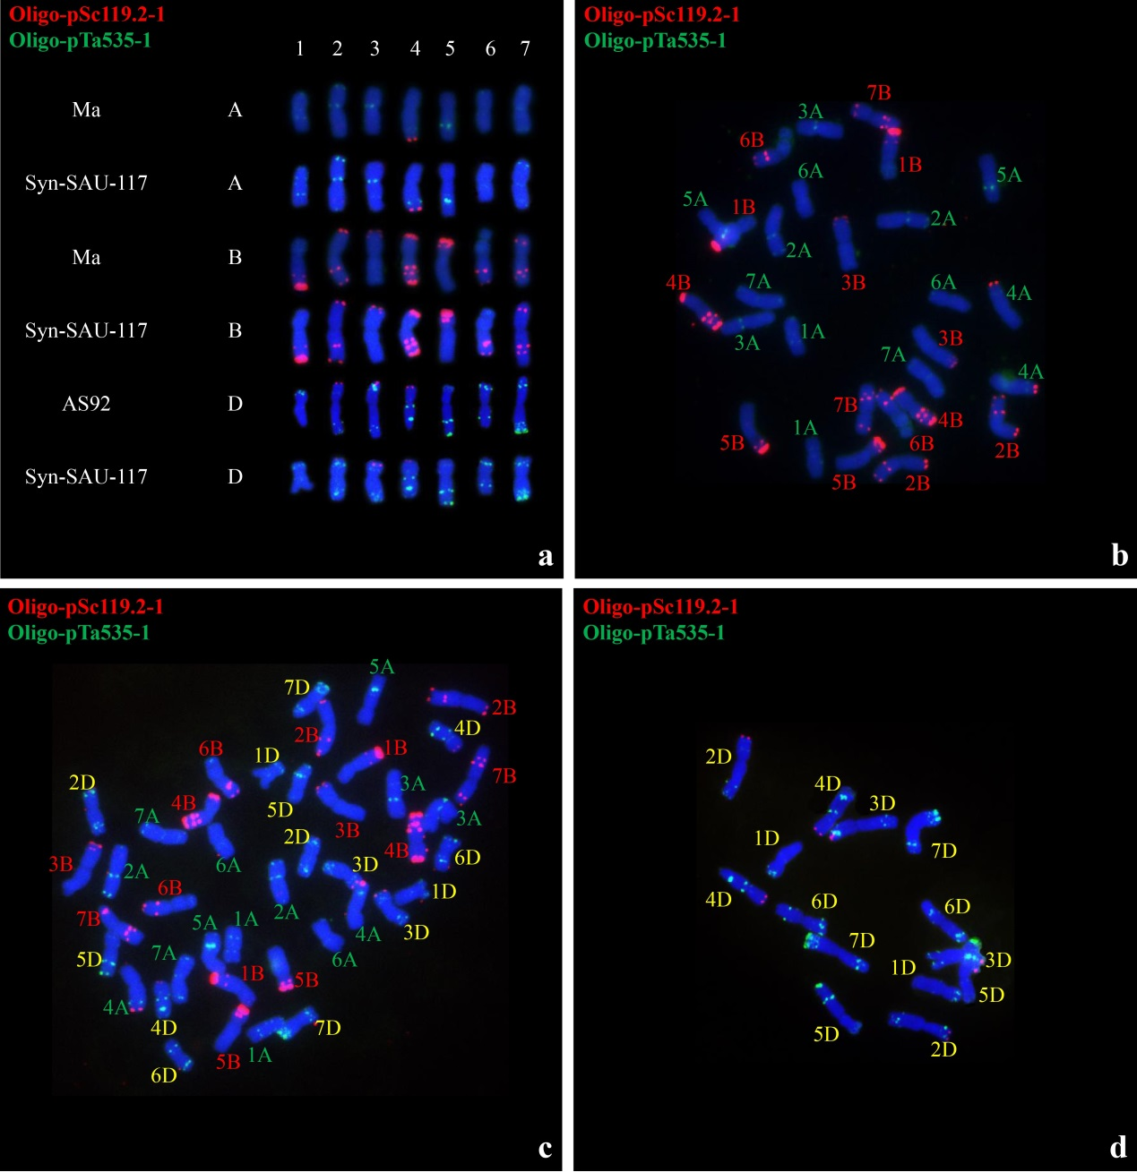
Figure S2
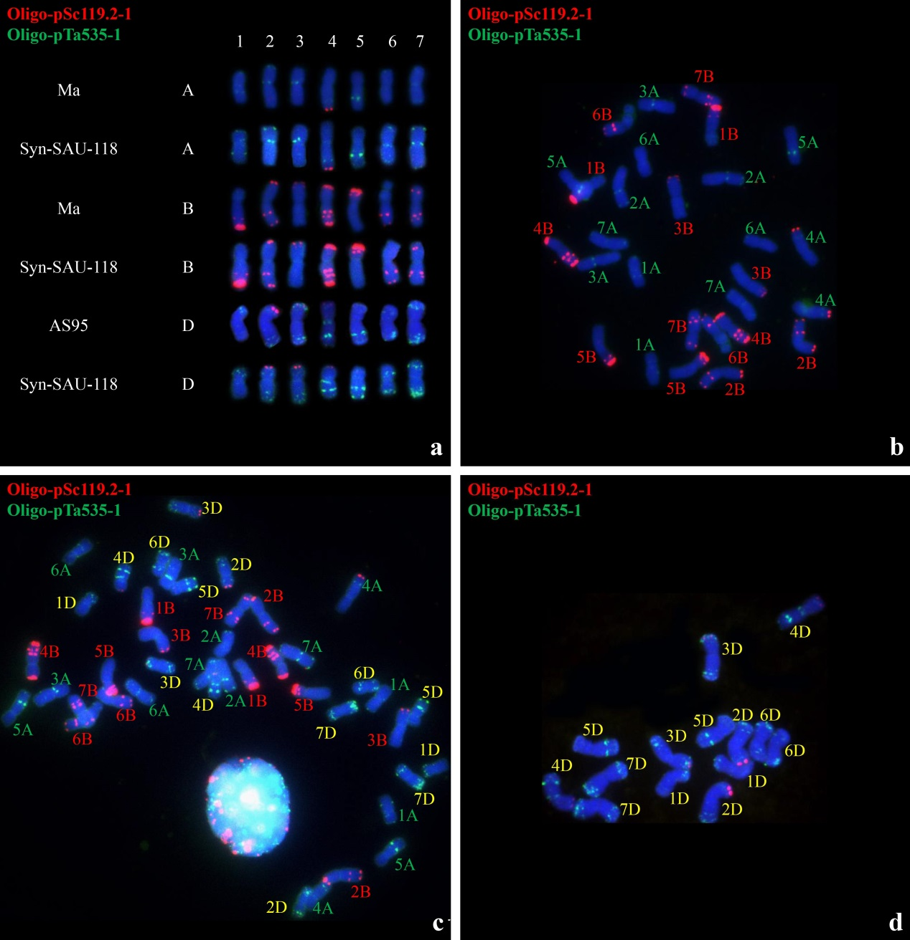

Figure S3
