Supplementary 1: Questionnaire
Follow up of the Midwifery Initiated Oral Health Program

Questionnaire

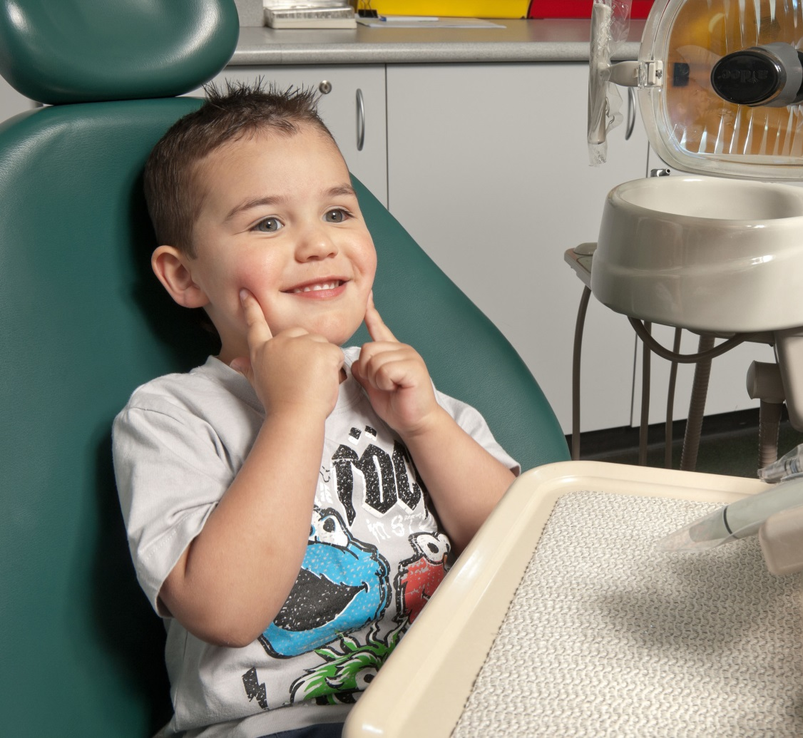

Parent Section
The following are questions related to your dental health
your dental health and care

First some questions about your dental health and care

- Do you currently have any problems or concerns with your teeth, gums or mouth?

Yes No go to Q3

If yes, what are your main problems/concerns (tick all that apply)

Bleeding gums
Toothache (pain in your teeth)
Cavities (holes in your teeth)
Loose teeth
Sensitive teeth
Broken teeth
Swellings
Other problems

- Have you sought advice from a dental professional for this problem/concern?

Yes No

If no, why not? (tick all that apply)

Don’t have time
Not important
Would cost too much
Would have to travel too far
Don’t have a way to get there
No one to care for other children or family members
It is not safe
I am nervous or afraid to go
Others issues

- Have you received any information about “oral health care during early childhood”?

Yes No go to next section

If yes,
- What information have you received?

- Where have you received this information from? (place, person etc)

- On a scale of 1-5 where 1 = “very dissatisfied” and 5 is “very satisfied”, how satisfied are you with the information received about “oral health care during early childhood”? (please circle)

1 2 3 4 5
Very dissatisfied Very satisfied

Knowledge

- Please answer the following questions.
Questions | True | False
Having healthy baby teeth is not as important as having healthy permanent teeth because baby teeth will fall out.

A good way to prevent cavities in children is to give sugary snacks only at meal times

It is ok to use the same spoon to taste baby’s food

Dental caries is a disease in which bacteria in your mouth use sugar to produce acid that breaks down your tooth enamel
Early tooth decay appears as yellow areas that later break down into brownish holes
Undetected tooth decay can cause a child to suffer considerable pain and even hospitalisation
Children of mothers who have tooth decay are more likely to get tooth decay
Cheese is a snack that is least likely to cause decay
It is safe to put baby to bed with a bottle of milk.
A pea sized amount of toothpaste should be used when brushing children’s teeth
Children should be assisted in brushing till the age of 8 years
Parents should regularly perform a ‘lift the lip’ check on their child

- Tooth decay in early childhood is (tick one response)
Less common than asthma in children.
Becoming much less common
The single most common chronic childhood disease.
None of the above

- Untreated tooth decay can lead to: (tick one response)
Loss of concentration
Lack of appetite
Irritability
All of the above

- Which of the following drinks do not cause tooth decay?
Milk
Fruit juice
Soda
Water

- What are factors that might increase the risk of tooth decay? (Tick all that apply)
Taking too much sugary food or drinks
Not brushing teeth with fluoride toothpaste in the morning and at night
Eating or drinking too frequently
Not rinsing after meals
Lack of calcium
Breastfeeding beyond 12 months of age
Discontinuing bottle feeding before 12 months
Sipping from a bottle/cup throughout the day with something sweet in it
None of the above

- When should you start brushing a child’s teeth? (tick one response)
When the first tooth appears
When the child is 12 months old
When the child is 18months old
None of the above

- Before infant’s teeth appear, parents should: (tick one response)
Use toothpaste on their infant’s gums to get them used to the taste
Clean an infant’s gums with a damp washcloth after meals and before bed
Use a soft brush on their gums to get them used to the action of brushing
All of the above

- Tooth decay in early childhood is caused by a combination of many factors that include the following: (tick one response)
Decay-causing bacteria
Exposure to sugars
Inappropriate feeding practices
All of the above

- Which is not a risk factor for tooth decay in early childhood? (tick one response)
Sleeping with a bottle filled with orange juice
Sleeping with a bottle filled with plain water
Sleeping with a bottle filled with cow’s milk
Sleeping with a bottle filled with formula

- A child’s first dental visit should be: (tick one response)
At six months of age
At one year old
At two years old
Before they start school (5 years old)

Child section
The following are questions about your child’s dental health
Your child’s dental health and care

- How do you perceive your child’s oral health?
Very Good
Good
Average
Poor
Very Poor

- Do you currently have any concerns with your child’s teeth, gums or mouth?

Yes No

If yes, what are your main problems/concerns (tick all that apply)

Bleeding gums
Toothache (pain in your teeth)
Cavities (holes in your teeth)
Loose teeth
Sensitive teeth
Broken teeth
Swellings
Other problems

- Have your child’s dental problems affected what they eat and their overall health in general?

Never Sometimes Often Regularly Don’t know

If yes, how has it affected them?

- Have you taken your child to a dental professional for this problem/concern?

Yes No

If no, why not? (tick all that apply)

Don’t have time
Not important
Would cost too much
Would have to travel too far
Don’t have a way to get there
No one to care for other children or family members
It is not safe
I am nervous or afraid to go
Others issues

- Did you ever have to take your child to a hospital to treat dental problems?

Yes No

If yes, please explain why.

- Does your child regularly see a dentist every year?

Yes No

When was the last time your child saw a dentist?

Less than 12 months
1 year to less than 2 years
2 years to less than 5 years
More than 5 years
Never visited
Don’t know

- How old was your child when he/she first visited a dentist or oral health therapist for a check-up or treatment?

Under one year old
One year of age
Two years of age
Three years of age
Four years of age
Five years of age or older
Never visited for general dental care

- Where was your child’s last dental visit? Was it at a…
Private dental practice
Government dental clinic (inc dental hospital)
School dental service
Clinic operated by health insurance fund
Other site
Don’t know

Oral hygiene habits
The following questions are about your dental habits

- How often are your child’s teeth brushed with toothpaste?

Less than once a day
Once a day
Twice a day
More than twice a day

- What type of toothpaste is used for your child?

Standard fluoride toothpaste
Children’s toothpaste
Non-fluoride toothpaste
None
Don’t know/not sure

- How much toothpaste does your child (or do you) usually use on his/her toothbrush?

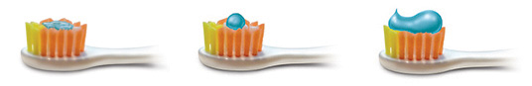

- Have you noticed your child eating or licking toothpaste?

Often
Sometimes
Never

- Do you usually assist your child to brush his/her teeth?

Yes No
If yes, what do you do?

Apply toothpaste and brush teeth
Only put toothpaste on brush
Watch and give advice
Other

Diet

- How often does your child eat or drink the following:

 | Item | Never | Rarely | Once a fortnight | Once a week | A few times a week | Once a day | More than once a day | Don’t know
1 | Juice | 1 | 2 | 3 | 4 | 5 | 6 | 7
2 | Tap water | 1 | 2 | 3 | 4 | 5 | 6 | 7
3 | Filtered/bottled water | 1 | 2 | 3 | 4 | 5 | 6 | 7
4 | Tea/coffee | 1 | 2 | 3 | 4 | 5 | 6 | 7
5 | Soft/fizzy drink | 1 | 2 | 3 | 4 | 5 | 6 | 7
6 | Flavoured milk | 1 | 2 | 3 | 4 | 5 | 6 | 7
7 | Sweet and savoury biscuits, cakes, donuts or muesli bars | 1 | 2 | 3 | 4 | 5 | 6 | 7
8 | Confectionary including chocolate, confectionary bars and lollies | 1 | 2 | 3 | 4 | 5 | 6 | 7

Feeding/Eating Practices

- How often does your child drink from:

No | Item | Never |  |  |  | Always | Don’t know
1 | Bottle | 1 | 2 | 3 | 4 | 5
2 | Feeder cup with spout/straw | 1 | 2 | 3 | 4 | 5
3 | Regular cup | 1 | 2 | 3 | 4 | 5
4 | Other | 1 | 2 | 3 | 4 | 5

- If your child has a bottle, how often does he/she drink the following drinks from the bottle?

No | Item | Never |  |  |  | Always | Don’t know
1 | Milk (cow, soy or formula) | 1 | 2 | 3 | 4 | 5
2 | Flavoured milk | 1 | 2 | 3 | 4 | 5
3 | Cordial, juice or fizzy drink | 1 | 2 | 3 | 4 | 5
4 | Tap water | 1 | 2 | 3 | 4 | 5
5 | Tea/coffee | 1 | 2 | 3 | 4 | 5
6 | Other ___________________ | 1 | 2 | 3 | 4 | 5

- Has your child ever been breastfed?

Yes No

- Is your child currently being breastfed?

Yes No

- Is your child currently using a bottle?

Yes No

- If your child has previously used a bottle, at what age did they stop using a bottle completely?
___________________ years

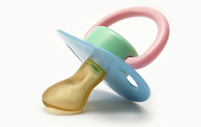
- Has your child regularly used a dummy or pacifier?

Yes No

- If yes, how old was your child when he/she stopped using a dummy or pacifier?
__________________ years

Still using a dummy or pacifier

- Do you/have you ever done the following? (tick all that apply)
Share spoons or eating utensils while feeding your child
Use your mouth to clean a pacifier for your child
Coated a pacifier/bottle teat with honey/sweet substances
Given your child a bottle when lying down to rest/sleep
- How frequently does your child snack?

Not at all
Once per day
2 times per day
3 times per day

Finally some questions about you and your child

Questions about you
- In which country were you born?

- What language do you speak at home?

- What is your post code?

- Do you have other children?
Yes If yes, how old are they? No

- Are you working? Working full time Working part time Not working

- What is your highest educational qualification?

Primary school
Secondary school
High school
Tafe
University
No education

- What is your marital status?

Single Married/partnered Divorced Widowed

- What is your combined average fortnightly household income?

$700 or less
Between $700 to $1,200
Between $1,200 to $2,000
Between $2,000 to $3,000
More than $3,000
Don’t know
Refused

- Do you have private health insurance?

Yes No Don’t know

- Do you currently have a pensioner concession card, a health care card or a Department of Veterans Affairs card?

Yes No Don’t know

11. MRN no _____________________

Questions about your child

- How old is your child? _____________________ years
- In which country was your child born? ______________________________

- Does your child attend day care or preschool?

Yes No Don’t know

4. MRN no _____________________

THANK YOU FOR PARTICIPATING

