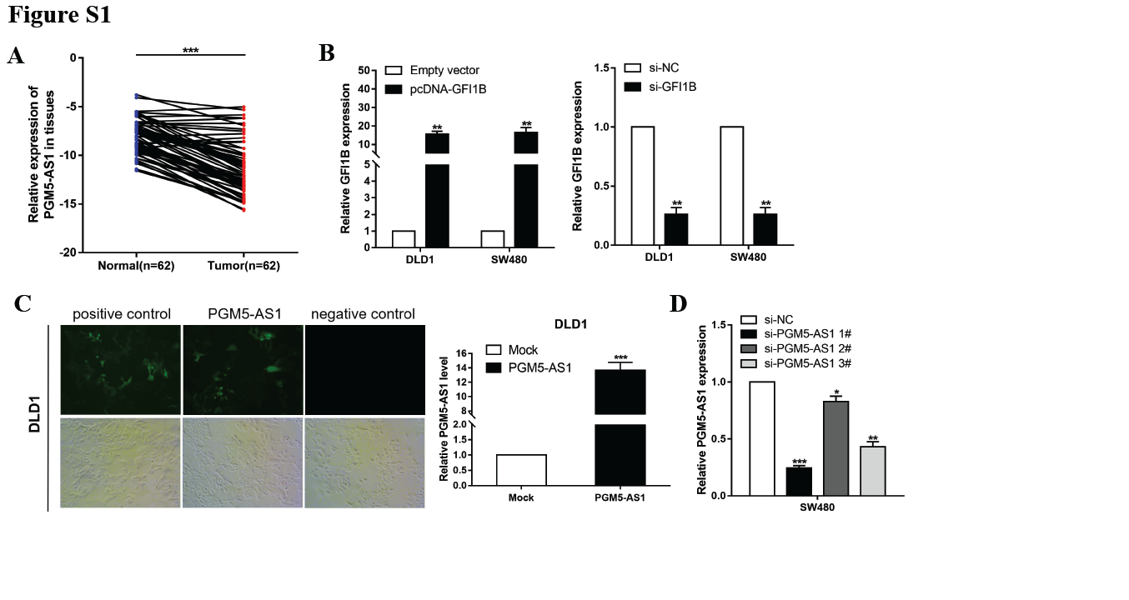
Figure S1.
- Expression level of PGM5-AS1 was examined in normal tissues and CRC tissues. B. GFI1B expression was upregulated and downregulated using the pcDNA-GFI1B plasmid and si-GFI1B, respectively. C. A lentiviral infection system was used to establish a DLD1 cell line stably overexpressing PGM5-AS1. D. Three siRNAs targeting different sites (si-PGM5-AS1 1 #, si-PGM5-AS1 2 #, and si-PGM5-AS1 3 #) were designed to silence PGM5-AS1 expression in SW480 cells. *P < 0.05, **P < 0.01, ***P < 0.001.

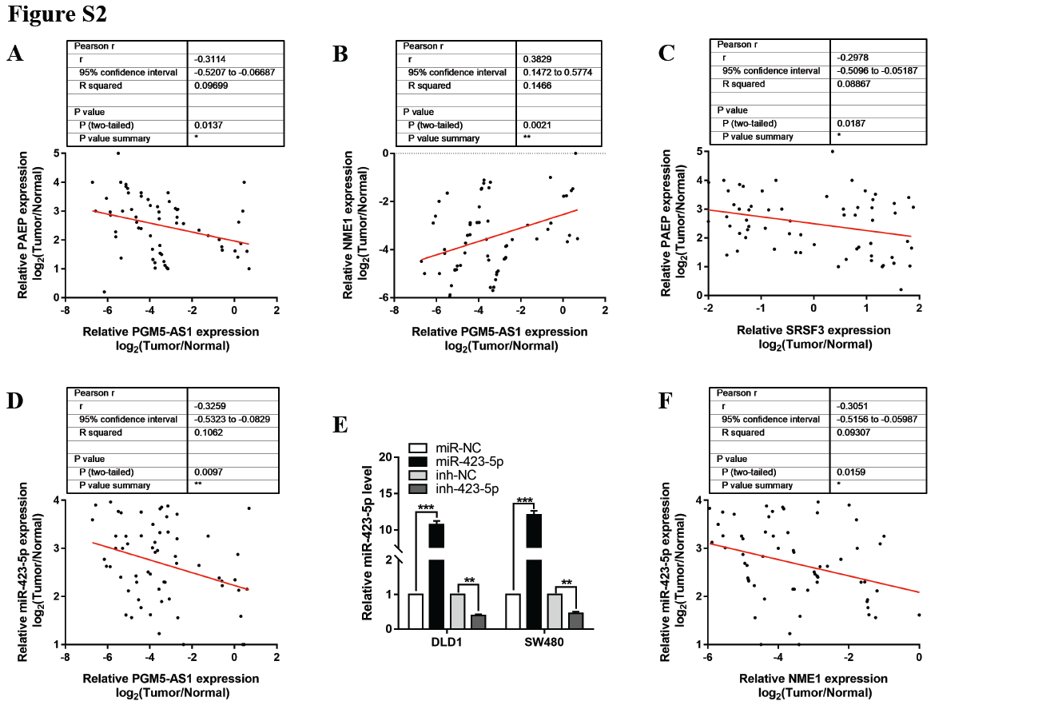
Figure S2.
A. Relationship between PGM5-AS1 expression and PAEP levels in CRC tissues compared with corresponding nontumor tissues. B. Relationship between PGM5-AS1 expression and NME1 levels in CRC tissues compared with corresponding nontumor tissues. C. Relationship between SRSF3 expression and PAEP levels in CRC tissues compared with corresponding nontumor tissues. D. Relationship between PGM5-AS1 expression and miR-423-5p levels in CRC tissues compared with corresponding nontumor tissues. E. A miR-423-5p mimic was used to exogenously upregulate the level of miR-423-5p expression, and a miR-423-5p inhibitor was used to downregulate miR-423-5p expression in CRC cell lines. F. Relationship between NME1 expression and miR-423-5p levels in CRC tissues compared with corresponding nontumor tissues. *P < 0.05, **P < 0.01, ***P < 0.001.

