Factor | Total (N) | Univariate analysis |  | Multivariate analysis
 |  | HR (95%CI) | P value | HR 95%CI | P value
XIST (High vs. Low) | 539 | 1.202 (0.890-1.623) | 0.230
Pathologic stage (Stage III & Stage IV & Stage II vs. Stage I) | 536 | 3.299 (2.342-4.648) | <0.001 | 3.244 (2.303-4.571) | <0.001
Age (>60 vs. <=60) | 539 | 1.765 (1.298-2.398) | <0.001 | 1.685 (1.238-2.291) | <0.001
Histologic grade (G3 & G4 & G2 vs. G1) | 531 | 9231340.001 (0.000-Inf) | 0.992
Gender (Male vs. Female) | 539 | 0.930 (0.682-1.268) | 0.648
Table. S1. Univariate and Multivariate Cox regression analysis of XIST in KIRC patients.

Table. S2. Univariate and Multivariate Cox regression analysis of hsa-miR-10a-5p in KIRC patients.
Factor | Total (N) | Univariate analysis |  | Multivariate analysis
 |  | HR (95%CI) | P value | HR 95%CI | P value
hsa-miR-10a-5p (High vs. Low) | 545 | 0.613 (0.453-0.830) | 0.002 | 0.681 (0.502-0.925) | 0.014
Pathologic stage (Stage III & Stage IV & Stage II vs. Stage I) | 542 | 3.192 (2.272-4.484) | <0.001 | 2.994 (2.128-4.211) | <0.001
Age (>60 vs. <=60) | 545 | 1.849 (1.361-2.512) | <0.001 | 1.737 (1.277-2.362) | <0.001
Histologic grade (G3 & G4 & G2 vs. G1) | 535 | 9267870.436 (0.000-Inf) | 0.991
Gender (Male vs. Female) | 545 | 0.918 (0.674-1.251) | 0.588

Table. S3. Univariate and Multivariate Cox regression analysis of SERPINE1 in KIRC patients.
Factor | Total (N) | Univariate analysis |  | Multivariate analysis
 |  | HR (95%CI) | P value | HR 95%CI | P value
SERPINE1 (High vs. Low) | 539 | 1.424 (1.054-1.923) | 0.021 | 1.456 (1.075-1.972) | 0.015
Pathologic stage (Stage III & Stage IV & Stage II vs. Stage I) | 536 | 3.299 (2.342-4.648) | <0.001 | 3.200 (2.271-4.509) | <0.001
Age (>60 vs. <=60) | 539 | 1.765 (1.298-2.398) | <0.001 | 1.728 (1.269-2.352) | <0.001
Histologic grade (G3 & G4 & G2 vs. G1) | 531 | 9231340.001 (0.000-Inf) | 0.992
Gender (Male vs. Female) | 539 | 0.930 (0.682-1.268) | 0.648

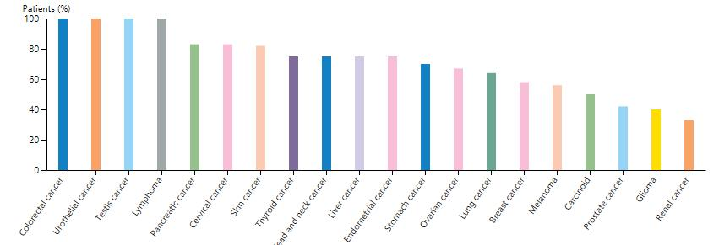
Figure S1. BAP1 protein level in pan-cancer.

Figure S2. Clinical relevance of XIST (A), has-miR-10a-5p (B), SERPINE1(C) in KIRC patients.
Figure S3. ROC analysis of XIST (A), has-miR-10a-5p (B), SERPINE1(C).

Figure S4. SERPINE1 was aberrantly highly expressed in kidney cancer, (A) mRNA expression in pan-cancer (B) immunohistochemical analysis of SERPINE1 in normal and tumor tissues.

