Supplemental material
Supplementary Figure 1
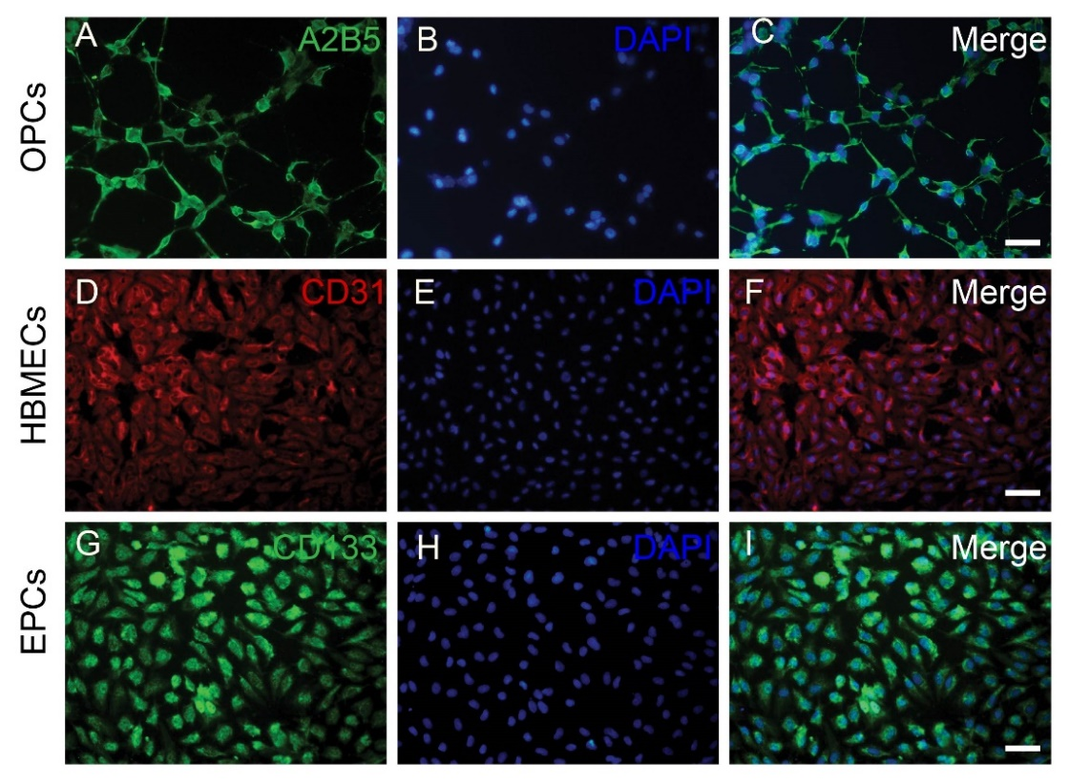
Figure1. OPCs, HBMECs and human EPCs were identified by A2B5 (A-C), CD31(D-F) and CD133 (G-I) immunofluorescent staining. Scale bars: 20μm.
Supplementary Figure 2

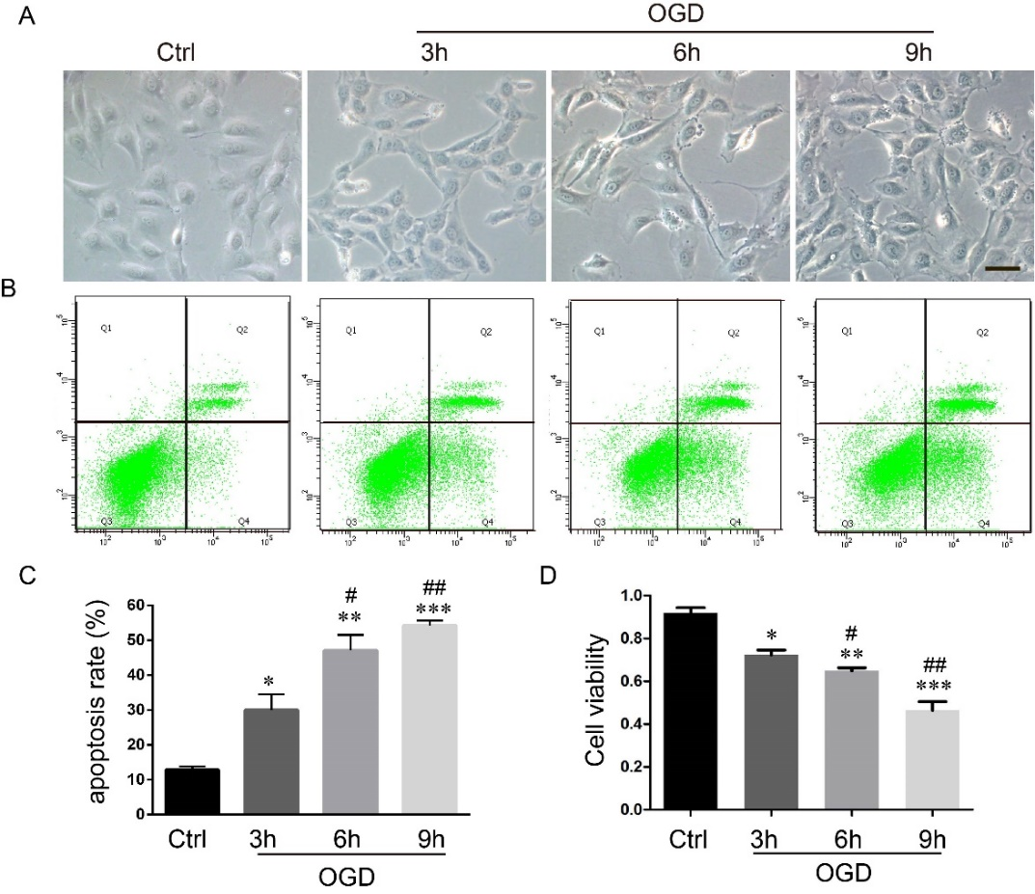
Figure 2. Oxygen-glucose deprivation (OGD) caused morphological changes and apoptosis of ECs. A, OGD caused morphological changes of ECs. Scale bar=50μm. B-C, ODG induced ECs apoptosis was detected by FACS and quantitative analyzed at different time points (n = 4, triplicates per group). D, OGD resulted in significant reduction of ECs viability by CCK-8 analysis (n = 6, triplicates per group). Data were analyzed using one-way ANOVA and shown as mean ± SEM. *P < 0.05, **P < 0.01, **P < 0.001 vs. Ctrl group; #P < 0.05, ##P < 0.01 vs. OGD 3 h group.
Supplementary Figure 3
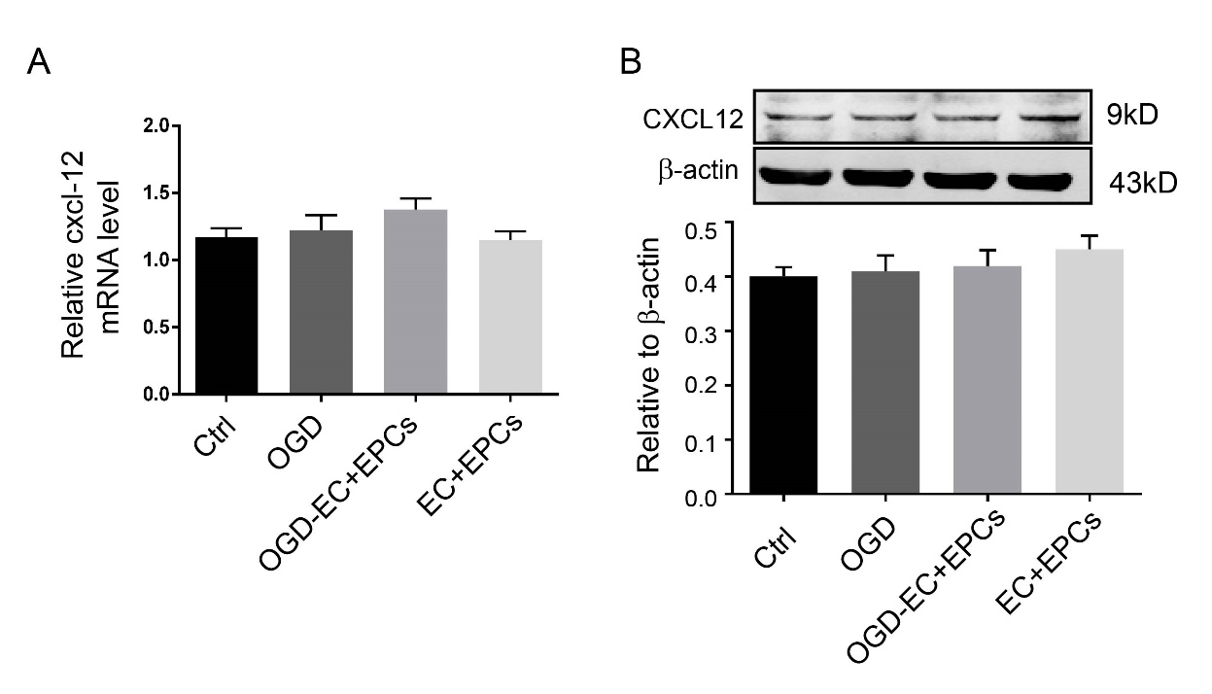
Figure 3. The mRNA and protein of CXCL12 of ECs were detected by RT-qPCR and western blotting. A, There was no statistically differences in the CXCL12 mRNA among the groups. B, Quantification of CXCL12protein levels from immunoblots, and no statistically significant differences among the four groups. Compared the mean ± SEM by one-way ANOVA (n = 4, triplicates per group).
Supplementary Figure 4
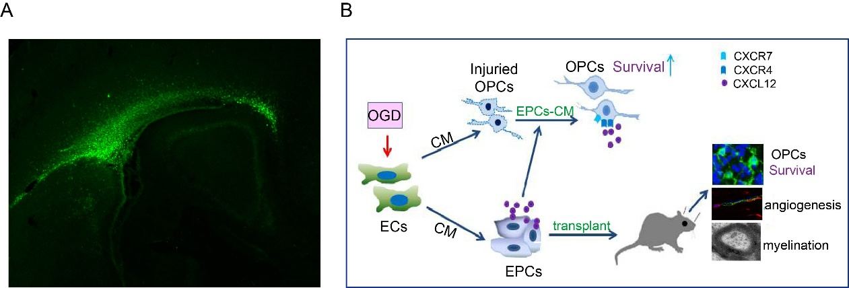
Figure 4. A, The transplanted EC-pEPCs (conditioned medium from hypoxic endothelial cells preconditioned EPCs ) were observed by immunofluorescent staining with the antibody that specifically binds to human CD133. EC-pEPCs distributed along corpus callosum. B, A schematic diagram was used to illustrate the effects and mechanism of EC-pEPCs on OPCs and oligovascular remodeling in vitro and in vivo.

