**Supplementary Table S4: the Egger’s test of different subgroup**

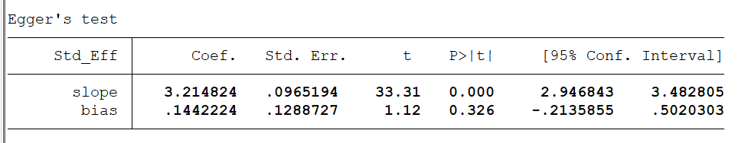**1.Sample size ≥60**

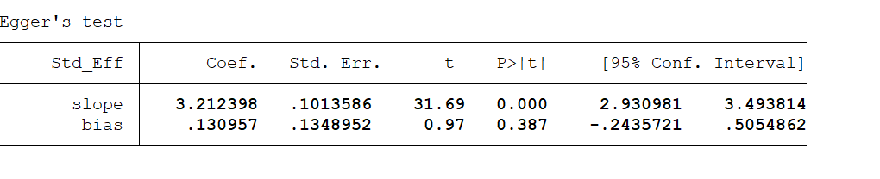**2.Quality scores ≥80**

**3.median group**

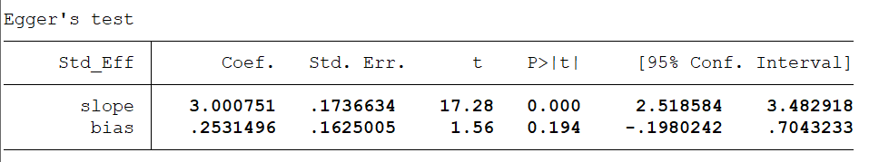

**Supplementary Table S5: the Egger’s test of different subgroup**

**1. tumor stage subgroup**

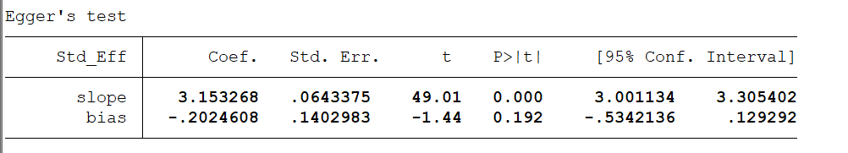

**2. distant metastasis subgroup**

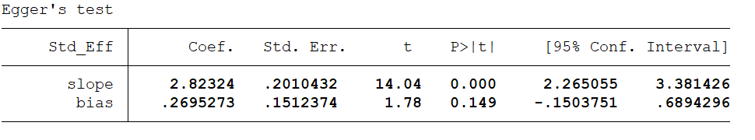

**3. Lymphatic metastasis subgroup**

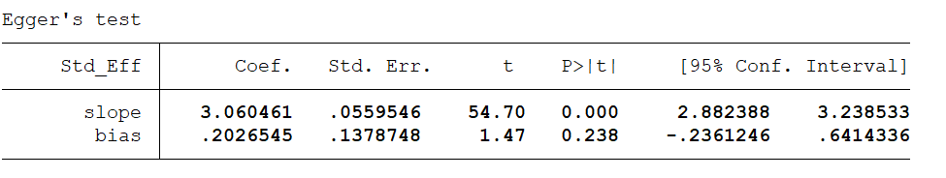

**4.** **tumor size subgroup**



**Supplementary Figure1：Sensitivity analysis of the effect of the individual subgroup on the pooled ORs.**

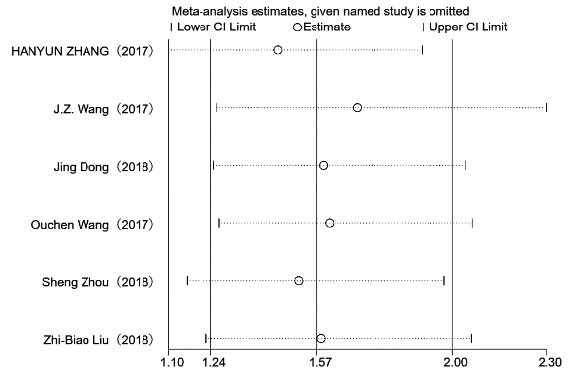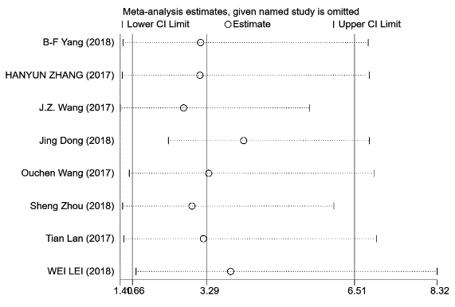**A B**

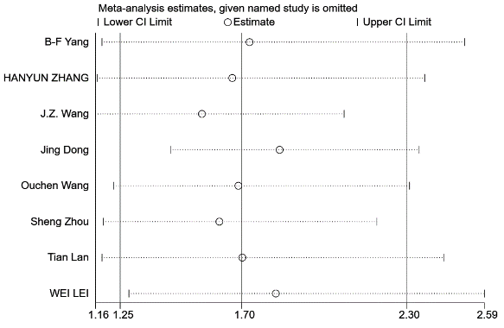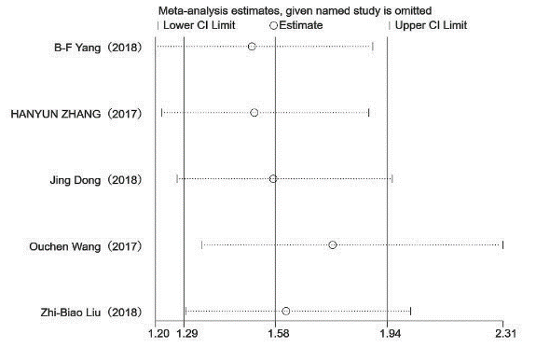

**C D**

**A：Sensitivity analysis of tumor stage subgroup. B：Sensitivity analysis of distant metastasis subgroup.**

**C：Sensitivity analysis of Lymphatic metastasis subgroup. D：Sensitivity analysis of tumor size subgroup.**