Supplementary data
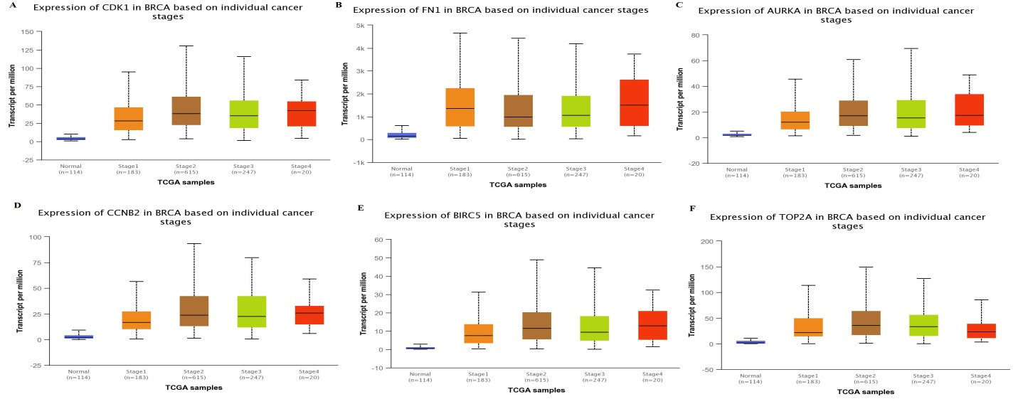
Supplementary data Figure 1: Relative transcription expression of six hub genes in normal tissues and breast cancer tissues with different breast cancer stages. (A) CDK1, (B) FN1, (C) AURKA, (D) CCNB2, (E) BIRC5, and (F) TOP2A. p-value (p<0.05) was used to represent the significance of the correlation between the observed parameters.

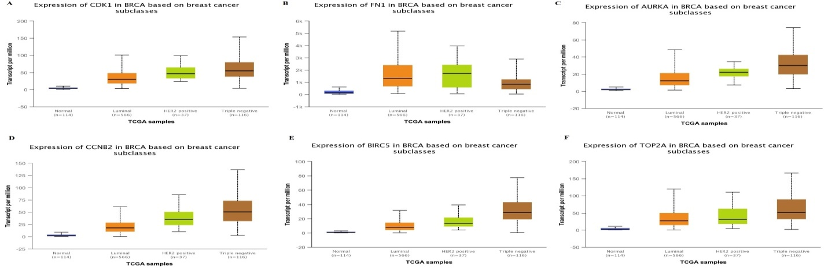
Supplementary data Figure 2: Relative transcription expression of six hub genes in normal tissues and breast cancer tissues with different subclasses. (A) CDK1, (B) FN1, (C) AURKA, (D) CCNB2, (E) BIRC5, and (F) TOP2A. p-value (p<0.05) was used to represent the significance of the correlation between the observed parameters.

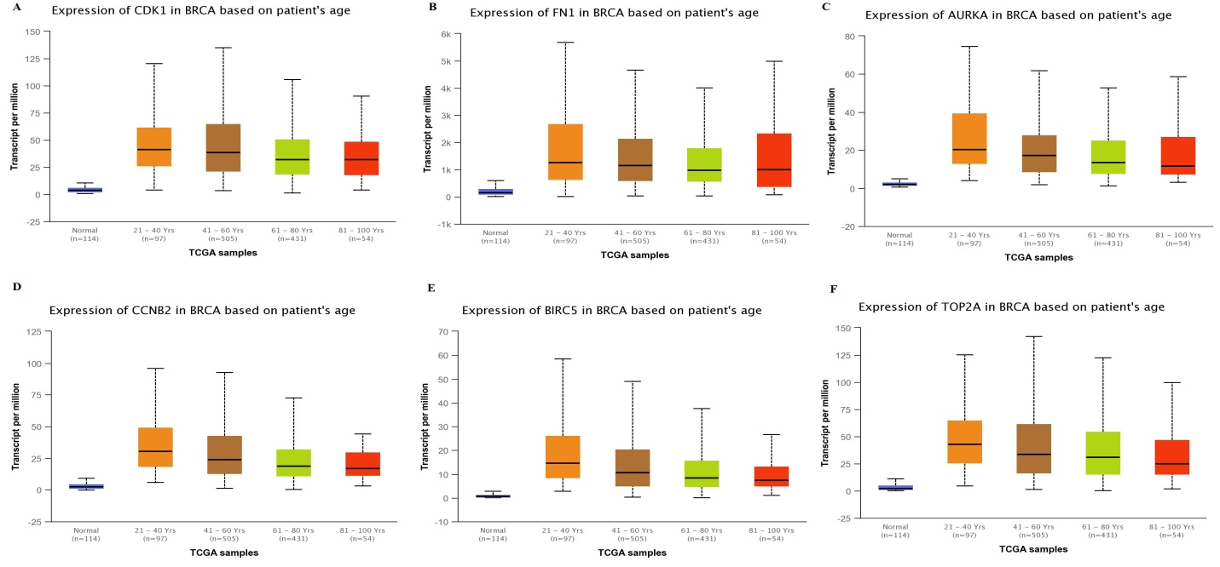
Supplementary data Figure 3: Relative transcription expression of six hub genes in normal individual and breast cancer patients with different age groups. (A) CDK1, (B) FN1, (C) AURKA, (D) CCNB2, (E) BIRC5, and (F) TOP2A. p-value (p<0.05) was used to represent the significance of the correlation between the observed parameters.

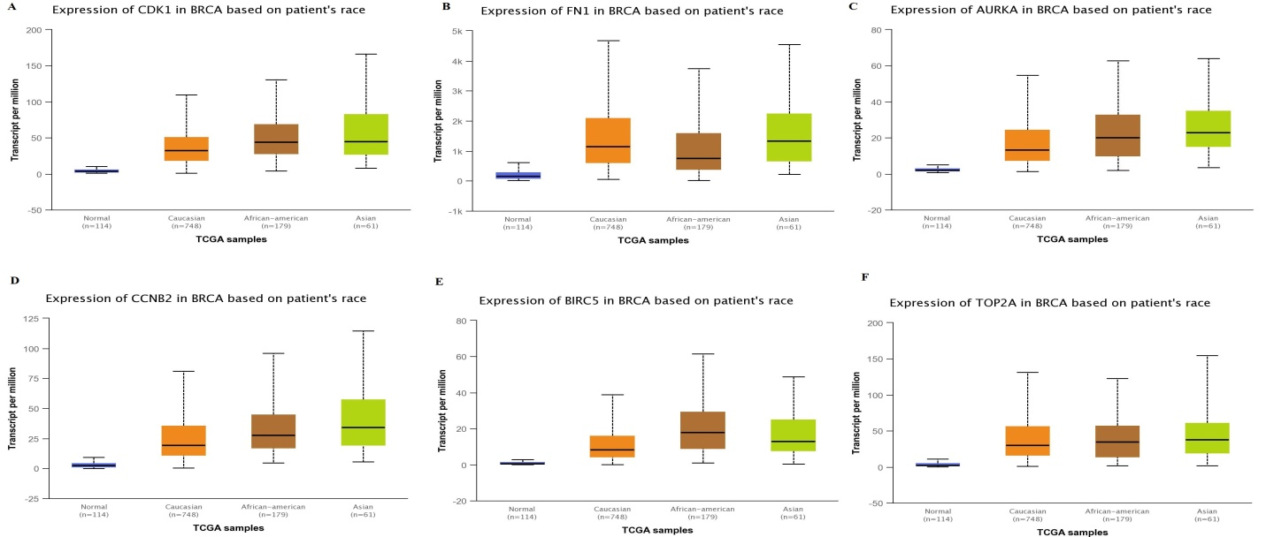
Supplementary data Figure 4: Relative transcription expression of six hub genes in normal individual and breast cancer patients with different races. (A) CDK1, (B) FN1, (C) AURKA, (D) CCNB2, (E) BIRC5, and (F) TOP2A. p-value (p<0.05) was used to represent the significance of the correlation between the observed parameters.
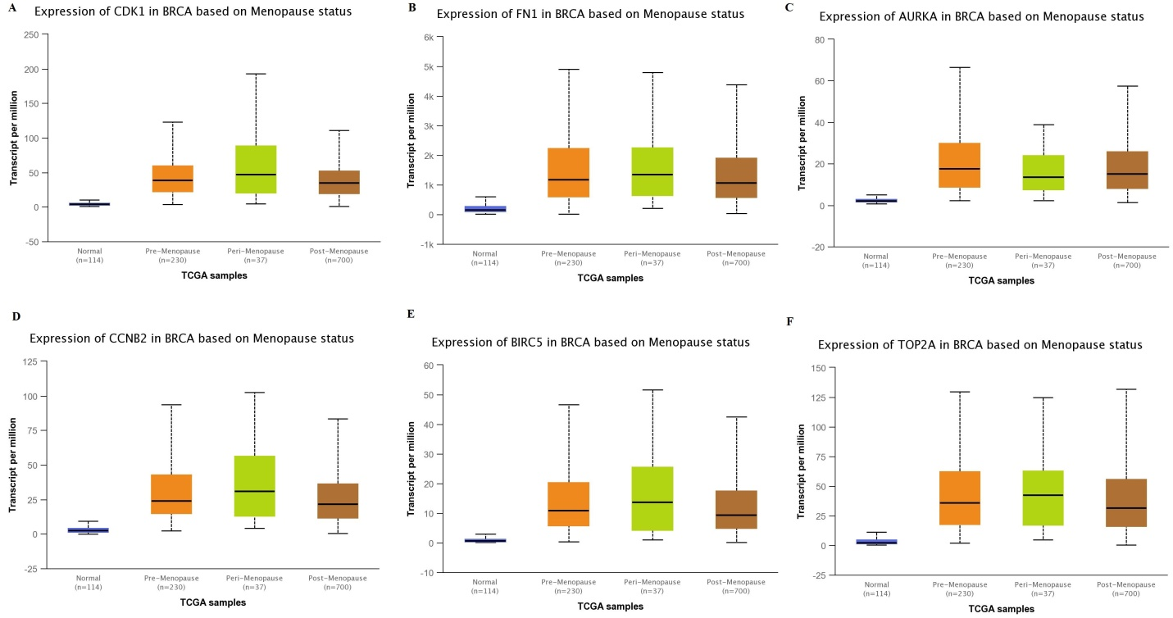
Supplementary data Figure 5: Relative transcription expression of six hub genes in normal individual and breast cancer patients with different menopause status. (A) CDK1, (B) FN1, (C) AURKA, (D) CCNB2, (E) BIRC5, and (F) TOP2A. p-value (p<0.05) was used to represent the significance of the correlation between the observed parameters.

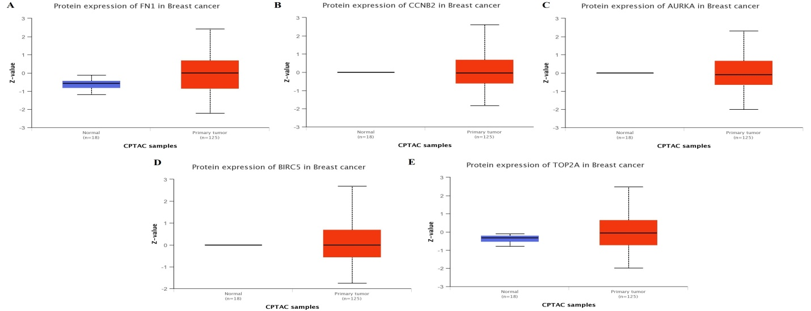
Supplementary data Figure 6: Relative translation expression of six hub genes in normal individual and breast cancer patients with different menopause status. (A) CDK1, (B) FN1, (C) AURKA, (D) CCNB2, (E) BIRC5, and (F) TOP2A. Z-value indicates standard deviations from the median documented across samples of a particular group. The log2 values of spectral count ratio, obtained from CPTAC analysis, were first normalized within profile of each type / group of sample profile followed by normalization across the samples. The number of samples in a particular dataset is represented by n.

