Table S1 Standardized and unstandardized direct effects of soil biodiversity and environmental factors on ecosystem multifunctionality in agricultural ecosystems from Fig. 2B. This table includes all significant and non-significant path considered by our model, and also includes those variable which were allow to covary. MAT: mean annual temperature; CEC: cation exchange capacity.
Parameters |  |  | Standardized regression weights | Regression weights | P
Soil biodiversity | → | Multifunctionality | 0.237 | 0.161 | <0.001
Soil pH | → | Multifunctionality | -0.212 | -0.130 | <0.001
Soil C | → | Multifunctionality | 0.549 | 0.245 | <0.001
Clay % | → | Multifunctionality | 0.010 | 0.005 | 0.824
CEC | → | Multifunctionality | 0.218 | 0.088 | <0.001
MAT | → | Multifunctionality | 0.124 | 0.039 | 0.012
Soil pH | → | Soil biodiversity | 0.087 | 0.079 | 0.184
Soil C | → | Soil biodiversity | 0.351 | 0.232 | <0.001
Clay % | → | Soil biodiversity | -0.113 | -0.074 | 0.078
MAT | → | Soil biodiversity | 0.146 | 0.068 | 0.028
MAT | → | Soil pH | -0.245 | -0.126 | <0.001
MAT | → | Soil C | -0.158 | -0.112 | 0.016
MAT | → | CEC | -0.365 | -0.287 | <0.001
MAT | → | Clay % | 0.135 | 0.097 | 0.039
Soil pH | ↔ | Soil C | -0.196 | -0.003 | 0.004
Soil pH | ↔ | Clay % | -0.096 | -0.002 | 0.150
Soil pH | ↔ | CEC | 0.463 | 0.008 | <0.001
Soil C | ↔ | Clay % | 0.197 | 0.005 | 0.003
Soil C | ↔ | CEC | 0.119 | 0.003 | 0.075
CEC | ↔ | Clay % | 0.076 | 0.002 | 0.252

Table S2. List of identified dominant soil phylotypes in agricultural ecosystems belonging to different ecological clusters

Supplementary Table 2 is available online as a Separate .XLS file under the Supplementary Information for this article.

Table S3 Significant correlations (Spearman) between the single topological features of soil networks and the different components (Comp) of the multiple axes from a multidimensional scaling analysis using these topological features based on moving-window analysis with window sizes of 30 samples. Noted that average path length and diameter, implying the network sparsity, was calculated the inverse of these variables (×-1) before calculating this index. Red and blue colors corresponded with positive and negative relationships, respectively. *P <0.05; ***P < 0.001.
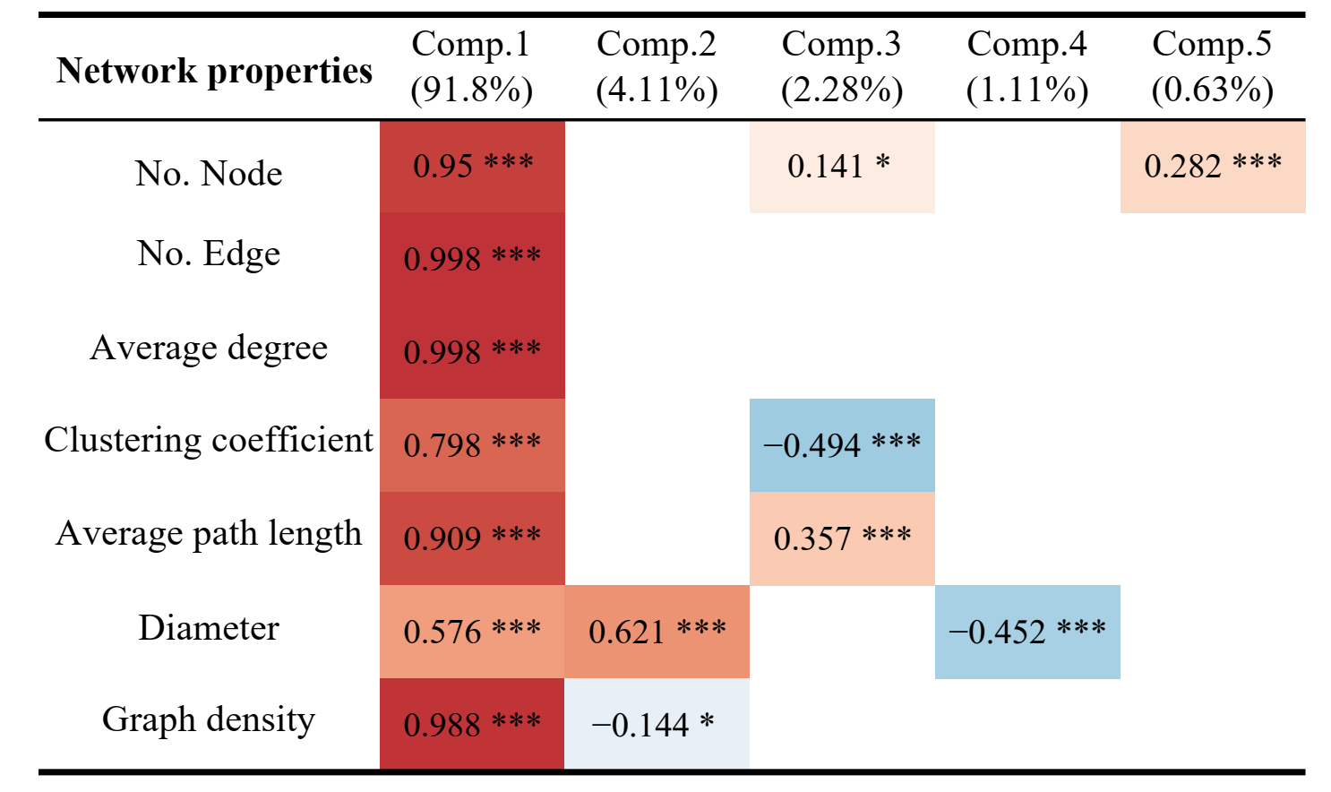

Table S4 Significant correlations (Spearman) between the single topological features of soil networks and the different components (Comp) of the multiple axes from a multidimensional scaling analysis using these topological features based on moving-window analysis with window sizes of 20 samples. Noted that average path length and diameter, implying the network sparsity, was calculated the inverse of these variables (×-1) before calculating this index. Red and blue colors corresponded with positive and negative relationships, respectively. *P <0.05; ***P < 0.001.
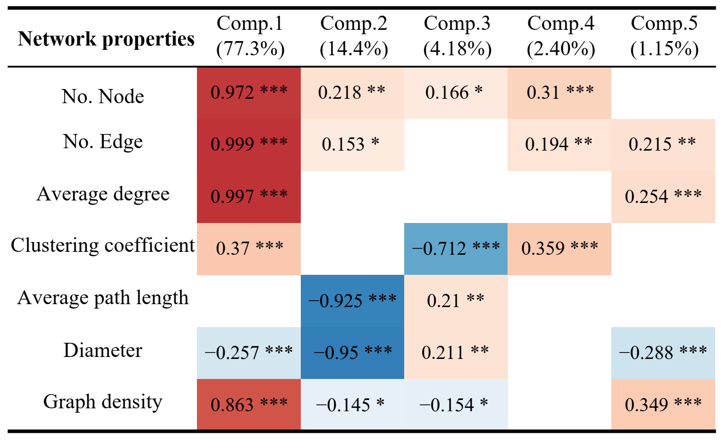
Table S5 Standardized and unstandardized direct effects of complexity of soil food webs and environmental factors on the strengths of BEF based on moving-window analysis with window sizes of 30 samples from Fig. 4C. This table includes all significant and non-significant path considered by our model, and also includes those variable which were allow to covary. MAT: mean annual temperature; CEC: cation exchange capacity.
Parameters |  |  | Standardized regression weights | Regression weights | P
Complexity of food webs | → | strengths of BEF | 0.220 | 0.053 | 0.004
Soil pH | → | strengths of BEF | -0.632 | -0.898 | 0.000
Soil C | → | strengths of BEF | 0.174 | 0.141 | 0.036
Clay % | → | strengths of BEF | -0.402 | -0.280 | 0.002
CEC | → | strengths of BEF | -0.369 | -0.216 | <0.001
MAT | → | strengths of BEF | -0.271 | -0.126 | 0.001
Soil pH | → | Complexity of food webs | -0.092 | -0.541 | 0.181
Soil C | → | Complexity of food webs | -0.141 | -0.475 | 0.065
Clay % | → | Complexity of food webs | 0.591 | 1.710 | <0.001
MAT | → | Complexity of food webs | 0.295 | 0.569 | <0.001
MAT | → | Soil pH | -0.498 | -0.163 | 0.000
MAT | → | Soil C | -0.052 | -0.030 | 0.462
MAT | → | CEC | -0.514 | -0.407 | <0.001
MAT | → | Clay % | 0.571 | 0.381 | <0.001
Soil pH | ↔ | Soil C | -0.679 | -0.005 | <0.001
Soil pH | ↔ | Clay % | -0.685 | -0.005 | <0.001
Soil pH | ↔ | CEC | 0.688 | 0.006 | <0.001
Soil C | ↔ | Clay % | 0.823 | 0.011 | <0.001
Soil C | ↔ | CEC | -0.660 | -0.011 | <0.001
CEC~~ | ↔ | Clay % | -0.805 | -0.013 | <0.001

Table S6 Standardized and unstandardized direct effects of complexity of soil food webs and environmental factors on the strengths of BEF based on moving-window analysis with window sizes of 20 samples from Fig. 4D. This table includes all significant and non-significant path considered by our model, and also includes those variable which were allow to covary. MAT: mean annual temperature; CEC: cation exchange capacity.
Parameters |  |  | Standardized regression weights | Regression weights | P
Complexity of food webs | → | strengths of BEF | 0.208 | 0.067 | 0.005
Soil pH | → | strengths of BEF | -0.456 | -0.792 | <0.001
Soil C | → | strengths of BEF | 0.058 | 0.056 | 0.477
Clay % | → | strengths of BEF | -0.101 | -0.091 | 0.384
CEC | → | strengths of BEF | -0.306 | -0.230 | 0.001
MAT | → | strengths of BEF | -0.318 | -0.190 | <0.001
Soil pH | → | Complexity of food webs | -0.314 | -1.683 | <0.001
Soil C | → | Complexity of food webs | -0.253 | -0.748 | <0.001
Clay % | → | Complexity of food webs | 0.583 | 1.620 | <0.001
MAT | → | Complexity of food webs | 0.051 | 0.093 | 0.460
MAT | → | Soil pH | -0.453 | -0.156 | 0.000
MAT | → | Soil C | -0.089 | -0.056 | 0.195
MAT | → | CEC | -0.505 | -0.400 | <0.001
MAT | → | Clay % | 0.532 | 0.352 | <0.001
Soil pH | ↔ | Soil C | -0.546 | -0.005 | <0.001
Soil pH | ↔ | Clay % | -0.574 | -0.004 | <0.001
Soil pH | ↔ | CEC | 0.655 | 0.006 | <0.001
Soil C | ↔ | Clay % | 0.743 | 0.011 | <0.001
Soil C | ↔ | CEC | -0.401 | -0.008 | <0.001
CEC~~ | ↔ | Clay % | -0.658 | -0.011 | <0.001

Figure S1 Location of the sampling sites of agricultural soils in eastern China.
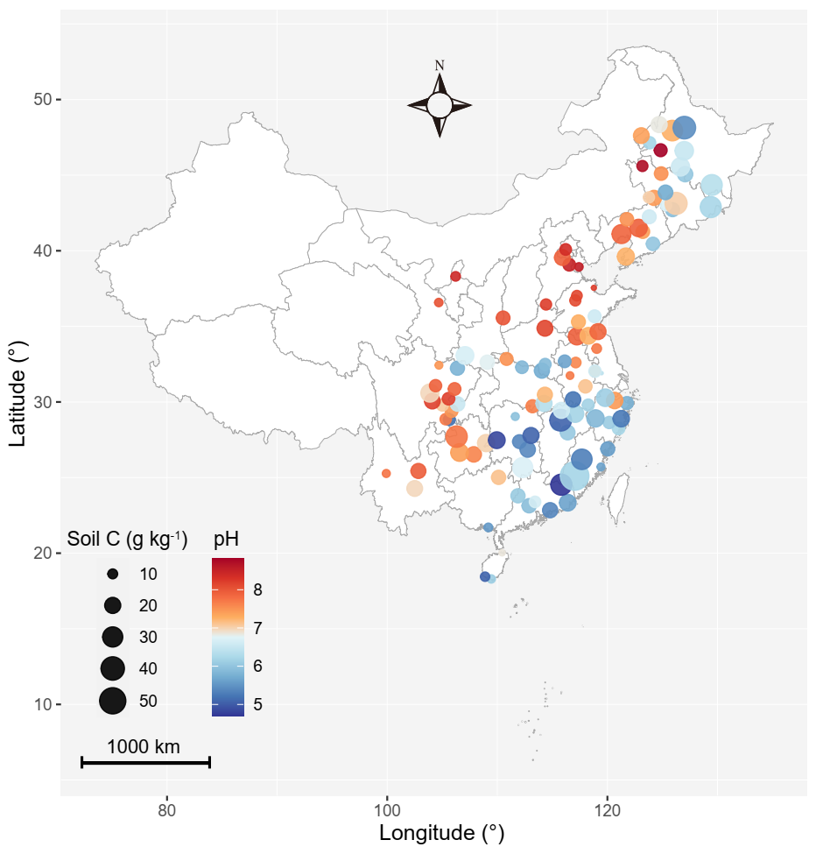

Figure S2 Rarefaction curves for the richness of five groups of soil organisms. Each line represents a soil sample.
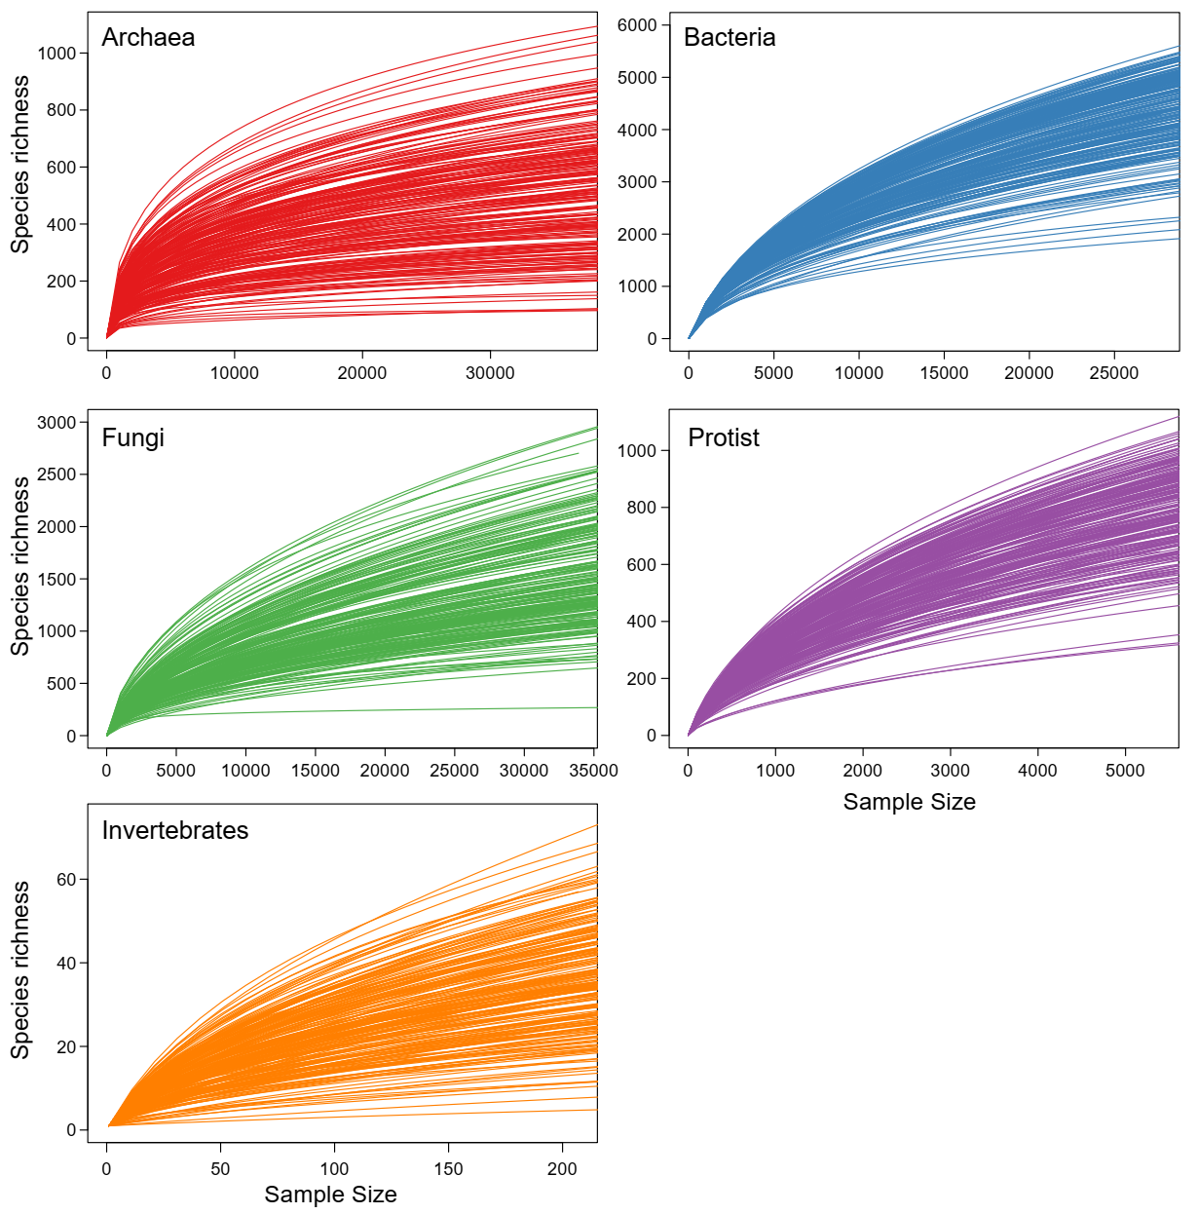

Figure S3 (A) Relationships between Shannon diversity and richness of each belowground group of organisms and multidiversity. (B) The linear relationships between multifunctionality and the multidiversity based on Shannon diversity. (C) Significant correlations (Spearman; P < 0.05) among the diversity of single groups of organisms based on richness (the lower triangle) and Shannon diversity (the upper triangle). P values were indicated by asterisks: *P < 0.05, **P < 0.01 and ***P < 0.001.
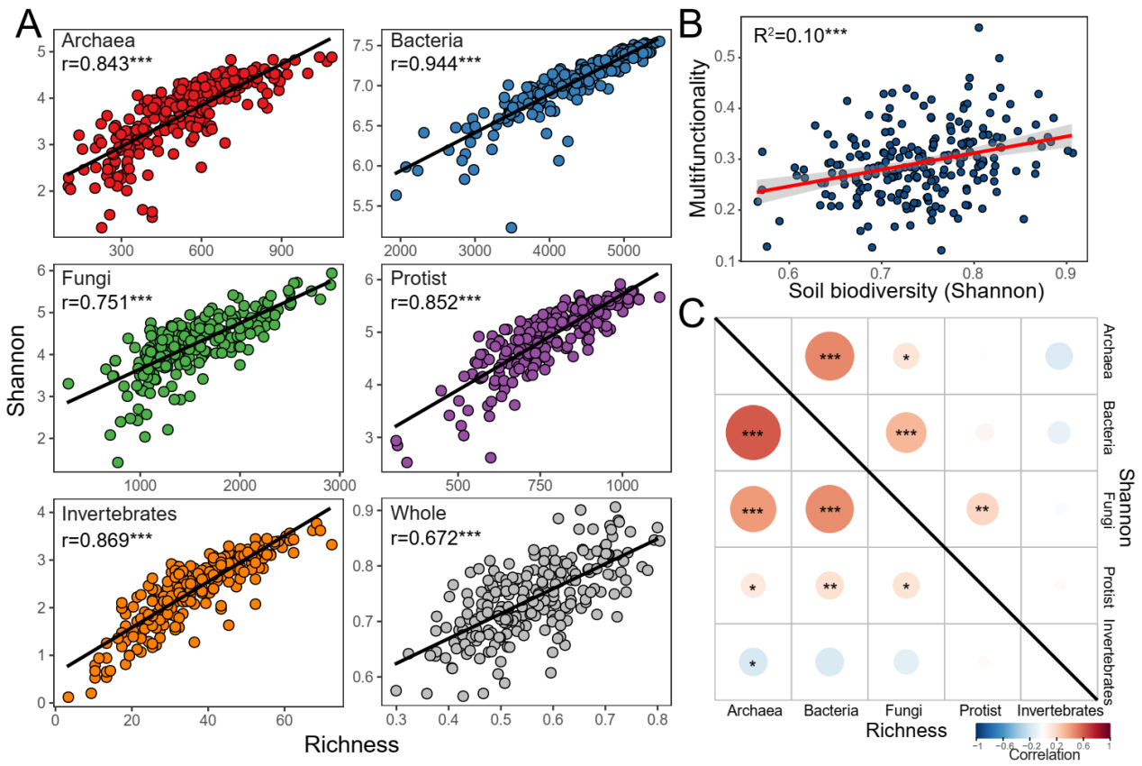

Figure S4 (A) Relationships between multifunctionality and the multidiversity based on phylogenetic diversity, estimated by linear least-squares regression. (B) Functional effects (standardized slopes (mean±s.e.m.) of phylogenetic diversity of multiple (triangle) and individual soil organisms (circle) on ecosystem multifunctionality.
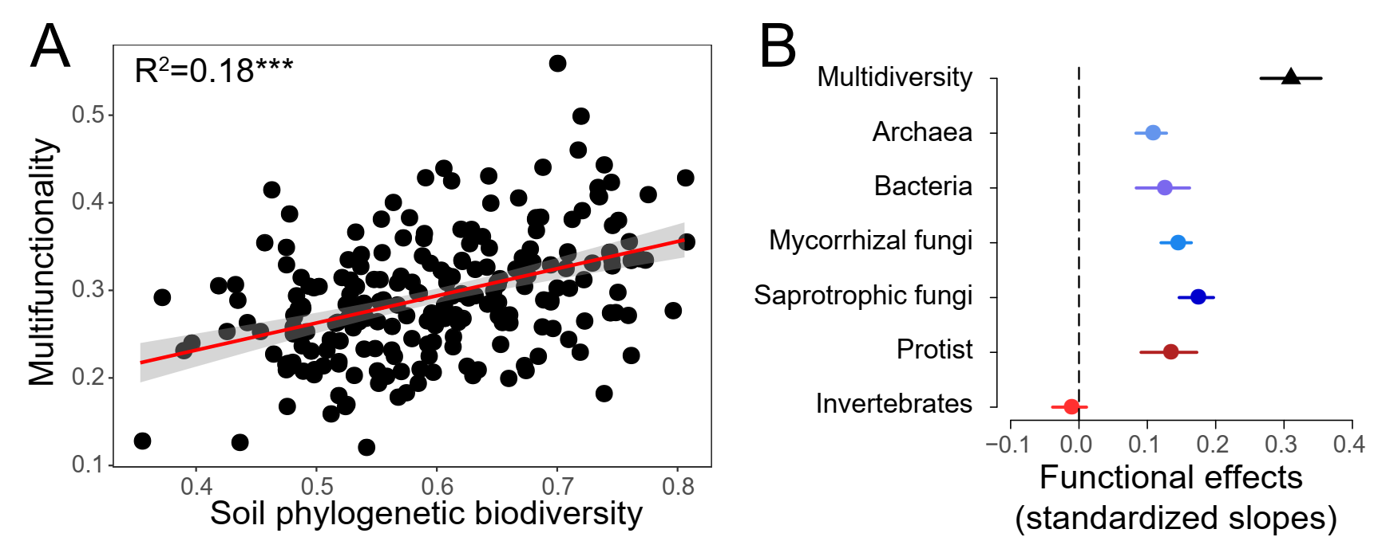

Figure S5 Relationships between multifunctionality and the diversity of major phylotypes in different groups, estimated by linear least-squares regression. We selected the dominated phylotypes of different groups, accounting for >85% sequences in total. Statistical analysis was performed using ordinary least squares linear regressions. Only regression lines for significant relationships were shown.
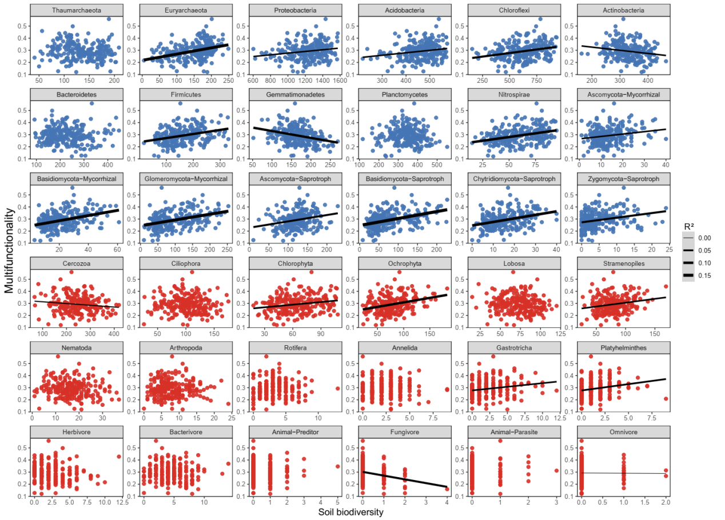

Figure S6 Significant correlations (Spearman; P < 0.05) between the diversity of major phylotypes in different groups and single ecosystem functions.
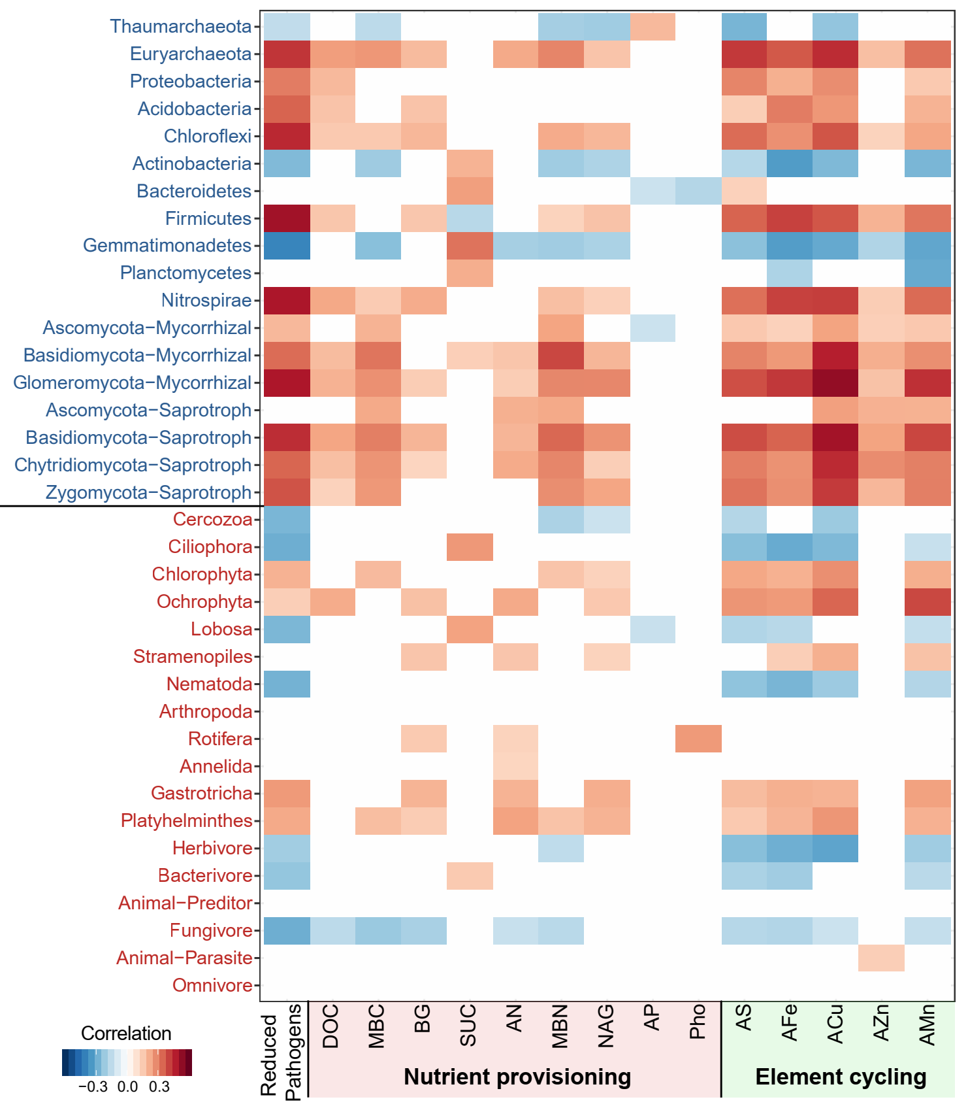

Figure S7 (A) Linear relationships between averaging ecosystem multifunctionality and soil biodiversity (multidiversity and the diversity of single groups of soil organisms; number of phylotypes) with a weighted version of the multifunctionality. For this weighted multifunctionality index, ecosystem functions are averaged into three ecosystem services: nutrient provisioning, element cycling, and pathogen control before multifunctionality is calculated, so that functions from each ecosystem service contributed equally to multifunctionality. . Statistical analysis was performed using ordinary least squares linear regressions; ***P < 0.001. Dashed and solid lines represent non-significant and significant relationships. (B) Standardized effects (mean±s.e.m.) of biodiversity of multiple and individual soil organisms on single ecosystem functions.
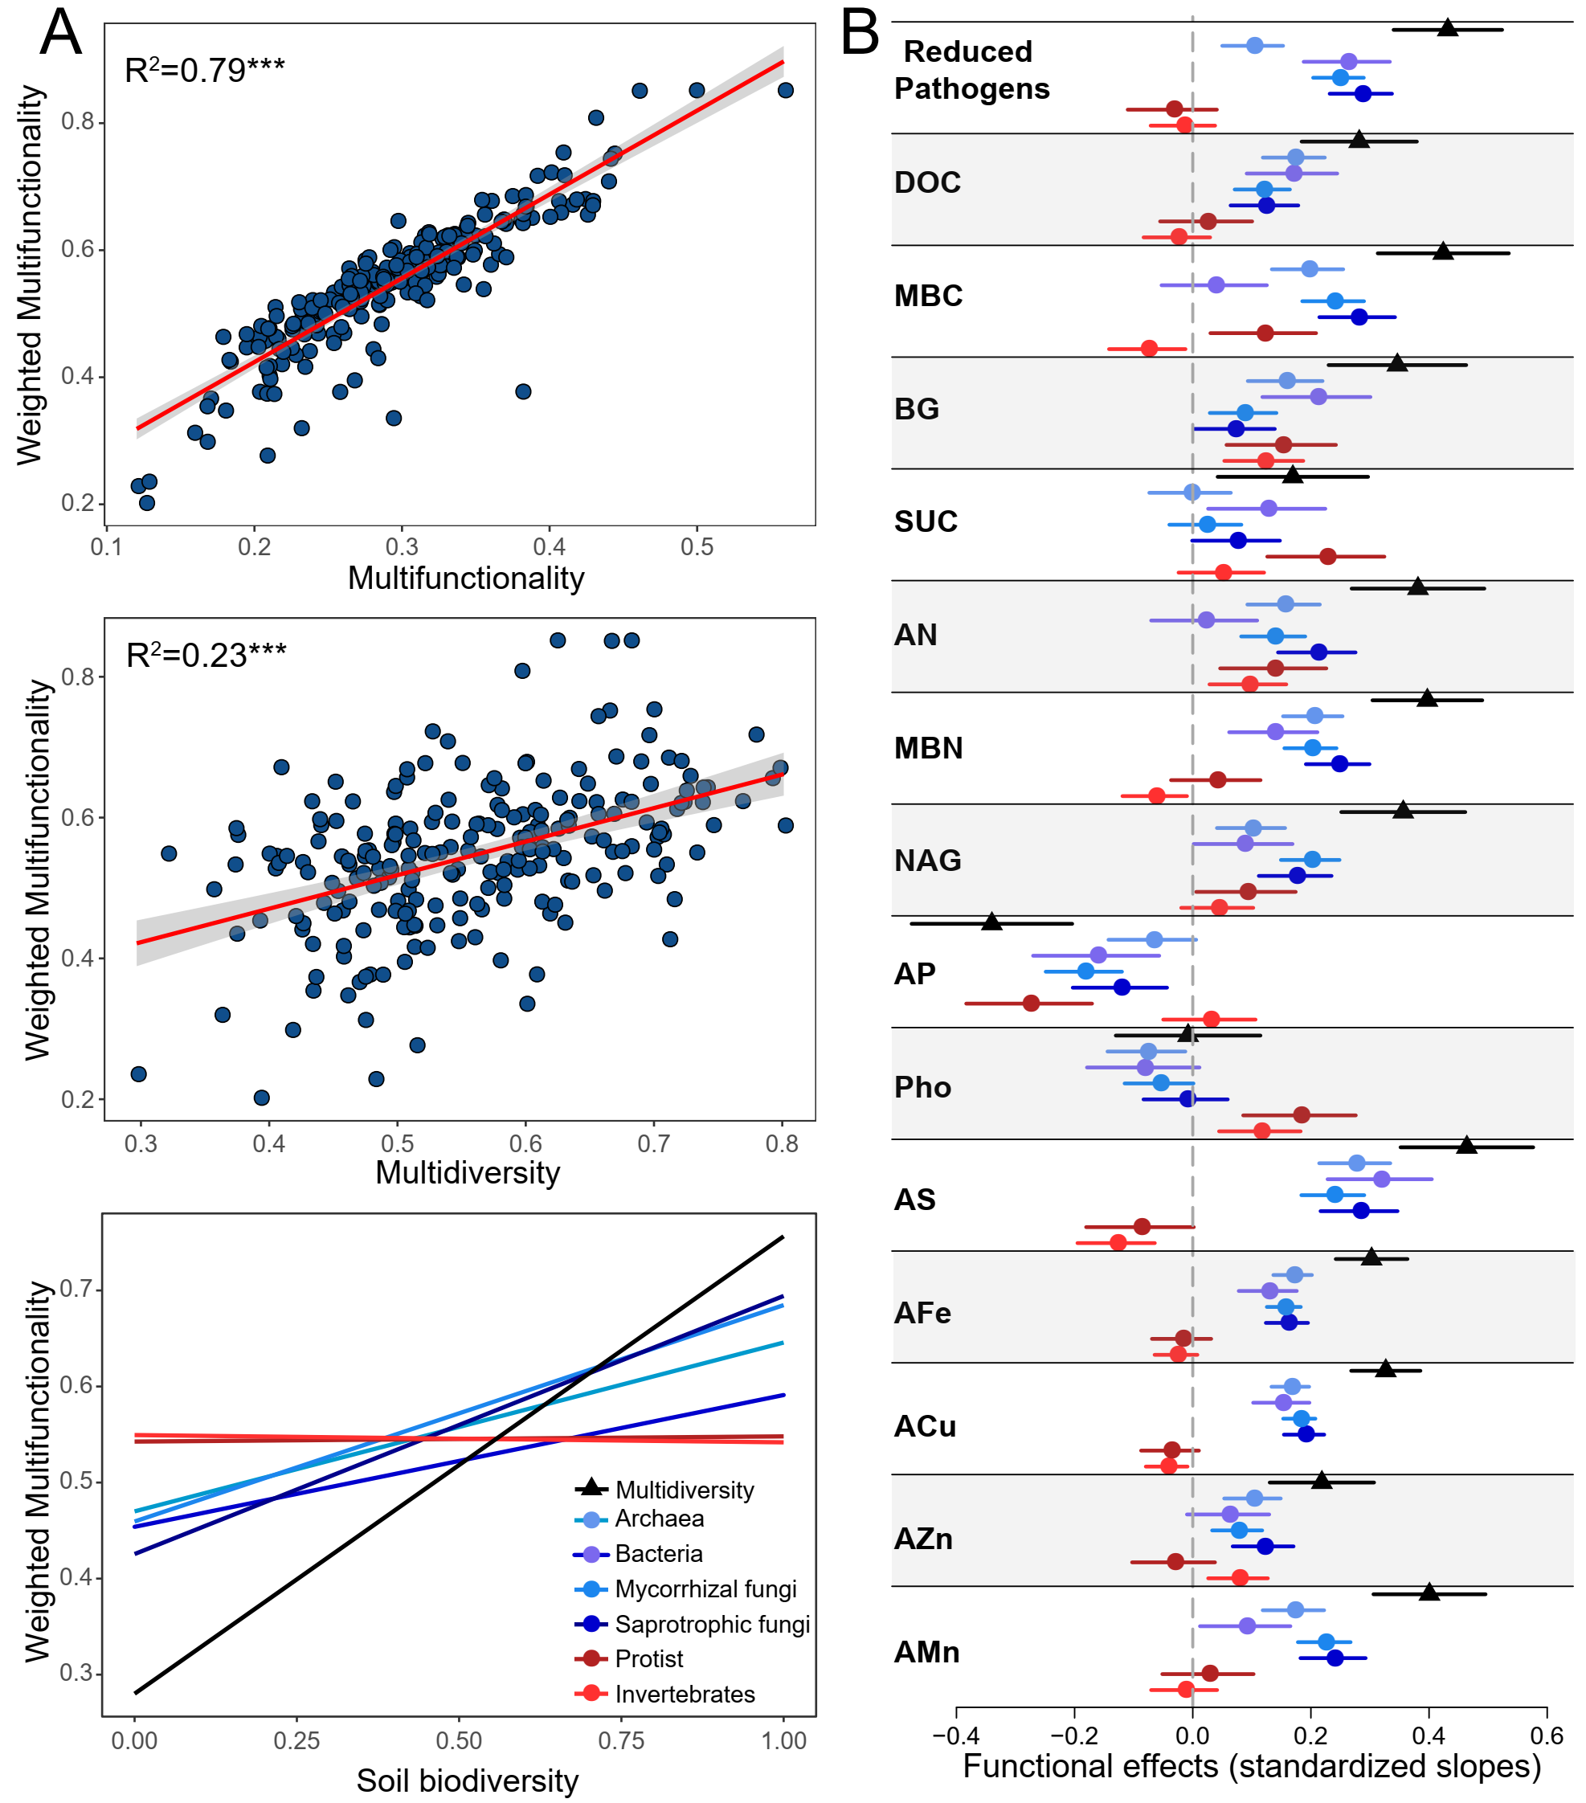

Figure S8 Linear relationships between averaging ecosystem multifunctionality and multidiversity in maize and rice fields separately. Statistical analysis was performed using ordinary least squares linear regressions; P values are indicated by asterisks: *P < 0.05 and ***P < 0.001.
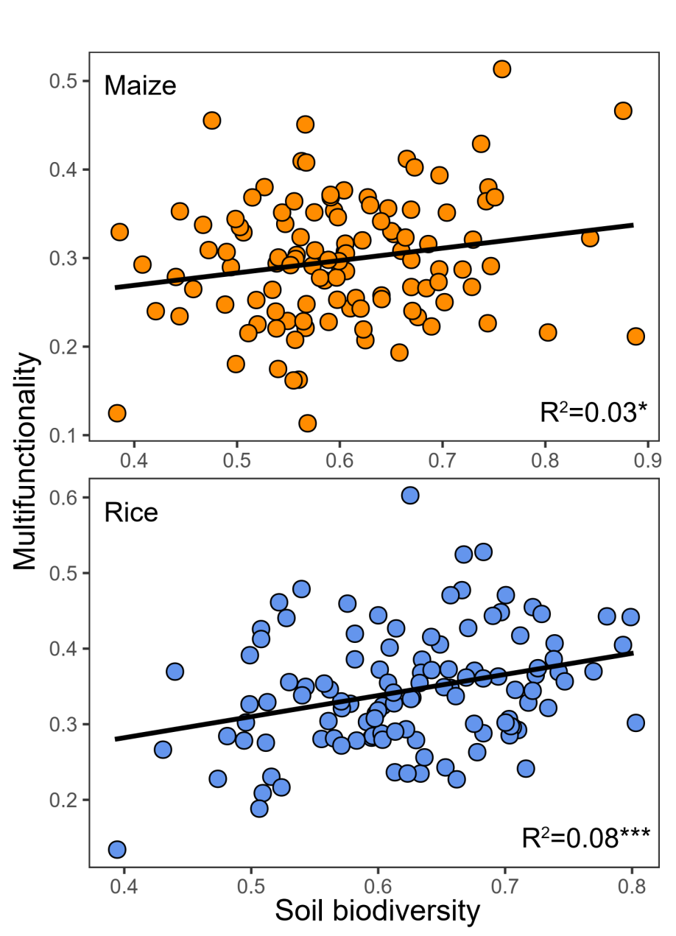

Figure S9 (A) Relationships between multidiversity and the multifunctionality represented by the first axes from a multidimensional scaling analysis including the 15 functions. Statistical analysis was performed using ordinary least squares linear regressions; P values are indicated by asterisks: ***P < 0.001. (B) Significant correlations (Spearman) between the diversity of single groups of organisms and the different components (Comp) of multifunctionality represented by the multiple axes from a multidimensional scaling analysis. Circle size represents the fitting R² of the linear regressions. Colors represent Spearman correlations. (C) Significant correlations (Spearman) between the single ecosystem functions and the different components (Comp) of multifunctionality represented by the multiple axes from a multidimensional scaling analysis.
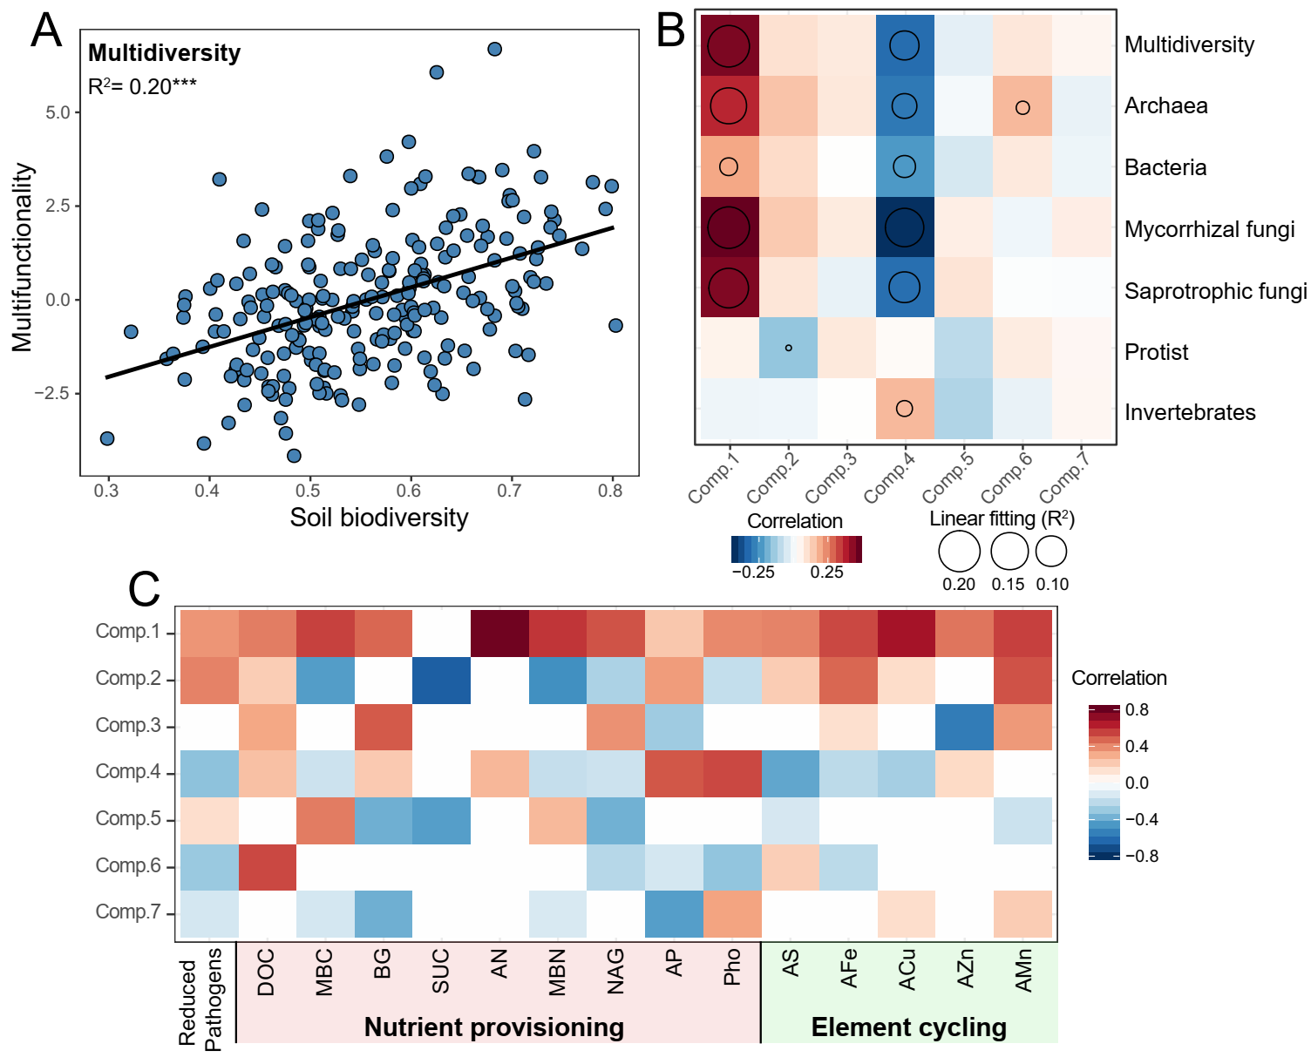

Figure S10 A priori structural equation modeling (SEM) metamodel aimed to evaluate the link between soil biodiversity and multifunctionality (EMF) after controlling for key ecological predictors such as climate and soil attributes. We grouped the edaphic properties into the same box in the model for graphical simplicity; however, these boxes do not represent latent variables. MAT: Mean annual temperature. The fitted model was available in Fig. 2A and Supplementary Table 1.
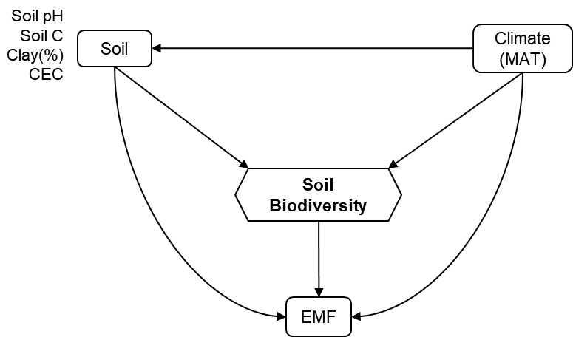

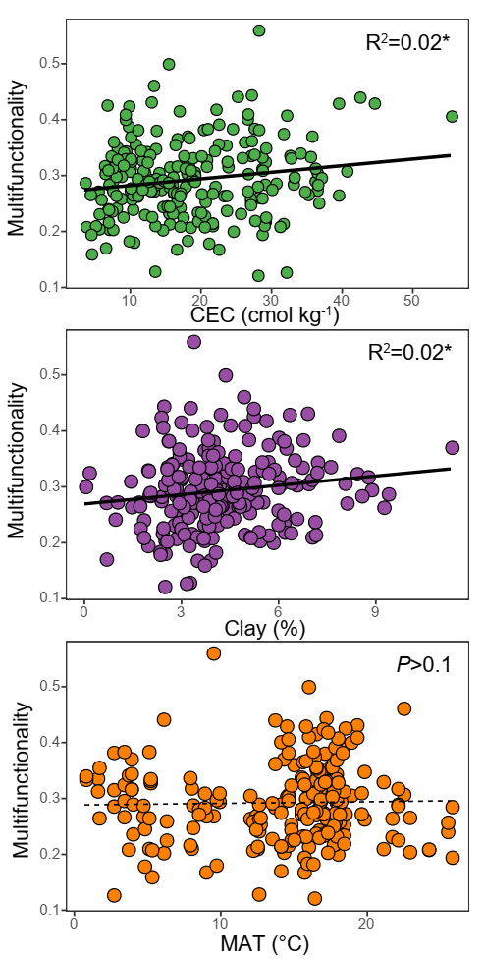
Figure S11 The linear relationships between multifunctionality and environmental factors. CEC: cation exchange capacity; MAT: mean annual temperature. P values were indicated by asterisks: *P < 0.05.

Figure S12 The linear relationships between average multifunctionality and the diversity (number of phylotypes) of soil phylotypes within the ecological cluster 5 of the network. Statistical analysis was performed using ordinary least squares linear regressions; P values were indicated by asterisks: ***P < 0.001.
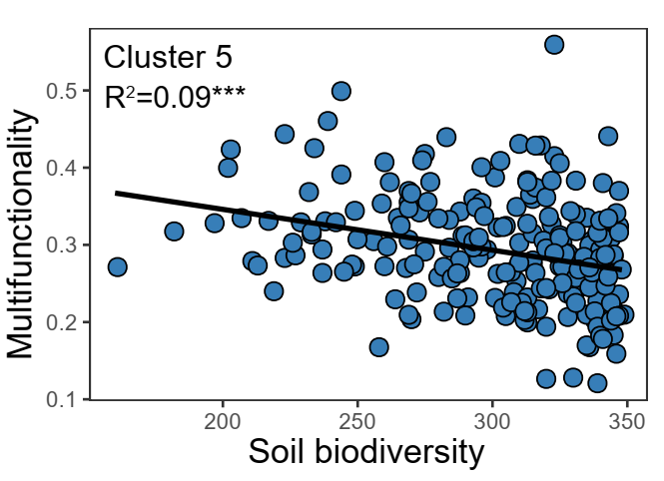

Figure S13 The linear relationships between average multifunctionality and the topological features of the sub-networks extracted by preserving the phylotypes of individual soil samples from the soil network. Statistical analysis was performed using ordinary least squares linear regressions; P values were indicated by asterisks: **P < 0.01 and ***P < 0.001.
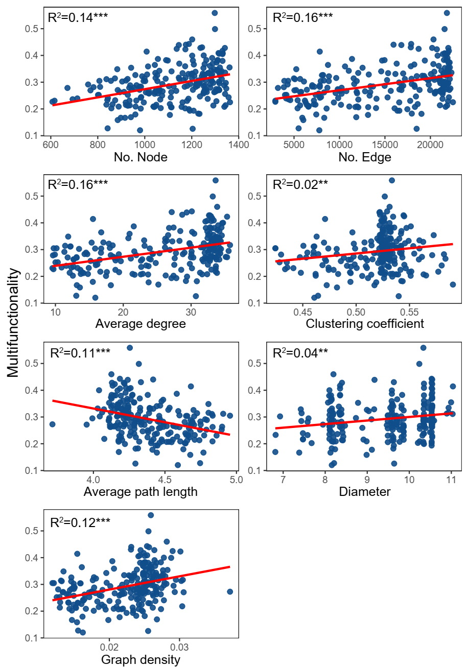

Figure S14 The relationships between the strengths of biodiversity-multifunctionality relationships and the topological features of soil networks based on moving-window analysis with window sizes of 30 (A) and 20 (B) samples. The strengths of biodiversity-multifunctionality relationships (BEF) were reflected by the explained variances (R² of the ordinary least squares linear regressions) of soil biodiversity to multifunctionality. Red and blue lines corresponded with positive and negative relationships, respectively. The upper triangle showed the significant correlations (Spearman; P < 0.05) among the topological features of soil networks. Statistical analysis was performed using ordinary least squares linear regressions; P values were indicated by asterisks: *P < 0.05, **P < 0.01 and ***P < 0.001. AD: average degree; CC: clustering coefficient; APL: average path length; Dia: diameter; and GC; graph density.
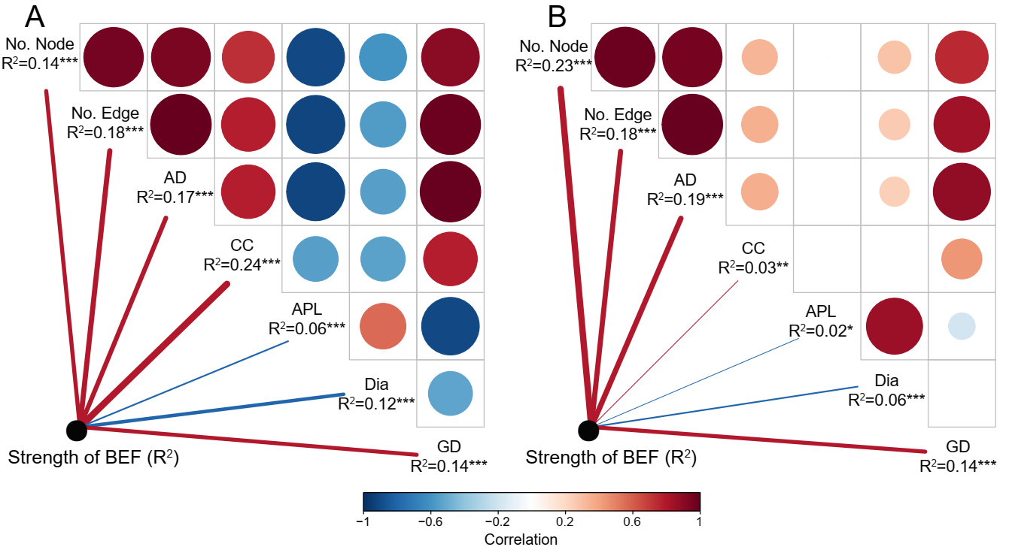

Figure S15 The relationships between the strengths of biodiversity-multifunctionality relationships and different influencing factors based on moving-window analysis with window sizes of 30 samples. The strengths of biodiversity-multifunctionality relationships (BEF) were reflected by the explained variances (R² of the ordinary least squares linear regressions) of soil biodiversity to multifunctionality. The potential complexity of soil food webs was estimated using the topological features of the soil networks via multidimensional scaling analysis. Statistical analysis was performed using ordinary least squares linear regressions; P values were indicated by asterisks: *P < 0.05 and ***P < 0.001. CEC: cation exchange capacity; MAT: mean annual temperature.
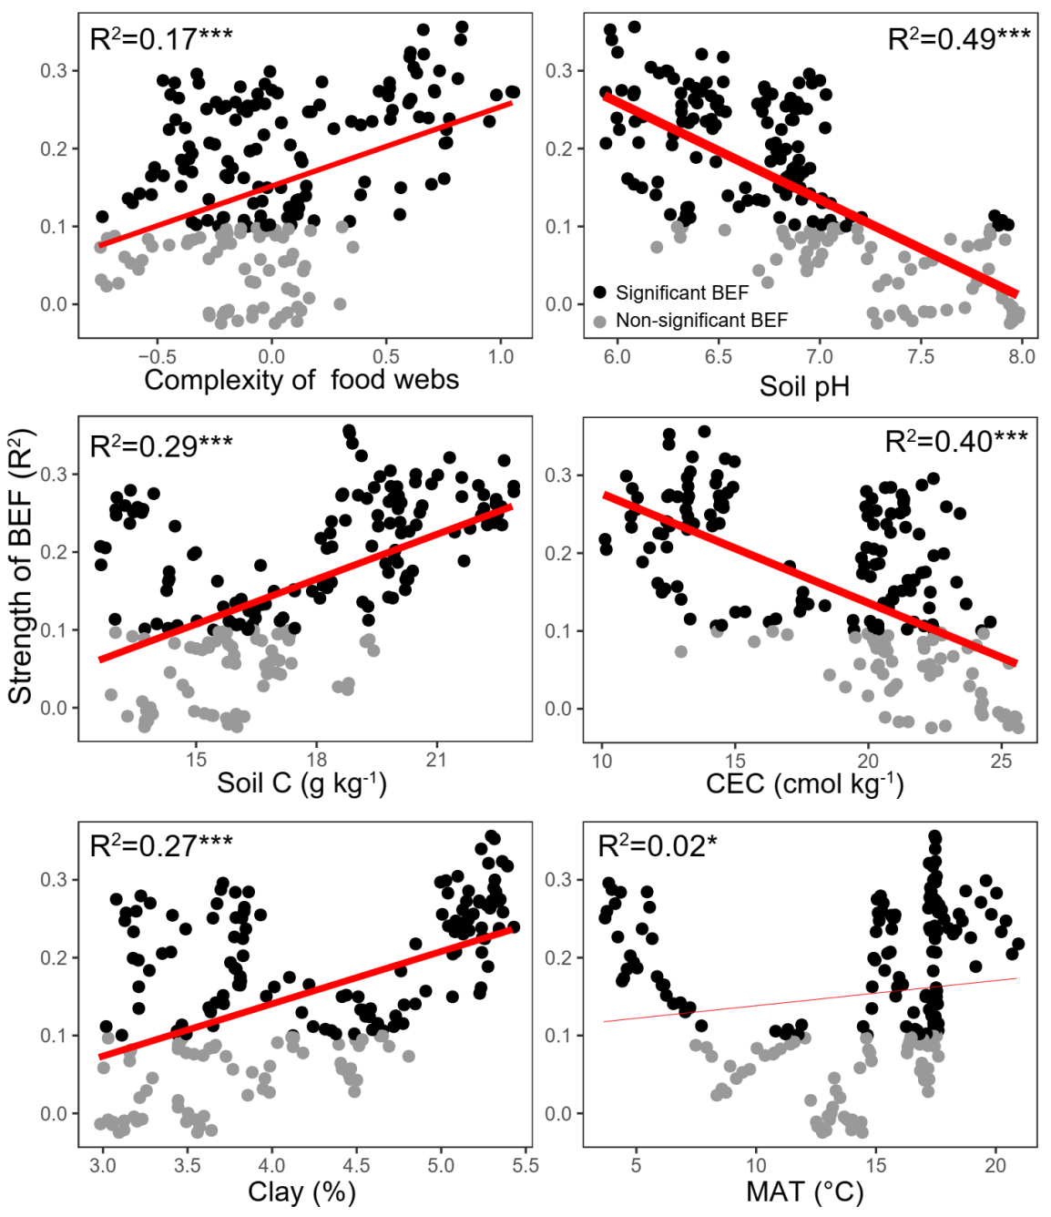

Figure S16 The relationships between the strengths of biodiversity-multifunctionality relationships and different influencing factors based on moving-window analysis with window sizes of 20 samples. The strengths of biodiversity-multifunctionality relationships (BEF) were reflected by the explained variances (R² of the ordinary least squares linear regressions) of soil biodiversity to multifunctionality. The potential complexity of soil food webs was estimated using the topological features of the soil networks via multidimensional scaling analysis. Statistical analysis was performed using ordinary least squares linear regressions; P values were indicated by asterisks: ***P < 0.001. CEC: cation exchange capacity; MAT: mean annual temperature.
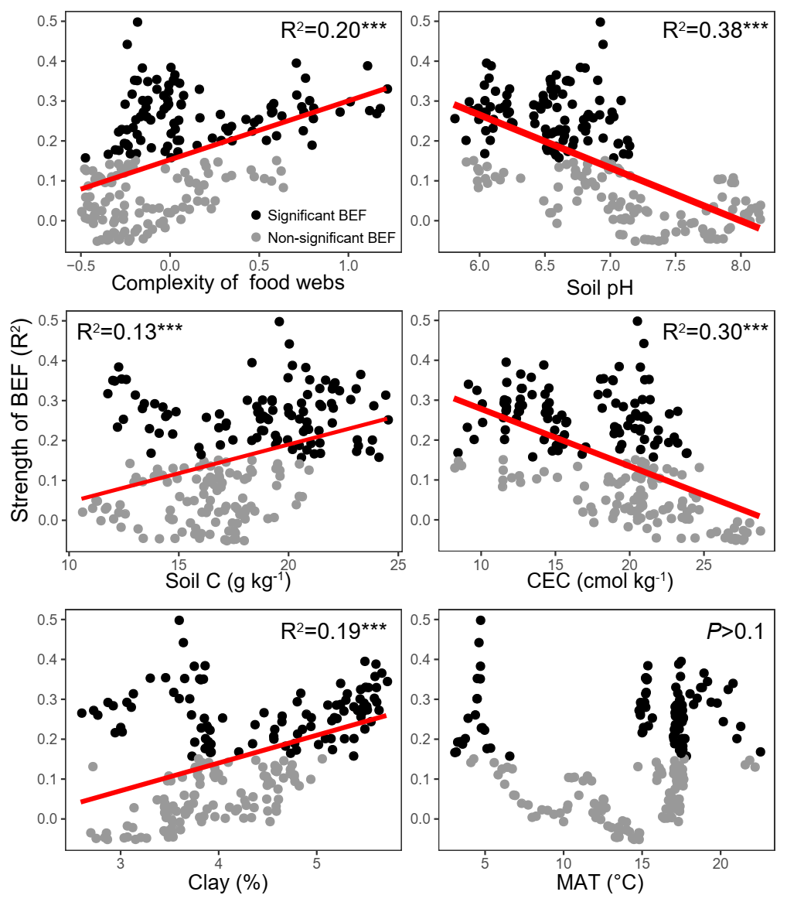

Figure S17 A priori structural equation modeling (SEM) metamodel aimed to evaluate the link between the complexity of soil food webs and the BEF strengths after controlling for key ecological predictors such as climate and soil attributes. We grouped the edaphic properties into the same box in the model for graphical simplicity; however, these boxes do not represent latent variables. MAT: Mean annual temperature. The fitted model was available in Fig. 4C and 4D and Supplementary Table 5 and 6.
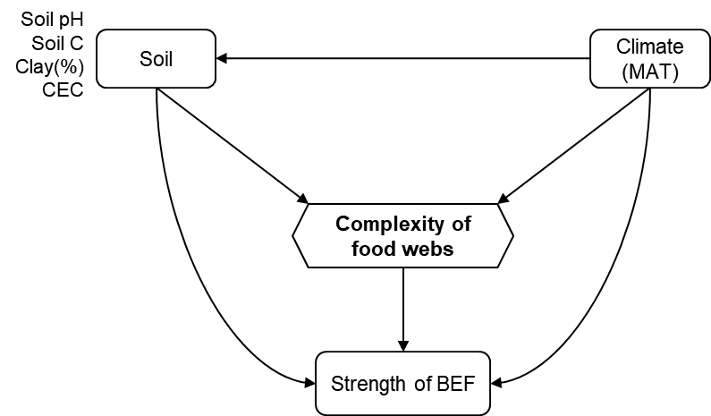

Figure S18 Random Forest mean predictor importance of influencing factors for the BEF strengths based on moving-window analysis with window sizes of 30 (A) and 20 (B) samples. The accuracy importance measure was computed for each tree and averaged over the forest (5000 trees). Percentage increases in the MSE (mean squared error) of variables was used to estimate the importance of these predictors, and higher MSE% values implied more important predictors. All of the variables were significant (P <0.001) MSE: mean squared error; MAT: mean annual temperature; CEC: cation exchange capacity.
