Supporting Information

Growth, crystal structure, Hirshfeld surface analysis, DFT studies, physicochemical characterization and cytotoxicity assays of novel organic triphosphate
Yathreb Oueslati, Sevgi Kansız, Necmi Dege, Cristina de la Torre Paredes, Antoni Llopis-Lorente, Ramón Martínez-Máñez and Wajda Sta

Table S-1. Crystal data and refinement of (C₁₀H₁₅N₂)₂H₃P₃O₁₀.
Empirical formula | (C₁₀H₁₅N₂)₂H₃P₃O₁₀
Formula weight  Temperature (K)  Wavelength (A ˚ )  Crystal system  Space group  a (Å)  b (Å)  c (Å)  α(°)  β(°)  γ(°)  Volume (Å³)  Z  D_{calc} (Mg cm⁻³)  Absorption coefficient  F (000)  Theta range for data collection  Crystal size (mm³)  Limiting indices  Reflections collected  Reflections observed  Goodness-of-fit on F²  Final R indices  Largest diff. peak and hole (e Å⁻³) | 582.41 (g.mol⁻¹)  293  0.71073  Triclinic  P$\overline{1}$  9.511(2)  10.622(2)  13.653(2)  84.58(2)  86.59(2)  68.78(2)  1279.5(4)  2  1.512  0.24 (mm⁻¹)  612  2.06°- 32.78°  0.21 x 0.16 x 0.14  -14<h< 14, -12<k<12, -4<l< 18  8386  6138  1.06  R₁ = 0.054 and wR₂ = 0.153  0.54 and -0.63

Table S-2. Principal intermolecular hydrogen bonding geometry (Å, ˚).

D-H…A | D-H(Å) | H...A(Å) | D...A(Å) | D-H...A(˚)
O(9)-H(7)…O(8) | 0.75(5) | 1.89(5) | 2.624(4) | 169(5)
O(1)-H(8)…O(10) | 0.99(6) | 1.60(6) | 2.557(4) | 162(5)
O(2)-H(9)…O(6) | 0.89(4) | 1.72(4) | 2.605(3) | 173(5)
N(2)-H(2A)…O(6) | 0.90 | 2.04 | 2.851(3) | 150
N(2)-H(2B)…O(7) | 0.90 | 1.64 | 2.478(3) | 153
N(4)-H(4A)...O(8) | 0.90 | 2.22 | 2.991(3) | 143
N(4)-H(4B)…O(3) | 0.90 | 1.83 | 2.700(3) | 162
C(8)-H(8A) ...O(3) | 0.97 | 2.13 | 2.989(3) | 147
C(9)-H(9A) ...O(7) | 0.97 | 2.55 | 3.095(3) | 116
C(19)-H(19B)...O(10) | 0.97 | 2.23 | 3.190(4) | 170

Figure S-1. The asymmetric unit of (C₁₀H₁₅N₂)₂H₃P₃O₁₀.

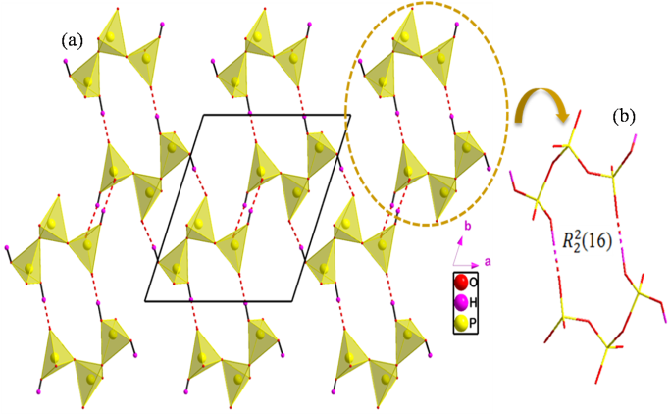

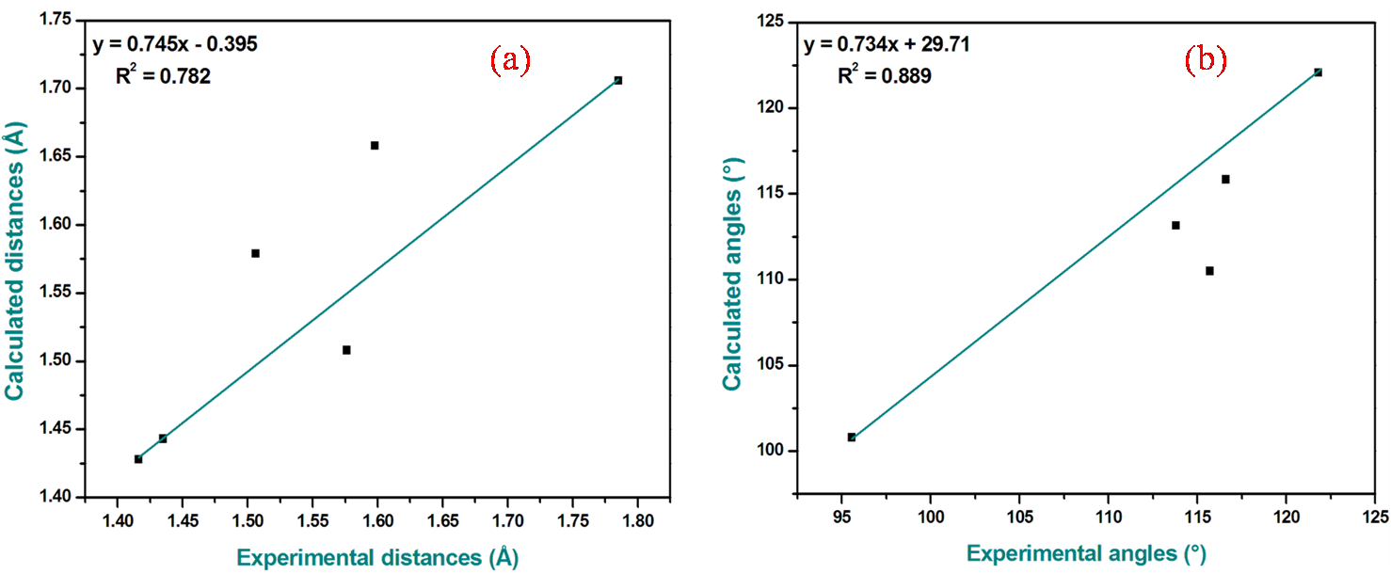
Figure S-2. (a) Infinite layers of [H₃P₃O₁₀]²⁻ viewed along the c axis. (b) Hydrogen bonding sired with dashed lines.
.
Figure S-3. Graphical correlation of theoretical and experimental geometric parameters (a): distances (b): angles.

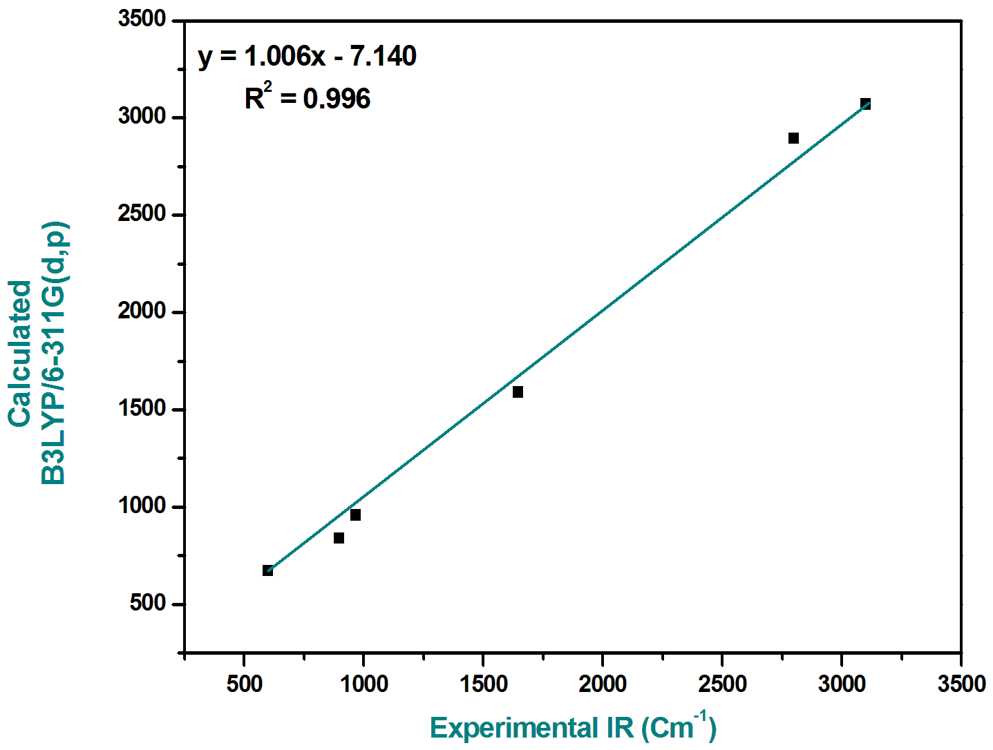

Figure S-4. Graphical correlation of theoretical and experimental infrared values.
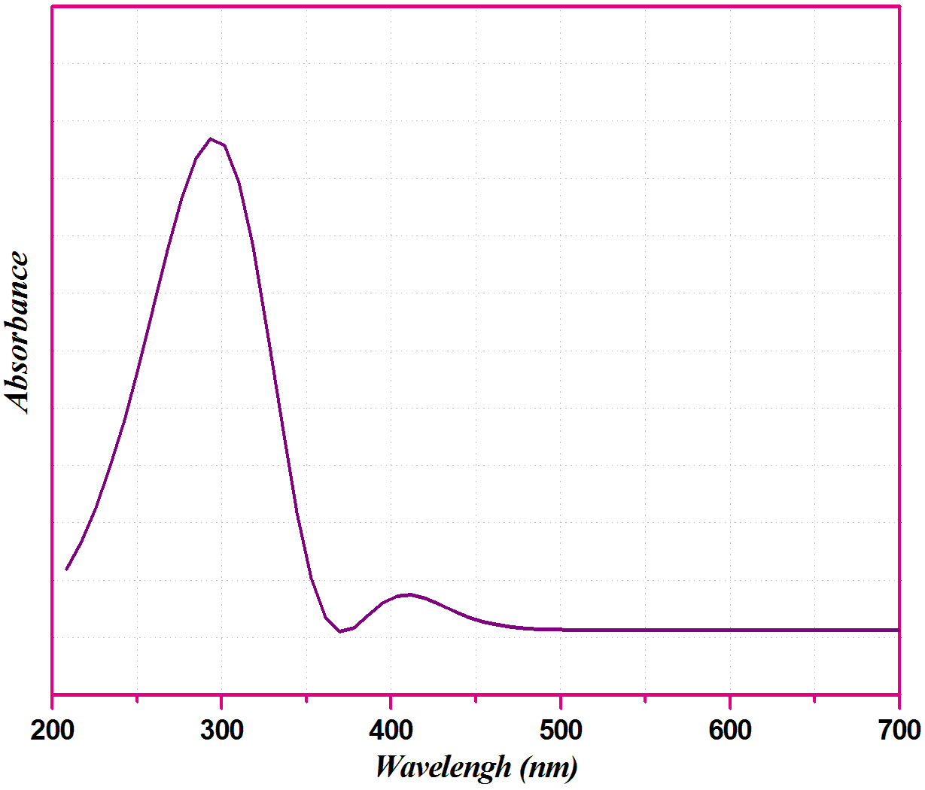

Figure S-5. UV-Vis Spectrum of (C₁₀H₁₅N₂)₂H₃P₃O₁₀ in solid state.

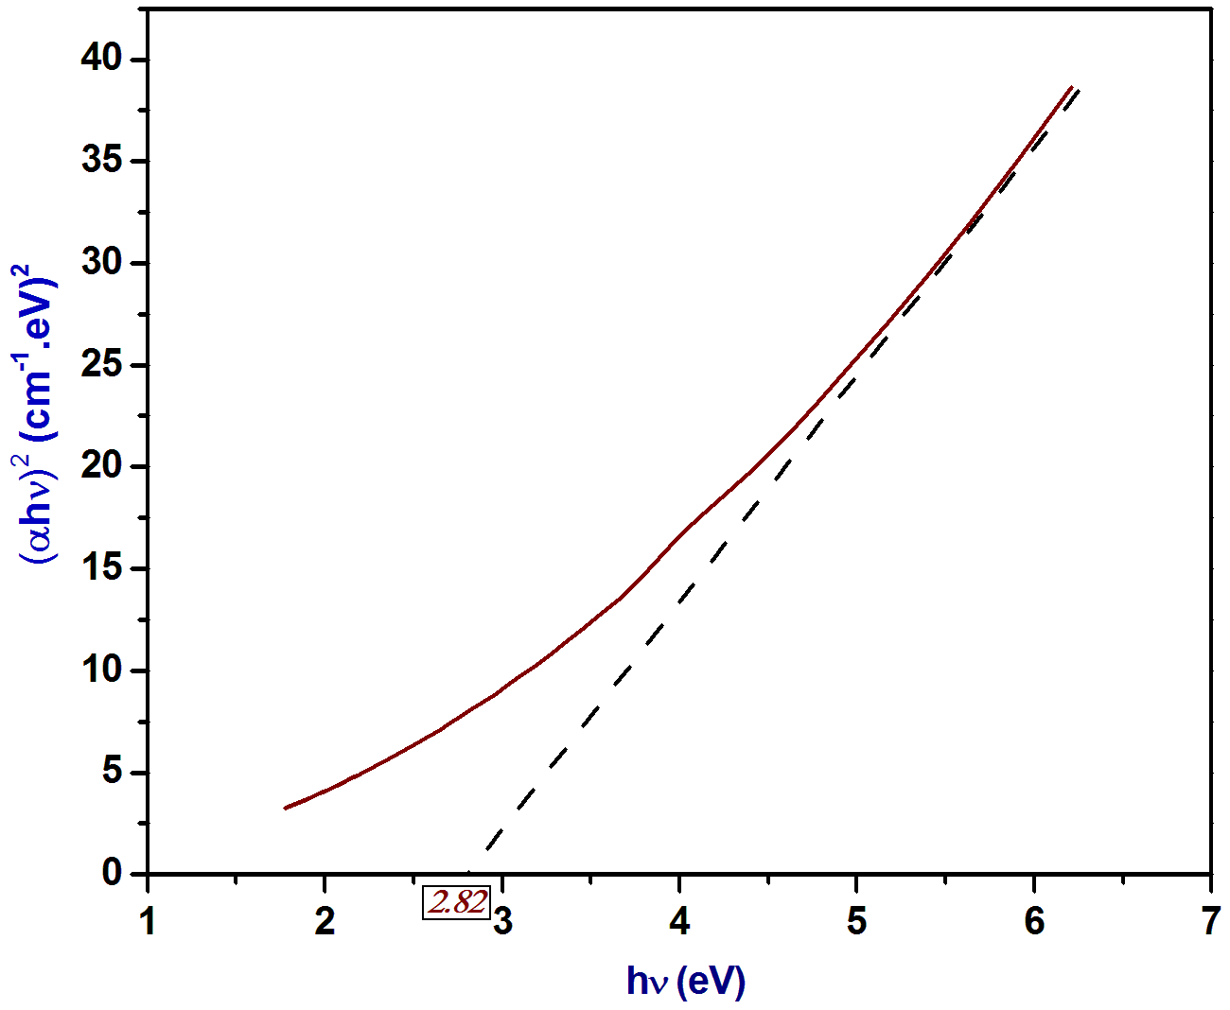

Figure S-6. Dependence of (αhυ)² on the photon energy and optical band gap value of (C₁₀H₁₅N₂)₂H₃P₃O₁₀.
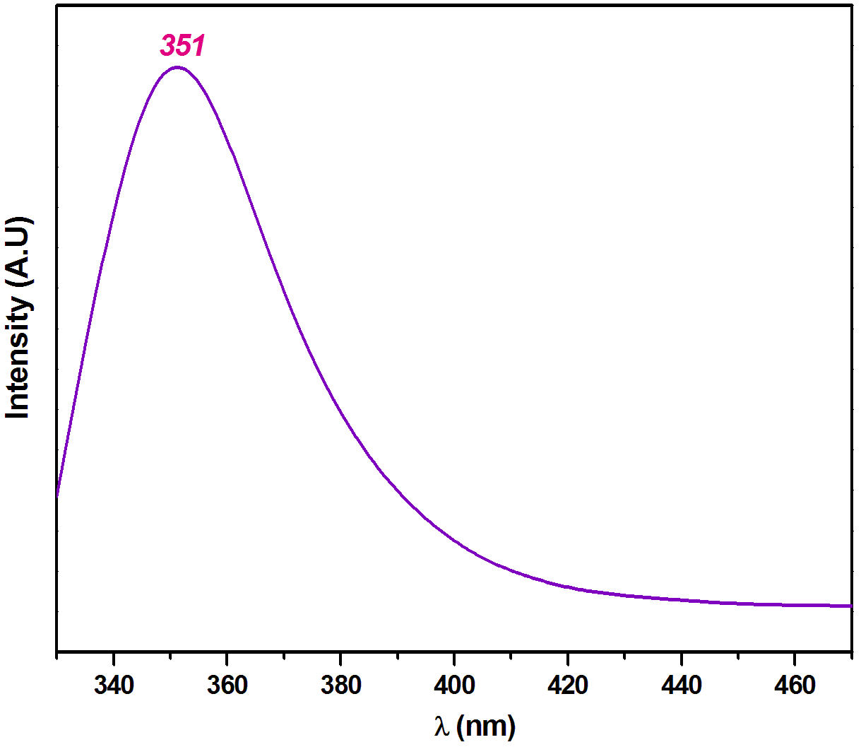

Figure S-7. Solid-state photoluminescence spectrum of (C₁₀H₁₅N₂)₂H₃P₃O₁₀.

