- Supplementary Material
Table S1 - Summary of demographics and clinical data. Significant group differences are shown in bold (p<0.05). Numbers represent mean ± standard deviation (or percentage). *Data available for 16 patients; ** Data available for 15 patients; BP = Blood Pressure; sSVD=Sporadic Small Vessel Disease.
 | SVD (N=17) |  | Healthy controls  (N = 12) | Group comparison
 | CADASIL  (N=6) | sSVD  (N = 11)
Age (years) | 50 ± 9 |  | 52 ± 6 | p = 0.70
 | 47 ± 11 | 52 ± 7 |  | p = 0.44†
Sex (% Female) | 13 (77) |  | 6 (50) | p = 0.14
 | 4 (67) | 9 (82) |  | p = 0.28†
Education (years) | 10 ± 6 |  | 17 ± 4 | p < 0.001
 | 10 ± 6 | 11 ± 5 |  | p = 0.72†
Hypertension (%)* | 10 (62) |  | - | -
 | 1 (20) | 9 (82) |  | p = 0.02†
Systolic BP (mmHg)** | 134 ± 20 |  | - | -
 | 135 ± 22 | 133 ± 21 |  | p = 0.92†
Diastolic BP (mmHg)** | 79 ± 14 |  | - | -
 | 79 ± 12 | 78 ± 16 |  | p = 0.97†
Diabetes Mellitus (%)* | 1 (6) |  | - | -
 | 0 | 1 (9) |  | p = 0.49†
Hypercholesterolaemia (%)* | 9 (56) |  | - | -
 | 2 (12) | 7 (41) |  | p = 0.38†
Previous Stroke (%)* | 4 (25) |  | - | -
 | 2 (12) | 2 (12) |  | p = 0.35†
Smoker (%)* | 5 (31) |  | - | -
 | 1 (6) | 4 (24) |  | p = 0.51†
History of depression (%)* | 8 (50) |  | - | -
 | 2 (12) | 6 (35) |  | p = 0.59†
†Comparison between CADASIL and sSVD groups.

Table S2 – Composite scores used for evaluation of executive function and processing speed: individual tests used to obtain the composite scores.
Cognitive Index | Neuropsychological Test | Measures | Composite Score
Executive Function | Stroop (Fernandes, 2013) | Total Interference Score | Stroop+TMTB-A=  Average of z-scores
 | Trail Making Test (Cavaco et al., 2013) | Part B-A - Time to complete
Processing Speed | Trail Making Test (Cavaco et al., 2013) | Part B - Time to complete | TMTA+TMTB=  Average of z-scores
 |  | Part A - Time to complete

Figure S1 – Illustrative examples of FA histograms from all subjects obtained using the different masks: TBSS (left) and NAWM (right); and demonstrating the histogram-based metrics (median and peak width).
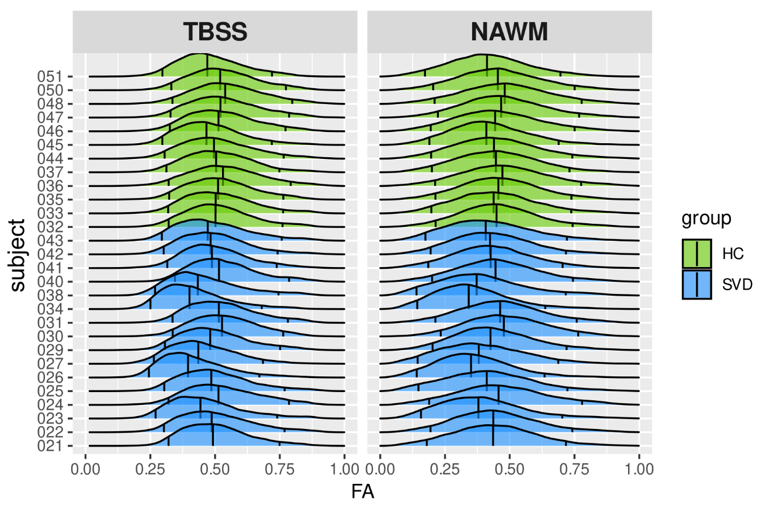
Figure S2 – Illustrative examples of MD histograms from all subjects obtained using the different masks: TBSS (left) and NAWM (right); and demonstrating the histogram-based metrics (median and peak width).
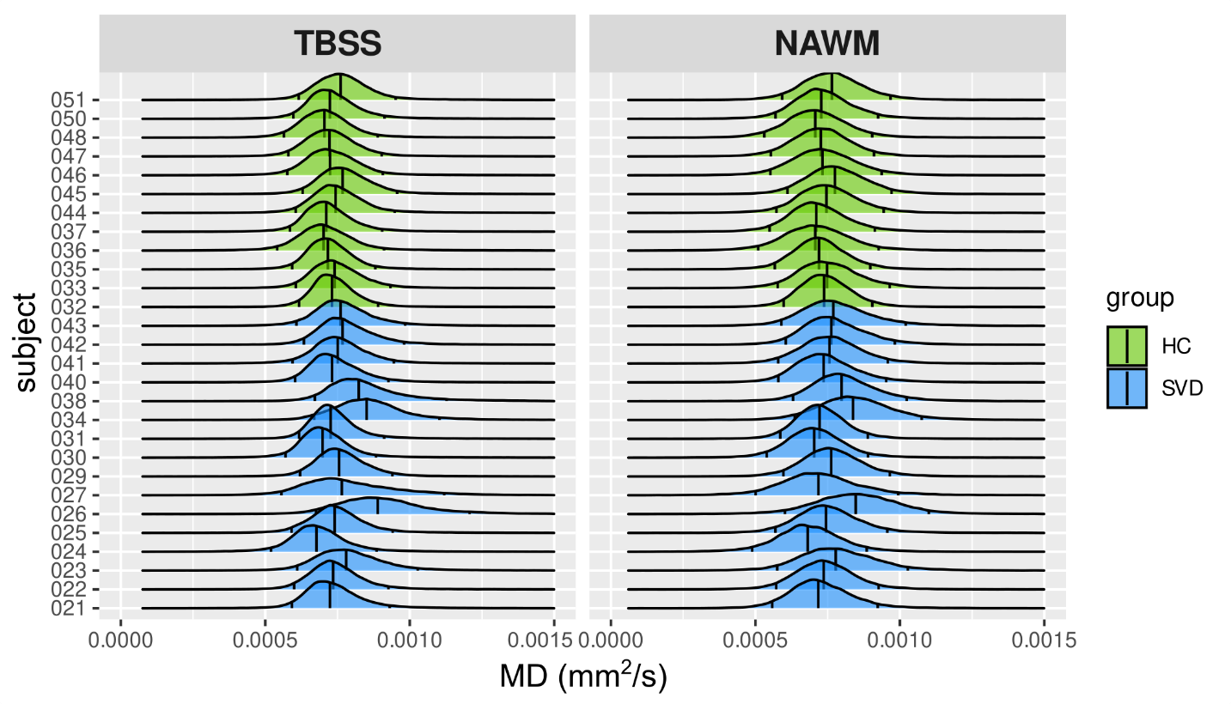
Figure S3 – Illustrative examples of scatter plots showing the relationship between one DTI metric and both cognitive domains. In this example, the relation between MD peak width for both masks: TBSS and NAWM; executive function (upper panel) and processing speed (lower panel) are displayed. The correlation coefficients (r), uncorrected p-values and 95% confidence interval (gray area) are reported.
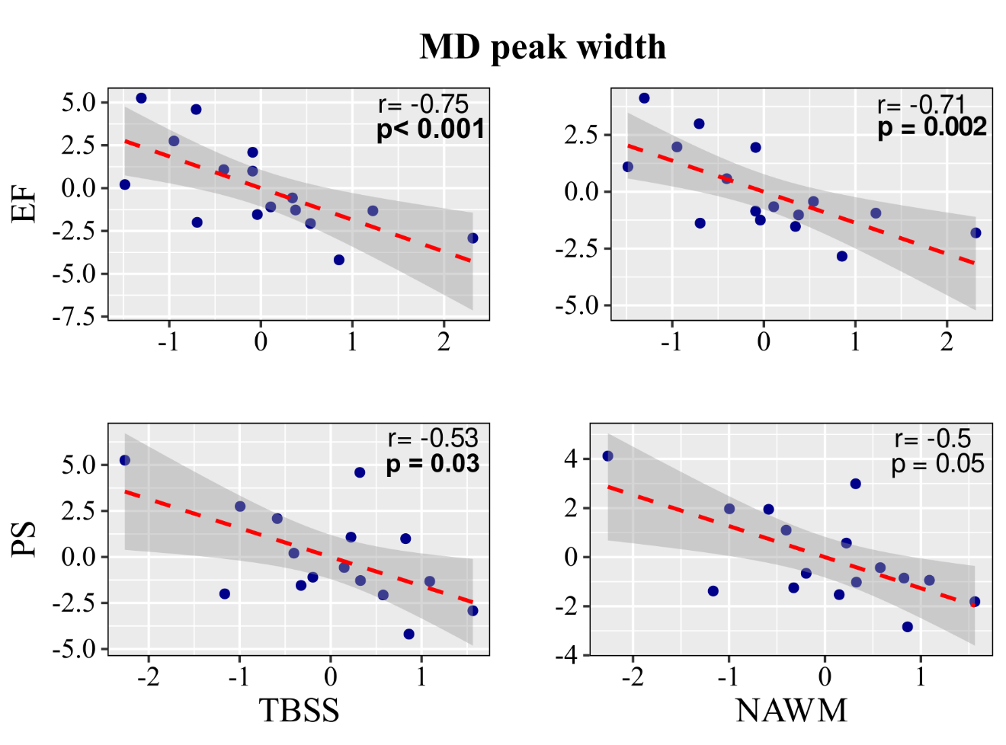

Figure S4 – Illustrative examples of scatter plots showing the relationship between one DTI metric and both cognitive domains. In this example, the relation between MD peak height for both masks: TBSS and NAWM; executive function (upper panel) and processing speed (lower panel) are displayed. The correlation coefficients (r), uncorrected p-values and 95% confidence interval (gray area) are reported.
