Supplementary figures

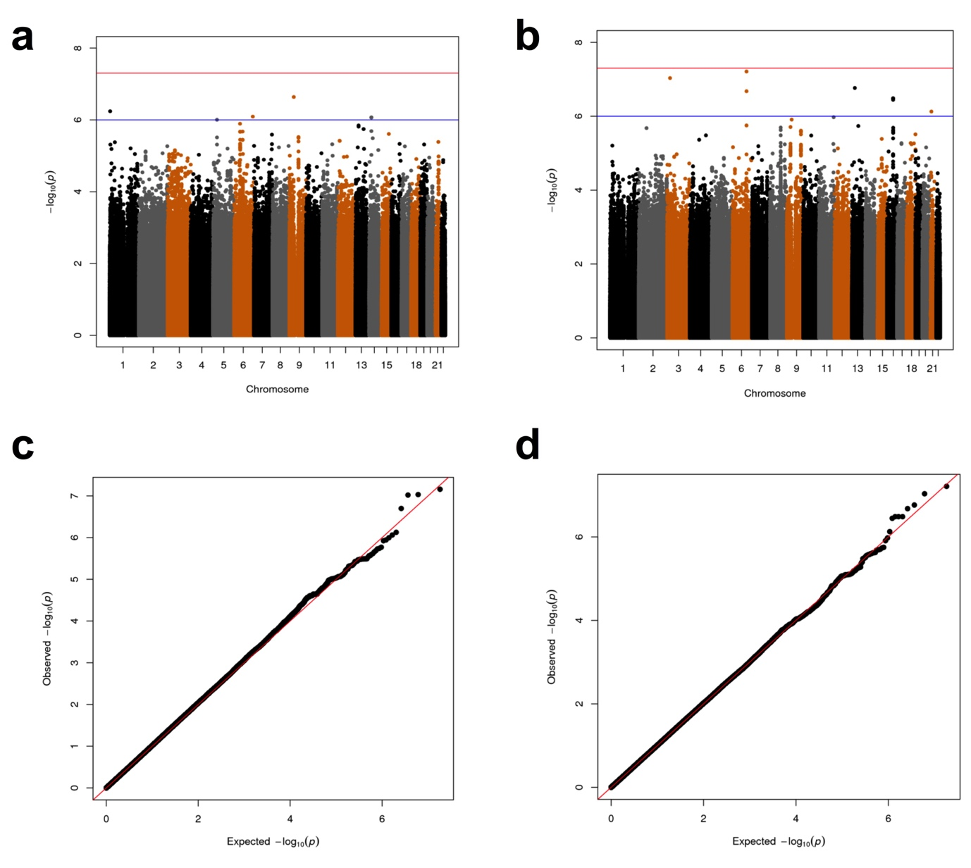
Supplementary figure S1. (a, b) Manhattan plots showing the (−log10) p-values by genomic position and (c, d) QQ-plot of associations with (a, c) type I and (b, d) type IIa fiber distribution from the meta-analysis in the Malmö Men, Malmö Exercise Intervention and Uppsala Longitudinal Study of Adult Men cohorts. n_{tot} = 656 in a and c; n_{tot} = 653 in b and d. The blue and red lines in a and b indicate the treschholds for suggestive (p < 1 x 10⁻⁶) and genome-wide significance (p < 5 x 10⁻⁸), respectively.

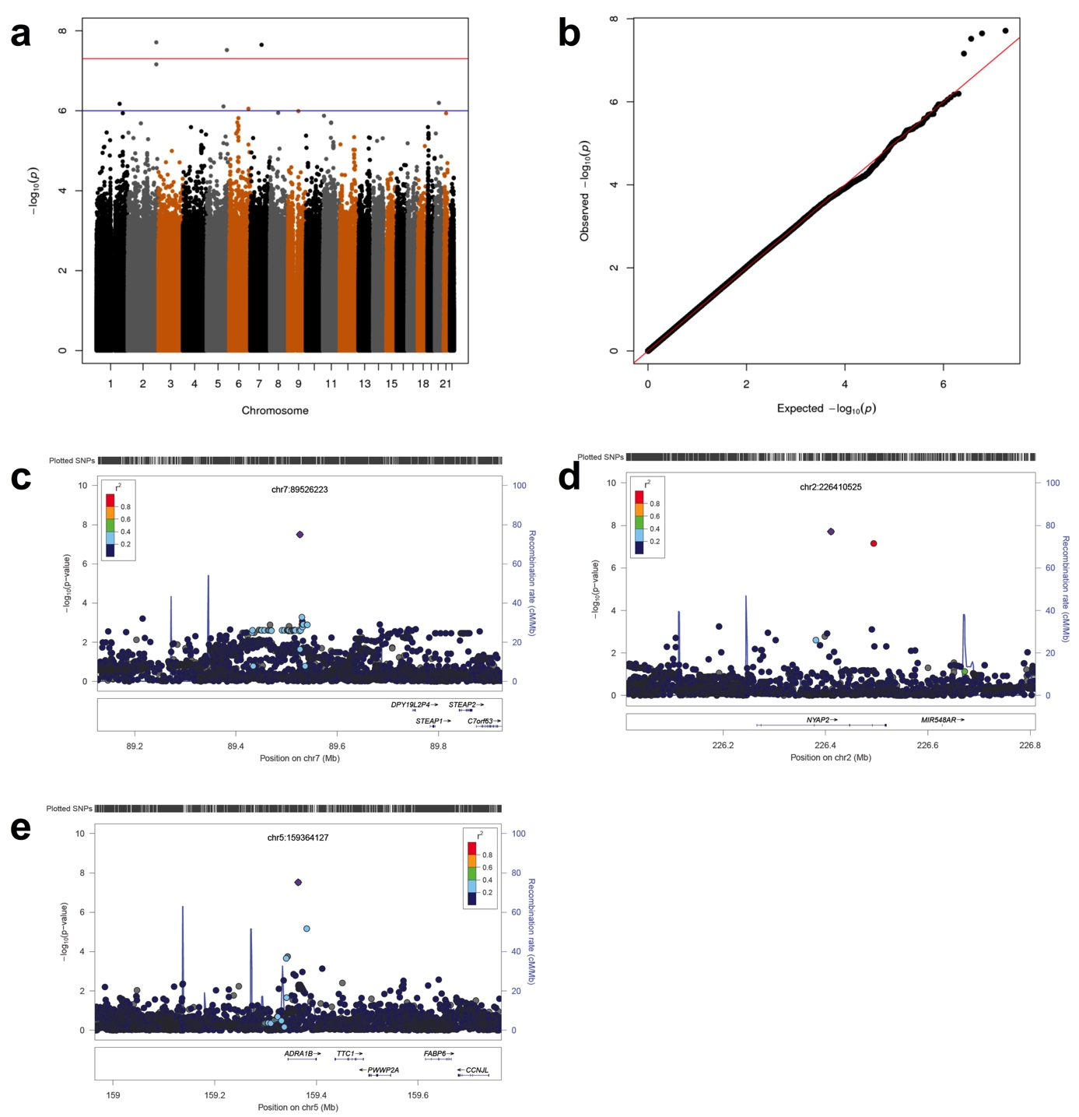
Supplementary figure S2. (a) Manhattan plot showing the (−log10) p-values by genomic position and (b) QQ-plot of associations with type IIx fiber distribution from the meta-analysis in the Malmö Men, Malmö Exercise Intervention and Uppsala Longitudinal Study of Adult Men cohorts (n_{tot} = 651). The blue and red lines in a indicate the treshholds for suggestive (p < 1 x 10⁻⁶) and genome-wide significance (p < 5 x 10⁻⁸), respectively. (c - e) LocusZoom plots of regions harbouring the genetic variants with genome-wide significance. The purple circle represents the genetic variant with the lowest p-value (left y-axis) in the region. Other variants (circles) are coulored according to their linkage disequilibrium with this variant, i.e. from highest (red) to lowest (dark blue). Estimated recombination rates are shown on the right y-axis. (c) rs7776803, (d) rs145631867 and (e) rs149081100.
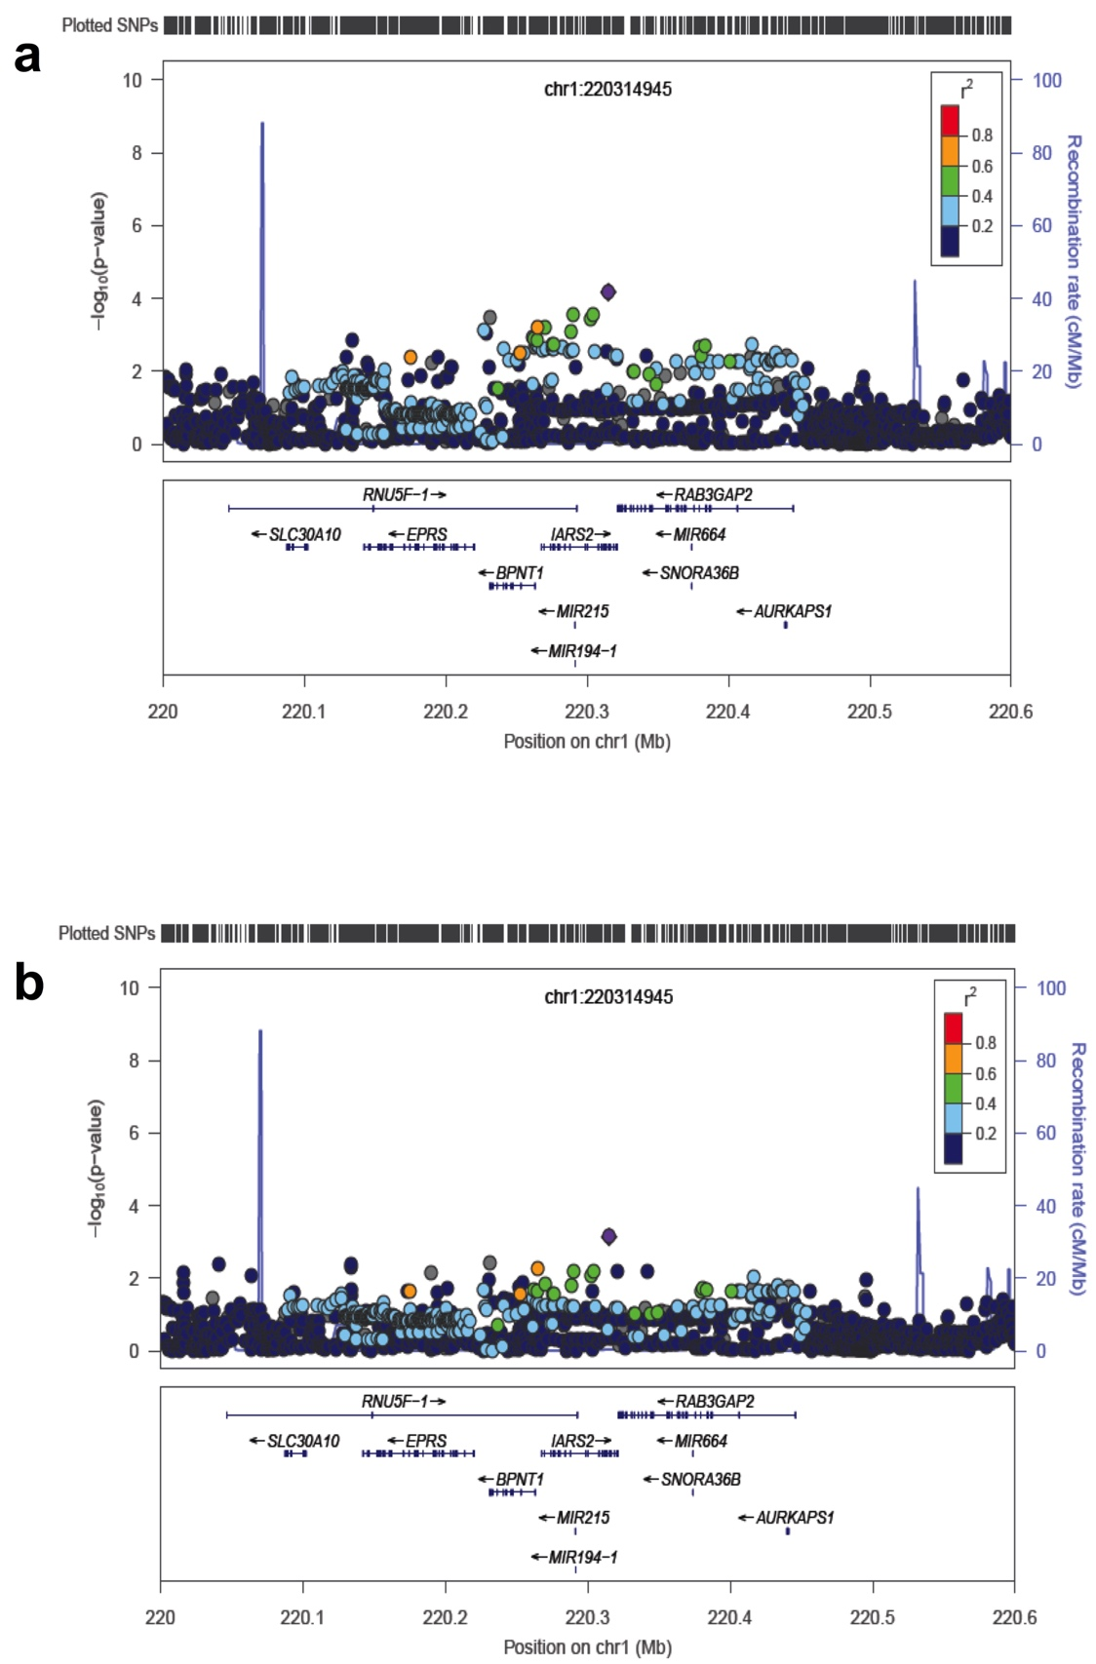
Supplementary figure S3. LocusZoom plots of the region on chromosome 1 associated with capillary density. The purple circle represents the genetic variant with the lowest p-value (left y-axis) in the region. Other variants (circles) are coulored according to their linkage disequilibrium with this variant, i.e. from highest (red) to lowest (dark blue). Estimated recombination rates are shown on the right y-axis. (a) Shows conditioning on the rs115660502 and (b) on the rs191465330.
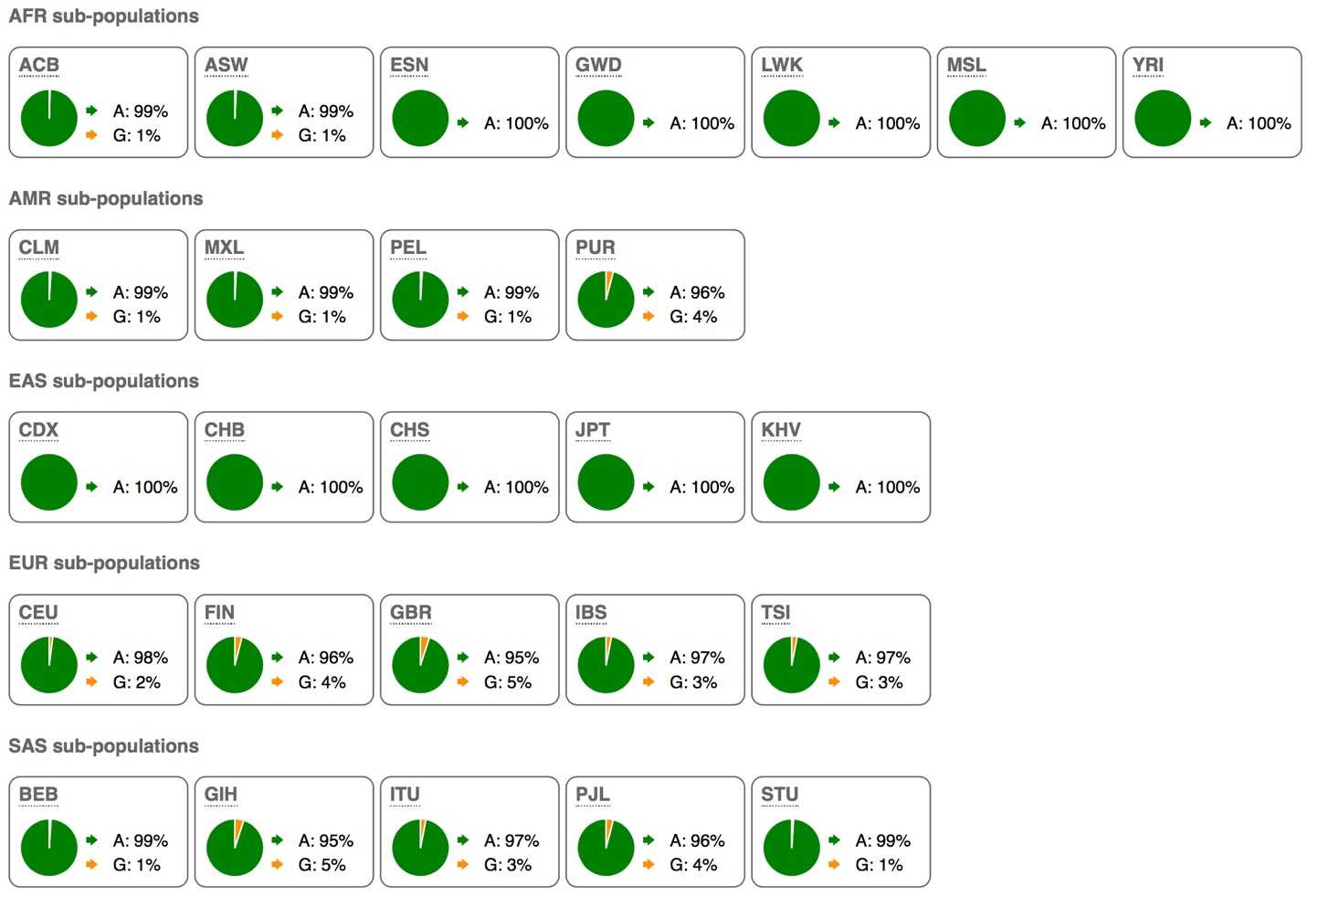
Supplementary figure S4. Allele frequvencies of the rs115660502 in different populations from the 1000G. The geografic distribution of the C:F increasing G-allele is indicating that it is a fairly young allele (< 50.000 years) as it is present only in non-african populations or at a low frequvency in European-admixed african populations.

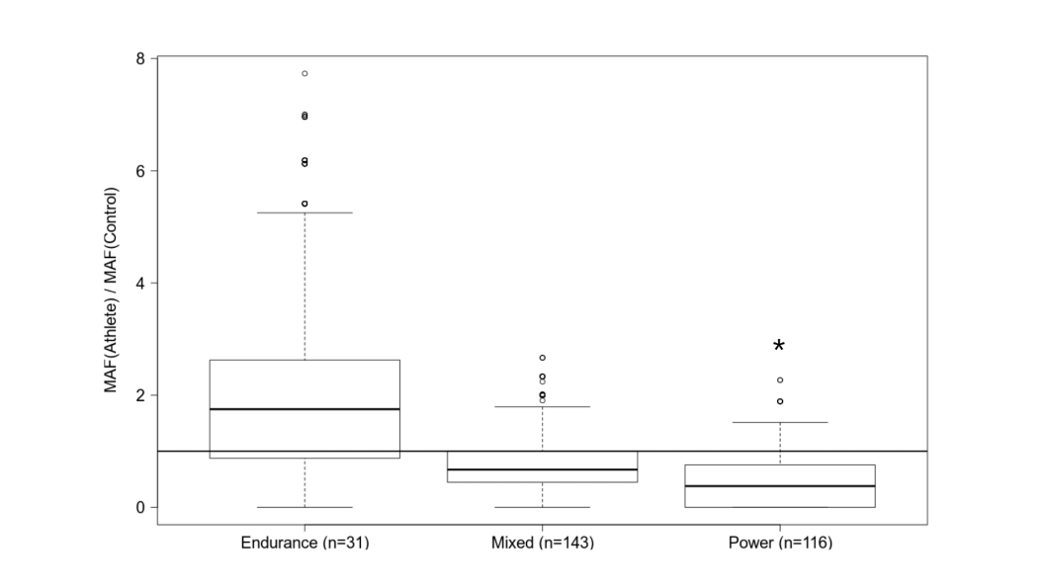
Supplementary figure S5. Ratio of the frequencies of the capillary increasing G-allele at rs115660502 in elite athletes compared to population-matched controls. The ratios were calculated in randomly drawn samples of individuals from the population-matched controls with n equal to the corresponding athlete cohort (10⁵ bootstraps). * p < 0.05.

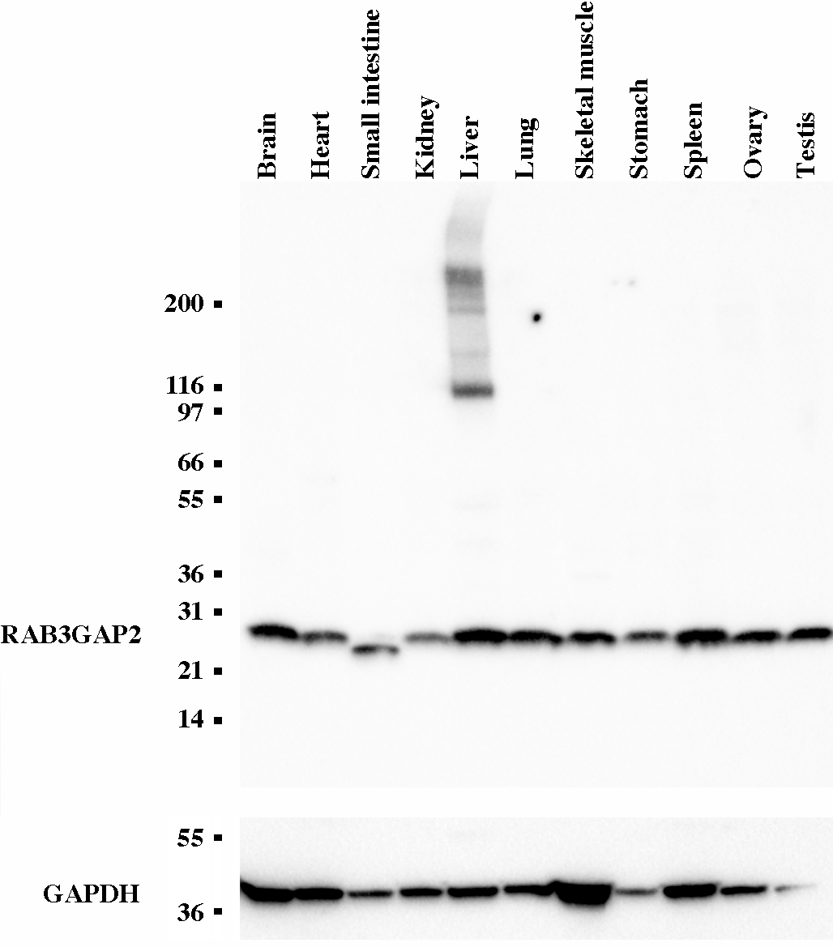
Supplementary figure S6. Western blot of RAB3GAP2 with a pre-blotted membrane with different human tissue lysates (Novusbio).

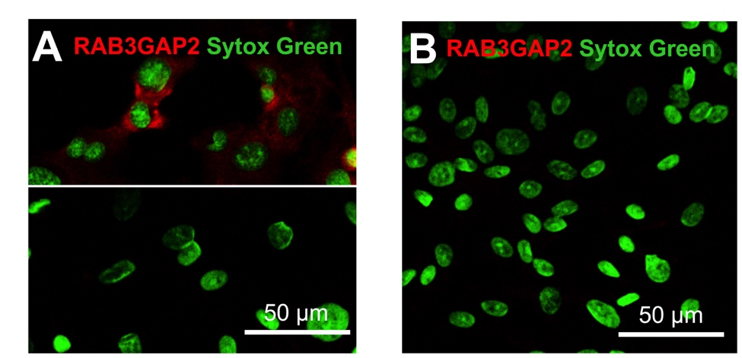
Supplementary figure S7. (A) Representative confocal immunofluorescence images showing staining of human microvascular endothelial cells (HMEC) with rabbit anti-RAB3GAP2 (red; upper panel) or with non-immune isotype control (lower panel). (B) Confocal immunofluorescence image of human umbilical vein endothelial cells (HUVEC) showing no detection of RAB3GAP2 (red) when cells are stained as in the upper panel in A. Nuclei are stained with the DNA-binding dye SYTOX Green.

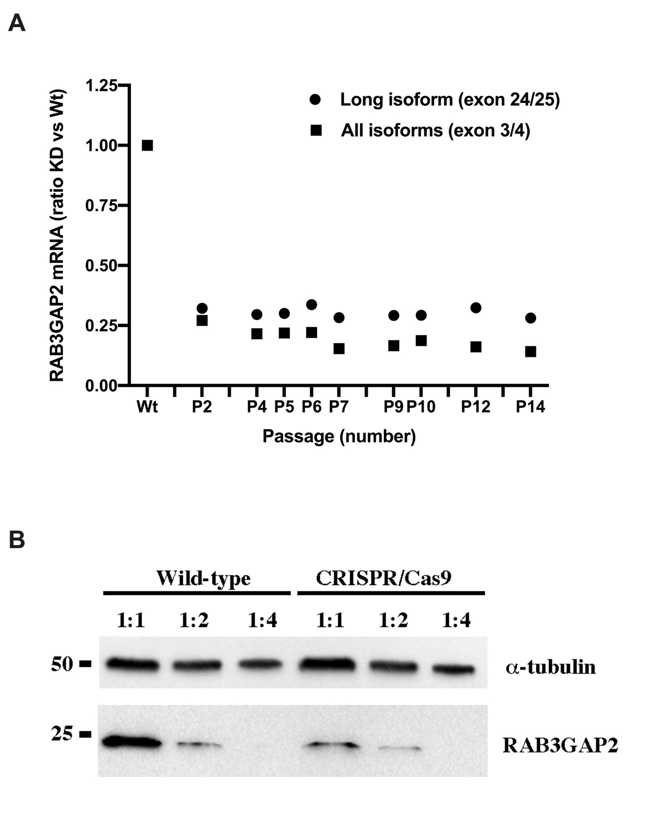
Supplementary figure S8. (a) Sustained CRISPR-Cas9-mediated RAB3GAP2 mRNA knockdown (KD) in human microvascular endothelial cells (HMEC) in different passages estimated with quantitative real-time PCR. Dots and squares showing RAB3GAP2 KD ratio vs Wildtype of long isoform and all isoforms, respectively. (b) Western blot for RAB3GAP2 and alpha-tubulin (reference) on protein lysates obtained from wild-type and RAB3GAP2 CRISPR/Cas9-mediated knockdown HMEC cells. Different dilutions of protein lysates (1:1, 1:2, 1:4) were loaded on the gel to assess linearity between protein quantity and band intensity.

