Supplementary Information

ELOVL2: a novel tumor suppressor attenuating tamoxifen resistance in breast cancer

Jeong et al.

Fig. S1
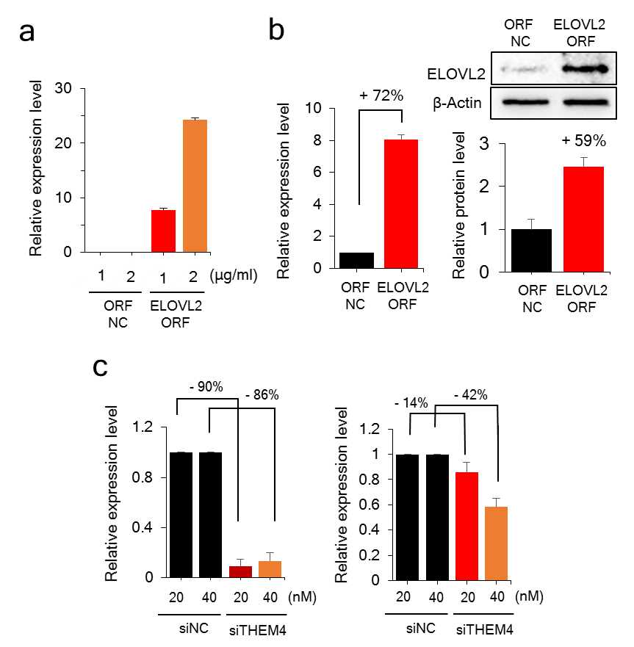

Fig. S1. Optimization of plasmid and siRNA transfection into cultured cells. MCF-7/TamR cells are transiently transfected with an ORF to induce upregulation or with a siRNA to induce downregulation of the indicated gene. a Overexpression of ELOVL2. Recombinant plasmid DNA (1–2 μg/mL) is transfected, and 2 μg/mL is used for further transfection. b Expression of ELOVL2 is confirmed by qPCR and Western blot analysis. c Downregulation of THEM4 using siRNA, as judged by qPCR. siRNA targeting THEM4 is used in MCF-7/TamR cells (left) and MCF-7/TamR ELOVL2 ORF cells (right).
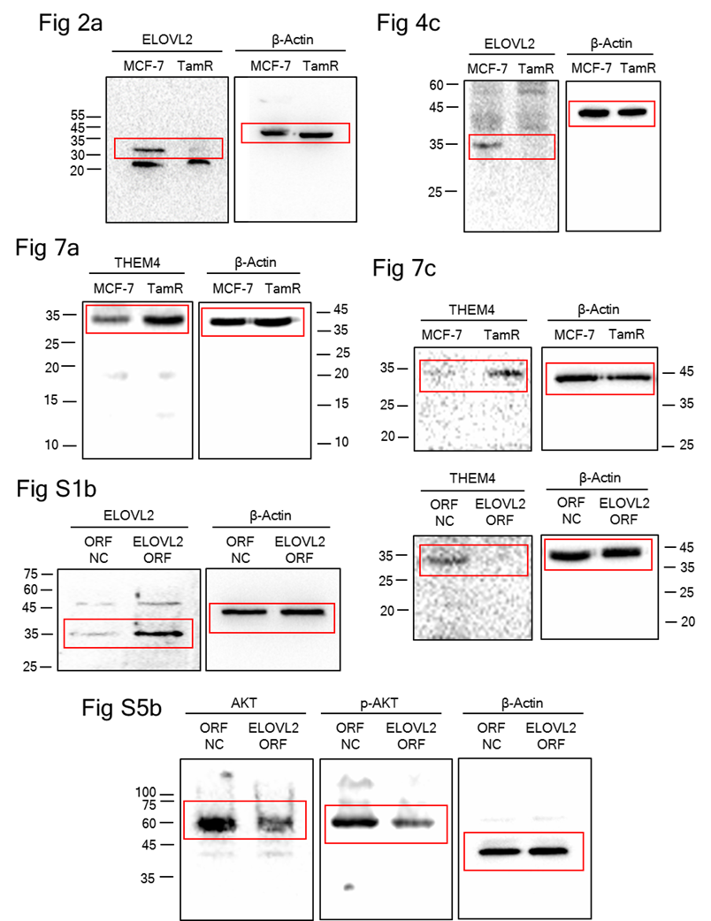
Fig. S2

Fig. S2. Uncropped blots corresponding to Western blots in the main text and Supplementary Figures. Boxed areas correspond to the images in the main and Supplementary text.

Fig. S3
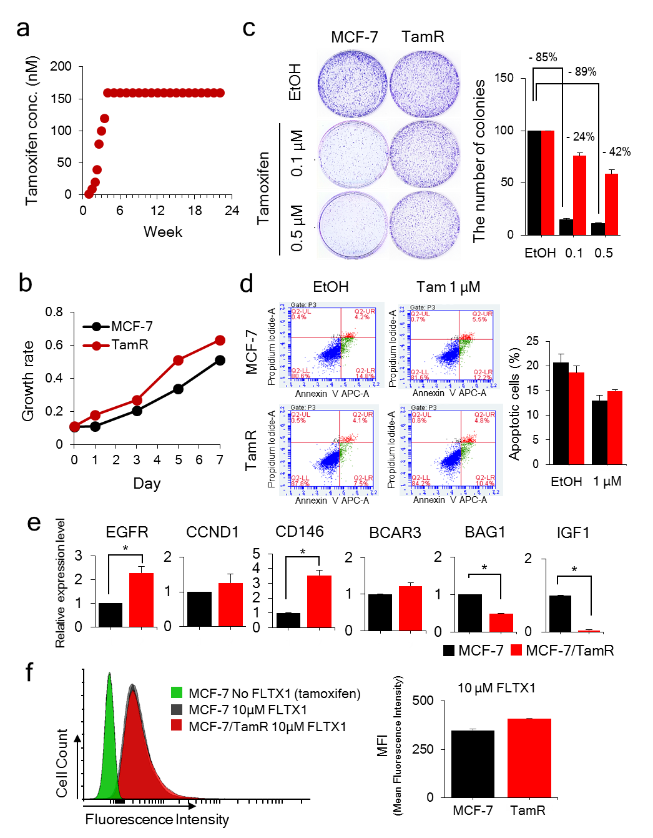
Fig. S3. Establishment of MCF-7/TamR cells. a MCF-7 cells are treated with Tam by a step-wise increase up to 160 µM for 8 weeks and further cultured until 22 weeks to finally obtain TamR cells. b Drug resistance of MCF-7/TamR cells is confirmed by colony formation assay. TamR cells show a higher survival rate than the parental cells under Tam pressure. The bar graph shows the quantification of three independent experiments. c Expression profiles of TamR marker genes. A few genes, the expressions of which were previously revealed to be altered in the TamR cells, are examined by qPCR and the result confirm a similar expression alteration. d Comparison of growth rate between TamR and parental cells. TamR cells show a higher growth rate than MCF-7 cells. e Lower apoptosis of TamR cells. FACS analysis indicates that TamR cells became resistant to Tam for apoptosis, especially with regard to early apoptosis. f The uptake rate of Tam into the cell. The uptake of fluorescent Tam is monitored by FACS and the result indicates no significant change with just a slight increase in TamR cells. All assays are performed in triplicates, and the results are depicted as mean ± SE.

Fig. S4
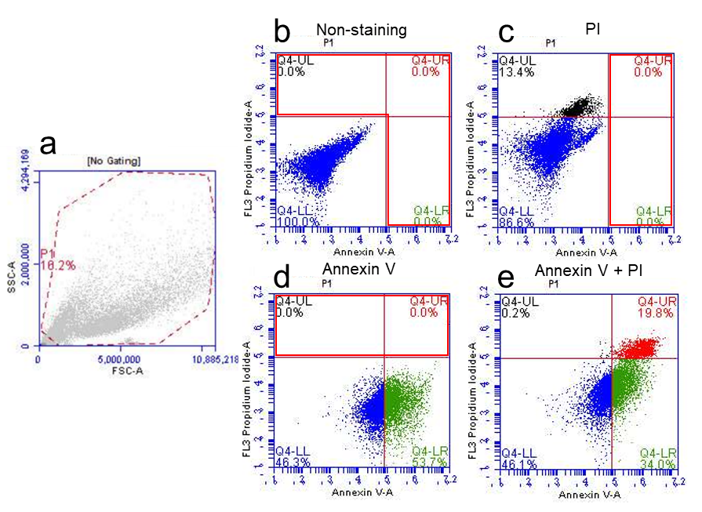

Fig. S4. Gating strategy for flow cytometry analysis. a Cells were first gated to detect single cells excluding cell debris. The cells were further analyzed for their annexin V and PI staining. In all experiments to determine apoptosis the following controls were set to determine the appropriate quadrant allocation: b unlabeled cells where the quadrants were set to allow only viable cells in this quadrant; c PI- labeled cells; d Annexin V-labeled cells; e Dual stained cells. Each quadrant was designated based on the non-stained area.

Fig. S5

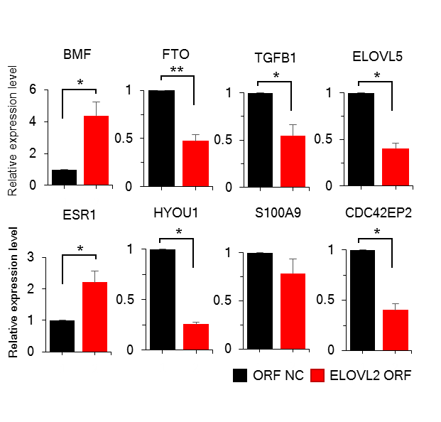

Fig. S5. ELOVL2 regulates genes in AKT and ERα networks. A few genes in the top IPA network (Fig. 6b) are selected and qPCR is performed to confirm the microarray expression data. All genes show the same expression trend with being up- or down-regulated in ELOVL2 overexpression cells compared with the MCF-7/TamR cells, although the alteration level is not the same.

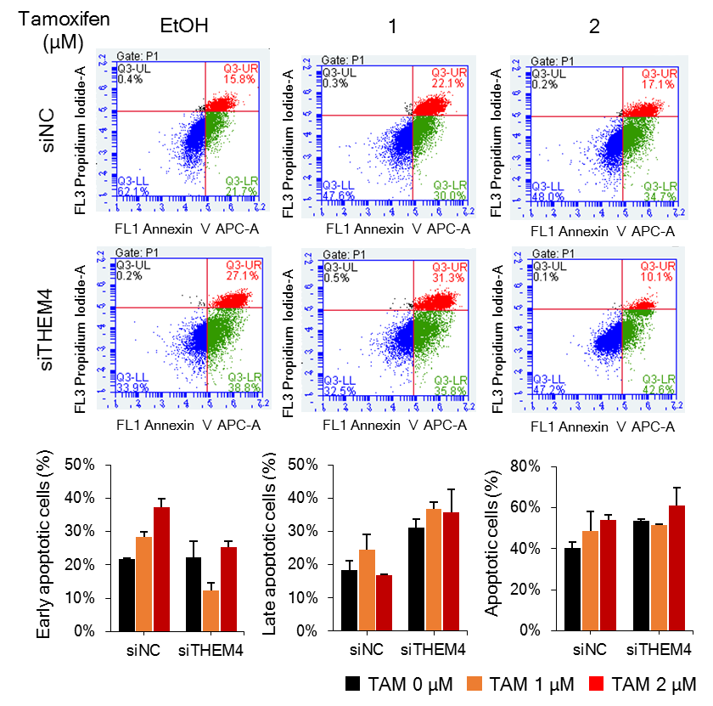
Fig. S6

Fig. S6. Effect of THEM4 on apoptosis of MCF-7/TamR cells. FACS analysis is performed after downregulating THEM4 using siRNA. Overall apoptosis rate is not changed significantly, but the early and late apoptosis is decreased and increased, respectively, by the downregulation of THEM4.

Fig. S7
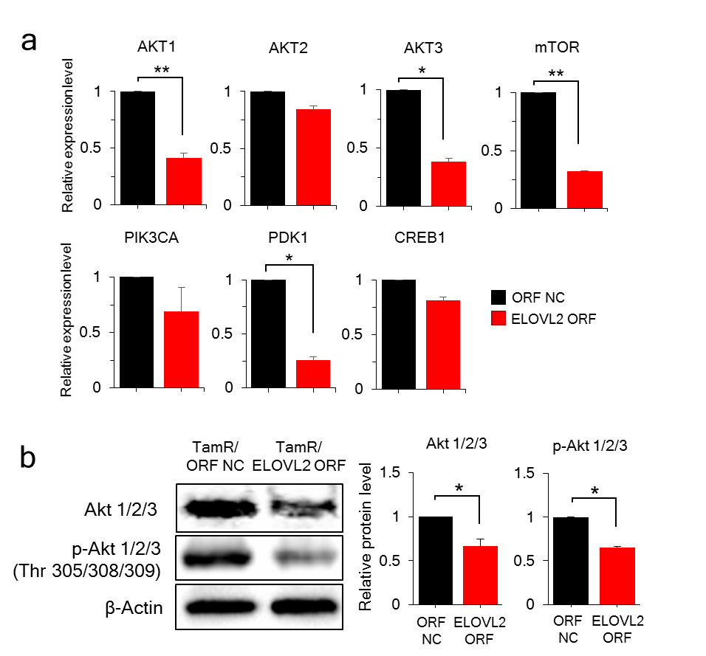

Fig. S7. ELOVL2 downregulates total amount of AKT and p-AKT. a Downregulation of genes in the AKT pathway by ELOVL2. qPCR is performed for seven genes in the AKT pathway in the ELOVL2-overexpressing MCF-7/TamR cells. Samples are analyzed in triplicates, and the result is shown as mean ± SE. b Protein level of AKT and p-AKT is analyzed in the MCF-7/TamR cells transiently transfected with a recombinant ELOVL2 cDNA plasmid. Western blot analysis is performed in triplicates, and a representative image is shown with a bar graph depicted as mean ± SE.
Table S1. Clinicopathologic features in the tamoxifen resistant and the control group.
 | Tamoxifen resistant  (n=28) | Control  (n=33) | P-value
Menopausal status |  |  | 0.53
Pre | 5 | 3
Post | 23 | 30
Primary tumor size |  |  | 0.33
≤2.5cm | 10 | 17
>2.5cm | 18 | 16
Presence of node metastasis |  |  | 0.51
Negative | 12 | 18
Positive | 16 | 15
Ki-67 |  |  | 0.15
≤20% | 14 | 23
>20% | 14 | 10
Table S2. Information of primers for qPCR and siRNAs employed in this study.
Gene | Forward primer (5´→ 3´) | Reverse primer (5´→ 3´) | Supplier
GAPDH | ACATCGCTCAGACACCATG | TGTAGTTGAGGTCAATGAAGGG | IDT
SLC19A1 | CATCGCCACCTTTCAGATTG | CGGAGTATAACTGGAACTGCTTG | Bionics
SKAP1 | TGCTAATGAGAAGAGCAAGCA | GCTGGACTAGTAGCTGTAAACTCA
ELOVL2 | ATGCTGGCAGAGCTCATTCT | ACCTTGGCTACCCGGATGT
CD59 | TGGGATTACAGGTTCTGTGGA | TGCAGGCTATGACCTGAATG
MMP1 | GACAGATTCTACATGCGCAC | CCCTTTGAAAAACCGGACTTC
THEM4 | ACCCGAGCTGAGGTCATTTT | GCTTTGGGTCAAGAAAATGGG
EGFR | GCGTTCGGCACGGTGTATAA | GGCTTTCGGAGATGTTGCTTC
CCND1 | TGTGCCACAGATGTGAAGTT | CGGGTCACACTTGATCACTC
CD146 | CACCGTCCCTGTTTTCTACC | GTGCTGGGGTTCTGCTTG
BCAR3 | CCCGACAGGTGTCTGAAAAC | CGCTGAGTCGCAGAACTGT
BAG1 | CACACTGATCCTGCCAGAAA | GCCAGGGCAAAGTTTGTAGA
IGF1 | ACCTTGGGCAAGTCACTTCA | TGTTGCACCCTTACAGCAAC
BMF | GAGCCATCTCAGTGTGTGGAG | GCCAGCATTGCCATAAAAGAGTC
FTO | ATAGCTGTGAAGGCCCTGAA | TTGGTGGGTGGCATTGAGAT
TGFB1 | GTTGTGCGGCAGTGGTTG | GTGAACCCGTTGATGTCCAC
ELOVL5 | GGTGCCACACTTAATAGCTTCA | GGGACTGACGACAAACCATAGT
ESR1 | CTTGCTCTTGGACAGGAACC | GACAGAAATGTGTACACTCCAGA
HYOU1 | GGCAAGAGGGGCACTATGG | CTTCATGGACTCACTGCCCA
S100A9 | GCTCCTCGGCTTTGACAGA | CACCAGCTCTTTGAATTCCCC
CDC42EP2 | AGCTCCTGAGACCTTGCTG | AGGACGGCAAACTCTTCTGA
AKT1 | AAGGAAGTCATCGTGGCCAA | AGTACTTCAGGGCTGTGAGG
AKT2 | ACGGGCTAAAGTGACCATGA | TGTGTGAGCGACTTCATCCT
AKT3 | GATACTCCAGAGGAAAGGGAAGA | GATGGGTTGTAGAGGCATCC
mTOR | CCTCAGTGGTACAGGCACAC | CTCAGACGCTCTCCCTCCAT
PIK3CA | AGAGCCCCGAGCGTTTCT | CTAGGATTCTTGGGGGCATC
PDK1 | TGCTAGGCGTCTGTGTGATT | TGGCTCTCATTGCATTCTTG
CREB1 | GAGGAGCTTGTACCACCGG | TGCTGGCATAGATACCTGGG
ELOVL2 M | ATAATTAGGTAGATGGTAcg | TCCATATTCAATATTTACCTC | Bionics
ELOVL2 U | ATAATTAGGTAGATGGTAtg | TCCATATTCAATATTTACCTC
 | Product name or sequence (5´→3´) |  | Supplier
THEM4  siRNA | Sense: GAGGAUUCAGUUUCCAUCUtt |  | Bioneer
 | Antisense: AGAUGGAAACUGAAUCCUCtt
Control  siRNA | Negative control siRNA (Cat. No. SN-1003)
* ELOVL2 ORF vector (pEZ-M02) |  |  | Cosmogenetech
Negative control ORF vector (pReceiver-M02CT, Cat. No. EX-NEG-M02) |  |  | Genecopoeia
ELOVL2(NM_017770) Human ORF Clone Lenti Particle (Cat. No. RC209232L4V) |  |  | Origene
Lenti-ORF Control Particles (Cat. No. PS100093V)
* ELOVL2 ORF is subcloned into Genecopoeia ORF Vector (Cat. No. EX-M0461-M02)
Table S3. Top 20 genes of which methylation is highly altered in the MCF-7/TamR cells.
Symbol | Accession | Description | Δ β-valueª | Fold change^{b}
SLC19A1 | NM_194255 | solute carrier family 19 member 1 | 0.8372 | 12.6487
ELOVL2 | NM_017770 | ELOVL fatty acid elongase 2 | 0.4891 | 4.0003
ARHGAP6 | NM_013427 | Rho GTPase activating protein 6 | 0.4738 | 3.9104
HES6 | NM_018645 | hes family bHLH transcription factor 6 | 0.4559 | 2.4814
ZCCHC5 | NM_152694 | zinc finger, CCHC domain containing 5 | 0.4464 | 2.6917
PLEKHG7 | NM_001004330 | pleckstrin homology domain containing, family G member 7 | 0.4338 | 2.6532
P2RY10 | NM_014499 | purinergic receptor P2Y 10 | 0.429 | 2.235
SKAP1 | NM_003726 | src kinase associated phosphoprotein 1 | 0.4168 | 2.7189
TRAPPC2 | NM_014563 | trafficking protein particle  complex 2 | 0.4066 | 2.8467
OFD1 | NM_003611 | oral-facial-digital syndrome 1 | 0.4066 | 2.8467
SRPX2 | NM_014467 | sushi-repeat containing protein,  X-linked 2 | -0.3303 | -1.7687
LNX1 | NM_032622 | ligand of numb-protein X 1 | -0.3306 | -1.8897
MMP1 | NM_002421 | matrix metallopeptidase 1 | -0.3312 | -1.9492
GPX5 | NM_001509 | glutathione peroxidase 5 | -0.3323 | -2.0417
GUCY1B3 | NM_000857 | guanylate cyclase 1, beta 3 | -0.3624 | -1.8898
CD59 | NM_203329 | CD59 molecule | -0.3951 | -1.9305
RPS6KL1 | NM_031464 | ribosomal protein S6 kinase-like 1 | -0.4119 | -2.5277
TLR6 | NM_006068 | toll-like receptor 6 | -0.42 | -2.012
RASAL2 | NM_170692 | RAS protein activator like 2 | -0.4394 | -2.5287
LRP11 | NM_032832 | low density lipoprotein receptor-related protein 11 | -0.5875 | -3.2229
ªThe values are obtained by subtracting the methylation level of MCF-7 cells from that of MCF-7/TamR cells.
^{b}The values are obtained by dividing the expression level of MCF-7/TamR cells by that of MCF-7 cells.

