Additional file 9. Maximum ICP values prior to start high TIL use per treatment group
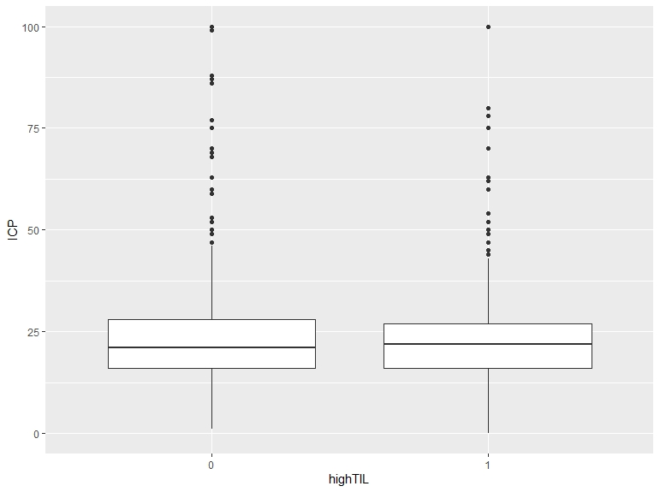
This figure shows the differences in maximum ICP values prior to high TIL treatment between patients with a high TIL (1) versus a low TIL treatment (0). The median ICP for low TIL is 22 [16-28] and for high TIL 22 [16-27]. This difference is not statistically significant.

