Supplementary Figures
Chen et al.
Dominant drivers of the human plasma metabolome

Table of Contents
Figure S1. Overview of study cohorts and summary of plasma metabolites. 2
Figure S2. Comparison of the proportion of the variation explained by microbe and genetics at two time points. 3
Figure S3. Comparison of metaQTL effect sizes in different LifeLines cohorts. 4
Figure S4. Tissue-specific gene expression analysis with FUMA. 5
Figure S5. Metabolites associated with gutSMASH pathways. 6
Figure S6. Leave-one-out sensitivity analysis for significant MR linkages. 7

Figure S1. Overview of study cohorts and summary of plasma metabolites.
A. Summary of cohorts and datasets that involved in the analyses. B. Number of metabolites per metabolic categories of plasma metabolites, based on the annotation of the HMDB database. C. Comparison of metabolite concentrations between un-targeted LC-MS/MS and NMR platforms. D. Inter-correlation between metabolites in the Lifelines-DEEP baseline samples. Rows and columns represent metabolites. The color scheme represents the Spearman correlation coefficient.

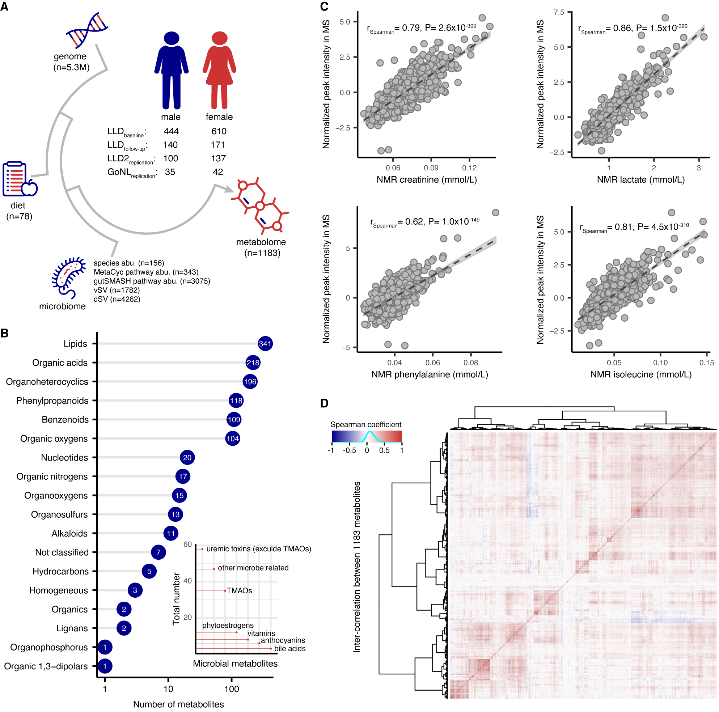

Figure S2. Comparison of the proportion of the variation explained by microbe and genetics at two time points.
A. Proportion of the variation explained by the gut microbiome. B. Proportion of the variation explained by genetics. Each dot represents a metabolite. The x-axis refers to the explained variation at the baseline. The y-axis refers to the explained variation at the follow-up. The similarity between two time points was assessed using the Spearman correlation.

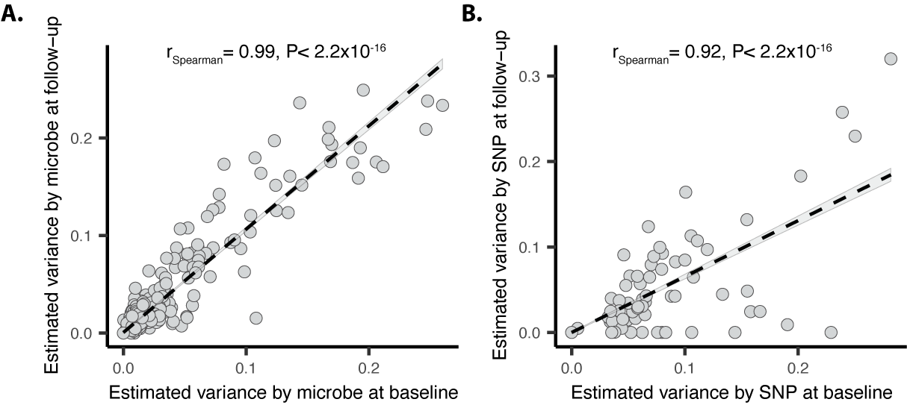

Figure S3. Comparison of metaQTL effect sizes in different LifeLines cohorts.
Dots represent identified independent metaQTLs identified in the Lifelines-DEEP baseline samples. The x-axis refers to the effect size estimated in the LLD baseline cohort. The y-axis refers to the effect size estimated in the LLD follow-up, LLD2, and GoNL samples, respectively. The mbQTL that was significant at P<0.05 level in the corresponding cohort is filled with black color, otherwise with gray.

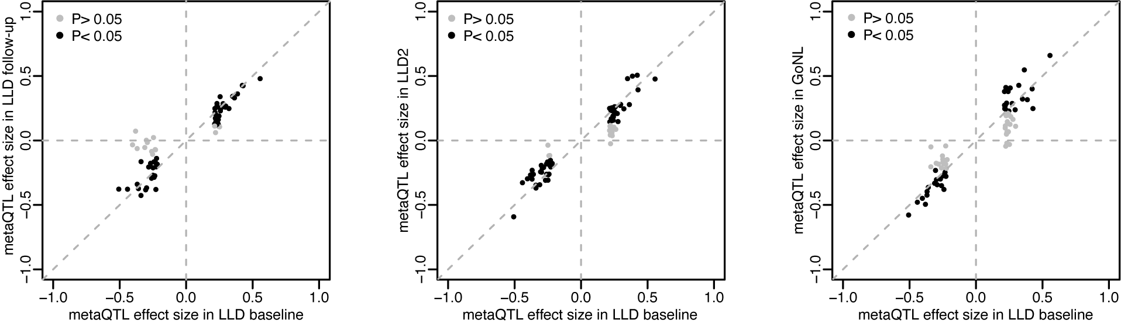

Figure S4. Tissue-specific gene expression analysis with FUMA.
All significant metaQTLs observed in the LLD baseline were used to check the enrichment of differentially expressed gene (DEG) sets in a certain tissue compared to all other tissue types based on GTEx (version 8).

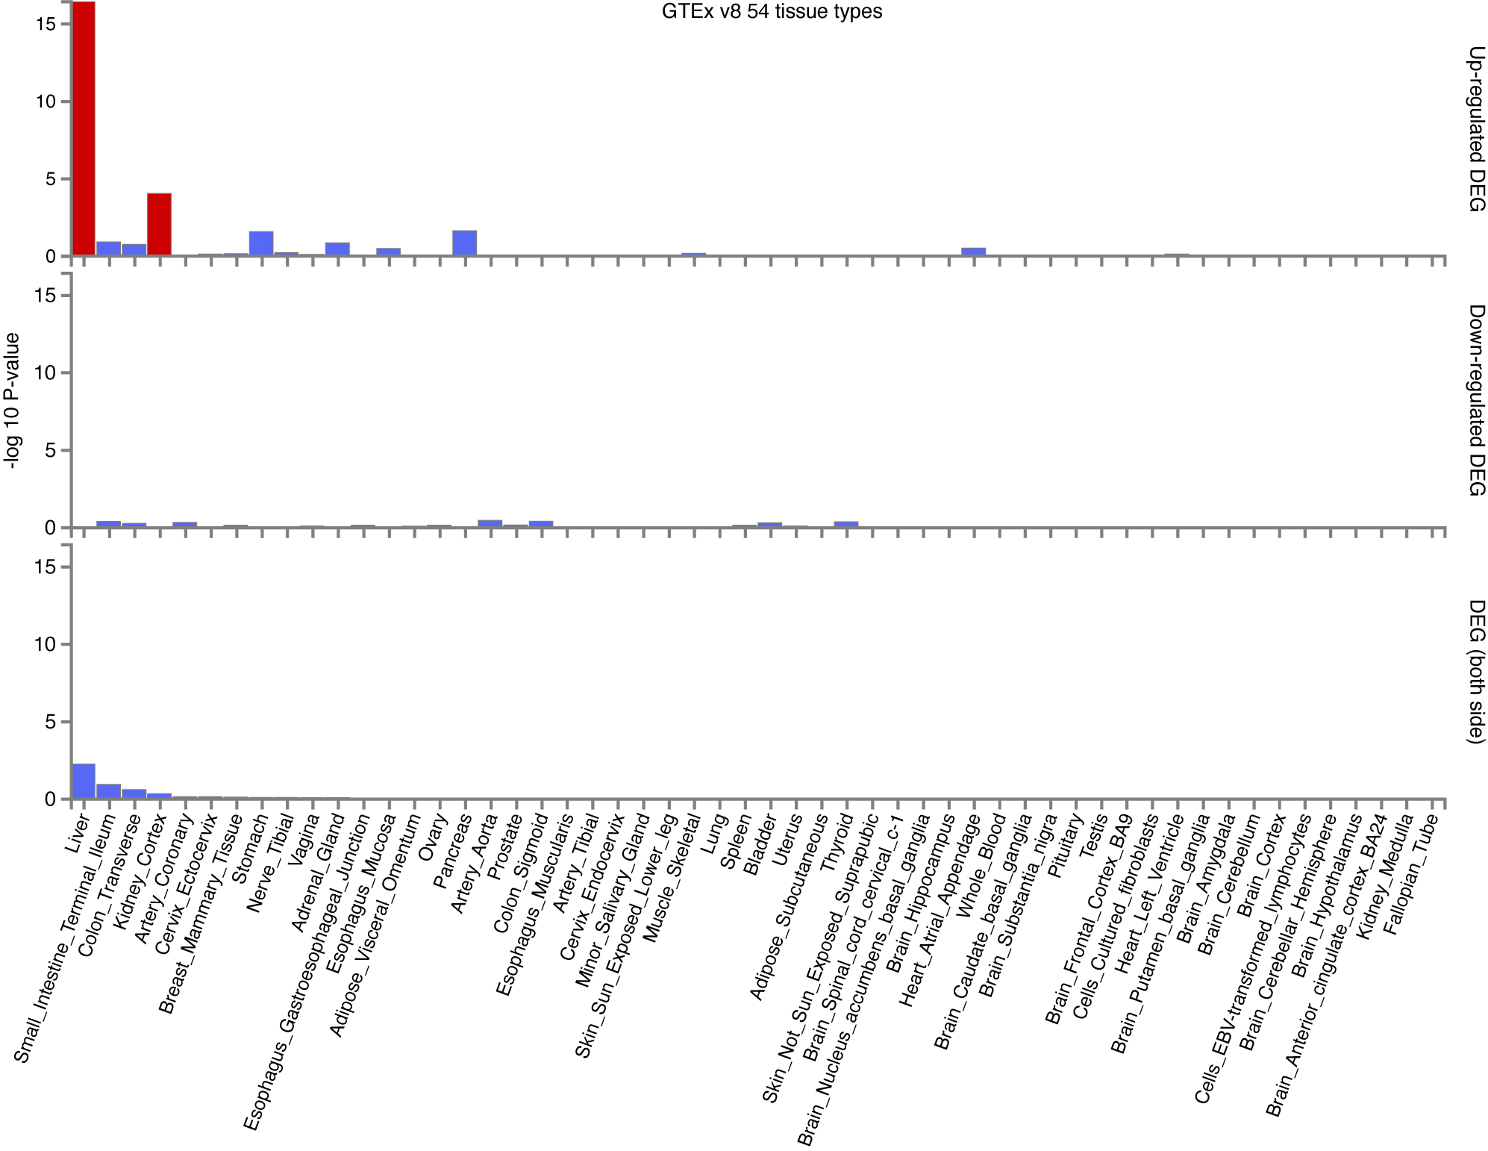

Figure S5. Metabolites associated with gutSMASH pathways.
A. Correlation between microbial glycine cleavage pathway and plasma hippuric acid levels. B. Correlation between microbial hydroxybenzoate to phenol pathway and plasma phenol sulfate levels. The upper part indicates the chemical transformation of the gutSMASH pathways. The lower part indicates the correlation between the pathway abundance (x-axis) and the plasma level of the corresponding metabolite (y-axis).

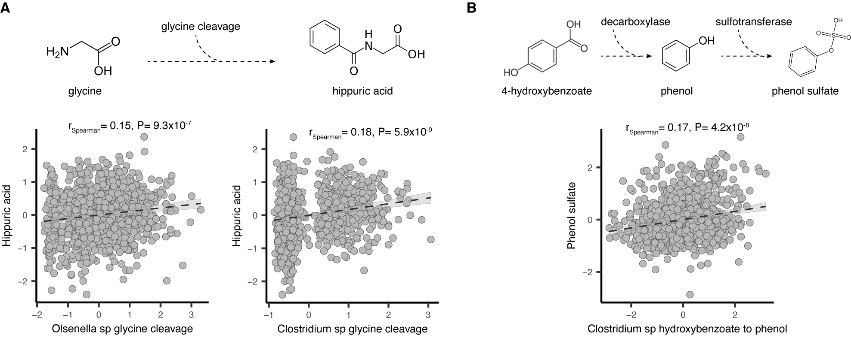

Figure S6. Leave-one-out sensitivity analysis for significant MR linkages.
Forest plots of MR leave-one-out sensitivity results (IVW method) on 7 significant bi-directional MR linkages in the LLD baseline and follow-up. Bars represent 95% confidence intervals and X-axis represent effect size of MR.

