SUPPLEMENTARY MATERIALS

Title: Testing behaviour and positivity for SARS-CoV-2 infection: Insights from web-based participatory surveillance

Authors: Scott A. McDonald¹, Loes Soetens¹, Maarten Schipper¹, Ingrid H. M. Friesema¹, Cees C. van den Wijngaard¹, Anne Teirlinck¹, Nienke Neppelenbroek¹, Susan van den Hof¹, Jacco Wallinga^{1,2}, Albert Jan van Hoek¹

¹ Centre for Infectious Disease Control, Netherlands National Institute for Public Health and the Environment, Bilthoven, the Netherlands
² Department of Biomedical Data Sciences, Leiden University Medical Center, Leiden, the Netherlands

Fig. S1. Heatmap showing positive predictive value (PPV) per symptom, among subpopulations corresponding to each of the six identified lower test propensity/higher positivity participant factors.
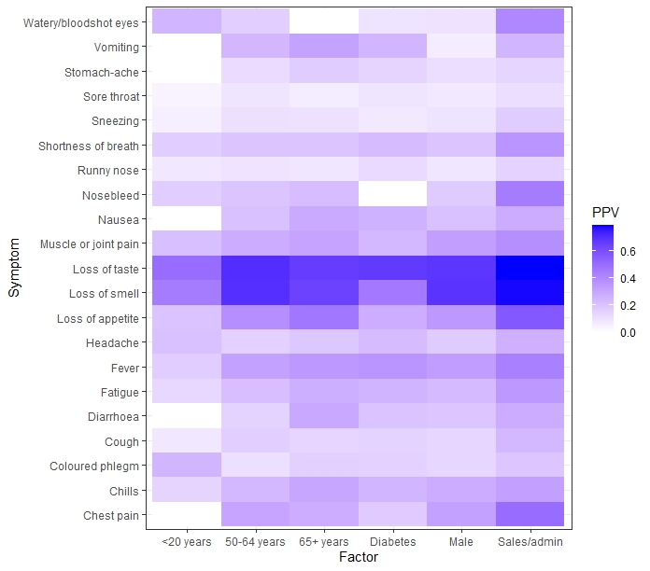

Fig. S2. Results of sensitivity analysis restricting to the approximate working age population (20-64 years). Adjusted ORs for test propensity and positivity, for the same participant factors, are shown (analysis period 17 November 2020 to 18 April 2021; n=41,017 surveys). Light blue crosses indicate the 95% CIs in each dimension. The shaded quadrant indicates the combination of interest: lower test propensity and higher positivity. Lung condition not shown (very low and uncertain OR (0.09, 95% CI: 0–38.9) for positivity).
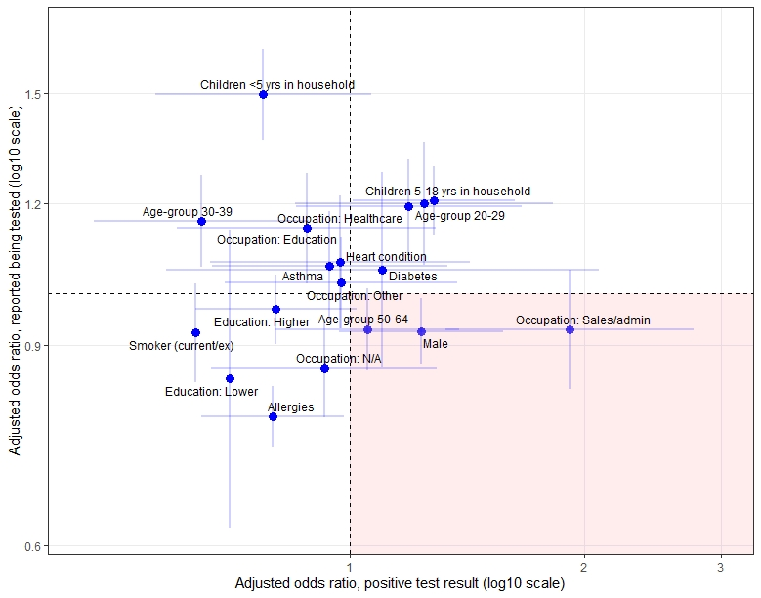

Table S1. Distribution of sex, age-group and education level, comparing Infectieradar participants (n=16,807) to the general population. Data for the year 2020 were obtained from Statistics Netherlands [1,2].

Variable  Group | Study population (%) | Netherlands population (%)
Age-group  <20 years  20-29  30-39  40-49  50-64  65+  Sex  Male  Female  Education level (15+ years old)  None/primary  Middle  Higher | 2.3  7.0  13.1  18.4  38.2  21.0  42.8  57.2  2.3  36.3  61.4 | 21.7  12.8  12.3  12.7  21.0  19.5  49.7  50.3  30.9  36.7  32.4

1. Statistics Netherlands. Population; sex, age and martial status. https://opendata.cbs.nl/statline/#/CBS/en/dataset/7461eng/table?ts=1615898674521. Accessed 15 March 2021.
2. Statistics Netherlands. Bevolking; onderwijsniveau; geslacht, leeftijd en migratieachtergrond. https://opendata.cbs.nl/statline/#/CBS/nl/dataset/82275NED/table?ts=1615899135543. Accessed 15 March 2021.

