Supplementary Information

Towards accurate state of charge estimation for lithium-ion batteries using self-supervised transformer model: A deep learning approach

M A Hannan^{1*}, Dickson N T How¹, M S Hossain Lipu², M. Mansor¹, Pin Jern Ker³, Z Y Dong⁴, K S M Sahari⁵, S K Tiong³, K M Muttaqi⁶, T M Indra Mahlia⁷, F Blaabjerg⁸

¹Department of Electrical Power Engineering, COE, Universiti Tenaga Nasional, Kajang 43000, Malaysia
²Dept of Electrical, Electronic and Systems Engineering, Universiti Kebangsaan Malaysia, Bangi 43600, Malaysia
³Institute of Sustainable Energy, Universiti Tenaga Nasional, Kajang 43000, Malaysia
⁴School of Electrical Engineering and Telecommunications, UNSW, Kensington NSW 2033, Australia
⁵Department of Mechanical Engineering, COE, Universiti Tenaga Nasional, Kajang 43000, Malaysia
⁶School of Electrical, Computer and Telecommunications Engineering, University of Wollongong, NSW 2522, Australia
⁷School of Information, Systems and Modelling, University of Technology Sydney, Ultimo NSW 2007, Australia
⁸Department of Energy Technology, Aalborg University, 9220 Aalborg, Denmark

*Corresponding author’s email: hannan@uniten.edu.my; dickson@uniten.edu.my

Supplementary Table 1: Specifications of the cylindrical LG18650 LiNiMnCoO₂ cell.

Supplementary Table 2: Specifications of the cylindrical Panasonic LiNiMnCoO₂ cell.

Supplementary Table 3: Train, validation, and test set drive cycles.

Supplementary Table 4: Architecture hyperparameter values for model.

Supplementary Table 5: Training hyperparameter of the proposed Transformer model.

Supplementary Fig. 1: (a) Optimal region (in green shade) of learning rate values that corresponds to the most rapid decline in the loss value and hence are better suited to be used in training. (b) Learning rate schedule during the training process. (c) Loss values on the training and validation set during training. (d) RMSE metric on the training and validation set during training.

Supplementary Fig. 2: (a) Relation between training modes and the RMSE metric. (b) Relation between training modes and training time.

Supplementary Table 1. Specifications of the cylindrical LG18650 LiNiMnCoO₂ cell.

Type | Nominal  Capacity (Ah) | Nominal  Voltage (V) | Cut-off  Voltage (V) | Maximum  Current (A) | Specific  Energy (Wh/kg)
18650 NMC | 3.0 | 3.6 | 2.5/4.2 | 20 | 240

Supplementary Table 2. Specifications of the cylindrical Panasonic LiNiMnCoO₂ cell.

Type | Nominal  Capacity (Ah) | Nominal  Voltage (V) | Cut-off  Voltage (V) | Maximum  Current (A) | Specific  Energy (Wh/kg)
18650 NMC | 2.9 | 3.6 | 2.5/4.2 | 10 | 206

Supplementary Table 3. Train, validation, and test set drive cycles.

Dataset | Dataset Drive Cycles | Total timesteps
Train | Mix1, Mix2, Mix3, Mix4, Mix5, Mix6, HPPC, HWFET | 318,072
Validation | Mix7, Mix8 | 68,032
Test | UDDS, LA92, US06 | 152,215

Supplementary Table 4. Architecture hyperparameter values for model.

Hyperparameter | Value
Input dimension | 3 (voltage, current, temperature)
Number of layers in encoder | 3
Sequence length | 400
Number of features | 128
Type of positional encoder | Zeros
Number multiheaded attention heads | 16
Batch normalization | False
Dimension of feedforward layer | 256
Activation function | Gaussian Error Linear Units (GELU)
Dropout in feedforward layer | 0.2
Residual dropout in encoder | 0.1

Supplementary Table 5. Training hyperparameter of the proposed Transformer model.

Hyperparameter | Value
Pretraining LR | 1e-3
Retraining LR | 2e-4
LR Schedule | Flat and cosine annealing
Optimizer | Ranger
Minibatch size | 128
Training epochs | 25
Loss function | Log-cosh
Error metric | RMSE & MAE

Supplementary Figures

Supplementary Fig. 1 (a) shows the optimal region (in green shade) of learning rate values that corresponds to the most rapid decline in the loss value and hence are better suited to be used in training. Supplementary Fig. 1 (b) shows the learning rate schedule during the training process. In the beginning 75% of the training loop, the learning rate is held at a constant value and during the last 25% of the training, the learning rate value is decayed following the cosine function. Supplementary Fig. 1 (c) shows the loss values on the training and validation set during training. Supplementary Fig. 1 (d) shows the RMSE metric on the training and validation set during training.

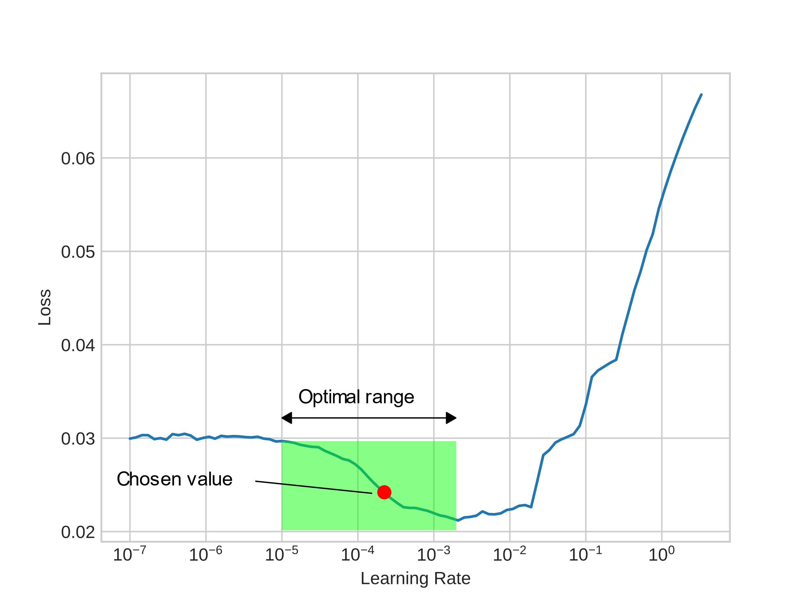 | 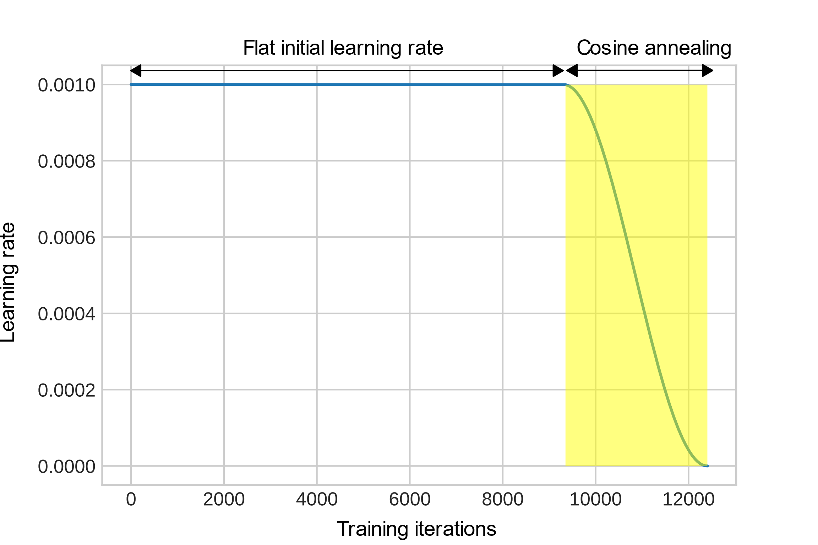
(a) | (b)
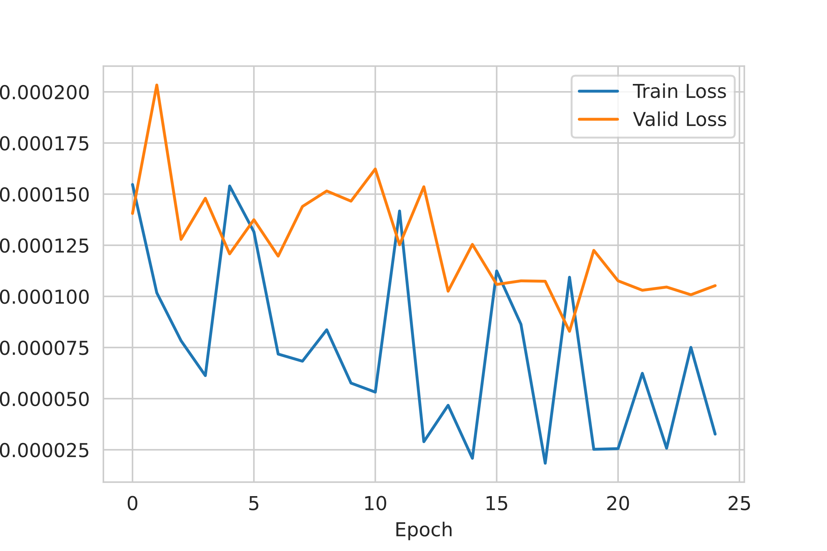 | 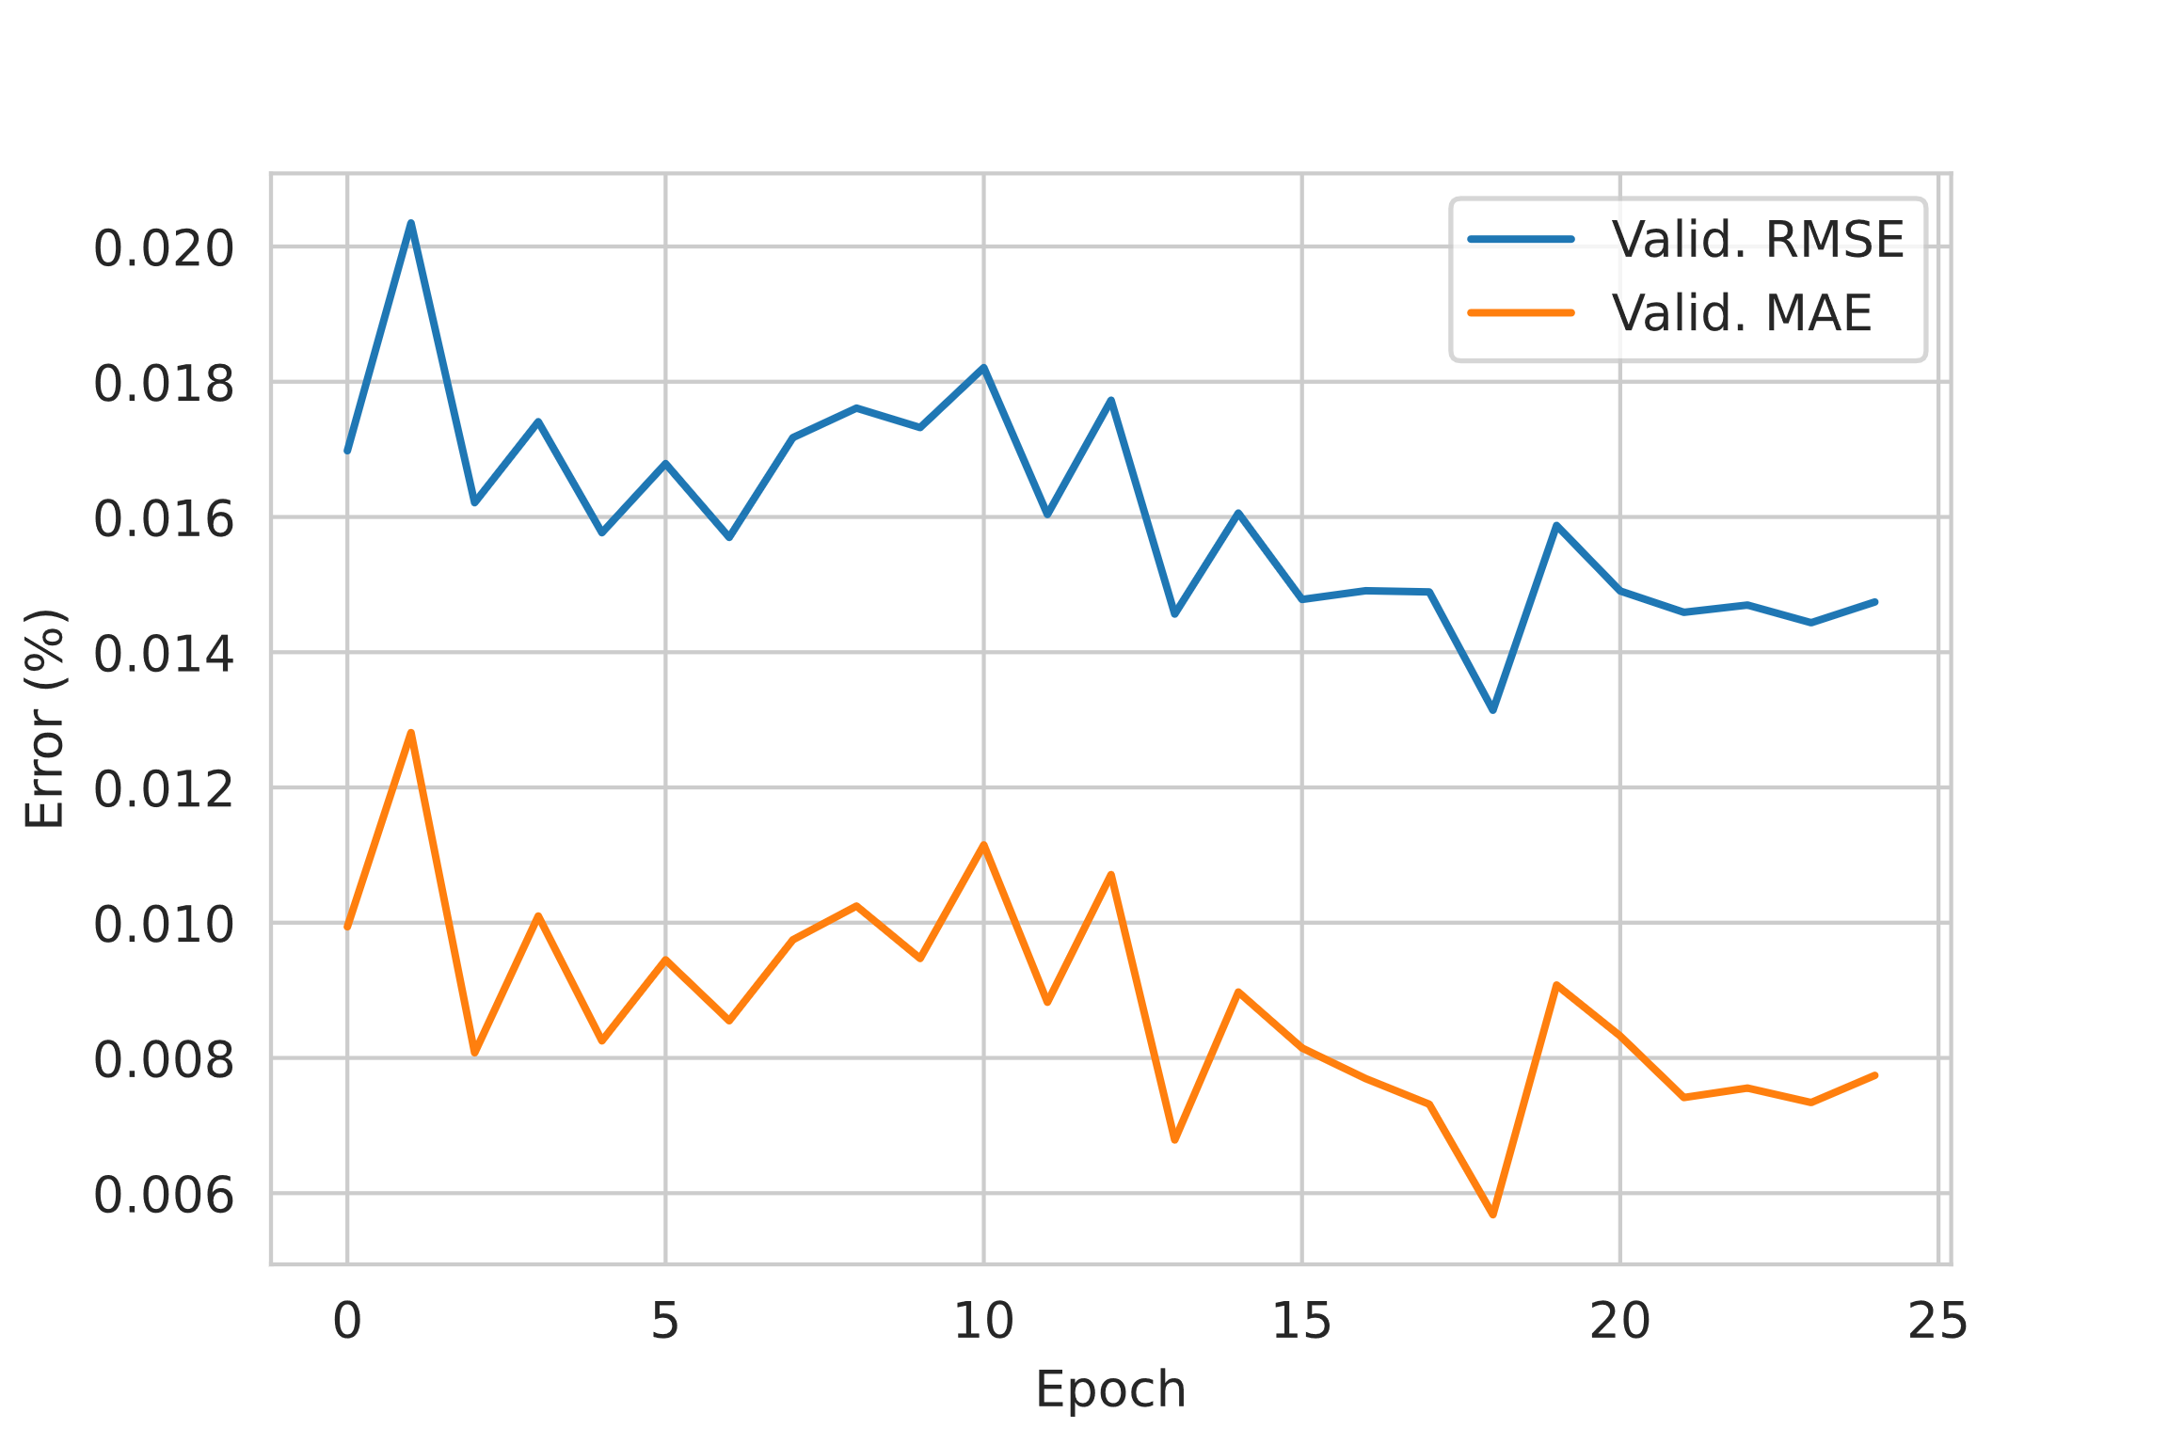
(c) | (d)

Supplementary Fig. 1 (a) Optimal region (in green shade) of learning rate values that corresponds to the most rapid decline in the loss value and hence are better suited to be used in training. (b) Learning rate schedule during the training process. (c) Loss values on the training and validation set during training. (d) RMSE metric on the training and validation set during training.

Supplementary Fig. 2 (a) shows the relation between training modes and the RMSE metric and supplementary Fig. 2 (b) shows the relation between training modes and training time. Supplementary Fig. 2 (a) shows that PT+RT always results in lower RMSE compared to T and PT+FT. Supplementary Fig. 2 (b) shows that PT+RT takes almost the same amount of training time compared to training mode T. In both subfigures, it is evident that PT+RT mode contributes to the lowest RMSE and take approximately the same amount of time compared to models trained in training mode T.

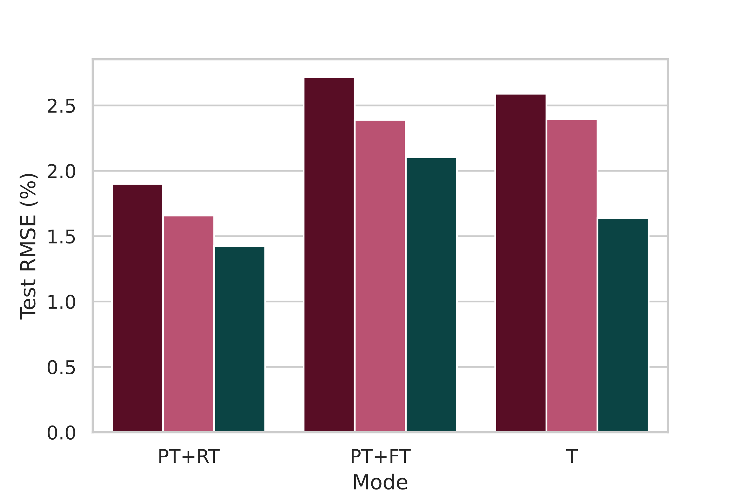 | 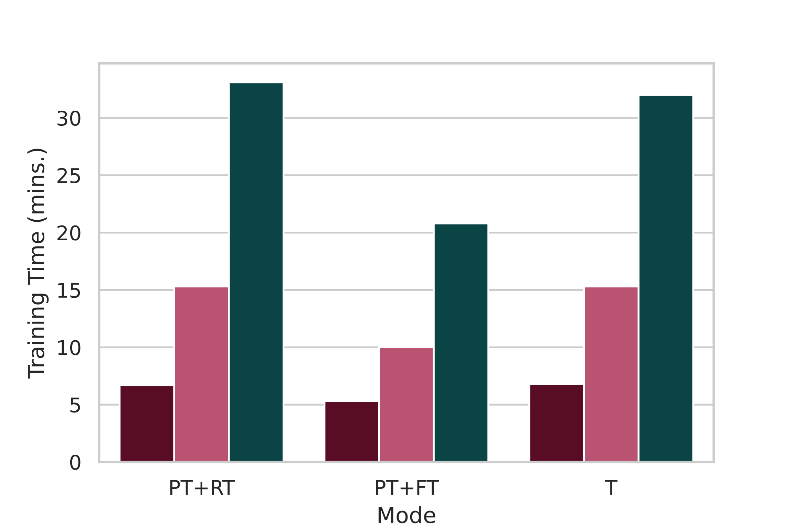
(a) | (b)
Supplementary Fig. 2. (a) Relation between training modes and the RMSE metric. (b) Relation between training modes and training time.

