Supplement 9
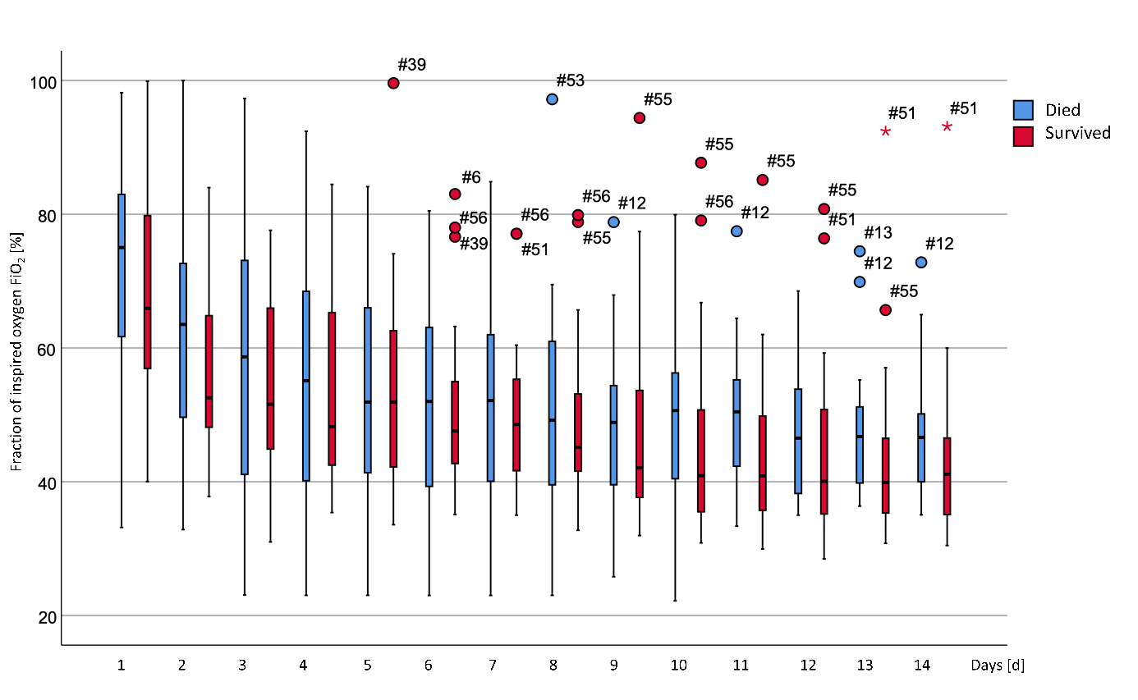
Figure 1 Daily mean values for the fraction of inspired oxygen (FiO₂). Significant differences between the two groups are marked with an asterisk in the legend of the x-axis.
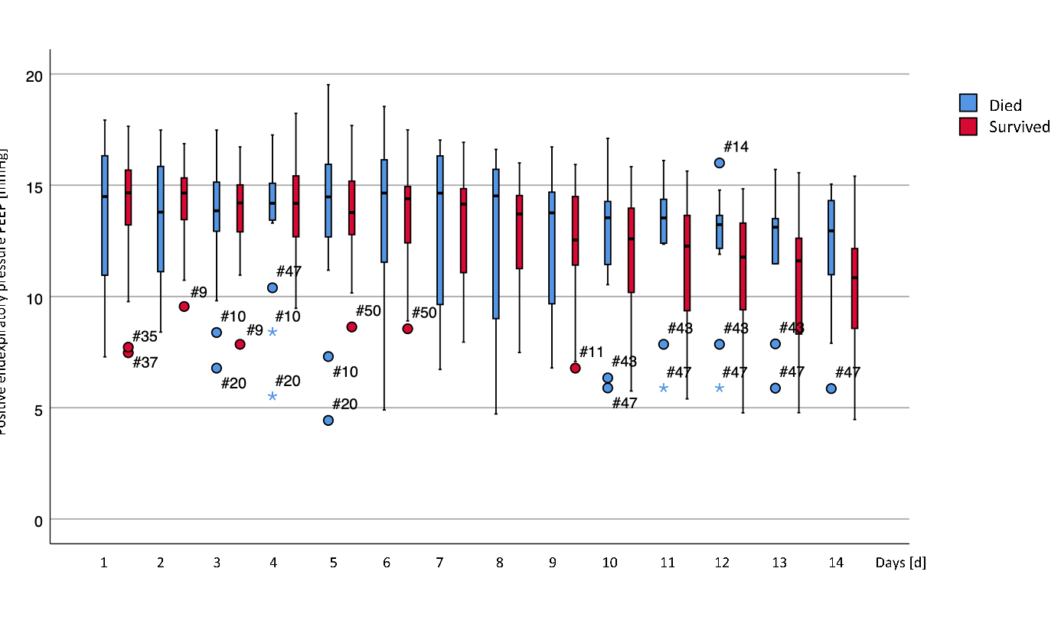
Figure 2 Daily mean values for positive endexpiratory pressure (PEEP). Significant differences between the two groups are marked with an asterisk in the legend of the x-axis.
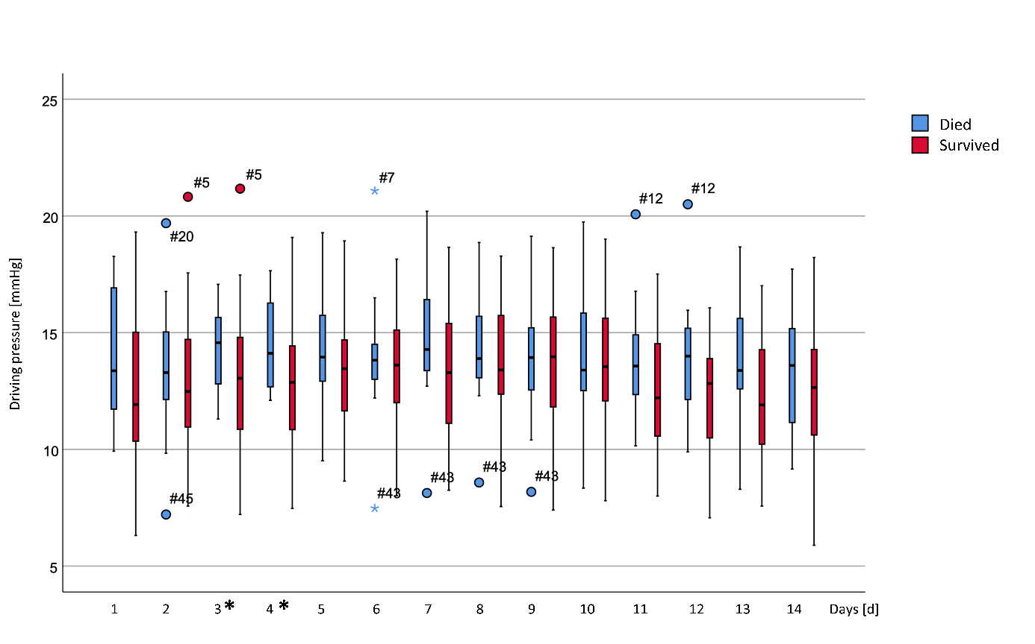
Figure 3 Daily mean values for driving pressure. Significant differences between the two groups are marked with an asterisk in the legend of the x-axis.
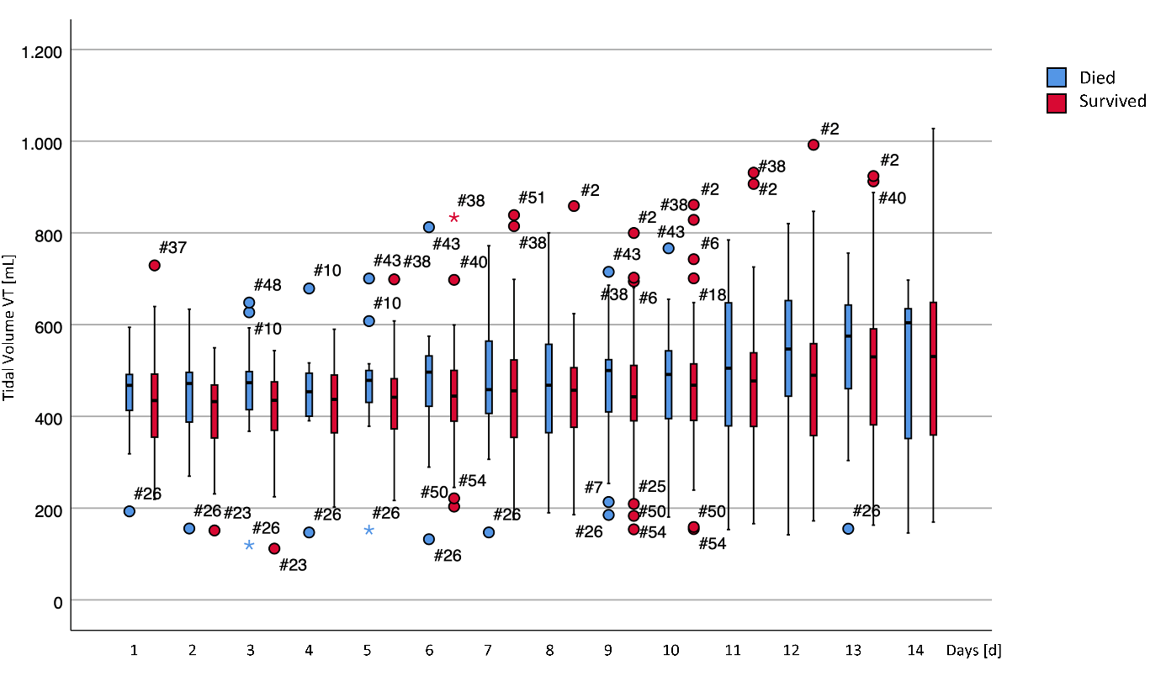
Figure 4 Daily mean values for tidal volume (VT). Significant differences between the two groups are marked with an asterisk in the legend of the x-axis.
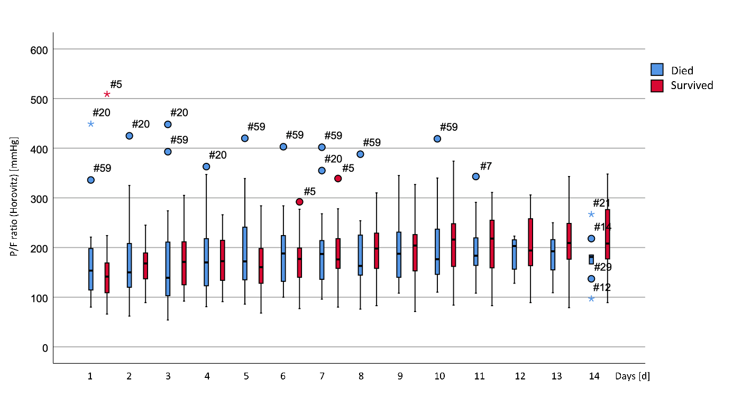
Figure 5 Daily mean values for the paO₂/FiO₂ ratio (P/F ratio). Significant differences between the two groups are marked with an asterisk in the legend of the x-axis.

