**Supplement 3**



***Figure 1*** *Distribution of age*



***Figure 2*** *Distribution of body-massindex (BMI)*

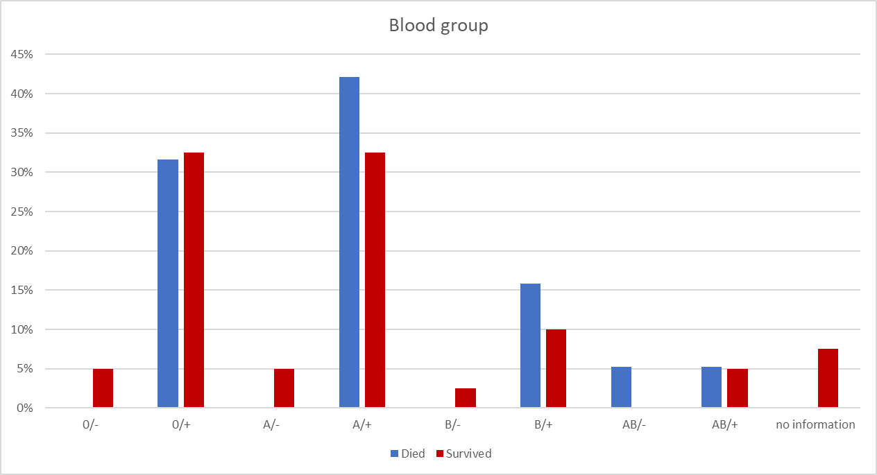

***Figure 3*** *Distribution of the blood groups*

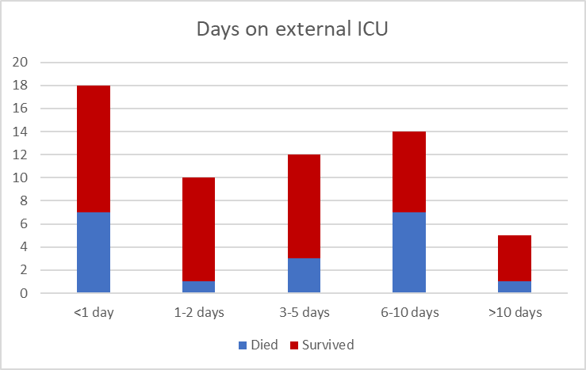

***Figure 4*** *Number of days treated at an external intensive care unit (ICU) before transfer to an ICU at the University Medical Center Regensburg*