Supporting Information
Catalytic Core-shell Nanoparticles with Self-supplied Calcium and H₂O₂ to enable Combinational Tumor Inhibition
Chao Fang,^{1, #} Hanjing Kong,^{1, #} Qiang Chu,^{1, 2} Zefeng Hu,¹ Yi Zhou, ³ Gaorong Han¹ and Xiang Li^{1, 2} *

¹ State Key Laboratory of Silicon Materials, School of Materials Science and Engineering, Zhejiang University, Hangzhou 310027, P.R. China

² ZJU-Hangzhou Global Scientific and Technological Innovation Center, Zhejiang University, Hangzhou, 311200, P.R. China.

³ Stomatology Hospital, School of Medicine, Zhejiang University, 310006, P.R. China

# Authors with equal contribution
* Corresponding author: xiang.li@zju.edu.cn (XL)

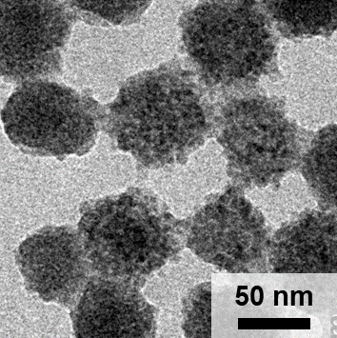
Figure S1 TEM image of CaO₂.

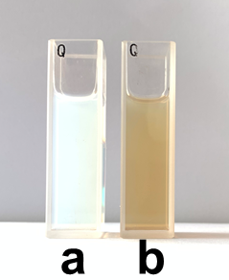
Figure S2 Optical images of solutions containing (a) CaO₂ and (b) CaO₂@Co-Fc.

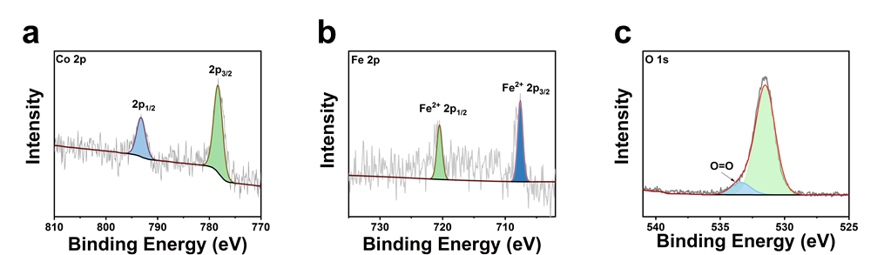
Figure S3 High-resolution XPS spectra of (a) Co 2p, (b) Fe 2p and (c) O 1s.

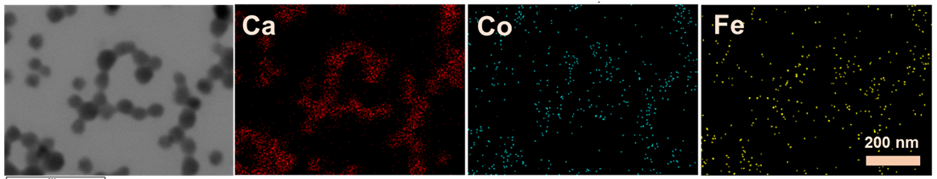
Figure S4 Elemental mapping of CaO₂@Co-Fc.

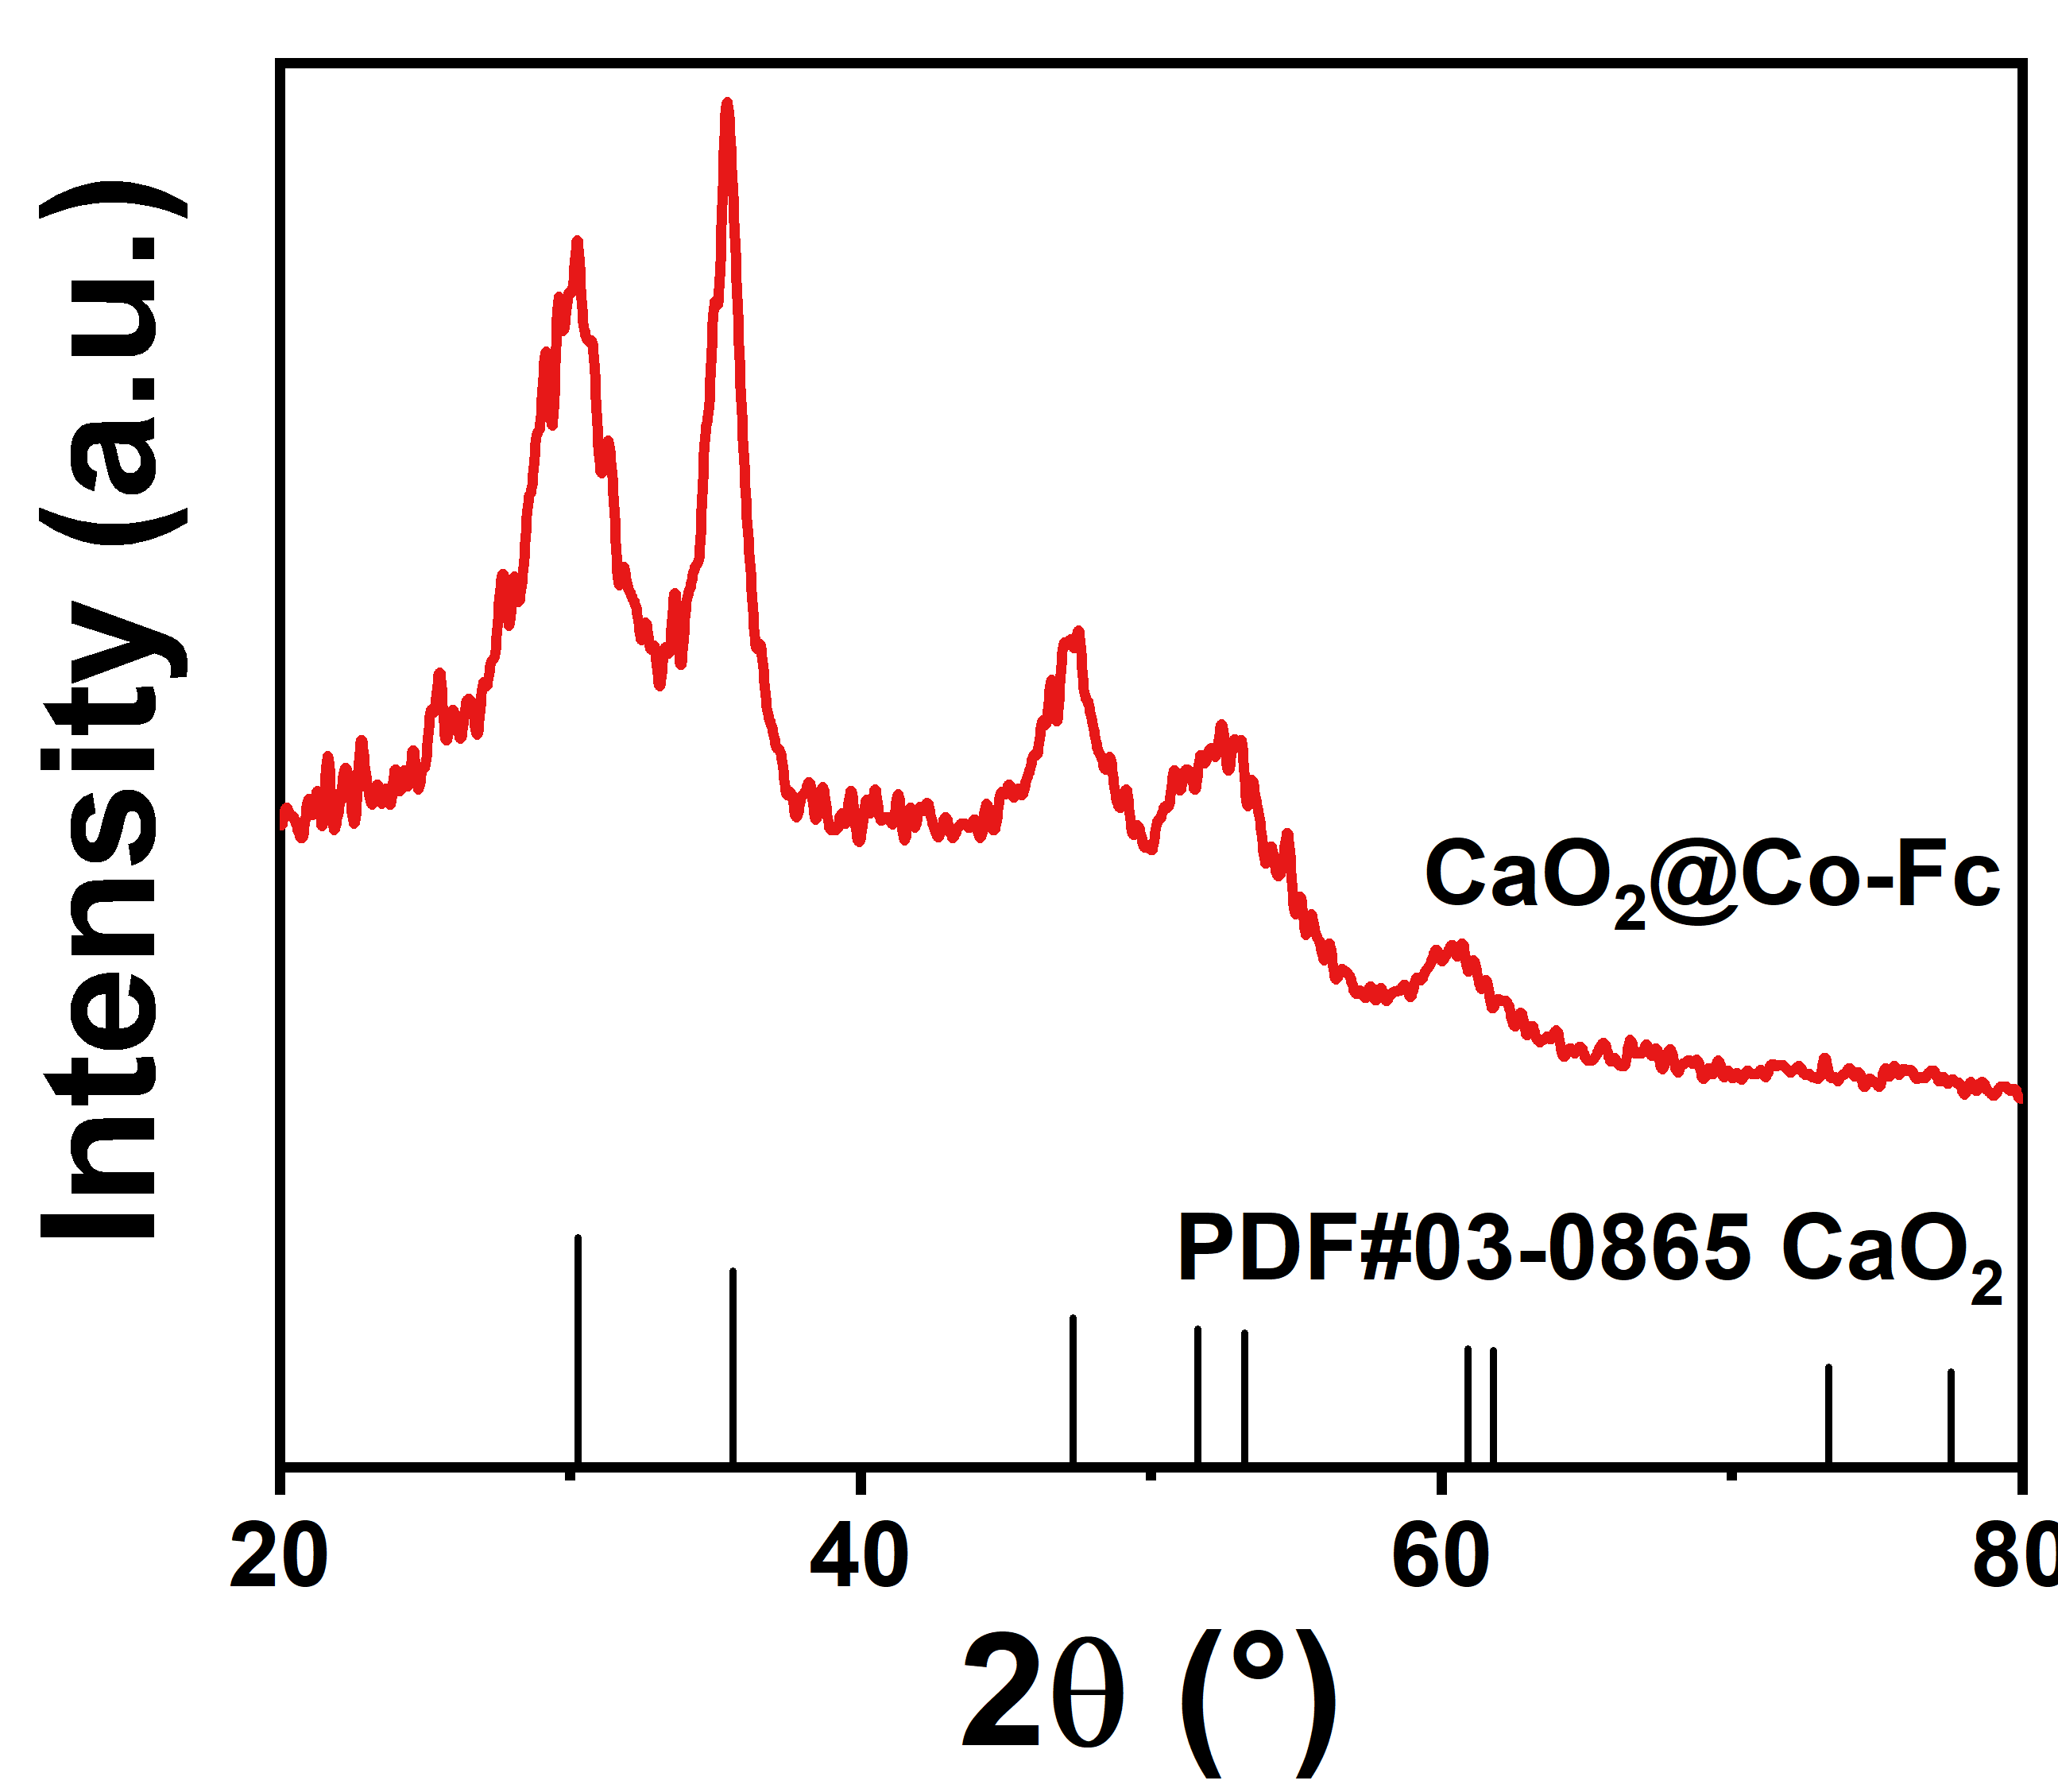
Figure S5 XRD pattern of CaO₂@Co-Fc.

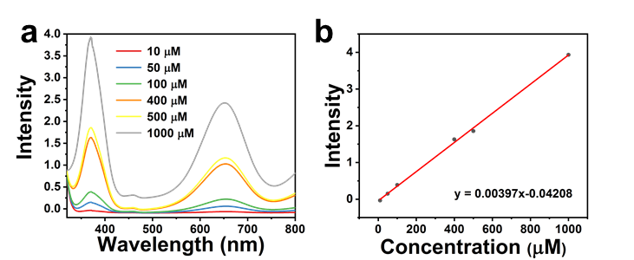
Figure S6 Standard curves of H₂O₂ at the peak of 372 nm by TMB method: (a) UV-vis absorbance spectra and (b) plotting curve of TMB solution with the addition of different concentrations of H₂O₂.

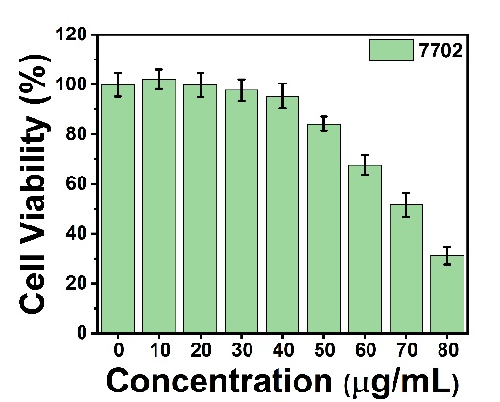
Figure S7 The viability of 7702 cells cultured with CaO₂ with varied concentrations.

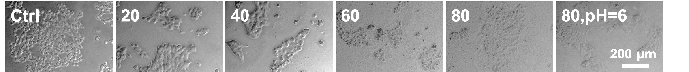
Figure S8 Bright field images of 4T1 cells incubated with different concentrations of CaO₂@Co-Fc after calcein-AM and PI staining for live & dead.

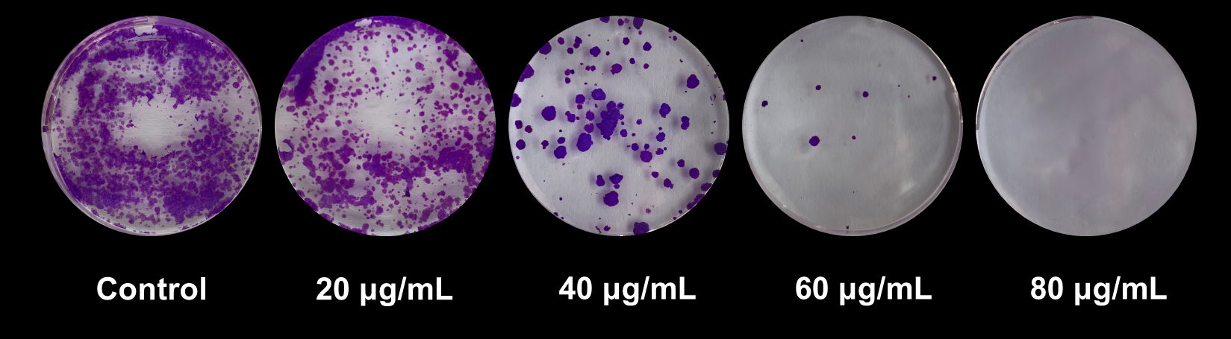
Figure S9 Colony formation of 4T1 cells incubated with different concentrations of CaO₂@Co-Fc.

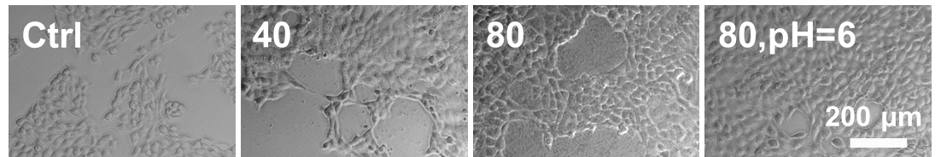
Figure S10 Bright field images of 4T1 cells incubated with different treatments after DCFH-DA staining for intercellular ROS.

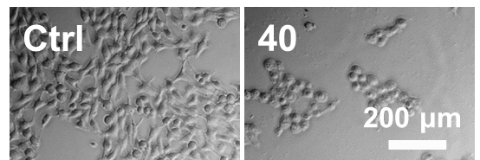
Figure S11 Bright field images of 4T1 cells incubated with or without CaO₂@Co-Fc after Fluo-4 AM staining for intercellular Ca²⁺ accumulation.

