**Supplementary fig. S2** Comparison of WT and AAT1-MT with respect to AKG level

(a) HPLC analysis of standard solutions of AKG showed peaks atretention time 1.5 min. (b and c) Compared with the extraction of WT (Figure S3 b), the extraction AAT1-MT (Figure S3 c) showed decreased level of AKG.

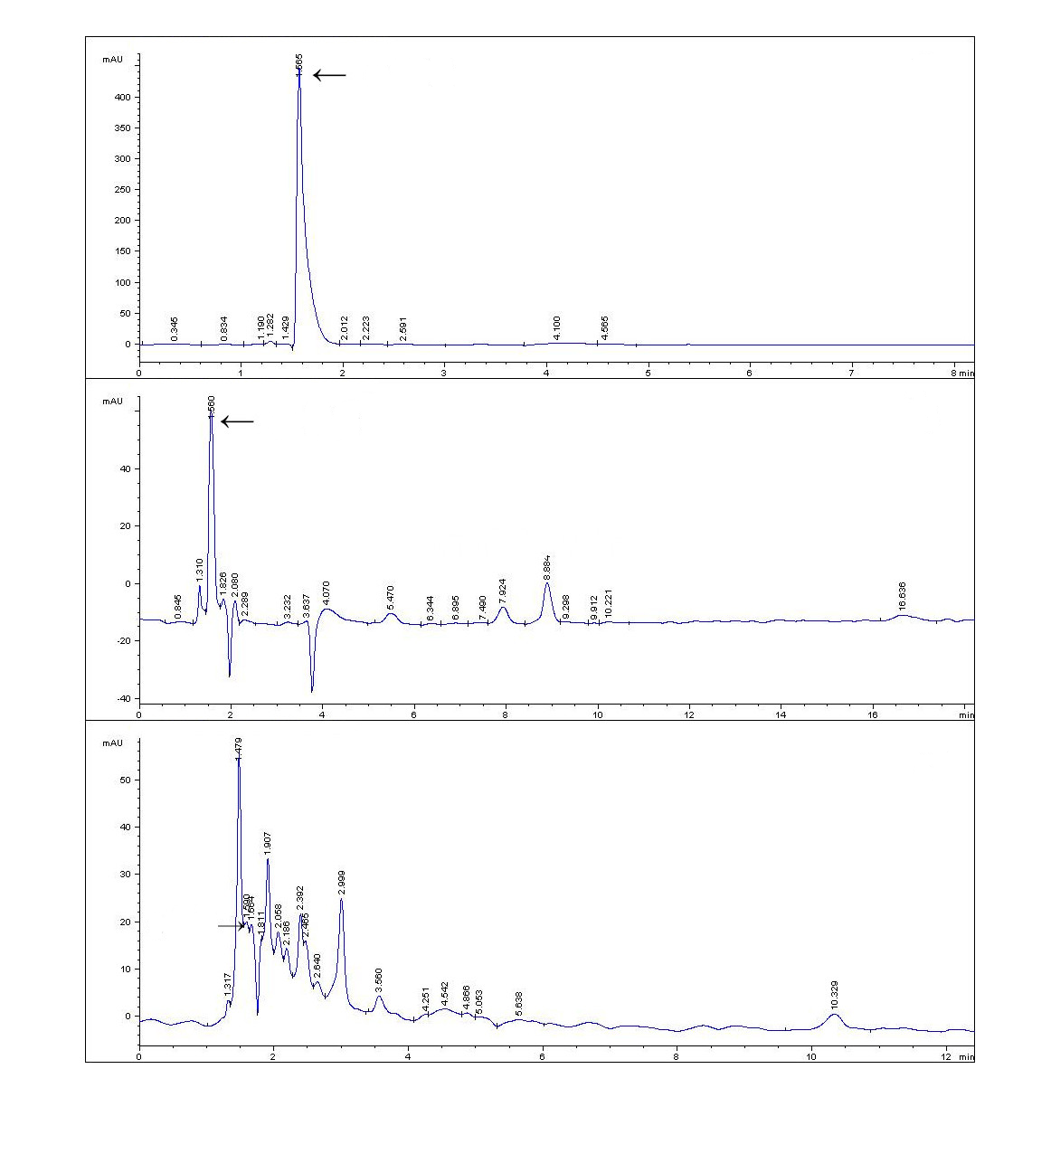

a

AKG

Standards

b

AKG

WT

c

AKG

AAT1-MT