Supplementary material

Cr(III) and Ni(II) complexes of isatin-hydrazone ligand: Preparation, characterization, DFT studies, biological activity, and ion-flotation separation of Ni(II)

Hany M. Youssef^{1,2*}, Yasir Kh. Abdulhamed², T. A. Yousef ^{3,4}, G. M. Abu El-Reash²

¹Department of Chemistry, College of Science and Humanities in Al-Kharj, Prince Sattam bin Abdulaziz University, Al-Kharj 11942, Saudi Arabia
²Department of Chemistry, Faculty of Science, Mansoura University, Mansoura 35516, Egypt
³Department of Chemistry, Science College, Imam Mohammad Ibn Saud Islamic University, (IMSIU), Riyadh, KSA, P.O. Box 90950, Riyadh 11623, Saudi Arabia
⁴Department of Toxic and Narcotic drug, Forensic Medicine, Mansoura Laboratory, Medicolegal organization, Ministry of Justice, Egypt
Table 1S. Selected bond lengths of H₄MDI in using DFT-method from DMol³ calculations.
Bond | Length(Å) | Bond | Length(Å) | Bond | Length(Å)
C(26)-C(27) | 1.417 | C(25)-C(26) | 1.422 | C(24)-C(25) | 1.422
C(27)-C(23) | 1.423 | C(22)-C(24) | 1.411 | C(22)-C(23) | 1.443
N(21)-C(22) | 1.392 | C(20)-O(28) | 1.264 | C(20)-N(21) | 1.417
C(19)-C(23) | 1.452 | C(19)-C(20) | 1.47 | N(18)-C(19) | 1.353
N(16)-N(18) | 1.374 | C(15)-O(17) | 1.263 | C(15)-N(16) | 1.41
C(14)-C(15) | 1.522 | C(12)-C(14) | 1.51 | C(12)-O(13) | 1.28
N(11)-C(12) | 1.396 | N(10)-N(11) | 1.358 | C(9)-N(10) | 1.357
C(8)-O(29) | 1.353 | C(9)-C(8) | 1.449 | C(8)-N(7) | 1.354
C(5)-C(9) | 1.46 | C(6)-C(5) | 1.422 | N(7)-C(4) | 1.382
C(5)-C(4) | 1.461 | C(4)-C(3) | 1.417 | C(2)-C(3) | 1.415
C(1)-C(6) | 1.425 | C(2)-C(1) | 1.425

Table 2S. Selected bond angles of H₄MDI in using DFT-method from DMol³ calculations.
Angle | Degree (°) | Angle | Degree (°) | Angle | Degree (°)
C(26)-C(25)-C(24) | 120.954 | C(26)-C(27)-C(23) | 118.468 | C(27)-C(26)-C(25) | 121.6
C(27)-C(23)-C(19) | 133.619 | C(25)-C(24)-C(22) | 117.223 | C(27)-C(23)-C(22) | 119.094
C(24)-C(22)-N(21) | 129.349 | C(22)-C(23)-C(19) | 107.222 | C(24)-C(22)-C(23) | 122.63
O(28)-C(20)-N(21) | 122.69 | C(23)-C(22)-N(21) | 107.946 | C(22)-N(21)-C(20) | 111.484
C(23)-C(19)-C(20) | 107.518 | O(28)-C(20)-C(19) | 131.426 | N(21)-C(20)-C(19) | 105.778
C(19)-N(18)-N(16) | 117.396 | C(23)-C(19)-N(18) | 131.682 | C(20)-C(19)-N(18) | 120.497
O(17)-C(15)-C(14) | 120.763 | N(18)-N(16)-C(15) | 123.496 | O(17)-C(15)-N(16) | 121.622
C(14)-C(12)-O(13) | 125.537 | N(16)-C(15)-C(14) | 117.352 | C(15)-C(14)-C(12) | 119.108
C(12)-N(11)-N(10) | 122.629 | C(14)-C(12)-N(11) | 118.568 | O(13)-C(12)-N(11) | 115.686
N(10)-C(9)-C(5) | 135.286 | N(11)-N(10)-C(9) | 116.469 | N(10)-C(9)-C(8) | 120.693
O(29)-C(8)-N(7) | 122.163 | C(8)-C(9)-C(5) | 104.002 | O(29)-C(8)-C(9) | 123.932
C(5)-C(6)-C(1) | 119.131 | C(9)-C(8)-N(7) | 113.902 | C(8)-N(7)-C(4) | 105.468
C(6)-C(5)-C(4) | 118.695 | C(9)-C(5)-C(6) | 136.809 | C(9)-C(5)-C(4) | 104.489
C(5)-C(4)-C(3) | 121.46 | N(7)-C(4)-C(5) | 112.057 | N(7)-C(4)-C(3) | 126.481
C(6)-C(1)-C(2) | 121.507 | C(4)-C(3)-C(2) | 118.814 | C(3)-C(2)-C(1) | 120.354

Table 3S. Selected bond lengths of [Cr₂(H₂MDI)(H₂O)₂Cl₄] in using DFT-method from DMol³ calculations.
Bond | Length(Å) | Bond | Length(Å) | Bond | Length(Å)
C(4)-C(5) | 1.453 | Cr(31)-Cl(37) | 2.575 | Cr(31)-Cl(36) | 2.479
O(33)-Cr(31) | 2.267 | Cr(30)-Cl(35) | 2.423 | Cr(30)-Cl(34) | 2.522
O(32)-Cr(30) | 2.349 | O(29)-Cr(30) | 2.349 | O(28)-Cr(31) | 2.357
C(26)-C(27) | 1.43 | C(25)-C(26) | 1.43 | C(24)-C(25) | 1.428
C(27)-C(23) | 1.427 | C(22)-C(24) | 1.417 | C(22)-C(23) | 1.451
N(21)-C(22) | 1.402 | C(20)-O(28) | 1.291 | C(20)-N(21) | 1.408
C(23)-C(19) | 1.443 | C(19)-C(20) | 1.45 | N(18)-Cr(31) | 2.125
N(18)-C(19) | 1.364 | O(17)-Cr(31) | 2.194 | N(16)-N(18) | 1.349
C(15)-O(17) | 1.311 | C(15)-N(16) | 1.376 | C(14)-C(15) | 1.52
O(13)-Cr(30) | 2.199 | C(12)-C(14) | 1.513 | C(12)-O(13) | 1.314
N(11)-C(12) | 1.374 | N(10)-Cr(30) | 2.158 | N(10)-N(11) | 1.347
C(9)-N(10) | 1.369 | C(8)-O(29) | 1.295 | C(8)-C(9) | 1.455
C(8)-N(7) | 1.404 | C(9)-C(5) | 1.44 | C(5)-C(6) | 1.424
C(4)-N(7) | 1.401 | C(3)-C(4) | 1.416 | C(2)-C(3) | 1.423
C(6)-C(1) | 1.425 | C(1)-C(2) | 1.425

Table 4S. Selected bond angles of [Cr₂(H₂MDI)(H₂O)₂Cl₄] in using DFT-method from DMol³ calculations.
Angle | Degree (°) | Angle | Degree (°) | Angle | Degree (°)
Cl(37)-Cr(31)-Cl(36) | 163.633 | Cl(37)-Cr(31)-O(33) | 80.414 | Cl(37)-Cr(31)-O(28) | 87.542
Cl(37)-Cr(31)-N(18) | 99.586 | Cl(37)-Cr(31)-O(17) | 93.183 | Cl(36)-Cr(31)-O(33) | 83.38
Cl(36)-Cr(31)-O(28) | 95.074 | Cl(36)-Cr(31)-N(18) | 96.737 | Cl(36)-Cr(31)-O(17) | 92.717
O(33)-Cr(31)-O(28) | 107.104 | O(33)-Cr(31)-N(18) | 176.198 | O(33)-Cr(31)-O(17) | 103.172
O(28)-Cr(31)-N(18) | 76.682 | O(28)-Cr(31)-O(17) | 149.393 | N(18)-Cr(31)-O(17) | 73.026
Cl(35)-Cr(30)-Cl(34) | 88.083 | Cl(35)-Cr(30)-O(32) | 89.292 | Cl(35)-Cr(30)-O(29) | 105.971
Cl(35)-Cr(30)-O(13) | 105.071 | Cl(35)-Cr(30)-N(10) | 176.693 | Cl(34)-Cr(30)-O(32) | 173.184
Cl(34)-Cr(30)-O(29) | 93.978 | Cl(34)-Cr(30)-O(13) | 97.988 | Cl(34)-Cr(30)-N(10) | 91.698
O(32)-Cr(30)-O(29) | 80.702 | O(32)-Cr(30)-O(13) | 88.768 | O(32)-Cr(30)-N(10) | 91.283
O(29)-Cr(30)-O(13) | 146.996 | O(29)-Cr(30)-N(10) | 77.335 | O(13)-Cr(30)-N(10) | 71.69
Cr(30)-O(29)-C(8) | 105.446 | Cr(31)-O(28)-C(20) | 105.864 | C(26)-C(27)-C(23) | 118.249
C(27)-C(26)-C(25) | 121.099 | C(26)-C(25)-C(24) | 121.366 | C(25)-C(24)-C(22) | 117.414
C(27)-C(23)-C(22) | 119.773 | C(27)-C(23)-C(19) | 134.08 | C(22)-C(23)-C(19) | 106.122
C(24)-C(22)-C(23) | 122.045 | C(24)-C(22)-N(21) | 129.399 | C(23)-C(22)-N(21) | 108.522
C(22)-N(21)-C(20) | 110.017 | O(28)-C(20)-N(21) | 127.024 | O(28)-C(20)-C(19) | 125.886
N(21)-C(20)-C(19) | 106.97 | C(23)-C(19)-C(20) | 108.353 | C(23)-C(19)-N(18) | 136.495
C(20)-C(19)-N(18) | 114.82 | Cr(31)-N(18)-C(19) | 116.553 | Cr(31)-N(18)-N(16) | 119.735
C(19)-N(18)-N(16) | 122.355 | Cr(31)-O(17)-C(15) | 113.202 | N(18)-N(16)-C(15) | 111.598
O(17)-C(15)-N(16) | 121.975 | O(17)-C(15)-C(14) | 120.596 | N(16)-C(15)-C(14) | 117.069
C(15)-C(14)-C(12) | 111.08 | Cr(30)-O(13)-C(12) | 115.209 | C(14)-C(12)-O(13) | 121.759
C(14)-C(12)-N(11) | 116.732 | O(13)-C(12)-N(11) | 121.058 | C(12)-N(11)-N(10) | 111.607
Cr(30)-N(10)-N(11) | 120.428 | Cr(30)-N(10)-C(9) | 115.095 | N(11)-N(10)-C(9) | 122.575
N(10)-C(9)-C(8) | 114.957 | N(10)-C(9)-C(5) | 136.789 | C(8)-C(9)-C(5) | 108.088
O(29)-C(8)-C(9) | 127.029 | O(29)-C(8)-N(7) | 125.625 | C(9)-C(8)-N(7) | 107.013
C(8)-N(7)-C(4) | 110.285 | C(5)-C(6)-C(1) | 118.749 | C(9)-C(5)-C(6) | 135.064
C(9)-C(5)-C(4) | 106.387 | C(6)-C(5)-C(4) | 118.547 | N(7)-C(4)-C(5) | 108.22
N(7)-C(4)-C(3) | 129.101 | C(5)-C(4)-C(3) | 122.679 | C(4)-C(3)-C(2) | 117.679
C(3)-C(2)-C(1) | 120.524 | C(6)-C(1)-C(2) | 121.814

Table 5S. Selected bond lengths of [Ni₂(MDI)(H₂O)₆].4H₂O in using DFT-method from DMol³ calculations.
Bond | Length(Å) | Bond | Length(Å) | Bond | Length(Å)
C(4)-C(5) | 1.464 | C(26)-C(27) | 1.424 | C(25)-C(26) | 1.429
C(24)-C(25) | 1.426 | C(27)-C(23) | 1.427 | C(22)-C(24) | 1.422
C(22)-C(23) | 1.466 | N(21)-C(22) | 1.384 | C(20)-O(28) | 1.299
C(20)-N(21) | 1.388 | C(23)-C(19) | 1.44 | C(19)-C(20) | 1.47
N(18)-C(19) | 1.385 | N(16)-N(18) | 1.384 | C(15)-O(17) | 1.315
C(15)-N(16) | 1.37 | C(14)-C(15) | 1.524 | C(12)-C(14) | 1.518
C(12)-O(13) | 1.305 | N(11)-C(12) | 1.375 | N(10)-N(11) | 1.346
C(9)-N(10) | 1.359 | C(8)-O(29) | 1.301 | C(8)-C(9) | 1.466
C(8)-N(7) | 1.382 | C(9)-C(5) | 1.436 | C(5)-C(6) | 1.423
C(4)-N(7) | 1.386 | C(3)-C(4) | 1.422 | C(2)-C(3) | 1.426
C(6)-C(1) | 1.427 | C(1)-C(2) | 1.433 | O(35)-Ni(31) | 2.275
O(34)-Ni(31) | 2.387 | O(33)-Ni(31) | 2.416 | O(37)-Ni(30) | 2.476
O(36)-Ni(30) | 2.435 | O(32)-Ni(30) | 2.224 | O(29)-Ni(30) | 2.358
O(28)-Ni(31) | 2.39 | N(18)-Ni(31) | 2.107 | O(17)-Ni(31) | 2.238
O(13)-Ni(30) | 2.264 | N(10)-Ni(30) | 2.057

Table 6S. Selected bond angles of [Ni₂(MDI)(H₂O)₆].4H₂O in using DFT-method from DMol³ calculations.
Angle | Degree (°) | Angle | Degree (°) | Angle | Degree (°)
C(26)-C(27)-C(23) | 118.24 | C(27)-C(26)-C(25) | 121.523 | C(26)-C(25)-C(24) | 121.087
C(25)-C(24)-C(22) | 118.261 | C(27)-C(23)-C(22) | 120.139 | C(27)-C(23)-C(19) | 135.594
C(22)-C(23)-C(19) | 104.254 | C(24)-C(22)-C(23) | 120.749 | C(24)-C(22)-N(21) | 127.065
C(23)-C(22)-N(21) | 112.173 | C(22)-N(21)-C(20) | 106.593 | O(28)-C(20)-N(21) | 126.705
O(28)-C(20)-C(19) | 122.673 | N(21)-C(20)-C(19) | 110.35 | C(23)-C(19)-C(20) | 106.619
C(23)-C(19)-N(18) | 134.078 | C(20)-C(19)-N(18) | 119.066 | C(19)-N(18)-N(16) | 116.8
N(18)-N(16)-C(15) | 112.796 | O(17)-C(15)-N(16) | 123.276 | O(17)-C(15)-C(14) | 119.825
N(16)-C(15)-C(14) | 116.547 | C(15)-C(14)-C(12) | 110.396 | C(14)-C(12)-O(13) | 119.091
C(14)-C(12)-N(11) | 117.887 | O(13)-C(12)-N(11) | 122.956 | C(12)-N(11)-N(10) | 112.432
N(11)-N(10)-C(9) | 120.983 | N(10)-C(9)-C(8) | 117.174 | N(10)-C(9)-C(5) | 136.627
C(8)-C(9)-C(5) | 106.198 | O(29)-C(8)-C(9) | 121.917 | O(29)-C(8)-N(7) | 126.844
C(9)-C(8)-N(7) | 111.192 | C(8)-N(7)-C(4) | 105.832 | C(5)-C(6)-C(1) | 117.876
C(9)-C(5)-C(6) | 134.355 | C(9)-C(5)-C(4) | 104.306 | C(6)-C(5)-C(4) | 121.302
N(7)-C(4)-C(5) | 112.434 | N(7)-C(4)-C(3) | 127.676 | C(5)-C(4)-C(3) | 119.872
C(4)-C(3)-C(2) | 118.36 | C(3)-C(2)-C(1) | 121.543 | C(6)-C(1)-C(2) | 120.929
O(35)-Ni(31)-O(34) | 97.739 | O(35)-Ni(31)-O(33) | 96.808 | O(35)-Ni(31)-O(28) | 88.636
O(35)-Ni(31)-N(18) | 157.753 | O(35)-Ni(31)-O(17) | 92.649 | O(34)-Ni(31)-O(33) | 89.622
O(34)-Ni(31)-O(28) | 77.995 | O(34)-Ni(31)-N(18) | 96.991 | O(34)-Ni(31)-O(17) | 168.506
O(33)-Ni(31)-O(28) | 167.068 | O(33)-Ni(31)-N(18) | 99.872 | O(33)-Ni(31)-O(17) | 84.253
O(28)-Ni(31)-N(18) | 78.237 | O(28)-Ni(31)-O(17) | 107.283 | N(18)-Ni(31)-O(17) | 74.592
O(37)-Ni(30)-O(36) | 172.36 | O(37)-Ni(30)-O(32) | 88.903 | O(37)-Ni(30)-O(29) | 90.373
O(37)-Ni(30)-O(13) | 85.808 | O(37)-Ni(30)-N(10) | 91.09 | O(36)-Ni(30)-O(32) | 83.458
O(36)-Ni(30)-O(29) | 91.501 | O(36)-Ni(30)-O(13) | 96.047 | O(36)-Ni(30)-N(10) | 96.546
O(32)-Ni(30)-O(29) | 103.214 | O(32)-Ni(30)-O(13) | 105.233 | O(32)-Ni(30)-N(10) | 179.136
O(29)-Ni(30)-O(13) | 151.204 | O(29)-Ni(30)-N(10) | 77.65 | O(13)-Ni(30)-N(10) | 73.906
Ni(30)-O(29)-C(8) | 106.377 | Ni(31)-O(28)-C(20) | 104.776 | Ni(31)-N(18)-C(19) | 112.479
Ni(31)-N(18)-N(16) | 116.916 | Ni(31)-O(17)-C(15) | 110.036 | Ni(30)-O(13)-C(12) | 109.557
Ni(30)-N(10)-N(11) | 120.834 | Ni(30)-N(10)-C(9) | 116.241

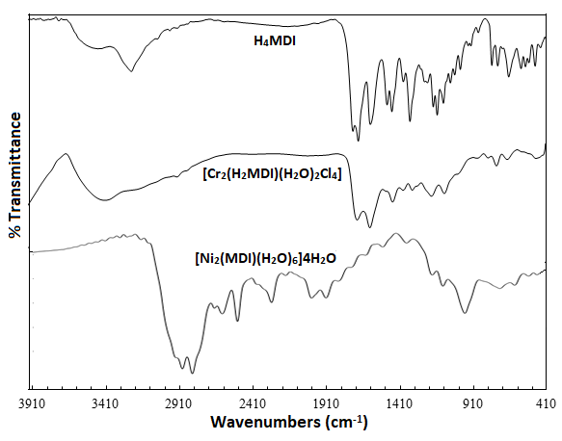
Figure 1S. Infrared spectra of H₄MDI and its metal complexes.
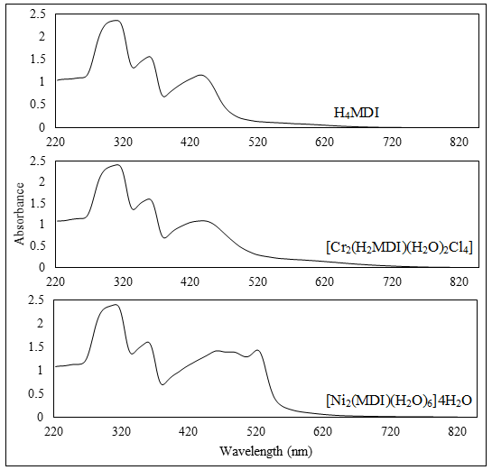
Figure 2S. Electronic spectra of H₄MDI and its metal complexes.

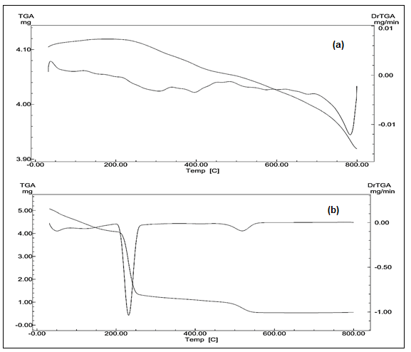
Figure 3S. TGA curves of (a) [Cr₂(H₂MDI)(H₂O)₂Cl₄] and (b) [Ni₂(MDI)(H₂O)₆].4H₂O.

