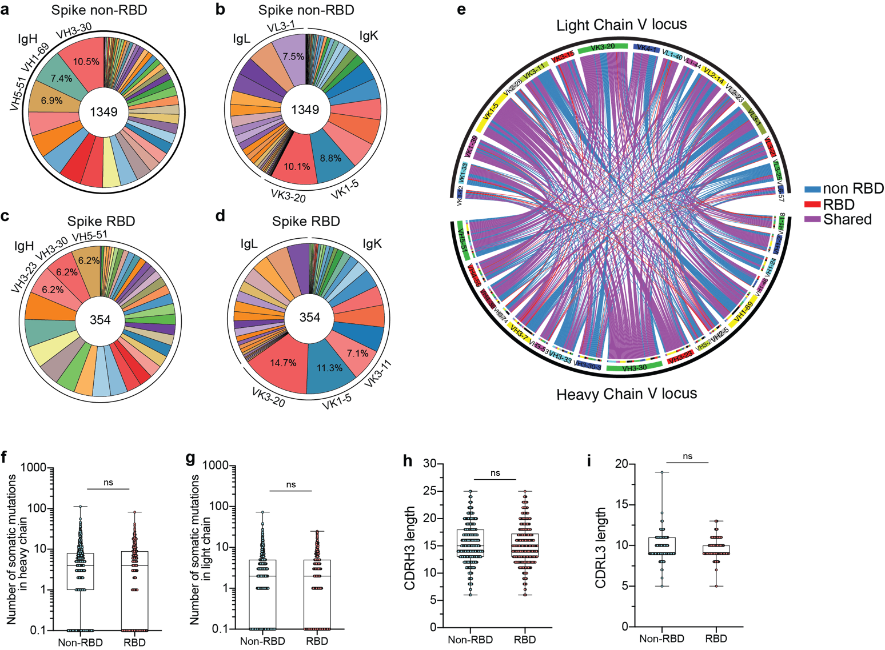
Supplementary Figure 1: MAb genetic, somatic hypermutation, and CDR3 length features. a-d, The distribution of V gene usage of spike-non RBD and spike RBD antibodies for all paired heavy (a, c) and light (b, d) chains. Percentage shown indicates proportion of the top 3 utilized genes. e, Clonal relationships between heavy and light chain variable gene locus of spike non-RBD and spike RBD-specific antibodies. Connecting lines represent the pairing of heavy and light chain of antibody clones specific to spike non-RBD (blue) or RBD (red) and antibody clones shared between both groups (purple). f, g, Comparison of number of somatic hypermutations of heavy (f) and light chains (g) of spike non-RBD and spike RBD-binding B cells. h and i, The complementarity determining region 3 (CDR3) amino acid length for heavy (h) and light chains (i) of spike non-RBD and spike RBD-binding B cells. Median indicated as line in the box and whisker graph. Each dot represents an individual antibody with range from minimum to maximum value. Data in f-i were analyzed using Mann-Whitney non-parametric test.
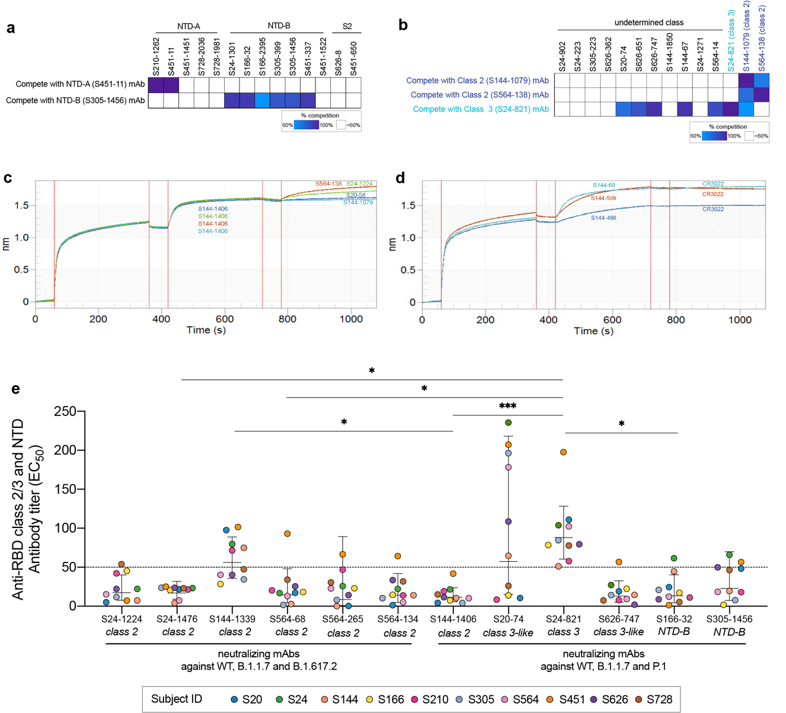

Supplementary Figure 2: MAb binding competition by ELISA and BLI and serum competition by ELISA. a, Competition ELISA of RBD mAbs of spike non-RBD mAbs with NTD-A (S451-11) and NTD-B (S305-1456). b, Competition ELISA of RBD mAbs of undetermined class with class 2 mAbs (S144-1079 and S564-138) and class 3 mAb (S24-821). c, MAb binding competition by BLI of class 2 mAb, S144-1406, with the other class 2 mAbs (n=4) that did not neutralize P.1. d, MAb binding competition by BLI between class 4 mAbs that utilized VH5-51 (S144-466, S144-509, S144 and S144-69) with CR3022. e, EC₅₀ of serum antibodies of 10 convalescent subjects competing with RBD-reactive mAbs for binding to RBD class 2, class 3 and class 3-like epitopes, and NTD-reactive mAbs for binding to NTD-B epitopes. Dashed line represents the limit of detection. Data in a-b and e are representative of two independent experiments performed in duplicate. Data in e were analyzed using nonparametric Friedman's test with Dunn’s multiple comparison test.
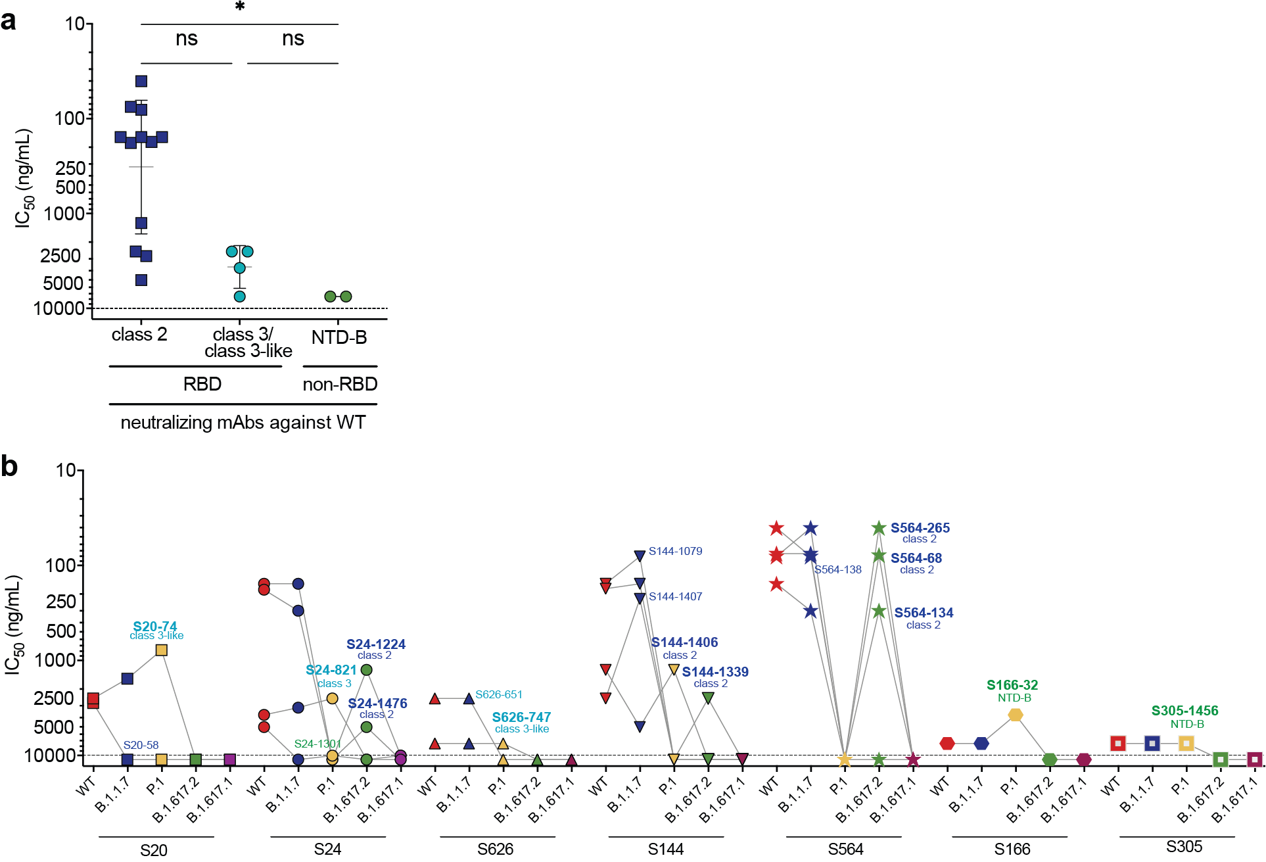
Supplementary Figure 3: Comparison of neutralization potency of SARS-CoV-2 neutralizing mAbs. a, Neutralization potency (IC₅₀) of RBD-binding mAbs, class 2 and class 3, and NTD-B binding mAbs against WT SARS-CoV-2. b, Neutralization potency of each mAb from each subject against WT SARS-CoV-2 (red), B.1.1.7 (blue), P.1 (yellow), B.1.617.1 (green) and B.1.617.2 (plum). Each dot indicates one mAb. MAbs that neutralize VOCs are bolded. Data in a-c are representative of two independent experiments performed in duplicate. Data in a were analyzed using Mann-Whitney non-parametric test.

Supplementary Table 1: COVID-19 convalescent subjects.
Subject ID | Age | Sex | SARS-CoV-2 PCR Test | Duration of symptoms (days) | Symptom start to  donation (days)
24 | 34 | M | 3/23/20 | 12 | 41
20 | 31 | M | 3/31/20 | 19 | 48
564 | 24 | F | 3/19/20 | 32 | 60
144 | 56 | M | 3/16/20 | 23 | 54
305 | 43 | F | 4/17/20 | 4 | 47
166 | 42 | F | 3/25/20 | 17 | 55
210 | 47 | M | 4/4/20 | 7 | 41
451 | 46 | M | 4/4/20 | 11 | 49
626 | 44 | M | 3/31/20 | 19 | 56
728 | 62 | F | 3/15/20 | 53 | 130

Supplementary Table 2: Characteristics of SARS-CoV-2 spike binding mAbs. Cross-neutralizing mAbs against WT, B.1.1.7 and P.1 or B.1.617.2 are bolded.

mAb ID | Epitope specificity | VH gene | VL gene | # VH SHM | #VL SHM | CDRH3 length | CDRL3 length | Database availability
S20-58 | Spike RBD  Class 2 | IGHV4-30-4*08 | IGKV2-24*01 | 5 | 2 | 15 | 9 | reference 27
S20-74 | Spike RBD  Class 3-like | IGHV4-59*11 | IGLV2-8*01 | 7 | 3 | 15 | 11 | reference 27
S24-223 | Spike RBD  undetermined | IGHV2-5*02 | IGLV2-14*01 | 1 | 3 | 11 | 11 | reference 27
S24-821 | Spike RBD  Class 3 | IGHV2-70*15 | IGKV1-5*03 | 3 | 0 | 16 | 9 | reference 27
S24-902 | Spike RBD  undetermined | IGHV1-69*04 | IGLV7-46*01 | 0 | 0 | 15 | 8 | reference 27
S24-1002 | Spike RBD  Class 2 | IGHV3-30-3*01 | IGKV1-13*02 | 4 | 5 | 25 | 9 | reference 27
S24-1224 | Spike RBD  Class 2 | IGHV1-46*01 | IGLV1-40*01 | 8 | 7 | 20 | 11 | reference 27
S24-1271 | Spike RBD  undetermined | IGHV3-66*01 | IGLV3-1*01 | 7 | 6 | 22 | 9 | reference 27
S24-1301 | Spike  NTD-B | IGHV1-24*01 | IGLV10-54*01 | 6 | 4 | 18 | 11 | reference 27
S24-1384 | Spike RBD  Class 4 | IGHV3-48*04 | IGLV3-21*02 | 3 | 4 | 17 | 12 | reference 27
S24-1476 | Spike RBD  Class 2 | IGHV3-49*03 | IGKV3-15*01 | 3 | 0 | 18 | 8 | reference 27
S144-67 | Spike RBD  Class 3-like | IGHV5-51*01 | IGLV1-40*01 | 8 | 5 | 17 | 12 | reference 27
S144-69 | Spike RBD  Class 4 | IGHV5-51*01 | IGKV1-5*01 | 3 | 3 | 11 | 8 | reference 27
S144-466 | Spike RBD  Class 4 | IGHV5-51*01 | IGKV1-5*01 | 7 | 6 | 11 | 9 | reference 27
S144-509 | Spike RBD  Class 4 | IGHV5-51*01 | IGKV1-5*01 | 3 | 1 | 12 | 9 | reference 27
S144-1079 | Spike RBD  Class 2 | IGHV1-69*02 | IGKV3-20*01 | 9 | 3 | 19 | 9 | reference 27
S144-1339 | Spike RBD  Class 2 | IGHV1-2*06 | IGLV2-14*01 | 15 | 5 | 18 | 11 | reference 27
S144-1406 | Spike RBD  Class 2 | IGHV1-3*01 | IGKV1-5*01 | 4 | 0 | 11 | 17 | reference 27
S144-1407 | Spike RBD  Class 2 | IGHV1-69*02 | IGKV1-5*01 | 9 | 2 | 12 | 10 | reference 27
S144-1850 | Spike RBD  undetermined | IGHV3-23*04 | IGKV1-5*01 | 2 | 3 | 13 | 9 | reference 27
S166-32 | Spike  NTD-B | IGHV3-11*01 | IGKV1-5*01 | 10 | 2 | 19 | 8 | reference 27
S166-2395 | Spike  NTD-B | IGHV4-4*07 | IGLV3-21*02 | 3 | 5 | 16 | 12 | reference 27
S210-1262 | Spike  NTD-A | IGHV4-39*01 | IGLV4-69*01 | 11 | 4 | 10 | 9 | reference 27
S305-223 | Spike RBD  Class 2 | IGHV3-33*06 | IGKV3-11*01 | 18 | 8 | 6 | 9 | reference 27
S305-399 | Spike RBD  undetermined | IGHV1-24*01 | IGKV3-15*01 | 4 | 4 | 18 | 9 | reference 27
S305-1456 | Spike  NTD-B | IGHV1-24*01 | IGKV3-15*01 | 3 | 3 | 20 | 9 | reference 27
S451-11 | Spike  NTD-A | IGHV3-23*01 | IGKV3D-20*01 | 8 | 3 | 15 | 8 | internal data
S451-337 | Spike  NTD-B | IGHV4-59*01 | IGKV3-20*01 | 10 | 1 | 15 | 10 | internal data
S451-650 | Spike S2 | IGHV3-30*01 | IGKV3-20*01 | 6 | 4 | 14 | 8 | internal data
S451-1451 | Spike  NTD-A | IGHV4-31*01 | IGLV2-11*01 | 9 | 5 | 14 | 10 | internal data
S451-1522 | Spike  NTD-B | IGHV2-26*01 | IGLV2-14*01 | 8 | 5 | 20 | 11 | internal data
S564-14 | Spike RBD  Class 3-like | IGHV3-7*01 | IGLV3-21*04 | 6 | 3 | 18 | 12 | reference 27
S564-68 | Spike RBD  Class 2 | IGHV1-2*02 | IGLV2-8*01 | 6 | 2 | 15 | 10 | reference 27
S564-134 | Spike RBD  Class 2 | IGHV1-2*02 | IGLV2-8*01 | 2 | 6 | 15 | 10 | reference 27
S564-138 | Spike RBD  Class 2 | IGHV1-2*02 | IGLV2-14*01 | 10 | 1 | 18 | 10 | reference 27
S564-152 | Spike RBD  Class 4 | IGHV3-33*06 | IGKV1-33*01 | 4 | 4 | 20 | 10 | reference 27
S564-265 | Spike RBD  Class 2 | IGHV1-2*02 | IGLV2-8*01 | 4 | 3 | 15 | 10 | reference 27
S626-8 | Spike S2 | IGHV1-8*01 | IGLV3-19*01 | 7 | 5 | 24 | 12 | this study
S626-362 | Spike RBD  undetermined | IGHV3-48*01 | IGLV1-40*01 | 18 | 3 | 16 | 11 | this study
S626-651 | Spike RBD  Class 3-like | IGHV1-69*04 | IGLV1-40*01 | 6 | 4 | 17 | 11 | this study
S626-747 | Spike RBD  Class 3-like | IGHV3-9*01 | IGKV1-33*01 | 6 | 6 | 22 | 10 | this study
S728-1981 | Spike  NTD-A | IGHV1-46*01 | IGKV3-11*01 | 17 | 3 | 16 | 11 | this study
S728-2036 | Spike  NTD-A | IGHV1-2*02 | IGLV2-23*02 | 14 | 12 | 17 | 10 | this study

Supplementary Table 3: Antigen information and source. VOC refers to variant of concern and VOI refers to variant of interest.
Antigen | S1 NTD | RBD | S1 CTD | S2 | Mutation detected in | Source
Spike FL, 2-P, trimer
WT | - | - | - | - | - | In-house
D614G | - | - | D614G | - | VOC | In-house
B.1.1.7 | H69del, V70del, Y144del | N501Y | A570D, D614G, P681H | T716I, S982A, D1118H | VOC | Sather lab
B.1.351 | L18F, D80A, D215G, del241-243, R246I | K417N, E484K, N501Y | D614G | A701V | VOC | Sather lab
P.1 | L18F, T20N, P26S, D138Y, R190S | K417T, E484K, N501Y | D614G, H655Y | T1027I, V1176F | VOC | Sather lab
B.1.526 | L5F, T95I, D253G | E484K | D614G | A701V | VOI | Sather lab
B.1.617.1 | T95I, G142D, E154K | L452R, E484Q | D614G, P681R | Q1071H | VOI | Sather lab
A.23.1 | F157L | V367F | Q613H, P681R | - | VOI | Sather lab
S1 monomeric
WT | - | - | - | - | - | SinoBiological
S2 monomeric
WT | - | - | - | - | - | SinoBiological
RBD
WT | - | - | - | - | - | In-house
E406Q | - | E406Q | - | - | Circulating variant, In vitro escape | Krammer lab
K417N (B.1.351) | - | K417N | - | - | VOC, In vitro escape | SinoBiological
K417T (P.1) | - | K417T | - | - | VOC, In vitro escape | In-house
K417E | - | K417E | - | - | In vitro escape | Krammer lab
K417V | - | K417V | - | - | In vitro escape | Krammer lab
K417A | - | K417A | - | - | RBD-ACE2 contacting | In-house
Y453F (B.1.427, B.1.429) | - | Y453F | - | - | VOC, In vitro escape | Krammer lab
F486A | - | F486A | - | - | In vitro escape | Krammer lab
N487R | - | N487R | - | - | In vitro escape | Krammer lab
E484K (P.1, B.1.526, B.1.351, B.1.1.318, B.1.525, R.1, B.1.526.2, B.1.1, B.1.621, B.1, B.1.1.7) | - | E484K | - | - | VOC, In vitro escape | Krammer lab
F490K | - | F490K | - | - | In vitro escape | Krammer lab
Q493R | - | Q493R | - | - | In vitro escape | Krammer lab
N439K | - | N439K | - | - | VOC, In vitro escape | Krammer lab
N440K (B.1.36) | - | N440K | - | - | Circulating variant, In vitro escape | Krammer lab
L452R (B.1.526.1, B.1.429, B.1.427, B.1.617.2, B.1, B.1.617.1, C.36, A.2.5) | - | L452R | - | - | VOC, In vitro escape | SinoBiological
N501Y (B.1.1.7) | - | N501Y | - | - | VOC | Krammer lab
N501Q | - | N501Q | - | - | RBD-ACE2 contacting | Krammer lab
N501A | - | N501A | - | - | RBD-ACE2 contacting | Krammer lab
B.1.351 |  | K417N, E484K, N501Y |  |  | VOC | Krammer lab
P.1 |  | K417T, E484K, N501Y |  |  | VOC | Krammer lab
Other coronaviruses
SARS-CoV-1 RBD WT |  |  |  |  | - | In-house
MERS-CoV RBD WT |  |  |  |  | - | In-house

Supplementary Table 4: SARS-CoV-2 virus information and source.
Antigen | S1 NTD | RBD | S1 CTD | S2 | Source
WT | - | - | - | - | SARS-CoV-2/UT-NCGM02/Human/2020/Tokyo from BEI
B.1.1.7 | L5F, H69del, V70del, Y144del | N501Y | A570D, D614G, P681H | T716I, S982A, D1118H | hCoV-19/Japan/QHN001/2020 from BEI
P.1 | L18F, T20N, P26S, D138Y, G181V, R190S | K417T, E484K, N501Y | D614G, H655Y | T1027I, V1176F | hCoV-19/Japan/TY7-501/2021 from BEI
B.1.617.1 | G142D, E154K | L452R, E484Q | D614G, P681R | Q1071H, H1101D | hCoV-19/USA/CA-Stanford-15_S02/2021 from BEI
B.1.617.2 | T19R, T95I, G142D, E156G, F157del, R158del | L452R, T478K | D614G, P681R | D950N | hCoV-19/USA/WI-UW-5250/2021

