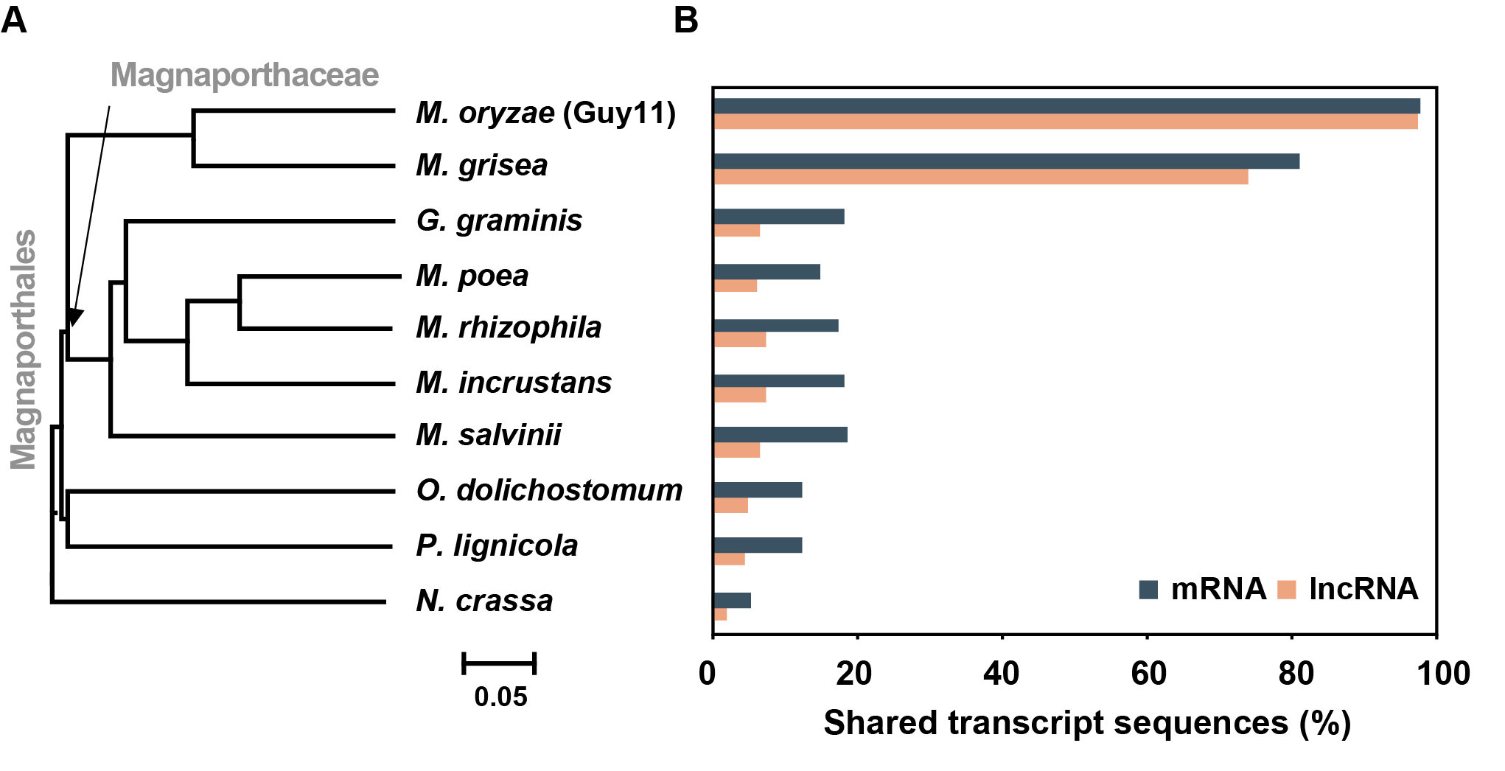

Figure S1. Conservation of lncRNAs among Magnaporthales species and N. crassa.
Proportion of mRNAs (bluish green) and lncRNAs (brown) identified using BLASTn and M. oryzae lncRNA sequences against the genome with an e-value cutoff < 1e-5. M. oryzae, Magnaporthe oryzae; M. grisea, Magnaporthe grisea; G. gramininis, Gaeumannomyces graminis; M. poae, Magnaporthe poae; M. rhizophila, Magnaporthiopsis rhizophila; M. incrustans, Magnaporthiopsis incrustans; M. salvinii, Magnaporthe salvinii; O. dolichostomum, Ophioceras dolichostomum; P. lignicola, Pseudohalonectria lignicola; N. crassa, Neurospora crassa.

