Supplementary Material

Table S1. Antimicrobial susceptibility profile of MSSA and MRSA isolates.
S. aureus (112) | mecA gene | Oxacillin  R S | Cefoxitin  R S | Linezolid  R S | Q/D  R S | S/T  R S | Vancomycin MIC* (μg/mL)
MSSA (97) | 0 | 0 97 | 0 97 | 0 97 | 0 97 | 1 96 | 0.19 – 1.5
MRSA (15)  Total (112) | 15  15 | 7 8  7 105 | 11 4  11 101 | 0 15  0 112 | 0 15  0 112 | 0 15  1 111 | 0.38– 1.5  0.19 – 1.5
Note. Isolates identified as MSSA and MRSA based on the presence of the mecA gene. R= resistant; S= susceptible; Q/D=quinupristin/dalfopristin; S/T= sulfamethoxazole/trimethoprim; MIC = minimum inhibitory concentration. *Range of vancomycin susceptibility obtained for mecA-negative (MSSA) and mecA-positive (MRSA) isolates.

Dendrogram generated by the PFGE technique for MSSA isolates from insulin-dependent diabetics from Botucatu, SP. Brazil.

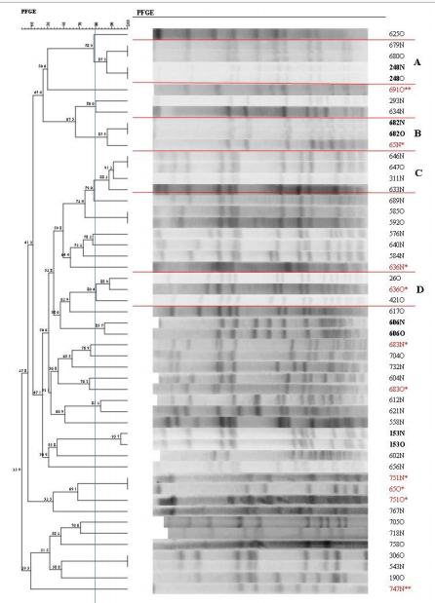
Note. Isolates in bold are from the same subject and have the same profile at both sampling sites (nasal/oropharyngeal). * Isolates obtained from the same subject but showing different profiles. ** The isolates identified as 691N and 747O and obtained from the same subjects as isolates 691O and 747N, respectively, were not typed with SmaI. N = nasal mucosa; O = oropharyngeal mucosa.
Figure S1. Dendrogram generated by Dice analysis/UPGMA (BioNumerics, Applied Maths) of the PFGE SmaI profiles of MSSA isolated from insulin-dependent diabetic individuals.

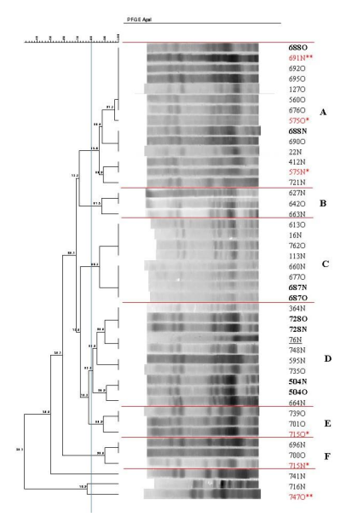

Note. Isolates in bold are from the same subject and have the same profile at both sampling sites (nasal/oropharyngeal)). * Isolates obtained from the same subject but showing different profiles. ** The isolates identified as 691N and 747O and obtained from the same subjects as isolates 691O and 747N, respectively, were typed with SmaI. Strain 76N previously isolated in another study and identified as S. aureus ST398 in a patient from the same city is underlined in the dendrogram. N = nasal mucosa; O = oropharyngeal mucosa.
Figure S2. Dendrogram generated by Dice analysis/UPGMA (BioNumerics, Applied Maths) of the PFGE ApaI profiles of MSSA isolated from insulin-dependent diabetic individuals.

