Supporting information

Salivary protein NlSP7 of the brown planthopper functions as an effector for mediating tricin metabolism in rice plants
Gu Gong ^{1, 2, #}, Long-Yu Yuan ^{1, #}, Yi-Feng Li ¹, Hang-Xiang Xiao ¹, Yan-Fang Li ¹, Yang Zhang ¹, Wei-Jian Wu ², Zhen-Fei Zhang ^{1, *}
¹ Guangdong Provincial Key Laboratory of High Technology for Plant Protection, Plant Protection Research Institute, Guangdong Academy of Agricultural Sciences, Guangzhou 510640, P R China
² College of Plant Protection, South China of Agricultural University
* Correspondence: Zhen-fei Zhang, Guangdong Provincial Key Laboratory of High Technology for Plant Protection/Plant Protection Research Institute, Guangdong Academy of Agricultural Science, Guangzhou 510640, China.
E-mail address: zhangzhenfei@gdaas.cn
# These authors contributed equally to this work.
Declarations of interest: none.

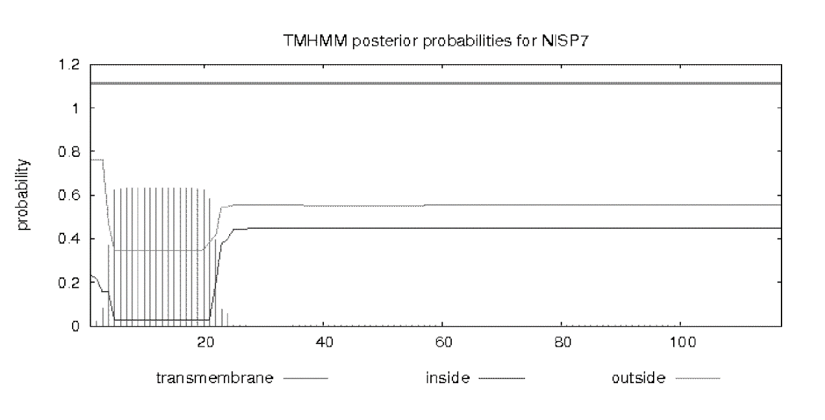
Fig. S1 Posterior probabilities predicted by the TMHMM server for NLSP7 and prediction of transmembrane helices in NLSP7 protein. Prediction of transmembrane helices in NLSP7 protein. Transmembrane position is 1–20 base pairs of NLSP7.

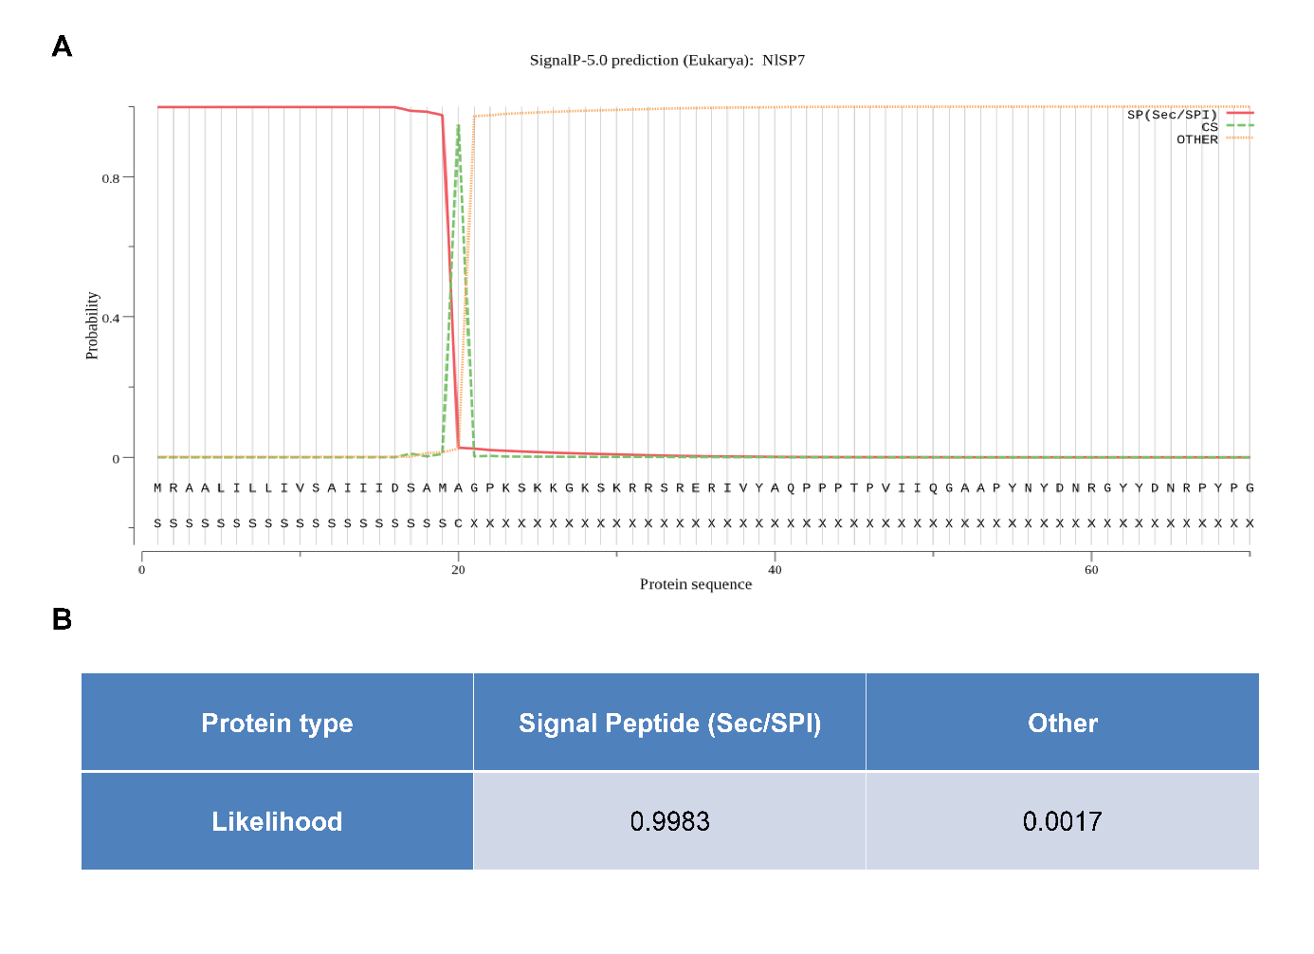
Fig. S2 Signal peptide (sec/ Signal Peptidase I) prediction of NLSP7 using the SignalP 5.0 server. A-B cleavage site between pos. 20 and 21: AMA -GP (sequence position). Probability: 0.9477.

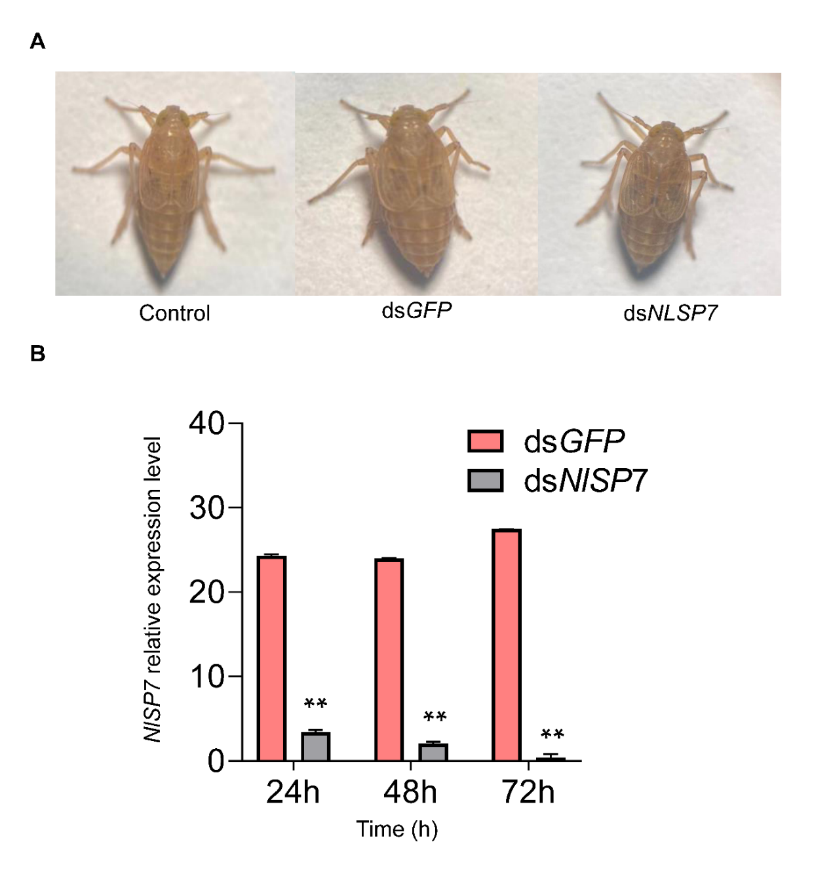
Fig. S3 Brown planthoppers were injected with specific double-stranded RNA. A BPHs after three days of three different treatments. B the expression level of NLSP7 was determined at 24 h intervals. Data are represented as the mean ± SD from three biological replicates. Asterisks (**) indicate significant difference (P < 0.01, t-test).

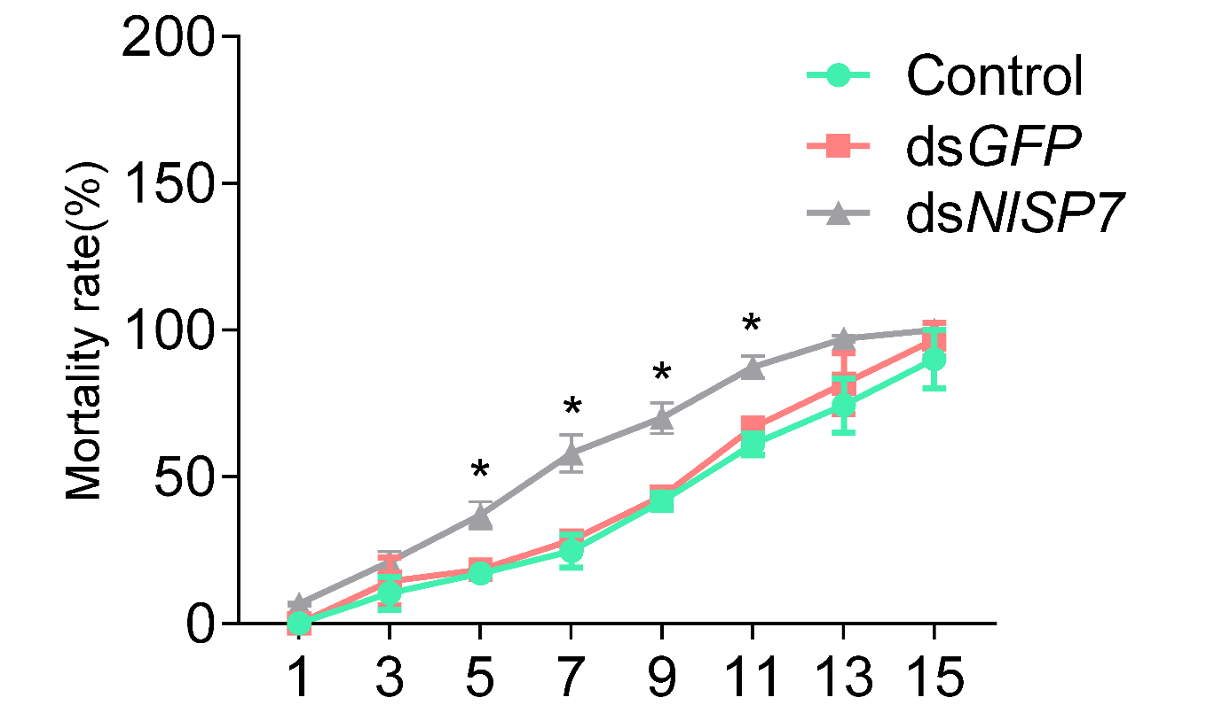
Fig. S4 Mortality rate of BPHs fed TN1 rice, repeated three times, respectively. Each treatment repeated with 100 brown planthoppers. Data are represented as the mean ± SD (P < 0.01, Duncan’s multiple range test).

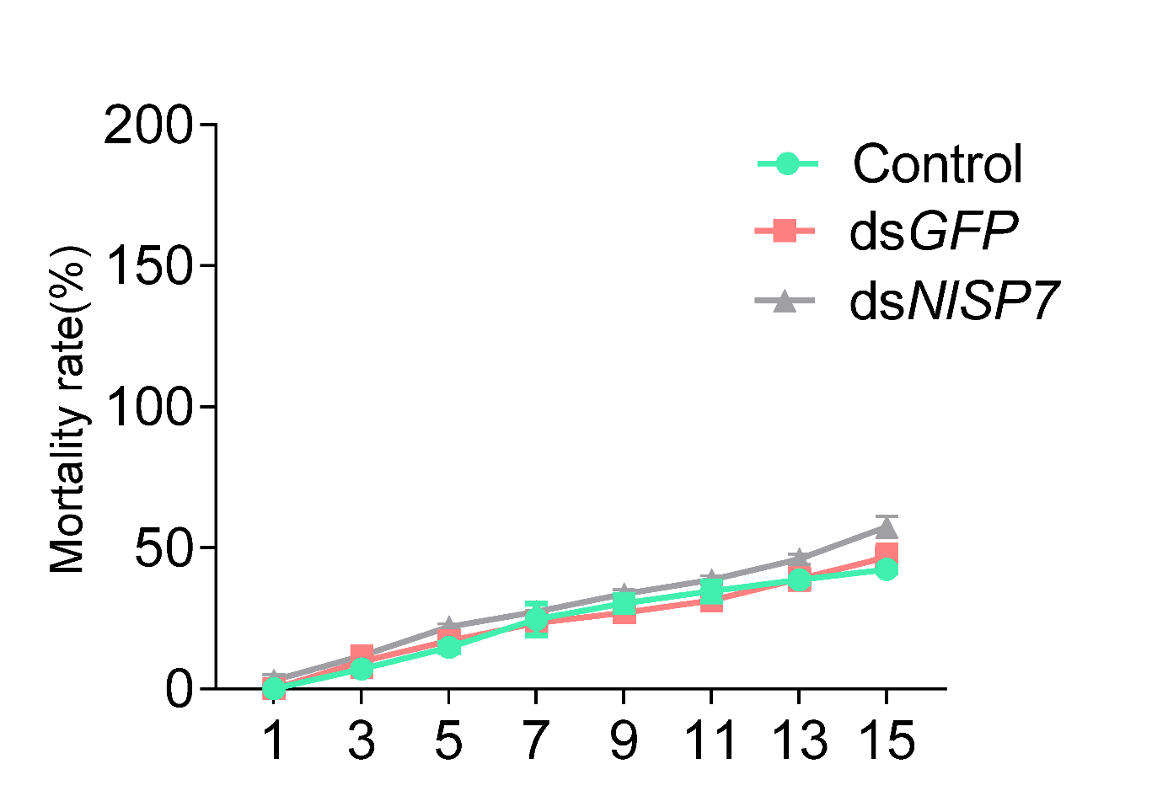
Fig. S5 Mortality rate of BPHs fed an artificial diet with 0 mg/l tricin, repeated three times. Each treatment repeated with 100 brown planthoppers. Data are represented as the mean ± SD (P < 0.01, Duncan’s multiple range test).

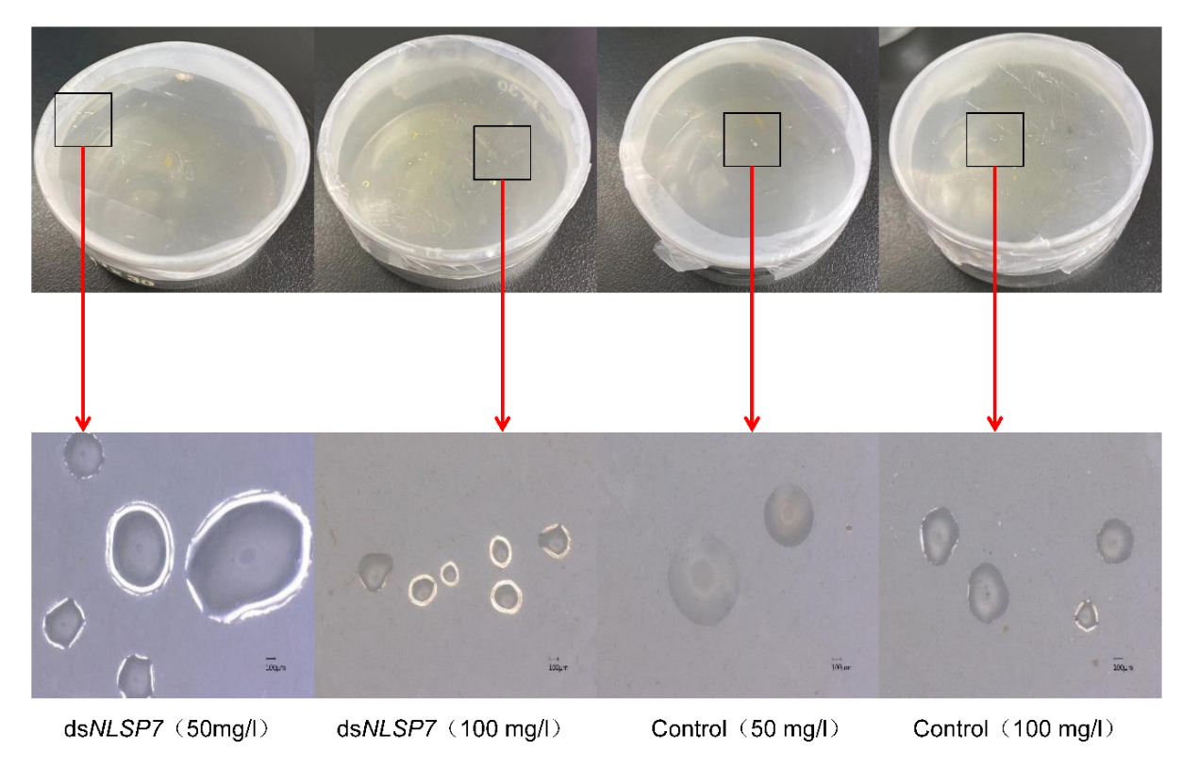
Fig. S6 Effect of NLSP7 expression silencing on salivary flanges based on an artificial diet with different tricin concentrations. Significant differences were observed for different concentrations of tricin. Each bar represents the mean ± SD from 30 replicates. Bars with different letters indicate significant differences among the three treatments (P < 0.01, Duncan’s multiple range test).
Table S1. Primers used for qRT-PCR and PCR.
Gene | Description | Forward primer (5'-…-3') | Reverse primer (5'…-3')
NLSP7 | QPCR | AAGAAAGGCAAGAGCAAG | GTAGGCTGCACATAAGGA
NLSP7 | Cloning | ATGAGGGCTGCCCTGATT | TAGACAACCTGTGGTCCA
NLSP7 | dsRNA synthesis | GGATCCTAATACGACTCACTATAGG  ATGAGGGCTGCCCTGATT | GGATCCTAATACGACTCACTATAGG  TAGACAACCTGTGGTCCA
GFP | dsRNA synthesis | GGATCCTAATACGACTCACTATAGGAA  GGGCGAGGAGCTGTTCACCG | GGATCCTAATACGACTCACTATAGGCA  GCAGGACCATGTGATCGCGC

