Figure S1. Detailed process of lymphocyte infiltration in tumor microenvironment.
Figure S2. Screen the genes related to TILs by WGCNA and chromosome location
a Hierarchical cluster tree of gene expression patterns in 111 LSCC samples. b Power value screening of WGCNA. When the power value is 5, R2=0.9, the average connectivity is the best. c Clustering and merging of gene co-expression modules. d Visualize the WGCNA network using heat map drawing. This heat map describes the topological overlap matrix (TOM) between all modules included in the analysis. Bright colors indicate high overlap, while dimming reds indicate low overlap. e A Chromosomal distribution of potential TILs related genes.
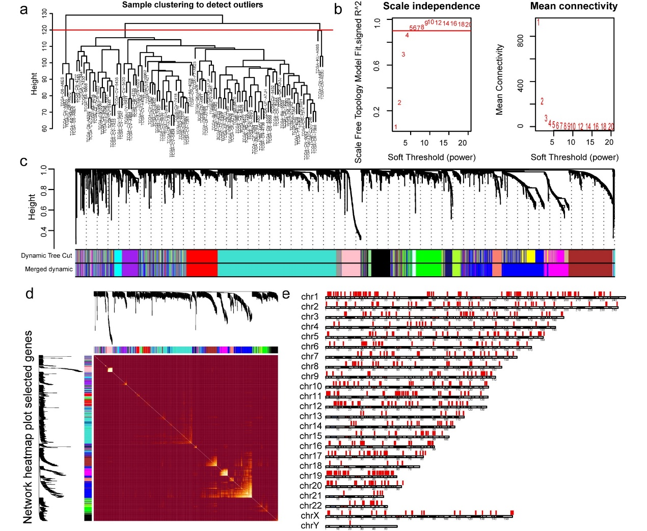
Figure S3. Risk assessment model for prognosis prediction.
a Forest map showing 69 differentially expressed genes related to prognosis identified by univariate COX analysis. b Validation was performed for tuning parameter selection through the Lasso regression model for OS. c Elucidation for LASSO coefficient profiles of prognostic WGCNA-Genes. d Time-dependent ROC curve of the WGCNA-Genes signature in the TCGA cohort. The optimal cutoff value of the WGCNA-Genes signature is 3.51; patients are divided into the high-risk group and the low-risk group according to the cutoff value.
Figure S4. The relationship between WGCNA-Genes signature and clinical characteristics is in the ICGC database
a The AUC values of 1-year, 3-year and 5-year ROC curves of the optimal model were 0.628, 0.815 and 0.821, respectively. b Patients were sorted by increasing risk score in the ICGC set. c The Kaplan-Meier survival curve with log-rank test was drawn to demonstrate the relationship between risk model and OS. Compared with the high-risk group, patients in the low-risk group experienced a longer survival time. The survival time and survival status of patients worsened as the risk score increased (y=-0.54x+1.14, R²=0.17). d Correlation between gender differences and risk scores. e Correlation between clinical characteristics and risk score.
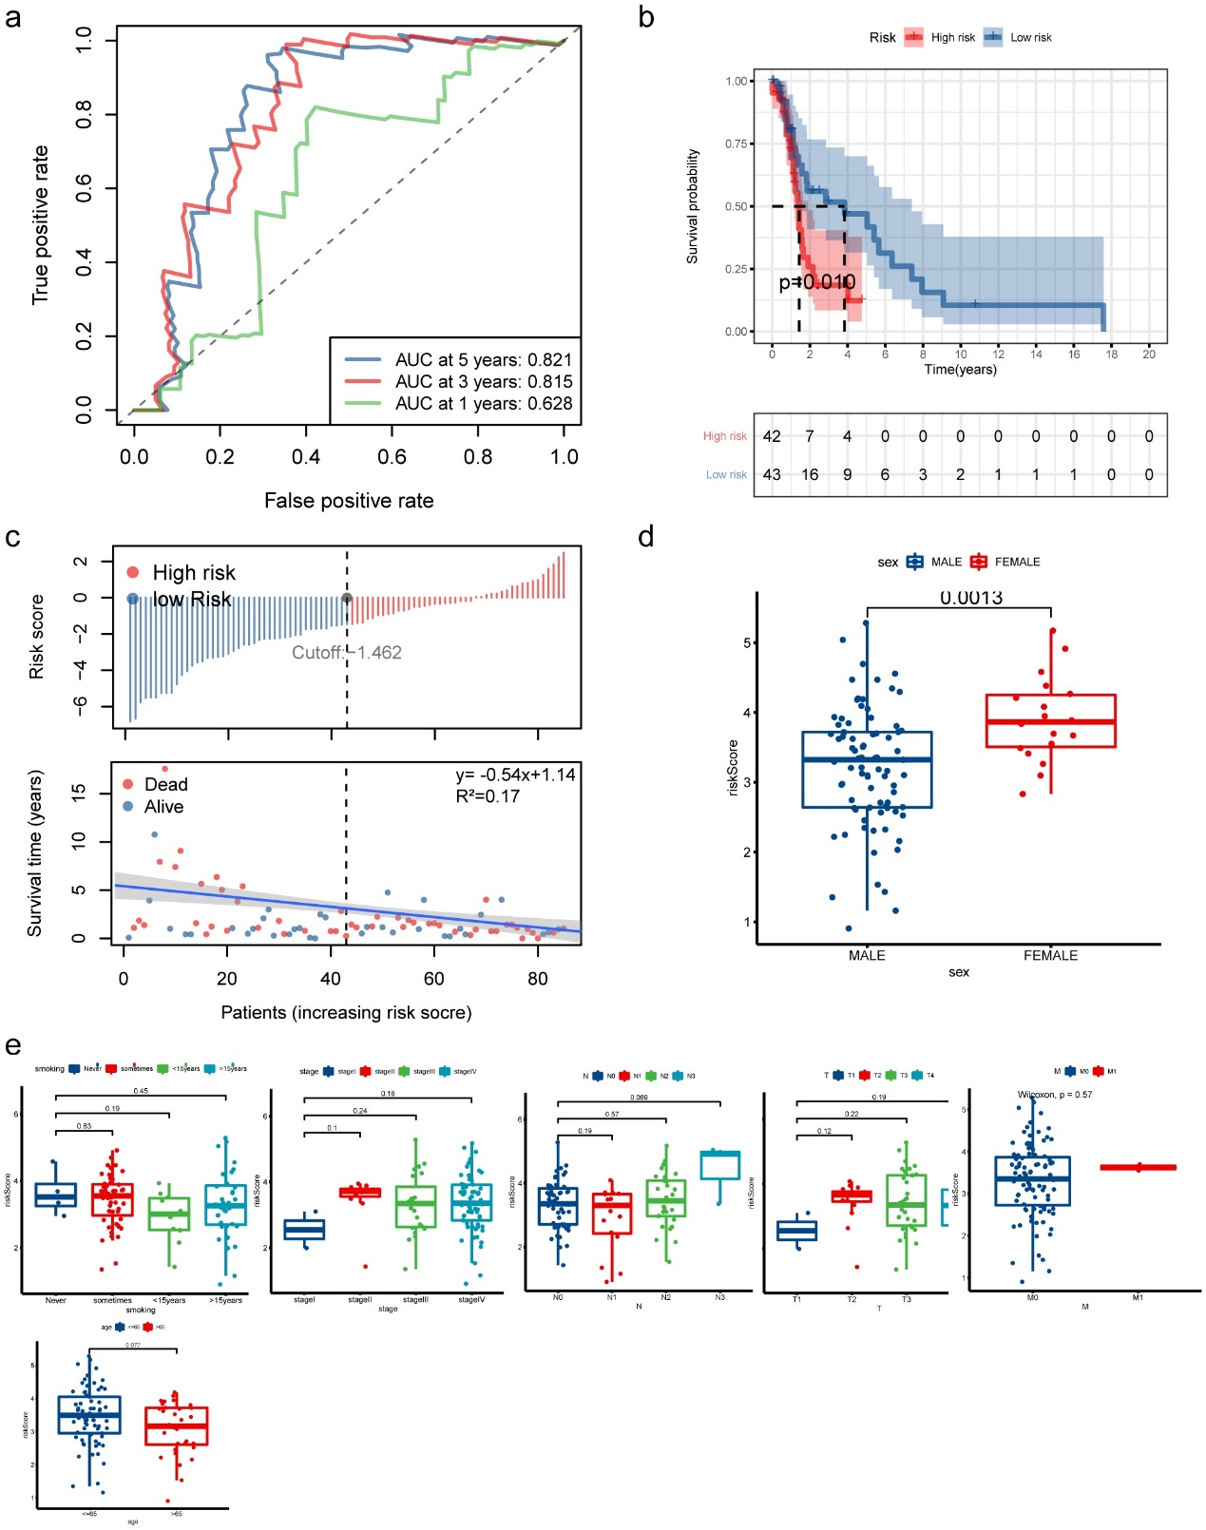
Table S1. Information of 19 WGCNA-Genes. *Gene information was annotated by website of genecards (https://www.genecards.org/).
Gene | Information* | coefficient
ANTXR2 | extracellular matrix adhesion | 0.011288
AQP9 | immunological response | 0.093181
ARG2 | extra-urea cycle arginine metabolism | 0.185226
CADM1 | Cell junction organization and Cell adhesion molecules | 0.256285
CTSL | intracellular protein catabolism | 0.499733
DNASE1L3 | protein hydrolyzes DNA | -0.01072
HCLS1 | antigen receptor signaling | -0.14695
KDM5D | histocompatibility antigen | -0.234
LCK | maturation of developing T-cells | -0.13901
LGALS2 | galactoside binding | -0.20164
MAP3K14 | the interleukin-1 type-I receptor | -0.15503
MT-ATP8 | proton transmembrane transporter activity | 0.179484
NUPR2 | cell viability and cell proliferation | 0.093988
RBP1 | carrier protein | 0.069595
RIPOR3 | protein binding | -0.10012
S1PR4 | the endothelial differentiation | -0.02142
SLC39A8 | inflammation | 0.252092
TNFRSF4 | receptor in CD4+ T cell response, as well as in T cell-dependent B cell proliferation and differentiation | -0.03606
VAMP5 | the vesicle-associated membrane protein | -0.14924

