Supplementary Materials and Methods
The cleaned data were then aligned to the reference human genome (hg19) using the Burrows-Wheeler Aligner (version 0.7.12) (1). The alignment information was stored in *.sam format and Samtools software (version 1.8) (2) was used to create binary sequence alignment/map files for each sample. Duplicate reads were removed using Picard Tools (version 1.119) (3) according to the standard data pipeline from the Broad Institute. Local realignments and base quality score recalibrations were performed using the Genome Analysis Toolkit (version 3.8.1) (4).
Somatic Mutation Calling
Somatic point mutations (single-nucleotide variants, SNVs) and small insertions and/or deletions (indels) were identified by comparing tumour and matched normal BAM files using Mutect2 (v 4.0.8.0) (5) and Strelka (v 2.9.7) (6), and only variants that passed both quality filters were used in the follow-up analysis. All analyses were performed with default parameters. SNVs and indels falling within the target regions defined by VariantBaits™ Human All Exon Kit were included in further analyses. The Variant Effect Predictor (VEP) (7) tool was utilized to add biological information to the variant set. Variants were removed if present in either the dbSNP or 1000 Genomes database. Variants were filtered to exclude intronic and silent changes and to retain mutations resulting in missense mutations, nonsense mutations, frameshift alterations, or splice site alterations. Candidate variants were further annotated using ANNOVAR (8) to add location, function, previously reported data and sequencing data supporting the status of the mutation, and the files were converted to Mutation Annotation Format (MAF) files with vcf2maf (https://github.com/mskcc/vcf2maf).
Identification of Somatic Copy Number Alterations (SCNAs)
Control-FREEC (v 11.5) (9, 10) was used to detect copy number variations. The GC content of the sequences was applied to normalize the read distribution, and the normalized distribution of aligned reads in slide windows was employed to calculate the copy number difference between tumour and normal samples.
Identification of Driver Genes
MutSigCV (v 1.4.1) (10), which identifies significantly mutated genes, was used to detect driver genes. Both somatic point mutations and indels were used for this analysis. The required coverage file and covariate file were downloaded from the MutSigCV website, and the workflow described on the website was applied. MAF files were used as input files. An FDR-adjusted P-value (q-value) cut-off of 0.1 was applied to obtain the driver genes.
Extraction of Mutation Signatures
Somatic point mutation signatures were identified with the Bioconductor package deconstructSigs (11), which identifies the linear combination of predefined signatures that most accurately reconstruct the mutational profile of a tumour sample. These candidate signatures were compared with COSMIC signatures. Each mutational signature was assigned a calculated weight representing its contribution to the case samples, with a higher weight indicating a greater relative contribution of the signature.
Prediction of HLA Types and Neoantigens
The human leukocyte antigen (HLA) types of 40 patients were identified computationally using HLA-HD (v 1.2.1) (12) and HLAscan (v 2.1.2) (13) with default parameters, and BAM files were input to determine genotypes at four-digit resolution. To predict the number of neoepitopes from nonsynonymous mutations, each nonsynonymous SNV was translated into a 22-mer peptide sequence centred on the mutated amino acid. Subsequently, the 22-mer was separated into 8-11-mers, which is a common length for peptides presented by human MHC class I molecules, via a sliding window to detect MHC class I binding. We then predicted the MHC binding affinity for each peptide, as described previously (14). The NetMHCpan 4.0 (15) tool was used to determine the binding affinity strength between each mutated peptide and patient-specific HLA allele. To cover most of the potential immune binding interactions, neoantigens with a predicted binding affinity % rank < 0.5 were considered binders.
To verify the accuracy of the predicted neoantigens in this study, we searched for data related to these candidate neoantigens in three neoantigen-related databases: Tumour-Specific Neoantigen Database (TSNAdb, http://biopharm.zju.edu.cn/tsnadb/ (16)), Immune Epitope Database (IEDB, http://www.iedb.org/ (17)) and CTDatabase (http:/s/www.cta.lncc.br) (18). The methods for somatic mutation calling, identification of somatic copy number alterations (SCNAs), identification of driver genes, extraction of mutation signatures, prediction of HLA types and neoantigens are shown in supplementary materials.
Bioinformatics analysis
The cBioPortal database was used to evaluate relationships between survival outcomes and gene mutation frequency, smoking status, and TMB. The relationships between TIL characteristics and mutations in TP53 and complement C1q B chain (C1QB) were evaluated using the TIMER database (versions 1 and 2).

Supplementary Result

Potential driver genes in patients with LC&TB
A list of potential driver genes is shown in Supplementary Table S10. The cBioPortal for Cancer Genomics database (https://www.cbioportal.org/) was used to evaluate whether the potential driver genes were related to clinicopathological characteristics and survival outcomes using data from 12 studies of patients with NSCLC (Supplementary Table S7) and one pan-cancer study of 4,075 patients (19). The greatest difference in mutation frequency between the LC&TB and LC groups was observed for TP53, which was more frequently mutated in the LC group than in the LC&TB group (P = 0.003, Supplementary Figure S9A). A lollipop plot showing the TP53 mutation frequencies, hotspots, and affected protein domains based on the WES results is shown in Supplementary Figure S10A. The previous studies revealed TP53 mutation frequencies of 37.9–67.8%. We further analysis the data of the MSKCC study from the cBioPortal and revealed that TP53 mutations were associated with significantly better outcomes (vs. wild-type TP53) (Supplementary Figure S10 B-C). There was a clear correlation between CD274 and TP53 mutations (P < 0.001, Supplementary Figure S10D), and a high TP53 mutation rate was associated with a high TMB and cigarette smoke exposure based on the pan-cancer data from the MSKCC study (19). The TIMER analysis revealed that the TP53 CNV was closely related to macrophage and dendritic cell infiltration (Supplementary Figure S8C), while TP53 mutations were significantly associated with dendritic cell infiltration (Supplementary Figure S8D).
The LC&TB group included 4 patients (4/19, 21.1%) harbouring C1QB c.274_311del, while the LC group included no patients harbouring C1QB mutations (Supplementary Figure S11B). Significant differences in CIQB mutations were observed between the LC&O/CTB, LC&ATB, and LC groups (P = 0.028). A lollipop plot showing the C1QB mutation frequencies is shown in Supplementary Figure S11C. Variant Effect Predictor was used to predict the effect of each mutation, which revealed that C1QB c.274_311del was predicted to substantially influence protein function. Interestingly, the previous studies revealed a low frequency of C1QB mutations in patients with LC (26/3, 673 cases, 0.7%) (Supplementary Figure S11E), and the pan-cancer analysis from the MSKCC study (19) revealed no C1QB mutations in 350 patients with NSCLC. The present study revealed that C1QB mutations in lung adenocarcinoma (LUAD) and lung squamous cell carcinoma (LUSC) were significantly associated with tumour infiltration by macrophages, M2 macrophages, and T follicular helper cells (all P < 0.05). Furthermore, C1QB mutations were marginally associated with dendritic cell infiltration (P = 0.065). Combined data from the 12 previous studies revealed no significant difference in median survival times according to C1QB mutation status among patients with NSCLC (mutated: 47.47 months vs. wild-type: 54.34 months, P = 0.514) (Supplementary Figure S11D), although C1QB mutations were associated with increased exposure to cigarette smoke (P < 0.003, Supplementary Figure S11F). The mRNA expression of C1QB was decreased in LUAD and LUSC (Supplementary Figure S12A), and mRNA expression was positively correlated with NSCLC infiltration of CD4⁺ T-cells, CD8⁺ T-cells, macrophages, and dendritic cells (Supplementary Figure S12B). These results suggest that C1QB may play an important role in the tumour microenvironment of LC&TB.
In addition, 3 of 4 tested patients (75%) harboured POU3F3 c.737_739del and 1 of 4 tested patients (25%) harboured POU3F3 c.829_831del. Only 1 patient in the LC group harboured POU3F3 c.609_611del. We did not perform additional bioinformatics analysis because there were no significant differences in the POU3F3 mutation frequencies between the LC&O/CTB, LC&ATB, and LC groups.

REFERENCES

1. Li H, Durbin R. Fast and accurate long-read alignment with Burrows-Wheeler transform. Bioinformatics. 2010;26(5):589-95.
2. Li H, Handsaker B, Wysoker A, Fennell T, Ruan J, Homer N, et al. The Sequence Alignment/Map format and SAMtools. Bioinformatics. 2009;25(16):2078-9.
3. Picard Toolkit. 2019. Broad Institute, GitHub Repository. http://broadinstitute.github.io/picard/; Broad Institute.
4. DePristo MA, Banks E, Poplin R, Garimella KV, Maguire JR, Hartl C, et al. A framework for variation discovery and genotyping using next-generation DNA sequencing data. Nat Genet. 2011;43(5):491-8.
5. Cibulskis K, Lawrence MS, Carter SL, Sivachenko A, Jaffe D, Sougnez C, et al. Sensitive detection of somatic point mutations in impure and heterogeneous cancer samples. Nat Biotechnol. 2013;31(3):213-9.
6. Saunders CT, Wong WS, Swamy S, Becq J, Murray LJ, Cheetham RK. Strelka: accurate somatic small-variant calling from sequenced tumor-normal sample pairs. Bioinformatics. 2012;28(14):1811-7.
7. McLaren W, Gil L, Hunt SE, Riat HS, Ritchie GR, Thormann A, et al. The Ensembl Variant Effect Predictor. Genome Biol. 2016;17(1):122.
8. Wang K, Li M, Hakonarson H. ANNOVAR: functional annotation of genetic variants from high-throughput sequencing data. Nucleic Acids Res. 2010;38(16):e164.
9. Boeva V, Popova T, Bleakley K, Chiche P, Cappo J, Schleiermacher G, et al. Control-FREEC: a tool for assessing copy number and allelic content using next-generation sequencing data. Bioinformatics. 2012;28(3):423-5.
10. Lawrence MS, Stojanov P, Polak P, Kryukov GV, Cibulskis K, Sivachenko A, et al. Mutational heterogeneity in cancer and the search for new cancer-associated genes. Nature. 2013;499(7457):214-8.
11. Rosenthal R, McGranahan N, Herrero J, Taylor BS, Swanton C. DeconstructSigs: delineating mutational processes in single tumors distinguishes DNA repair deficiencies and patterns of carcinoma evolution. Genome Biol. 2016;17:31.
12. Kawaguchi S, Higasa K, Shimizu M, Yamada R, Matsuda F. HLA-HD: An accurate HLA typing algorithm for next-generation sequencing data. Hum Mutat. 2017;38(7):788-97.
13. Ka S, Lee S, Hong J, Cho Y, Sung J, Kim HN, et al. HLAscan: genotyping of the HLA region using next-generation sequencing data. BMC Bioinformatics. 2017;18(1):258.
14. Gubin MM, Zhang X, Schuster H, Caron E, Ward JP, Noguchi T, et al. Checkpoint blockade cancer immunotherapy targets tumour-specific mutant antigens. Nature. 2014;515(7528):577-81.
15. Hoof I, Peters B, Sidney J, Pedersen LE, Sette A, Lund O, et al. NetMHCpan, a method for MHC class I binding prediction beyond humans. Immunogenetics. 2009;61(1):1-13.
16. Wu J, Zhao W, Zhou B, Su Z, Gu X, Zhou Z, et al. TSNAdb: A Database for Tumor-specific Neoantigens from Immunogenomics Data Analysis. Genomics Proteomics Bioinformatics. 2018;16(4):276-82.
17. Vita R, Mahajan S, Overton JA, Dhanda SK, Martini S, Cantrell JR, et al. The Immune Epitope Database (IEDB): 2018 update. Nucleic Acids Res. 2019;47(D1):D339-D43.
18. Almeida LG, Sakabe NJ, deOliveira AR, Silva MC, Mundstein AS, Cohen T, et al. CTdatabase: a knowledge-base of high-throughput and curated data on cancer-testis antigens. Nucleic Acids Res. 2009;37(Database issue):D816-9.
19. Samstein RM, Lee CH, Shoushtari AN, Hellmann MD, Shen R, Janjigian YY, et al. Tumor mutational load predicts survival after immunotherapy across multiple cancer types. Nat Genet. 2019;51(2):202-6.

Supplementary Tables

Supplementary Table S1. The clinicopathological characteristics of entire patient cohort (divided into three groups)

Patient Characteristics | LC with Active TB（N=33） | LC with Old TB（N = 26*） | LC（N=28） | P value
Sex |  |  |  | 0.113
Male | 24 (72.7%) | 24 (92.3%) | 20 (71.4%)
Female | 9 (27.3%) | 2 (7.7%) | 8 (28.6%)
Median Age  (Range) | 58 (36-75) years | 66 (52-79) years | 62 (37-75) years
Smoking status |  |  |  | 0.743
Non-smoker | 12 (36.4%) | 7 (26.9%) | 9 (32.1%)
Smoker | 21 (63.6%) | 19 (73.1%) | 19 (67.9%)
Histology |  |  |  | 0.720
adenocarcinoma | 17 (51.5%) | 11 (42.3%) | 12 (42.9%)
Non-adenocarcinoma | 16 (48.5%) | 15 (57.7%) | 16 (57.1%)
Pathologic T stage |  |  |  | 0.242
T1+T2 | 24 (72.7%) | 16 (64.0%) | 22 (84.6%)
T3+T4 | 9 (27.3%) | 9 (36.0%) | 4 (15.4%)
Lymph node metastasis |  |  |  | 0.607
N0 | 14 (42.4%) | 10 (41.7%) | 15 (53.6%)
N1-3 | 19 (57.6%) | 14 (58.3%) | 13 (46.4%)
Distant metastasis |  |  |  | 0.813
M0 | 24 (72.7%) | 20 (80.0%) | 21 (75.0%)
M1 | 9 (27.3%) | 5 (20.0%) | 7 (25.0%)
Clinical stage |  |  |  | 0.101
I+II | 15 (45.5%) | 7 (28.0%) | 16 (57.1%)
III+IV | 18 (54.5%) | 18 (72.0%) | 12 (42.9%)
Differentiation degree |  |  |  | 0.974
Poor or undifferentiated | 11 (50.0%) | 11 (52.4%) | 7 (53.8%)
Well-intermediate | 11 (50.0%) | 10 (47.6%) | 6 (46.2%)
EGFR |  |  |  | 0.283
Positive | 1 (7.7%) | 0 (0%) | 6 (21.4%)
Negative | 12 (92.3%) | 6 (100%) | 22 (78.6%)
PD-L1 |  |  |  | 0.001
Positive | 9 (30.0%) | 4 (15.4%) | 18 (64.3%)
Negative | 21 (70.0%) | 22 (84.6%) | 10 (35.7%)
CD3 |  |  |  | 0.004
Positive | 4 (16.7%) | 3 (12.5%) | 11 (52.4%)
Negative | 20 (83.3%) | 21 (87.5%) | 10 (47.6%)
CD4 |  |  |  | <0.001
Positive | 2 (8.3%) | 1 (4.2%) | 14 (66.7%)
Negative | 22 (91.7%) | 23 (95.8%) | 7 (33.3%)
CD8 |  |  |  | <0.001
Positive | 0 (0%) | 3 (12.5%) | 15 (53.6%)
Negative | 24 (100%) | 21 (87.5%) | 13 (46.4%)
Venous/lymphatic/Perineural invasion |  |  |  | 0.149
No | 11 (64.7%) | 7 (100%) | 17 (81.0%)
Yes | 6 (35.3%) | 0 (0%) | 4 (19.0%)
Adjuvant radiotherapy |  |  |  | 0.562
No | 10 (43.5%) | 11 (57.9%) | 12 (57.1%)
Yes | 13 (56.5%) | 8 (26.7%) | 9 (30.0%)
Adjuvant chemotherapy |  |  |  | 0.268
No | 27 (81.8%) | 22 (84.6%) | 19 (67.9%)
Yes | 6 (18.2%) | 4 (15.4%) | 9 (32.1%)
Family history of cancer |  |  |  | 0.187
No | 31 (93.9%) | 21 (80.8%) | 22 (78.6%)
Yes | 2 (6.1%) | 5 (19.2%) | 6 (21.4%)
*NOTE: One of the patients had no staging information.

Supplementary Table S2. The PD-L1 expression and T lymphocytes infiltrate in tumor foci and tuberculosis foci of 10 patients
Patients | Whether active | Tumor |  |  |  |  |  | Tuberculosis
 |  | PD-L1 in TC | PD-L1 in IC | CD3 | CD4 | CD8 |  | PD-L1 in TC | PD-L1 in IC | CD3 | CD4 | CD8
1 | ATB | 0% | 0% | 0% | 0% | 1% |  | 0% | 0% | NA | 0% | 0%
2 | OTB | 0% | 0% | 5% | 0% | 5% |  | 0% | 0% | 5% | 5% | 0%
3 | OTB | 0% | 0% | 1% | 0% | 5% |  | 0% | 0% | 5% | 5% | 0%
4 | ATB | 0% | 0% | 0% | 0% | 5% |  | 0% | 10% | 10% | 20% | 10%
5 | OTB | 0% | 0% | 10% | 0% | 15% |  | 0% | 0% | 0% | 0% | 0%
6 | ATB | <1% | 40% | 3% | 0% | 15% |  | 0% | 0% | 30% | 30% | 0%
7 | ATB | <1% | 0% | 0% | 0% | 0% |  | <1% | 5% | 20% | 40% | 10%
8 | ATB | <1% | 0% | 0% | 0% | 0% |  | 0% | 55% | 20% | 30% | 15%
9 | ATB | <1% | 0% | 0% | 0% | 0% |  | 0% | 2% | 40% | 25% | 10%
10 | ATB | 0% | 0% | 40% | 1% | 5% |  | 0% | 0% | 5% | 0% | 0%

Supplementary Table S3. Univariate analysis of factors that influence overall survival of lung cancer patients with tuberculosis.
Factors | P value of univariate survival analysis in LC&TB  (N = 59)
Sex
Male | 0.450
Female
Age
 | 0.201
Smoking status
Non-smoker | 0.669
Smoker
Histology
adenocarcinoma | 0.051
Non-adenocarcinoma
Pathologic T stage
T1+T2 | 0.049
T3+T4
Lymph node metastasis
N0 | 0.007
N1-3
Distant metastasis
M0 | 0.138
M1
Clinical stage
I+II | 0.006
III+IV
Differentiation
Poor or undifferentiated | 0.053
Well-intermediate
Venous/lymphatic/Perineural invasion
No | 0.239
Yes
Adjuvant radiotherapy
No | 0.586
Yes
Adjuvant chemotherapy
No | 0.519
Yes
Family history of cancer
No | 0.762
Yes
EGFR
Positive | 0.520
Negative
PD-L1
Positive | 0.132
Negative
CD3
Positive | 0.229
Negative
CD4
Positive | 0.140
Negative
CD8
Positive | 0.111
Negative

Supplementary Table S4. The significantly difference gene in three groups.
No | Gene | Frequency in LC | Frequency in LC&OTB | Frequency in LC&ATB | Frequency in LC&TB | P-value (LC&ATB vs. LC&OTB vs. LC) | P-value (LC&TB vs. LC)
1 | ZNF208 | 4.76% | 83.33% | 69.23% | 73.68% | 0.000 | 0.000
2 | HRNR | 4.76% | 66.67% | 53.85% | 57.89% | 0.001 | 0.002
3 | TP53 | 76.19% | 66.67% | 23.08% | 36.84% | 0.010 | 0.003
4 | USP17L2 | 0.00% | 50.00% | 38.46% | 42.11% | 0.001 | 0.004
5 | ZNF626 | 0.00% | 0.00% | 46.15% | 31.58% | 0.001 | 0.007
6 | IGFN1 | 0.00% | 33.33% | 38.46% | 36.84% | 0.003 | 0.009
7 | KIF13A | 0.00% | 16.67% | 38.46% | 31.58% | 0.006 | 0.009
8 | LRRC37A3 | 0.00% | 33.33% | 38.46% | 36.84% | 0.003 | 0.009
9 | TRIOBP | 0.00% | 16.67% | 38.46% | 31.58% | 0.006 | 0.009
10 | ZNF729 | 9.52% | 100.00% | 46.15% | 63.16% | 0.000 | 0.009
11 | LRRC37A2 | 0.00% | 50.00% | 30.77% | 36.84% | 0.002 | 0.009
12 | ZNF91 | 0.00% | 50.00% | 30.77% | 36.84% | 0.002 | 0.009
13 | FLG | 19.05% | 50.00% | 76.92% | 68.42% | 0.003 | 0.012
14 | ZNF486 | 0.00% | 0.00% | 38.46% | 26.32% | 0.003 | 0.018
15 | ZNF724P | 0.00% | 0.00% | 38.46% | 26.32% | 0.003 | 0.018
16 | ABCA13 | 0.00% | 16.67% | 30.77% | 26.32% | 0.025 | 0.021
17 | CTNND2 | 0.00% | 16.67% | 30.77% | 26.32% | 0.025 | 0.021
18 | NPIPB7 | 0.00% | 16.67% | 30.77% | 26.32% | 0.025 | 0.021
19 | ZNF117 | 0.00% | 16.67% | 30.77% | 26.32% | 0.025 | 0.021
20 | ZNF254 | 0.00% | 16.67% | 30.77% | 26.32% | 0.025 | 0.021
21 | ZNF721 | 0.00% | 16.67% | 30.77% | 26.32% | 0.025 | 0.021
22 | ZNF93 | 0.00% | 50.00% | 23.08% | 31.58% | 0.004 | 0.021
23 | RANBP2 | 4.76% | 50.00% | 38.46% | 42.11% | 0.011 | 0.021
24 | GPR112 | 0.00% | 66.67% | 15.38% | 31.58% | 0.000 | 0.022
25 | AHNAK | 9.52% | 16.67% | 53.85% | 42.11% | 0.011 | 0.032
26 | ANKRD36C | 9.52% | 50.00% | 46.15% | 47.37% | 0.021 | 0.034
27 | ANKRD26 | 0.00% | 0.00% | 30.77% | 21.05% | 0.015 | 0.042
28 | KIAA1462 | 0.00% | 0.00% | 30.77% | 21.05% | 0.015 | 0.042
29 | MRC2 | 0.00% | 0.00% | 30.77% | 21.05% | 0.015 | 0.042
30 | OTOP2 | 0.00% | 0.00% | 30.77% | 21.05% | 0.015 | 0.042
31 | PCNXL3 | 0.00% | 0.00% | 30.77% | 21.05% | 0.015 | 0.042
32 | TRANK1 | 0.00% | 0.00% | 30.77% | 21.05% | 0.015 | 0.042
33 | ZNF141 | 0.00% | 0.00% | 30.77% | 21.05% | 0.015 | 0.042
34 | ZNF431 | 0.00% | 0.00% | 30.77% | 21.05% | 0.015 | 0.042
35 | ANKRD18B | 4.76% | 16.67% | 38.46% | 31.58% | 0.037 | 0.045
36 | FLG2 | 4.76% | 33.33% | 38.46% | 36.84% | 0.030 | 0.045
37 | MKI67 | 4.76% | 33.33% | 38.46% | 36.84% | 0.030 | 0.045
38 | NPIPB11 | 4.76% | 33.33% | 38.46% | 36.84% | 0.030 | 0.045
39 | RGPD3 | 4.76% | 16.67% | 38.46% | 31.58% | 0.037 | 0.045
40 | ZNF680 | 4.76% | 16.67% | 38.46% | 31.58% | 0.037 | 0.045
41 | AKAP9 | 0.00% | 16.67% | 23.08% | 21.05% | 0.047 | 0.048
42 | C5orf42 | 0.00% | 16.67% | 23.08% | 21.05% | 0.047 | 0.048
43 | CELSR1 | 0.00% | 16.67% | 23.08% | 21.05% | 0.047 | 0.048
44 | CEP290 | 0.00% | 33.33% | 23.08% | 26.32% | 0.025 | 0.048
45 | CHD7 | 0.00% | 16.67% | 23.08% | 21.05% | 0.047 | 0.048
46 | CTB-134H23.2 | 0.00% | 16.67% | 23.08% | 21.05% | 0.047 | 0.048
47 | HOXA3 | 0.00% | 16.67% | 23.08% | 21.05% | 0.047 | 0.048
48 | JAK1 | 0.00% | 16.67% | 23.08% | 21.05% | 0.047 | 0.048
49 | KCNH1 | 0.00% | 16.67% | 23.08% | 21.05% | 0.047 | 0.048
50 | LAMB2 | 0.00% | 16.67% | 23.08% | 21.05% | 0.047 | 0.048
51 | MYO3B | 0.00% | 33.33% | 23.08% | 26.32% | 0.025 | 0.048
52 | NBPF9 | 0.00% | 33.33% | 23.08% | 26.32% | 0.025 | 0.048
53 | NF1 | 0.00% | 33.33% | 23.08% | 26.32% | 0.025 | 0.048
54 | NPIPB15 | 0.00% | 16.67% | 23.08% | 21.05% | 0.047 | 0.048
55 | OR2L5 | 0.00% | 16.67% | 23.08% | 21.05% | 0.047 | 0.048
56 | RGPD4 | 0.00% | 16.67% | 23.08% | 21.05% | 0.047 | 0.048
57 | SVIL | 0.00% | 16.67% | 23.08% | 21.05% | 0.047 | 0.048
58 | TRIM42 | 0.00% | 16.67% | 23.08% | 21.05% | 0.047 | 0.048
59 | ZNF28 | 0.00% | 33.33% | 23.08% | 26.32% | 0.025 | 0.048
60 | ZNF678 | 0.00% | 33.33% | 23.08% | 26.32% | 0.025 | 0.048
61 | ZNF736 | 0.00% | 16.67% | 23.08% | 21.05% | 0.047 | 0.048
62 | ZNF85 | 0.00% | 16.67% | 23.08% | 21.05% | 0.047 | 0.048
63 | CACNA1C | 0.00% | 50.00% | 15.38% | 26.32% | 0.005 | 0.048
64 | DPCR1 | 0.00% | 50.00% | 15.38% | 26.32% | 0.005 | 0.048
65 | POTEE | 0.00% | 50.00% | 15.38% | 26.32% | 0.005 | 0.048
66 | RP1L1 | 0.00% | 50.00% | 15.38% | 26.32% | 0.005 | 0.048
67 | ZNF90 | 0.00% | 50.00% | 15.38% | 26.32% | 0.005 | 0.048
68 | ZNF107 | 4.76% | 0.00% | 38.46% | 26.32% | 0.023 | 0.085
69 | ZNF493 | 4.76% | 0.00% | 38.46% | 26.32% | 0.023 | 0.085
70 | AHNAK2 | 14.29% | 33.33% | 53.85% | 47.37% | 0.041 | 0.085
71 | BDP1 | 4.76% | 33.33% | 30.77% | 31.58% | 0.049 | 0.093
72 | HERC1 | 4.76% | 33.33% | 30.77% | 31.58% | 0.049 | 0.093
73 | ERVW-1 | 4.76% | 50.00% | 23.08% | 31.58% | 0.028 | 0.095
74 | C1QB | 0.00% | 33.33% | 15.38% | 21.05% | 0.028 | 0.107
75 | DCHS1 | 0.00% | 33.33% | 15.38% | 21.05% | 0.028 | 0.107
76 | FAT2 | 0.00% | 33.33% | 15.38% | 21.05% | 0.028 | 0.107
77 | GPR179 | 0.00% | 33.33% | 15.38% | 21.05% | 0.028 | 0.107
78 | IGHV3-20 | 0.00% | 33.33% | 15.38% | 21.05% | 0.028 | 0.107
79 | LRRTM4 | 0.00% | 33.33% | 15.38% | 21.05% | 0.028 | 0.107
80 | LYST | 0.00% | 33.33% | 15.38% | 21.05% | 0.028 | 0.107
81 | POLQ | 0.00% | 33.33% | 15.38% | 21.05% | 0.028 | 0.107
82 | PRR14L | 0.00% | 33.33% | 15.38% | 21.05% | 0.028 | 0.107
83 | RIMS2 | 0.00% | 33.33% | 15.38% | 21.05% | 0.028 | 0.107
84 | ZMYND8 | 0.00% | 33.33% | 15.38% | 21.05% | 0.028 | 0.107
85 | ZNF479 | 0.00% | 33.33% | 15.38% | 21.05% | 0.028 | 0.107
86 | ZNF595 | 0.00% | 33.33% | 15.38% | 21.05% | 0.028 | 0.107
87 | ZNF737 | 0.00% | 33.33% | 15.38% | 21.05% | 0.028 | 0.107
88 | ZNF845 | 0.00% | 33.33% | 15.38% | 21.05% | 0.028 | 0.107
89 | ZNF92 | 0.00% | 33.33% | 15.38% | 21.05% | 0.028 | 0.107
90 | KANSL1 | 0.00% | 50.00% | 7.69% | 21.05% | 0.003 | 0.108
91 | KRAS | 0.00% | 50.00% | 7.69% | 21.05% | 0.003 | 0.108
92 | PPIAL4G | 0.00% | 50.00% | 7.69% | 21.05% | 0.003 | 0.108
93 | TENM4 | 0.00% | 50.00% | 7.69% | 21.05% | 0.003 | 0.108
94 | ZNF429 | 0.00% | 50.00% | 7.69% | 21.05% | 0.003 | 0.108
95 | ZNF681 | 0.00% | 50.00% | 7.69% | 21.05% | 0.003 | 0.108
96 | ZNF726 | 0.00% | 50.00% | 7.69% | 21.05% | 0.003 | 0.108
97 | MUC17 | 28.57% | 83.33% | 61.54% | 68.42% | 0.031 | 0.131
98 | MGA | 4.76% | 50.00% | 15.38% | 26.32% | 0.031 | 0.185
99 | ZNF578 | 4.76% | 50.00% | 15.38% | 26.32% | 0.031 | 0.185
100 | ANO6 | 0.00% | 33.33% | 7.69% | 15.79% | 0.022 | 0.232
101 | ATP7B | 0.00% | 33.33% | 7.69% | 15.79% | 0.022 | 0.232
102 | BRWD3 | 0.00% | 33.33% | 7.69% | 15.79% | 0.022 | 0.232
103 | C4orf51 | 0.00% | 33.33% | 7.69% | 15.79% | 0.022 | 0.232
104 | COBLL1 | 0.00% | 33.33% | 7.69% | 15.79% | 0.022 | 0.232
105 | CSGALNACT1 | 0.00% | 33.33% | 7.69% | 15.79% | 0.022 | 0.232
106 | DCN | 0.00% | 33.33% | 7.69% | 15.79% | 0.022 | 0.232
107 | FAM221A | 0.00% | 33.33% | 7.69% | 15.79% | 0.022 | 0.232
108 | IGKV1-16 | 0.00% | 33.33% | 7.69% | 15.79% | 0.022 | 0.232
109 | IGKV1D-8 | 0.00% | 33.33% | 7.69% | 15.79% | 0.022 | 0.232
110 | KCNT2 | 0.00% | 33.33% | 7.69% | 15.79% | 0.022 | 0.232
111 | MAP4K2 | 0.00% | 33.33% | 7.69% | 15.79% | 0.022 | 0.232
112 | MYH8 | 0.00% | 33.33% | 7.69% | 15.79% | 0.022 | 0.232
113 | PABPC1L | 0.00% | 33.33% | 7.69% | 15.79% | 0.022 | 0.232
114 | PJA1 | 0.00% | 33.33% | 7.69% | 15.79% | 0.022 | 0.232
115 | PPARGC1A | 0.00% | 33.33% | 7.69% | 15.79% | 0.022 | 0.232
116 | PPARGC1B | 0.00% | 33.33% | 7.69% | 15.79% | 0.022 | 0.232
117 | RTTN | 0.00% | 33.33% | 7.69% | 15.79% | 0.022 | 0.232
118 | SALL1 | 0.00% | 33.33% | 7.69% | 15.79% | 0.022 | 0.232
119 | SIPA1L2 | 0.00% | 33.33% | 7.69% | 15.79% | 0.022 | 0.232
120 | SORCS3 | 0.00% | 33.33% | 7.69% | 15.79% | 0.022 | 0.232
121 | STEAP2 | 0.00% | 33.33% | 7.69% | 15.79% | 0.022 | 0.232
122 | UGGT2 | 0.00% | 33.33% | 7.69% | 15.79% | 0.022 | 0.232
123 | CASP9 | 0.00% | 50.00% | 0.00% | 15.79% | 0.002 | 0.233
124 | VPS13D | 4.76% | 50.00% | 7.69% | 21.05% | 0.033 | 0.345
125 | AAAS | 0.00% | 33.33% | 0.00% | 10.53% | 0.019 | 0.488
126 | ACE | 0.00% | 33.33% | 0.00% | 10.53% | 0.019 | 0.488
127 | AHI1 | 0.00% | 33.33% | 0.00% | 10.53% | 0.019 | 0.488
128 | ANO4 | 0.00% | 33.33% | 0.00% | 10.53% | 0.019 | 0.488
129 | AQR | 0.00% | 33.33% | 0.00% | 10.53% | 0.019 | 0.488
130 | BTNL3 | 0.00% | 33.33% | 0.00% | 10.53% | 0.019 | 0.488
131 | BUD13 | 0.00% | 33.33% | 0.00% | 10.53% | 0.019 | 0.488
132 | C21orf62 | 0.00% | 33.33% | 0.00% | 10.53% | 0.019 | 0.488
133 | CCDC138 | 0.00% | 33.33% | 0.00% | 10.53% | 0.019 | 0.488
134 | CCDC154 | 0.00% | 33.33% | 0.00% | 10.53% | 0.019 | 0.488
135 | CCDC87 | 0.00% | 33.33% | 0.00% | 10.53% | 0.019 | 0.488
136 | CCNL1 | 0.00% | 33.33% | 0.00% | 10.53% | 0.019 | 0.488
137 | CD38 | 0.00% | 33.33% | 0.00% | 10.53% | 0.019 | 0.488
138 | CENPT | 0.00% | 33.33% | 0.00% | 10.53% | 0.019 | 0.488
139 | CIC | 0.00% | 33.33% | 0.00% | 10.53% | 0.019 | 0.488
140 | CLCA4 | 0.00% | 33.33% | 0.00% | 10.53% | 0.019 | 0.488
141 | CLIP2 | 0.00% | 33.33% | 0.00% | 10.53% | 0.019 | 0.488
142 | CLN6 | 0.00% | 33.33% | 0.00% | 10.53% | 0.019 | 0.488
143 | COL17A1 | 0.00% | 33.33% | 0.00% | 10.53% | 0.019 | 0.488
144 | CRBN | 0.00% | 33.33% | 0.00% | 10.53% | 0.019 | 0.488
145 | DBN1 | 0.00% | 33.33% | 0.00% | 10.53% | 0.019 | 0.488
146 | EIF2B3 | 0.00% | 33.33% | 0.00% | 10.53% | 0.019 | 0.488
147 | FAM214A | 0.00% | 33.33% | 0.00% | 10.53% | 0.019 | 0.488
148 | FANCI | 0.00% | 33.33% | 0.00% | 10.53% | 0.019 | 0.488
149 | FLII | 0.00% | 33.33% | 0.00% | 10.53% | 0.019 | 0.488
150 | GAPVD1 | 0.00% | 33.33% | 0.00% | 10.53% | 0.019 | 0.488
151 | GSPT1 | 0.00% | 33.33% | 0.00% | 10.53% | 0.019 | 0.488
152 | HNRNPC | 0.00% | 33.33% | 0.00% | 10.53% | 0.019 | 0.488
153 | ISPD | 0.00% | 33.33% | 0.00% | 10.53% | 0.019 | 0.488
154 | LAMC2 | 0.00% | 33.33% | 0.00% | 10.53% | 0.019 | 0.488
155 | LMBR1 | 0.00% | 33.33% | 0.00% | 10.53% | 0.019 | 0.488
156 | MACC1 | 0.00% | 33.33% | 0.00% | 10.53% | 0.019 | 0.488
157 | MCTP2 | 0.00% | 33.33% | 0.00% | 10.53% | 0.019 | 0.488
158 | MTTP | 0.00% | 33.33% | 0.00% | 10.53% | 0.019 | 0.488
159 | MUC3A | 0.00% | 33.33% | 0.00% | 10.53% | 0.019 | 0.488
160 | NALCN | 0.00% | 33.33% | 0.00% | 10.53% | 0.019 | 0.488
161 | NCDN | 0.00% | 33.33% | 0.00% | 10.53% | 0.019 | 0.488
162 | NIN | 0.00% | 33.33% | 0.00% | 10.53% | 0.019 | 0.488
163 | OR2G3 | 0.00% | 33.33% | 0.00% | 10.53% | 0.019 | 0.488
164 | OR51G1 | 0.00% | 33.33% | 0.00% | 10.53% | 0.019 | 0.488
165 | OR5K1 | 0.00% | 33.33% | 0.00% | 10.53% | 0.019 | 0.488
166 | PDCD11 | 0.00% | 33.33% | 0.00% | 10.53% | 0.019 | 0.488
167 | PIGK | 0.00% | 33.33% | 0.00% | 10.53% | 0.019 | 0.488
168 | PKP1 | 0.00% | 33.33% | 0.00% | 10.53% | 0.019 | 0.488
169 | PNLIPRP2 | 0.00% | 33.33% | 0.00% | 10.53% | 0.019 | 0.488
170 | PRRC2B | 0.00% | 33.33% | 0.00% | 10.53% | 0.019 | 0.488
171 | PTPRH | 0.00% | 33.33% | 0.00% | 10.53% | 0.019 | 0.488
172 | RAB3IP | 0.00% | 33.33% | 0.00% | 10.53% | 0.019 | 0.488
173 | REG3G | 0.00% | 33.33% | 0.00% | 10.53% | 0.019 | 0.488
174 | REV3L | 0.00% | 33.33% | 0.00% | 10.53% | 0.019 | 0.488
175 | SDHB | 0.00% | 33.33% | 0.00% | 10.53% | 0.019 | 0.488
176 | SESN3 | 0.00% | 33.33% | 0.00% | 10.53% | 0.019 | 0.488
177 | SLC6A16 | 0.00% | 33.33% | 0.00% | 10.53% | 0.019 | 0.488
178 | SMAD6 | 0.00% | 33.33% | 0.00% | 10.53% | 0.019 | 0.488
179 | SNTG2 | 0.00% | 33.33% | 0.00% | 10.53% | 0.019 | 0.488
180 | STK11 | 0.00% | 33.33% | 0.00% | 10.53% | 0.019 | 0.488
181 | SUZ12 | 0.00% | 33.33% | 0.00% | 10.53% | 0.019 | 0.488
182 | THSD7B | 0.00% | 33.33% | 0.00% | 10.53% | 0.019 | 0.488
183 | TIGD1 | 0.00% | 33.33% | 0.00% | 10.53% | 0.019 | 0.488
184 | TRIM41 | 0.00% | 33.33% | 0.00% | 10.53% | 0.019 | 0.488
185 | UNC5D | 0.00% | 33.33% | 0.00% | 10.53% | 0.019 | 0.488
186 | WDFY3 | 0.00% | 33.33% | 0.00% | 10.53% | 0.019 | 0.488
187 | WDTC1 | 0.00% | 33.33% | 0.00% | 10.53% | 0.019 | 0.488
188 | ZAN | 0.00% | 33.33% | 0.00% | 10.53% | 0.019 | 0.488
189 | ZC3H12A | 0.00% | 33.33% | 0.00% | 10.53% | 0.019 | 0.488
190 | ZC3HC1 | 0.00% | 33.33% | 0.00% | 10.53% | 0.019 | 0.488
191 | ZFR | 0.00% | 33.33% | 0.00% | 10.53% | 0.019 | 0.488
192 | ZNF491 | 0.00% | 33.33% | 0.00% | 10.53% | 0.019 | 0.488
193 | ZNF585A | 0.00% | 33.33% | 0.00% | 10.53% | 0.019 | 0.488
194 | RP11-166B2.1 | 14.29% | 66.67% | 7.69% | 26.32% | 0.016 | 0.701
195 | ZNF804A | 14.29% | 50.00% | 0.00% | 15.79% | 0.016 | 1.000

Supplementary Table S5. TMB, HLA types and the number of nonsynomous and neoantigens in 40 patients.
Group | TMB | Number of nonsynomous | The number of neoantigens | HLA-A* | HLA-B* | HLA-C*
LC&ATB | 12.69 | 263 | 877 | 02*01/02*07 | 54*01/46*01 | 01*02/01*03
LC&ATB | 28.24 | 650 | 1518 | 11*01/02*07 | 40*01/57*01 | 07*02/03*04
LC&ATB | 13.72 | 318 | 761 | 02*01/02*07 | 46*01/15*02 | 01*02/08*01
LC&ATB | 26.61 | 673 | 2041 | 01*01/24*02 | 40*01/13*01 | 06*02/03*04
LC&ATB | 26.03 | 698 | 1924 | 24*02/02*01 | 54*01/51*01 | 14*02/01*02
LC&ATB | 16.77 | 438 | 1060 | 24*02/23*01 | 54*01/45*01 | 01*02/06*02
LC&ATB | 15.32 | 373 | 1203 | 11*01/11*02 | 15*18/40*01 | 07*02/08*01
LC&ATB | 22.5 | 540 | 1107 | 11*01/26*01 | 46*01/40*02 | 07*02/01*02
LC&ATB | 10.63 | 239 | 1743 | 02*01/02*07 | 55*02/15*01 | 01*02/04*01
LC&ATB | 24.71 | 563 | 998 | 11*01/02*01 | 46*01/40*01 | 01*02/07*02
LC&ATB | 10.07 | 200 | 672 | 24*02/02*07 | 46*01/54*01 | 01*02/07*02
LC&ATB | 25.78 | 583 | 609 | 24*02/11*01 | 55*02/15*27 | 03*03/04*01
LC&ATB | 9.33 | 204 | 386 | 02*07/02*01 | 46*01/39*05 | 07*02/01*02
LC&OTB | 18.42 | 480 | 877 | 02*03/02*01 | 40*01/13*01 | 03*04/01*02
LC&OTB | 15.98 | 366 | 803 | 02*06/02*01 | 40*01/57*01 | 03*02/03*04
LC&OTB | 30.57 | 806 | 1665 | 02*01/02*07 | 46*01/51*01 | 14*02/01*02
LC&OTB | 23.3 | 516 | 725 | 24*02/02*01 | 40*02/40*01 | 03*03/15*02
LC&OTB | 7.5 | 174 | 623 | 11*01/02*07 | 46*01/40*01 | 01*02/07*02
LC&OTB | 17.39 | 406 | 637 | 24*02/11*01 | 15*01/40*02 | 03*04/04*01
LC | 10.9 | 282 | 403 | 11*01/33*03 | 58*01/15*27 | 03*02/04*01
LC | 8.66 | 195 | 178 | 24*02/11*01 | 07*02/27*04 | 07*02/12*02
LC | 15.5 | 288 | 438 | 24*02/11*01 | 48*01/40*01 | 03*04/08*01
LC | 19.12 | 481 | 631 | 11*01/33*03 | 39*05/58*01 | 07*02/03*02
LC | 10.67 | 216 | 231 | 24*02/02*01 | 39*01/51*02 | 07*02/15*02
LC | 8.34 | 170 | 181 | 11*01/02*01 | 55*02/40*02 | 07*02/03*04
LC | 10.96 | 189 | 365 | 11*01/24*02 | 15*02/51*01 | 15*02/08*01
LC | 18.71 | 462 | 2279 | 02*03/02*07 | 48*01/46*01 | 01*02/08*01
LC | 3.13 | 49 | 13 | 24*02/11*01 | 40*01/46*01 | 07*02/01*02
LC | 2.67 | 51 | 288 | 11*01/02*01 | 46*01/15*01 | 01*02/04*01
LC | 12.91 | 259 | 205 | 33*03/02*07 | 46*01/44*03 | 01*02/14*03
LC | 25.08 | 463 | 429 | 24*02/11*01 | 35*05/15*27 | 04*01/07*02
LC | 7.98 | 169 | 190 | 02*06/02*07 | 39*01/46*01 | 07*02/01*02
LC | 1.99 | 19 | 0 | 24*02/30*01 | 13*02/40*01 | 06*02/01*02
LC | 5.67 | 129 | 69 | 02*01/02*07 | 46*01/40*01 | 07*66/01*02
LC | 11.62 | 276 | 253 | 02*06/24*02 | 40*01/35*01 | 03*04/03*03
LC | 10.77 | 249 | 312 | 02*01/02*07 | 46*01/15*11 | 01*02/03*03
LC | 7.58 | 182 | 486 | 11*01/24*02 | 54*01/55*02 | 03*03/01*02
LC | 9.25 | 202 | 562 | 02*03/24*02 | 40*01/38*02 | 07*02/04*01
LC | 11.8 | 299 | 416 | 24*02/11*01 | 54*01/15*01 | 01*02/04*01
LC | 6.17 | 132 | 372 | 11*01/02*07 | 46*01/15*27 | 01*02/04*01

Supplementary Table S5. Driver gene and high frequency genes worth studying in LC&TB and LC group
NO | Gene | Class | Significantly different genes | Frequency in LC&ATB | Frequency in LC&OTB | Frequency in LC | Frequency in LC&TB | P-value (LC&ATB vs. LC&OTB vs. LC) | P-value (LC&TB vs. LC)
1 | TP53 | DG3/SG3 | Yes | 23.08% | 66.67% | 76.19% | 36.84% | 0.010 | 0.003
2 | AGAP3 | DG3/SG3 |  | 7.69% | 16.67% | 33.33% | 10.53% | 0.232 | 0.130
3 | ANTXR2 | DG3 |  | 0.00% | 0.00% | 19.05% | 0.00% | 0.192 | 0.108
4 | NFE2L2 | DG3/SG3 | Yes | 7.69% | 0.00% | 33.33% | 5.26% | 0.090 | 0.046
5 | DEAF1 | DG3 |  | 0.00% | 16.67% | 19.05% | 5.26% | 0.209 | 0.343
6 | RB1 | DG3 |  | 7.69% | 16.67% | 9.52% | 10.53% | 0.811 | 1.000
7 | ABHD17A | DG3 |  | 0.00% | 16.67% | 19.05% | 5.26% | 0.209 | 0.343
8 | C1QB | DG12 | Yes | 15.38% | 33.33% | 0.00% | 21.05% | 0.028 | 0.107
9 | CDKN2A | DG12 |  | 7.69% | 16.67% | 9.52% | 10.53% | 0.810 | 1.000
10 | POU3F3 | DG12 |  | 15.38% | 33.33% | 4.76% | 21.05% | 0.154 | 0.343
11 | RANBP2 | DG12 | Yes | 38.46% | 50.00% | 4.76% | 42.11% | 0.011 | 0.021
12 | USP17L2 | DG12 | Yes | 38.46% | 50.00% | 0.00% | 42.11% | 0.001 | 0.004
13 | ZNF208 | SG12 | Yes | 69.23% | 83.33% | 4.76% | 73.68% | 0.000 | 0.000
14 | FLG | SG12 | Yes | 76.92% | 50.00% | 19.05% | 68.42% | 0.003 | 0.012
15 | MUC17 | SG12 | Yes | 61.54% | 83.33% | 28.57% | 68.42% | 0.031 | 0.131
16 | ZNF729 | SG12 | Yes | 46.15% | 100.00% | 9.52% | 63.16% | 0.000 | 0.009
17 | HRNR | SG12 | Yes | 53.85% | 66.67% | 4.76% | 57.89% | 0.001 | 0.002
18 | AHNAK2 | SG12 | Yes | 53.85% | 33.33% | 14.29% | 47.37% | 0.041 | 0.086
19 | ANKRD36C | SG12 | Yes | 46.15% | 50.00% | 9.52% | 47.37% | 0.021 | 0.034
20 | MUC16 | SG12 |  | 46.15% | 50.00% | 14.29% | 47.37% | 0.056 | 0.088
21 | AHNAK | SG12 |  | 53.85% | 16.67% | 9.52% | 42.11% | 0.011 | 0.033
22 | KMT2C | SG12 |  | 38.46% | 50.00% | 19.05% | 42.11% | 0.289 | 0.310
23 | MUC12 | SG123 |  | 46.15% | 83.33% | 33.33% | 57.89% | 0.105 | 0.543
24 | TTN | SG123 |  | 69.23% | 33.33% | 66.67% | 57.89% | 0.296 | 0.530
25 | RYR2 | SG123 |  | 46.15% | 66.67% | 42.86% | 52.63% | 0.624 | 1.000
26 | MUC4 | SG123 |  | 46.15% | 50.00% | 38.10% | 47.37% | 0.830 | 1.000
27 | MUC19 | SG123 |  | 38.46% | 50.00% | 33.33% | 42.11% | 0.824 | 1.000
28 | KMT2D | SG3 |  | 23.08% | 0.00% | 38.10% | 15.79% | 0.183 | 0.163
29 | CSMD3 | SG3 |  | 23.08% | 16.67% | 33.33% | 21.05% | 0.704 | 0.484
30 | DNAH5 | SG3 |  | 7.69% | 16.67% | 33.33% | 10.53% | 0.232 | 0.130
31 | RELN | SG3 |  | 23.08% | 16.67% | 33.33% | 21.05% | 0.704 | 0.484
32 | USH2A | SG3 |  | 30.77% | 33.33% | 33.33% | 31.58% | 1.000 | 1.000
33 | ZFHX4 | SG3 |  | 30.77% | 16.67% | 33.33% | 26.32% | 0.896 | 0.734
34 | C1orf173 | SG3 |  | 0.00% | 16.67% | 28.57% | 5.26% | 0.098 | 0.093

Note: DG3: Driver gene of LC; DG12: Driver gene of LC&TB; SG3: High frequency genes; SG12: High frequency genes of LC&TB; SG123: High frequency genes of LC&TB and LC.

Supplementary Table S7. 12 studies selected in cBioPortal database
NO | Study name | PMID
1 | Non-Small Cell Lung Cancer (MSK, Cancer Cell 2018) | 29657128
2 | Non-Small Cell Lung Cancer (MSKCC, J Clin Oncol 2018) | 29337640
3 | Non-Small Cell Lung Cancer (TRACERx, NEJM & Nature 2017) | 28445112
4 | Non-Small Cell Lung Cancer (University of Turin, Lung Cancer 2017) | 27346245
5 | Non-small cell lung cancer (MSK, Science 2015) | 25765070
6 | Pan-Lung Cancer (TCGA, Nat Genet 2016) | 27158780
7 | Lung Adenocarcinoma (Broad, Cell 2012) | 22980975
8 | Lung Adenocarcinoma (MSKCC, Science 2015) | 25765070
9 | Lung Adenocarcinoma (OncoSG, Nat Genet 2020) | 32015526
10 | Lung Adenocarcinoma (TCGA, PanCancer Atlas) | 18948947
11 | Lung Adenocarcinoma (TSP, Nature 2008) | 28336552
12 | Non-Small Cell Cancer (MSKCC, Cancer Discov 2017) | 29625055

Supplementary Figures

Supplementary Figure S1. Immunohistochemical staining showing positive PD-L1 expression (A, C, and E) and negative expression (B, D, and F) in tissues from patients with lung cancer and tuberculosis (original magnification, ×200).
A tumour proportion score (TPS) of >25% was used to identify positive expression of PD-L1.
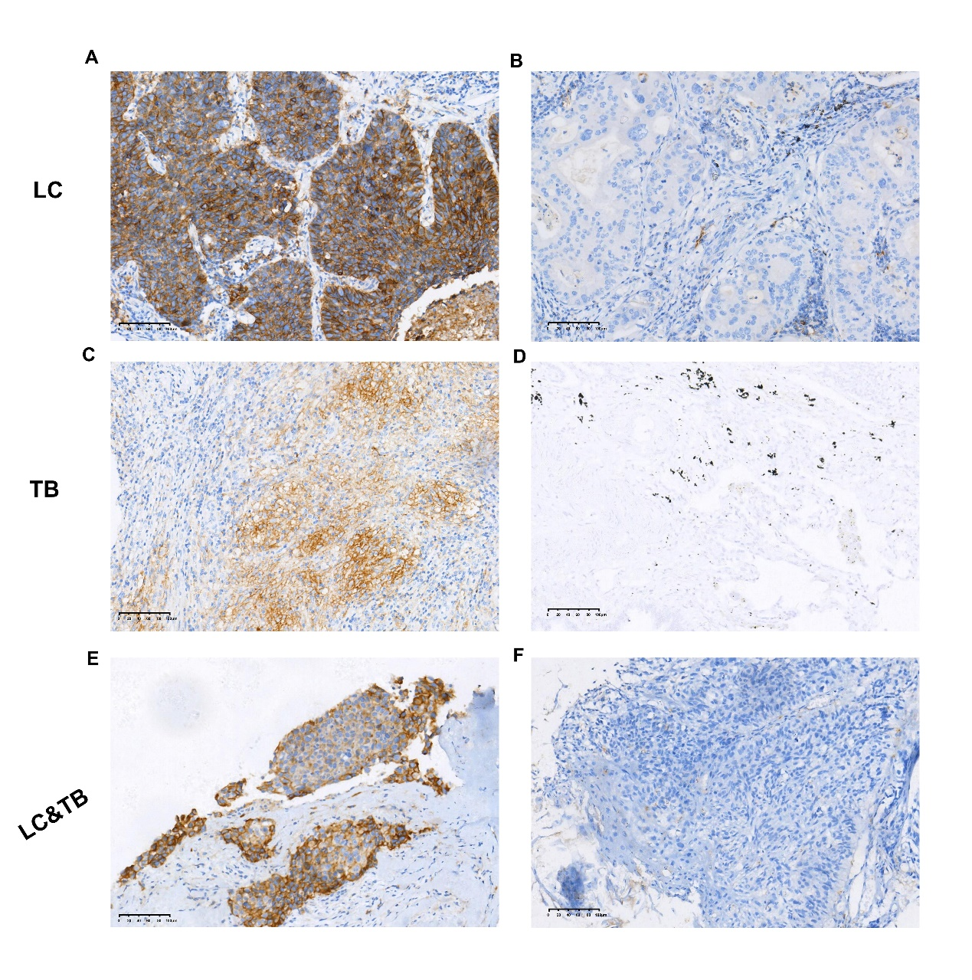
Supplementary Figure S2. Immunohistochemical staining showing positive CD3 expression (A, C, and E) and negative expression (B, D, and F) in tissues from patients with lung cancer and tuberculosis (original magnification, ×200).
A tumour proportion score (TPS) of >25% was used to identify positive expression of CD3.
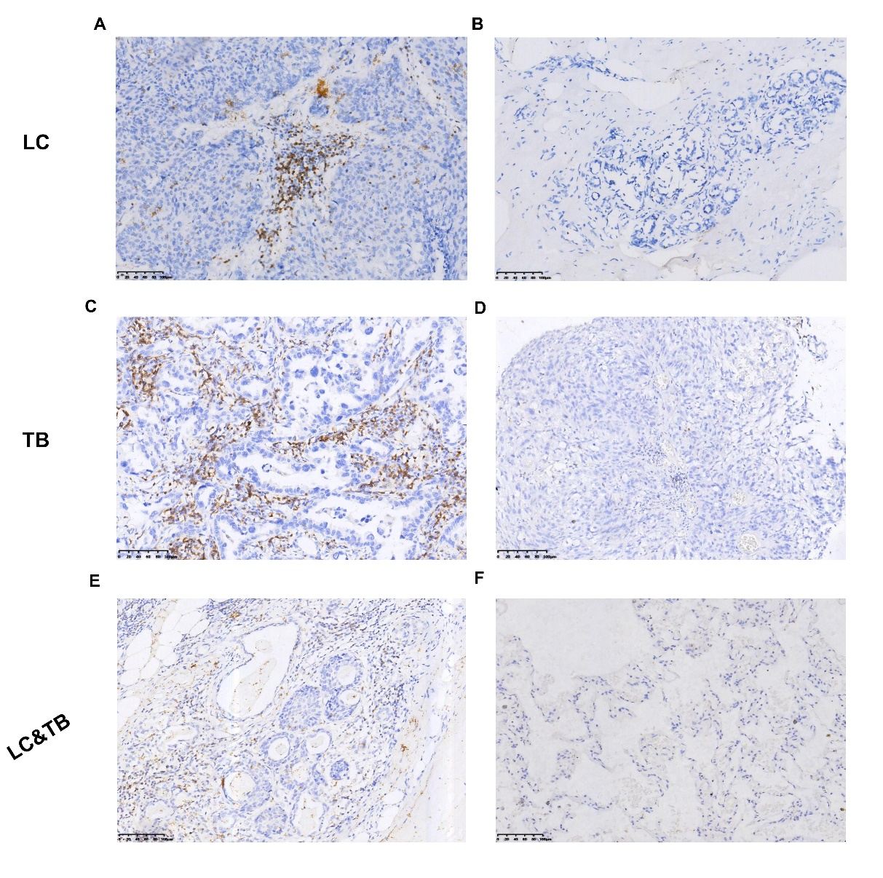
Supplementary Figure S3. Immunohistochemical staining showing positive CD4 expression (A, C, and E) and negative expression (B, D, and F) in tissues from patients with lung cancer and tuberculosis (original magnification, ×200).
A tumour proportion score (TPS) of >25% was used to identify positive expression of CD4, although the CD4 expression rate was only 5% (C).
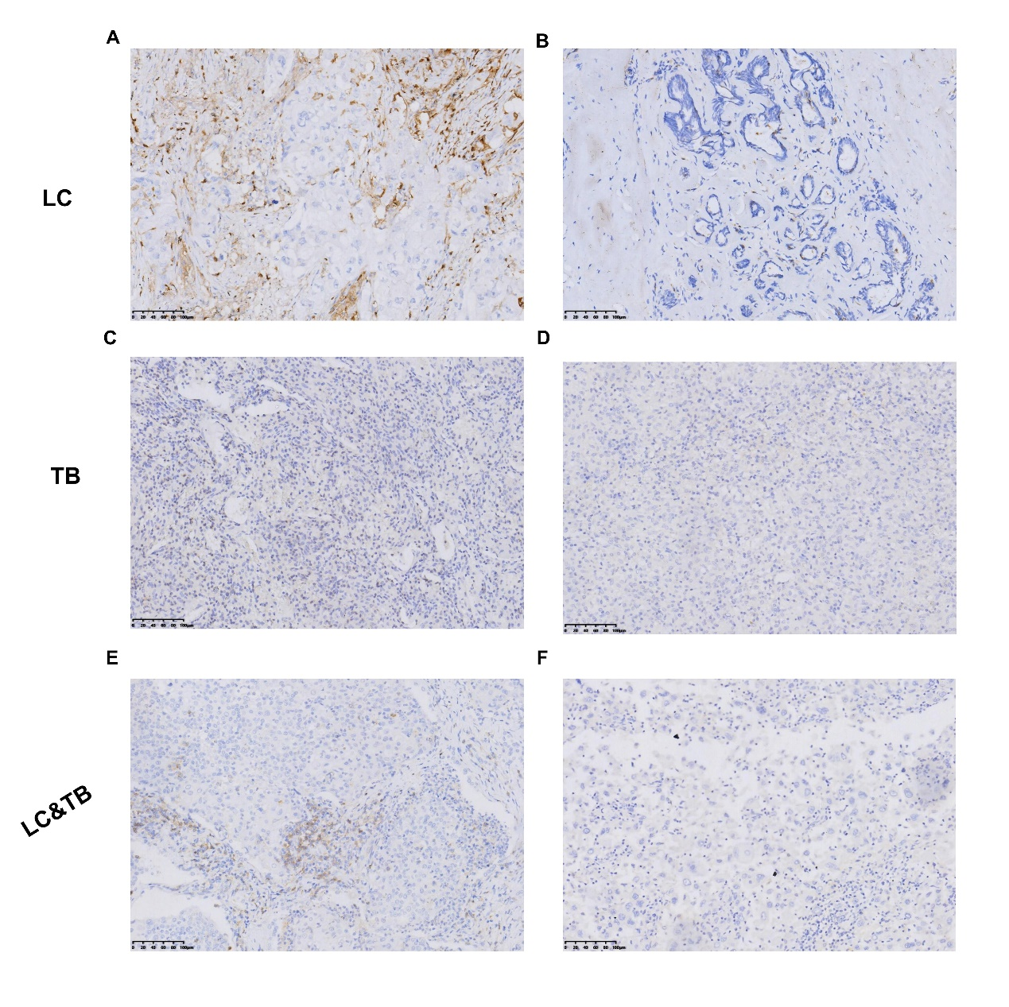
Supplementary Figure S4. Immunohistochemical staining showing positive CD8 expression (A, C, and E) and negative expression (B, D, and F) in tissues from patients with lung cancer and tuberculosis (original magnification, ×200).
A tumour proportion score (TPS) of >25% was used to identify positive expression of CD8.
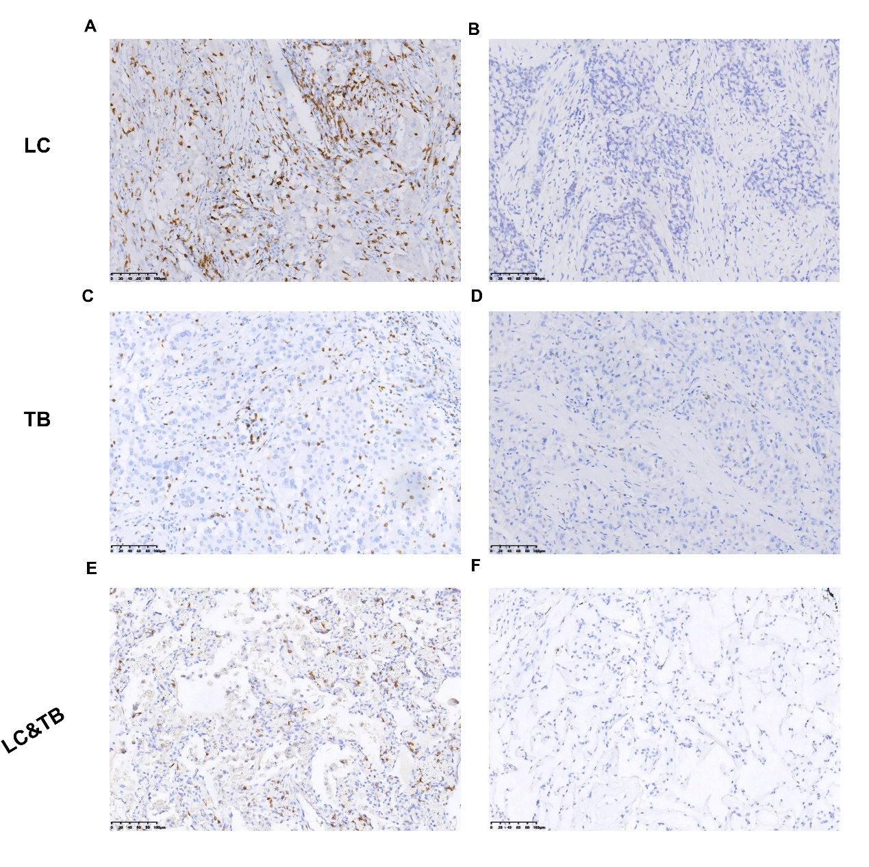
Supplementary Figure S5. The 30 most common genomic alterations in patients with LC&TB or LC.
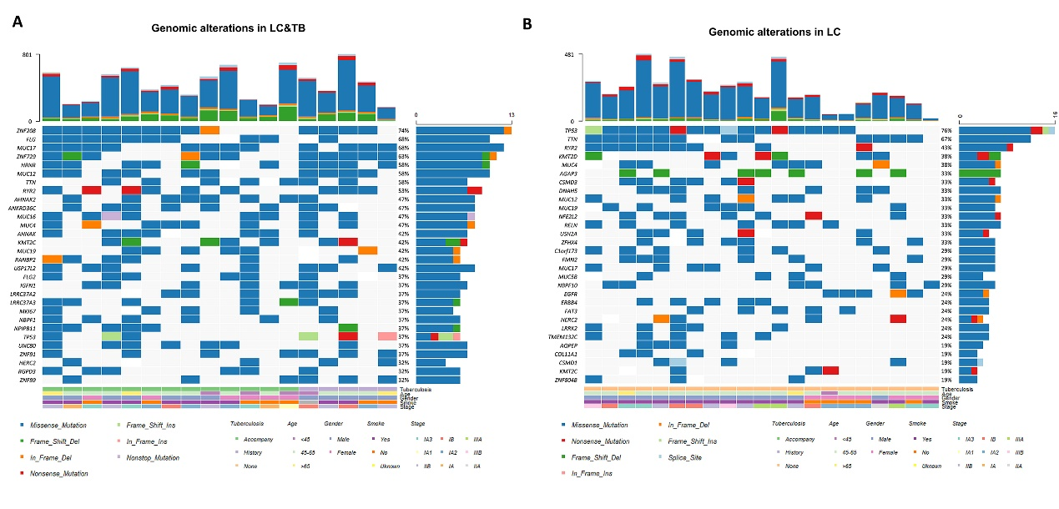
Supplementary Figure S6. Somatic mutation/copy number variations in candidate genes from the LC&O/CTB, LC&TB, and LC groups.
(A–G) Bar plots showing the somatic mutations in candidate genes from the LC&O/CTB, LC&TB, and LC groups. (H) The CD274 and CDKN2A copy number variations in the LC&TB and LC groups.
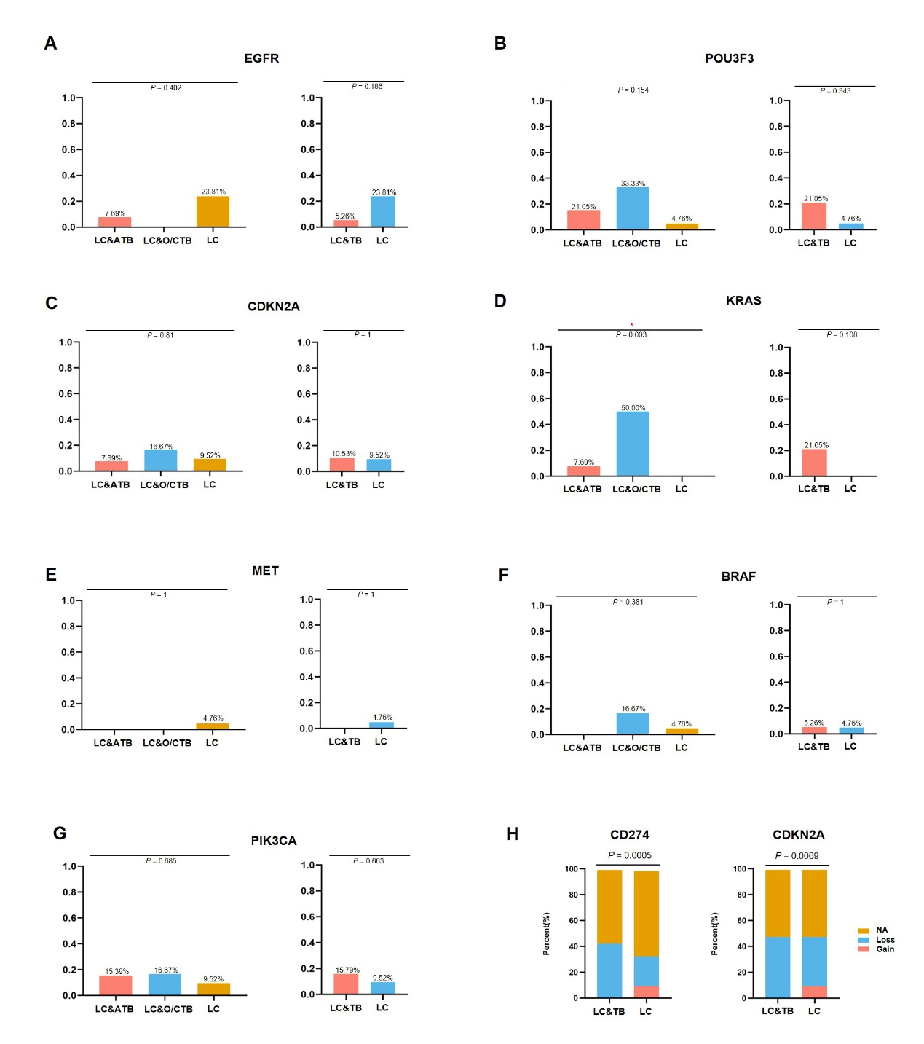
Supplementary Figure S7. Heatmap showing the number of gains/losses (CNVs) per patient and pathway analysis.
(A) Heatmap showing the number of gains/losses (CNVs) per patient for each chromosome. (B) The results of pathway analysis showing the top 12 functional clusters for the LC&TB group (top panel), the LC&TB and LC groups (middle panel), and the LC group (bottom panel). (C) A summary of the top 50 significant gene gains and losses in the LC&TB and LC groups. (D) Bar plot showing the top 20 Gene Ontology pathways in the LC&TB and LC groups.
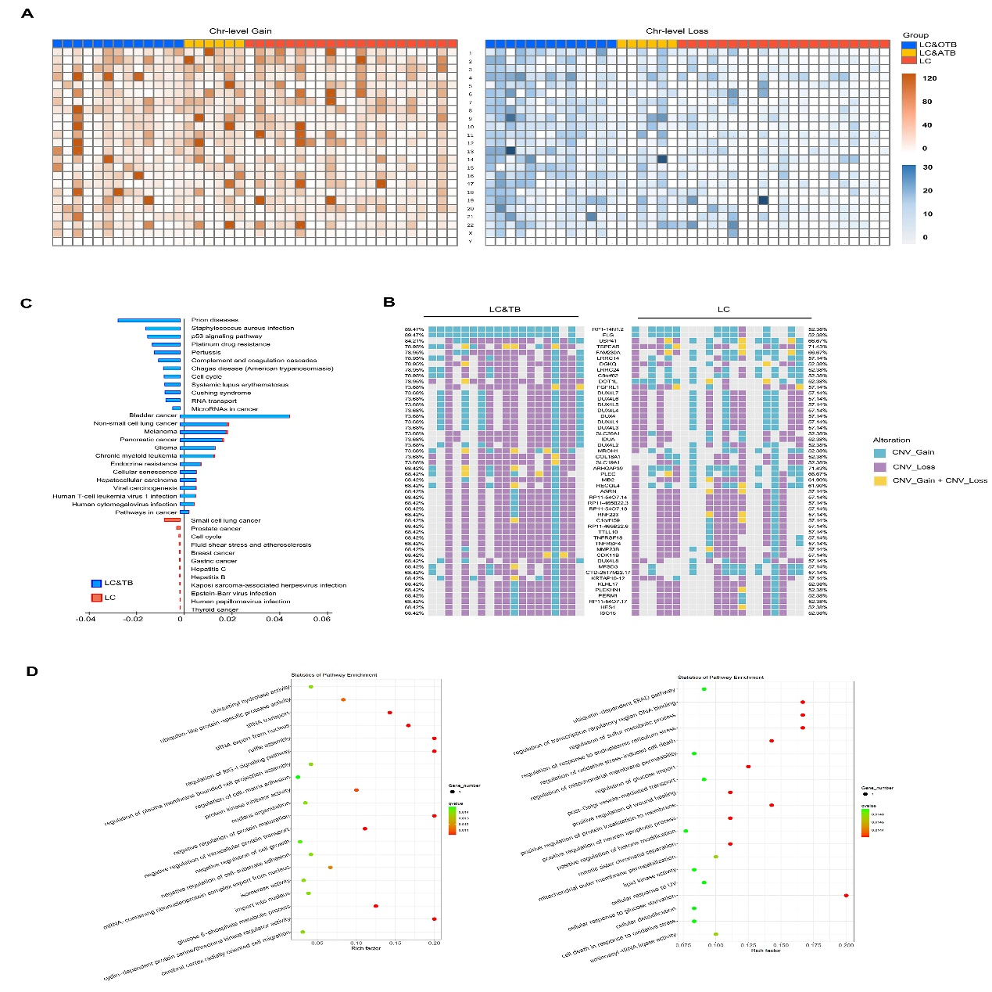
Supplementary Figure S8. The mutation signatures and correlation analysis of genes with high mutation frequencies in the LC&TB and LC groups.
(A, B) Mutation signatures in the LC&TB and LC groups. The top panel shows the tumour mutational profile based on the fraction of mutations found in each trinucleotide context, the middle panel shows the reconstructed mutational profile created by multiplying the calculated weights by the signatures, and the bottom panel shows the sum of squares error between the tumour mutational profile and the reconstructed mutational profile. (C) Heatmaps showing the top 8 mutation signatures in each patient. (D) Mutually exclusive and cooccurring gene pairs in the LC&TB and LC groups, which are displayed as a triangular matrix. Green indicates a tendency towards cooccurrence and pink indicates a tendency towards mutual exclusivity.
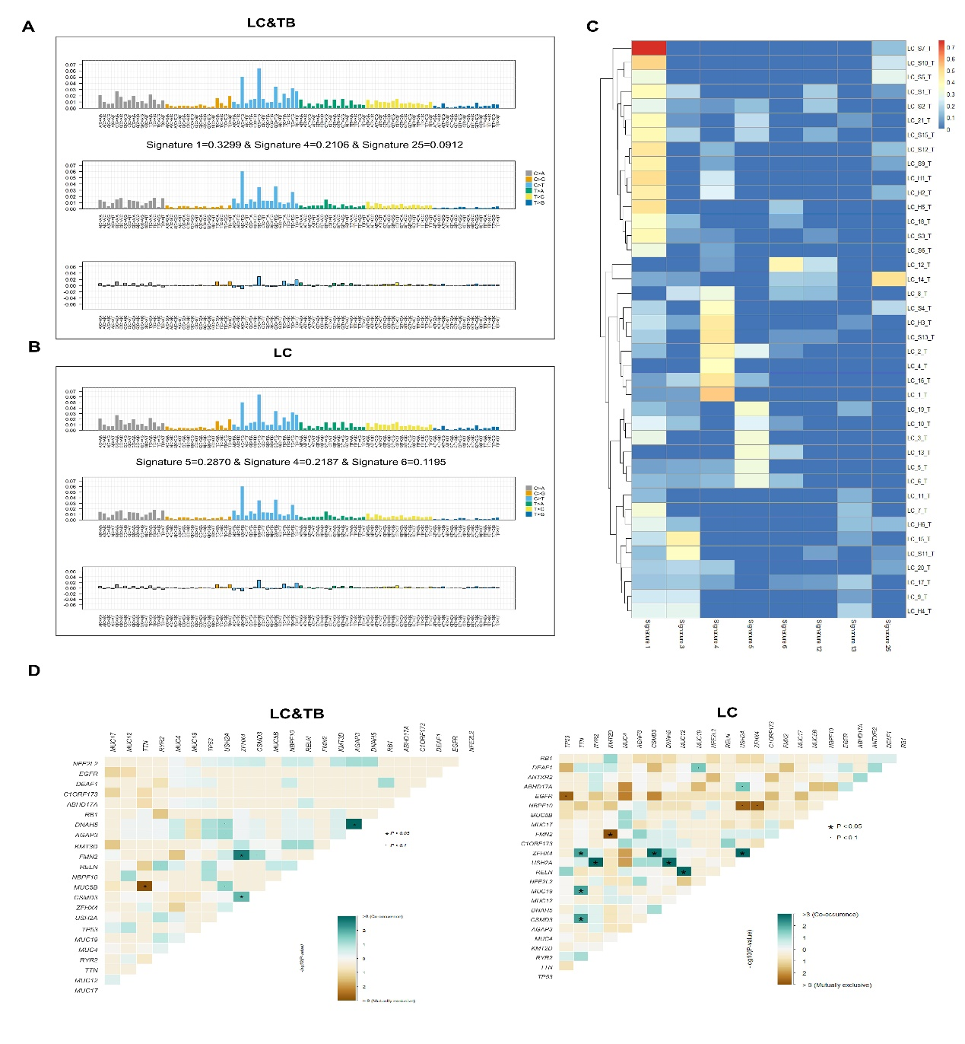
Supplementary Figure S9. TP53 mutations in patients with LC&O/CTB, LC&ATB, or LC, as well as their roles in lung cancer immune infiltration according to public databases.
(A) Bar plots showing the frequency of TP53 somatic mutations in the LC&O/CTB, LC&ATB, and LC groups, as well as in the LC&TB and LC groups. (B) The signalling pathways that are most related to TP53 mutations based on cBioportal data. (C) Comparing tumour infiltration levels according to the different somatic copy number alterations of TP53, which were defined according to the GISTIC 2.0 module as: deep deletion (–2), arm-level deletion (–1), diploid/normal (0), arm-level gain (1), and high amplification (2). Boxplots show the distributions of each immune subset at each copy number status in LUAD and LUSC. The infiltration level for each category was compared to that of the normal group using the two-sided Wilcoxon rank-sum test. (D) Comparing immune infiltration between tumours with and without the TP53 gene based on the two-sided Wilcoxon rank-sum test (*** P < 0.001, ** P < 0.01, * P < 0.05).
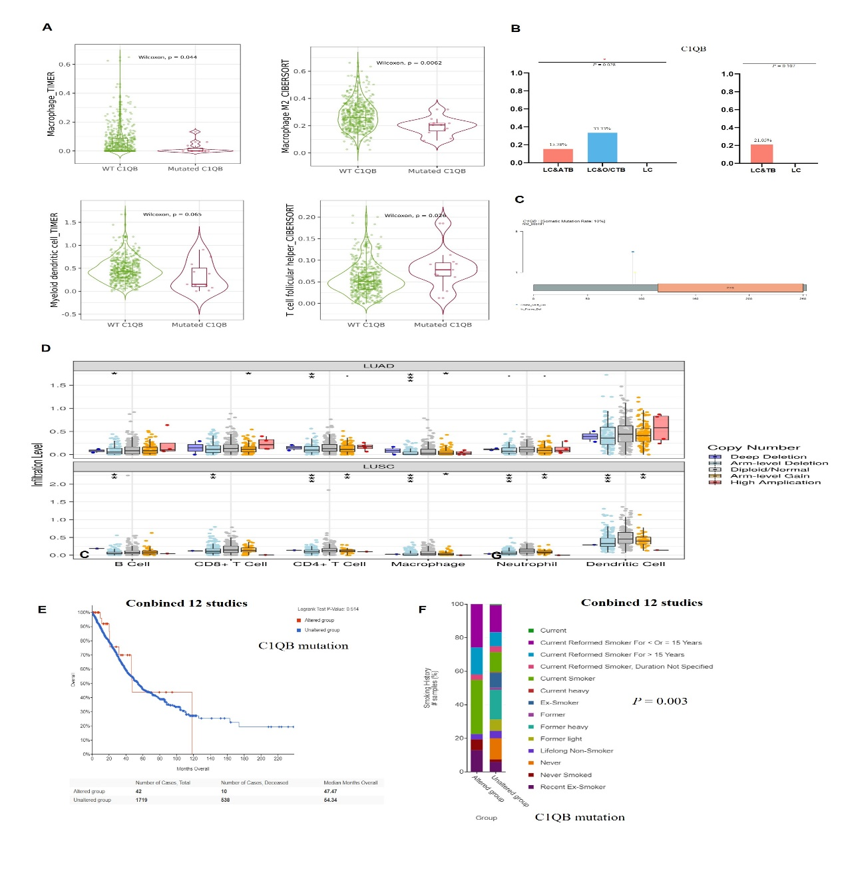
Supplementary Figure S10. TP53 mutations in patients with LC&TB or LC patients, as well as their associations with clinicopathological features and survival of LC patients according to public databases.
(A) Lollipop plot showing the TP53 mutation distributions and protein domains in 40 patients. The mutation hotspots are labelled and the somatic mutation frequencies and transcript names are indicated. The effects of TP53 mutations on overall survival are shown based on data from 12 studies (B) and the MSKCC study (C) from the cBioPortal database. (D) Correlations between CD274 and TP53 mutation status (Spearman: –0.17, P < 0.001; Pearson: –0.1, P = 0.028). (F) Correlation between smoking history and TP53 mutation status (P < 0.001) among LC patients from 12 studies. (G) Correlation between TMB and TP53 mutation status in the pan-cancer MSKCC study (P < 0.001).
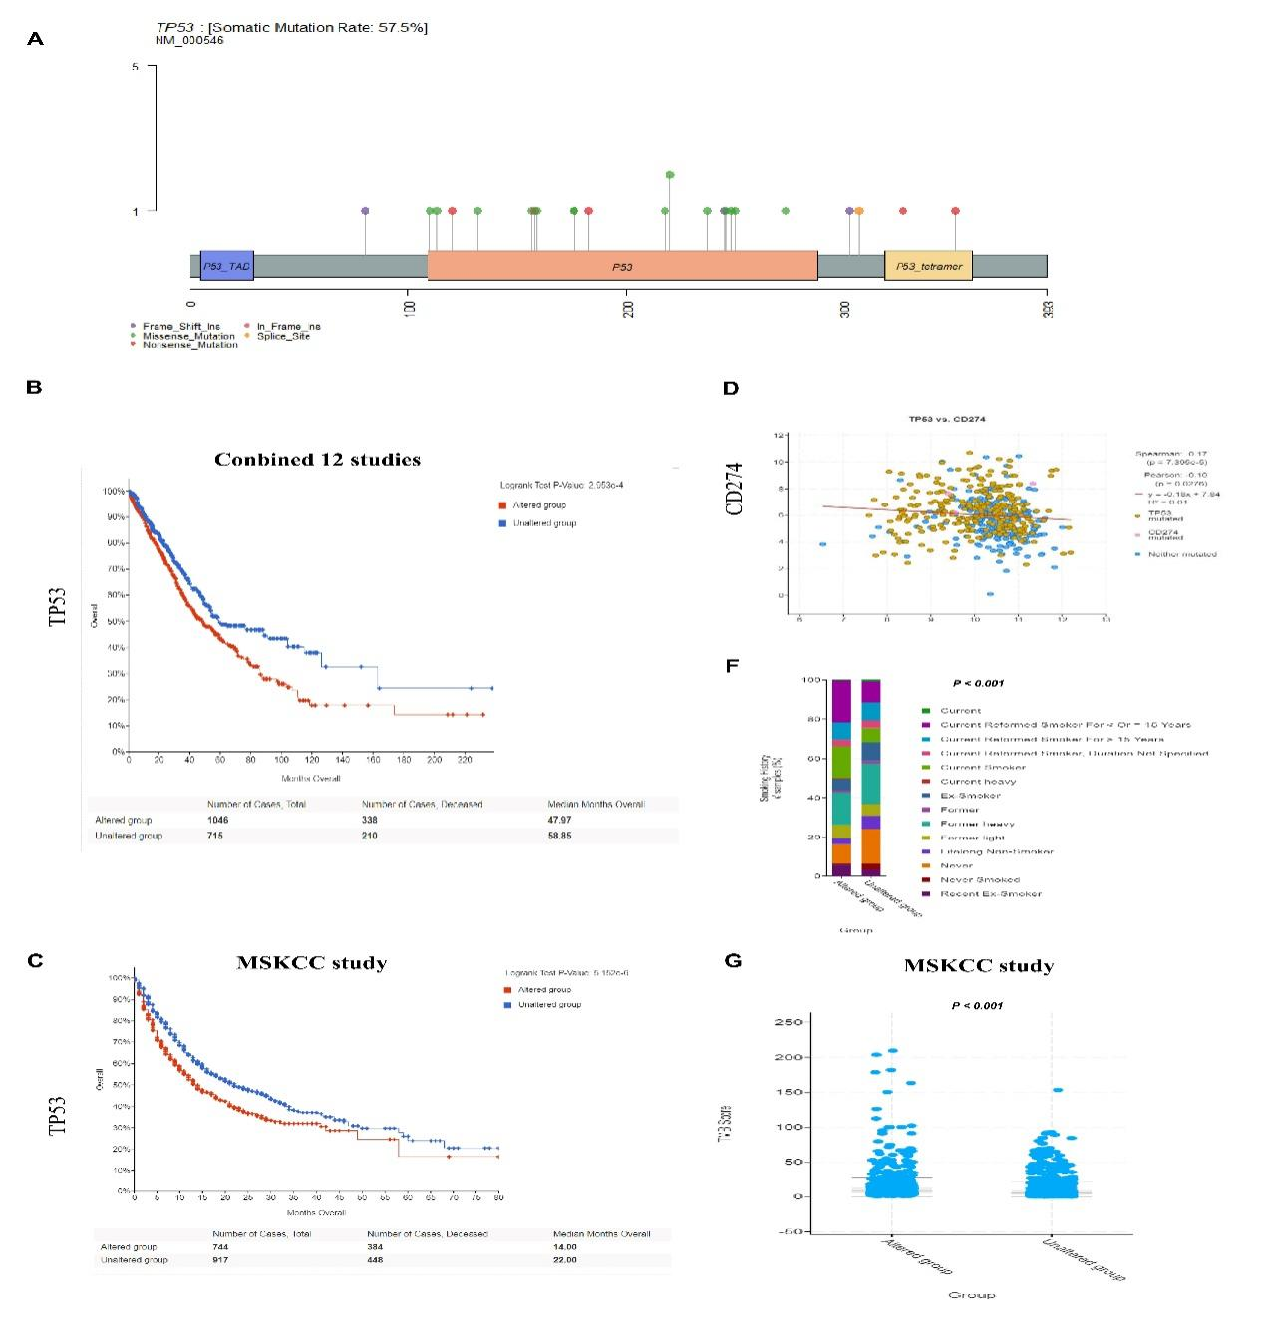
Supplementary Figure S11. C1QB mutations in patients with LC&O/CTB, LC&ATB, or LC, as well as their associations with clinicopathological features, immune tumour infiltration, and patient survival according to public databases.
(A) Correlations between C1QB mutations and macrophage/dendritic cell infiltration of lung cancer based on the TIMER 2.0 database. The violin plots show differences between LUAD tumours with mutant or wild-type C1QB in terms of macrophage infiltration (TIMER-estimated), myeloid dendritic cell infiltration (TIMER-estimated), M2 macrophage infiltration (CIBERSORT-estimated), and T follicular helper cell infiltration (CIBERSORT-estimated). (B) Differences in C1QB mutation frequencies between the LC&O/CTB, LC&TB, and LC groups. (C) Lollipop plot showing the C1QB mutations and protein domains in 40 patients. The mutation hotspots are labelled and the somatic mutation frequencies and transcript names are indicated. (D) Comparing tumour infiltration levels according to different somatic copy number alterations of C1QB, which were defined according to the GISTIC 2.0 module as: deep deletion (–2), arm-level deletion (–1), diploid/normal (0), arm-level gain (1), and high amplification (2). (E) Effect of C1QB mutation status on overall survival in 12 studies. (F) Correlation between smoking history and C1QB mutation status (P = 0.003) in LC patients from 12 studies.
*** P < 0.001, ** P < 0.01, * P < 0.05.
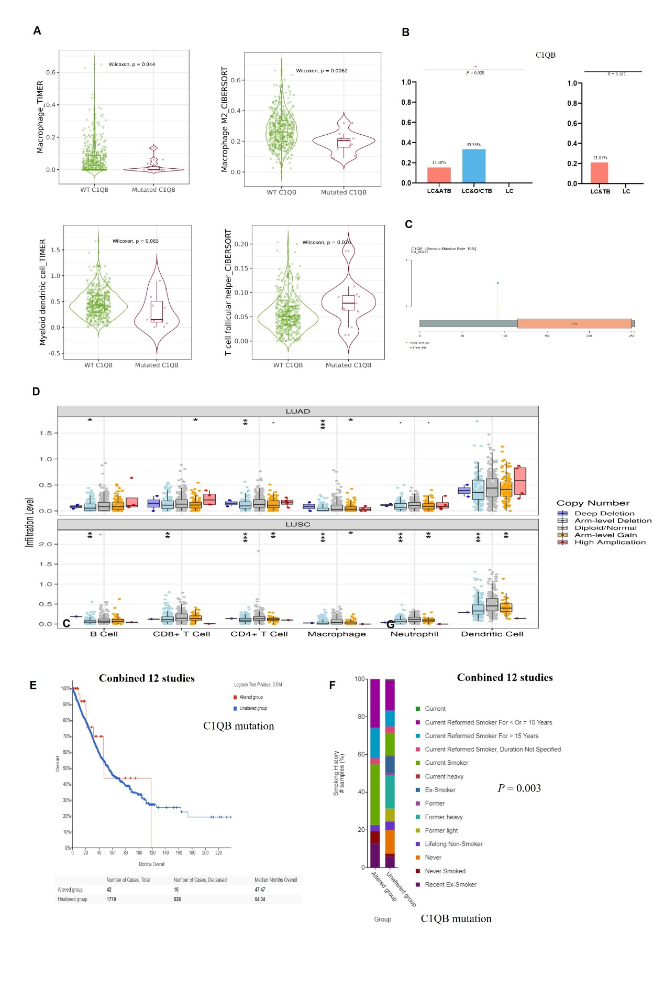
Supplementary Figure S12. C1QB expression in LUAD and LUSC tumours and its correlation with tumour-infiltrating lymphocyte levels estimated using the TIMER 1.0 database.
(A) Boxplots showing C1QB expression in tumour and adjacent normal tissues across all TCGA tumours. (B) Scatter plots showing the correlations of C1QB expression in LUAD and LUSC with tumour purity and the infiltration of B-cells, CD8+ T-cells, CD4+ T-cells, macrophages, neutrophils, and dendritic cells as estimated using the TIMER 1.0 database. (C) Scatter plots showing the correlations of TP53 expression in LUAD and LUSC with tumour purity and the infiltration of B-cells, CD8+ T-cells, CD4+ T-cells, macrophages, neutrophils, and dendritic cells as estimated using the TIMER 1.0 database.
*** P < 0.001, ** P < 0.01, * P < 0.05.
