Supplementary Information for: Large regional variability in coastal erosion caused by ENSO
Kilian Vos¹, Mitchell D. Harley¹, Ian L. Turner¹, Kristen D. Splinter¹
¹ Water Research Laboratory, School of Civil and Environmental Engineering, UNSW Sydney, 110 King Street, Manly Vale, NSW 2093, Australia
Corresponding author: Kilian Vos, Water Research Laboratory, School of Civil and Environmental Engineering, UNSW Sydney. Email address: k.vos@unsw.edu.au
Figure 1. Criteria used to select wave-dominated sandy coastlines across the Pacific Basin that are suitable for satellite-derived shoreline detection.
Figure 2. Number of sandy beaches and their orientation along each selected stretch of coastline.
Figure 3. Example of shoreline time-series at Ocean Beach (San Francisco, USA) and associated ENSO anomalies.
Figure 4. Example of shoreline time-series at Narrabeen (Australia) and associated ENSO anomalies.
Figure 5. Example of wave energy flux time-series at Ocean Beach (San Francisco, USA) and associated ENSO anomalies.
Figure 6. Example of sea level anomalies time-series at Ocean Beach (San Francisco, USA) and associated changes during ENSO phases.
Figure 7. Anomalies in oceanographic forcing during the past three major El Niño events (1997/1998, 2009/2010, 2015/2016).

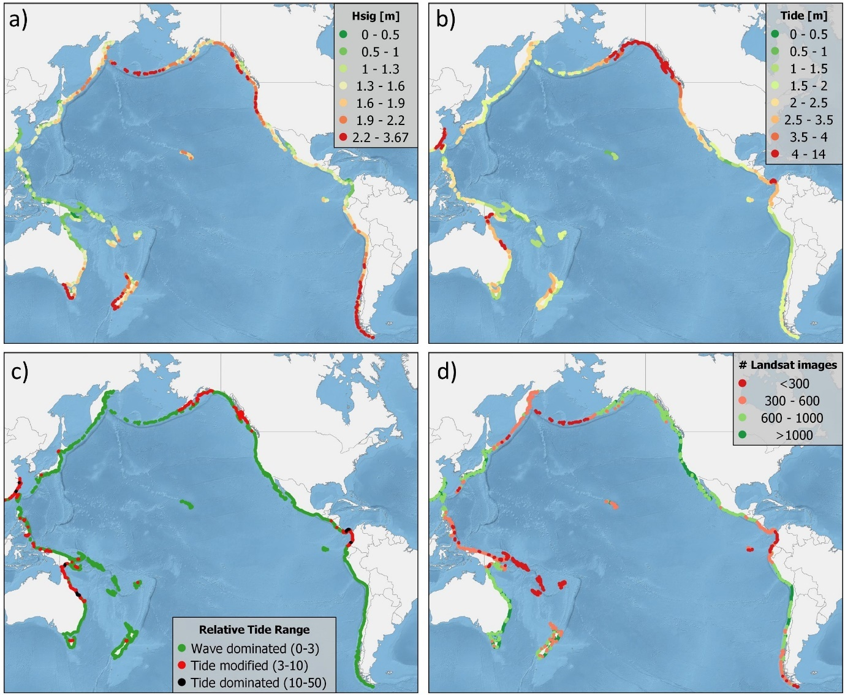
Figure 1 | Selection of wave-dominated coastlines across the Pacific Basin for satellite-derived shoreline detection. a) Mean deep-water significant wave height from ERA5 reanalysis (1979-2020). b) Springs tidal range from FES2014 global tide model. c) Relative Tide Range calculated as the ratio between the significant wave height and the springs tidal range. d) Number of images available on Google Earth Engine for Landsat 5, 7 and 8 Tier 1 collections.

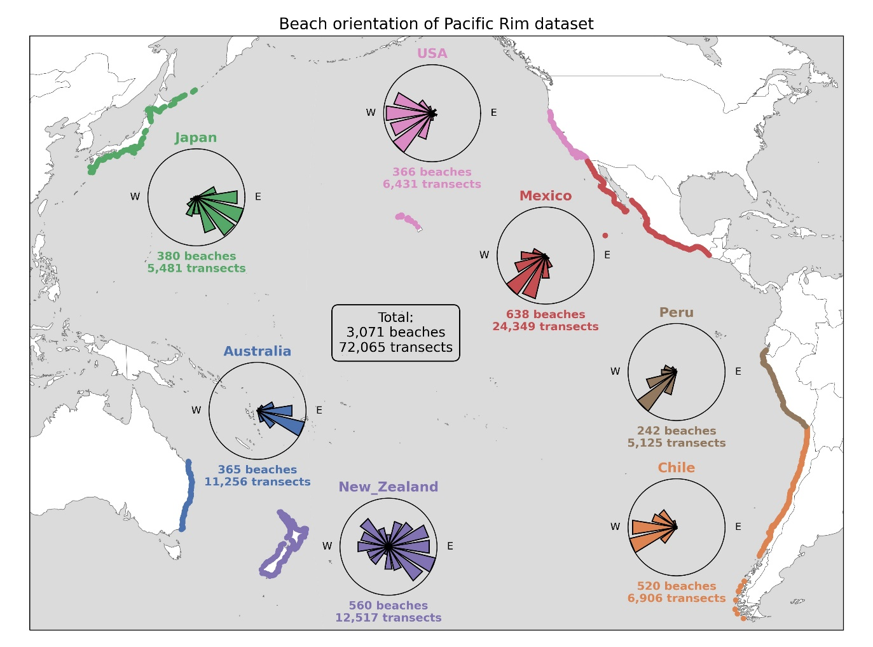
Figure 2 | Dataset of sandy beaches and cross-shore transects for 7 selected wave-dominated regions. The roses show the orientation of the sandy beaches along each stretch of coastline. The number of individual beaches and shore-normal transects are also reported for each region.

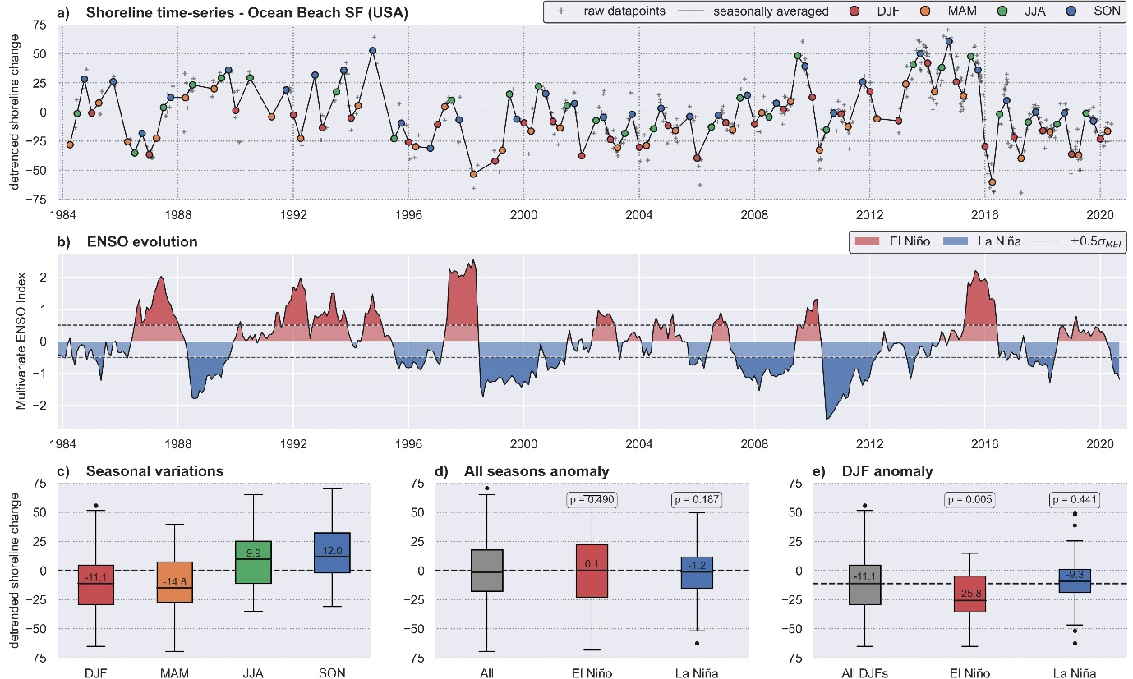
Figure 3 | Anomalies in shoreline position during ENSO phases, example at a seasonal northern hemisphere beach: Ocean Beach, San Francisco, USA. a) Detrended time-series of shoreline change at Ocean beach (San Francisco, USA), including seasonal averages (DJF, MAM, JJA, SON), between 1984 and 2020. b) Time-series of the intensity and phase of ENSO as described by the Multivariate ENSO Index (MEI). A threshold of 0.5 standard deviation was used to identify El Niño and La Niña phases. c) Seasonal variations in shoreline position. d) Anomaly in shoreline position during El Niño and La Niña phases for all seasons and with respect to the long-term average. e) Anomaly in shoreline position during El Niño and La Niña phases for the boreal winter (DJF) and with respect to the long-term DJF average.

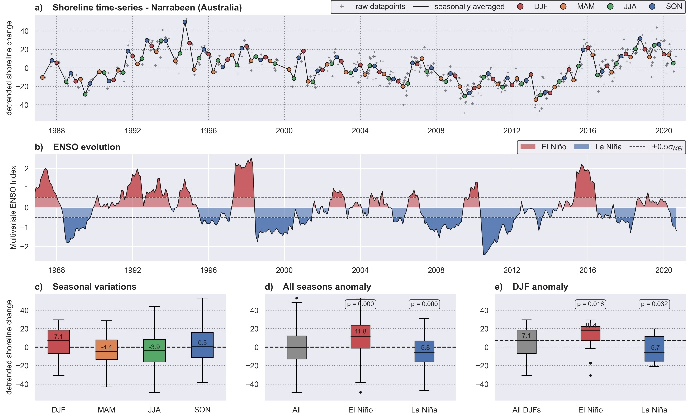
Figure 4 | Anomalies in shoreline position during ENSO phases, example at a non-seasonal beach: Narrabeen, Sydney, Australia. a) Detrended time-series of shoreline change at Narrabeen, Australia, including seasonal averages (DJF, MAM, JJA, SON), between 1987 and 2020. b) Time-series of the intensity and phase of ENSO as described by the Multivariate ENSO Index (MEI). A threshold of 0.5 standard deviation was used to identify El Niño and La Niña phases. c) Seasonal variations in shoreline position. d) Anomaly in shoreline position during El Niño and La Niña phases for all seasons and with respect to the long-term average. e) Anomaly in shoreline position during El Niño and La Niña phases for the boreal winter (DJF) and with respect to the long-term DJF average.

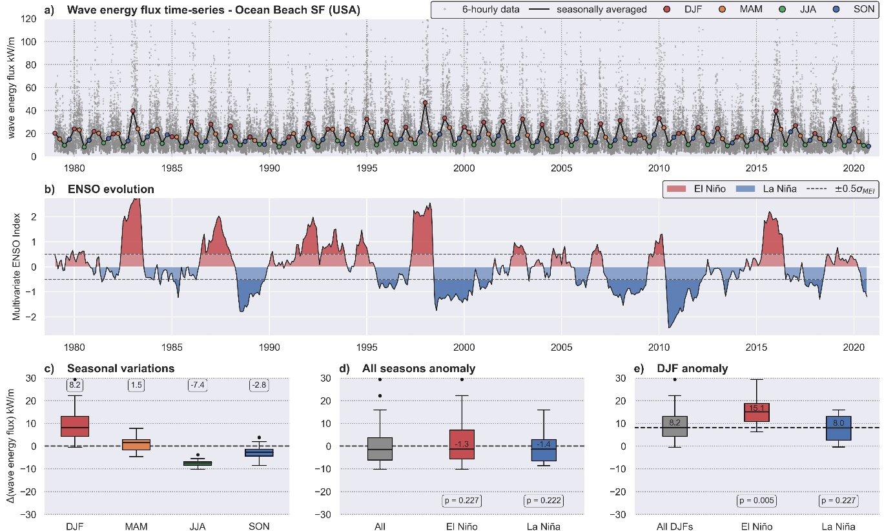
Figure 5 | Anomalies in wave energy flux during ENSO phases. a) Time-series of wave energy flux, including seasonal averages (DJF, MAM, JJA, SON), between 1970 and 2020 offshore of Ocean Beach (San Francisco, USA). b) Time-series of the intensity and phase of ENSO as described by the Multivariate ENSO Index (MEI). A threshold of 0.5 standard deviation was used to identify El Niño and La Niña phases. c) Seasonal variations in wave energy flux with respect to the long-term average flux (17.5kW/m). d) Anomaly in wave energy flux during El Niño and La Niña phases for all seasons and with respect to the long-term average. e) Anomaly in wave energy flux during El Niño and La Niña phases for the boreal winter (DJF) and with respect to the long-term DJF average.

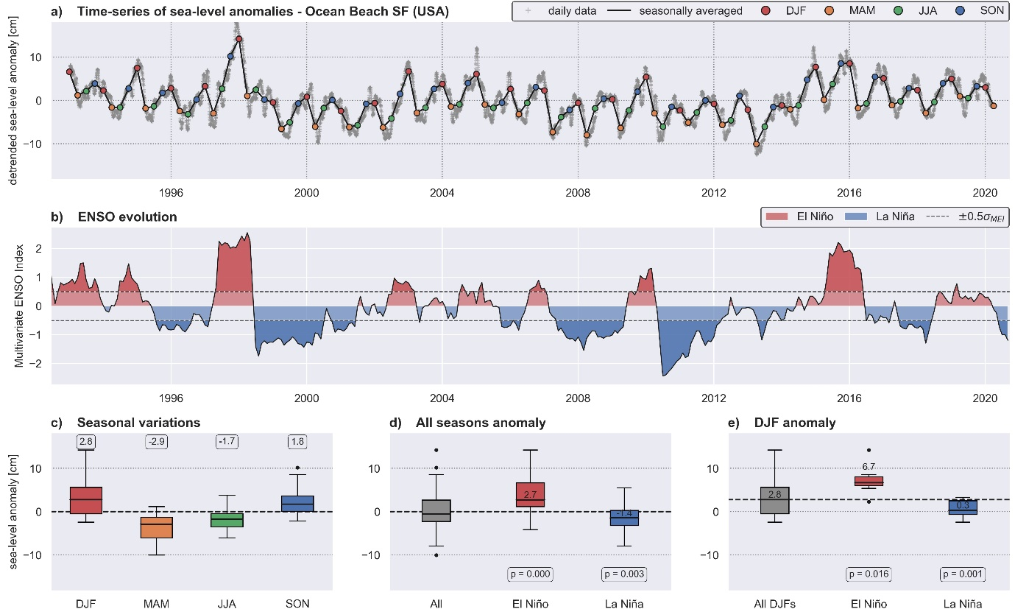
Figure 6 | Sea-level anomalies during ENSO phases. a) Time-series of detrended sea-level anomalies, including seasonal averages (DJF, MAM, JJA, SON) between 1993 and 2020 at Ocean Beach (San Francisco, USA). b) Time-series of the intensity and phase of ENSO as described by the Multivariate ENSO Index (MEI). A threshold of 0.5 standard deviation was used to identify El Niño and La Niña phases. c) Seasonal variations in sea-level anomalies. d) Change in sea-level anomalies during El Niño and La Niña phases for all seasons. e) Change in sea-level anomalies during El Niño and La Niña phases for the boreal winter (DJF) and with respect to the long-term DJF average.
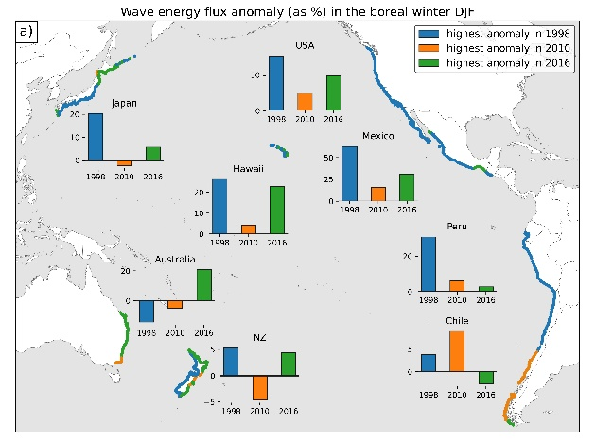
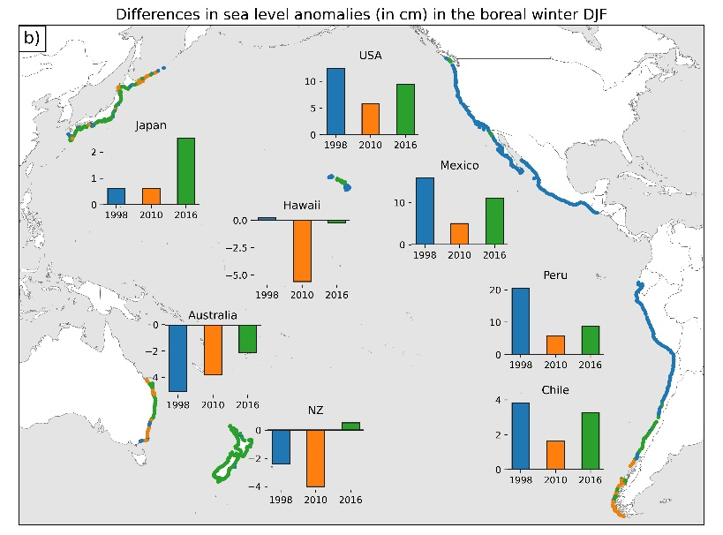
Figure 7 | Oceanographic forcing during the past three major El Niño events (1997/1998, 2009/2010, 2015/2016). Percentage increase in wave energy flux during boreal winter (DJF) relative to the long-term average (a) and differences in sea-level anomalies in centimetres (b) for the three events. Dots along the coast are color-coded with the event when the largest anomaly occurred.

