Supplementary Information for

Title: Temperature and precipitation drive elevational patterns of microbial beta diversity in alpine grasslands

Running title: Temperature and precipitation drive microbial beta diversity

Author Names: Xiaoqin Yang^{1,2}, Yue Li³, Bin Niu^{1,2}, Qiuyu Chen^{1,4}, Yilun Hu^{1,4}, Yibo Yang¹, Lili Song¹, Jianjun Wang^{5*} and Gengxin Zhang^{1,4*}
1 State Key Laboratory of Tibetan Plateau Earth System, Resources and Environment (TPESRE), Institute of Tibetan Plateau Research, Chinese Academy of Sciences, Beijing 100101, China
2 University of Chinese Academy of Sciences, Beijing 100049, China
3 China University of Geosciences, Beijing 100083, China
4 Key Laboratory of Alpine Ecology, CAS Center for Excellence in Tibetan Plateau Earth Sciences and Institute of Tibetan Plateau Research, Chinese Academy of Sciences, Beijing 100101, China
5 State Key Laboratory of Lake Science and Environment, Nanjing Institute of Geography and Limnology, Chinese Academy of Sciences, Nanjing 210008, China

*Corresponding authors:
Jianjun Wang
Phone: 00 86(025) 8688 2219 Fax: 00 86(025) 8688 2219
Email: jjwang@niglas.ac.cn
Gengxin Zhang
Phone: 00 86(010) 8409 7071 Fax: 00 86(010) 8409 7071
Email: zhangg@itpcas.ac.cn

The file includes:
Supplementary Materials and Methods
Supplementary Tables (S1-S7)
Supplementary Figures (S1-S19)
Supplementary Tables

Table S1. Elevational patterns of climate variables and soil microbial species richness.

ID number | Studies | Elevation ranges (m) | Prec-patterns | Rich-patterns | Domain | Main drivers of rich-patterns |  | Group | Note
P01 | (Fierer et al., 2011) | 200-3,450 | H | N | Bacteria | - | -
P02 | (Gai et al., 2012) | 1,990-4,648 | I | D | Fungi | - | -
P03 | (Gomez-Hernandez et al., 2012) | 100-3,500 | I | N | Fungi | Slope, relative humidity | Local
P04 | (Shen et al., 2013) | 530-2,200 | I | N | Bacteria | pH | Local
P05 | (Singh et al., 2014) | 500-1,950 | I | U | Bacteria | MAT, MAP | Climate |  | Gwaneumsa transect
P06 |  |  | I | U | Bacteria | MAT, MAP | Climate |  | Yeongsil transect
P07 | (Miyamoto et al., 2014) | 1,100-2,250 | I | H | Fungi | Precipitation, C/N ratio | Climate
P08 | (Shen et al., 2014) | 530-2,200 | I | N | Eukarya | pH | Local
P09 | (Siles and Margesin, 2016) | 550-1,980 | I | U | Bacteria | pH | Local
P10 |  |  | I | U | Fungi | pH | Local
P11 | (Rincon et al., 2015) | 1,250-1,850 | I | H | Fungi | pH | Local
P12 | (Shearer et al., 2015) | 218-3,870 | H | H | Fungi | pH | Local
P13 | (Lanzen et al., 2016) | 1,500-2,600 | H | N | 18S | C/N ratio | Local
P14 |  |  | H | N | ITS | C/N ratio | Local
P15 |  |  | H | N | 16S | C/N ratio | Local
P16 | (Peay et al., 2017) | 50-1,000 | I | H | Bacteria | Soil carbon, pH | Local
P17 |  |  | I | I | Fungi | Soil carbon | Local
P18 |  |  | I | H | Archaea | Nitrogen mineralization rate | Local
P19 | (Tian et al., 2017) | 1,600-2,800 | I | D | Fungi | Temperature | Climate
P20 | (Li et al., 2018) | 1,800-4,100 | I | D (Stair-step) | Bacteria | pH, vegetation types | Local
P21 | (Yang et al., 2017) | 700-2,600 | I | D | Fungi | Forest type, climatic changes | Energy
P22 | (Vetaas et al., 2019) | 100-4,000 | H | N | Fungi | PET, precipitation | Climate
P23 | (Luo et al., 2019) | 934-3,058 | I | D | Bacteria | Soil water content and pH | Local
P24 | (Hu et al., 2020) | 700-3,760 | D | H (Breakpoint) | Bacteria | MAT and soil pH | Climate
P25 | (Peters et al., 2019) | 700-5,895 | H | D | 16S | Climate and land use | Climate
 |  |  |  |  |  | interactions | -
P26 | (Sheng et al., 2019) | 1,030-2,750 | I | D | Fungi | pH, soil moisture | Local
P27 | (Yang et al., 2020) | 3,329-4,522 | D | H | Bacteria | pH | Local
P28 | (Bayranvand et al., 2020) | 0-2,500 | U | N | Bacteria | Soil chemistry | Local
P29 |  |  | U | N | Fungi | Plant mycorrhizal type | Energy
P30 | (Yang and Wu, 2020) | 1,600-3,200 | I | N | Bacteria | Climate, vegetation, soil | Climate
P31 |  |  | I | N | Fungi | Climate, spatial, vegetation, soil | Climate
P32 | (Shen et al., 2020) | 767-4,190 | H | U | Bacteria | pH | Local
P33 |  |  | H | D | Fungi | MAT | Climate
Note: Temperature showed a decreasing elevational pattern in all studies. Prec-patterns: elevational patterns of precipitation; Rich-patterns, elevational patterns of species richness. D, I, H, U and N represent decreasing, increasing, hump-shaped, U-shaped patterns and nonsignificant elevational patterns, respectively.

Table S2. Abbreviations for the detected phyla.

Phyla | Abbreviation | OTU
Acidobacteria | ACI | 36933
Actinobacteria | ACT | 69041
Armatimonadetes | ARM | 2854
Bacteroidetes | BAC | 15495
Chloroflexi | CHF | 18473
Crenarchaeota | CRE | 1942
Cyanobacteria | CYA | 2162
Firmicutes | FIR | 3911
Gemmatimonadetes | GEM | 5613
Nitrospirae | NIT | 4144
OD1 | OD1 | 1875
Planctomycetes | PLA | 22698
Proteobacteria | PRO | 65107
TM7 | TM7 | 2945
Verrucomicrobia | VER | 24176
Note: We finally selected 15 microbial phyla, including 14 bacterial phyla and 1 archaeal phylum with OTUs larger than 1500 for all samples.
Table S3. Climate variables used to explain microbial alpha and beta diversity.

Climate variables | Retained in the study | Description | Unit
MAT | Yes | Mean annual temperature | ℃
BIO2 |  | Mean diurnal range (mean of monthly | ℃
 |  | (maximum temp - mininmum temp))
BIO3 |  | Isothermality (BIO2/BIO7) (*100)
BIO4 |  | Temperature seasonality
 |  | (standard deviation*100)
BIO5 |  | Max temperature of warmest month | ℃
MTCM | Yes | Min temperature of coldest month | ℃
BIO7 |  | Annual temperature range (BIO5-BIO6) | ℃
BIO8 |  | Mean temperature of wettest quarter | ℃
BIO9 |  | Mean temperature of driest quarter | ℃
BIO10 |  | Mean temperature of warmest quarter | ℃
BIO11 |  | Mean temperature of coldest quarter | ℃
GSP/AccT | Yes | Ratio of growing season precipitation
 |  | to ≥ 5 °C accumulated temperature
MAP | Yes | Mean annual precipitation | mm
BIO13 |  | Precipitation of wettest month | mm
PMD | Yes | Precipitation of driest month | mm
PSCV | Yes | Precipitation seasonality
 |  | (coefficient of variation)
BIO16 |  | Precipitation of wettest quarter | mm
BIO17 |  | Precipitation of driest quarter | mm
BIO18 |  | Precipitation of warmest quarter | mm
BIO19 |  | Precipitation of coldest quarter | mm
T_{min} | Yes | Mean annual coldest temperature | ℃

Table S4. Environmental variables used to explain microbial alpha and beta diversity.

Group | Sub-group | Variable | Description | Unit
Climate | Temperature | MAT | Mean annual temperature | ℃
 |  | MTCM | Min temperature of coldest month | ℃
 |  | Tmin | Mean annual coldest temperature | ℃
 |  | GSP/AccT | the ratio of growing season precipitation (GSP) to ≥ 5 °C
 |  |  | accumulated temperature
 | Precipitation | MAP | Mean annual precipitation | mm
 |  | PMD | Precipitation of driest month | mm
 |  | PSCV | Precipitation seasonality (coefficient of variation)
Energy |  | NDVI | Normalized difference vegetation index
 |  | Veg.rich | Vegetation richness
 |  | Veg.shan | Vegetation Shannon index
 |  | Veg.even | Vegetation evenness
 |  | DOC | Soluble organic carbon | mg kg⁻¹
 |  | DON | Soluble organic nitrogen | mg kg⁻¹
 |  | DOC/DON | Soluble organic carbon and soluble organic nitrogen ratio
Local |  | pH | Soil pH
 |  | TP | Total phosphorus | g kg⁻¹
 |  | SWC | Soil water content
 |  | TOC | Total organic carbon | g kg⁻¹
 |  | TN | Total nitrogen | g kg⁻¹
 |  | Aspect | the compass direction that a hillside slope faces
 |  | Slope | the rise and fall of the terrain surface
 |  | CIA | the chemical index of alteration
 |  | Ti/Al | Titanium content and aluminium content ratio
 |  | Na/Al | Sodium content and aluminium content ratio
 |  | K/Al | Potassium content and aluminium content ratio
 |  | Na/K | Sodium content and potassium content ratio
 |  | metal.pc1 | The first principal component analysis (PCA) axis of
 |  |  | metal variables
 |  | metal.pc2 | The second PCA axis of metal variables
Note: The environmental variables included three groups of predictors: climate, energy and local variables. The average values of climate variables from 2007 to 2013 were reported. The metal variables included Al, Fe, K, Na, Ca, Mg, Ti, Mn, Ba, Sr, Zn and P.
Table S5. Formulae for calculating composite variables for alternative structural equation models (SEMs) of microbial alpha and beta diversity.

Response | Composite | Formula
Archaeal | Climate | Temp=1.132e+00*MAT+8.435e-01*GSP/ACCT
richness |  | Prec=-3.146e-01*MAP
 | Energy | Energy=-2.518e-01*NDVI
 | Local | Local= 2.756e-01*TP-4.168e-01*TOC+3.624e-01*Na/K+4.736e-01*CIA-5.620e-01*metal.pc2
Archaeal | Climate | Temp=-1.023e+00*MTCM+1.718e+00*Tmin+1.023e+00*GSP/ACCT
evenness |  | Prec=-3.777e-01*MAP-1.425e-01*PSCV
 | Energy | Energy=-3.528e-01*NDVI-3.049e-01*DOC+3.216e-01*DON
 | Local | Local=-1.145e+00*TOC+ 8.337e-01*TN+3.020e-01*Na/K+3.086e-01*CIA-4.823e-01*
 |  | metal.pc2
Archaeal | Climate | Temp=-5.790e+00*MAT-5.812e+00*MTCM+9.645e+00*Tmin+1.944e+00*GSP/ACCT
LCBD |  | Prec=-3.224e-01*MAP+1.458e-01*PSCV
 | Energy | Energy=-2.802e-01*NDVI+3.965e-01*DOC/DON
 | Local | Local=1.372e+00*TOC-1.230e+00*TN+5.046e-01*Ti/Al+9.162e-01*metal.pc1-3.575e-01*
 |  | metal.pc2
Archaeal | Climate | Temp=5.738e+00*MAT+6.443e+00*MTCM-1.042e+01*Tmin-2.710e+00*GSP/ACCT
PCoA1 |  | Prec=4.054e-01*MAP-2.938e-01*PSCV
 | Energy | Energy=2.665e-01*NDVI+2.444e+00*Veg.rich-2.266e+00*Veg.shan+1.466e+00*Veg.even-
 |  | 4.021e-01*DOC.DON
 | Local | Local=-1.432e-01*Aspect+2.919e-01*Slope-1.804e+00*TOC+1.623e+00*TN-2.889e-01
 |  | *Ti/Al+1.152e+00*Na/Al-9.201e-01*Na/K+6.985e-01*CIA-1.065e+00*metal.pc1+3.199e-01*
 |  | metal.pc2
Bacterial | Climate | Temp=4.623e+00*MAT+3.293e+00*MTCM-5.639e+00*Tmin
richness |  | Prec=-2.283e-01*PSCV
 | Energy | Energy=-1.512e-01*DOC/DON+3.128e-01*Veg.rich-4.983e-02*DOC-4.428e-01*Veg.shan
 | Local | Local=2.012e-01*TP+2.335e-01*CIA+3.977e-01*metal.pc1+4.349e-01*Slope
Bacterial | Climate | Temp=-1.529e+00*MTCM+2.009e+00*Tmin+1.419e+00*GSP/ACCT
evenness |  | Prec=-4.223e-01*MAP
 | Energy | Energy=-3.420e-01*NDVI-7.676e-01*DOC+6.789e-01*DON+4.967e-01*DOC/DON
 | Local | Local=-1.356e-01*Aspect+2.618e-01*Slope-3.303e-01*pH+5.212e-01*SWC-1.887e+00
 |  | *TOC+1.337e+00*TN+3.122e-01*Ti/Al-8.787e-01*Na/Al+9.644e-01*Na/K+1.247e+00*
 |  | metal.pc1-7.681e-01*metal.pc2
Bacterial | Climate | Temp=-5.503e+00*MAT-5.239e+00*MTCM+7.933e+00*Tmin+8.293e-01*GSP/ACCT
LCBD |  | Prec=-4.448e-01*MAP+4.065e-01*PSCV
 | Energy | Energy=-2.008e-01*NDVI-6.664e-01*DOC+4.988e-01*DON+9.280e-01*DOC/DON
 | Local | Local=-2.369e-01*Slope+1.806e+00*TOC-1.849e+00*TN-2.876e-01*CIA+3.445e-01*
 |  | metal.pc1-3.117e-01*metal.pc2
Bacterial | Climate | Temp=4.778e+00*MAT+5.503e+00*MTCM-8.678e+00*Tmin-1.853e+00*GSP/ACCT
PCoA1 |  | Prec=7.187e-01*MAP-2.378e-01*PSCV
 | Energy | Energy=3.051e-01*NDVI+5.198e-01*Veg.rich-3.729e-01*Veg.shan+5.996e-01*
 |  | DOC-4.654e-01*DON-6.117e-01*DOC/DON
 | Local | Local=2.326e-01*Slope+3.698e-01*TN-2.627e-01*Ti/Al+9.423e-01*Na/Al-9.907e-01*
 |  | Na/K+3.224e-01*CIA-7.332e-01*metal.pc1+5.162e-01*metal.pc2
Note: The obtained composite variables are shown in Fig. 4. The abbreviations of the included variables are listed in Table S4.
Table S6. Summary of the model fit statistics evaluated for the standardized SEMs.

SEMs | Response | df | χ² | P | CFI | SRMR | AICc | ΔAICc
Archaea
1 | Richness | 3 | 4.312 | 0.23 | 0.991 | 0.026 | 236.26 | 0
2 | Evenness | 3 | 2.138 | 0.544 | 1 | 0.009 | 337.19 | 0
3 | LCBD | 1 | 1.517 | 0.218 | 0.997 | 0.019 | 548.67 | 0
4 | PCoA1 | 2 | 0.829 | 0.661 | 1 | 0.012 | 665.09 | 0
Bacteria
5 | Richness | 3 | 0.826 | 0.843 | 1 | 0.019 | 264.18 | 0
6 | Evenness | 3 | 2.259 | 0.52 | 1 | 0.017 | 337.19 | 0
7 | LCBD | 1 | 0.106 | 0.745 | 1 | 0.003 | 691.87 | 0
8 | PCoA1 | 2 | 0.892 | 0.229 | 1 | 0.003 | 598.03 | 0
Note: We constructed the full SEMs based on our conceptual framework and further ran sequential models by removing nonsignificant paths from the full models. χ2: Chi-square. P: p-value of chi-square test. df: degrees of freedom. CFI: comparative fit index. SRMR: standardized root mean squared residual. AICc: second-order Akaike information criterion. ΔAICc: delta AICc.
Table S7. The direct, indirect and total effects of predictor variables on microbial alpha and beta diversity.

Response | Predictor | Direct | Indirect | Total
Archaeal | Temp | 0 | 0.102 | 0.102
richness | Prec | 0 | 0.232 | 0.232
 | Energy | 0.062 | 0 | 0.062
 | Local | 0.422 | 0 | 0.422
Archaeal | Temp | 0 | 0.289 | 0.289
evenness | Prec | 0 | 0.17 | 0.17
 | Energy | 0.201 | 0 | 0.201
 | Local | 0.415 | 0 | 0.415
Archaeal | Temp | 0.241 | 0.223 | 0.464
LCBD | Prec | 0 | 0.134 | 0.134
 | Energy | 0.153 | 0 | 0.153
 | Local | 0.306 | 0.016 | 0.322
Archaeal | Temp | 0.372 | 0.349 | 0.721
PCoA1 | Prec | 0 | 0.073 | 0.073
 | Energy | 0.042 | 0 | 0.042
 | Local | 0.448 | 0 | 0.448
Bacterial | Temp | 0 | 0.229 | 0.229
richness | Prec | 0 | 0.074 | 0.074
 | Energy | 0.246 | 0 | 0.246
 | Local | 0.256 | 0 | 0.256
Bacterial | Temp | 0 | 0.542 | 0.542
evenness | Prec | 0 | 0.081 | 0.081
 | Energy | 0.124 | 0 | 0.124
 | Local | 0.672 | 0 | 0.672
Bacterial | Temp | 0.393 | 0.343 | 0.736
LCBD | Prec | 0 | 0.043 | 0.043
 | Energy | 0.307 | 0 | 0.307
 | Local | 0.215 | 0.08 | 0.295
Bacterial | Temp | 0.433 | 0.327 | 0.76
PCoA1 | Prec | 0 | 0.129 | 0.129
 | Energy | 0.073 | 0 | 0.073
 | Local | 0.417 | 0 | 0.417
Note: These effects were related to the best-fitting standardized SEMs, as shown in Figs. 4 and S17. The predictor variables included temperature, precipitation and energy and local variables. Temp: temperature, Prec: precipitation.s

Supplementary Figures

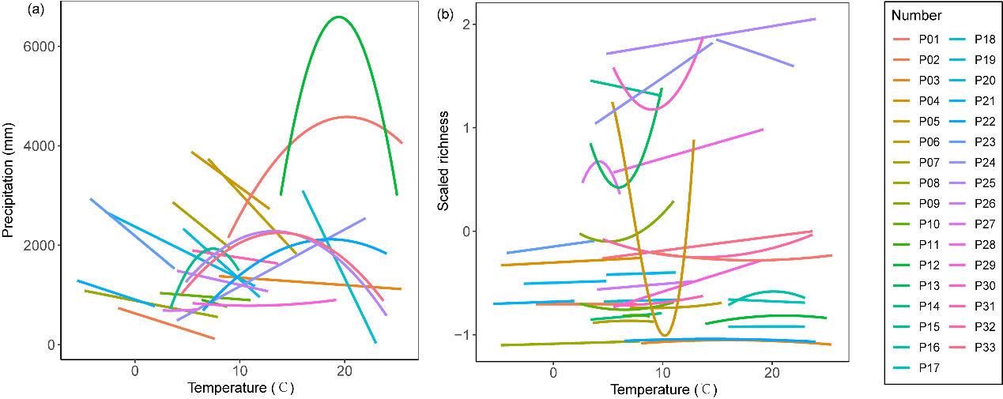
Fig. S1 Relationships between temperature and precipitation (a) and soil microbial richness (b). We used temperature as a substitute variable for elevation because temperature exhibited a consistent decreasing pattern with elevation. Identification numbers are listed in Table S1. A linear or quadratic model was selected based on the lower value of Akaike’s information criterion (AIC).
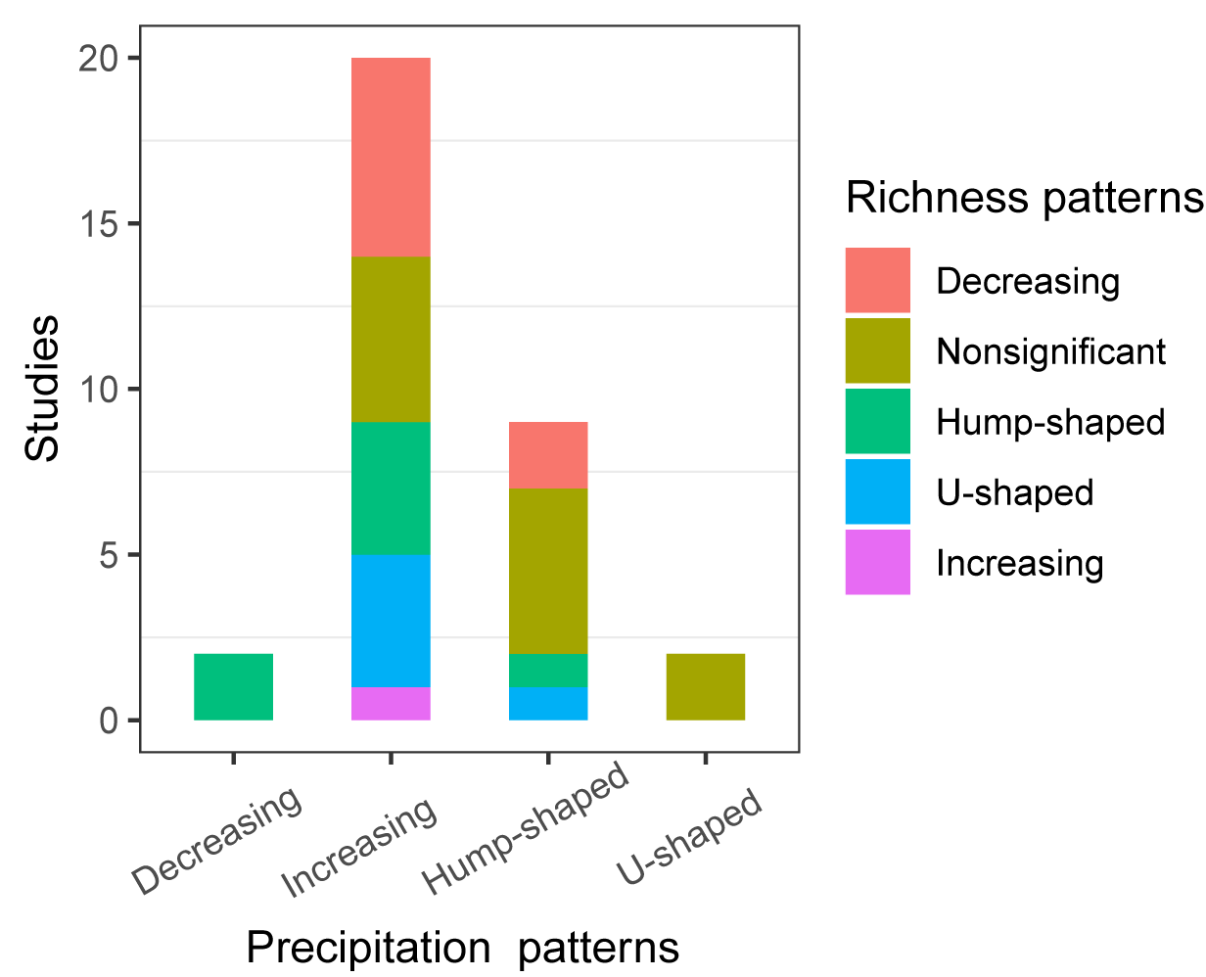
Fig. S2 Elevational patterns of soil microbial richness under different elevational patterns of precipitation. Temperature showed a decreasing elevational pattern in all studies. Precipitation showed decreasing, increasing, hump-shaped and U-shaped elevational patterns. Richness showed decreasing, increasing, hump-shaped and U-shaped and nonsignificant elevational patterns.
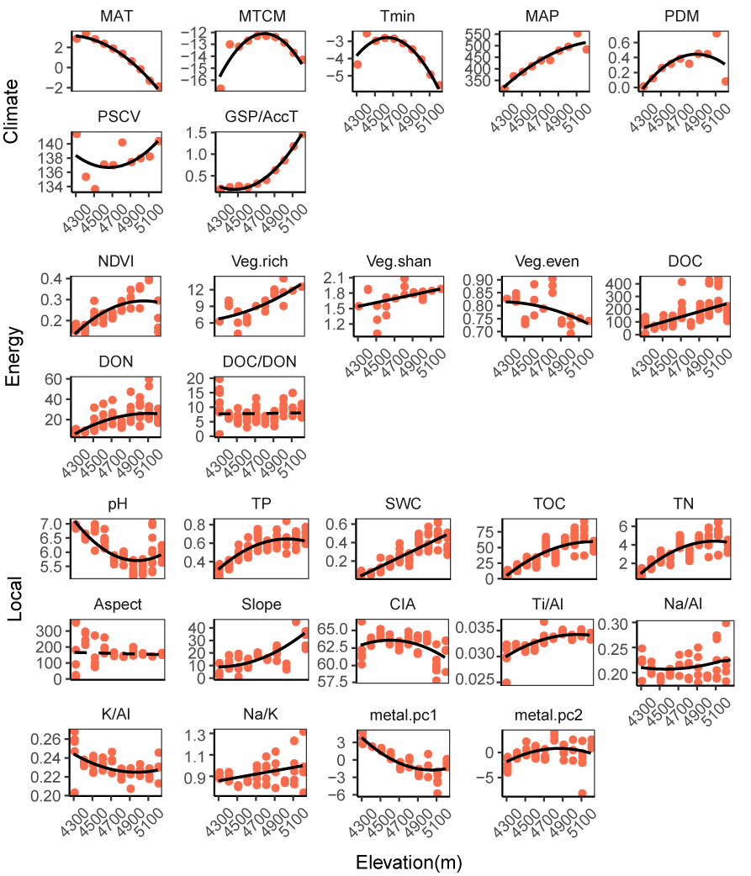
Fig. S3 Elevational patterns of climate, energy and local variables. A linear or quadratic model was selected based on the lower value of AIC. The solid and dotted lines represent significant (P＜0.05) and nonsignificant (P＞0.05) results, respectively. The abbreviations of the environmental variables are listed in Table S4.
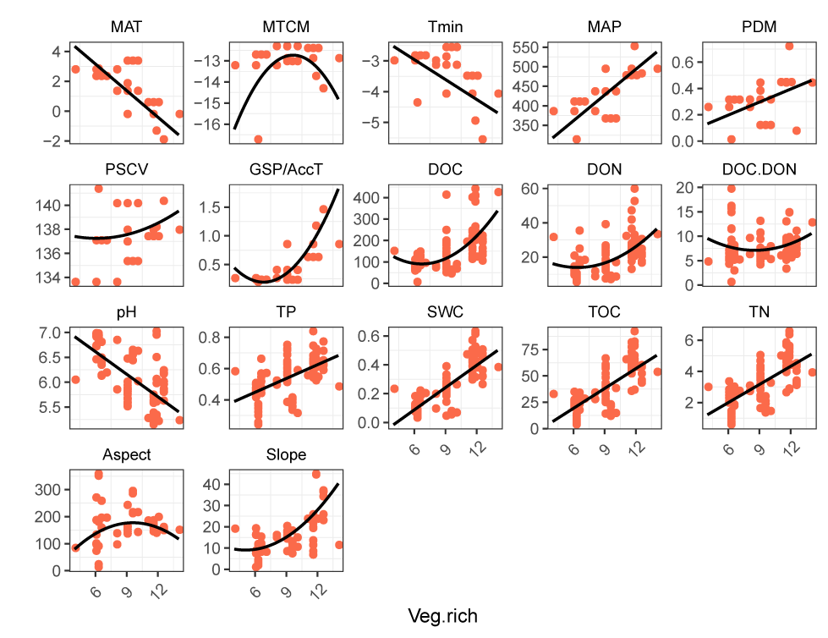Fig. S4 Relationships between vegetation richness and environmental variables. A linear or quadratic model was selected based on the lower value of AIC. The solid and dotted lines represent significant (P＜0.05) and nonsignificant (P＞0.05) results, respectively. The abbreviations of the environmental variables are listed in Table S4.
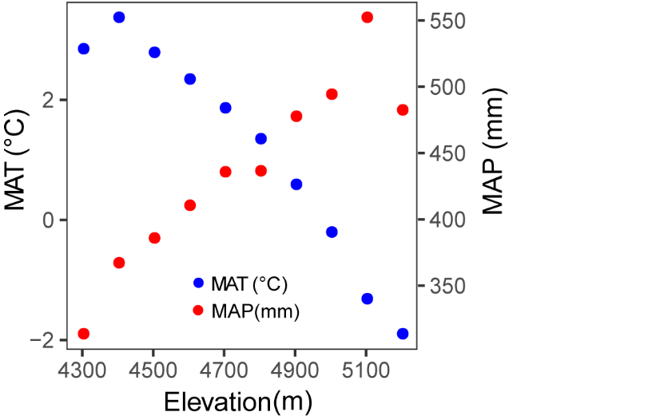
Fig. S5 Elevational patterns of mean annual temperature (MAT) and mean annual precipitation (MAP). Biodiversity is limited by drought or low temperature at lower or higher elevations, respectively (Wang et al., 2013).

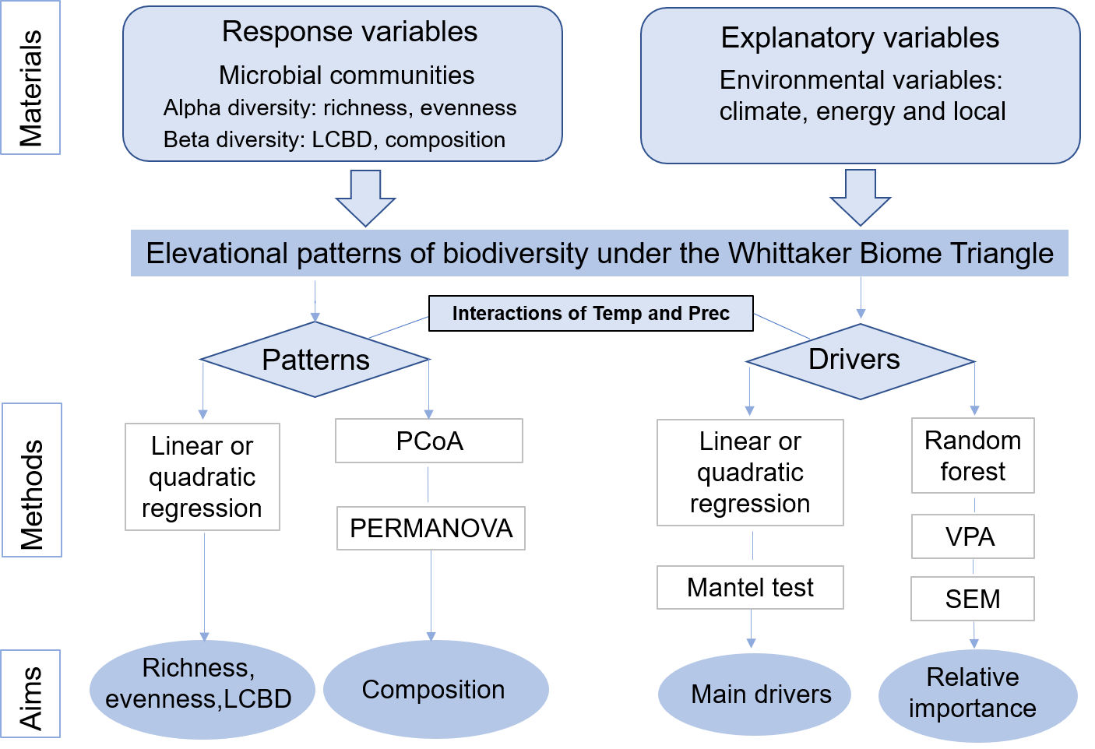
Fig. S6 “Materials, Methods and Aims” framework. LCBD: local contribution to beta diversity. PCoA: principal coordinate analysis. PERMANOVA: permutational multivariate analysis of variance. VPA: variation partitioning analysis. SEM: structural equation model. Temp: temperature. Prec: precipitation.
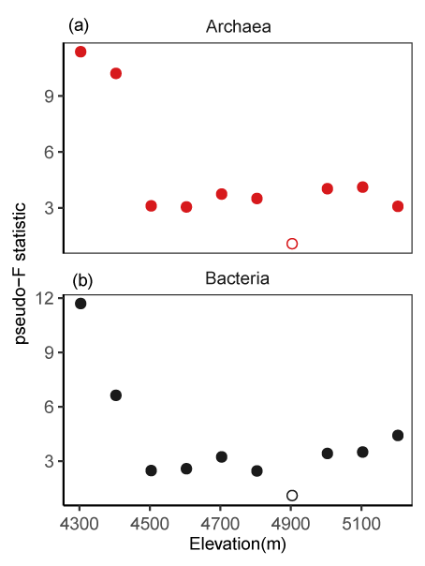
Fig. S7 The community composition of archaea and bacteria. The differences between the communities from one elevation and those from other elevations were tested by permutational multivariate analysis of variance (PERMANOVA) with the pseudo-F statistic; solid and open circles indicate significant (P < 0.05) and nonsignificant (P > 0.05) results, respectively.
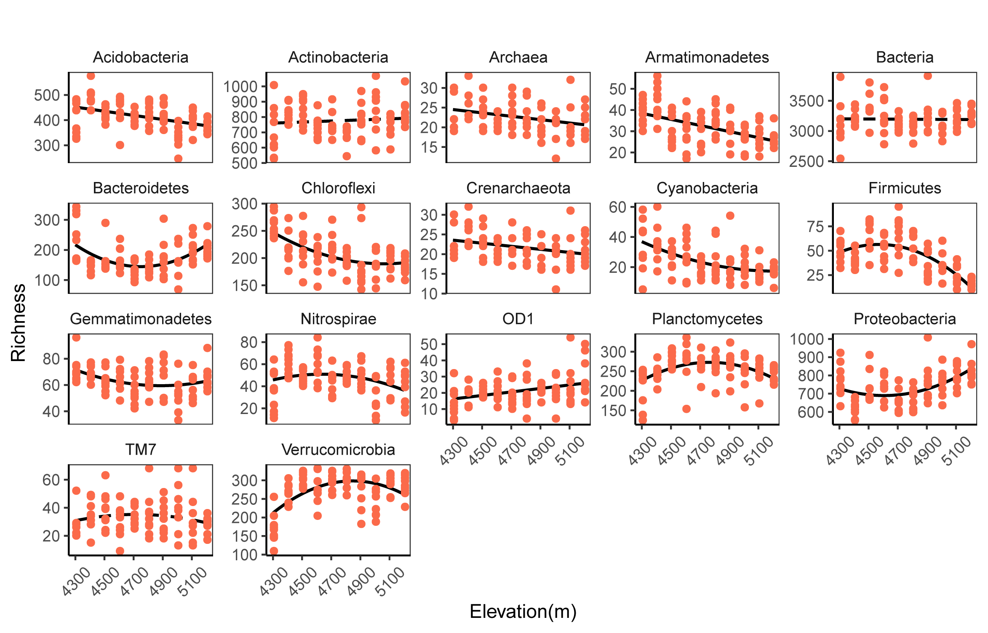Fig. S8 Elevational patterns in richness of the whole microbial communities and their phyla. A linear or quadratic model was selected based on the lower value of AIC. The solid and dotted lines represent significant (P＜0.05) and nonsignificant (P＞0.05) results, respectively.
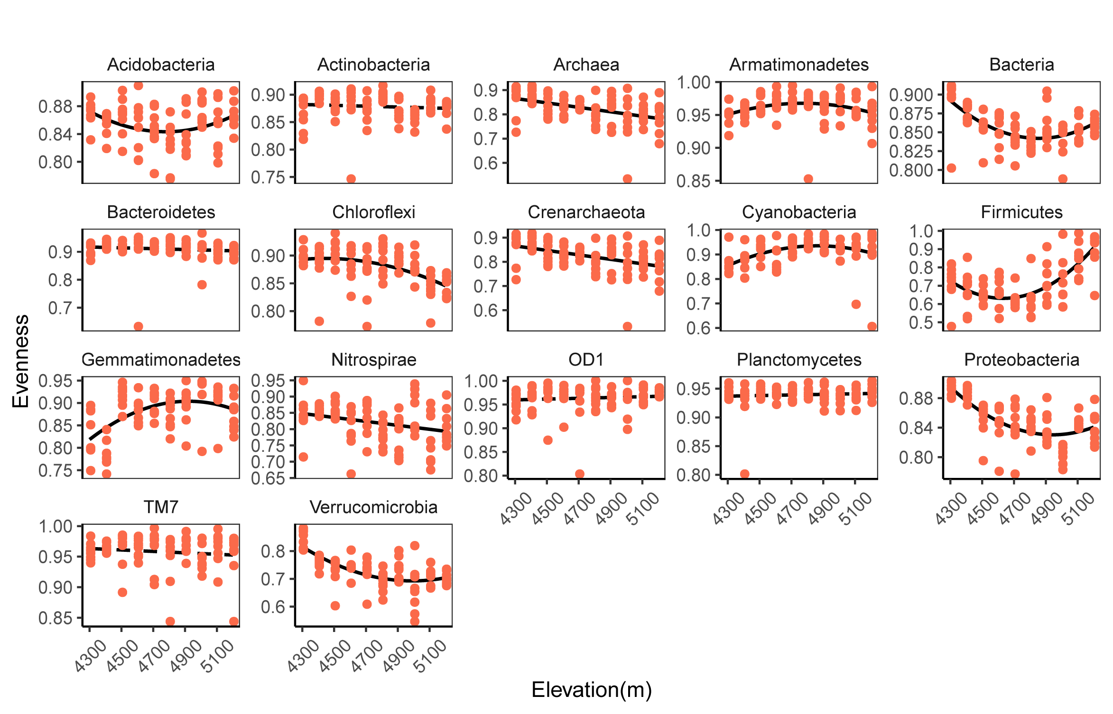Fig. S9 Elevational patterns in evenness of the whole microbial communities and their phyla. A linear or quadratic model was selected based on the lower value of AIC. The solid and dotted lines represent significant (P＜0.05) and nonsignificant (P＞0.05) results, respectively.
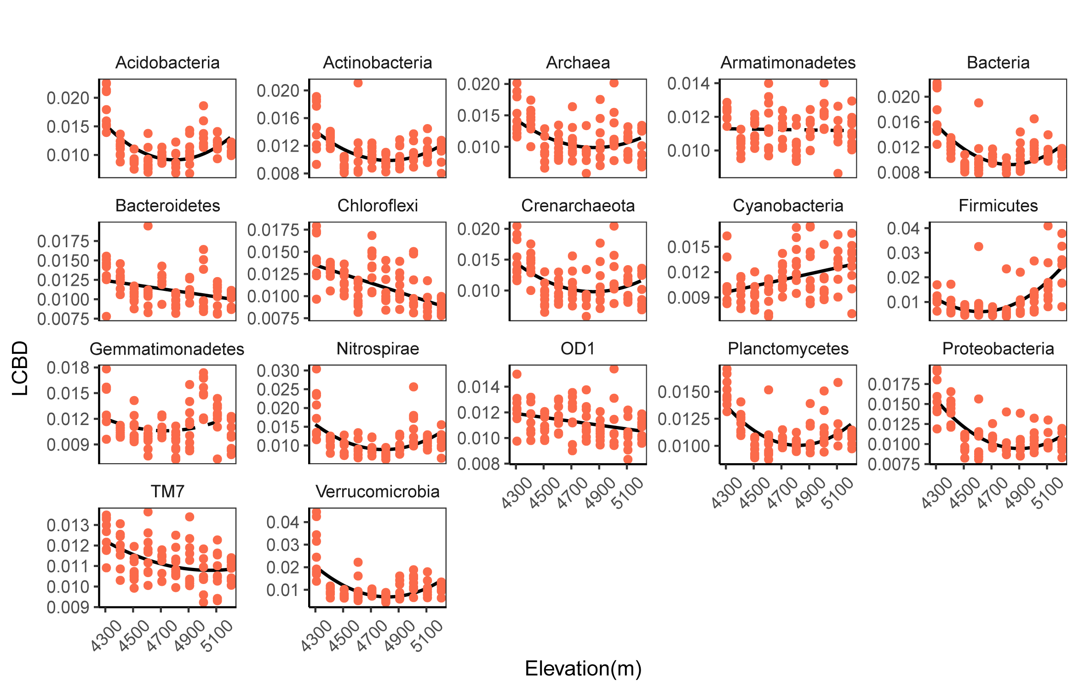Fig. S10 Elevational patterns in LCBD of the whole microbial communities and their phyla. A linear or quadratic model was selected based on the lower value of AIC. The solid and dotted lines represent significant (P＜0.05) and nonsignificant (P＞0.05) results, respectively.
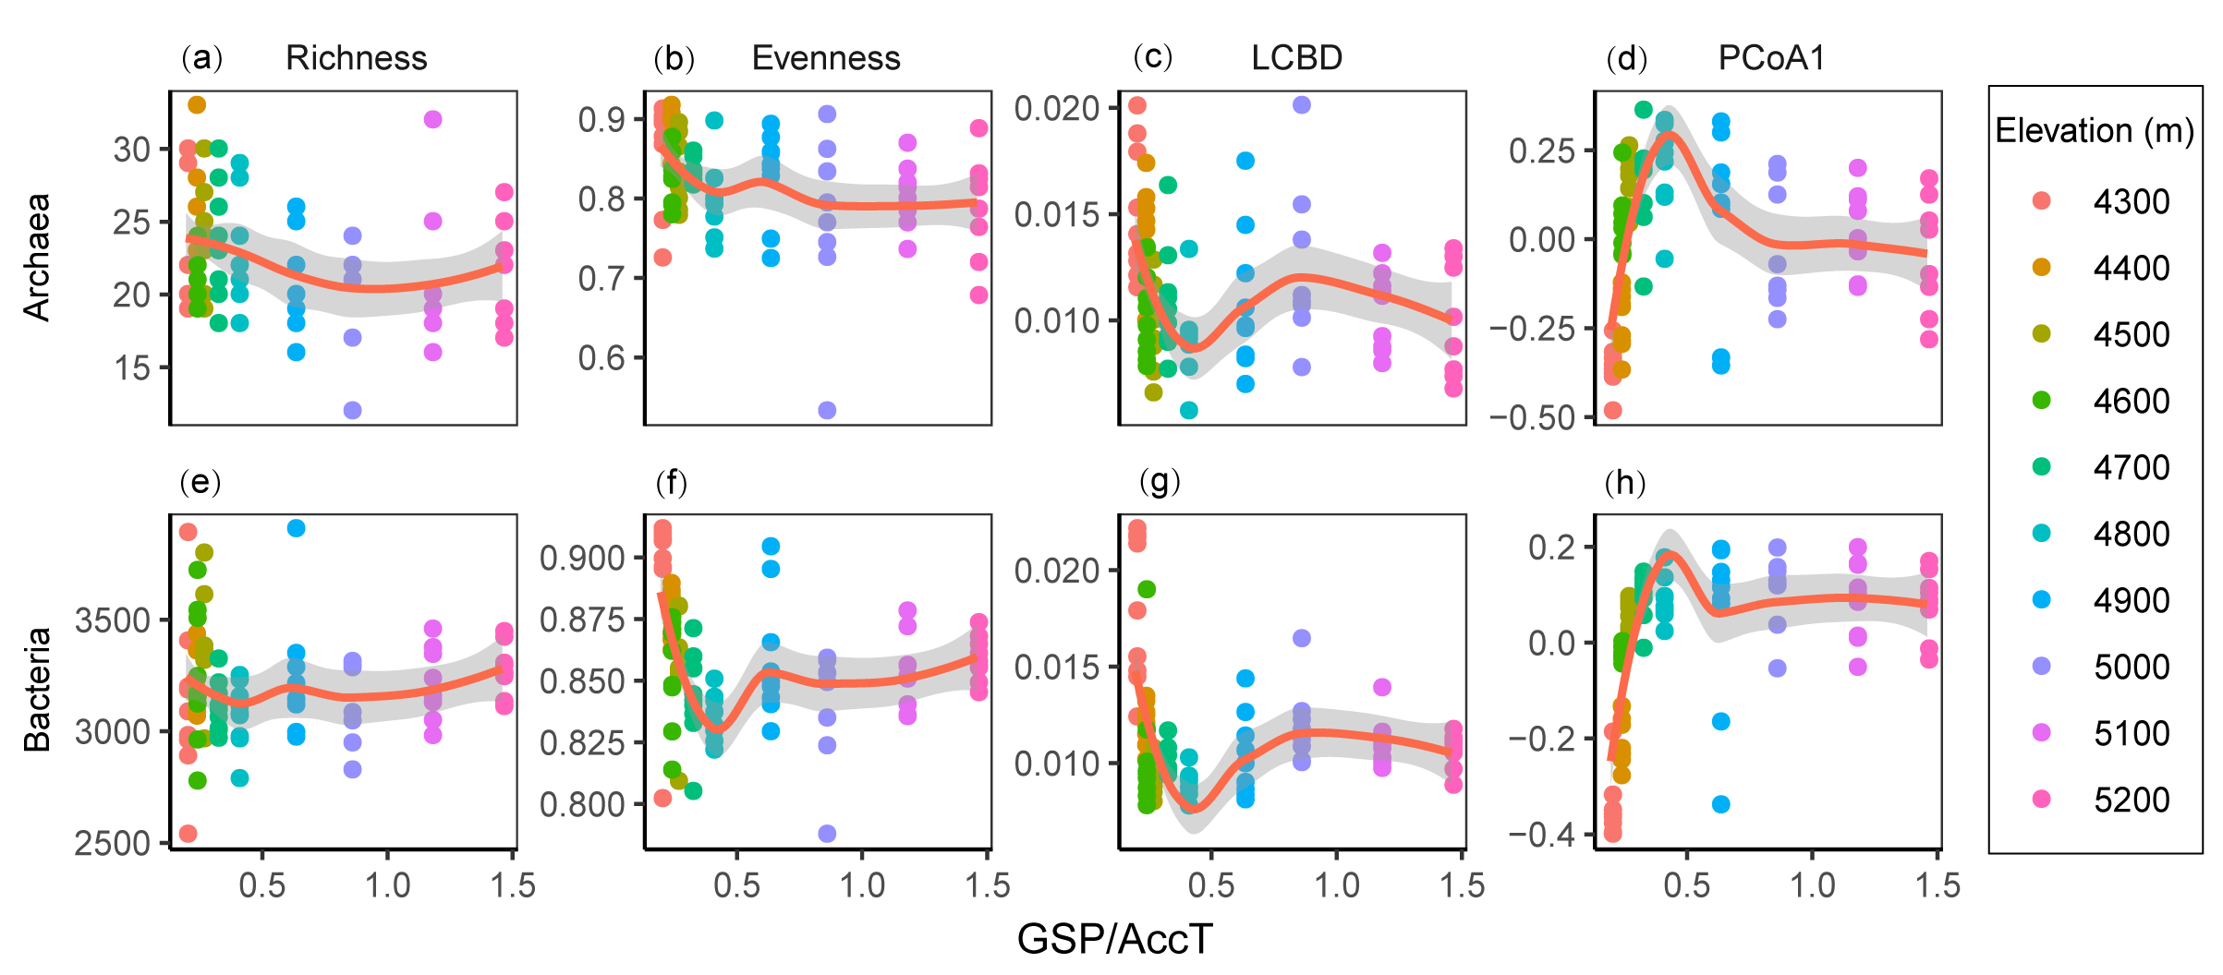Fig. S11 Relationships between archaeal and bacterial richness (a, e), evenness (b, f), LCBD (c, g), PCoA1 (d, h) and the moisture index (the GSP/AccT ratio). We used locally weighted regression (loess). GSP/AccT: The ratio of growing season precipitation to the total accumulated temperature above 5 °C.

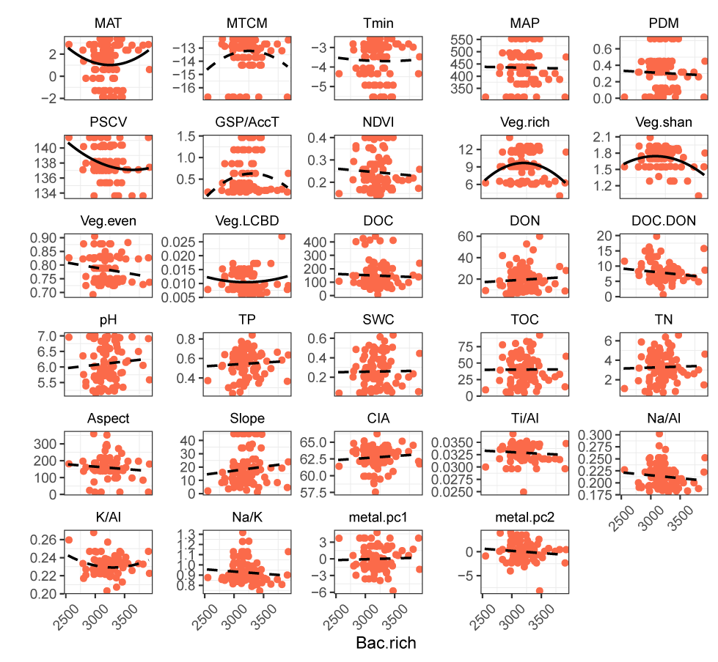Fig. S12 Relationships between bacterial richness and environmental variables. The abbreviations of the environmental variables are listed in Table S4. A linear or quadratic model was selected based on the lower value of AIC. The solid and dotted lines represent significant (P＜0.05) and nonsignificant (P＞0.05) results, respectively.
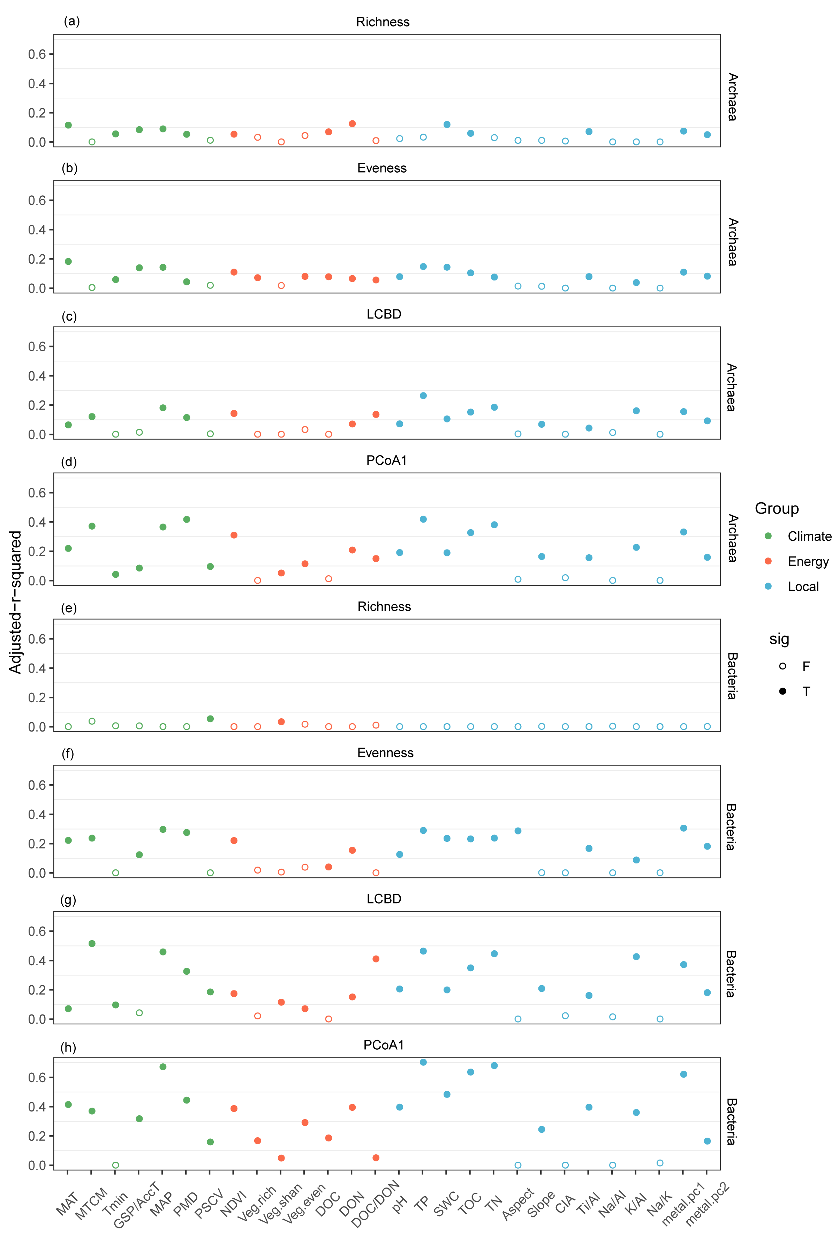
Fig. S13 Relative influence of environmental variables on archaeal and bacterial richness (a, e), evenness (b, f), LCBD (c, g) and PCoA1 (d, h) using a linear or quadratic model. Each circle represents the adjusted r-squared value for an individual environmental variable. The solid and dotted lines represent significant (P＜0.05) and nonsignificant (P＞0.05) results, respectively. The abbreviations of the environmental variables are listed in Table S4.
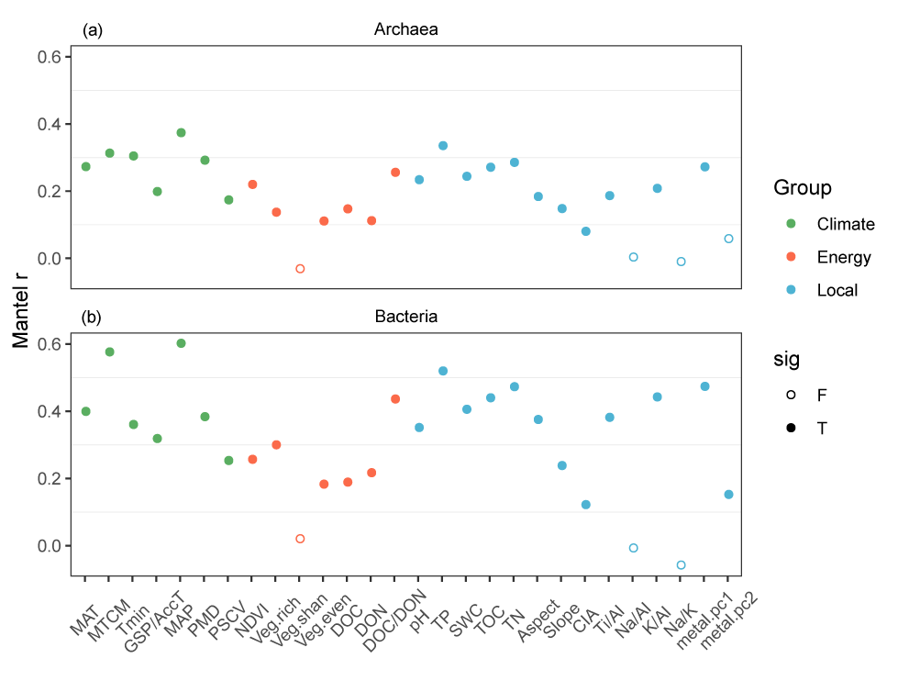
Fig. S14 Relative influence of environmental variables on archaeal (a) and bacterial (b) communities based on the Mantel test. Each circle represents the adjusted r-squared for an individual environmental variable. Solid and open circles indicate significant (P < 0.05) and nonsignificant (P > 0.05) results, respectively. The abbreviations of the environmental variables are listed in Table S4.
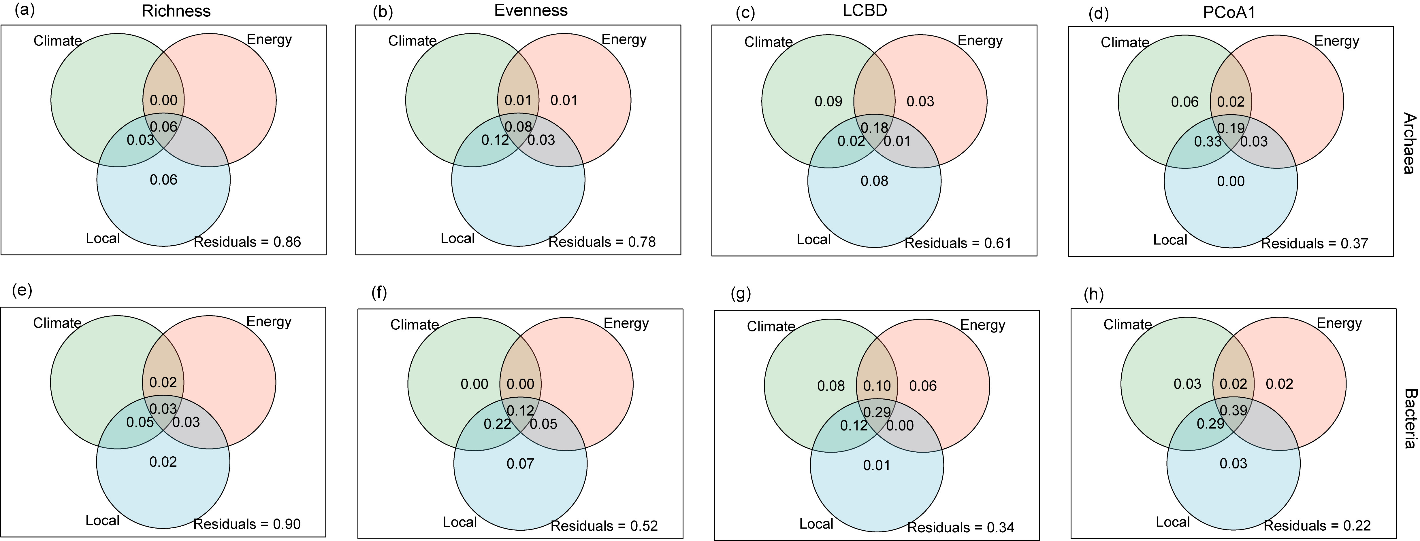Fig. S15 Relative influence of environmental variables on archaeal and bacterial richness (a, e), evenness (b, f), LCBD (c, g) and PCoA1 (d, h) determined by variation partitioning analysis (VPA). The environmental variables included three groups of predictors: climate, energy and local variables. The environmental variables and their groups are listed in Table S4.
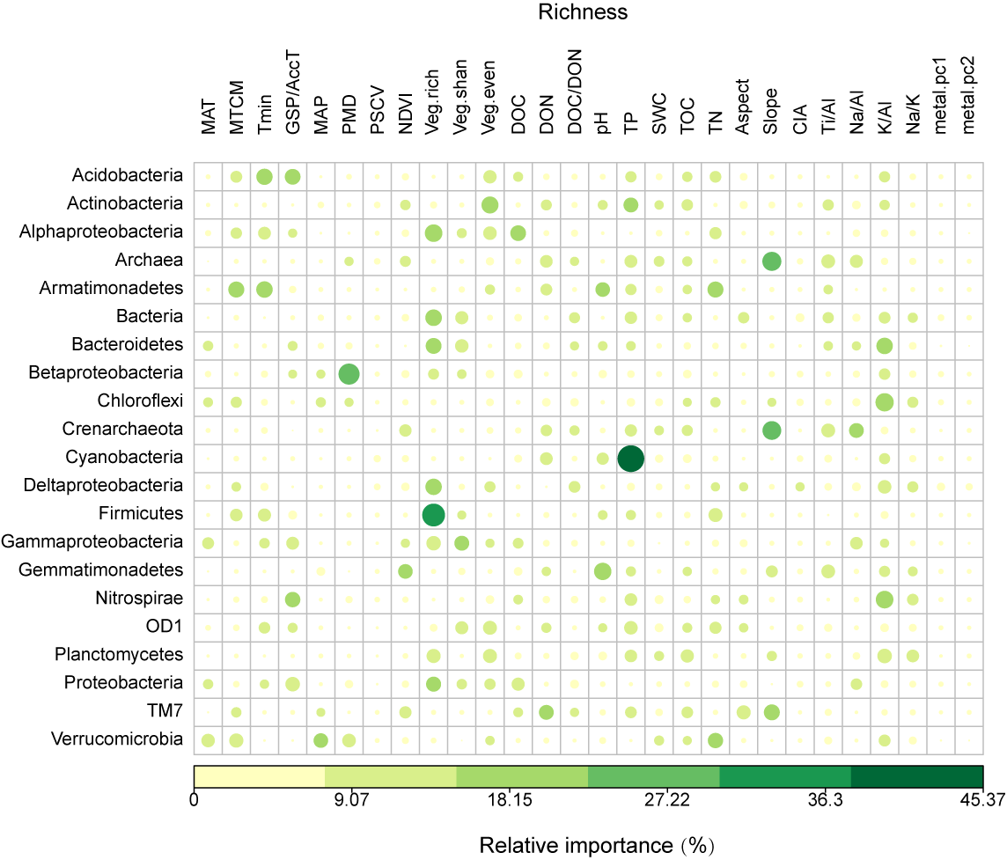
Fig. S16 Relative importance of environmental variables for richness of the whole microbial communities and their phyla determined by random forest analysis. The environmental variables included three groups of predictors: climate, energy and local variables. All environmental variables were Z-score transformed, which enabled us to compare the influences of different environmental variables with different measurement units on species richness. The abbreviations of the environmental variables are listed in Table S4.
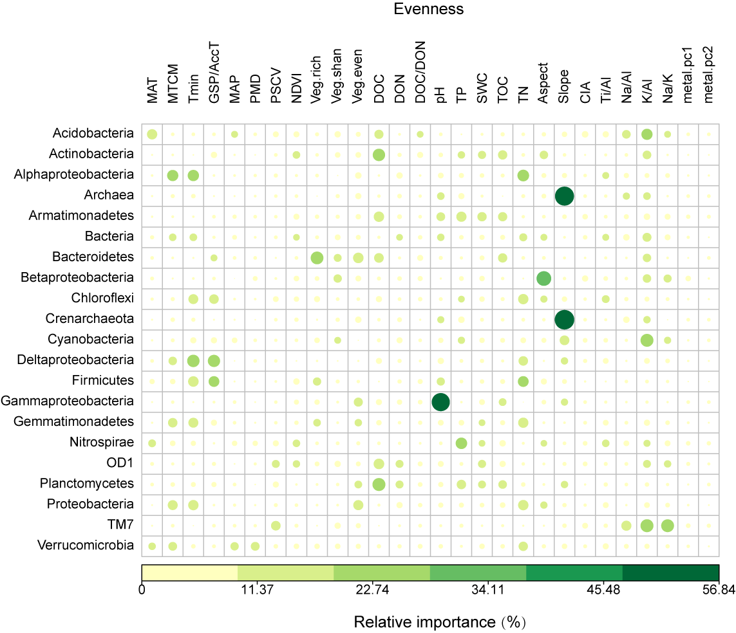
Fig. S17 Relative importance of environmental variables for evenness of the whole microbial communities and their phyla determined by random forest analysis. The environmental variables included three groups of predictors: climate, energy and local variables. All environmental variables were Z-score transformed, which enabled us to compare the influences of different environmental variables with different measurement units on microbial evenness. The abbreviations of the environmental variables are listed in Table S4.

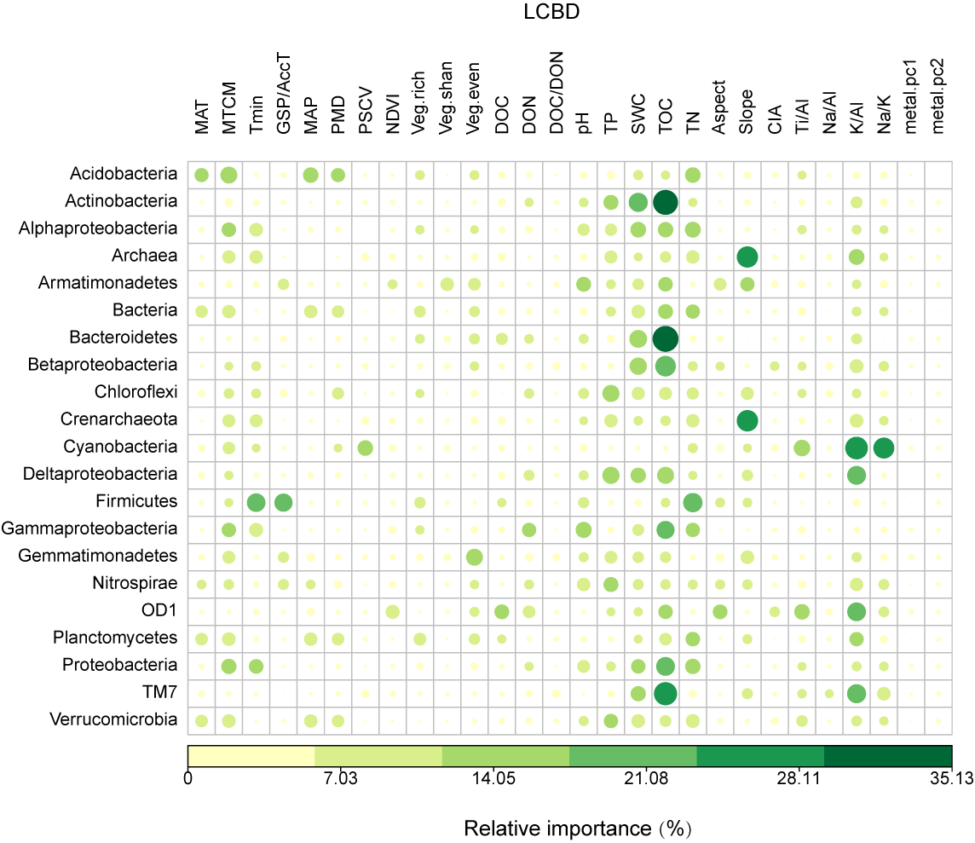
Fig. S18 Relative importance of environmental variables for LCBD of the whole microbial communities and their phyla determined by random forest analysis. The environmental variables included three groups of predictors: climate, energy and local variables. All environmental variables were Z-score transformed, which enabled us to compare the influences of different environmental variables with different measurement units on microbial LCBD. The abbreviations of the environmental variables are listed in Table S4.
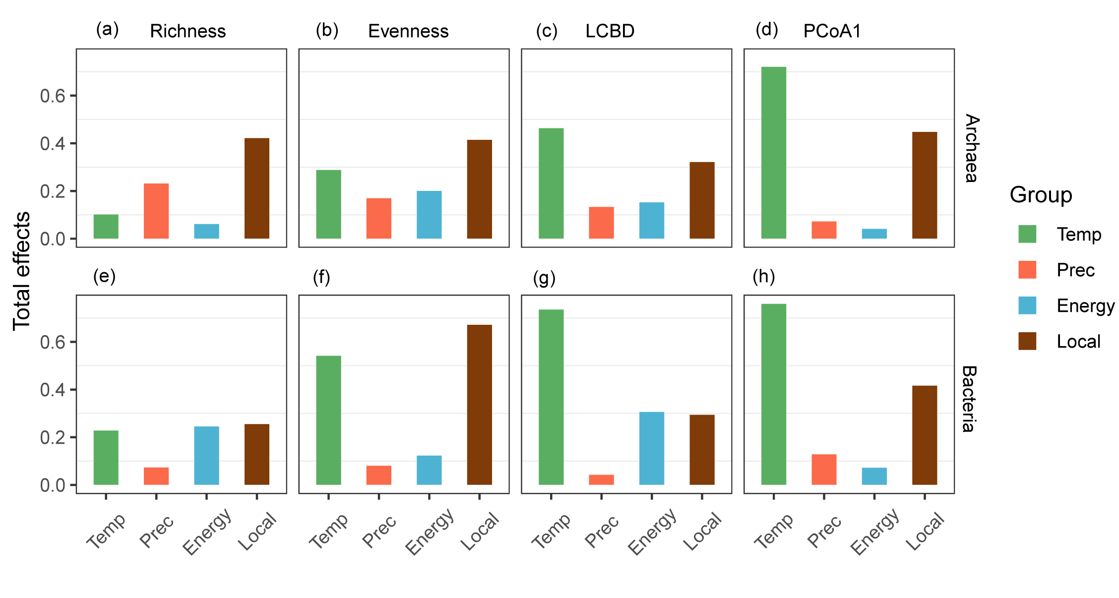Fig. S19 Structural equation models of the total effects of environmental variables on archaeal and bacterial richness (a, e), evenness (b, f), LCBD (c, g) and PCoA1 (d, h). The environmental variables included four groups of predictors: temperature, precipitation, energy and local variables. The environmental variables and their groups are listed in Table S4. The total effects included the direct and indirect effects of each group. More details on the direct, indirect and total effects of the predictor variables on microbial alpha and beta diversity are summarized in Table S6. Temp: temperature, Prec: precipitation.
References
Bayranvand M, Akbarinia M, Jouzani GS et al. Composition of soil bacterial and fungal communities in relation to vegetation composition and soil characteristics along an altitudinal gradient. FEMS Microbiol Ecol 2020;97:fiaa201.
Fierer N, McCain CM, Meir P et al. Microbes do not follow the elevational diversity patterns of plants and animals. Ecology 2011;92:797-804.
Gai JP, Tian H, Yang FY et al. Arbuscular mycorrhizal fungal diversity along a Tibetan elevation gradient. Pedobiologia 2012;55:145-151.
Gomez-Hernandez M, Williams-Linera G, Guevara R et al. Patterns of macromycete community assemblage along an elevation gradient: options for fungal gradient and metacommunity analyse. Biodiver Conserv 2012;21:2247-2268.
Hu A, Wang J, Sun H et al. Mountain biodiversity and ecosystem functions: interplay between geology and contemporary environments. ISME J 2020;14:931-944.
Lanzen A, Epelde L, Blanco F et al. Multi-targeted metagenetic analysis of the influence of climate and environmental parameters on soil microbial communities along an elevational gradient. Sci Rep 2016;6:28257.
Li J, Shen Z, Li, C et al. Stair-step pattern of soil bacterial diversity mainly driven by pH and vegetation types along the elevational gradients of Gongga mountain, China. Front Microbiol 2018;9:569.
Luo Z, Liu J, Zhao P et al. Biogeographic patterns and assembly mechanisms of bacterial communities differ between habitat generalists and specialists across elevational gradients. Front Microbiol 2019;10:169.
Miyamoto Y, Nakano T, Hattori M et al. The mid-domain effect in ectomycorrhizal fungi: range overlap along an elevation gradient on Mount Fuji, Japan. ISME J 2014;8:1739-1746.
Peay KG, von Sperber C, Cardarelli E et al. Convergence and contrast in the community structure of bacteria, fungi and archaea along a tropical elevation-climate gradient. FEMS Microbiol Ecol 2017;93:5.
Peters MK, Hemp A, Appelhans T et al. Climate-land-use interactions shape tropical mountain biodiversity and ecosystem functions. Nature 2019;568:88-92.
Rincon A, Santamaria-Perez B, Rabasa SG et al. Compartmentalized and contrasted response of ectomycorrhizal and soil fungal communities of Scots pine forests along elevation gradients in France and Spain. Environ Microbiol 2015;17:3009-3024.
Shearer CA, Zelski SE, Raja HA et al. Distributional patterns of freshwater ascomycetes communities along an Andes to Amazon elevational gradient in Peru. Biodiver Conserv 2015;24:1877-1897.
Shen C, Gunina A, Luo Y et al. Contrasting patterns and drivers of soil bacterial and fungal diversity across a mountain gradient. Environ Microbiol 2020;22:3287-3301.
Shen C, Liang W, Shi Y et al. Contrasting elevational diversity patterns between eukaryotic soil microbes and plants. Ecology 2014;95:3190-3202.
Shen C, Xiong J, Zhang H et al. Soil pH drives the spatial distribution of bacterial communities along elevation on Changbai Mountain. Soil Boil Biochem 2013;57:204-211.
Sheng Y, Cong W, Yang L et al. Forest soil fungal community elevational distribution pattern and their ecological assembly processes. Front Microbiol 2019;10: 02226.
Siles JA, Margesin R. Abundance and diversity of bacterial, archaeal, and fungal communities along an altitudinal gradient in alpine forest soils: what are the driving factors? Microb Ecol 2016;72:207-220.
Singh D, Lee-Cruz L, Kim WS et al. Strong elevational trends in soil bacterial community composition on Mt. Halla, South Korea. Soil Boil Biochem 2014;68:140-149.
Tian J, Wu B, Chen H et al. Patterns and drivers of fungal diversity along an altitudinal gradient on Mount Gongga, China. J Soils Sediments 2017;17:2856-2865.
Vetaas OR, Paudel KP, Christensen M. Principal factors controlling biodiversity along an elevation gradient: Water, energy and their interaction. J Biogeogr 2019;46:1652-1663.
Wang Z, Luo T, Li R et al. Causes for the unimodal pattern of biomass and productivity in alpine grasslands along a large altitudinal gradient in semi-arid regions. J Veg Sci 2013;24:189-201.
Yang H, Lu G, Jiang H et al. Diversity and distribution of soil micro-fungi along an elevation gradient on the north slope of Changbai Mountain. J For Res 2017;28:831-839.
Yang Y, Wu P. Soil bacterial community varies but fungal community stabilizes along five vertical climate zones. Catena 2020;195:104841.
Yang Y, Zhou Y, Shi Z et al. Interactive effects of elevation and land use on soil bacterial communities in the Tibetan Plateau. Pedosphere 2020;30:817-831.

