**Appendix A. Supplementary data**

**Electricity generation and pollutants removal of landfill leachate by osmotic microbial fuel cells with different forward osmosis membranes**

Nan Jiang a, Li Huanga, Teng Caic, Jialing Songa, Shengyang Zhenga, Jili Guoa, Zhuang Konga, Manhong Huanga,b,*

aCollege of Environmental Science and Engineering, State Environmental Protection Engineering Center for Pollution Treatment and Control in Textile Industry, Donghua University, Shanghai 201620, China. E-mail: huangmanhong@dhu.edu.cn

bShanghai Institute of Pollution Control and Ecological Security, Shanghai 200092, China

cShanghai Key Lab for Urban Ecological Processes and Eco-Restoration, School of Ecological and Environmental Sciences, East China Normal University, Shanghai, 200241, China

----------------------------------

* Corresponding author. E-mail: huangmanhong@dhu.edu.cn (Manhong Huang)

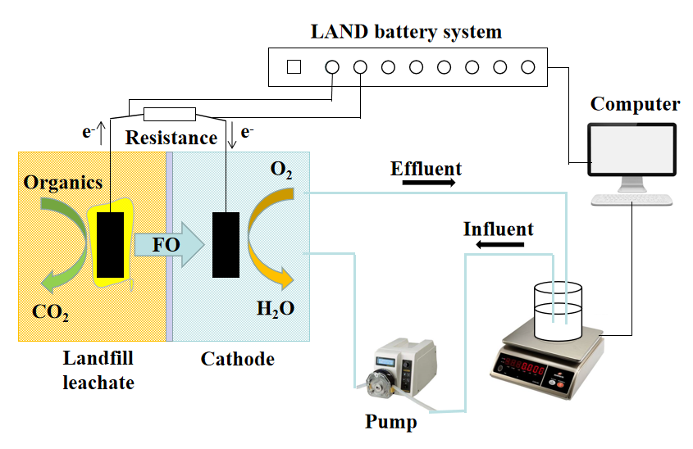

**Fig. S1** Schematic of the experimental design for the OsMFC



**Fig. S2** Rarefaction curves of different membranes

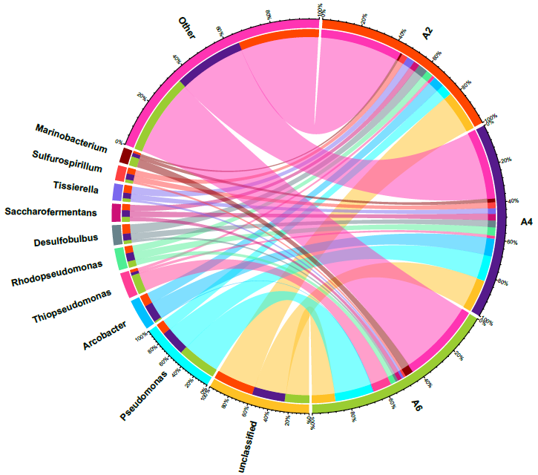

**Fig. S3** Genus level relationship between the sample and the species（A2：CTA-NW-OsMFC、A4：CTA-ES-OsMFC、 A6：TFC-ES-OsMFC）

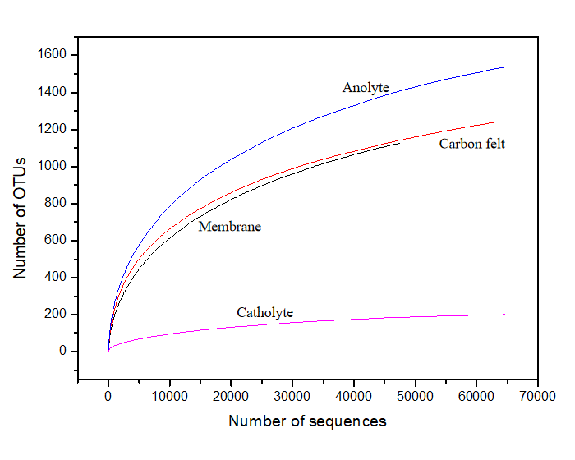

**Fig. S4** Rarefaction curves of different OsMFCs sites

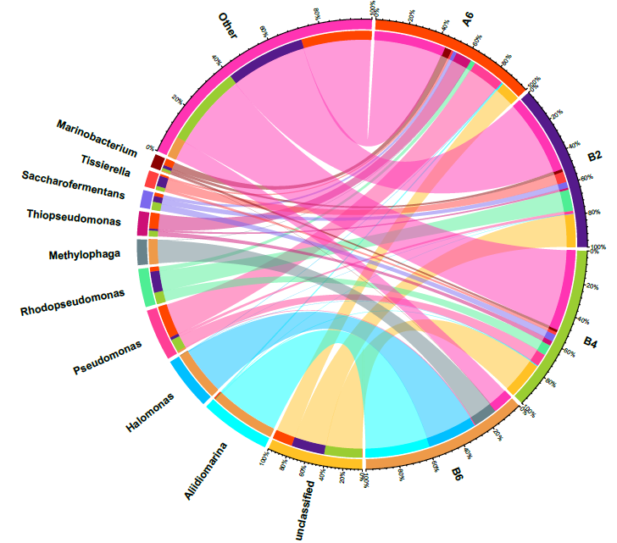

**Fig. S5** Genus level relationship between the sample and the species（A6: membrane; B2: carbon felt; B4: anolyte; B6: catholyte）