**Supporting information**

**Architecture engineering of one body nanostructured catalyst: layer-by-layer adornment of multiple nanocatalysts on silica nanorod arrays for hydrogenation of nitroarenes**

Kootak Hong1,+, Jun Min Suh1,+, Tae Hyung Lee1, Seeram Ramakrishna2, Rajender S. Varma3,*, Ho Won Jang1,*, and Mohammadreza Shokouhimehr1,*

1Department of Materials Science and Engineering, Research Institute of Advanced Materials, Seoul National University, Seoul 08826, Republic of Korea.

2Faculty of Mechanical Engineering, National University of Singapore, 117574, Singapore.

3Regional Centre of Advanced Technologies and Materials, Palacký University, Šlechtitelů 27, 783 71 Olomouc, Czech Republic.

Corresponding Authors

varma.rajender@epa.gov (R.S.V.), hwjang@snu.ac.kr (H.W.J.), mrsh2@snu.ac.kr (M.S.)

+ K.H., J.M.S., contributed equally to this work.

**Heterogeneous reduction of substituted nitroarenes**

The reduction of nitroarenes was performed in a glass flask. In a typical procedure, v-SiO2 NRs@Pd nanostructured catalyst (1 mol%) was immersed in H2O (20 mL). Then, a nitroarenes compound (0.1 mmol), NaBH4 (0.12 mol%) and a small stirring bar were added to the glass flask. The reaction mixture was stirred at room temperature for 1.5 h under air atmosphere. After completion of the reaction, the v-SiO2 NRs@Pd nanostructured catalyst was drawn out from the reaction mixture by tweezers, rinsed with ethanol, and reused in the next cycle.

**Heterogeneous Suzuki cross-coupling reactions**

Suzuki reactions were expedited using v-SiO2 NRs@Pd nanostructured catalyst in a round-bottom flask containing dimethylformamide (DMF)/H2O (5:1) solvent. Aryl halide (0.1 mmol), phenylboronic acid (0.12 eq.), K2CO3 (1.5 eq.), and a small stirring bar were added to the flask immersed in an oil bath (100 °C). The reaction mixtures were stirred under air atmosphere for adequate time to obtain the expected biphenyl products.

C:\Users\me\Desktop\그림1.tif

**Fig. S1.** XPS analysis of (a) survey, (b) Si, and (c) O present in v-SiO2 NRs@Pd

nanostructured catalyst.

C:\Users\me\Desktop\그림3.tif

**Fig. S2.** (a) Cross-sectional FESEM image of v-SiO2 NRs@Pd/Au nanostructured catalyst. (b-e) EDS element maps of (b) Si, (c) O, (d) Au, and (e) Pd of v-SiO2 NRs@Pd/Au nanostructured catalyst. HRTEM images of (f) Au and (g) Pd existing in v-SiO2 NRs@Pd/Au nanostructured catalyst. XPS analysis of (h) Au and (i) Pd in v-SiO2 NRs@Pd/Au nanostructured catalyst.



**Fig. S3.** Cross-sectional FESEM image of v-SnO2 NRs@Pd nanostructured catalyst.



**Fig. S4.** C-13 NMR spectrum of 3-vinylbenzenamine (Table 1, entry).

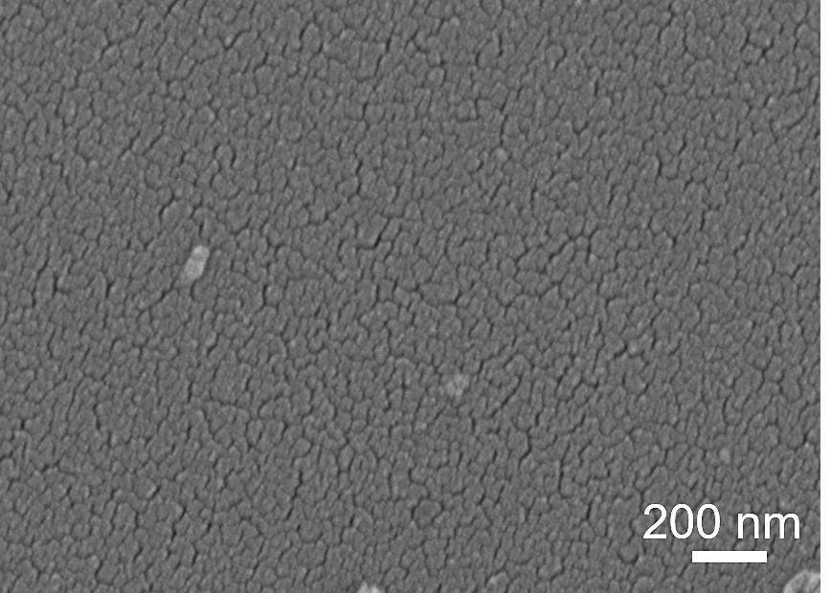

**Fig. S5.** FESEM image of Pd NPs deposited directly on silicon wafer.

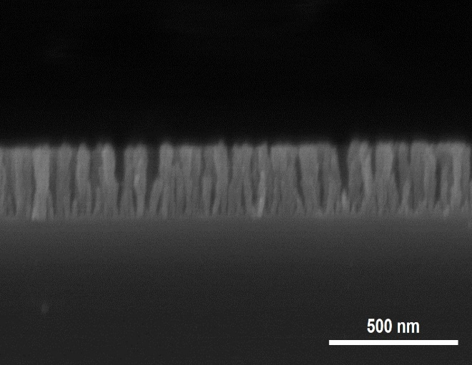

**Fig. S6.** Cross-sectional FESEM image of ~200 nm v-SiO2 NRs@Pd nanostructured catalyst.

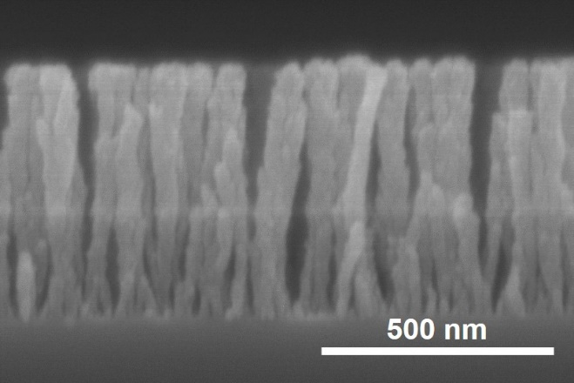

**Fig. S7.** Cross-sectional FESEM image of ~600 nm v-SiO2 NRs@Pd nanostructured catalyst.

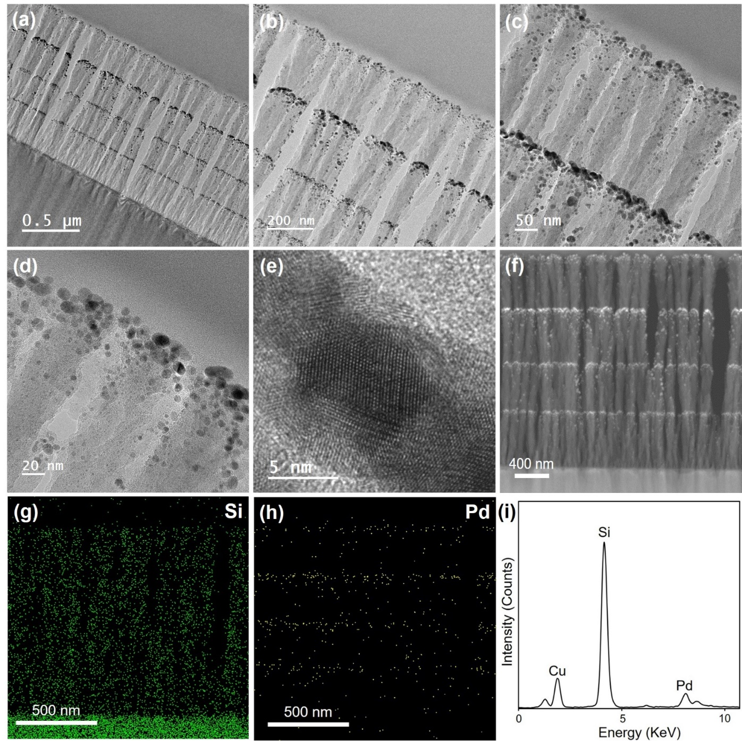

**Fig. S8.** (a-e) Cross-sectional TEM and HRTEM images, and (F) STEM image of recycled v-SiO2 NRs@Pd nanostructured catalyst. (g) Si, and (h) Pd elemental mapping of recycled v-SiO2 NRs@Pd nanostructured catalyst. (i) EDX spectrum of recycled v-SiO2 NRs@Pd nanostructured catalyst.

**Table S1.** Heterogeneous reduction of nitrobenzene catalyzed by different nanostructured catalyst.

|  |  |  |  |
| --- | --- | --- | --- |
| **Entry** | **Nanostructured catalyst** | **Yields (%)a** |  |
| 1 | Pd NPs on silicon wafer | 15 |  |
| 2 | Pd NPs on ~200 nm SiO2 NRs | 35 |  |
| 3 | Pd NPs on ~600 nm SiO2 NRs | 58 |  |
| 4 | v-SiO2 NRs@Pd catalyst | 99 |  |

Reaction conditions: Nitrobenzene (0.1 mmol), NaBH4 (0.12 mmol), nanostructured catalyst (1 mol% Pd), H2O (20 mL), room temperature, and 1.5 h. a Yields were determined by GC-MS.