Ciprofloxacin induced antibiotic resistance in Salmonella Typhimurium mutants and genome analysis

Aarti S. Kakatkarª, Anubrata Das^{c}, Ravindranath Shashidhar^{ab#}

Food Technology Division, Bhabha Atomic Research Centre, Mumbai, Indiaª
Life Sciences, Homi Bhabha National Institute (Deemed to be University), Mumbai, India^{b}

Bio Organic Division, Bhabha Atomic Research Centre, Mumbai, India^{c}

#Corresponding author: Ravindranath Shashidhar, Food Technology Division, Bhabha Atomic Research Centre, Trombay, India- 400085, (O)+91 22-25593961

Address correspondence to shashi@barc.gov.in
Journal name Archives of Microbiology

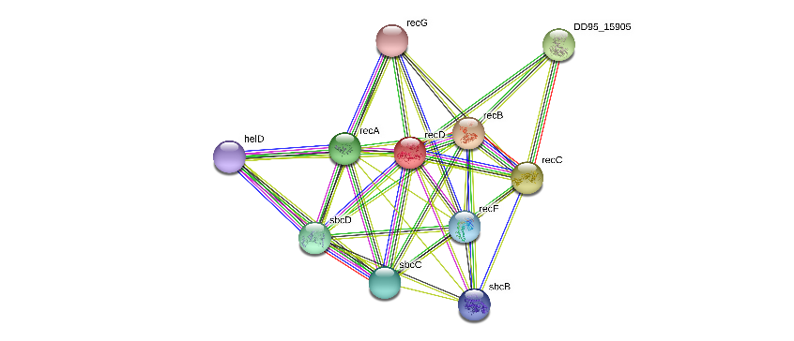
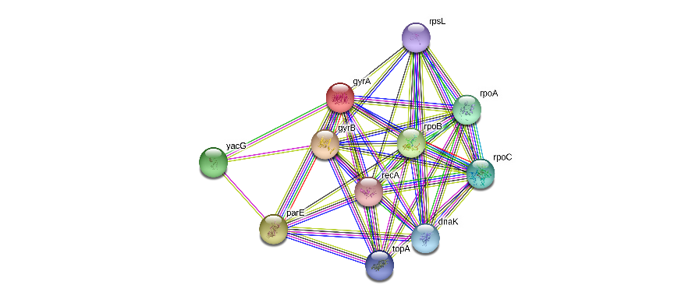
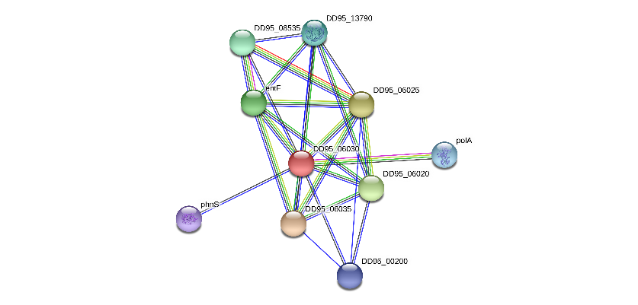
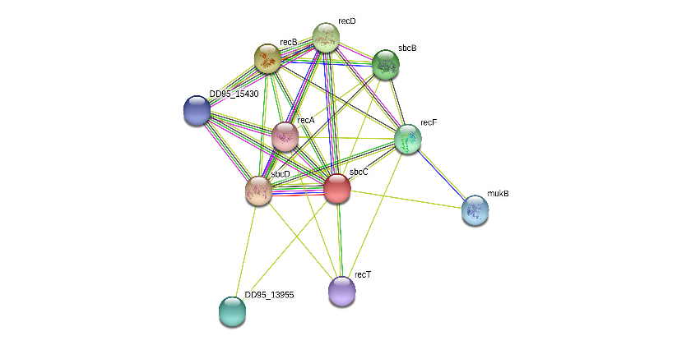
sbcC
recD
gyrA
iroC

Fig. S1 Relationship between different genes. recD, sbcC interact very strongly. they interact with gyrA via recA. surprisingly iroC interacts with gyrA through polA another polymerase; so, we propose that to develop resistance to ciprofloxacin, the mutations in these genes collected probably led to DNA breakages/slippage during replication etc and error prone recombination repair leading to such high number of mutations

